FOUR-POINT BENDING

Glass beam

Loading Force 90 N

Field of view:
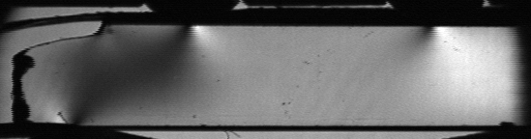

Retardation map:
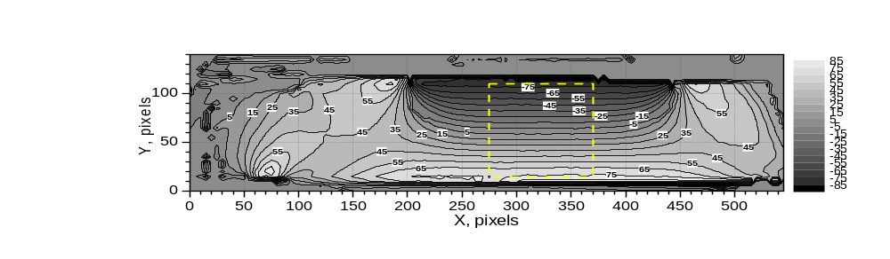
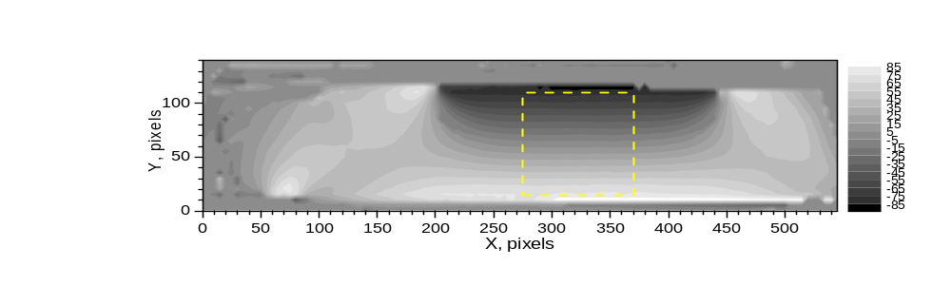

Azimuth map:
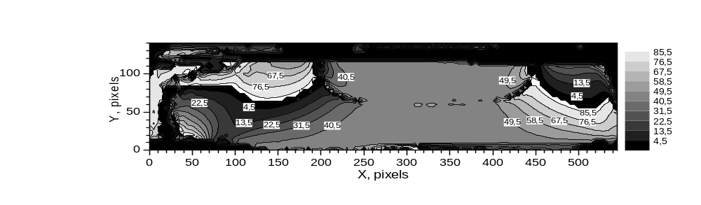

Average Retardation Vs Y coordinate:
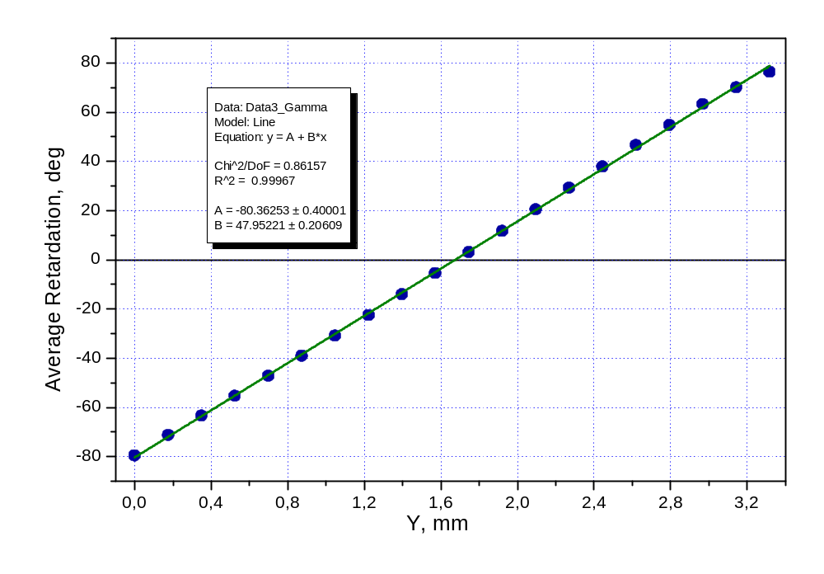

Using fitting constant B, we can calculate photoelastic coefficient C₂:

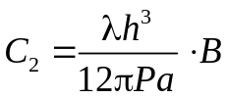

For λ = 632.8 nm, h = 4 mm, a = 4 mm, P = 90 N, B = 47.95 deg/mm = 0.8369 rad/mm we obtain:

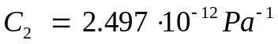

Retardation map:
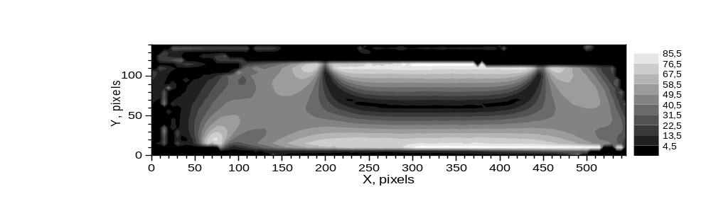

Azimuth map:

