**Project1 – P2**

The folder contains a python file, P2.py and the sampled anonymized edge list, anonymizededges.csv which is the output from Problem1.

P2.py takes the path of the anonymizededges.csv as a command line argument. Use the following commands to execute the script in a command prompt or terminal:

*python P2.py anonymizededges.csv*

Results:

* In degree distribution

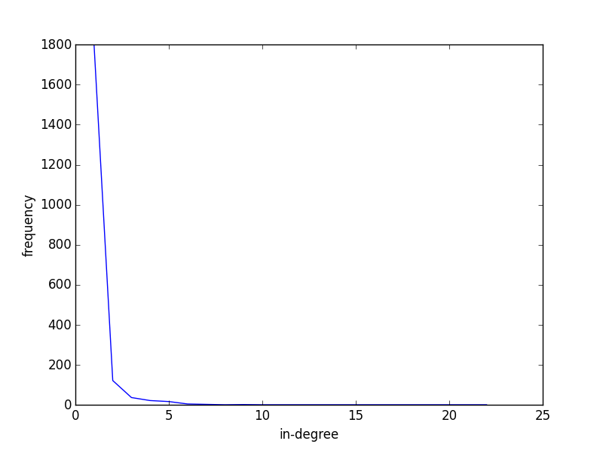

* Out degree distribution

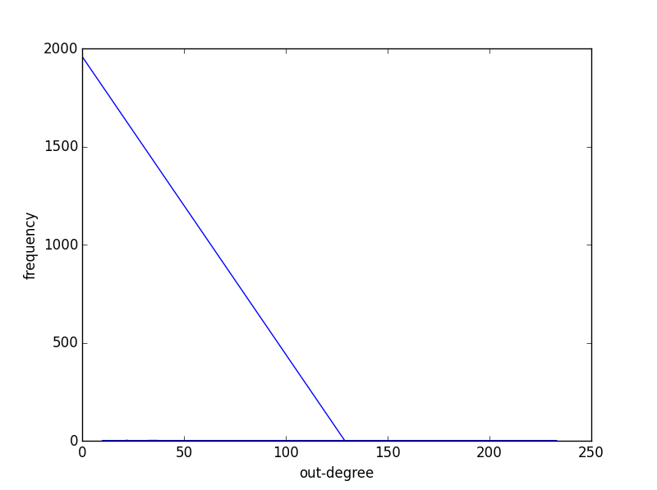

* In-degree exponent – 6.60537806412
* Out-degree exponent – 3.59791399433
* Number of bridges – 1778
* Number of 3 cycle – 404
* Graph Diameter – 5

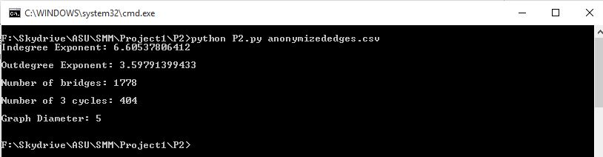

* * Remove x% of edges randomly then:

Compute the size |S| of the largest connected component

Do for x from 1 to 100. Plot x versus |S|.

If you have a directed graph, make it undirected

