**Project1 – P4**

The folder contains a python file, P4.py and the sampled anonymized edge list, anonymizededges.csv which is the output from Problem1.

P4.py takes the path of the anonymizededges.csv as a command line argument. Use the following commands to execute the script in a command prompt or terminal:

*python P4.py anonymizededges.csv*

**Output:**

**Degree Distribution**

* Original Graph

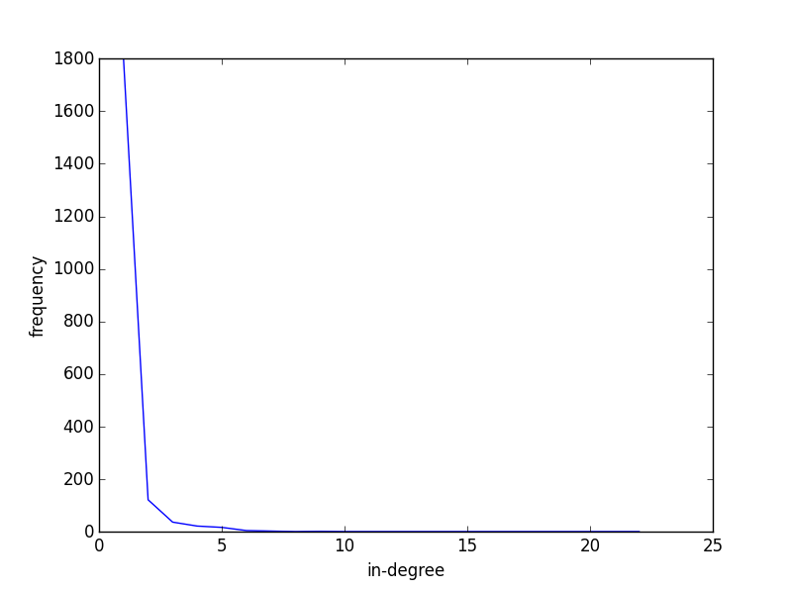

Random Graph

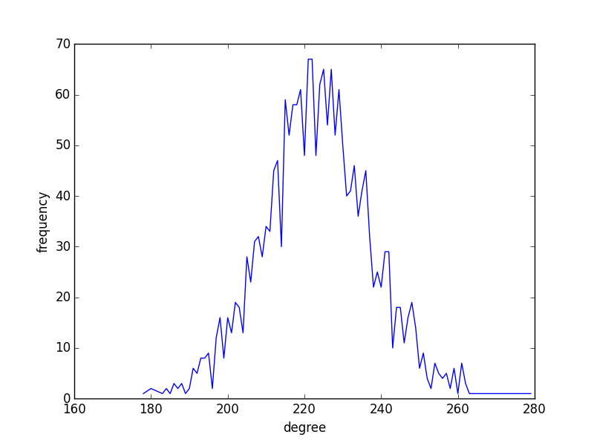

Small World Model

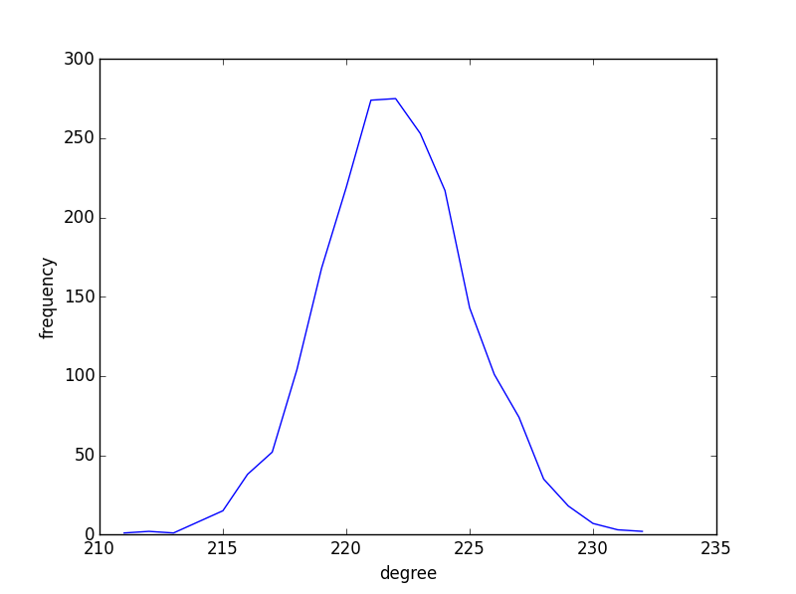

Preferential Attachment Model

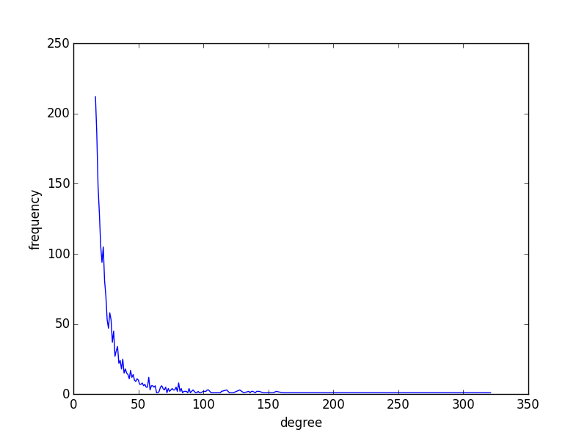

**Comparison :**

|  |  |  |  |  |
| --- | --- | --- | --- | --- |
|  | **Real-world graphs** | **Random Graphs** | **Small World Model** | **Preferential Attachment** |
| **Degree Distribution** | Power-Law | Poisson | Poisson | Power-Law |
| **Clustering Coefficient** | 0.00363919069741 | 0.111370963526 | 0.656356167806 | 0.0501319688695 |
| **Average Path Length** | 3.97074507998 | 1.40576374813 | 1.97448001407 | 3.74873279997 |

