
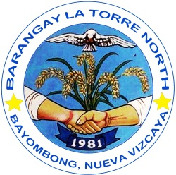
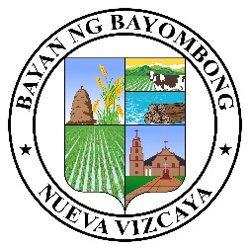

Republic of the Philippines
Province of Nueva Vizcaya
Municipality of Bayombong
ooOoo
BARANGAY LA TORRE NORTH
Provincial Road, La Torre North, Bayombong, Nueva Vizcaya Email: barangaylatorrenorthnuevvizcay@gmail.com Philippines, 3700 TEL#s - (078) 321-4745 / 392-1894 Contact Numbers: 0916-174-9428/0927-570-6819
FB Page: Barangay La TORRE NORTH
SANGGUNIANG BARANGAY

JOEL C. CASTRICIONES
Punong Barangay

BARANGAY KAGAWADS

MILAGROS P. PADILLA

VILLAFUERTE T. MARTINEZ JR.

MELITA P. SANCHEZ

IRENE C. BAJO

VIRGIL P. COVITA

CAROLINA V. VICENTE

JOSEPH P. ESTEBAN

SAMUEL JAMES B. DEL ROSARIO
SK Chairperson
CERTIFICATION OF INDIGENCY

TO WHOM IT MAY CONCERN:

This is to CERTIFY that {name}, {civilStatus}, and a bona fide resident of {purok}, Barangay La Torre North, Bayombong, Nueva Vizcaya.
FURTHER CERTIFY that the family of the person mentioned above is one of the indigents of this barangay.
CERTIFICATION is being issued upon the request of the person mentioned above for {purpose}.

ISSUED this {dayOrdinal} day of {month}, {year} at La Torre North, Bayombong, Nueva Vizcaya

Certified By:
HON. JOEL C. CASTRICIONES
Punong Barangay

NOTE: NOT VALID WITHOUT OFFICIAL SEAL
***** This is for a 1(one) single transaction only.

