A Capstone Proposal Presented to the Faculty of the
TransparaBrgy: Proposed Blockchain-Based Barangay Management System for BLGU La Torre North

School of Engineering, Architecture and Information Technology
Department of Information Technology
Saint Mary’s University
Bayombong, Nueva Vizcaya

In Partial Fulfillment of the Requirements for the Degree
Bachelor of Science in Information Technology

by:
Lance Krystian D. Andres
Marc Christian C. Delos Santos
Felix C. Leid Jr.
Rohann Harold N. Mondiguing

Dr. Adonis V. Garces
Research Adviser

December 2025

TABLE OF CONTENTS
Title Page i
Table of Contents ii
List of Figures iii
List of Tables iv
List of Appendices v
CHAPTER I INTRODUCTION 7
Rationale 7
Conceptual Framework 27
Statement of the Problem 29
CHAPTER II METHODOLOGY 31
Research Design 31
Research Participants 34
Research Instruments 37
Data Gathering Procedure 40
Treatment of Data 42
Software Development 45
System Architecture 46
System Development Procedures 49
Development Tools 53
Software Requirements 55
Ethical Considerations 57
REFERENCES 63
APPENDICES 69

LIST OF FIGURES
Figure 1. Conceptual Framework 27
Figure 2. Research Environment 32
Figure 3. Data Gathering Procedure Flowchart 40
Figure 4. Rapid Application Development 45
Figure 5. System Architecture 46

LIST OF TABLES
Table 1. Classification of Participants 35
Table 2. Population Distribution of Barangay La Torre North per Purok 36
Table 3. Measurement of the Extent of Compliance with ISO 25010:2015 Software Quality Standards 44
Table 4. System Software Requirements 56
Table 5. System Hardware Requirements 57

LIST OF APPENDICES
APPENDIX A FORM10 69
APPENDIX B FORM11 70
APPENDIX C FORM12 71
APPENDIX D INFORMED CONSENT/ASSENT FORM 72
APPENDIX E INTERVIEW GUIDE 76
APPENDIX F ISO 25010 QUESTIONNAIRE 77
APPENDIX G SURVEY QUESTIONNAIRE 84
APPENDIX H CURRICULUM VITAE FOR RESEARCHERS 87

CHAPTER I

INTRODUCTION
Rationale
Barangays are the Philippines' most important and smallest administrative divisions, responsible for storing huge public documents and improving local governance. Barangay systems have typically used manual methods or basic digital technologies to store public documents (Abubo et al., 2024). In the case of Barangay La Torre North, the current system used for records and administrative processes is provided by the Department of the Interior and Local Government (DILG). While functional for core tasks, this system is strictly regulated and not permitted to be integrated with third-party or custom-built platforms, limiting the barangay’s ability to adapt or innovate using more advanced technologies.
Blockchain technology, a decentralized, transparent, and tamper-proof breakthrough, has opened up new possibilities for improving openness, security, and efficiency in local government (Dighe et al., 2024). Blockchain's trustless characteristics and decentralized architecture have enormous promise for improving democratic processes by ensuring that once recorded, records are immutable and verifiable (Jutlad, 2023). With blockchain technology, barangay transactions, government expenditures, and document management can be tracked in real-time, giving citizens increased trust in public administration (Dapnet, 2024). The world's transition towards digital transformation has also placed priority on secure data management, with research citing the use of computer-based systems in enhancing organizational effectiveness and decision-making (Espaldon, 2016; Simba, 2024).
Despite the increasing popularity of blockchain's benefits, majority of barangays in the Philippines remain to depend on manual or fundamental computer-based bookkeeping (Quccol, 2020). Such an approach creates vulnerabilities like loss of documents, forgery, poor workflows, and difficulty in auditing public records. Current systems lack real-time openness, safety, and accessibility aspects essential in contemporary public administration. Furthermore, while the promise of blockchain for government use is well known around the world, its infrastructure at the barangay level remains modest due to limiting factors such as confusing legal frameworks, technical capacity deficits, and data scalability and interoperability issues (Jordan Cole, 2024). The lack of a decentralized and people-accessible platform for document management poses an urgent need for a system that provides secure, tamper-proof, and efficient transactions, especially for critical documents such as barangay clearances, certificates, and permits.
In response to these challenges, this research suggests the creation of TransparaBrgy: A Blockchain-Based Barangay Management System for BLGU La Torre North. The system will update barangay documentation procedures using blockchain technology to guarantee data immutability, security, and transparency. To balance privacy and transparency, a blockchain platform will be deployed, using Hyperledger Fabric for permissioned transactions. TransparaBrgy will strengthen data integrity, minimize unauthorized modifications, and conduct real-time verification of documents. It will simplify the issuance and maintenance of barangay clearances, certifications, and resident records, empowering both officials and residents with an accessible and efficient means. In addition, the system is developed on the MERN Stack (MongoDB, Express.js, React.js, and Node.js) and adheres to the Rapid Application Development (RAD) methodology to guarantee quick, user-oriented system development. By this method, TransparaBrgy hopes to promote stronger accountability, trust, and transparency in barangay governance, align with Sustainable Development Goals, most especially SDG 16 on peace, justice, and strong institutions, and be a model for future blockchain-based public administration systems.
Implementation of Blockchain in the Government
Mohamed et al. (2022) conducted a systematic review of literature to explore how blockchain technology impacts smart government services. The authors looked at peer-reviewed studies, technical reports as well as gray literature from several countries and different administrative situations. Their main interest was identification of the ways blockchain helps to modernize government tasks. It can address ongoing problems like slow bureaucracy, lack of openness next to not enough citizen involvement. A central discovery is the ability of blockchain to put immutable and auditable records into public services. This trait greatly improves accountability in government activities. This is especially true in areas like public procurement and land registration in addition to welfare payment. By making transaction histories able to be verified by the public, blockchain develops trust between people also the state. Perceptions of corruption often damage that trust.
Mansour et al. (2024) identified several of the most important issues in blockchain implementation in e-government services. These are the scalability constraints of current blockchain platforms, which fail to process the high volume of transactions characteristic of the operations of the public sector. Public blockchains experience high latency, and private blockchains, as fast as they are, sacrifice decentralization. The research also points out a shortage of well-defined regulatory frameworks, where most governments have not set forth legal definitions for smart contracts, digital identities, and decentralized autonomous organizations (DAOs), thus inducing uncertainty and deterring innovation. The authors further identify sociotechnical hindrances in the form of institutional resistance, poor digital literacy among officials, and bureaucratic displacement concerns, all of which impede proper adoption even with technological readiness.
Liu et al. (2021) also performed a systematic literature review to explore governance models for blockchain technologies, with particular emphasis on their applicability in public sector use. With governments venturing into blockchain integration to enhance transparency, accountability, and efficiency in services, the authors also contend that the governance frameworks supporting these technologies are also pivotal to their sustainability over the long term and their social acceptability. The research places governance at the center of playing a mediating role in facilitating the relationship between blockchain systems and institutional norms, especially within public administration. As much as blockchain usually carries the images of decentralization and elimination of intermediaries, Liu et al. discuss that the public-sector environments need adaptive and hybrid modes of governance that strike a balance between control and decentralization. The models need to be able to sustain both blockchain technology and government institutions' regulatory and ethical responsibilities.
Blockchain Security
Hassan et al. (2021) surveyed anomaly detection models in blockchain networks, indicating their central function in ensuring security and reliability. As blockchain platforms expand, they are increasingly susceptible to advanced cyber-attacks such as double-spending, Sybil attacks, and DDoS attacks. They advocate that conventional static security measures fall short in dynamic environments and require intelligent anomaly detection systems (ADS). Anomaly detection in blockchain means detecting patterns of behavior or transactions that are different from the normal expectation, which may indicate malicious activity or system failure. They surveyed several machine learning and statistical models such as supervised, unsupervised, and hybrid learning methods to deal with this problem.
Li et al. (2023) provided an extensive discussion of collaborative defense mechanisms in blockchain systems, emphasizing the growing solidarity and decentralized nature of these technologies in the face of security threats. The centralized security enforcement in a traditional system, in contrast to the blockchain's distributed architecture, requires that collective intelligence, and network coordination are adopted for security strategies for detecting, preventing and countering the attack. The authors start off by faulting typical, detached defense mechanisms adopted in blockchain networks, since such strategies tend to fall short of the dynamic responses and scalability requirements necessary to mitigate coordinated, multi-vector attacks. For example, security adopted solely at the level of individual nodes or restricted to smart contract auditing tends to be incapable of sensing network-wide irregularities or concerted exploitation of protocol weaknesses.
Review of Related Studies about Blockchain in the Government
The Dubai Government's "Dubai Blockchain Strategy" aims to become the world's first blockchain-powered city. The study by Alketbi, Nasir, and Talib (2020) highlights the significant improvements in transparency, operational efficiency, and data security through blockchain integration. The immutable ledger system enables real-time data verification, reducing reliance on centralized authorities and enhancing public accountability. Smart contracts streamline administrative processes, reducing delays and transactional costs. The enhanced cryptographic security minimizes data manipulation and unauthorized access, ensuring information integrity. However, the study also highlights challenges such as the lack of a unified regulatory framework, difficulties in interoperability between blockchain platforms and legacy government systems, and significant stakeholder buy-in and workforce training. Despite these obstacles, the initiative demonstrated measurable impacts, such as reduced processing costs and carbon emissions, and improved citizen trust in digital services. The Dubai case serves as a model for other governments exploring blockchain, emphasizing the importance of legal, infrastructural, and institutional preparedness for sustainable implementation.
Alcaide et al. (2024) proposed a blockchain-based e-government system tailored to support the documentation needs of quantity surveyors in Spain, addressing longstanding challenges in transparency, data integrity, and cross-institutional coordination. Quantity surveyors, who are essential to the planning and cost management of construction projects, rely heavily on accurate and secure records such as cost estimates, contracts, and certifications. Traditional methods for handling these documents—often centralized or paper-based—have been prone to inefficiencies, errors, and opportunities for manipulation. By leveraging blockchain technology, the authors aim to ensure the immutability and traceability of professional documentation, enabling a more reliable and tamper-proof system for all stakeholders.
The proposed system introduces a decentralized ledger that enables real-time, verifiable updates to documentation and property records, creating a unified and consistent version of truth accessible across various professional associations and government entities. Through smart contracts and permissioned access protocols, the platform facilitates automated validation and approval processes, reducing administrative bottlenecks and minimizing the risks of human error or fraudulent activity. This system not only streamlines workflows but also strengthens institutional trust—especially critical in sectors like construction, where regulatory compliance, financial accountability, and project transparency are paramount. Importantly, the model aligns with broader European Union digital governance initiatives by embedding privacy-preserving features that ensure compliance with data protection standards such as the General Data Protection Regulation (GDPR).
Beyond the immediate benefits to quantity surveying, Alcaide et al.'s (2024) study highlights the potential scalability of blockchain applications across other professional and regulatory domains within e-government. The system demonstrates how decentralized technologies can bridge the gap between siloed institutions, fostering interoperability, reducing redundancy, and enabling faster service delivery. As a case study, it offers concrete evidence of how blockchain can enhance the security, efficiency, and accountability of government services, making it a valuable reference for policymakers and system architects considering similar reforms in other areas of public administration. Through its sector-specific application and alignment with legal and technological frameworks, the study contributes meaningfully to the literature on blockchain-enabled e-governance.
Accountability of Barangay Officials in Public Administration
According to Dagohoy (2021), barangay officials encountered numerous challenges throughout the budgeting process which includes preparation authorization, and accountability. He found that officials with higher education attainment shows that they are more capable in managing the processes in the barangay. It suggested that some officials that lack training and education may contribute to transparency issues. This can lead to mismanagement of funds and a lack of transparency in financial dealings, undermining public trust in local governance.
Another study Sitchon et al. (2024) examines the broader context of transparency and accountability in local governance. They found that transparency and accountability in barangay governance is crucial for ethical and effective public administration. It reinforces the importance of these principles by demonstrating that the barangay officials in the barangay that they conducted their research uphold accountability in various governance domains.
Blockchain can enhance the ability to verify the accuracy and authenticity of public documents which increases the trust in government-issued credentials and reduce the incidence of fraud. Increased trust can result in more efficient interactions between citizens, businesses, and government agencies, expediting processes such as job applications, business registrations, and access to public services. The immutability of blockchain data is especially important for sensitive documents like land titles, birth and death certificates, and court transcripts. Blockchain provides a trustworthy foundation for public record-keeping by ensuring its permanence and tamper-resistance.
Barangay Management System
The Barangay Information Management System is a significant advancement in local governance, demonstrating high user acceptance and effectiveness while providing essential tools for better record management and administrative efficiency. The positive reception indicates a strong foundation for future improvements and adaptations to meet evolving community needs. The system plays a pivotal role in establishing a comprehensive repository of essential records. This feature is vital for local governance, as it allows for better management and accessibility of important documents, thereby reshaping how local governance operates in the digital age (Cruz et al., 2023).
One of the essential findings is the need for a decentralized data storage system. The system that would be proposed would enable secure and systematic storage of community data, minimizing the possibility of data loss and enhancing access for authorized individuals. This is presented as a timely intervention to these new demands, offering a more structured approach to managing community member files and services in such situations. It seeks to establish a more structured and safer platform for handling community information, which is critical for efficient governance and service provision (Jamis et al., 2022).
With an information system, barangays are able to serve their constituents better and utilize their resources more efficiently. This is consistent with the worldwide trend of utilizing technology to support government services. The study reveals that the BMIS can accommodate a vast array of information, such as barangay profiles, constituent information, clearances, disputes, activities, and mandatory reports. With this holistic approach, all required information is made available for decision-making and reporting. The implications of the paper highlight the imperative of revitalizing data handling in barangays with the use of the One Barangay platform, which commits to making barangay operations more efficient, more secure, and more responsive to community needs.
Residents are allowed to schedule appointments and lodge complaints without having to physically go to the barangay office. This function serves to minimize face-to-face contact, which is particularly necessary during health emergencies such as the pandemic. It is considered a move towards improving public service delivery in the barangay through modernization, rendering it more responsive to the community's needs. Barangay Integrated Management System not only improves the barangay office and health center efficiency but also enhances the overall resident experience through timely access to services and information (Lim, 2022).
Document Verification and Management System Using Blockchain
Documents and certifications are critical for demonstrating professional accomplishments, making them necessary for career advancement. The existing process for issuing and validating these certificates is frequently sluggish and labor-intensive.
Implementing blockchain in the barangay has various advantages, including increased transparency, reduced corruption, and greater citizen trust. According to George Burlakov (2024), blockchain permits safe and transparent transactions which can expedite operations, eliminate intermediaries, and increase efficiency. However, for blockchain technology to be implemented successfully, difficulties such as scalability, interoperability, and the establishment of specialized regulatory frameworks must be overcome. The fundamental and most significant characteristic of blockchain technology is that it is a decentralized network in which every data provided by a single node is confirmed by all other available nodes, and only after a consensus is reached can the shared data be recorded to the blockchain (Karavate, 2023).
According to Saranga et al. (2022), he discussed about blockchain’s current capability to maintain transparency and enable a secure data transaction as it prevents unauthorized alterations. Weston (2022) discussed about the concept of distributed consensus mechanism which automatically validates transactions without any centralized control. He also ensures the security of digital documents due to the reduced risks of fraud and forgery. Also, studies found that scalability and performance of the blockchain networks indicates efficiency in handling large volumes of document transaction. (Hyperledger, 2023)
Rahman et al. (2021) discussed about the efficiency of blockchain in document verification. It emphasized that traditional verification methods rely on centralized systems, making them prone to fraud and unauthorized modification. With blockchain, it can provide a decentralized version of verification mechanisms where-in transactions is time-stamped and cryptographically secured. (Li et al., 2023).
Another research by Kim & Park (2022) suggests that smart contracts can enhance the document management with its automating verification processes, which reduces human errors and eliminating intermediaries. These self-executing contracts streamline authentication procedures as it ensures the transparency and efficiency of the documents.
Rapid Application Development in Barangay Management Systems
The expansion in the application of digital technologies has led to the necessity for efficient software solutions for barangay management. The Internet-based barangay management systems enable real-time tracking, automation, and multiple-device access, thus ensuring effectiveness in operations. Rapid Application Development (RAD) is one of the very effective ways of building such systems as it enables faster prototyping and iterative refinement through continuous user input. RAD is a more flexible and responsive model than traditional software development models, and it is well suited for dynamic barangay management environments.
In their study, Zahran et al. (2023) explored Rapid Application Development in designing a web-based barangay system where-in he highlighted the benefits of rapid prototyping in streamlining inventory management. With Rapid Application Developments’ iterative approach allowed developers to refine the system based on the user input which results an inventory solution that can access data real-time, tracking the accuracy of inventories, and efficient reports. He found that RAD facilitates the quick deployment of a functional system.
Another study, Muhammad and Fadly studied the implementation of RAD in an inventory management system for small businesses. They found that RAD helps reduce the development time and at the same time, it ensures adaptability to their needs. With its iterative cycle, they were able to enhance the system functionalities like automated stock updates and transaction monitoring with real-time user feedback. He concluded that RAD is beneficial for small and medium enterprises that requires cost-effective and customizable inventory solutions without long development cycles.
The importance of user-centered design in Rapid Application Development (RAD)-based inventory systems was also investigated by Firmansyah and Widiastuti (2023). They performed a study on a mobile inventory tracking app developed using RAD techniques. The results will show that integrating user feedback in every development phase led to increased user satisfaction, improved usability of the interface, and greater accuracy in managing inventories. The authors noted that RAD's concentration on continuous testing and validation in actual usage environments ensures that the resulting system meets operational needs adequately.tog
Nugroho et al. (2023) carried out research that applied Rapid Application Development (RAD) in developing a web-based inventory system based on QR-code technology. This allowed for the quick scanning and updating of stock records by businesses, thereby eliminating human errors in data entry by a great extent. The research established that the RAD-based system lowered stock differences by 35% and improved the speed of inventory processing by 40%. The research brought out the merits of RAD's modularity, which allowed for quick incorporation of other features such as barcode scanning and automatic reporting of inventory.
While RAD has proven to be extremely effective in creating web-based inventory management systems, there are some limitations. Setiawan (2023) reported that resource availability and user participation can affect the success of RAD projects. As the process is based on ongoing user participation, organizations need to ensure that stakeholders are actively involved in the development process. Scalability is also an issue as RAD is generally applied to small- to medium-sized applications. Making RAD-based inventory systems scalable enough to handle larger, enterprise-level operations is something that needs to be researched. Together, these studies highlight the effectiveness of Rapid Application Development (RAD) in the creation of web-based inventory systems tailored to the needs of businesses and institutions. With the application of RAD's iterative approach, developers can rapidly create, test, and refine inventory solutions that maximize operational effectiveness and improve user experience. Nevertheless, it is necessary to address scalability and long-term maintenance issues to maximize the use of RAD in inventory management.
Barangay Management System Using MERN Stack
MERN stack is one of the most popular choices for creating systems due to its being flexible, scalable, and efficient. In creating a Barangay Management System, it can be very beneficial as it can efficiently track and manage supplies that need to be stored such as public documents.
With MERN stack in developing a barangay management system, it allows developers to take advantage of web technologies which can create powerful and high-performance applications. For example, MongoDB can be used to store and manage inventory data such as documents, transaction history, and records. Express.js on the other hand serves as the backend framework which enables the creation of APIs and is made as the server-side logic that manages the inventory updates, orders, and user authentication. React on the other hand provides a dynamic and responsive user interface which allows users to efficiently view and interact with inventory records. Lastly, Node.js is used to run the application on the server-side, which ensures smooth performance and real-time processing.
MERN stack for barangay management systems has developed several successful systems. Some examples of inventory systems are Airbnb, Netflix, and Uber (Airbnb, 2024; Netflix, Inc., 2024; Uber Technologies, Inc., 2024). This shows that MERN stack can build a customizable and scalable inventory system that is secure and can minimize errors and improve operational efficiency.
Overall, MERN stack is a powerful and widely used technology stack in creating a barangay management application. This can provide a cohesive and modern approach in creating a system that requires automatic updates, handling large amounts of data, and a user-friendly interface.
Alignment to the SDG’s and School of Engineering, Architecture and Information Technology Research Agenda
The United Nations in 2015 established The Sustainable Development Goals (SDGs) which provides a comprehensive framework for addressing global challenges and promoting sustainability in various dimensions. TransparaBarangay plays a significant contribution to several of the SDGs with its innovative approach to governance and data security.
With TransparaBarangay, it will directly impact SDG 16 which is about Justice, Peace, and Strong Institutions. The system will ensure the integrity, security, and transparency of public records with the implementation of blockchain technology. They are immutable because blockchain prevents unauthorized alterations of documents which prevents fraud and corruption in local governance such as barangay officials. This creates trust between citizens and barangay officials which promotes accountable and inclusive institutions.
Target 16.6 of SDG 16 which focuses on developing effective, accountable, and transparent institutions. TransparaBarangay can achieve SDG 16 with its blockchain technologies providing a decentralized and tamperproof ledger for document management. Residents can access copies of verified documents in the barangay such as clearance, certifications and even cedulas with ease. This reduces bureaucratic inefficiencies and delays. This can create a broader goal of enhancing public service delivery and strengthening the governance at the barangay level.
Additionally, TransparaBarangay may also support other SDGs specifically the SDG 9: Industry, Innovation, and Infrastructure. Blockchain technology can modernize their record-keeping systems and foster technology adoption in public administration. Another is SDG 11: Sustainable Cities and Communities. TransparaBarangay allows barangays to manage records efficiently which ensures public services deliver equitably and will allow the data to remain accessible and secure for urban and rural communities.
TransparaBarangay also aligns with the School of Engineering, Architecture, and Information Technology Research Agenda 2021-2026. This integrates sub-themes such as network design, software customization, emerging trends, artificial intelligence, and data science to the barangays. It is also aligned with specific themes which are IT-based applications for governance, cloud computing, data security, and information and communication technologies (ICT) for governance and e-commerce.
Using blockchain for the barangay’s information system ensures secure and transparent document management. This can enhance the e-learning opportunities of barangay officials with digital training in blockchain technology. The system provides seamless access to official documents while it also maintains high security as they use the system. It has a decentralized nature of blockchain technology and with this, it reduces the risk of data breaches and ensures that the citizens’ information remain protected.
TransparaBarangay is a practical example of how technology can harness and improve the current public administration that we have. It bridges the governance and digital transformation and creates a unique opportunity for barangays to have a more efficient service while also ensuring the data’s integrity and fostering the trust of the community through blockchain’s transparency and security while also contributing to the SEAIT Research Agenda’s priorities.

Conceptual Framework
Figure 1.
Conceptual Framework
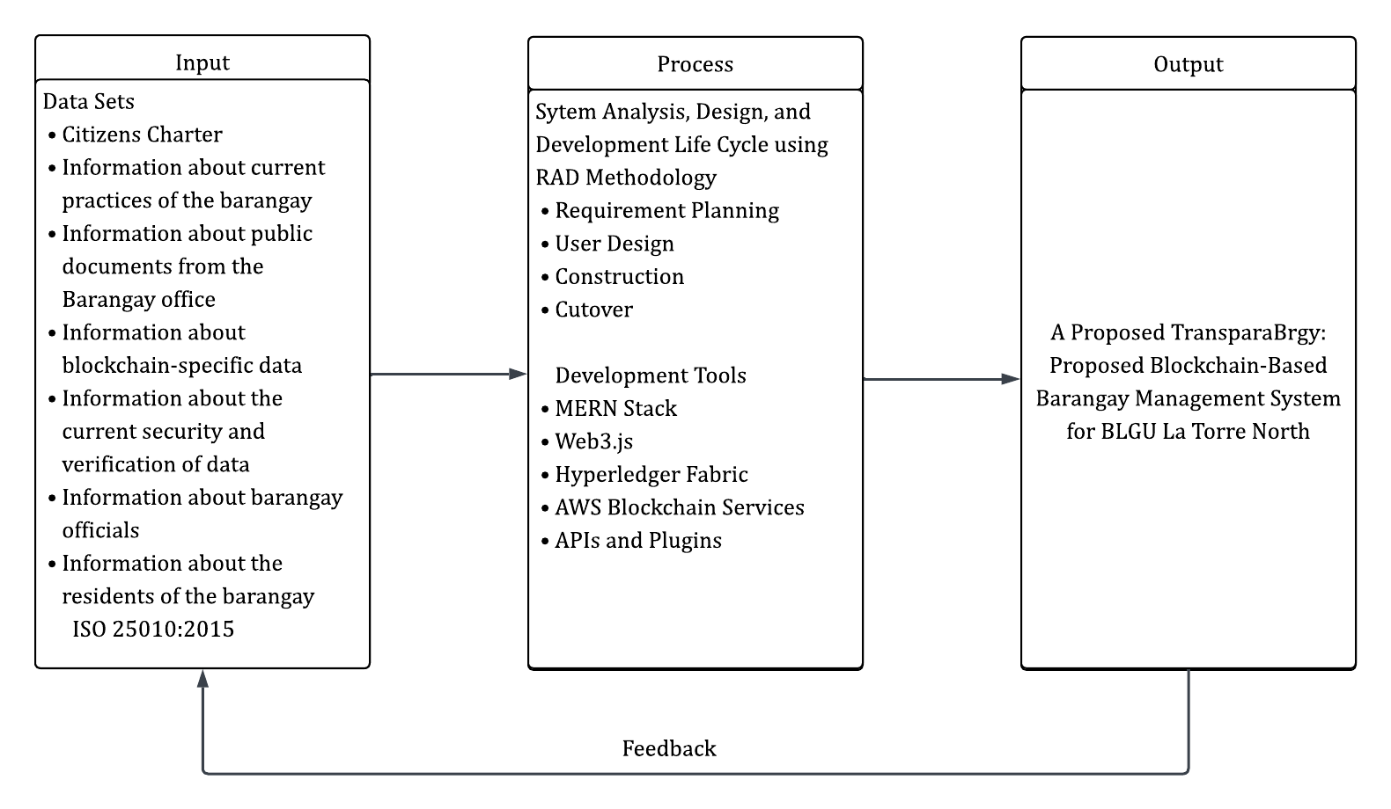
The above framework is the reference framework in creating " TransparaBarangay: Proposed Blockchain-Based Barangay Management System for BLGU La Torre North" The system creation relies heavily on valuable inputs such as barangay offices' public documents' data, blockchain information, security and verification processes, and barangay record management existing practices. The inputs ensure the implementation of blockchain technology responds to the requirements of barangay offices to achieve enhanced transparency, security, and document handling efficiency.
The development cycle follows the Rapid Application Development (RAD) model with four primary stages: requirement planning, user design, construction, and cutover. Requirement planning was achieved by gathering necessary data through interviews, surveys, and document analysis. User design will be achieved by creating wireframes, system flowcharts, and UI/UX designs from the gathered requirements. The system was developed iteratively in the construction stage, including feedback to offer ongoing improvements. Finally, the cutover stage was devoted to system implementation, user testing, and deployment.
To build the system, the MERN Stack (MongoDB, Express.js, React.js, Node.js) will be utilized, providing an efficient and scalable development environment. A hybrid blockchain configuration made up of Hyperledger Fabric will also be utilized. Hyperledger Fabric is used for private and permissioned transactions for the barangay offices to grant secure, controlled access to internal records. This configuration will allow barangays to maintain sensitive records confidential while public access to verifiable information is also accessible when necessary. Additional blockchain platforms such as Web3.js for cross-blockchain interactions, AWS Blockchain Services for cloud support, and additional APIs and plugins will also be implemented to provide advanced system capabilities.
The result of this development will be the "TransparaBarangay: Proposed Blockchain-Based Barangay Management System for BLGU La Torre North" The system enables barangays to securely store and authenticate public documents using blockchain technology, preventing loss and tampering of documents and ensuring transparency and accessibility. Continuous feedback from the stakeholders and barangay officials will be incorporated during the development process to improve the system and make it effective in addressing user requirements.
Statement of the Problem (or Objectives)
This study aims to develop and implement TransparaBrgy: A Blockchain-Based Barangay Management System for Barangay La Torre North, focusing on secure, transparent, and efficient handling of barangay records and services, within the period of January 2025 to December 2025. Specifically, this study aims to give solutions to the following:
- What are the current problems of the Barangay La Torre based on their current practices in terms of their:
1.1. Data Management
- Administrative Records
- Resident Information and Documents
- Regulatory and Compliance Monitoring
- Public and Transaction Processing
1.2. Decision-Making Based on the Gathered Data
- Issuance of Barangay Clearances
- Financial and Resource Allocation Reports
- What system would be developed to solve these problems?
- What is the extent of compliance of the proposed “TransparaBarangay: Proposed Blockchain-Based Barangay Management System for BLGU La Torre North” with ISO/IEC 25010:2015 Software Quality Standards, as assessed by barangay officials, residents, and local authorities, in terms of:
6.1. Functional suitability,
6.2. Performance efficiency,
6.3. Compatibility,
6.4. Usability,
6.5. Reliability,
6.6. Security,
6.7. Maintainability, and
6.8. Portability?
Significance of the Study
This study is significant as it introduces TransparaBrgy, which is a barangay management system that utilizes blockchain technology to create transparency, security and efficiency in local government. Using this technology, data related to the barangay is immutable, independent verifiable and secured from unauthorized access or tampering. This addresses the concerns of forgery of documents, loss of data, and inefficiencies of manual services, and instills integrity and confidence between residents and officials.
In addition to the facilitation of public documents by barangay officials, residents can obtain and track those public documents online, instead of waiting around physically in line or endlessly returning to the barangay. Local government auditors and regulators have access to cryptographically reputable records, which support tracing and verifying. Researches and software engineers may also use this study as a case for future blockchain-based governance application.
TransparaBarangay represents a shift to digital transformation in local government. It cross functions between governance and software technology and provides a secure and transparent approach to obtaining and managing barangay documents. The original purpose of this technology is to demonstrate to governments and their residents, how these kinds of emergent technologies can facilitate better service, greater accountability, and civic confidence in their local government.
Scope and Delimitation
The scope of this study is organized around the building and implementation of a blockchain-powered management tool called TransparaBarangay, for improved transparency, accountability, and efficiency in barangay operations. The transparaBarangay platforms permits barangay officials and its residents to submit, verify, and publish basic barangay documentation from a decentralized digital platform with blockchain promised immutability and data integrity.
Particularly, the system will enable barangay officials to issue and manage barangay clearances, business clearances, certificates of indigency, and certificates of residency, while the residents can submit requests and check the status of those requests in real-time and provide feedback through a simple interface. There are properly defined access privileges for each type of user, whether they be residents or officials, so that the integrity and accountability of the system is maintained.
This research is delimited to Barangay La Torre North, Bayombong, Nueva Vizcaya and will not serve as developments for municipal, provincial, or national local government operations. Since this research pertains to a document management system, it will not include functions such as data sharing and/or verification between barangays or with other government agencies, collecting documents, such as a requisition to verify their identity, like passports, tax clearance, or birth documentation.
While this research has limited applications, it is developing a concept that future researchers or local government units that are interested in using blockchain technology as a safe and transparent way to facilitate digital government operations can use it to develop and implement a framework for research and practice in digital governance.
CHAPTER II
METHODOLOGY
Research Design
Descriptive and developmental study designs will be used to ensure that research is maximized, making the research more efficient. The descriptive research design will utilize questionnaires, observation, and document analysis to obtain relevant information from samples and barangay records. The use of data collection methods will enable researchers to gather accurate information on existing practices and systems in the barangay. In terms of the development design, the Rapid Application Development (RAD) method will be applied in this research. Through the application of the RAD method, organizations are able to create high-quality applications that align with changing user needs and business goals by adopting four fundamental rapid application development stages: requirements planning, user design, rapid construction, and cutover. (Kolosky, 2024).
The study will first start with the requirement planning phase, wherein the researchers will conduct interviews from the barangay to gather and analyze the data needed for the study. It was followed by the user design phase, wherein the researchers worked together to create prototypes and collect feedback continuously to refine functionality and usability (Smith, T., & Johnson, L., 2021). Then the construction phase was followed after wherein the system was built using reusable components, automation, and parallel testing to accelerate the delivery of the study while also maintaining quality (Patel & Lee, 2021). Finally, the cutover phase deployed the study with user training, data migration, and optimization of the performance. It also collects feedback post-launch for the system to ensure continuous improvement (Garcia et al. 2021).
Research Environment
Figure 2.
La Torre North, Bayombong, Nueva Vizcaya
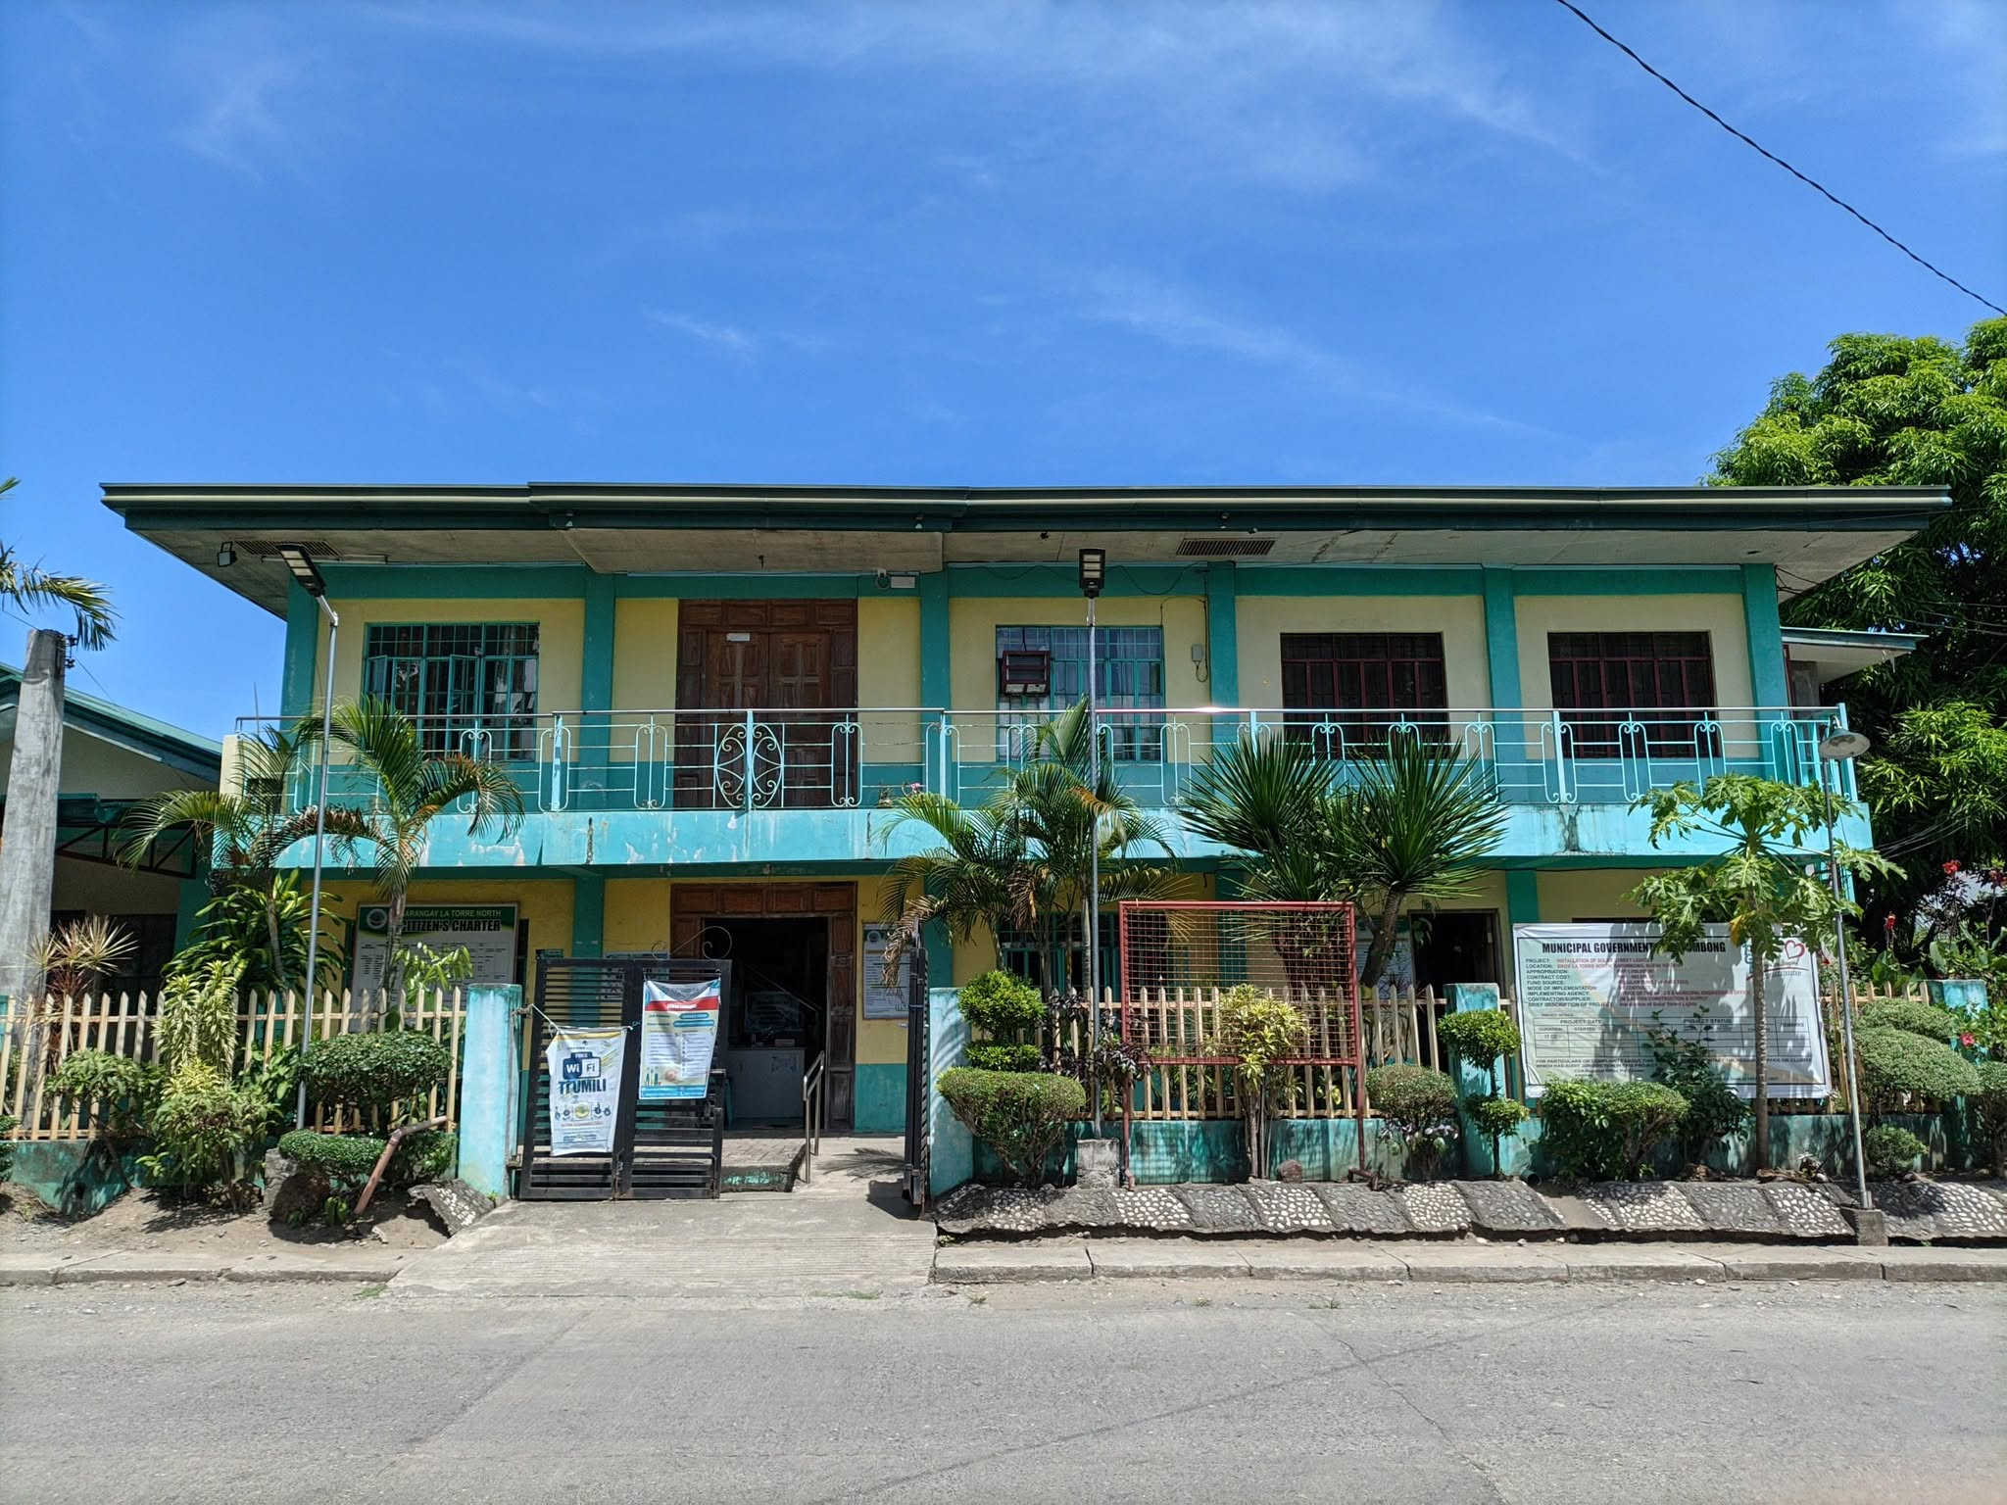

The Transparabarangay is a blockchain-based document management system for the barangay offices in the Philippines to have a secure, transparent, and efficient way of managing and storing public records.
The system is convinced that public service can be further improved by leveraging technology such that residents and barangay officials would be able to experience faster and reliable access to get the barangay documents they need (e.g., barangay clearances, indigency records, business permits, etc.). And with the help of blockchain, TransparaBarangay means records will be persistent, transparent, and safeguarded from tampering, which promotes trust and accountability for the local governance.
Despite that, there are ongoing efforts to digitize barangay transactions, but most local government offices still experience fragmented records, document losses, and a lack of transparency.
TransparaBarangay will first be deployed in Barangay La Torre North, Bayombong, Nueva Vizcaya, as a pilot in the deployment of the system. The barangay office will serve as the operational scenario in which the blockchain technology will be combined with the daily administrative tasks, providing a model that can be replicated across other barangays and local government units in the future.

Research Participants
The functionalities and success of “TransparaBarangay: A Blockchain-Based Barangay Management System for BLGU La Torre North” will depend on the active involvement of various stakeholders.
Barangay Officials and Sangguniang Kabataan Representatives
They will manage and supervise public documents (e.g. announcements, projects, and activities), certificates (e.g. Certificate of Indigency and Certificate of Residency) and local governance operations. Additionally, barangay officials will contribute by sharing insights through meetings, participating in system usability testing, and assessing the system’s effectiveness in enhancing transparency and security.
Residents
They will act as the main users of the platform, using it to request barangay documents and access other different online services. Residents will also provide feedback on its user experience, accessibility and overall reliability of the new platform after the involvement in the testing of the system's features and functions.

Table 1.
Classification of Participants
Participant Group | Number | Percentage
Barangay Officials and Sangguniang Kabataan representatives | 20 | 20%
Residents | 80 | 80%
TOTAL | 100 | 100%

Two groups of will be selected in this study: barangay officials and residents.
The barangay officials will comprise elected and appointed members of Barangay La Torre North, including the Barangay Captain, Secretary, Treasurer, Kagawads, and Sangguniang Kabataan representatives. They will be chosen using purposive sampling, where those directly engaged in document handling and governance will be the target respondents.

Table 2.
Population Distribution of Barangay La Torre North per Purok
Purok | Population
Purok 1 | 250
Purok 2 | 556
Purok 3 | 579
Purok 4 | 415
Purok 5 | 684
Total | 2,484

This population data was used to guide the allocation of respondents per purok during the sampling process.
Barangay La Torre North has a total population of 2,484 residents subdivided into or within five puroks: Purok 1 (250), Purok 2 (556), Purok 3 (579), Purok 4 (415), and Purok 5 (684). Purposive sampling will be used to enable representation of community members and key stakeholder groups. A total of 96 resource persons will be tapped, 20 from barangay officials and Sangguniang Kabataan (SK), who are capacitated in the delivery and supply of barangay services. The remaining 76 participants will be households residing in the five puroks that will have 15 or 16 households each participating to balance representation. While some of the puroks have larger populations and some smaller, a fair mix of opinions can be achieved and all parts of the terrain and concerned stakeholder are represented. This is a qualitative systems development study and is well suited to the purpose of study where rich insights are required rather than statistical generalization.
Furthermore, using Slovin’s formula at a 95% confidence level with a 10% margin of error:
$$n=\frac{N}{1+{Ne}^{2}}=\frac{2484}{1+2484{(0.1)}^{2}}≈\frac{2484}{1+24.84}≈\frac{2484}{25.84}≈96$$
This yields a recommended sample size of approximately 96 respondents. By meeting this benchmark, the study ensures a reliable foundation for system design and evaluation, while also keeping the data collection process manageable within the scope and timeline of the research.
Research Instruments
Interview
The researchers will use an interview guide to gather information from chosen Barangay Officials and Sangguniang Kabataan representative. This would assist the researchers learn how documents are now managed in the barangay, what issues they encounter, and how they feel about implementing a blockchain-based system.
The interview follows a semi-structured pattern. Some questions are prepared ahead of time. However, researchers can also ask questions that relate to the answers given. This allows for more thorough and complete knowledge from everyone involved.
For the interview, every participant will receive a request for consent of the interview that proceeds for a duration of 10 to 15 minutes that will also be recorded. If the participant agrees to the condition, it allows the researchers to review the provided responses in detail after the session. Furthermore, the interview guide will be evaluated by instructors or experts to ensure that the questions are clear and aligned with the objectives of the study.
Questionnaire
The researchers will conduct a survey using a standardized questionnaire distributed to residents. This tool aims to assess the level of satisfaction of the residents with the current system and process of requesting documents from the barangay. It will help identify existing issues, inefficiencies, or areas for improvement in the current practices related to document processing and delivery.
Before deployment, teachers or field experts will pilot-test the questionnaires to ensure clarity, appropriateness, and alignment with the purpose of the study. Each questionnaire will have a consent form that will inform respondents of the survey purpose, confidentiality, and voluntary participation.
Observation
Researchers will conduct first-hand, nonintrusive observation of current operations of the barangay office, from document handling to staff routines and transactions with the public.
Observation is conducted in order to learn directly how documents are processed, retained, and made available at the barangay office. Researchers will focus on operational procedures, bottlenecks, and system inefficiencies that may not be discovered using surveys alone.
An observation checklist will be used to provide uniformity and objectivity in the process. Observations will be conducted with advance authorization of barangay officials, strictly following privacy and ethical standards.
Document Review
The researchers aim to examine the original documents and records applied at the barangay. These include forms, certificates, permits, and other documents concerning public documentation and service delivery.
The aim is to analyze the way such records are stored, secured, and conserved. The analysis will consider availability, security, and susceptibility of the current record management system to data loss or alteration.

A document evaluation checklist will be used as the basis for the assessment where researchers can identify strengths and weaknesses. All the documents to be analyzed will be handled appropriately and with necessary authorization, with confidentiality and privacy being maintained at all times.
Data Gathering Procedure
Figure 3.
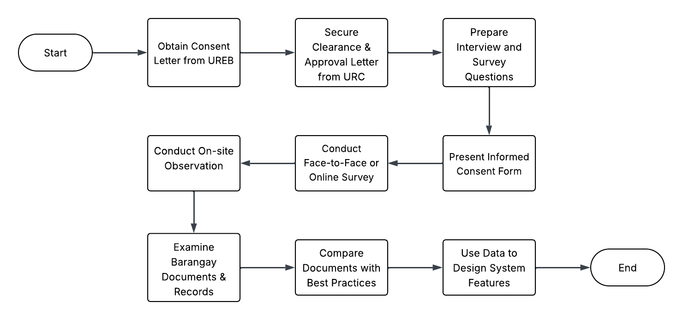
Data Gathering Procedure Flowchart
Source: Lucid.app

The researcher will procure the necessary consent letter from the University Research Ethics Board (UREB) office. The researcher will also obtain a clearance and approval letter from the University Research Committee (URC) office permitting the conduct of the study.
Researchers will prepare questions that will be responded to by barangay authorities, employees, and residents. Researchers will seek permission from the Barangay Captain and the Council of La Torre North through a letter of request. In this letter, the aims of the study would be presented and consent would be requested to include barangay officials and the residents in the study. The barangay officials will be asked to help identify prospective participants who meet the inclusion criteria of the study. Residents who have previously requested documents or services from the barangay will be prioritized for recruitment as respondents. A face-to-face or online questionnaire will be administered to the participants based on the availability and feasibility of the participants 10. The researchers will either conduct a face-to-face or online survey depending on the respondents' accessibility and preference. The informed consent form will be presented to the respondents before they participate in the study. The purpose of the research as well as the right of the participants will be expressed clearly. The researchers will make sure that all the answers are handled with utmost secrecy. Data gathered from the questionnaire will be utilized in building the TransparaBarangay system.
Moreover, on-site observations of the current document handling and record management procedures of the barangay will be made by the researchers. This will enable the researchers to have first-hand understanding of what workflows, issues, and practices are currently being used.
Researchers will also examine barangay documents and forms, certificates, permits, and other public records. These documents will be compared with best practices in managing digital public documents. The results of the document analysis will be used as the basis for designing the security, integrity, and proper management of public records features of the system's digital submission and verification.
Treatment of Data
The information collected from the data tools will be the foundation for the software architecture of the TransparaBarangay application. In the processing of data, the researchers will make the verbatim record of the data with utmost confidentiality because the data may include sensitive information volunteered by the respondents. The data will be categorized systematically to ease analysis. The researchers will first sort the data in terms of its applicability to the statement of the problem of the study.
After gathering user requirements and needs by using questionnaires, observation, and document analysis, prototypes will be created and shown to a pilot group of the target users of the application. Comments and suggestions will be gathered along with feedback and used in the subsequent version of the system. If no additional recommendations or changes are found—specifically in the user flow, interface design, handling of information, and system logic—the application will be deemed complete and ready for release.
In order to maintain confidentiality and anonymity of respondents, we will not collect names or PII. Before entering the survey, the respondents receive an informed consent statement that explains the purpose of the study, how the information will be used, that participation is voluntary, and that the response is confidential.
All completed data will be kept in a password locked and encrypted cloud drive that only the authorized research team can have access to. Appropriate measures will be taken to ensure the confidentiality and security of any printed materials such as locking into a cabinet and shredding after the study period.
During transcription and analysis, participant names will be replaced by pseudonyms or response codes. Any non-direct identifiers that might make a participant recognizable will be removed.
The data will be analyzed and reported in the aggregate only. No responses of individual students will be identified in the final report or reporting.
All gathered data will be used exclusively for the creation and validation of the TransparaBarangay system and will remain confidential with the researchers. Following completion of and approval for the study, all source documentation (both digital and paper format) will be irrecoverably deleted or shredded, as appropriate, to maintain the long-term privacy and confidentiality of this information.
For the evaluation of the system, the ISO/IEC 25010:2011 Software Quality Standards will be utilized by various types of system users. Descriptive statistical measures like frequency, percentage, and mean will be employed to evaluate the results of the assessment. The weighted mean will identify how much the application meets the ISO/IEC 25010:2011 quality standards.
The extent of compliance was rated using the following 4-point Likert scale:
Table 3.
Measurement of the Extent of Compliance with ISO 25010:2015 Software Quality Standards
Mean Range | Descriptive Equivalent | Interpretation
4.20 – 5.00 | Compliant to a very great extent | The measure described in the item is compliant to a very great extent or OUTSTANDING.
3.40 – 4.19 | Compliant to a great extent | The measure described in the item is compliant to a great extent or VERY SATISFACTORY.
2.60 – 3.39 | Compliant to a moderate extent | The measure described in the item is compliant to a moderate extent or SATISFACTORY.
1.80 – 2.59 | Compliant to a little extent | The measure described in the item is compliant to a little extent or FAIR.

Software Development
Figure 4.
Rapid Application Development
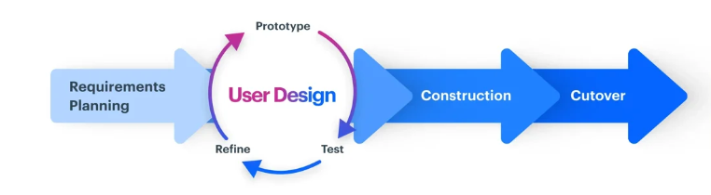
Source: Team Kissflow, What is Rapid Application Development (RAD)?
Rapid Application Development (RAD) methodology is a useful approach in developing TransparaBarangay, a Blockchain-Based Barangay Management System for BLGU La Torre North. It prioritizes iterative development, rapid prototyping, and user feedback, enabling teams to build usable applications more quickly. In this post, we'll look at the top five benefits of rapid application development, as well as how to maximize RAD success. (Kolosky, 2024).
Rapid application development (RAD) is a project management style that prioritizes ongoing software projects and user feedback over a predetermined plan or set of processes. The RAD approach entails releasing a series of prototypes and soliciting input from clients and/or end users for each iteration (Sherrer, 2024).

System Architecture
Figure 5.
System Architecture
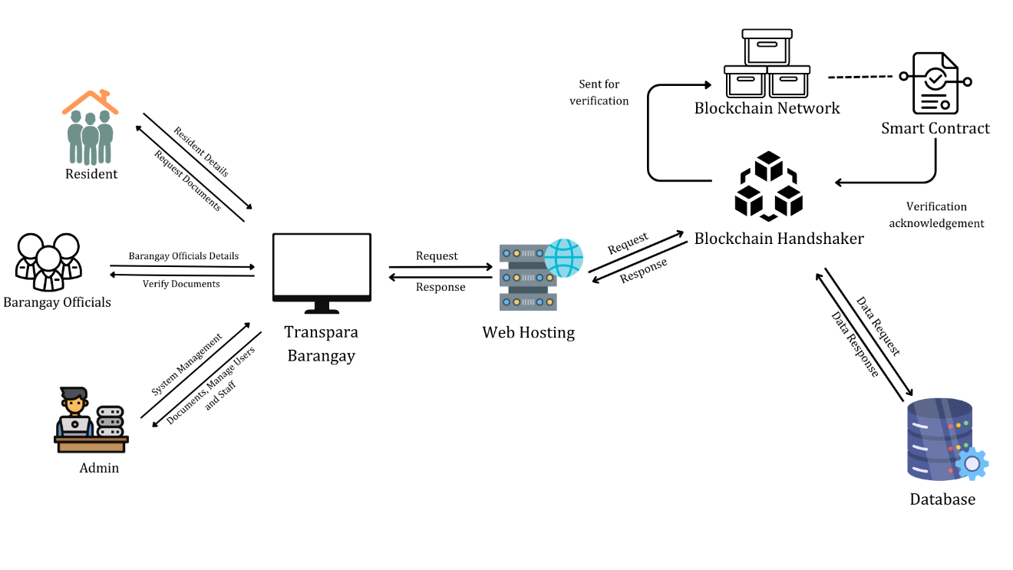Source: Canva.com

The TransparaBarangay system architecture shows the concept of how the entire application carries out its functions.
The four key user types in the system are: residents, barangay officials, administrators, and the blockchain network. Every user interacts with the system based on their role for TransparaBarangay. It also operates online, which will require devices, a web browser, and an internet connection to access its functionalities.
Every user must create an account before using the system. Residents can request barangay documents such as barangay clearance and certificates. Residents must provide necessary details (e.g. Full Name, Request Type, Purpose of the Request, Date of Request, and Preferred Method of Release) and submit their requests through the TransparaBarangay platform.
Barangay officials, on the other hand, verify the submitted documents and requests by the residents. They can either reject or approve the request of the residents based on the residents’ details by verifying the documents requested. Once the request is verified, the approved documents are processed and stored in the system.
The verification process is crucial for secure, efficient, and transparent public service delivery. Residents submit document requests, including barangay clearances, business permits, and certificates, which are reviewed by barangay officials. The approved documents are logged on a blockchain using Hyperledger Fabric, ensuring data integrity. Smart contracts automate key verification steps, reducing human error and enhancing processing speed. The system supports real-time tracking, with access managed through role-based controls. Residents can also provide feedback, which barangay officials can respond to.
The administrator controls the entire system in a way that manages the users, officials, and document records. Administrators have control over user accounts and allow them to add or remove barangay officials, especially if the barangay decides to change one of its officials. They can also update the system settings and ensure efficient operation.
The system’s core functionalities are hosted on a web server that communicates with the database and a decentralized blockchain network. Resident and document data are stored in the database, while the blockchain is used specifically for logging approved document transactions to ensure integrity and non-repudiation. The backend server manages the communication between the client, database, and blockchain.
The blockchain layer comprising Hyperledger Fabric for private transactions for public transparency enhances the system’s security and trustworthiness. When a document is approved, a cryptographic hash and relevant metadata are recorded on the blockchain that will ensure that any tampering can be detected, and that the document’s authenticity can be independently verified by querying the blockchain. The backend handles all smart contract interactions and sends verification status back to the client.
With this system, TransparaBarangay will provide a more efficient, secure, and transparent platform for barangay document management compared to a traditional barangay inventory system. It ensures a seamless transaction between the users of the system.

System Development Procedures
Requirement Planning
The researchers will be collecting essential information by conducting an interview with the officials, residents, and personnel from BLGU La Torre North. The interview will be mainly centered on the existing process of the related barangay management. This includes resident registration, document issuance, and request of indigency, barangay clearance, and business clearance. The data gathering will play a critical role in shaping the initial framework of the TransparaBarangay system.
Residents will also be interviewed to understand the current experience in the barangay, particularly regarding concerns about efficiency, availability, and transparency. This allows the study to identify key areas that can be improved and is vital in tailoring the blockchain-based solution to meet community needs. Collected data will be systematically analyzed and will be used to guide the planning and development of the system.
With this, the researchers will be able to gain meaningful insights on how the barangay operates and what challenges they face by both from the barangay officials and the residents. These can help in designing a blockchain-integrated management system that will be used to address transparency gaps, enhance security, and streamline administrative processes.

User Design
The design phase layout the functionality of the TransparaBarangay which will be taking into account what will be needed and required inside the system. The design will be based on the requirements and features that will be identified during the requirement gathering and analysis stage. This phase is a critical step in order to provide a clearer blueprint in developing TransparaBarangay.
In this stage, the user will be developing a prototype of the TransparaBarangay where-in there will be a selected number of pilot users, including barangay officials and residents which they will then provide valuable feedback on the application’s features and usability. Once the feedback is collected during the pilot testing, it will be carefully analyzed and used to refine the application’s design which will ensure an effective address of what the users’ needs. With the iterative process, the testing and improvement will contribute to making the system more user-friendly and reliable which results in the risk of future errors reduced and a better user satisfaction.
It is important to note that this phase will involve a close collaboration between the researcher and the users. This ensures an application that reflects the real operational workflows of the barangay and accommodates the preference and requirement of what the residents and the barangay officials need. As a result, the design of the system, TransparaBarangay will be able to deliver a system that is aligned to what the expectation of the barangay officials and residents of La Torre North aimed to serve.
Construction Phase
Construction phase involves translating the refined design into a working system. This requires a collaboration between the researcher, barangay officials, and residents to ensure that the development stays true to the project’s goals.
This will be guided based on the feedback of the prototyping phase where-in each feature will be developed and tested incrementally. With this approach, this allows a quick identification and resolution of issues that maintains a high functionality and system quality.
An iterative development life cycle will be used, incorporating ongoing planning, coding, testing, and re-refining for the quality and stability of the system. A particular focus on integrating blockchain technology will be addressed to ensure barangay transactions are transparent, secure, and immutable.
In addition, timely communication between the researcher, barangay staff, and pilot users shall be maintained during the development period. Through collaboration, this will guarantee that feedback is integrated into development in a timely fashion, thus facilitating timely alterations. Documented evidence and version control shall also be practiced to ensure project orderliness and to facilitate future system improvement.
The collaborative efforts and systematic approach during the construction process will guarantee the successful development of a reliable, secure, and user-friendly TransparaBrgy system.
Cutover Phase
The cutover stage will consist of the actual pilot deployment and implementation of the TransparaBrgy system to BLGU La Torre North. This stage will be critical, as it will signal the shift from system development to actual use in live applications.
At this point, an implementation plan shall be created with the activities and timelines for system deployment, user familiarization, and training. The residents and barangay officials shall be oriented to the functionalities of the system, and targeted pilot users shall conduct trial operations like resident registration, request for documents, and transaction verifications using the blockchain platform.
Conducting pilot testing during the cutover phase will be essential for assessing how the system performs and functions in real-world scenarios. Feedback collected through this testing will be thoroughly analyzed and utilized to make appropriate adjustments and improvements to the system. Any problems identified will be addressed immediately to guarantee the system’s reliability before its full deployment.
Additionally, a maintenance plan will be established to ensure the continued functionality and stability of the TransparaBrgy system after deployment. During the transition phase, the researcher will remain actively involved to monitor system performance, address any technical concerns, and assist users as they adapt to the new platform.
During the cutover period, there will be regular interaction among the researcher, barangay officials, and users to provide a smooth transition. Version control and documentation will be adhered to strictly in order to control system updates properly.
Development Tools
HTML 5
The hypertext markup language, or HTML, is going to be utilized as a formatting mechanism for presenting information obtained from the Internet. It served as a simple building. Block for defining the web structure.
CSS 3
CSS stands for Cascading Style Sheets, which will be used to style and layout websites. It can also change the content's size, spacing, color, and font. Add decorative features such as animations and column-based content.
React.JS
React.js is an open-source JavaScript package used to create single-page applications. Mobile app user interfaces and is responsible for the view layer in web and mobile apps.

Node.JS
Node.js is going to be used to run JavaScript code outside of a web browser in this cross-platform, open-source back-end JavaScript runtime environment that makes use of the V8 engine.
Visual Studio Code
Visual Studio Code is a simpler code editor that will be used for debugging, tasks, Features include execution and model control. It gives the tools that developers need in a quick code-build-debug cycle, leaving more advanced workflows to IDEs. There are more features.
Express
A Node.js web application framework that provides a wide range of features for creating online and mobile applications.
MongoDB
MongoDB will be used as a scale-out document database for the TransparaBarangay data collection.
Hyperledger Fabric
Hyperledger Fabric will be used to create a private blockchain that enables confidentiality through its channel architecture and private data feature.

Software Requirements
Table 4.
System Software Requirements
Platform | Description
Mobile | - Operating System:  - Minimum:  Android: version 4.4 (Kitkat) and iOS: version 9  - Recommended:  Android: version 8.0 (Oreo) and iOS: version 12 or greater  - Browser: Compatible with all kinds of modern browsers
Desktop | - Operating System:  - Minimum:  Windows: 7 and macOS: Sierra (10.12)  - Recommended:  Windows: 10 and macOS: Mojave (10.14)  - Browser: Compatible with all kinds of modern browsers
The table describes the minimum and recommended software requirements for the application's operation with mobile and desktop platforms.
Hardware Requirements
Table 5.
System Hardware Requirements
Platform | Description
Mobile | Minimum:  - Processor: Quad-core 1.4 GHz (Snapdragon 400 series) and A7 Chip  - Memory: 1GB RAM or higher  - Network: Any stable internet connection  - Storage: 500MB  Recommended:  - Processor: Octa-core 2.0 GHz (Snapdragon 600 series) and A12 Chip or greater  - Memory: 4GB RAM or more  - Storage: 1GB or more
Desktop | - Processor: Intel Pentium 4 and AMD Athlon 64 (Ryzen 3) or greater  - Memory: 4GB RAM or higher  - Network: Any stable internet connection  - Storage: 500MB
The table presents the minimum and recommended hardware requirements with the mobile and desktop platforms.
Ethical Considerations
This study will be submitted to the Research Ethics Board (SMUREB) at Saint Mary's University for ethics review, located on the 2nd Floor, Rev. John Van Bauwel Hall, SMU Main Campus, Ponce Street, Don Mariano Marcos; Bayombong, 3700 Nueva Vizcaya, Philippines (email: reb@smu.edu.ph; cellphone: 09177053041).
Conflict of Interest
Researchers will conduct this study to maintain the integrity of the results. They will work to eliminate any possibility of personal gain or benefits that could affect the objectivity and reliability of findings. This way, researchers uphold the standards of fairness and impartiality. It will strengthen the credibility, besides the trustworthiness of the study’s outcomes.
For objectivity in design, implementation, along reporting, there is no conflict of interest. Research proceeds for academic goals. The people involved have no financial, personal, or professional involvement. It ensures the integrity and impartiality of the results.
Confidentiality and Data Protection
The information collected in this study will be handled with utmost confidentiality. Individual identities will not be disclosed in any publications or findings. The data files were exclusively accessible to the researcher, and only individuals with a legitimate need to examine additional personally identifiable information were granted access to the necessary files.
In cases where respondents responded positively and agreed to participate in the research project, they were furnished with the necessary information. Participants were assured that their responses would be kept confidential. Instead, their generous cooperation played a crucial role in the project's success. The data will be retained for the duration of the school year 2025-2026. After this period, the data will be securely archived or destroyed in accordance with data protection policies.
Management of Vulnerability
Researchers plan to do interviews that are easy to understand for community members with different backgrounds and levels of expertise. This method intends to prevent the misuse of residents and staff with limited technical information. With plain language, participants get information about the study's purpose, the steps taken, and the effects of participation. This dedication to openness, besides inclusion, encourages participation, grows understanding, and protects vulnerable individuals involved.
Risk/Benefit Ratio
The TransparaBarangay study presents a highly favorable risk-benefit ratio, as the anticipated benefits significantly outweigh the minimal risks involved.
Benefits
The study is anticipated to have several important benefits which will clearly offset the minimal risks of participation. One is better delivery of public service, and here the transparaBarangay system seeks to simplify crucial barangay transactions such as applying for documents, service assessment and contact between officials and constituents. This results in less processing time, easier waiting, and a more transparent local government. It's a system that enables users to take control of their decisions, by actually designing it around how people really need and interact with the service. This makes certain that the final application will actually help solve the real problems and priorities of the barangay staff and supporters, creating more useful and lasting solutions.
The other benefit is the utilization of technology at the community level where the barangay serves as an exemplar of digital transformation in governance. Other than increasing efficiency and the need to embrace technology, the innovation motivates adjacent settlements to also embrace such systems for better service provision. The research also has academic implications for the IS community, especially community led software development. Results of such paper may be used by other researchers and practitioners in future during the development of other e- governance solutions. Lastly, the research contributes to the empowerment of the users, in which the residents can avail of an improved easier, anytime, anywhere, and more user-friendly process of submission of services and documents and that it requires less to visit the barangay office and take long hours fall in line.
Risks
With the many benefits the study provides comes very few risks. One possible worry is participant privacy, since there is a small chance that confidentiality may be violated. However this is effectively addressed through stringent data protections procedures (the refusal to record any personal identifying information, the use of pseudonyms or response codes, storage of all data in an encrypted and password protected system accessible only to the research team members). A final minor risk is survey fatigue or distress when participants feel uncomfortable or weary whilst completing questionnaires. To mitigate this, participation is completely voluntary; all respondents are notified of their right to discontinue at any time without penalty. These measures are contributing to the ethical soundness and the low risk of the study.

Informed Consent
Participants will receive detailed information about the study's purpose, procedures, risks, and benefits before agreeing to take part. This information will be provided through an informed consent form sent at the beginning of the research, before any data collection. The form will be explained by the primary investigator or designated team member, who will ensure that participants understand. Participants can ask questions about the study or the consent process. After reviewing and asking questions, participants will sign the form to indicate their voluntary consent to participate, confirming their understanding of the study's nature and their role.
Terms of Reference
The research will belong to the university that offers institutional support and guidance to the research undertaking. The researcher, however, owns the research methodology, analysis of data, and the outcome. Intellectual property rights to the work, including any publications, reports, or other outputs that result from the research, shall belong to the researcher.
Dissemination Plan
The study findings will be shared through the following channels:
Research Proponent Sharing: The proponents/researcher will initiate sharing the study results with interested departments, faculty members, or student bodies who could gain from the findings.
Publication in the SEAIT Journal: The end research product will be lodged for publication within the School of Engineering, Architecture, and Information Technology (SEAIT) Journal to facilitate scholarly dissemination and academic accessibility.

REFERENCES
Abubo, Katherine D., Ramos, Eldrin Dave A., & Valencia, Faith A. (2024). Full paper: Blockchain for transparent transactions. Retrieved from https://jurnal.stiki.ac.id/IC-ITECHS/article/download/1712/840/
Alcaide, Á. F., Núñez-Gómez, C., Delicado, F. M., Carrión, C., & Caminero, M. B. (2023). A Blockchain-Based e-Government service for quantity surveyors. IT Professional, 25(4), 61–66. https://doi.org/10.1109/mitp.2023.3268567
Cruz, L. A., Balilia, C. J., Abana, E. C., Pagulayan, L., Mebaña, J.-E., Datul, D. J., & Acoba, J. A. (2023). Enhanced Barangay Information Management System with Residency Certificate Issuance. 1–7. https://doi.org/10.1109/icraie59459.2023.10468134
Dagohoy. (2024). Capabilities and difficulties of barangay officials on local budgeting process. Retrieved from https://www.researchgate.net/publication/352640459_Capabilities_and_Difficulties_of_Barangay_Officials_on_Local_Budgeting_Process
DapNet. (2024). Leveraging blockchain for transparent government transactions. Retrieved from https://dapnet.org/articles/leveraging-blockchain-for-transparent-government-transactions
Espaldon, Rosalinda N. (2016). Barangay Information System of Aurora West, Diffun, Quirino. Retrieved March 5, From Saint Mary’s University
Firmansyah, A., & Widiastuti, L. (2023). User-Centered Design in RAD-Based Mobile Inventory Tracking Systems. Journal of Information Systems Research, 18(2), 56-70.
Hassan, M. U., Rehmani, M. H., & Chen, J. (2021, December 11). Anomaly detection in
Blockchain Networks: A Comprehensive survey. Retrieved from https://arxiv.org/abs/2112.06089.
IJCRT. (2024). Blockchain for government transparency and accountability. Retrieved from https://ijcrt.org/papers/RT2409643.pdf
Jamis, M. N., Yabut, E. R., & Caluya, S. S. (2022). One Barangay: A Mobile And Web Barangay Management System. 202–207. https://doi.org/10.1109/iCORE58172.2022.00055
Jordan, Cole. (2024). Use cases: Blockchain for public records and identity verification. Retrieved from https://blockapps.net/blog/use-cases-blockchain-for-public-records-and-identity-verification/
Karavate, Patricia B. (2023). Blockchain and public services: Enhancing transparency and efficiency. Retrieved from https://www.ijirps.org/papers/2023/3/230191.pdf
Khan, S., Shael, M., Majdalawieh, M., Nizamuddin, N., & Nicho, M. (2022). Blockchain for governments: The case of the Dubai Government. Sustainability, 14(11), 6576. https://doi.org/10.3390/su14116576.
Kim, D., & Park, J. (2022). Smart contract-based document authentication using blockchain. Computational Intelligence Review, 10(2), 202-218.
Li, X., Cheng, J., Shi, Z., Liu, J., Zhang, B., Xu, X., . . . Sheng, V. S. (2023). Blockchain Security Threats and Collaborative Defense: A Literature review. Computers, Materials & Continua/Computers, Materials & Continua (Print), 76(3), 2597–2629. https://doi.org/10.32604/cmc.2023.040596.
Li, X., Zhang, Y., & Zhao, L. (2023). Cryptographic security in blockchain-based document verification. Journal of Cryptology and Information Security, 18(2), 56-79.
Lim, J. (2022). Barangay Integrated Management System with Mobile Support. International Journal of Computer Science and Mobile Computing, 11(7), 119–127. https://doi.org/10.47760/ijcsmc.2022.v11i07.011
Liu, Y., Lu, Q., Zhu, L., Paik, H., & Staples, M. (2021, May 12).
A Systematic Literature Review on Blockchain Governance. Retrieved from https://arxiv.org/abs/2105.05460.
Mansour, M., Salama, M., Helmi, H., & Mursi, M. (2024).
A survey on Blockchain in E-Government Services: Status and challenges. arXiv.org. https://doi.org/10.17577/IJERTV12IS040157.
Mohamed, A. a. D., Alkhateeb, Y. M., Agarwal, P., Abdelwahab, A. R., & Alrababah, O.
(2022). Characteristics of Blockchain and Smart Services, for Smart Governments: A systematic review of the literature. Deleted Journal, 10(3), 30–55. https://doi.org/10.12821/ijispm100302.
Mr. Sachin Dighe, Aditya M., Bhaveshsingh R., & Rishabh M. (2024). Research paper on blockchain applications in governance. Retrieved from https://iarjset.com/wp-content/uploads/2024/04/IARJSET.2024.11350.pdf
Muhammad, R., & Fadli, H. (2023). Implementing Rapid Application Development for Small Business Inventory Management. International Journal of Business Technology, 21(4), 112-125.
Nugroho, R., Setiawan, B., & Pratama, D. (2023). Integrating QR-Code Technology in Web-Based Inventory Systems Using RAD. Journal of Digital Business Innovation, 12(3), 85-98.
Quccol, J.M. (2020). Barangay Bonfal Proper Web-Based Record Management System. Retrieved March 6, From Saint Mary’s University.
Rahman, S., Ahmed, I., & Chowdhury, M. (2021). The inefficiencies of centralized document verification systems and blockchain’s role. International Journal of Digital Trust, 9(1), 75-89.
Rosalinda, N. Espaldon. (2016). Barangay Information System of Aurora West, Diffun, Quirino. Retrieved March 5, From Saint Mary’s University.
Sarang, Shikhar, Rana, Dhruv, Patel, Smit, Savaliya, Darshil, Rao, Udai Pratap, & Chaurasia, Akhil. (2022). Blockchain applications in public sector governance. Retrieved from https://www.sciencedirect.com/science/article/pii/S187705092202107X
Setiawan, B. (2023). Challenges and Considerations in Implementing RAD for Large-Scale Inventory Systems. Journal of Software Development Studies, 25(1), 44-58.
Singh, A., Chatterjee, S., & Srivastava, S. (2022). Privacy-preserving blockchain networks: A comparative study of Ethereum and Hyperledger Fabric. International Journal of Information Security, 6(2), 78-92. https://doi.org/10.1109/IJIS.2022.0015
Sitchon, Mary, Ramos, Vilma, & Alicuman, Wilson. (2024). Implementation Of Transparency and Accountability in Barangay Sta. Rita & San Nicolas Minalin, Pampanga. The QUEST: Journal of Multidisciplinary Research and Development.
Thakkar, P., Nathan, S., & Vishwanathan, B. (2021). Performance benchmarking of Hyperledger Fabric and Ethereum. IEEE Blockchain Transactions, 3(4), 22-36. https://doi.org/10.1109/TBC.2021.00004
Ucbas, H., Eleyan, A., Hammoudeh, M., & Alohaly, M. (2023). Performance and scalability analysis of Ethereum and Hyperledger Fabric in IoT applications. IEEE Internet of Things Journal, 10(5), 1123-1138. https://doi.org/10.1109/JIOT.2023.0075
Wood, G. (2025). Ethereum: A secure decentralized generalized transaction ledger Ethereum Foundation. Retrieved from https://ethereum.github.io/yellowpaper/paper.pdf
Zahran, M. F., Rahman, A., & Putri, S. (2023). Application of Rapid Application Development (RAD) in Web-Based Inventory Management Systems: A Case Study. Institut Teknologi Telkom Purwokerto Repository.

Appendix A
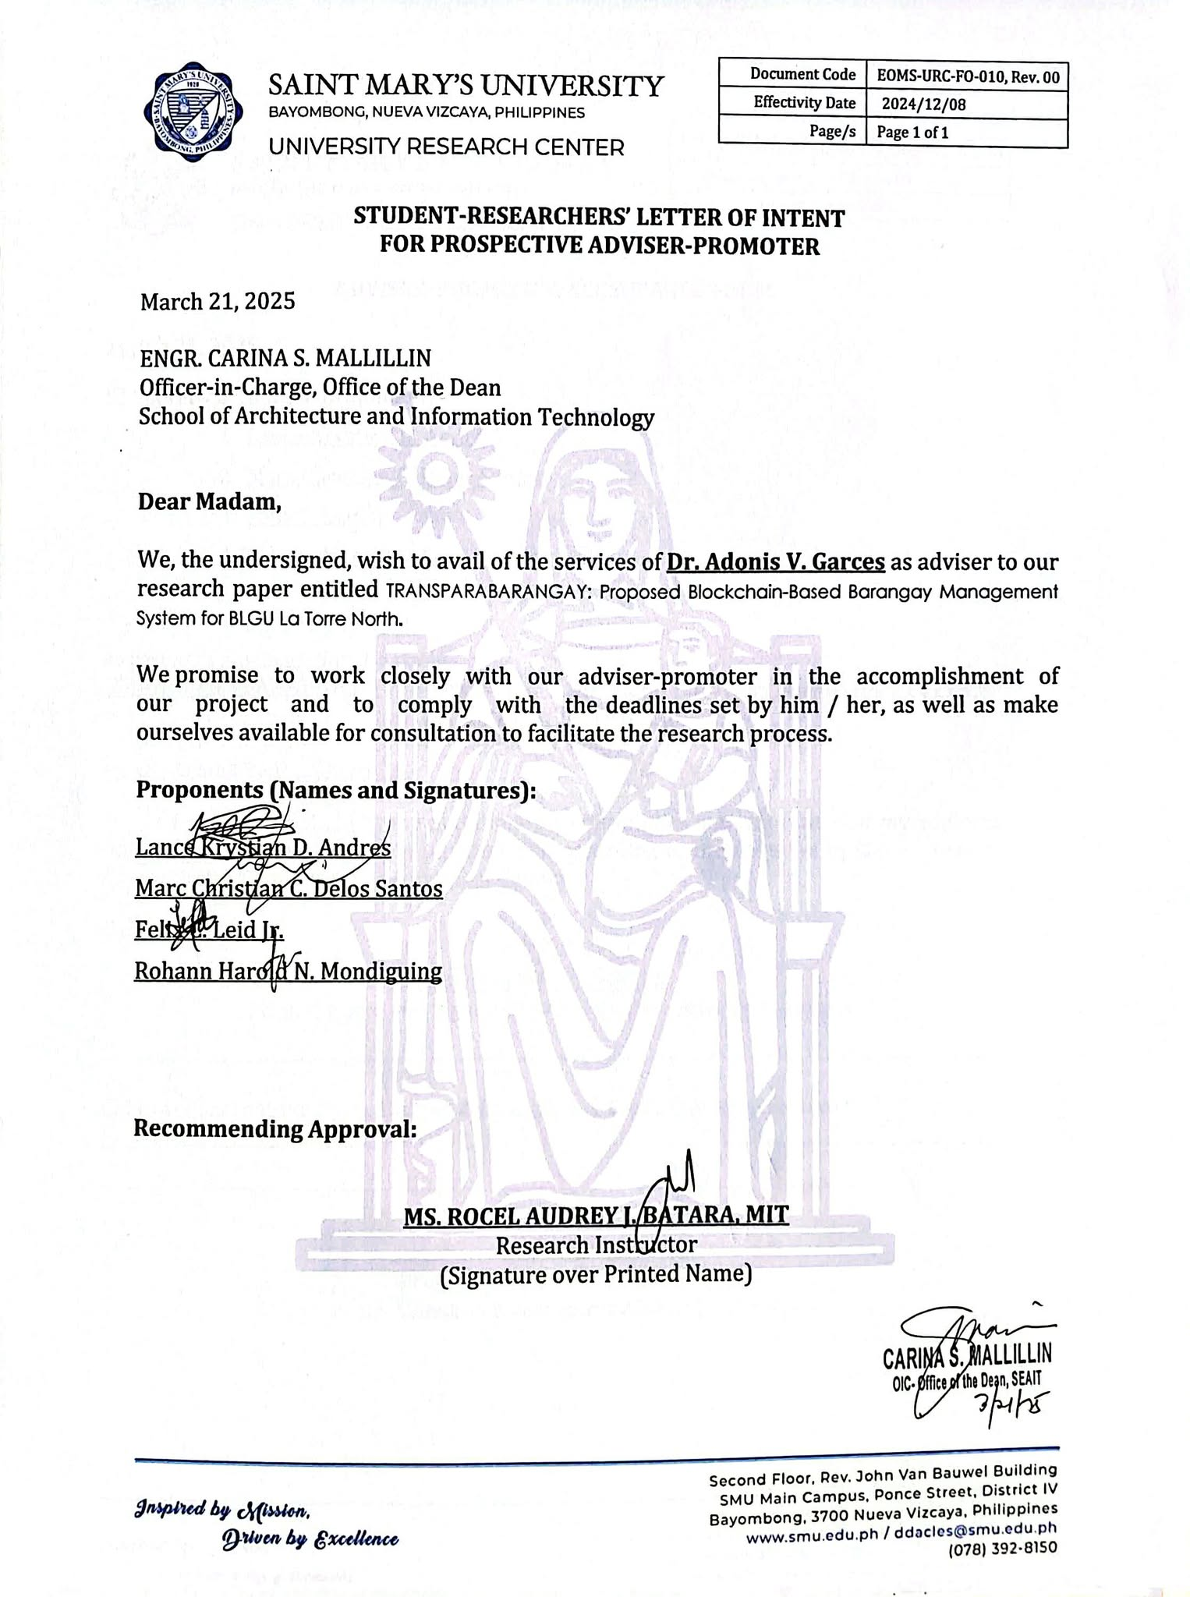
FORM 10

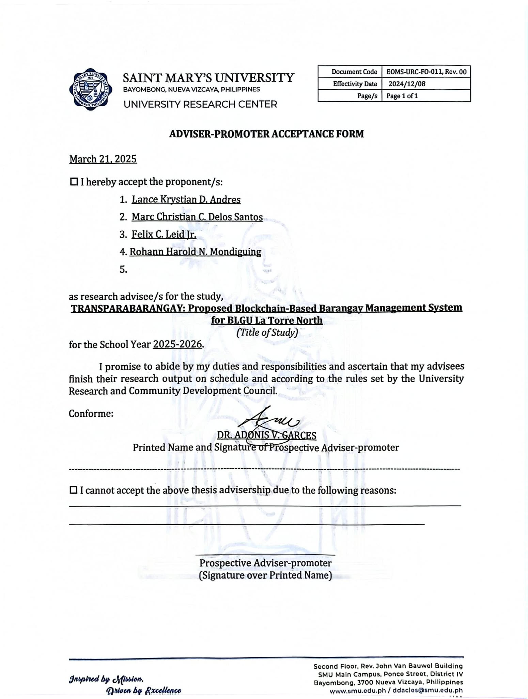
APPENDIX B
FORM 11

APPENDIX C

FORM 12

Appendix D
INFORMED CONSENT/ASSENT FORM
TITLE OF THE STUDY
TransparaBrgy: Proposed Blockchain-Based Barangay Management System for BLGU La Torre North
PRINCIPAL INVESTIGATOR
FELIX C. LEID JR.
SAINT MARY’S UNIVERSITY
BAGUIO VILLAGE, DIFFUN, QUIRINO
09207797592
felixleidjr@gmail.com / hed-fleidjr@smu.edu.ph
SECONDARY INVESTIGATOR
LANCE KRYSTIAN D. ANDRES
MARC CHRISTIAN C. DELOS SANTOS
ROHANN HAROLD N. MONDIGUING
PURPOSE OF THE STUDY
You are being asked to take part in a research study. Before you decide to participate in this study, it is important that you understand why the research is being done and what it will involve. Please read the following information carefully. Please ask the researcher if there is anything that is not clear or if you need more information.

The purpose of this study is to collect relevant data for the development of TransparaBrgy: Proposed Blockchain-Based Barangay Management System for BLGU La Torre North
STUDY PROCEDURES
An interview shall be conducted by the researcher with a total of 20 participants which consists of Barangay officials and SK representatives to collect much needed information for the success of the study. The interview proper shall not take more than an hour. Depending on the discussions, and how the researcher and participant shall talk, the interview will only be 15 minutes or less. Audio will also be recorded during the interview properly using a smartphone. Only audio will be recorded to further preserve the anonymity of the participant. Notes shall also be taken will the interview is on-going using pen and paper or the use of mobile phone.
RISKS
The researcher ensures that information will not be leaked in any means possible. All files that will be gathered from this interview will be stored in a secured storage to avoid leakage. The researcher shall also preserve the anonymity of the participant.
You may decline to answer any or all questions and you may terminate your involvement at any time if you choose.
BENEFITS
We hope that the information obtained from this study may contribute to a larger body of knowledge, specifically in the field of community governance, and public administration. The study benefit barangay officials, staff, and residents as it may be used as a basis for barangay activities, services, and resources.
CONFIDENTIALITY
Your responses to the interview will be anonymous. Every effort will be made by the researcher to preserve your confidentiality, including the following:
- Assigning code names/numbers for participants that will be used on all research notes and documents
- Keeping notes, interview transcriptions, and any other identifying participant information in a locked file cabinet in the personal possession of the researcher.
Participant data will be kept confidential except in cases where the researcher is legally obligated to report specific incidents. These incidents include, but may not be limited to, incidents of abuse and suicide risk.
CONTACT INFORMATION
If you have questions at any time about this study, or you experience adverse effects as the result of participating in this study, you may contact the researcher whose contact information is provided on the first page. If you have questions regarding your rights as a research participant, or if problems arise which you do not feel you can discuss with the Primary Investigator, please contact the Saint Mary’s University Research Center (Bayombong, Nueva Vizcaya, Mobile Number: 09654317801, m.me/SMUresearchcenter).

VOLUNTARY PARTICIPATION
Your participation in this study is voluntary. It is up to you to decide whether or not to take part in this study. If you decide to take part in this study, you will be asked to sign a consent form. After you sign the consent form, you are still free to withdraw at any time and without giving a reason. Withdrawing from this study will not affect the relationship you have, if any, with the researcher. If you withdraw from the study before data collection is completed, your data will be returned to you or destroyed.
CONSENT
I have read and I understand the provided information and have had the opportunity to ask questions. I understand that my participation is voluntary and that I am free to withdraw at any time, without giving a reason and without cost. I understand that I will be given a copy of this consent form. I voluntarily agree to take part in this study.

Participant's signature ______________________________ Date __________

Investigator's signature _____________________________ Date __________

Appendix E
INTERVIEW GUIDE
Barangay Officials
- How long have you been serving as a barangay official? Can you describe your experience?
- What programs or projects has your barangay implemented recently? What are their main objectives and requirements?
- What are the administrative and legal processes involved in implementing barangay projects? (e.g., budgeting, permits, fund sourcing)
- How do you handle resident feedback or complaints? What are the standard procedures?
- How do you ensure accountability and prevent misuse of barangay funds?
- What improvements would you like to see in terms of transparency, information access, or citizen engagement in your barangay?

Appendix F
ISO 25010 QUESTIONNAIRE
Dear Respondent,
Thank you very much for using TransparaBrgy. Give brief details about your capstone project, for example – This capstone project is a Blockchain-Based Barangay Management System for BLGU La Torre North. which provides a systematic approach in managing the residents' profile and enables document generation for effective planning and monitoring at the barangay level.
In this regard, we would like to seek your cooperation by completing this survey form to help us evaluate the quality and assess the level of acceptability of the application to you as our target user/partner. Your feedback will be used to further improve its features to serve you better. Rest assured that the data gathered through this survey will be treated with utmost confidentiality in accordance with the provisions of RA 10173 or the Data Privacy Act of 2012.
Again, thank you very much for being our partner on this endeavor.

Questionnaire for End User
PART 1: RESPONDENT’S PROFILE
Name: _________________________________________________________________
Age: ___________________________________________________________________
Affiliated Institution: ______________________________________________________
Position/Designation: _____________________________________________________
PART 2: SOFTWARE QUALITY EVALUATION
A. Directions: Please evaluate the software quality of the "TransparaBrgy: Proposed Blockchain-Based Barangay Management System for BLGU La Torre North” based on the three characteristics of ISO 25010 Software Product Quality Standards for end user. Choose on the appropriate box using the four-point scale with its corresponding verbal descriptions (4 as the highest and 1 as the lowest)
Functional Suitability - represents the degree to which a product or system provides functions that meet stated and implied needs when used under specified conditions
Questions | 1  Poorly Functional | 2  Moderately Functional | 3  Functional | 4  Very Functional
Functional completeness - Degree to which the set of functions covers all the specified tasks and user objectives
Functional correctness - Degree to which a product or system provides the correct results with the needed degree of precision.
Functional appropriateness - Degree to which the functions facilitate the accomplishment of specified tasks and objectives.

Performance Efficiency - represents the performance relative to the amount of resources used under stated conditions.
Questions | 1  Poorly Efficient | 2  Moderately Efficient | 3  Efficient | 4  Very Efficient
Time behaviour - Degree to which the response and processing times and throughput rates of a system, when performing its functions, meet requirements.
Resource utilization - Degree to which the amounts and types of resources used by a system, when performing its functions, meet requirements.
Capacity - Degree to which the maximum limits of a product or system parameter meet requirements.

Usability - Degree to which a product or system can be used by specified users to achieve specified goals with effectiveness, efficiency and satisfaction in a specified context of use.
Questions | 1 Poorly Usable | 2  Moderately Usable | 3  Usable | 4  Very Usable
Appropriateness recognizability - Degree to which users can recognize whether a system is appropriate for their needs.
Learnability - Degree to which a system can be used by specified users to achieve specified goals of learning to use the product or system with effectiveness, efficiency, freedom from risk and satisfaction in a specified context of use.
Operability - Degree to which a system has attributes that make it easy to operate and control.
User error protection - Degree to which a system protects users against making errors.
User interface aesthetics - Degree to which a user interface enables pleasing and satisfying interaction for the user.
Accessibility - Degree to which a system can be used by people with the widest range of characteristics and capabilities to achieve a specified goal in a specified context of use.

PART 4: FEEDBACK AND SUGGESTIONS
Please provide further comments about your experience in using TransparaBrgy: Proposed Blockchain-Based Barangay Management System for BLGU La Torre North. Kindly identify its Strong point/s to be enhanced and its weak points that need to be addressed for improvements.

______________________________________________________________________________________________________________________________________________________________________________________________________________________________________________________________________________________________________________________________________________________________________________________________________________________________________________________________________________

Do you have any thoughts on other Features/Functions that can be added to TransparaBrgy: Proposed Blockchain-Based Barangay Management System for BLGU La Torre North? Kindly share any suggestions with us so we can better improve it.

______________________________________________________________________________________________________________________________________________________________________________________________________________________________________________________________________________________________________________________________________________________________________________________________________________________________________________________________________________

Respondent’s Signature: ___________________________
Date of Evaluation: _______________________

Appendix G
SURVEY QUESTIONNAIRE FOR RESIDENTS
RESPONDENT’S PROFILE
Name: _________________________________________________________________
Age: ___________________________________________________________________
A. Accessibility and Convenience
No. | Statement | 1 | 2 | 3 | 4 | 5
1 | The process of requesting documents from the barangay is easy to understand.
2 | The location and hours of the barangay office are convenient for me.
3 | I find it easy to access information on how to request documents.
4 | There are enough staff members available to assist with my document request.
5 | The current method (in-person or online) for requesting documents is convenient for me.

B. Efficiency and Timeliness
No. | Statement | 1 | 2 | 3 | 4 | 5
6 | The staff processes my document request in a timely manner.
7 | The overall waiting time for document processing is reasonable.
8 | I receive my requested documents on or before the expected date.
9 | The steps required to complete a document request are efficient and straightforward.

C. Staff and Service Quality
No. | Statement | 1 | 2 | 3 | 4 | 5
10 | Barangay staff are courteous and respectful when I request documents.
11 | Barangay staff are knowledgeable about the document request process.
12 | I feel comfortable asking questions or clarifying steps during the process.

D. Satisfaction and Overall Experience
No. | Statement | 1 | 2 | 3 | 4 | 5
13 | I am satisfied with the current process of requesting documents from the barangay.
14 | The current system meets my expectations for barangay services.
15 | I would prefer to continue using the current system in the future.

Respondent’s Signature: ___________________________
Date of Evaluation: _______________________

Appendix H
Observation Checklist
Location: Barangay La Torre North
Date of Observation: __________________
Category | Criteria | Observed? (✔/✘) | Remarks
Document Handling Process | Documents are manually filled and filed
 | Documents are stored in physical cabinets or boxes
 | Filing system follows a consistent format (e.g., labeled folders)
 | Sensitive documents have restricted access
 | Backups (physical or digital) are created for important records
Digital Tools and Systems | Existing software is used for document processing
 | Internet connection is available for office use
 | Computers are available for staff
 | No integration with third-party platforms (e.g., custom apps, blockchain)
Transaction Efficiency | Residents must physically go to office for requests
 | Request process involves multiple steps or signatories
 | Document processing takes more than 1 day
 | No real-time status updates for requests
Staff Workflow | Staff follow a fixed routine for processing requests
 | Bottlenecks or long wait times observed during processing
 | Staff provide clear instructions to residents
 | Feedback or complaints are logged
Security & Transparency | Official documents are prone to misplacement or tampering
 | No digital logging or transaction history
 | No transparency mechanism for residents to verify documents
Additional Notes:
__________________________________________________________________
__________________________________________________________________
__________________________________________________________________
Signature of Observer: ___________________________

Appendix I
CURRICULUM VITAE FOR RESEARCHERS

I. GENERAL INFORMATION
Name: Lance Krystian Andres |  | 
Date of birth: November 12, 2002
Contact number: 09603874231
Email address: lanceandres12.la@gmail.com
Address: Buenavista, Maddela, Quirino
Affiliation | Name of Institution: Saint Mary’s University
Affiliation | Name of Department: School of Engineering, Architecture, And Information Technology
Affiliation | Position: Student
Affiliation | Specialty (Course and Year for Students): Bachelor of Science in Information Technology 3rd Year
II. Educational Background
Name of Institution: |  | Course/Degree: | Year/s attended:
Saint Mary’s University College Department |  | Bachelor of Science in Information Technology | 2022-Present
Adamson University |  | Bachelor of Science in Computer Engineering | 2021-2022
Saint Vincent Ferrer Senior High School |  | STEM | 2019-2021
Saint Vincent Ferrer School |  | Junior High School | 2015-2019
III. RESEARCH RELATED TRAINING WITHIN THE LAST 5 YEARS
Name of Course: |  | Offered by: | Actual Date:
Research Workshop: Artificial Intelligence: Application and Implication in Education, Healthcare, and Cultural Heritage |  | National University of Singapore | February 24, 2025
Dig Deeper: Build Better: Writing Research Introductions & Literature Reviews |  | Haydee D. James, PhD GPCDH, SoGS | April 24, 2025
SEAIT Research Forum – Linggo ng Likha at Lingkod |  | SEAIT Department | April 28, 2025
IV. DESCRIPTION OF PAST AND PRESENT RESEARCH-RELATED INVOLVEMENT THAT IS ALIGNED WITH THE PROPOSED RESEARCH TOPIC
V. SIGNATURE
 |  |  | May 5, 2025
 | Signature of Research Proponent |  | Date

I. GENERAL INFORMATION
Name: Marc Christian C. Delos Santos |  | 
Date of birth: September 23, 2004
Contact number: +63 928 809 6727

Email address: delossantosyowcam@gmail.com
Address: #13 Castriciones St. La Torre North, Bayombong, Nueva Vizcaya
Affiliation | Name of Institution: Saint Mary’s University
Affiliation | Name of Department: School of Engineering, Architecture, and Information Technology
Affiliation | Position: Student
Affiliation | Specialty (Course and Year for Students): Bachelor of Science in Information Technology 3rd Year
II. Educational Background
Name of Institution: |  | Course/Degree: | Year/s attended:
Saint Mary’s University College Department |  | Bachelor of Science in Information Technology | 2022 – Present
Nueva Vizcaya General Comprehensive High School |  | Science, Technology, Engineering, and Mathematics | 2020 - 2022
Nueva Vizcaya General Comprehensive High School |  | High School | 2016 - 2020
La Torre Elementary School |  | Elementary | 2010 - 2016
III. RESEARCH RELATED TRAINING WITHIN THE LAST 5 YEARS
Name of Course: |  | Offered by: | Actual Date:
Research Workshop: Artificial Intelligence Application and Implication in Education, Healthcare, and Cultural Heritage |  | National University of Singapore | February 24, 2025
Dig Deeper, Build Better: Writing Research Introductions & Literature Reviews |  | Haydee D. James, Ph.D. GPCDH, SoGS | April 24, 2025
SEAIT Research Forum – Linggo ng Likha at Lingkod |  | SEAIT Department | April 28, 2025
IV. DESCRIPTION OF PAST AND PRESENT RESEARCH-RELATED INVOLVEMENT THAT IS ALIGNED WITH THE PROPOSED RESEARCH TOPIC
V. SIGNATURE
 |  |  | May 05, 2025
 | Signature of Research Proponent |  | Date

I. GENERAL INFORMATION
Name: Felix C. Leid Jr. |  | 
Date of birth: February 27, 2004
Contact number: 09207797592
Email address: felixleidjr@gmail.com
Address: Baguio Village, Diffun, Quirino
Affiliation | Name of Institution:  Saint Mary’s University
Affiliation | Name of Department:  School of Engineering, Architecture, and Information Technology
Affiliation | Position:  Student
Affiliation | Specialty (Course and Year for Students):  Bachelor of Science in Information Technology - 3
II. Educational Background
Name of Institution:  Saint Mary’s University |  | Course/Degree:  Bachelor of Science in Information Technology | Year/s attended:  2022 - Present
Nagtipunan National Highschool |  | Junior & Senior Highschool | 2019 - 2022
Sangbay Integrated School |  | Junior Highschool | 2018 - 2019
Quirino State University |  | Junior Highschool | 2016 - 2018
Baguio Village Elementary School |  | Elementary Education | 2015 - 2016
III. RESEARCH RELATED TRAINING WITHIN THE LAST 5 YEARS
Name of Course: |  | Offered by: | Actual Date:
Research Workshop: Artificial Intelligence: Application and Implication in Education, Healthcare, and Cultural Heritage |  | National University of Singapore | February 24, 2025
Dig Deeper. Build Better: Writing Research Introductions & Literature Reviews |  | Haydee D. James, PhD | April 24, 2025
SEAIT Research Forum – Linggo ng Likha at Lingkod |  | SEAIT Department | April 28, 2025
IV. DESCRIPTION OF PAST AND PRESENT RESEARCH-RELATED INVOLVEMENT THAT IS ALIGNED WITH THE PROPOSED RESEARCH TOPIC
V. SIGNATURE
 |  |  | May 5, 2025
 | Signature of Research Proponent |  | Date

I. GENERAL INFORMATION
Name: Rohann Harold N. Mondiguing |  | 
Date of birth: August 28, 2003
Contact number: 09562033086

Email address: lil.hannro@gmail.com /
hed-rhmondiguing@smu.edu.ph
Address: Gate 3 Cabarroguis Street, Don Mariano Marcos, Bayombong, Nueva Vizcaya
Affiliation | Name of Institution: Saint Mary’s University
Affiliation | Name of Department: School of Engineering, Architecture and Information Technology
Affiliation | Position: Student
Affiliation | Specialty (Course and Year for Students): Bachelor of Science in Information Technology 3
II. Educational Background
Name of Institution: |  | Course/Degree: | Year/s attended:
Saint Mary’s University |  | Bachelor of Science in Information Technology | 2022 – Present
PLT College Inc. |  | Senior High school | 2020 – 2022
PLT College Inc. |  | Junior High school | 2016 – 2020
Bayombong Central School |  | Elementary | 2010 – 2016
III. RESEARCH RELATED TRAINING WITHIN THE LAST 5 YEARS
Name of Course: |  | Offered by: | Actual Date:
Research Workshop: Artificial Intelligence: Application and Implication in Education, Healthcare, and Cultural Heritage |  | National University of Singapore | February 24, 2025
Dig Deeper, Build Better: Writing Research Introductions and Literature Reviews |  | Haydee D. James, PhD | April 24, 2025
Research Forum- Linggo ng Likha at Lingkod |  | SEAIT Department | April 28, 2025
IV. DESCRIPTION OF PAST AND PRESENT RESEARCH-RELATED INVOLVEMENT THAT IS ALIGNED WITH THE PROPOSED RESEARCH TOPIC
V. SIGNATURE
 |  |  | May 5, 2025
 | Signature of Research Proponent |  | Date

