Performance of SDN Routing in Comparison with Legacy Routing Protocols

Matúš Brandýs
Slovak University of Technology in Bratislava
Faculty of Informatics and Information Technologies
xbrandys@is.stuba.sk
Dominik Pastierovič
Slovak University of Technology in Bratislava
Faculty of Informatics and Information Technologies
xpastierovic@is.stuba.sk

Abstract— OSPF routing protocol has been implemented in network for decades. It is one of mainly used routing protocols. But with its complexity it is hard to adapt this protocol for today's fast-growing Internet. As for replacing legacy routing protocols, there have been developed Software Defined Networks (SDNs). Advantage of SND networks is that it uses one centralized controller by with we can achieve better efficiency in routing computation. In this study we compare two major factors in each network and thus forwarding speed of packers and convergence time in both networks.
Keywords- OSPF, SDN, Mininet, GNS

Introduction
In its basic Internet served to interconnect laboratories engaged in government research. But since last century it has expanded to serve millions of users around the word and it is used for multitude of purposes. The routing protocols play the key role for delivering packets from one place to another. There have been implemented several routing protocols such as: OSPF, EIGRP, IS-IS and others to serve this purpose. Due to rapid expose of Internet this routing protocols show many bottlenecks. As one problem is scalability of the network using these protocols. By using SDN, which main concept is to use one centralized controller we can improve the network performance, facilitate the network management and improve scalability base on open-source software. One of the goals of the centralized controller is to take decisions regarding routing instead of distributing it among the network nodes. There has been made many studies in this field. Researches at University Politècnica de València in Spain studied OSPF routing protocols performance in SDN Networks. Their results show that, despite the proposal uses an OSPF implementation that does not have a performance as good as the traditional solution in terms of convergence time, with the SDN proposed we get better performance in terms of Quality of Service [1]. In this work we were testing the forwarding speed also as convergence time of legacy OSPF network and SND network. We were following the pattern of previous study [2]. As the results of this study [2] shows the packet forwarding speed in legacy network is faster than SDN network. But as the network scale get bigger, they were able to observe that the forwarding speed of SDN network is faster than legacy network. They also claimed that routing convergence time of legacy network is greatly influenced by the link delay. With the bigger link delay also significantly increased convergence time in OSPF network in contrast with SDN network, where in bigger topologies the convergence time increased only slightly. The reminder of this paper is organized as follows. In the second part of this document we give brief introduction how OSPF and SND networks work. The third part describe topologies, hardware and setting of our experiment. The forth part describe the process of testing. In the fifth part we demonstrate the results of the experiment. and in final sixth part we summarize the whole work.

ospf and sdn networks

Open Shortest Path First
OSPF (Open Shortest Path First) in a routing protocol for networks. It is based on LSR (link state routing) algorithm. LSR is protocol that is performed by every switching node in the network. Every node constructs a connectivity map to the network in the form of a graph. This graph contains information about connected nodes. Each node then calculates best path from itself to every other destination in the network. These routes are stored in each node in routing table.
LSR algorithm starts by each node sending periodically link-state advertisement. Thanks to link-state advertisement, other nodes are able to identify node which is sending advertisement. After each node received link-state advertisement from each node in the network, data needed for creating a routing map are collected.
Then each node creates its own map based on received link-state advertisements. For each link-state advertisement is created one link between given nodes. After all link-state advertisements had been processed, each node has map of all routes to all other nodes in the network.
Then from all possible paths to node, the best has to be chosen. Best path is determined by one of the shortest path in graph algorithms, generally some variant of Dijkstra’s algorithm.
Then routing table is created. Routing table contains first step on path to any node in the network. Only node at the head of the branch is required, because all other steps in path are located in routing tables of nodes along the path.
OSPF detects changes in topology, such as node or link failures. When change is detected, OSPF converges the network, creating new routing tables representing current state of the network. Time between node or link failure is known as convergence time. Converging of network is done by LSA (Link State Acknowledgement) packets, which contain information about the state of certain link in the network. Convergence requires a lot of communication between nodes in the network, making this process heavily dependent on link delay.

Software defined network
Thanks to Software Defined Networking technology network administrator can programmatically initialize, control, change and manage the behavior of whole network dynamically. SDN network is typical centralized routing model, and can be controlled by SDN controller alone. It can use many different controllers. To implement Shortest Path First algorithm in controller we can use Floodlight controller [3]. The link discovery services in Floodlight uses both LLDPs and broadcast packets (aka BDDPs) to detect links. TopologyService maintains the topology information for the controller, as well as to find routing in the network. The Topology Service computes topologies based on link information it learns from the ILinkDiscoveryService. All the information about the current topology is stored in an immutable data structure called the topology instance. If there is any change in the topology, a new instance is created, and the topology changed notification message is called [4].

experiment design

Topologies
In our experiment we use two different topologies. The first topology contains 16 nodes and 2 host(PC). The second one is composed of 32 nodes and 2 hosts(PC). In emulation of SND network, nodes are OVSSwitches all connected to the one Floodlight RemoteController. Emulation of legacy network was performed in program GNS3. All routers used cisco image and each of them belongs to the same area 0.
Both topology diagrams are shown below. For displaying topology, we used Ryu application in Mininet [5].

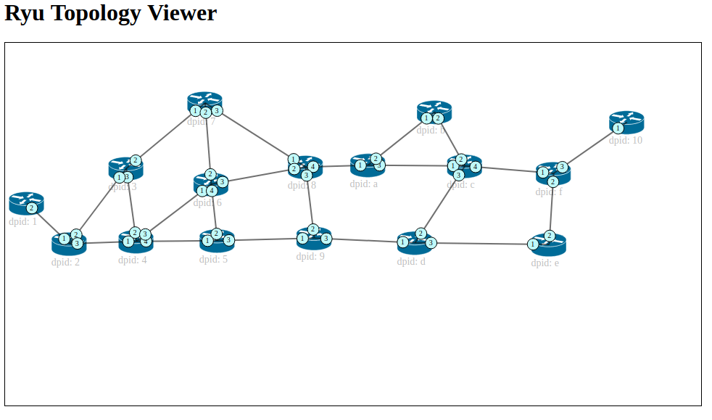
Figure 1. Topology with 16 nodes

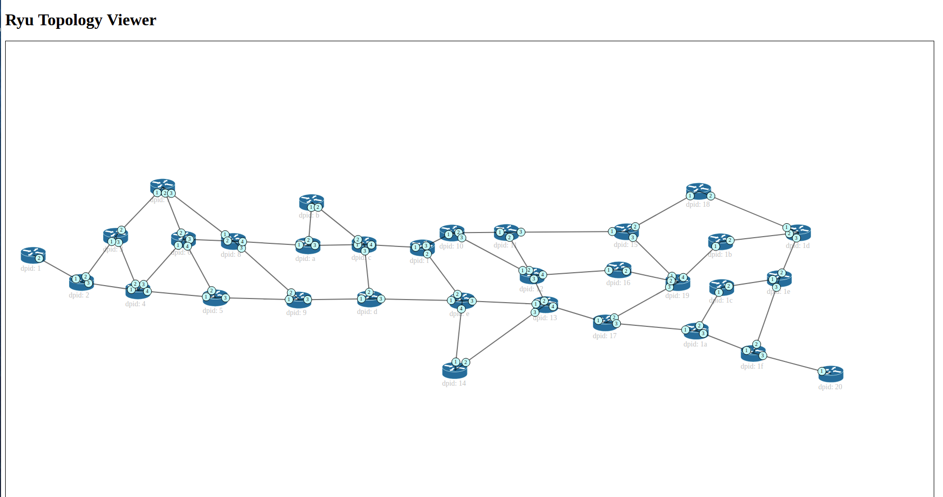
Figure 2. Topology with 32 nodes

Legacy network
Legacy network simulations were performed in GNS3 2.0.3.0 tool. We used Cisco routers with 256MB memory. Both tests were performed on the same machine, shown in Table 1.

SDN network
To simulate SDN topology we use Mininet version 2.2.2 with Floodlight controller version 1.2. The experiment was performed in vmware workstation virtual machine. The exact parameters of virtual machine are shown in Table 1.

Table 1. Parameters of virtual machine
VMware | Operating System | Hard Disk | RAM
12.5.7 | Ubuntu 14.04.5 LTS | 3 GB | 8G

Experiments

Forwarding speed of nodes under different network scales
In our first experiment we test forwarding speed of both topologies. We set link bandwidth to 1000Mbps and link delay to 2ms. After that we run ping command from host1 to host2 and measure response time. In SDN network this could be done by automatic scrip, however in GN3 we were forced to ping host with 200ms period and count number of failed pings until networks started to send pings again. This reduces accuracy of measurements, but convergence times were so long, that this error is only 1%. Figure 3 show our measured times in both topologies.

Convergence time of different network scales under different link
In the second experiment we measure convergence time of both topologies. First, we measure routing convergence time in smaller topology of 16 nodes. We set link bandwidth as 10 Mbps and link delay as 2ms and in different test we set link delay to 26ms. In Mininet we run HTTPServer on host2 and run httping from host1 to the destination of host2. When communication is established we simulate interruption by putting one link down. First, we test convergence time when link between node2 and node4 is down and in different test when link between node9 and node14 is down. In this way we are able to measure time needed for network to recover. The same test is also performed on the second topology with 32 nodes. We repeat each test for 10 times. The results are shown in figures 4 to 7.
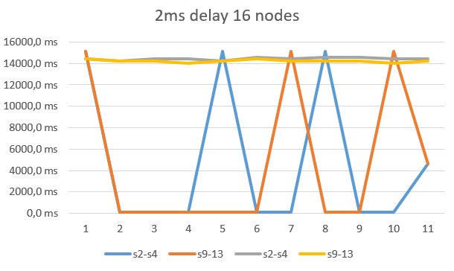
Figure 4. 2ms link delay in 16 nodes topology 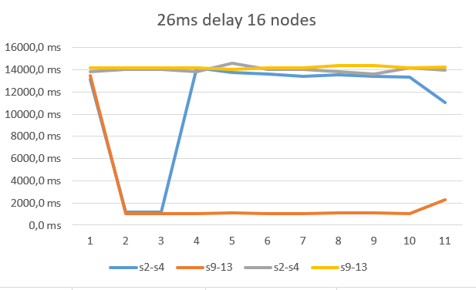Figure 5. 26ms link delay in 16 nodes topology 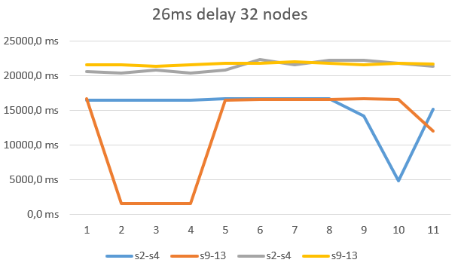Figure 6. 2ms link delay in 32 nodes topology 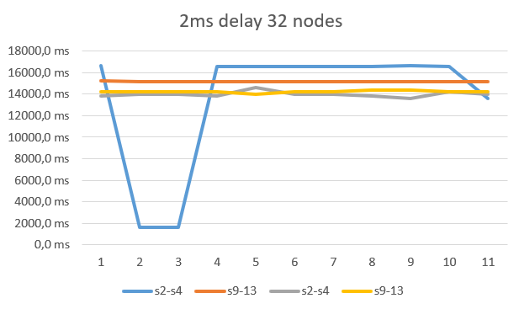 Figure 7. 26ms link delay in 32 nodes topology

conclusions
In our tests we followed the instructions, our virtual machine had same parameters than original machine, but our results are different by a large margin. While SDN network showed us short convergence time in small topology, under 100ms, sometimes this process lasted too long. This extremely long convergence times occurred more often the bigger the topology was. Legacy network had much longer times in each of our tests. If we remove values that are too low, we will see that overall point is proved, SDN network is faster in larger topologies with longer link delay, even in long tests lasting longer, as shown in Figures 8 and 9. 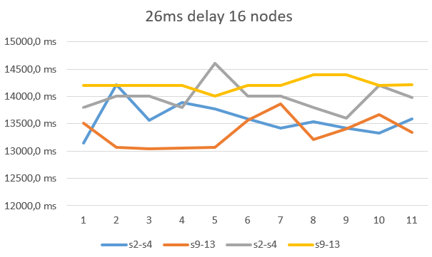
Figure 8. 26ms link delay in 16 nodes topology
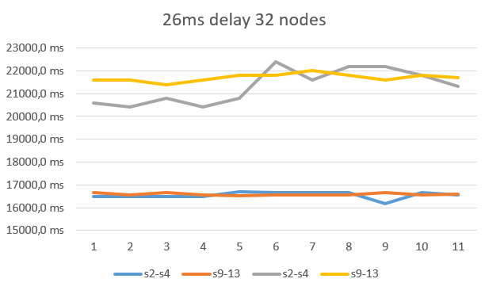 Figure 9. 26ms link delay in 32 nodes topology

We proved that Legacy routing protocols have higher convergence time, since they convergence time is heavily relying on network communication between each node, which scales bad with both topology size and link delay. SDN network however, needs only one controller and network communication is not that demanding in convergence process, so in larger topologies SDN performed better.

References

- A. Rego, S. Sendra, J. M. Jimenez and J. Lloret, "OSPF routing protocol performance in Software Defined Networks," 2017 Fourth International Conference on Software Defined Systems (SDS), Valencia, 2017, pp. 131-136.
- H. Zhang and J. Yan, "Performance of SDN Routing in Comparison with Legacy Routing Protocols," 2015 International Conference on Cyber-Enabled Distributed Computing and Knowledge Discovery, Xi'an, 2015, pp. 491-494.
[3] Project Floodlight, http://www.projectfloodlight.org/
[4] https://floodlight.atlassian.net/wiki/spaces/floodlightcontroller/pages/ 1343623/TopologyService+Dev
[5] http://mininet.org/

