**Retail Analysis Documentation**

**Project Overview**

Welcome to the Retail Analysis Documentation. In this document, we will outline the key components of our analysis, which include Sales Analysis, Product Analysis, Customer Analysis, Payment Analysis, and Order Analysis. This comprehensive examination of our retail business aims to provide valuable insights, inform decision-making, and enhance our overall performance.

**Objectives**The primary objective of the Retail Analysis Project is to gain comprehensive insights into the retail business by examining various aspects. This includes Sales Analysis, Product Analysis, Customer Analysis, Payment Analysis, and Order Analysis.

Sales Analysis:

To understand the performance of our sales activities.

In Sales Analysis, we will:

Examine sales trends and patterns.

Analyse sales by product categories, regions, and time periods.

Identify top-selling products and their impact on revenue.

Assess the effectiveness of sales channels, such as physical stores and e-commerce platforms.

Product Analysis:

To gain insights into our product inventory.

In Product Analysis, we will:

Evaluate the popularity of different product categories.

Analyse product performance, including best-sellers and slow-moving items.

Examine pricing strategies and their impact on product sales.

Identify opportunities for product diversification or optimization.

Customer Analysis:

To understand our customer base and their preferences.

In Customer Analysis, we will:

Segment customers based on demographic factors such as age, gender, income, and location.

Analyse customer buying behaviour and preferences.

Assess customer loyalty and lifetime value.

Tailor marketing and sales strategies to specific customer segments.

Payment Analysis:

To examine payment methods and their impact on sales.

In Payment Analysis, we will:

Investigate payment methods preferred by customers.

Analyse payment trends and their correlation with sales volume.

Identify any issues related to payment processing or customer experience.

Optimize payment options to enhance customer satisfaction and sales.

Order Analysis:

To evaluate the order fulfilment process.

In Order Analysis, we will:

Assess order processing times and efficiency.

Analyse order accuracy and potential issues.

Examine returns and order cancellations.

Identify opportunities to streamline the order fulfilment process.

**Significance of This Project**  
  
The significance of retail analysis offers valuable insights into business performance. These insights enable stakeholders to make data-driven decisions, identify new opportunities, and address potential challenges effectively. By balancing sales data, customer behaviour, and product performance, the dashboard helps retail businesses focus on areas that require improvement. Retailers can pinpoint underperforming products and optimize inventory management.

The dashboard facilitates the evaluation of various business strategies. Retailers can measure the effectiveness of marketing campaigns, assess customer attention efforts, and evaluate product promotions. This evaluation guides retailers in refining their approaches and reallocating resources for better results.

Through trend identification, the dashboard recognizes patterns in sales, customer preferences, and other trends. It helps retailers understand seasonal sales fluctuations, popular product categories, and customer payment behaviour over time. Identifying these trends enables proactive planning and adaptation of strategies to cope with changing market dynamics.

* Customer Understanding:

This project offers valuable insights into customer behaviour, preferences, and demographic characteristics.

* Product Optimization:

By leveraging sales data and customer feedback, product selection can be fine-tuned for improved performance.

* Inventory Management:

Efficient inventory management, with a focus on reducing carrying costs and preventing stockouts, is a key outcome of this project.

* Competitive Positioning:

The project aids in distinguishing the business from competitors, thereby strengthening its competitive positioning.

* Pricing Strategies:

Optimal pricing strategies can be determined to enhance profitability and competitiveness.

* Targeted Marketing:

Data-driven insights from this project facilitate the development of precise marketing campaigns and promotions based on customer data.

* Operational Efficiency:

This initiative contributes to cost savings and streamlining operational efficiency.

* Adaptation to Trends:

The project keeps the business current with evolving market trends and shifting customer demands.

* Customer Satisfaction:

Improvements in the shopping experience, increased customer loyalty, and enhanced repeat business are anticipated outcomes.

* Sustainability and Growth:

The insights obtained through this project lay the foundation for long-term growth and sustainability within the retail industry.

**Project Process Documentation**

**Process Overview**

This document offers a thorough overview of the processes entailed in our project, which centres on the analysis of retail data. These processes include data acquisition, transformation, tool integration, problem statement resolution, exploratory data analysis, generation of visual content, and comprehensive documentation.

1. Data Acquisition from GitHub

Objective: Acquire the specified dataset from a dedicated GitHub repository, encompassing vital information pertaining to retail store.

Action: Commenced the analysis by downloading the dataset directly from the GitHub repository as per the project requirements.

2. Data Transformation and Enhancement

Objective: Guarantee data quality and consistency through meticulous data transformation and enrichment processes.

Action: Executed necessary data transformation procedures to improve data quality. Additionally, explore opportunities to enrich the dataset by introducing new problem statements that can enhance the analysis potential. E.g.: Amount = price each * quantity ordered, create a country table

3. Connecting with Tools

Objective: Forge robust connections between the dataset and analytical tools to ensure seamless data integration and processing.

Action: Establish interfaces between the dataset and essential tools such as Power BI, Excel, and MySQL Workbench, enabling efficient data integration.

4. Problem Statement Solution in Power BI

Objective: Harness the capabilities of Power BI to tackle defined problem statements effectively.

Action: Utilized Power BI's powerful features for data visualization, exploration, and analysis, ultimately deriving valuable insights and innovative solutions.

5. Exploratory Data Analysis

Objective: Conduct in-depth exploratory data analysis.

Action: Utilized both Excel and MySQL Workbench tools based on analysis complexity, to extract significant patterns, relationships, and trends from data. These insights are invaluable for informed decision-making.

6. Creation of Visual and Insightful PowerPoint

Objective: Craft a comprehensive PowerPoint presentation that encapsulates the project's objective, methodology, problem statements, solutions, and key visualizations.

Action: Developed a PowerPoint presentation that includes dedicated sections for each problem statement, accompanied by relevant conclusions and insightful content.

7. Detailed Documentation

Objective: Thoroughly document every aspect of the project's lifecycle.

Action: Documented an extensive report encompassing data collection, transformation, problem statement formulation, tool integration, Power BI solutions, valuable insights, and content from the PowerPoint presentation.

This process document serves as a guide for the various phases of our project, ensuring a structured approach and successful completion.

**Data Dictionary**

TABLE 1 - CUSTOMERS

Customer Number (**PRIMARY KEY**):

Description: A unique identifier for each customer.

Customer Name:

Description: The name of the customer or the company.

Contact Last Name:

Description: The last name of the contact person.

Contact FirstName:

Description: The first name of the contact person.

Phone:

Description: The phone number for contacting the customer.

AddressLine1:

Description: The first line of the customer's address.

AddressLine2:

Description: The second line of the customer's address (if applicable).

City:

Description: The city where the customer is located.

State:

Description: The state or region where the customer is located.

Postal Code:

Description: The postal code or ZIP code for the customer's location.

Country:

Description: The country where the customer is located.

Sales Rep Employee Number:

Description: The employee number of the sales representative assigned to this customer.

Credit Limit:

Description: The credit limit or credit line assigned to the customer, indicating the maximum amount of credit the customer can have.

TABLE 2 - EMPLOYEES

Employee Number (**PRIMARY KEY**):

Description: A unique identifier for each employee.

Last Name:

Description: The last name of the employee.

First Name:

Description: The first name of the employee.

Extension:

Description: The phone extension for the employee.

Email:

Description: The email address of the employee.

Office Code:

Description: The code or identifier for the office where the employee works.

Reports To:

Description: A reference to the employee to whom this employee reports, usually represented by their employee Number.

Job Title:

Description: The job title or position held by the employee

TABLE 3 - OFFICE

Office Code (**PRIMARY KEY**):

Description: A unique identifier or code for each office.

City:

Description: The city where the office is located.

Phone:

Description: The phone number for contacting the office.

AddressLine1:

Description: The first line of the office's address.

AddressLine2:

Description: The second line of the office's address (if applicable).

State:

Description: The state or region where the office is located.

Country:

Description: The country where the office is located.

Postal Code:

Description: The postal code or ZIP code for the office's location.

Territory:

Description: The territory or region served by the office.

TABLE 4 - ORDER DETAILS

Order Number (**PRIMARY KEY**):

Description: A unique identifier for each order.

Product Code (**FOREIGN KEY**):

Description: A reference to the product associated with the order. This column typically relates to a "Products" table.

Quantity Ordered:

Description: The quantity of the product ordered in this specific line item.

Price Each:

Description: The price of each unit of the product in this line item.

Order Line Number:

Description: A sequential line number representing the order line item.

TABLE 5 - ORDERS

Order Number (**PRIMARY KEY**):

Description: A unique identifier for each order.

Order Date:

Description: The date when the order was placed.

Required Date:

Description: The date by which the order is required.

Shipped Date:

Description: The date when the order was shipped.

Status:

Description: The status of the order (e.g., "Shipped," "In Progress," "Cancelled," etc.).

Comments:

Description: Any additional comments or notes related to the order.

Customer Number (**FOREIGN KEY**):

Description: A reference to the customer who placed the order. This column typically relates to a "Customers" 54520. table

TABLE 6 - PAYMENTS

Customer Number (**FOREIGN KEY**):

Description: A reference to the customer making the payment. This column typically relates to a "Customers" table.

Check Number:

Description: The check number or payment reference for the transaction.

Payment Date:

Description: The date when the payment was made.

Amount:

Description: The amount of the payment.

TABLE 7 - PRODUCTS

Product Line:

Description: The product line or category to which the product belongs.

Product Scale:

Description: The scale or size of the product (e.g., 1:18, 1:24).

Product Vendor:

Description: The vendor or manufacturer of the product.

Product Description:

Description: A description or details about the product.

Quantity In Stock:

Description: The quantity of this product currently in stock or inventory.

Buy Price:

Description: The price at which the product is purchased.

MSRP (Manufacturer's Suggested Retail Price):

Description: The suggested retail price of the product

**ER DIAGRAM**

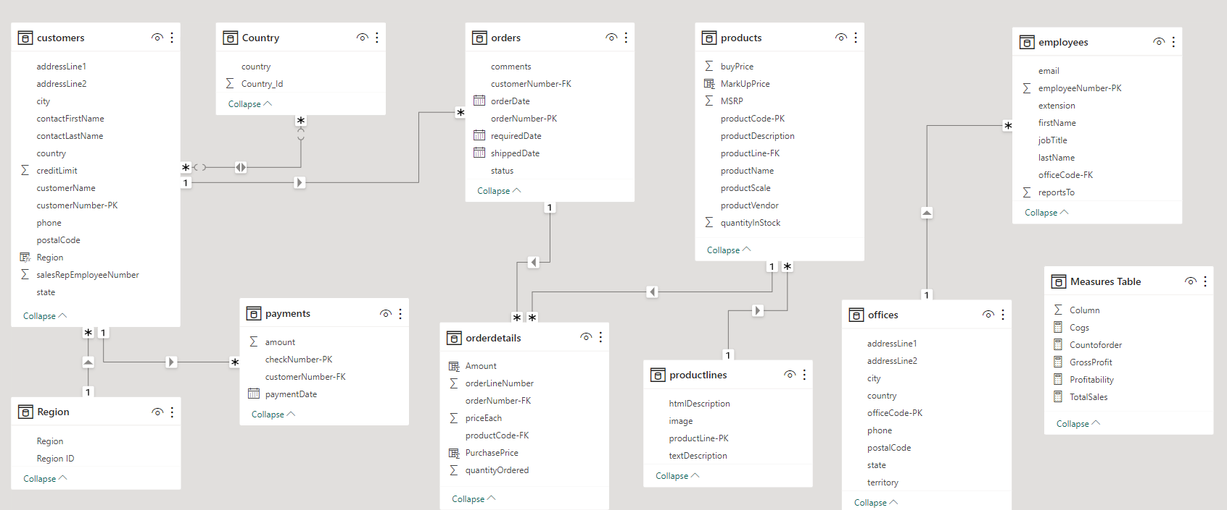

**EDA PROBLEM STATEMENT**

**Which factors contribute to the highest sales in a particular region?**

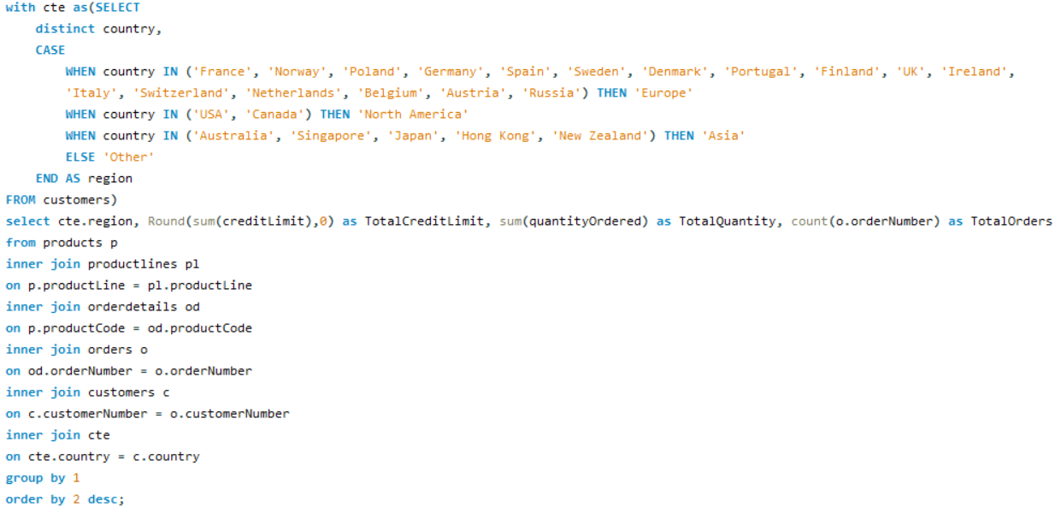

|  |  |
| --- | --- |
| Region | Sales |
| Europe | 4520712 |
| North America | 3479192 |
| Asia | 1516818 |
| Other | 87468 |

|  |  |  |  |
| --- | --- | --- | --- |
| Region | Credit Limit | QuantityOrdered | Total Orders |
| Europe | 16,62,75,200 | 49578 | 1415 |
| North America | 11,42,58,600 | 38137 | 1074 |
| Asia | 4,52,98,600 | 16840 | 481 |
| Other | 21,19,000 | 961 | 26 |

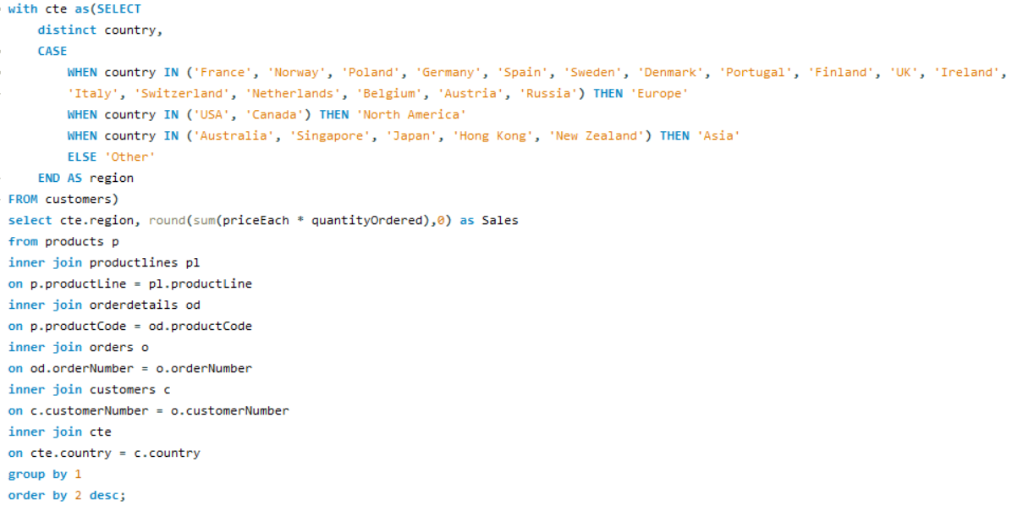

**Insight:**Europe has the highest sales among all regions and it has maximum credit limit and number of orders is also highest in the Europe Region  
  
**Reasons for Highest Sales:**  
High Consumption of goods and High Credit Limit Offered  
  
  
**Conclusion:**  
  
Firstly, the high consumption of goods in this region indicates a strong demand for various products, which, in turn, translates into increased sales.   
  
Secondly, the high credit limit empowers customers to make larger purchases, thereby boosting sales. It provides customers with the financial flexibility to invest in a wider array of products, driving up the overall sales volume.   
  
Additionally, the region's high number of orders also contributes to its status as the leader in sales.   
  
Lastly, Europe's position as the leader in sales can be attributed to its strong demand for goods, the availability of a substantial credit limit for customers, and the high number of orders placed. These factors collectively propel Europe to the forefront in terms of sales among all regions.

**How can customer purchasing patterns be influenced to increase average order value?**

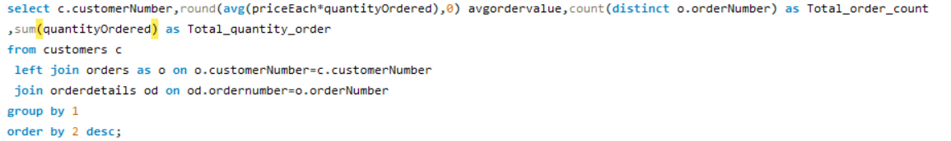

|  |  |  |  |
| --- | --- | --- | --- |
| CustomerNumber | Avg_Order_Value | Total_order_count | Total_quantity_order |
| 455 | 4140 | 2 | 636 |
| 209 | 3993 | 3 | 779 |
| 328 | 3896 | 3 | 988 |
| 175 | 3817 | 3 | 903 |
| 172 | 3763 | 3 | 836 |
| 151 | 3707 | 4 | 1775 |
| 204 | 3705 | 2 | 572 |
| 333 | 3679 | 3 | 545 |
| 201 | 3676 | 3 | 1046 |
| 381 | 3652 | 4 | 278 |
| 495 | 3641 | 2 | 695 |
| 148 | 3634 | 5 | 1524 |
| 357 | 3632 | 3 | 1003 |
| 344 | 3596 | 2 | 468 |
| 450 | 3588 | 4 | 1656 |
| 145 | 3586 | 5 | 1315 |
| 458 | 3514 | 3 | 1163 |
| 144 | 3510 | 4 | 647 |
| 298 | 3509 | 2 | 1078 |
| 334 | 3463 | 3 | 1031 |
| 424 | 3461 | 3 | 720 |
| 128 | 3452 | 4 | 811 |
| 382 | 3437 | 4 | 1442 |
| 259 | 3432 | 2 | 936 |
| 363 | 3425 | 3 | 1248 |
| 462 | 3409 | 3 | 903 |
| 452 | 3404 | 3 | 532 |
| 484 | 3399 | 2 | 589 |
| 250 | 3383 | 3 | 684 |
| 486 | 3379 | 3 | 730 |
| 157 | 3366 | 4 | 1111 |
| 475 | 3365 | 2 | 511 |
| 167 | 3364 | 3 | 973 |
| 385 | 3364 | 3 | 961 |
| 323 | 3361 | 5 | 1691 |
| 286 | 3354 | 2 | 976 |
| 227 | 3330 | 2 | 882 |
| 398 | 3298 | 4 | 1150 |
| 124 | 3288 | 17 | 6366 |
| 114 | 3283 | 5 | 1926 |
| 256 | 3271 | 2 | 637 |
| 121 | 3257 | 4 | 1082 |
| 362 | 3244 | 3 | 1036 |
| 321 | 3228 | 4 | 1447 |
| 386 | 3218 | 3 | 1280 |
| 239 | 3215 | 2 | 954 |
| 406 | 3201 | 3 | 1001 |
| 103 | 3188 | 3 | 270 |
| 202 | 3187 | 2 | 703 |
| 186 | 3185 | 3 | 1051 |
| 448 | 3183 | 3 | 1359 |
| 146 | 3178 | 3 | 1428 |
| 129 | 3177 | 3 | 692 |
| 473 | 3170 | 2 | 272 |
| 141 | 3169 | 26 | 9327 |
| 249 | 3162 | 2 | 843 |
| 233 | 3135 | 3 | 717 |
| 205 | 3127 | 3 | 1060 |
| 189 | 3119 | 2 | 490 |
| 177 | 3118 | 2 | 692 |
| 412 | 3115 | 3 | 1055 |
| 324 | 3098 | 3 | 937 |
| 353 | 3097 | 5 | 1433 |
| 171 | 3089 | 2 | 699 |
| 161 | 3075 | 4 | 1179 |
| 379 | 3064 | 3 | 795 |
| 131 | 3043 | 4 | 1631 |
| 242 | 3024 | 3 | 687 |
| 319 | 3017 | 2 | 929 |
| 166 | 2993 | 4 | 1236 |
| 119 | 2992 | 4 | 1832 |
| 311 | 2991 | 3 | 1110 |
| 276 | 2979 | 4 | 1469 |
| 216 | 2979 | 3 | 882 |
| 347 | 2965 | 2 | 500 |
| 173 | 2927 | 2 | 357 |
| 456 | 2923 | 2 | 381 |
| 282 | 2911 | 4 | 1601 |
| 320 | 2911 | 3 | 1140 |
| 187 | 2910 | 3 | 1778 |
| 181 | 2900 | 3 | 787 |
| 299 | 2877 | 2 | 787 |
| 496 | 2864 | 4 | 1647 |
| 350 | 2862 | 3 | 804 |
| 211 | 2843 | 2 | 596 |
| 487 | 2838 | 2 | 514 |
| 314 | 2834 | 3 | 796 |
| 112 | 2765 | 3 | 929 |
| 240 | 2761 | 2 | 895 |
| 339 | 2759 | 2 | 668 |
| 198 | 2694 | 3 | 287 |
| 278 | 2657 | 3 | 1650 |
| 219 | 2640 | 2 | 102 |
| 447 | 2630 | 3 | 666 |
| 260 | 2570 | 2 | 873 |
| 489 | 2466 | 2 | 357 |
| 471 | 2429 | 3 | 705 |
| 415 | 2236 | 1 | 401 |

**Insights:**  
  
By analysing the data, we have concluded the high-value customers and their buying habits. This insight guides targeted marketing and sales tactics, such as exclusive promotions, product bundles, and personalized suggestions, to boost their spending and raise the average order value.

**Conclusion:**   
  
To increase the average order value in a retail business:

1. Implement a loyalty program.
2. Use tiered pricing for discounts on larger quantities.
3. Create a sense of urgency with limited-time offers.
4. Use free shipping thresholds.
5. Offer discounts on bulk purchases.
6. Educate customers about premium products.
7. Follow up with post-purchase communication.
8. Highlight user reviews.
9. Have clear return policies.

My analysis has helped me identify customers who tend to spend more and understand what they like to buy. With this knowledge, we can create special offers, package deals, and personalized suggestions to encourage these valuable customers to spend even more. This should lead to an increase in the average amount people spend when making a purchase. Ultimately, this approach benefits both the customers and the business by boosting sales, making customers happier, and ensuring they keep coming back.

**What are the key drivers of sales growth, and how can they be leveraged for future success?**

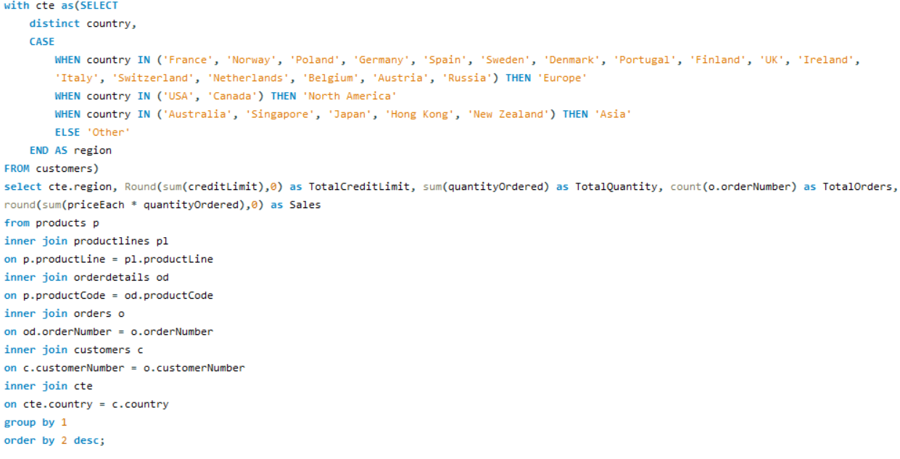

|  |  |  |  |  |
| --- | --- | --- | --- | --- |
| Region | TotalCreditLimit | TotalQuantity | TotalOrders | Sales |
| Europe | 16,62,75,200 | 49578 | 1415 | 45,20,712 |
| North America | 11,42,58,600 | 38137 | 1074 | 34,79,192 |
| Asia | 4,52,98,600 | 16840 | 481 | 15,16,818 |
| Other | 21,19,000 | 961 | 26 | 87,468 |

**Key drivers of sales growth include:**

* Total Credit Limit
* Total Quantity Sold
* Order Frequency
* Total Revenue Generated

**Some more examples of Sales Growth.**

1. Customer Experience
2. Pricing Strategies
3. Marketing and Promotion
4. Inventory Management
5. Customer Loyalty Programs
6. Employee Training
7. Technology Integration

By leveraging these key drivers of sales growth and adapting to changing consumer preferences and market trends, a retail business can position itself for future success and sustainable growth.

**Conclusion:**

In conclusion, identifying and capitalizing on the key drivers of sales growth is essential for the long-term success of a retail business. By understanding customer behavior, optimizing product offerings, implementing effective marketing strategies, and staying agile in response to changing trends, businesses can thrive in a competitive marketplace. The ability to leverage these drivers will not only boost current sales but also pave the way for continued growth and success in the future. It's a dynamic process that requires ongoing analysis and adaptation to stay ahead in the retail industry.

**Which product features or attributes are most appealing to customers?**  
  
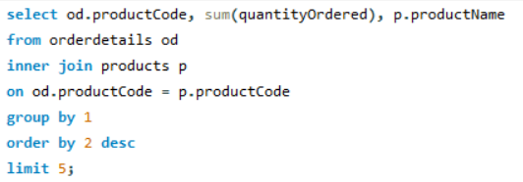

**Note:** Taken top 5 orders  
  
**Insights**: S18_3232 (**1992 Ferrari 360 Spider red)** has the most order   
So this attribute is most appealing to customers

**Product Feature of 1992 Ferrari 360 Spider red**His replica features opening doors, superb detail and craftsmanship, working steering system, opening forward compartment, opening rear trunk with removable spare, 4-wheel independent spring suspension as well as factory baked enamel finish.

**How can the product mix be optimized to cater to changing market demands?**

Optimizing the product mix to cater to changing market demands is a critical process that requires a combination of

* Market Research and Analysis
* Establish Clear Objectives
* Marketing and Promotion
* Pricing Strategy
* Supply Chain Optimization
* Product Development and Innovation

**Optimizing the product mix to adapt to evolving market demands is a vital initiative that demands a comprehensive strategy, encompassing:**

1. **Market Research and Analysis:** In-depth examination of market dynamics, customer preferences, and emerging trends to inform product selection.
2. **Establishing Clear Objectives:** Setting specific and measurable goals for product optimization, ensuring alignment with overall business objectives.
3. **Marketing and Promotion:** Crafting effective marketing strategies and promotional campaigns to drive product visibility and consumer engagement.
4. **Pricing Strategy:** Careful consideration of pricing models to maximize profitability while remaining competitive in the market.
5. **Supply Chain Optimization:** Streamlining supply chain processes to ensure efficient product sourcing, storage, and distribution.
6. **Product Development and Innovation:** Continuous improvement and innovation in product offerings to meet changing consumer needs and expectations.

By implementing these components in a coordinated manner, the business can effectively adjust its product mix to stay responsive to market dynamics and enhance its competitive edge.

**Are there any specific market segments where a particular product is underperforming, and how can it be improved?**

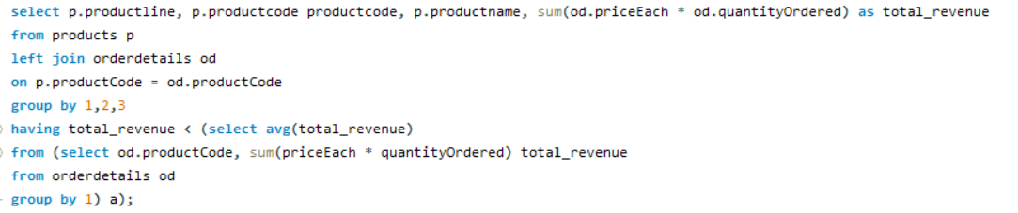

|  |  |  |  |
| --- | --- | --- | --- |
| Product Line | Product Code | ProductName | Total Revenue |
| Classic Cars | S12_3990 | 1970 Plymouth Hemi Cuda | 63489.95 |
| Vintage Cars | S18_1367 | 1936 Mercedes-Benz 500K Special Roadster | 46078.29 |
| Classic Cars | S18_1889 | 1948 Porsche 356-A Roadster | 66455.62 |
| Vintage Cars | S18_2248 | 1911 Ford Town Car | 45306.77 |
| Trucks and Buses | S18_2432 | 1926 Ford Fire Engine | 55835.3 |
| Planes | S18_2581 | P-51-D Mustang | 68741.91 |
| Motorcycles | S18_2625 | 1936 Harley Davidson El Knucklehead | 49992.72 |
| Vintage Cars | S18_2957 | 1934 Ford V8 Coupe | 55172.21 |
| Ships | S18_3029 | 1999 Yamaha Speed Boat | 74127.24 |
| Vintage Cars | S18_3136 | 18th Century Vintage Horse Carriage | 85328.57 |
| Trains | S18_3259 | Collectable Wooden Train | 82617.12 |
| Classic Cars | S18_3278 | 1969 Dodge Super Bee | 68783.93 |
| Vintage Cars | S18_3320 | 1917 Maxwell Touring Car | 87637.63 |
| Motorcycles | S18_3782 | 1957 Vespa GS150 | 54024.87 |
| Vintage Cars | S18_4409 | 1932 Alfa Romeo 8C2300 Spider Sport | 71526.22 |
| Vintage Cars | S18_4522 | 1904 Buick Runabout | 77800.54 |
| Vintage Cars | S18_4668 | 1939 Cadillac Limousine | 44037.84 |
| Classic Cars | S18_4933 | 1957 Ford Thunderbird | 50101.57 |
| Classic Cars | S24_1046 | 1970 Chevy Chevelle SS 454 | 53236.67 |
| Classic Cars | S24_1444 | 1970 Dodge Coronet | 50255.45 |
| Classic Cars | S24_1628 | 1966 Shelby Cobra 427 S/C | 42015.54 |
| Vintage Cars | S24_1937 | 1939 Chevrolet Deluxe Coupe | 28052.94 |
| Motorcycles | S24_2000 | 1960 BSA Gold Star DBD34 | 67193.49 |
| Vintage Cars | S24_2022 | 1938 Cadillac V-16 Presidential Limousine | 38449.09 |
| Motorcycles | S24_2360 | 1982 Ducati 900 Monster | 57995.25 |
| Classic Cars | S24_2766 | 1949 Jaguar XK 120 | 76670.02 |
| Classic Cars | S24_2840 | 1958 Chevy Corvette Limited Edition | 31627.96 |
| Planes | S24_2841 | 1900s Vintage Bi-Plane | 58434.07 |
| Classic Cars | S24_2972 | 1982 Lamborghini Diablo | 30972.87 |
| Vintage Cars | S24_3151 | 1912 Ford Model T Delivery Wagon | 77239.92 |
| Classic Cars | S24_3191 | 1969 Chevrolet Camaro Z28 | 67357.3 |
| Classic Cars | S24_3371 | 1971 Alpine Renault 1600s | 52339.53 |
| Vintage Cars | S24_3420 | 1937 Horch 930V Limousine | 52803.75 |
| Classic Cars | S24_3432 | 2002 Chevy Corvette | 87404.81 |
| Vintage Cars | S24_3816 | 1940 Ford Delivery Sedan | 71208.18 |
| Planes | S24_3949 | Corsair F4U ( Bird Cage) | 62269.67 |
| Vintage Cars | S24_3969 | 1936 Mercedes Benz 500k Roadster | 29763.39 |
| Planes | S24_4278 | 1900s Vintage Tri-Plane | 68276.35 |
| Classic Cars | S24_4620 | 1961 Chevrolet Impala | 69120.97 |
| Trucks and Buses | S32_1268 | 1980â€™s GM Manhattan Express | 78067.82 |
| Motorcycles | S32_2206 | 1982 Ducati 996 R | 33268.76 |
| Trucks and Buses | S32_2509 | 1954 Greyhound Scenicruiser | 46519.05 |
| Trains | S32_3207 | 1950's Chicago Surface Lines Streetcar | 53791.99 |
| Trucks and Buses | S32_3522 | 1996 Peterbilt 379 Stake Bed with Outrigger | 57282.49 |
| Vintage Cars | S32_4289 | 1928 Ford Phaeton Deluxe | 60493.33 |
| Motorcycles | S32_4485 | 1974 Ducati 350 Mk3 Desmo | 84039.24 |
| Vintage Cars | S50_1341 | 1930 Buick Marquette Phaeton | 41599.24 |
| Trains | S50_1514 | 1962 City of Detroit Streetcar | 52123.81 |
| Motorcycles | S50_4713 | 2002 Yamaha YZR M1 | 73670.64 |
| Ships | S700_1138 | The Schooner Bluenose | 56455.11 |
| Planes | S700_1691 | American Airlines: B767-300 | 73871.22 |
| Ships | S700_1938 | The Mayflower | 69531.61 |
| Ships | S700_2047 | HMS Bounty | 73298.42 |
| Ships | S700_2610 | The USS Constitution Ship | 66697.13 |
| Planes | S700_3167 | F/A 18 Hornet 1/72 | 76618.4 |
| Ships | S700_3505 | The Titanic | 84992.25 |
| Ships | S700_3962 | The Queen Mary | 78919.06 |
| Planes | S700_4002 | American Airlines: MD-11S | 71753.93 |
| Planes | S72_1253 | Boeing X-32A JSF | 42692.53 |
| Ships | S72_3212 | Pont Yacht | 47550.4 |

**Insight:**A critical observation reveals that the following products are underperforming, as the cumulative revenue from these products falls short of the average revenue earned across all products. **Conclusion:**  
  
A thorough analysis indicates that certain products are experiencing subpar performance, as the combined revenue generated by these specific products does not meet the established average revenue earned across the entire product range. This observation underscores the need for further examination and potential strategic adjustments to enhance the performance of these underperforming products

**What are the main factors that influence customer loyalty and repeat purchases?**

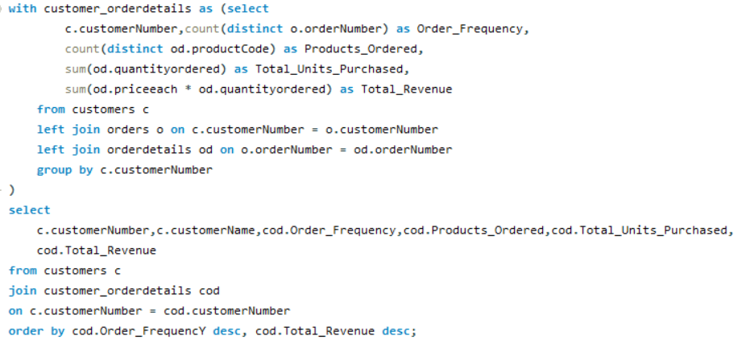

|  |  |  |  |  |  |
| --- | --- | --- | --- | --- | --- |
| customer Number | customer Name | Order requency | Products_Ordered | Total_Units_Purchased | Total Revenue |
| 141 | Euro+ Shopping Channel | 26 | 106 | 9327 | 820689.54 |
| 124 | Mini Gifts Distributors Ltd. | 17 | 77 | 6366 | 591827.34 |
| 114 | Australian Collectors, Co. | 5 | 40 | 1926 | 180585.07 |
| 148 | Dragon Souveniers, Ltd. | 5 | 37 | 1524 | 156251.03 |
| 323 | Down Under Souveniers, Inc | 5 | 42 | 1691 | 154622.08 |
| 145 | Danish Wholesale Imports | 5 | 31 | 1315 | 129085.12 |
| 353 | Reims Collectables | 5 | 37 | 1433 | 126983.19 |
| 151 | Muscle Machine Inc | 4 | 32 | 1775 | 177913.95 |
| 119 | La Rochelle Gifts | 4 | 43 | 1832 | 158573.12 |
| 131 | Land of Toys Inc. | 4 | 41 | 1631 | 149085.15 |
| 450 | The Sharp Gifts Warehouse | 4 | 39 | 1656 | 143536.27 |
| 382 | Salzburg Collectables | 4 | 36 | 1442 | 137480.07 |
| 496 | Kelly's Gift Shop | 4 | 45 | 1647 | 137460.79 |
| 276 | Anna's Decorations, Ltd | 4 | 41 | 1469 | 137034.22 |
| 282 | Souveniers And Things Co. | 4 | 44 | 1601 | 133907.12 |
| 321 | Corporate Gift Ideas Co. | 4 | 40 | 1447 | 132340.78 |
| 166 | Handji Gifts& Co | 4 | 29 | 1236 | 107746.75 |
| 398 | Tokyo Collectables, Ltd | 4 | 32 | 1150 | 105548.73 |
| 161 | Technics Stores Inc. | 4 | 30 | 1179 | 104545.22 |
| 157 | Diecast Classics Inc. | 4 | 31 | 1111 | 104358.69 |
| 121 | Baane Mini Imports | 4 | 32 | 1082 | 104224.79 |
| 128 | Blauer See Auto, Co. | 4 | 22 | 811 | 75937.76 |
| 144 | Volvo Model Replicas, Co | 4 | 19 | 647 | 66694.82 |
| 381 | Royale Belge | 4 | 8 | 278 | 29217.18 |
| 187 | AV Stores, Co. | 3 | 37 | 1778 | 148410.09 |
| 146 | Saveley & Henriot, Co. | 3 | 41 | 1428 | 130305.35 |
| 278 | Rovelli Gifts | 3 | 34 | 1650 | 127529.69 |
| 386 | L'ordine Souveniers | 3 | 39 | 1280 | 125505.57 |
| 448 | Scandinavian Gift Ideas | 3 | 38 | 1359 | 120943.53 |
| 363 | Online Diecast Creations Co. | 3 | 34 | 1248 | 116449.29 |
| 458 | Corrida Auto Replicas, Ltd | 3 | 26 | 1163 | 112440.09 |
| 201 | UK Collectables, Ltd. | 3 | 29 | 1046 | 106610.72 |
| 334 | Suominen Souveniers | 3 | 30 | 1031 | 103896.74 |
| 320 | Mini Creations Ltd. | 3 | 34 | 1140 | 101872.52 |
| 167 | Herkku Gifts | 3 | 29 | 973 | 97562.47 |
| 311 | Oulu Toy Supplies, Inc. | 3 | 31 | 1110 | 95706.15 |
| 186 | Toys of Finland, Co. | 3 | 30 | 1051 | 95546.46 |
| 175 | Gift Depot Inc. | 3 | 25 | 903 | 95424.63 |
| 357 | GiftsForHim.com | 3 | 26 | 1003 | 94431.76 |
| 205 | Toys4GrownUps.com | 3 | 29 | 1060 | 93803.3 |
| 412 | Extreme Desk Decorations, Ltd | 3 | 29 | 1055 | 90332.38 |
| 462 | FunGiftIdeas.com | 3 | 26 | 903 | 88627.49 |
| 385 | Cruz & Sons Co. | 3 | 22 | 961 | 87468.3 |
| 172 | La Corne D'abondance, Co. | 3 | 22 | 836 | 86553.52 |
| 406 | Auto Canal+ Petit | 3 | 18 | 1001 | 86436.97 |
| 362 | Gifts4AllAges.com | 3 | 21 | 1036 | 84340.32 |
| 328 | Tekni Collectables Inc. | 3 | 21 | 988 | 81806.55 |
| 324 | Stylish Desk Decors, Co. | 3 | 26 | 937 | 80556.73 |
| 112 | Signal Gift Stores | 3 | 24 | 929 | 80180.98 |
| 486 | Motor Mint Distributors Inc. | 3 | 17 | 730 | 77726.59 |
| 209 | Mini Caravy | 3 | 19 | 779 | 75859.32 |
| 379 | Collectables For Less Inc. | 3 | 24 | 795 | 73533.65 |
| 181 | Vitachrome Inc. | 3 | 25 | 787 | 72497.64 |
| 350 | Marseille Mini Autos | 3 | 24 | 804 | 71547.53 |
| 314 | Petit Auto | 3 | 20 | 796 | 70851.58 |
| 424 | Classic Legends Inc. | 3 | 20 | 720 | 69214.33 |
| 233 | QuÃ©bec Home Shopping Network | 3 | 22 | 717 | 68977.67 |
| 216 | Enaco Distributors | 3 | 22 | 882 | 68520.47 |
| 250 | Lyon Souveniers | 3 | 20 | 684 | 67659.19 |
| 129 | Mini Wheels Co. | 3 | 19 | 692 | 66710.56 |
| 242 | Alpha Cognac | 3 | 20 | 687 | 60483.36 |
| 471 | Australian Collectables, Ltd | 3 | 23 | 705 | 55866.02 |
| 333 | Australian Gift Network, Co | 3 | 15 | 545 | 55190.16 |
| 452 | Mini Auto Werke | 3 | 15 | 532 | 51059.99 |
| 447 | Gift Ideas Corp. | 3 | 19 | 666 | 49967.78 |
| 103 | Atelier graphique | 3 | 7 | 270 | 22314.36 |
| 198 | Auto-Moto Classics Inc. | 3 | 8 | 287 | 21554.26 |
| 298 | Vida Sport, Ltd | 2 | 17 | 1078 | 108777.92 |
| 286 | Marta's Replicas Co. | 2 | 27 | 976 | 90545.37 |
| 227 | Heintze Collectables | 2 | 27 | 882 | 89909.8 |
| 259 | Toms SpezialitÃ¤ten, Ltd | 2 | 17 | 936 | 89223.14 |
| 249 | Amica Models & Co. | 2 | 26 | 843 | 82223.23 |
| 239 | Collectable Mini Designs Co. | 2 | 25 | 954 | 80375.24 |
| 319 | Mini Classics | 2 | 26 | 929 | 78432.16 |
| 240 | giftsbymail.co.uk | 2 | 26 | 895 | 71783.75 |
| 455 | Super Scale Inc. | 2 | 17 | 636 | 70378.65 |
| 202 | Canadian Gift Exchange Network | 2 | 19 | 703 | 70122.19 |
| 299 | Norway Gifts By Mail, Co. | 2 | 24 | 787 | 69059.04 |
| 260 | Royal Canadian Collectables, Ltd. | 2 | 26 | 873 | 66812 |
| 495 | Diecast Collectables | 2 | 18 | 695 | 65541.74 |
| 177 | Osaka Souveniers Co. | 2 | 20 | 692 | 62361.22 |
| 171 | Daedalus Designs Imports | 2 | 14 | 699 | 61781.7 |
| 256 | Auto AssociÃ©s & Cie. | 2 | 17 | 637 | 58876.41 |
| 339 | Classic Gift Ideas, Inc | 2 | 21 | 668 | 57939.34 |
| 204 | Online Mini Collectables | 2 | 15 | 572 | 55577.26 |
| 484 | Iberia Gift Imports, Corp. | 2 | 15 | 589 | 50987.85 |
| 189 | Clover Collections, Co. | 2 | 16 | 490 | 49898.27 |
| 344 | CAF Imports | 2 | 13 | 468 | 46751.14 |
| 211 | King Kong Collectables, Co. | 2 | 12 | 596 | 45480.79 |
| 475 | West Coast Collectables Co. | 2 | 13 | 511 | 43748.72 |
| 487 | Signal Collectibles Ltd. | 2 | 15 | 514 | 42570.37 |
| 347 | Men 'R' US Retailers, Ltd. | 2 | 14 | 500 | 41506.19 |
| 173 | Cambridge Collectables Co. | 2 | 11 | 357 | 32198.69 |
| 489 | Double Decker Gift Stores, Ltd | 2 | 12 | 357 | 29586.15 |
| 456 | Microscale Inc. | 2 | 10 | 381 | 29230.43 |
| 473 | Frau da Collezione | 2 | 8 | 272 | 25358.32 |
| 219 | Boards & Toys Co. | 2 | 3 | 102 | 7918.6 |
| 415 | Bavarian Collectables Imports, Co. | 1 | 14 | 401 | 31310.09 |
| 125 | Havel & Zbyszek Co | 0 | 0 |  |  |
| 168 | American Souvenirs Inc | 0 | 0 |  |  |
| 169 | Porto Imports Co. | 0 | 0 |  |  |
| 206 | Asian Shopping Network, Co | 0 | 0 |  |  |
| 223 | NatÃ¼rlich Autos | 0 | 0 |  |  |
| 237 | ANG Resellers | 0 | 0 |  |  |
| 247 | Messner Shopping Network | 0 | 0 |  |  |
| 273 | Franken Gifts, Co | 0 | 0 |  |  |
| 293 | BG&E Collectables | 0 | 0 |  |  |
| 303 | Schuyler Imports | 0 | 0 |  |  |
| 307 | Der Hund Imports | 0 | 0 |  |  |
| 335 | Cramer SpezialitÃ¤ten, Ltd | 0 | 0 |  |  |
| 348 | Asian Treasures, Inc. | 0 | 0 |  |  |
| 356 | SAR Distributors, Co | 0 | 0 |  |  |
| 361 | Kommission Auto | 0 | 0 |  |  |
| 369 | Lisboa Souveniers, Inc | 0 | 0 |  |  |
| 376 | Precious Collectables | 0 | 0 |  |  |
| 409 | Stuttgart Collectable Exchange | 0 | 0 |  |  |
| 443 | Feuer Online Stores, Inc | 0 | 0 |  |  |
| 459 | Warburg Exchange | 0 | 0 |  |  |
| 465 | Anton Designs, Ltd. | 0 | 0 |  |  |
| 477 | Mit VergnÃ¼gen & Co. | 0 | 0 |  |  |
| 480 | Kremlin Collectables, Co. | 0 | 0 |  |  |
| 481 | Raanan Stores, Inc | 0 | 0 |  |  |

**Insight: Customer loyalty and repeat purchases are influenced by:**

1. Product/Service Quality

2. Customer Service  
3. Brand Trust

4. Discount

5. Competitive Pricing

6. Feedback and Improvement

7. Loyalty Incentives

**Focusing on these factors improves loyalty and encourages repeat purchases.**

**Insight:**

Customer loyalty and repeat purchases are influenced by:

1. Product/Service Quality

2. Customer Service  
3. Brand Trust

4. Discount

5. Competitive Pricing

6. Feedback and Improvement

**Conclusion:**

Customer loyalty and repeat purchases are significantly influenced by a combination of factors, with product quality, value, and exceptional customer service being at the forefront. Loyalty programs and personalization strategies further strengthen customer bonds. Consistency in delivering on promises and ensuring a convenient shopping experience is vital. A positive brand reputation, competitive pricing, and ongoing engagement through marketing and customer outreach play integral roles. To foster loyalty and encourage repeat business, a retail business should focus on excelling in these key areas.

**How do customer preferences differ based on geographic location, and how can marketing campaigns be customized accordingly?**

**Note:**Customer preferences can vary significantly based on geographic location due to cultural, economic, and environmental factors. To customize marketing campaigns effectively, businesses should consider the following:

1. **Language:** Tailor marketing content to the local language.
2. **Climate:** Adapt campaigns to match local weather patterns.
3. **Economy:** Adjust pricing and promotions based on economic factors.
4. **Culture:** Consider local traditions and trends in marketing.
5. **Compliance**: Ensure campaigns follow local regulations.
6. **Competition:** Stand out in the local competitive landscape.
7. **Research:** Conduct market research for regional insights.
8. **Feedback:** Listen to and act on customer feedback.

These highlights the need to customize marketing campaigns based on geographic location to better align with customer preferences.

**Conclusion:**

To optimize the effectiveness of marketing campaigns, understanding and catering to customer preferences based on geographic location is crucial. This involves considering language, climate, economic factors, local trends, and legal compliance. Customizing campaigns requires comprehensive research and feedback analysis while keeping an eye on local competition. Aligning with regional specificities can greatly enhance campaign success.

**Insight:   
  
Customer preferences can vary significantly based on geographic location due to cultural, economic, and environmental factors. To customize marketing campaigns effectively, businesses should consider the following:**

1. Language  
2. Climate and Seasonal Variation  
3. Economic Factors  
4. Local Trends and Traditions  
5. Legal and Regulatory Compliance  
6. Local Competition  
7. Market Research  
8. Customer Feedback

**What are the characteristics of high-value customers, and how can similar customers be targeted for acquisition?**

**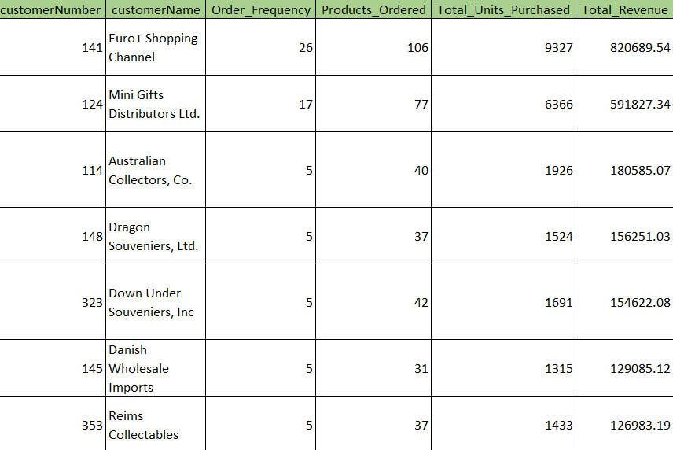  
  
Note:**

**Insight:**

**Characteristics of High-Value Customers:**

1. High Spending

2. Loyalty

3. Long-term Engagement  
4. Profitability

5. Advocacy  
  
**Targeting Similar Customers for Acquisition:**

1. Data Analysis  
2. Customer Segmentation  
3. Look-alike Modelling  
4. Personalized Marketing  
5. Referral Programs

6. Improve Customer Experience

7. Cross-selling and Upselling

8. Retention Strategies

9. A/B Testing

**Characteristics of High-Value Customers:**

1. High Spending

2. Loyalty

3. Long-term Engagement  
4. Profitability

5. Advocacy

**Targeting Similar Customers for Acquisition:**

1. Data Analysis  
2. Customer Segmentation  
3. Look-alike Modelling  
4. Personalized Marketing  
5. Referral Programs

6. Improve Customer Experience

7. Cross-selling and Upselling

8. Retention Strategies

9. A/B Testing

**Conclusion:**

Acknowledging and addressing geographic variations in customer preferences is vital for crafting effective marketing campaigns. By considering factors such as language, climate, economy, culture, compliance, competition, research, and feedback, businesses can tailor their strategies to resonate with local audiences. This localized approach enhances customer engagement, fosters stronger connections, and ultimately drives the success of marketing efforts across different geographic regions.  
  
  
 **How can marketing strategies be tailored to target specific demographic segments in different regions?**

**Note:**

Tailoring marketing strategies to target specific demographic segments in different regions involves a combination of Market Research, Customer Segmentation, Offer Customization, Testing and Optimization, Local Partnerships and Influencers, Monitor and Measure

**Conclusion:**

Customizing marketing strategies to target specific demographic segments in various regions is key to achieving relevance and success in diverse markets. Understanding and addressing the unique needs of different demographic groups within distinct regions enhances customer engagement and brand loyalty, contributing to the overall success of marketing campaigns.

**What are the potential untapped markets based on demographic indicators, and how can market penetration be increased?**

**Identifying potential untapped markets based on demographic indicators can be a strategic growth opportunity. Some demographic indicators are:**

1. Age Groups

2. Geographic Areas

3. Cultural Background  
4. Family Status  
5. Income Levels  
6. Gender  
7. Education Level  
8. Digital Adoption

**To increase market penetration in these untapped markets:**

1. Market Research
2. Product/Service Customization
3. Local Partnerships
4. Localized Marketing
5. Pricing and Promotions
6. Distribution Channels
7. Education and Awareness
8. Customer Feedback
9. Continuous Evaluation

**Conclusion:**

Identifying untapped markets based on demographic indicators provides a strategic advantage for businesses looking to expand their customer base. By leveraging these insights, companies can tailor their marketing efforts and develop targeted campaigns to reach specific demographic groups in these untapped markets. This proactive approach can help increase market penetration, capture new customers, and drive business growth.

**How do customer preferences and behaviour differ based on demographic factors, and how can they be leveraged for personalized marketing campaigns**?

**To leverage these differences for personalized marketing:**

1. Conduct thorough market research to understand the preferences of various demographic groups.

2. Segment our customer base by demographics to tailor our marketing campaigns.

3. Use data analytics to track and analyse customer behaviour, enabling dynamic personalization.

4. Craft tailored marketing messages, offers, and content that resonate with each demographic.

5. Implement A/B testing to refine your campaigns based on what works best for each group.  
  
  
 **Conclusion:**  
  
  
Analysing customer preferences and behaviour based on demographic factors offers valuable insights for businesses. By understanding these differences, companies can develop personalized marketing campaigns that resonate with specific customer segments. This tailored approach can lead to increased customer engagement, higher conversion rates, and improved customer satisfaction. Ultimately, leveraging demographic insights for personalized marketing campaigns can result in stronger customer relationships, repeat business, and potentially higher revenues for the company.

Top of Form

**POWER BI PROBLEM STATEMENT**

**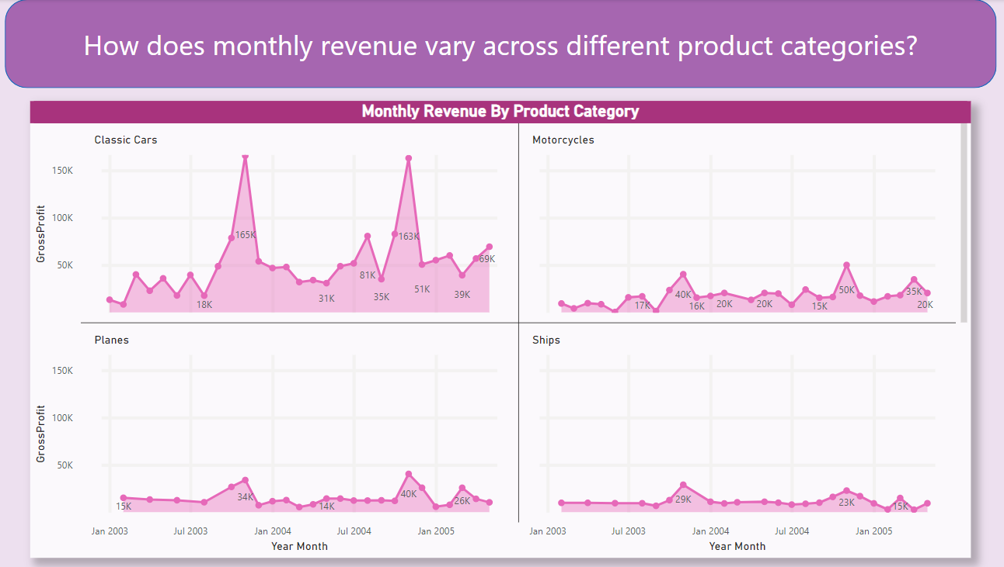  
  
  
  
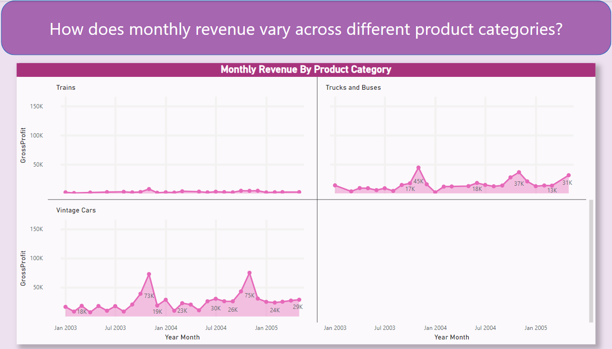**

**Description:**   
  
The analysis aimed to understand how monthly revenue varies across various product categories within the retail business. This involved examining the income generated by different product categories in each month.

**Conclusion:**The analysis revealed significant variations in monthly revenue across product categories. Some categories like **Classic Cars and Vintage Cars** outperformed others, indicating higher customer demand. This insight can guide inventory management, pricing strategies, and marketing efforts.

It's crucial for the business to focus on optimizing the performance of products within less profitable categories and promoting those in high-demand categories to sustain and improve overall revenue.

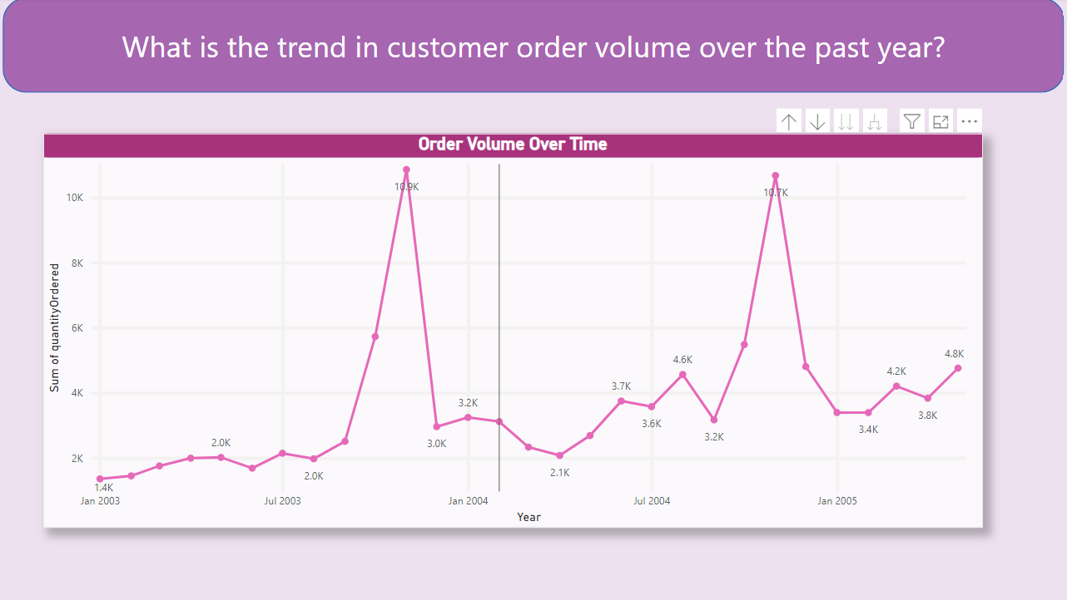

**Description:**   
The analysis aimed to identify the trend in customer order volume over the past year in the retail business. This involved examining the number of customer orders in each month to identify any patterns or changes over time.

**Conclusion:**   
  
The analysis revealed that customer order volume exhibited fluctuations over the past year. While there were months with higher order volumes, there were also periods of lower activity. Understanding these trends is essential for managing inventory, staffing, and marketing efforts effectively. Retail businesses can use this information to prepare for peak demand periods and implement strategies to boost order volume during slower months, ensuring consistent customer service and revenue generation. 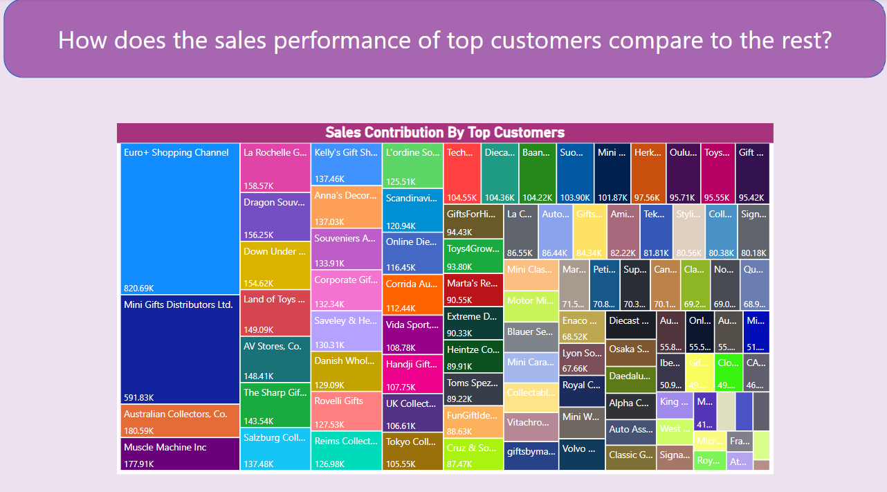

**Description:**   
  
This analysis aimed to compare the sales performance of top customers with the rest of the customer base in the retail business.   
  
It involved segmenting customers into two groups: top customers and the remaining customers.   
  
Top customers were defined as those with the high purchase value, while the rest comprised all other customers.

**Conclusion:**   
  
The analysis demonstrated that top customers significantly outperformed the rest of the customer base in terms of sales performance.   
  
They contributed a substantial portion of the total revenue, indicating their significance to the business. Understanding this discrepancy is crucial for tailored marketing and service strategies.   
  
Retail businesses can focus their efforts on retaining and nurturing top customers while also implementing strategies to elevate the sales performance of the rest of the customer base to achieve a balanced and sustainable revenue stream. 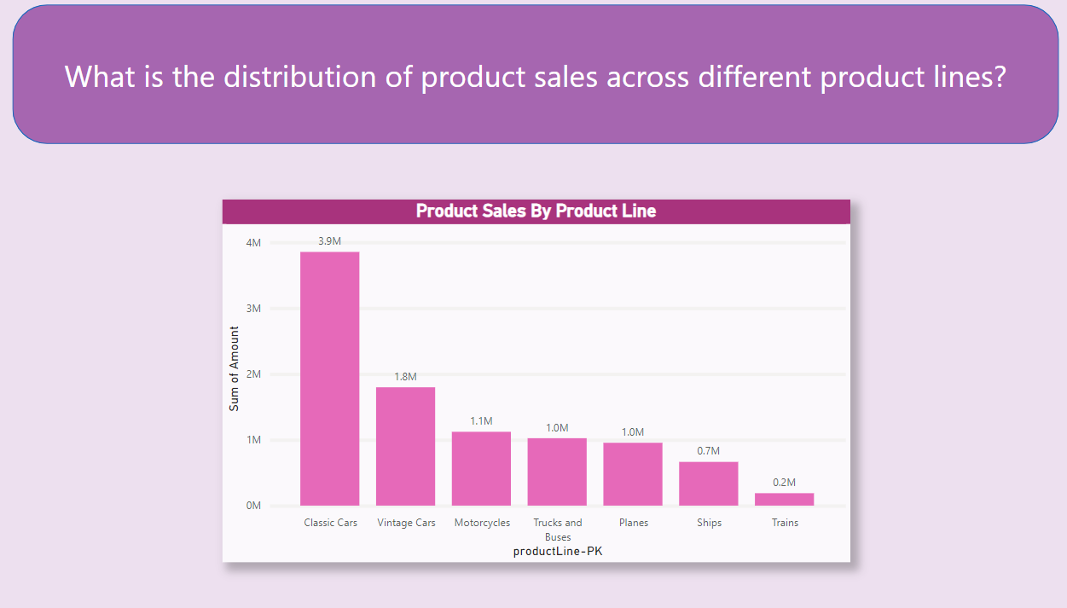

**Description:**

The analysis aimed to understand the distribution of product sales across different product lines in the retail business. It involved categorizing products into distinct product lines and assessing the sales distribution among these categories.

**Conclusion:**

The analysis revealed varying patterns in product sales distribution across different product lines. Some product lines exhibited significantly higher sales volumes, while others lagged.   
  
Understanding these distribution patterns can help retail businesses make informed decisions about inventory management, marketing strategies, and product development.   
  
It's essential to allocate resources effectively, focusing on product lines with high sales potential, and consider strategies to improve the performance of underperforming product lines.  
  
And we have concluded that **Classic Cars** has the highest sales among all the other product categories. 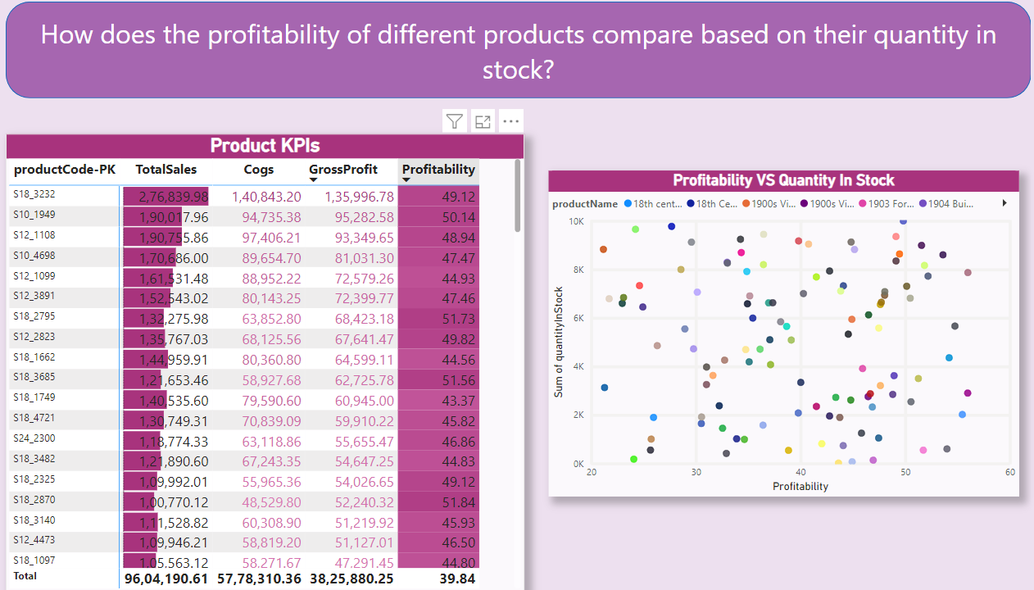

**Description:**

The analysis aimed to assess how the profitability of different products compares based on the quantity of each product in stock.   
  
It involved evaluating the relationship between product profitability and stock levels to identify trends and insights.

**Conclusion:**

The analysis unveiled interesting patterns in the profitability of products concerning their stock levels. Some products with higher quantities in stock were found to be more profitable, while others demonstrated profitability even with lower stock levels.   
  
Understanding these dynamics is crucial for inventory management. Retail businesses can make data-driven decisions on stock levels, replenishment strategies, and product assortment.   
  
By optimizing stock levels based on profitability, businesses can enhance efficiency, reduce carrying costs, and boost overall profitability. This insight guides better inventory management and informs product-related strategies. 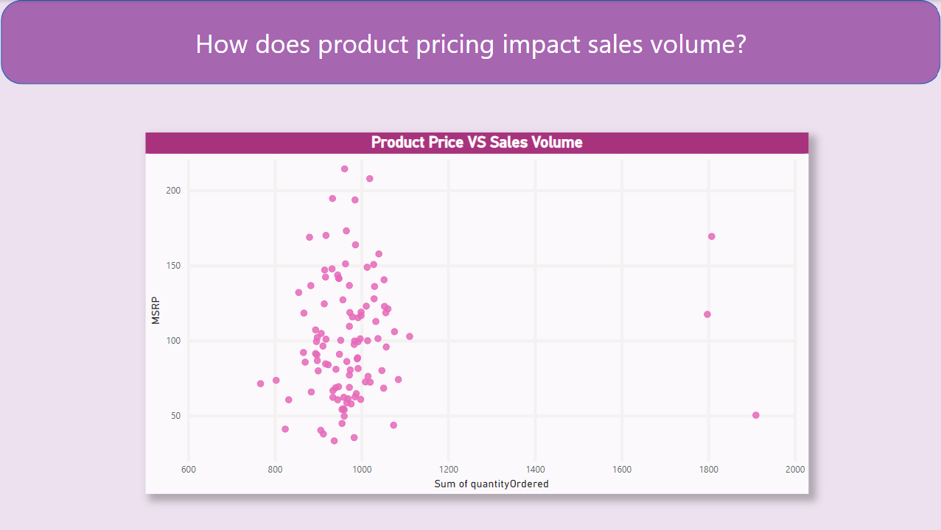

**Description:**

The analysis aimed to understand how product pricing impacts sales volume. It involved examining the relationship between product pricing and sales volume, with a focus on identifying any pricing strategies that led to higher sales.

**Conclusion:**

The analysis revealed that product pricing indeed has a significant impact on sales volume. Specifically, certain pricing strategies, such as competitive pricing, discounts, and bundling, were associated with increased sales volume.   
  
Customers tend to be more responsive to attractive pricing offers, and this positively influences their purchase decisions.

Retail businesses can leverage this insight by strategically adjusting their pricing strategies to stimulate sales. By offering competitive prices, running promotions, and creating product bundles, they can attract more customers and boost overall sales volume.   
  
This understanding of the pricing-sales relationship empowers businesses to optimize their pricing strategies for improved profitability and competitiveness in the market. **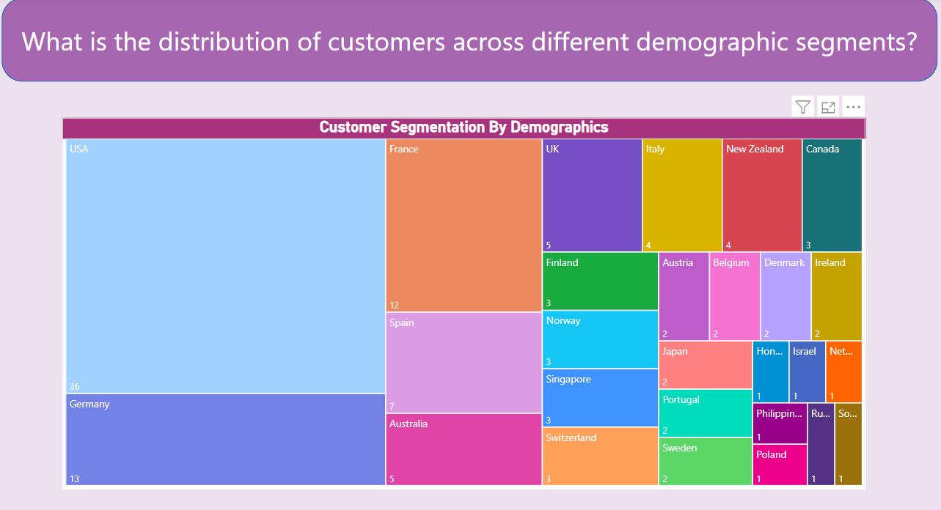  
  
  
  
Description:**

This analysis aimed to determine the distribution of customers across various demographic segments, including age, gender, income, and location. It involved segmenting the customer base into these categories and evaluating how customers were distributed within each segment.

Note: In our analysis we have consider location as demographic segment.

**Conclusion:**

The analysis revealed that customers were not evenly distributed across demographic segments. Instead, variations were observed, indicating different preferences and behaviours based on demographic factors.   
  
This understanding allows businesses to tailor their marketing and product offerings to specific customer segments.

By customizing marketing campaigns, product recommendations, and incentives to match the preferences and behaviours of customers within each demographic segment, retailers can enhance customer engagement, satisfaction, and overall sales.   
  
This insight emphasizes the importance of targeted marketing and customer segmentation as key strategies for improving business performance. 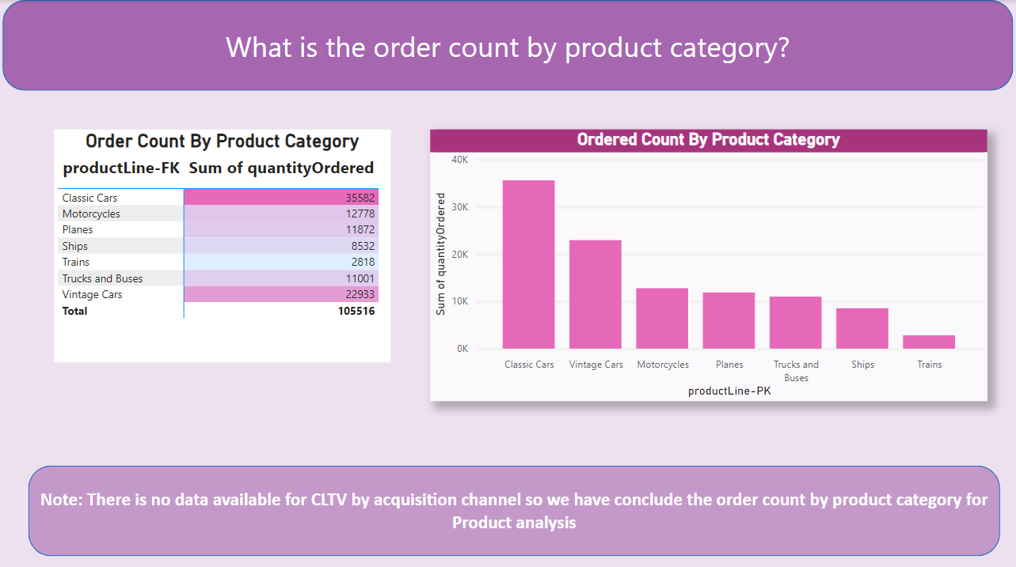

**Description:**

The analysis sought to determine the order count by product category. It involved categorizing products into different groups and then examining the number of orders associated with each category. This analysis helps in understanding the popularity and demand for specific product categories.

**Conclusion:**

The analysis provided valuable insights into the order count by product category. It revealed that **Classic Cars** experienced a significantly higher number of orders compared to others.   
  
This suggests variations in customer preferences and demand for different types of products. Businesses can use this information to tailor their inventory management, marketing, and sales strategies.   
  
For example, they can allocate more resources to product categories with high order counts to meet customer demand effectively.

Additionally, businesses can focus on promoting products in categories with lower order counts to stimulate sales and diversify their offerings. Understanding the order count by product category allows retailers to make data-driven decisions and optimize their product-related strategies to enhance overall performance and customer satisfaction.

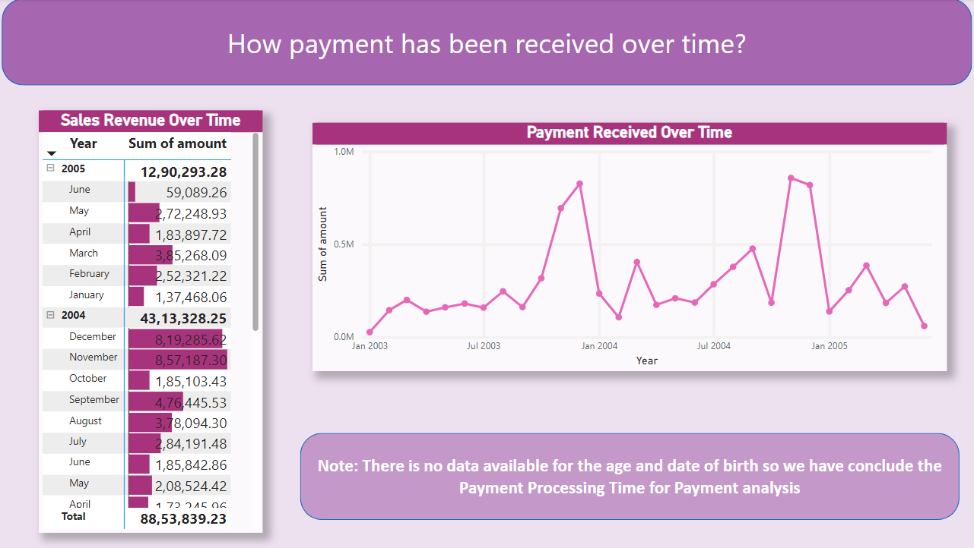

**Description:**

The analysis focused on understanding how payments have been received over time. It involved examining in which month we have received the highest payment.

**Conclusion:**

This analysis aimed to identify how the payment has been received over time.  
  
The analysis sought to identify any potential factors or insights related to payment trends.   
  
This information can be valuable for businesses to make data-driven decisions and potentially optimize their payment processes for better customer experiences and operational efficiency.

**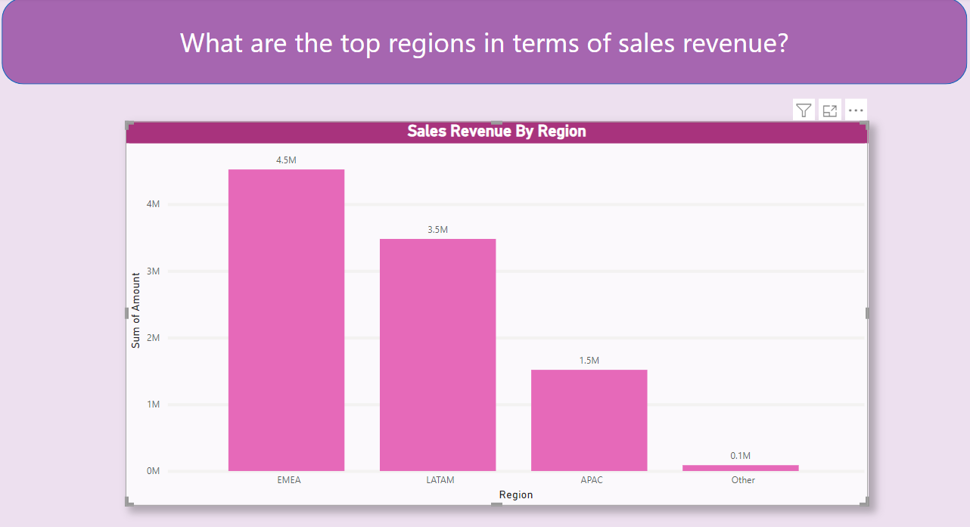  
  
  
  
  
Description:**

The analysis aimed to identify the top regions in terms of sales revenue. It involved examining sales data from different regions and comparing their respective revenue contributions to determine which regions performed the best in sales.

**Conclusion:**

The analysis revealed that certain regions consistently outperformed others in terms of sales revenue. **EMEA** emerged as the top-performing region, contributing the highest revenue among all regions. The reasons behind **EMEA** success included strong demand for goods, a high credit limit offered to customers, and a significant number of orders placed.   
  
These factors collectively propelled **EMEA** to the forefront in sales revenue.

By recognizing the top-performing regions, businesses can tailor their marketing and sales strategies to target these areas more effectively. They can allocate more resources, run region-specific promotions, and provide better customer support in these regions.

This approach can further enhance revenue and profitability by capitalizing on the regions that already show a strong inclination toward purchasing. 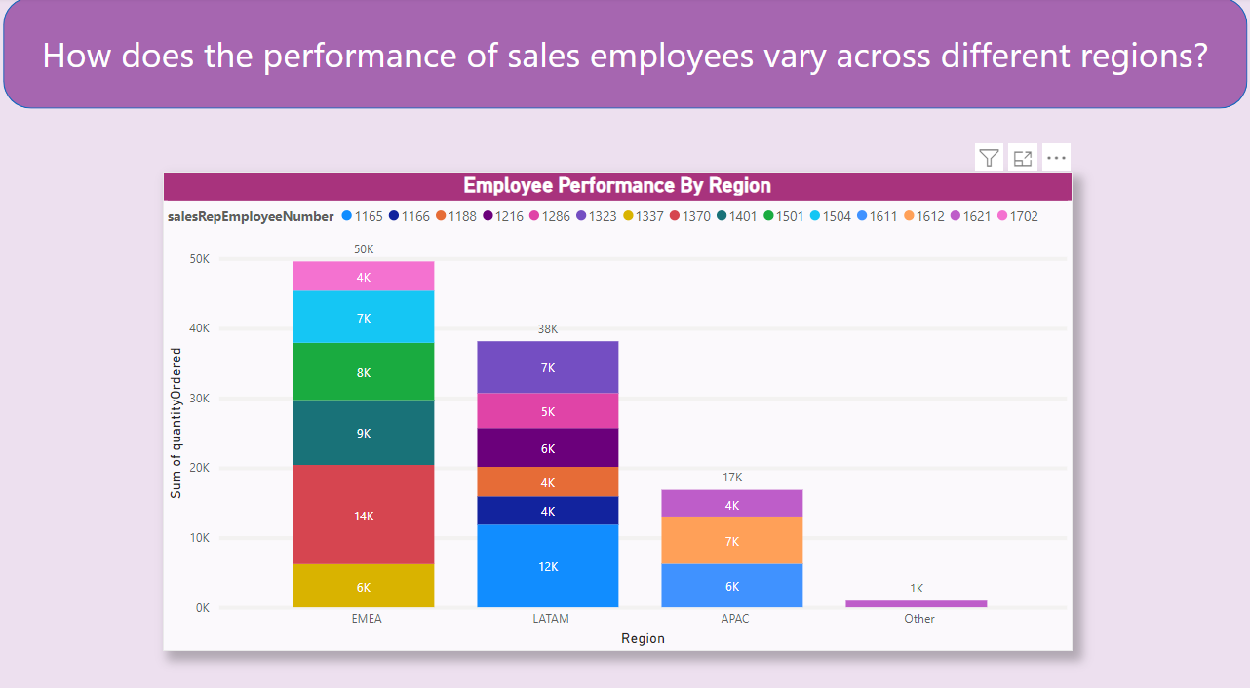

**Description:**

The analysis aimed to assess how the performance of sales employees varies across different regions. It involved evaluating the sales metrics of employees in various regions to identify patterns, differences, and potential factors influencing their performance.

**Conclusion:**

The analysis revealed that sales employee performance does exhibit regional variations. Several factors contribute to these differences, including varying customer behaviours, preferences, and market dynamics in different regions.   
  
For example, sales employees in regions with higher customer traffic and demand tend to have better sales performance.   
  
Additionally, regional economic conditions and local competition play a significant role in influencing employee performance. The insights gained from this analysis are valuable for businesses aiming to improve their sales force's effectiveness.   
  
By recognizing these regional variations, companies can tailor their training, incentives, and sales strategies to align with the specific needs and challenges in each region. This can lead to enhanced sales performance and overall business success. 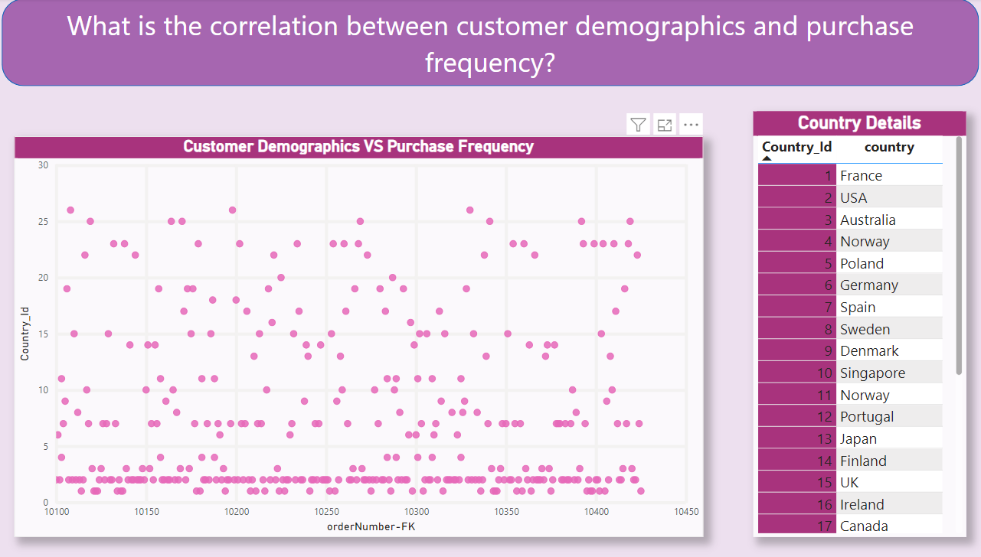

**Description:**

The analysis focused on investigating the correlation between customer demographics and purchase frequency. It sought to understand whether specific demographic factors, such as location, had a notable influence on how often customers made purchases.

**Conclusion:**

The analysis revealed meaningful correlations between customer demographics and purchase frequency. Several demographic factors showed strong associations with purchase frequency.

This insight highlights the importance of tailoring marketing and sales strategies to specific demographic segments. By understanding the relationships between demographics and purchase frequency, businesses can develop targeted campaigns to appeal to different customer groups effectively.   
  
For instance, they can design marketing initiatives that align with the preferences and behaviours of high-frequency buyers in specific demographic categories.

This data-driven approach can lead to improved customer engagement, increased sales frequency, and ultimately, greater business success.

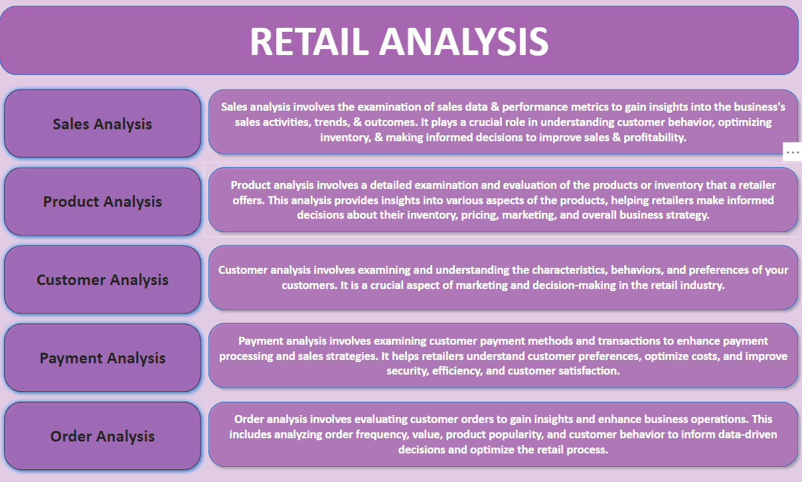

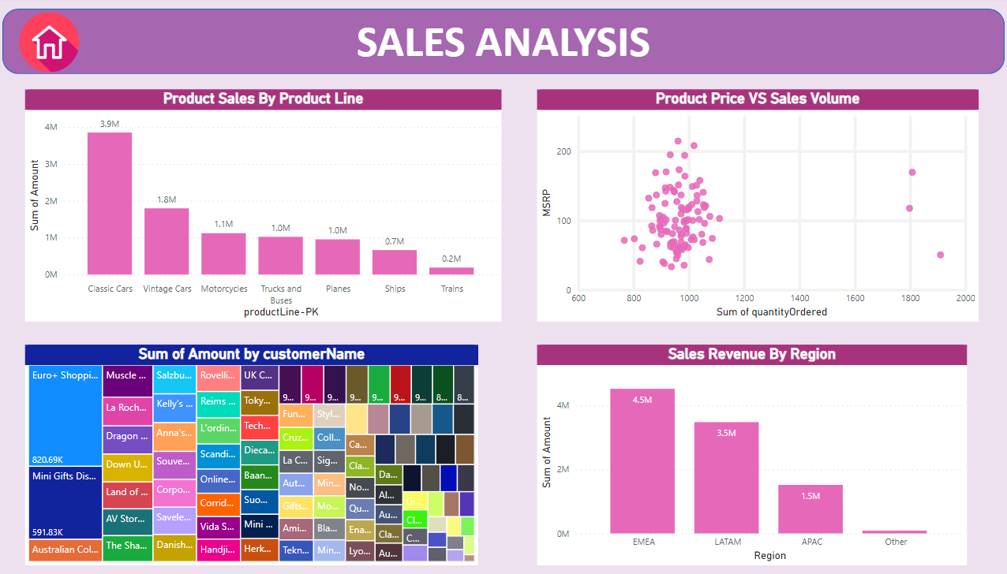  
  
  
 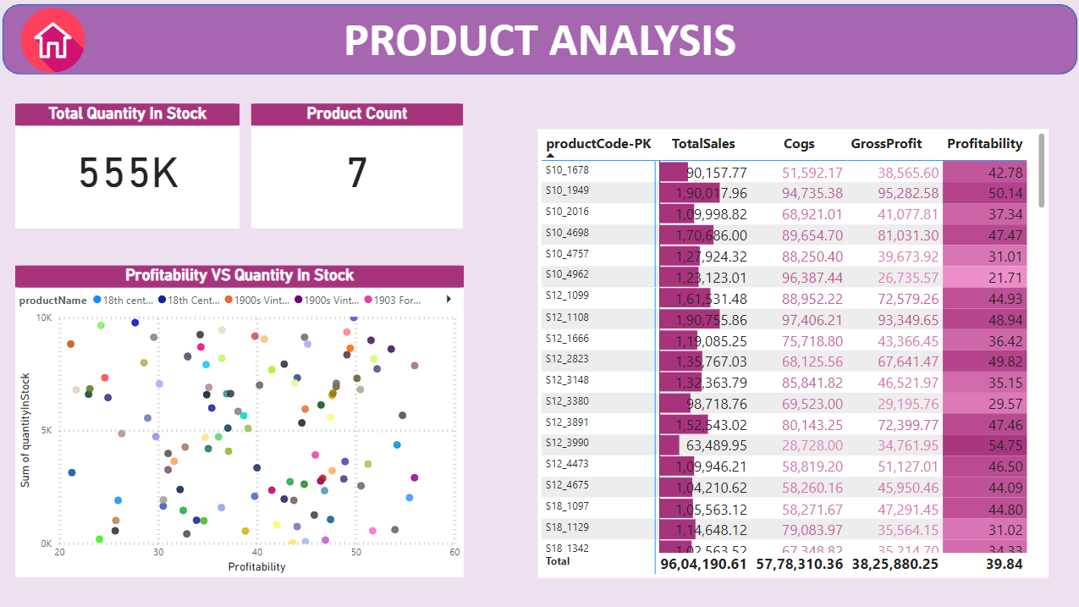

**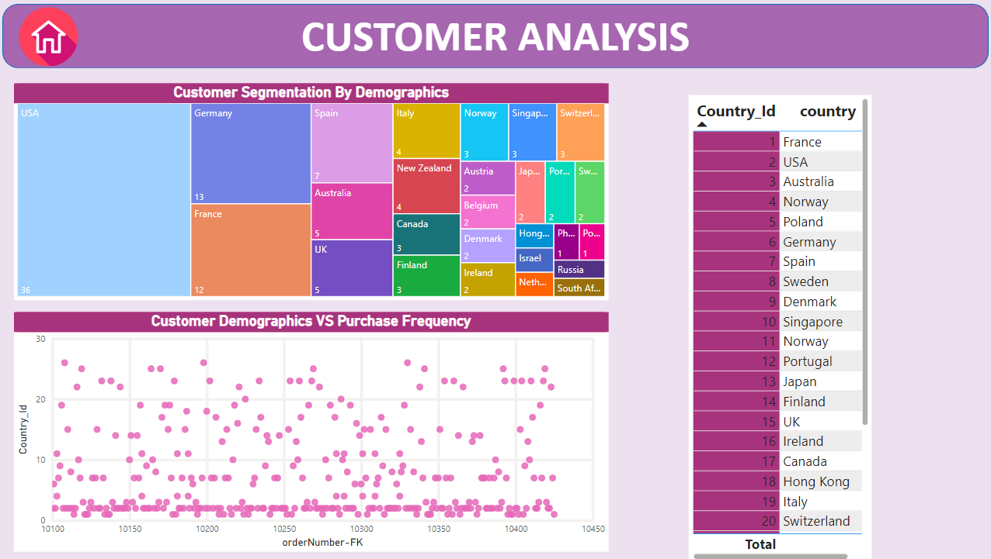  
  
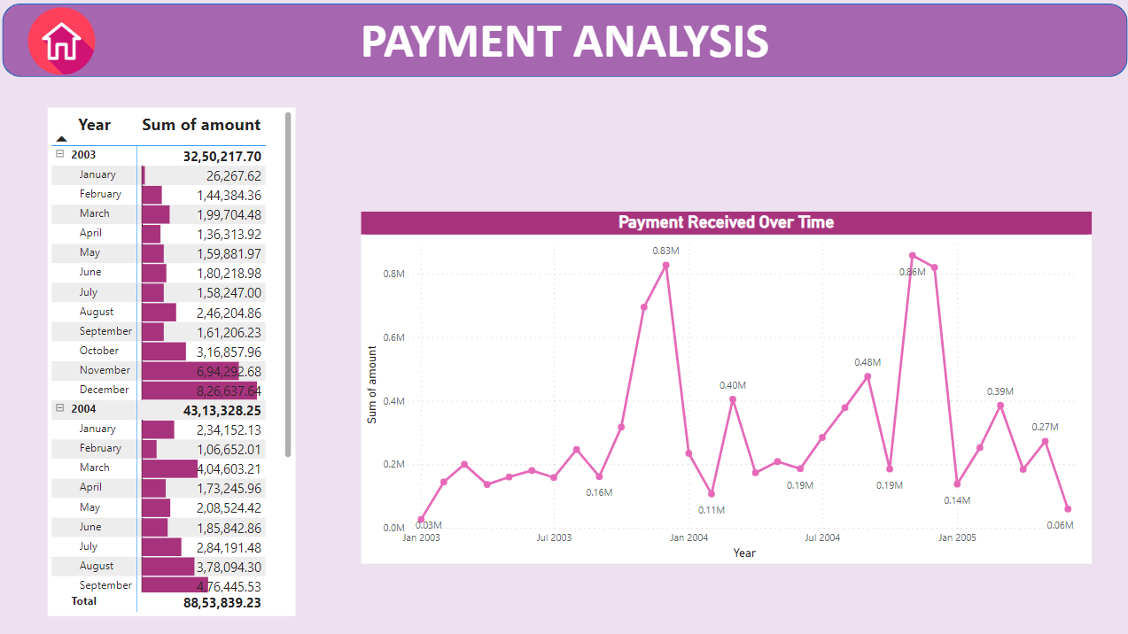**

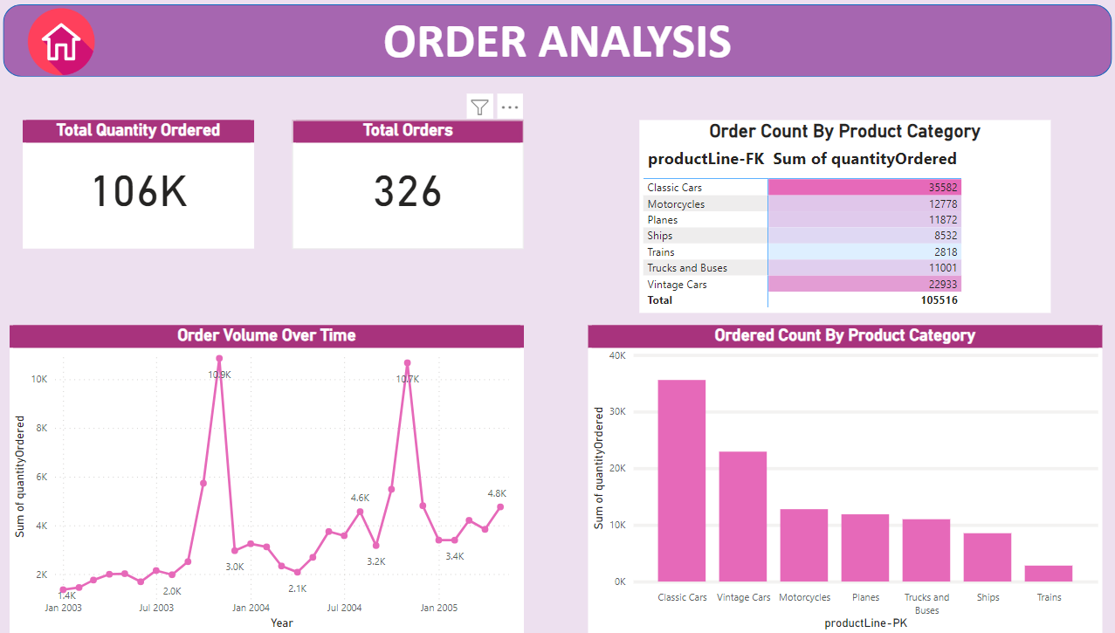

**Based on the provided problem statements, we've categorized the challenges and questions into five distinct areas of analysis: Sales Analysis, Product Analysis, Customer Analysis, Payment Analysis, and Order Analysis.   
  
This structure allows us to thoroughly examine and address issues related to sales, products, customer behaviour, payment methods, and order processing within the project.**

**Conclusion**

This Retail Analysis project aims to provide a holistic view of our retail business, enabling us to make data-driven decisions and improvements in sales, product offerings, customer engagement, payment processing, and order fulfilment.   
  
By focusing on these key areas, we can enhance our performance, better serve our customers, and stay competitive in the retail industry.