**Assignment Report**

**On**

**Design of Operating System (CSE 4049)**

**Submitted by**

**Name : Aman Kumar Singh**

**Reg. No. : 2141019334**

**Branch : CSE**

**Semester : 5th Sem**

**Section : 2141009( CSE-I)**

**Session : 2023-2024**

**Admission Batch : 2021**



**DEPARTMENT OF COMPUTER SCIENCE & ENGINEERING**

**FACULTY OF ENGINEERING & TECHNOLOGY (ITER)**

**SIKSHA ‘O’ ANUSANDHAN DEEMED TO BE UNIVERSITY**

**BHUBANESWAR, ODISHA – 751030**

**CONTENT**

|  |  |  |
| --- | --- | --- |
| **Assignment**  **No.** | **Name of the Assignment** | **Remarks** |
|  |  |  |
|  |  |  |
|  |  |  |
|  |  |  |
|  |  |  |
|  |  |  |
|  |  |  |
|  |  |  |
|  |  |  |
|  |  |  |

**Laboratory Assignment #No. 1**

**On**

**Design of Operating System (CSE 4049)**

**Submitted by**

**Name : Aman Kumar Singh**

**Reg. No. : 2141019334**

**Semester : 5th Sem**

**Branch : CSE**

**Section : 2141009 (CSE-I)**

**Session : 2023-2024**

**Admission Batch : 2021**



**DEPARTMENT OF COMPUTER SCIENCE & ENGINEERING**

**FACULTY OF ENGINEERING & TECHNOLOGY (ITER)**

**SIKSHA ‘O’ ANUSANDHAN DEEMED TO BE UNIVERSITY**

**BHUBANESWAR, ODISHA – 751030**

**Question 1:**

Write the commands to create the following directory hirarchy:

-> DOS_Regdno →DOSass1→dir1

**Solution :**

**Command :**

mkdir DOS_2141019334

cd DOS_2141019334

mkdir DOSass1

cd DOSass1

mkdir dir1

**Output :**

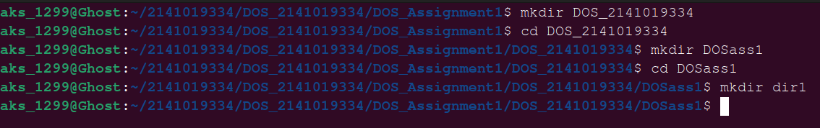

**Question 2:** Write the commands to create another directory with name dir2 in directory DOSass1 and make dir2 as the current working directory.

**Solution :**

**Command :**

mkdir dir2

cd dir2

pwd

**Output :**

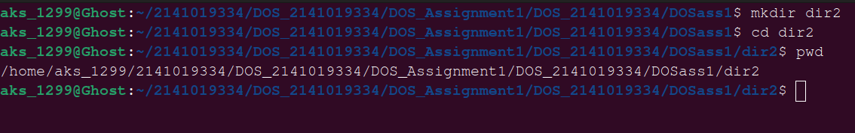

**Question 3:** Write the command to delete the directory dir2 , when DOS_Regdno will be the current working directory.

**Solution :**

**Command :**

cd ..

cd ..

rmdir DOSass1/dir2

cd DOSass1

ls

**Output :**

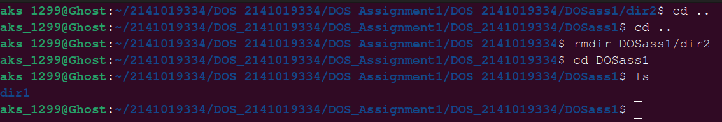

**Question 4:** Write the command to create a file named as file1 using cat command inside dir1. Write your name, regdno, branch, semester and section in file1. Then display the content of the file.

**Solution :**

**Command :**

cd dir1

cat > file1

Name : Aman Kumar Singh

Regd No.: 2141019334

Branch : CSE

Semester : 5th

Section : I

cat file 1

**Output :**

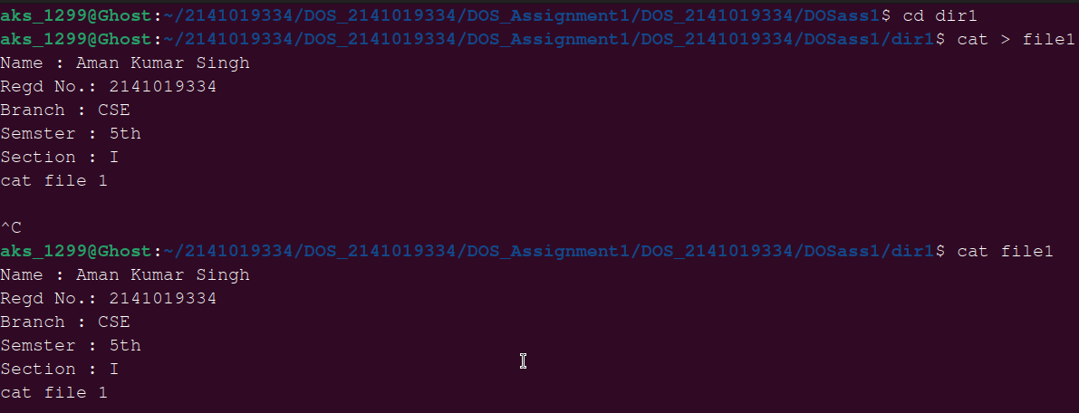

**Question 5:** Write the command to create a file named as file2 using cat command inside dir1. Write your semester wise SGPA in file2.

**Solution :**

**Command :**

cat >file2

SGPA:

7.13

8.13

8.92

8.82

**Output :**

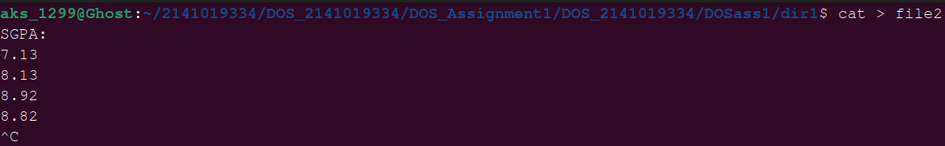

**Question 6:** Create a file named as file3 storing content of file1 merged with content of file2.

**Solution :**

**Command :**

cat > file1 file2 >> file3

cat file3

**Output :**

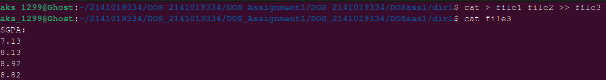

**Question 7:** Write the command to rename file2 as markinfo.

**Solution :**

**Command :**

mv file2 markinfo

ls

**Output :**



**Question 8:** Write the command to copy the content of file1 to reginfo.

**Solution :**

**Command :**

cp file1 reginfo

ls

**Output :**

**Q****uestion 9:** Write the command to display the inode values of file1,markinfo, reginfo.

**Solution :**

**Command :**

ls -I file1

ls

**Output :**



**Question 10:** Write the command to delete file1.

**Solution :**

**Command :**

rm file1

ls

**Output :**



**Question 11:** Write the command to count the number of lines, words, characters in markinfo.

**Solution :**

**Command :**

wc markinfo

**Output :**



**Question 12:** Write the command to create a file named as Personalinfo inside dir1. Write your name, regdno, address in the file.

**Solution :**

**Command :**

cat > personalinfo

Name: Aman Kumar Singh

Redgno:2141019334

Address: JSR

Branch: CSE

JSR

**Output :**



**Question 13:** Write the command to display the content of markinfo in reverse order.

**Solution :**

**Command :**

sort -r markinfo

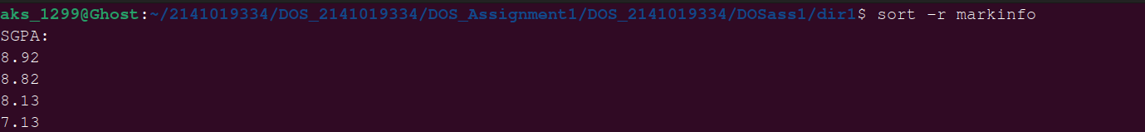**Output :**

**Question 14:** Check the output of the following command:

cmp reginfo personalinfo

diff reginfo personalinfo

**Solution :**

**Command :**

cmp reginfo personalinfo

diff reginfo personalinfo

**Output :**

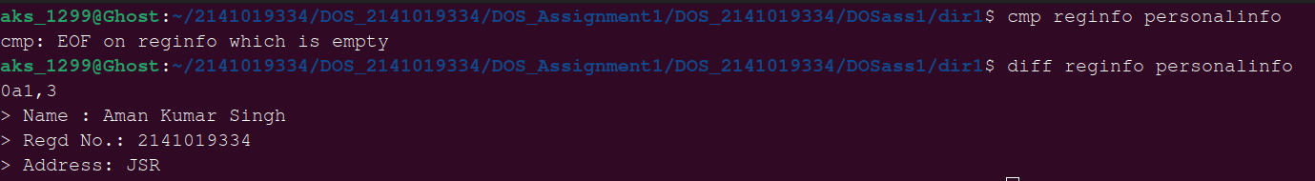

**Question 15:** Write a command to count the number of files in the current working directory and display that number.

**Solution :**

**Command :**

ls | wc -l

**Output :**



**Question 16:** Write a command to include all the file names present in a current working directory in a file named as filelist without causing filelist to be included in the names.

**Solution :**

**Command :**

ls > filelist

cat filelist

ls | grep -v filelist > filelist

cat filelist

**Output :**

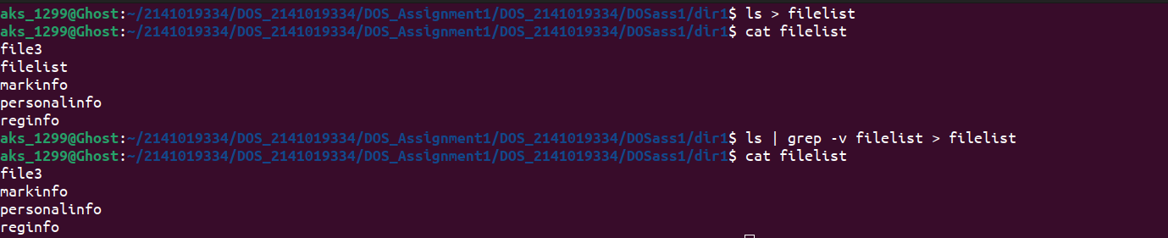

**Question 17:** Write a command to give write permission to all the users of file reginfo.

**Solution :**

**Command :**

chmod a+w reginfo

ls -l reginfo

**Output :**



**Question 18:** Write a command to discard write permission from group users group users of file reginfo.

**Solution :**

**Command :**

chmod g-w reginfo

ls -l reginfo

**Output :**



**Question 19:** Write the command to set rwx permissions for all the users of file reginfo.

**Solution :**

**Command :**

chmod a+rwx reginfo

ls -l reginfo

**Output :**



**Question 20:** Differentiate between following commands:

date; pwd

date; pwd | wc -l

(date; pwd) | wc -l

**Solution :**

**Command :**

date; pwd

date; pwd | wc -l

(date; pwd) | wc -l

**Output :**

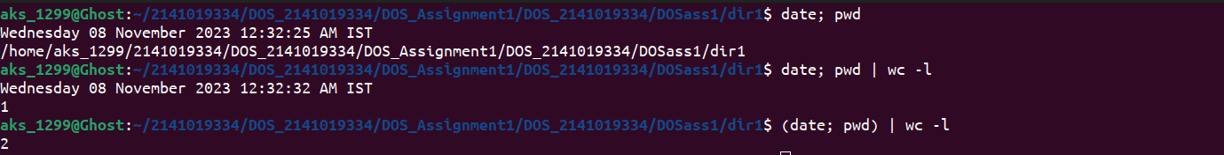

**Question 21: I**nterpret the output of the following commmands:

echo *

echo ***

echo '***'

echo \***

echo \*\*\*

echo */*

echo Don't do this

echo “Don't do this” (Quotes of one kind protect quotes of other kind)

echo Hello # world

echo “ Hello # world”

echo ' Hello # world'

echo date

echo 'date'

echo “date”

echo `date`

**Solution :**

**Command :**

echo *

echo ***

echo '***'

echo \***

echo \*\*\*

echo */*

echo Don't do this

echo “Don't do this” (Quotes of one kind protect quotes of other kind)

echo Hello # world

echo “ Hello # world”

echo ' Hello # world'

echo date

echo 'date'

echo “date”

echo `date`

**Output :**

