**Laboratory Assignment #No. 2**

**On**

**Design of Operating System (CSE 4049)**

**Submitted by**

**Name : Aman Kumar Singh**

**Reg. No. : 2141019334**

**Semester : 5th**

**Branch : CSE**

**Section : 2141009 (CSE-I)**

**Session : 2023-2024**

**Admission Batch : 2021**



**DEPARTMENT OF COMPUTER SCIENCE & ENGINEERING**

**FACULTY OF ENGINEERING & TECHNOLOGY (ITER)**

**SIKSHA ‘O’ ANUSANDHAN DEEMED TO BE UNIVERSITY**

**BHUBANESWAR, ODISHA – 751030**

**Question 1:** Write a shell script named as prog for merge the content of files a.txt, b.txt, and c.txt sort them and save the result in a file called result and display the sorted output on the screen.

(Note: a.txt, b.txt and c.txt file contain some numerical value. Make the script an executable file and run it as a command using its name only.)

**Code :**

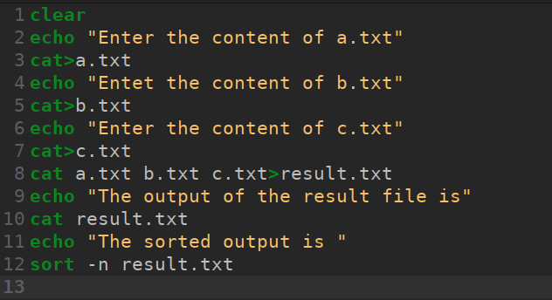**Output :**

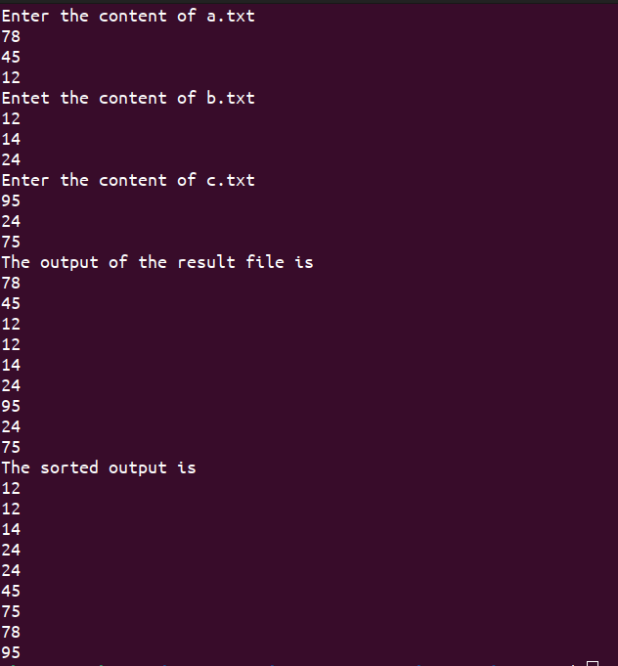

**Question 2:** Write a shell script named as systeminfo that will display the information about the login name of the user, name of the Unix system used by the user, type of the SHELL, Path of current working directory of the user and list of file contain in current working directory. (Make the script an executable file and run it as a command using its name only.)

**Code :**

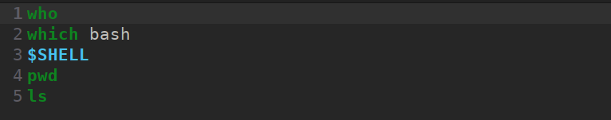

**Output :**



**Question 3:** Write a shell script named as dtcal for displaying both the system date and calendar for specific month, say march 2022, in the given format:-

Date : specific date

Calender : current calendar (Make the script an executable file and run it as a command using its name only.)

**Code :**

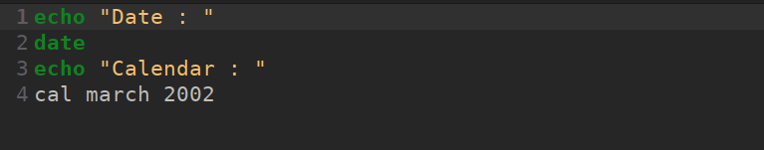**Output :**

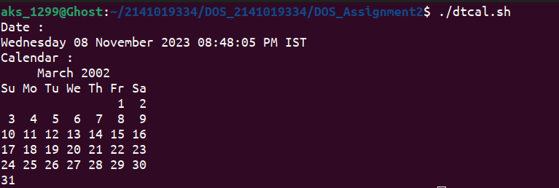

**Question 4:** Write a shell script named as nvwc which will display the filename and linecount, wordcount and char count of the file dtcal in the following format:

Filename: dtcal

Line count: -

Word count: -

Charcout: -

(Make the script an executable file and run it as a command using its name only.)

**Code :**

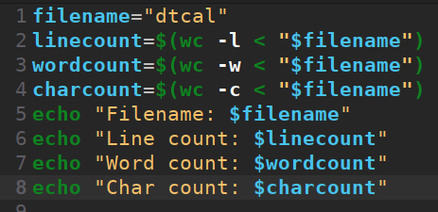

**Output :**

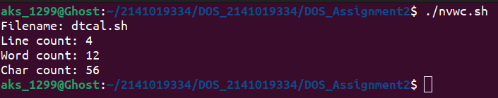

**Question 5:** Write a shell script named as nvwc2 which will display the filename and linecount, word count and char count of any file given as argument to nvwc2 in the following format:

filename linecount wordcount charcount

file1 - - -

(Make the script an executable file and run it as a command using its name only.)

**Code :**

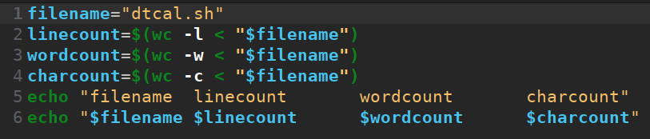

**Output :**

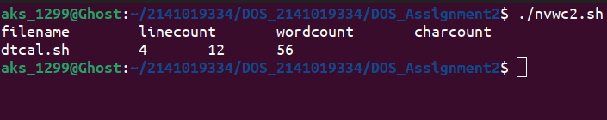

**Question 6:** Write a shell script named as darg to display the total number of command line arguments along with the first two arguments.

-Modify the script to display all the arguments.

(Make the script an executable file and run it as a command using its name only.)

**Code :**

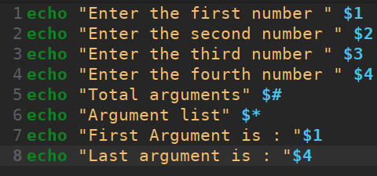

**Output :**

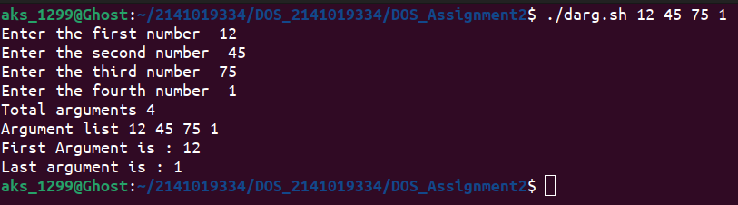

**Question 7:** Write a shell script named as ndisp that will take three command - line arguments specifying the value of n, m and a filename and display the first n number of lines and last m number of lines of the file given as argument.

(Make the script an executable file and run it as a command using its name only.)

**Code :**

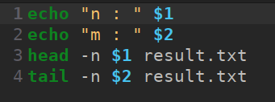

**Output :**

