**Laboratory Assignment #No. 3**

**On**

**Design of Operating System (CSE 4049)**

**Submitted by**

**Name : Aman Kumar Singh**

**Reg. No. : 2141019334**

**Semester : 5th**

**Branch : CSE**

**Section : 2141009 (CSE-I)**

**Session : 2023-2024**

**Admission Batch : 2021**



**DEPARTMENT OF COMPUTER SCIENCE & ENGINEERING**

**FACULTY OF ENGINEERING & TECHNOLOGY (ITER)**

**SIKSHA ‘O’ ANUSANDHAN DEEMED TO BE UNIVERSITY**

**BHUBANESWAR, ODISHA – 751030**

**Question1:** Write a shell script iaop to perform integer arithmetic on two numbers, where the value of the two numbers will be given during runtime.

**Code:**

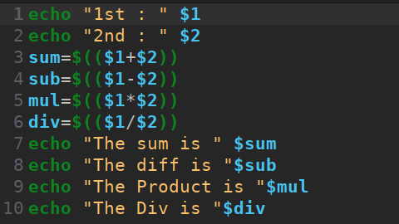

**Output:**

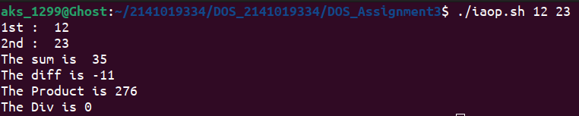

**Question 2:** Write a shell script faop to perform floating point arithmetic on two numbers, where the value of the two numbers will be given during runtime.

**Code:**

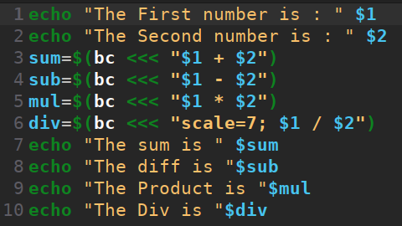

**Output:**

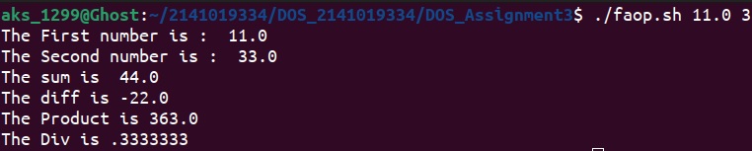

**Question 3:** . Ramesh’s basic salary is input through the keyboard. His dearness allowance is 40% of basic salary, and house rent allowance is 20% of basic salary. Write a program to calculate his gross salary.

**Code:**

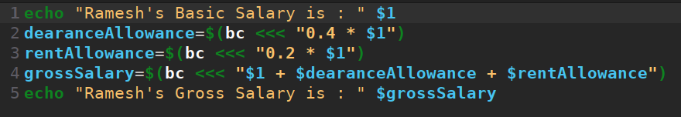**Output:**



**Question 4:**  If a five digit number is input given through the keyboard during runtime, write a program to calculate the sum of its digits.

**Code:**

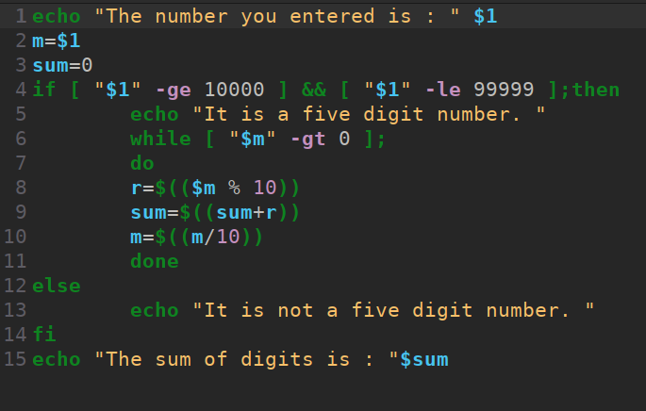

**Output:**

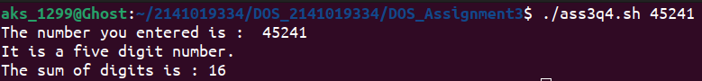**Question 5:** If cost price and selling price of an item is input through the keyboard, write a program to determine whether the seller has made profit or incurred loss. Also determine how much profit was made or loss incurred.

**Code:**

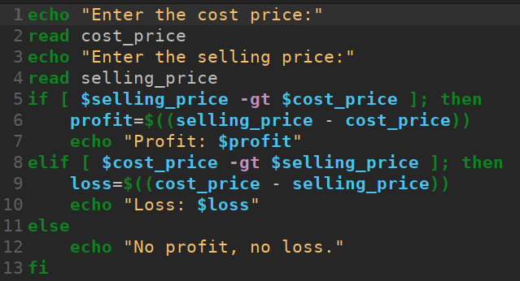**Output:**

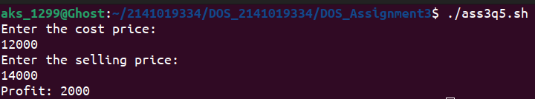

**Question 6:**  Write a shell script which receives any year from the keyboard and determines, whether the year is a leap year or not. If no argument is supplied the current year should be assumed.

**Code:**

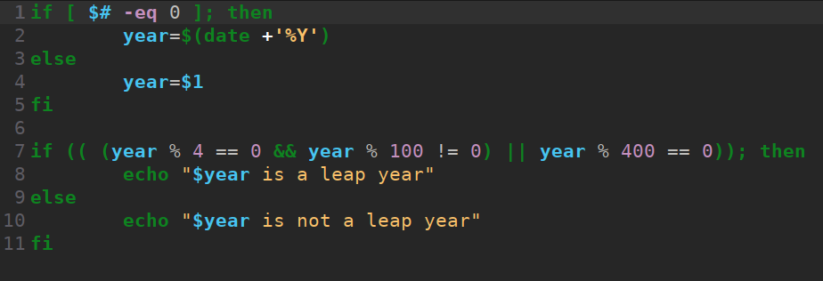**Output:**



**Question 7:**  Write a shell script allow that will display a message to enter internal mark and percentage in attendance, if the entered mark is greater than equal to 20 and entered percentage in attendance is greater that equal to 75 then display the message Allowed for Semester otherwise display the message Not allowed.

**Code:**

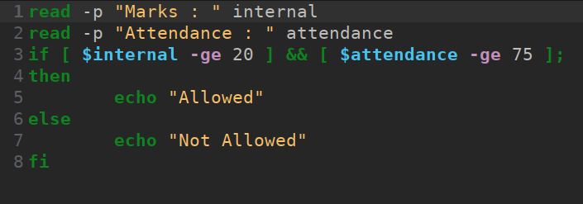**Output:**

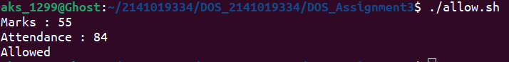

**Question 8:**  Write a shell script small3 that will compare three numbers passed as command linearguments and display the smallest one.

**Code:**

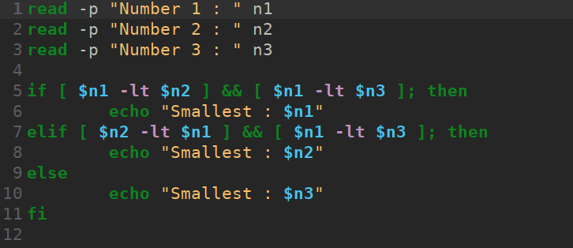**Output:**

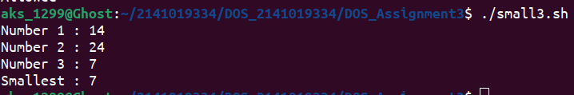**Question 9:**  Write a shell script check_char which will display one message to enter a character and according to the character entered it will display appropriate message from the following options:

a. You entered a lower case alphabet

b. You entered an upper case alphabet.

c. You have entered a digit.

d. You have entered a special symbol.

e. You have entered more than one character.

**Code:**

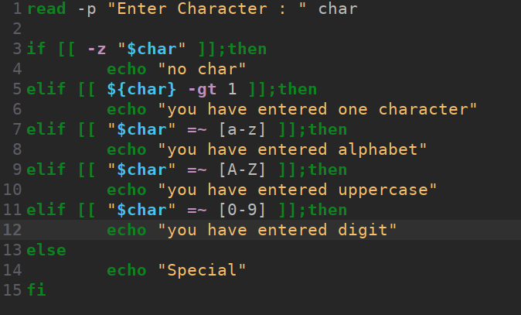**Output:**



**Question 10:**  Write a shell script class_time which will display one message to enter a day and according to the day entered it will display the DOS class time along with the room information or the message “No class on day_name” or “Holiday” for Sunday.

**Code:**

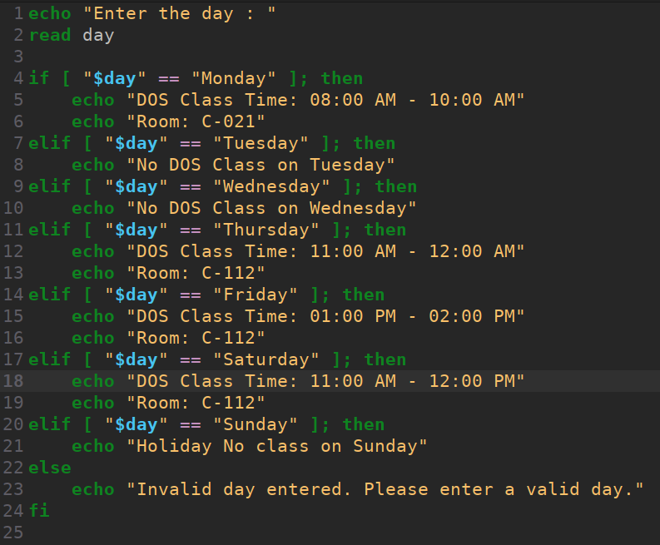**Output:**

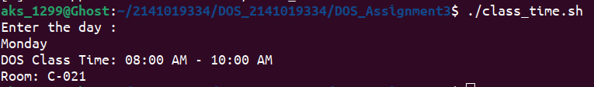**Question 11:**  Write a shell script filechk that will take two file names as command line arguments, and check whether the content of two files are same or not . If contents of two files are same, then it will display the message: Files filename1 and filename2 have same content. then delete the second file and display the message: So filename2 is deleted. Otherwise display the message: Files filename1 and filename2 have different content.

**Code:**

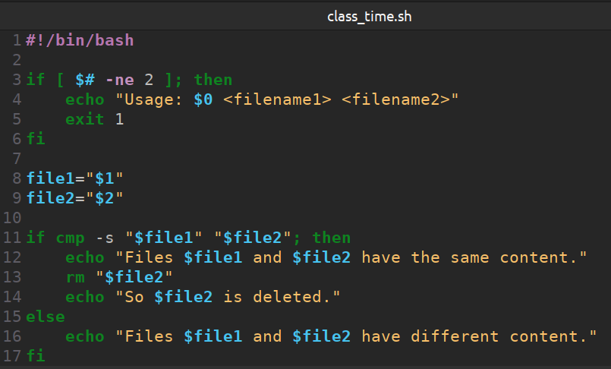**Output:**

**Question 12:**  Write a shell script calculator that will take three command line arguments, where the first argument will specify the first operand, second argument will specify the operator and the third argument will specify the second operand and display the output of the arithmetic operation specified in the following format: op1 operator op2 = result . If the arguments will be passed in any other sequence, it will display the message:

“Invalid input “

Enter input in following format: op1 operator op2

The symbols to be used for different operators are as follows:

Addition: + Subtraction: -

Multiplication: x Division: /

Modulo: % Exponent: ^

**Code:**

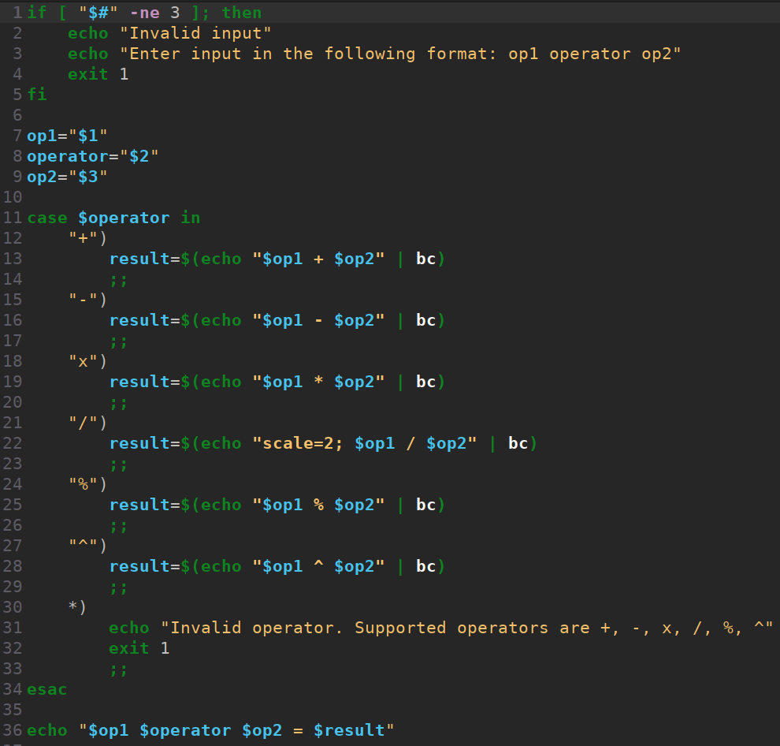

**Output:**

