PROJECT REPORT
On
ADT Dictionary using AVL tree
Submitted in partial fulfilment towards the degree of
BACHELOR OF TECHNOLOGY
in
Computer Engineering
Prepared by
Bhanderi Akshay H. { CE009} & Baldaniya Shubham H. {CE005 }
SUBJECT :- Data Structure & Algorithm.
SEMESTER :- III (3rd)
Guided by MRUDANG MAHETA SIR.

DEPARTMENT OF COMPUTER ENGINEERING.
FACULTY OF TECHNOLOGY
DHARMSINH DESAI UNIVERSITY, NADIAD.
2019-20
TABLE OF CONTENTS
1. | Problem Description
2 | Solution
3. | Design and Algorithm
4. | Source Code
5. | Testing

Problem Description:
Here,we are solving a problem related to ADT Dictionary Data Structure.ADT Dictionary is implemented by AVL tree Data Structure in this solution.ADT means Abstract Data Type. Dictionary (map, association list) is a data structure, which is generally an association of unique keys with some values. One may bind a value to a key, delete a key (and naturally an associated value) and lookup for a value by the key.Hence,it is used to store some value with unique key.In computer science, an AVL tree (named after inventors Adelson-Velsky and Landis) is a self-balancing binary search tree. It was the first such data structure to be invented. It is similar to red–black trees. AVL trees are height-balanced,where max difference of height of child node is 1.
Here,example of unordered dictionary and common functions by which we can access data of tree are given below.
Operation | Dictionary | Output
insertItem(5,A) | {(5,A)}
insertItem(7,B) | {(5,A),(7,B)}
insertItem(2,C) | {(5,A),(7,B),(2,C)}
insertItem(8,D) | {(5,A),(7,B),(2,C),(8,D)}
insertItem(2,E) | {(5,A),(7,B),(2,C),(8,D),(2,E)}
findItem(7) | {(5,A),(7,B),(2,C),(8,D),(2,E)} | B
findItem(4) | {(5,A),(7,B),(2,C),(8,D),(2,E)} | NO_SUCH_KEY
findItem(2) | {(5,A),(7,B),(2,C),(8,D),(2,E)} | C
Size() | {(5,A),(7,B),(2,C),(8,D),(2,E)} | 5
removeItem(5) | {(7,B),(2,C),(8,D),(2,E)} | A

But,we are going to implement ordered ADT dictionary tree.We have used AVL tree to implement the ADT dictionary.
Applications:-
- Bank accounts with SSN as Key
- Students records with UMID or uniqname as key
Solution:
There are many tree data structures by which we can implemnt ADT dictionary but there are problem regarding to balance of tree in Binery Search Tree.Hence we can use AVL tree or Red Black tree to avoid problem of balancing of tree.Here,ADT dictionary is implemented using AVL tree data structure.Also ,there is a problem with time taken to search data.In Binery Search Tree it is O(n) while in AVL tree it is O(log2(n)).Hence,time taken to search a key is less in the case of AVL tree.
There are some methods(functions) which should be implemented in the ADT dictionary using AVL tree implementation.
- put(String key,Integer value):-To insert a key with Integer value.
- get(String key):-To get the Integer value assigned with key.
- search(String key):-To search for a key in ADT dictionary.
- Remove(String key):-To remove the Ineger value having the key.
AVL tree is balanced Binery Search Tree.So,we can search a key as we do in BST but the tree becomes imbalanced.To avoid this problem we have to perfom some extra functionality during insertion and deletion.AVL tree checks the height of the left and the right sub-trees and assures that the difference is not more than 1 and not less than -1. This difference is called the Balance Factor.
To balance itself, an AVL tree may perform the following four kinds of rotations
1. Left rotation (Right-Right Case)
2. Right rotation (Left-Left Case)
3. Left-Right rotation (Left-Right Case)
4. Right-Left rotation (Right-Left Case)
The first two rotations are single rotations and the next two rotations are double rotations.
1. Right Rotation
AVL tree may become imbalanced, if a node is inserted in the left subtree of the left subtree.The tree then needs a right rotation.As depicted, the imbalanced node becomes the right child of its left child by performing a right rotation.
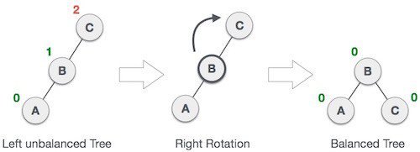
2.Left Rotation
If a tree becomes imbalanced, when a node is inserted into the right subtree of the right subtree, then a single left rotation is performed to balance it. In this example, node A has become imbalanced as a node C is inserted in the right subtree of A's right subtree. The left rotation is performed by making A the left-subtree of B.
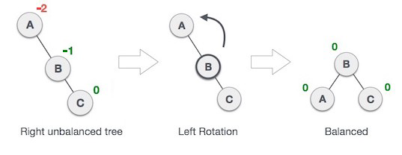

3. Left – Right Rotation
A left-right rotation is a combination of left rotation followed by right rotation.
State | Action
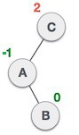 | A node has been inserted into the right subtree of the left subtree. This makes C an imbalanced node. These scenarios cause AVL tree to perform left-right rotation.
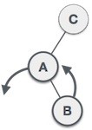 | First perform the left rotation on the left subtree of C. This makes A, the left subtree of B.
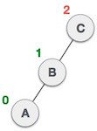 | Node C is still imbalanced; however now, it is because of the leftsubtree  of the left-subtree.
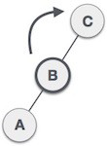 | Now right-rotate the tree, making B the new root node of this subtree. C now becomes the right subtree of its own left subtree.
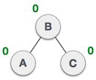 | The tree is now balanced.

4. Right – Left Rotation
A right - left rotation is a combination of right rotation followed by left rotation.
State | Action
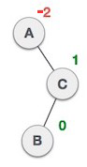 | A node has been inserted into the left subtree of the right subtree. This makes A, an imbalanced node with balance factor -2.
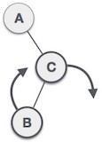 | First, perform the right rotation along C node, making C the right subtree of its own left subtree B.Now, B becomes the right subtree of A.
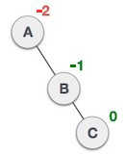 | Node A is still imbalanced because of the right subtree of its right subtree and requires a left rotation.
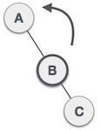 | A left rotation is performed by making B the new root node of the subtree. A becomes the left subtree of its right subtree B.
 | The tree is now balanced.

Design & Algorithm:
Class Diagram:-
Node
public String key
public Integer value
public int height
public Node(String k,Integer v)

ADT_BY_AVL
public ADT_BY_AVL()
public Node findNode(String k)
public Integer get(String k)
public void put(String k,Integer v)
public tri_node_restructure(Node x,Node y,Node z)
public void deleteNode(Node root,String k)
public void printnode(Node x,int h)
void printBST()
public void showR(Node t,int h)
public static int getMaxHeight(Node t1,Node t2)
public static int getDiffOfHeight(Node t1,Node t2)
public static void getHeight(Node x)

Test_ADT_AVL
public static void main(String []args)
int no_of_operation
String ky
Integer vl
Int code

Class Diagram:-
Node:parent,left,right

Node:root
Node:current,previous

Scanner:s
ADT_BY_AVL : x

Implementation Details:-
- public Node findNode(String k) :- This method will return the reference of the node which have key k when it is called.
- public Integer get(String k) :- This method will return the Integer value of the node which have key k when it is called.
- public void put(String k,Integer v) :- This method will insert a node having key k and Integer value v when it is called.
- public tri_node_restructure(Node x,Node y,Node z):- This method will determine relationsship between x,y and z.Then,it will rearrange them to balance the AVL tree.
- Public void remove(String k):-This method will delete the node having key value k when it is called.
- public void printnode(Node x,int h):-This method will print the key and its Integer value of the node which have reference x and height h when it is called.
- void printBST():-This method will print data of the AVL tree in inordered manner when it is called.
- public void showR(Node t,int h):-This method will print the data of AVL tree having Node t as root and h as height in inordered manner when it is called.Hence it is used to print subtree.
- public static int getMaxHeight(Node t1,Node t2):-This method will return the maximum height from node t1 and t2.
- public static int getDiffOfHeight(Node t1,Node t2):-This method will return difference of height of node t1 and t2.
- public static void getHeight(Node x):- This method will return Height of node x when it is called.
Algorithm:
- Tri-node restructuring algorithm:
public void tri_node_restructure(Node x,Node y,Node z)
{

Node a, b, c;
Node T0, T1, T2, T3;

boolean zIsLeftChild = (z == y.left);
boolean yIsLeftChild = (y == x.left);

if (zIsLeftChild && yIsLeftChild)
{
a = z; // x=c
b = y; // / \
c = x; // y=b T3
T0 = a.left; // / \
T1 = a.right; // z=a T2
T2 = b.right; // / \
T3 = c.right; // T0 T1
}
else if (!zIsLeftChild && yIsLeftChild)
{

a = y; // x=c
b = z; // / \
c = x; // y=a T3
T0 = a.left; // / \
T1 = b.left; // T0 z=b
T2 = b.right; // / \
T3 = c.right; // T1 T2
}
else if (zIsLeftChild && !yIsLeftChild)
{
a = x; // x=a
b = z; // / \
c = y; // T0 y=c
T0 = a.left; // / \
T1 = b.left; // z=b T3
T2 = b.right; // / \
T3 = c.right; // T1 T2
}
else
{
a = x; // x=a
b = y; // / \
c = z; // T0 y=b
T0 = a.left; // / \
T1 = b.left; // T1 z=c
T2 = c.left; // / \
T3 = c.right; // T2 T3
}

if ( x == root )
{
root = b; // Need to update root !
b.parent = null;
}
else
{
Node xParent;

xParent = x.parent; // Find x's parent

if ( x == xParent.left )
{
b.parent = xParent;
xParent.left = b;
}
else
{
b.parent = xParent;
xParent.right = b;
}
}

b.left = a;
a.parent = b;
b.right = c;
c.parent = b;

a.left = T0;
if ( T0 != null ) T0.parent = a;
a.right = T1;
if ( T1 != null ) T1.parent = a;

c.left = T2;
if ( T2 != null ) T2.parent= c;
c.right= T3;
if ( T3 != null ) T3.parent= c;

getHeight(a);
getHeight(c);
}

- The insert method for the AVL tree
public void put(String k, Integer v)
{
insert (k,v) using the ordinary BST put(k,v) algorithm;
(I leave the code out for brevity)

getHeight(p);

Node x, y, z;
x = y = z = q; // Start search at q (new node)

while ( x != null ) // Traverse all the way up to the root node....
{
if ( diffHeight(x.left, x.right) <= 1 )
{
z = y; // Go up the tree one level
y = x;
x = x.parent;
}
Else
{
break; // Found the first violation
}
}

if ( x != null )
{
tri_node_restructure( x, y, z ); // Re-balance the AVL tree
}
}

- The deleteNode method for the AVL tree

Node deleteNode(Node root, String k)
if (root == null)
return root;
if (k.compareTo( root.key ) < 0 )
root.left = deleteNode(root.left, k);
else if (k.compareTo( root.key ) > 0 )
root.right = deleteNode(root.right, k);
else
if ((root.left == null) || (root.right == null))
Node temp = null;
if (temp == root.left)
temp = root.right;
else
temp = root.left;

if (temp == null)
temp = root;
root = null;
else
root = temp;
else
Node temp = minValueNode(root.right);

root.key = temp.key;

root.right = deleteNode(root.right, temp.key);

if (root == null)
return root;

root.height = getMaxHeight((root.left),(root.right)) + 1;
int balance = getBalance(root);

if (balance > 1 && getBalance(root.left) >= 0)
return rightRotate(root);

if (balance > 1 && getBalance(root.left) < 0)
root.left = leftRotate(root.left);
return rightRotate(root);

if (balance < -1 && getBalance(root.right) <= 0)
return leftRotate(root);

if (balance < -1 && getBalance(root.right) > 0)
root.right = rightRotate(root.right);
return leftRotate(root);
return root;

- Algorithm for findnode() method:
public Node findNode(k)
while(current!=null)
if(k < key_of_current ) //compare k with key of current
Previous= current;
current =current.left
else if(k > key_of_current ) //compare k with key of current
previous = current;
current = current.right
else
return current
return previous
}
- Algorithm for get() method:
public Integer get(String k)
{
Node p; // Help variable
p = findNode(k);
if ( k.equals( p.key ) )
return p.value;
else
return null;
}
- Algorithm for printnode() method:
public void printnode(Node x, int h)
{
for (int i = 0; i < h; i++)
print(" ");
print("[" + x.key + "," + x.value + "](h=" + x.height + ")");
if ( getDiffOfHeight( x.left, x.right) > 1 )
print("*");
else
print();
}
- Algorithm for showR() method:
public void showR(Node t, int h)
{
if (t == null)
return;
showR(t.right, h+1);
printnode(t, h);
showR(t.left, h+1);
}
- Algorithm for getMaxHeight() method:
public static int getMaxHeight( Node t1, Node t2 )
{
int h1, h2;
if ( t1 == null )
h1 = 0;
else
h1 = t1.height;
if ( t2 == null )
h2 = 0;
else
h2 = t2.height;

return (h1 >= h2) ? h1 : h2 ;
}
- Algorithm for getDiffHeight() method:
public static int getDiffOfHeight( Node t1, Node t2 )
{
int h1, h2;
if ( t1 == null )
h1 = 0;
else
h1 = t1.height;
if ( t2 == null )
h2 = 0;
else
h2 = t2.height;

return ((h1 >= h2) ? (h1-h2) : (h2-h1)) ;
}
- Algorithm for getHeight() method:
public static void getHeight( Node x )
{
while ( x != null )
{
x.height = getMaxHeight( x.left, x.right ) + 1;
x = x.parent;
}
}
Source Code:-
import java.util.*;
/* =================================================================
Node structure

Added: height to determine if the BST is balanced
================================================================= */

class Node
{
public String key;
public Integer value;
public int height;

public Node parent;
public Node left;
public Node right;

public Node(String k, Integer v)
{
key = k;
value = v;

parent = null;
left = null;
right = null;
}
}

/* ================================================================
This is BST with balancing "height" (= AVL)

Each node has a height to determine if the BST is balanced
================================================================ */

class ADT_BY_AVL
{
public Node root; // References the root node of the BST

public ADT_BY_AVL()
{
root = null;
}

/* ================================================================
findNode(k): find node with key k

Return: reference to (k,v) IF k is in BST
reference to parent(k,v) IF k is NOT in BST (for put)
================================================================ */
public Node findNode(String k)
{
Node current; // Help variable
Node previous; // Help variable

/* --------------------------------------------
Find the node with key == "k" in the BST
-------------------------------------------- */
current = root; // Always start at the root node
previous = root; // Remember the previous node for insertion

while ( current != null )
{
if ( k.compareTo( current.key ) < 0 )
{
previous = current; // Remember prev. node
current = current.left; // Continue search in left subtree
}
else if ( k.compareTo( current.key ) > 0 )
{
previous = current; // Remember prev. node
current = current.right; // Continue search in right subtree
}
else
{
// Found key in BST
return current;
}
}

/* ======================================
When we reach here, k is NOT in BST
====================================== */
return previous; // Return the previous (parent) node
}

/* ================================================================
get(k): find key k and return assoc. value
================================================================ */
public Integer get(String k)
{
Node p; // Help variable

/* --------------------------------------------
Find the node with key == "key" in the BST
-------------------------------------------- */
p = findNode(k);

if ( k.equals( p.key ) )
return p.value;
else
return null;
}

/* ================================================================
put(k, v): store the (k,v) pair into the BST

1. if the key "k" is found in the BST, we replace the val
that is associated with the key "k"
1. if the key "k" is NOT found in the BST, we insert
a new node containing (k, v)
================================================================ */
public void put(String k, Integer v)
{
Node p; // Help variable

/* ----------------------------------------------------------
Just like linked list, insert in an EMPTY BST
must be taken care off separately by an if-statement
---------------------------------------------------------- */
if ( root == null )
{ // Insert into an empty BST

root = new Node( k, v );
root.height = 1;
return;
}

/* --------------------------------------------
Find the node with key == "key" in the BST
-------------------------------------------- */
p = findNode(k);

if ( k.equals( p.key ) )
{
p.value = v; // Update value
return;
}

/* --------------------------------------------
Insert a new node (k,v) under p !!!
-------------------------------------------- */
Node q = new Node( k, v );
q.height = 1;

q.parent = p;

if ( k.compareTo( p.key ) < 0 )
p.left = q; // Add q as left child
else
p.right = q; // Add q as right child

/* --------------------------------------------
Recompute the height of all parent nodes...
-------------------------------------------- */
getHeight(p);

/* --------------------------------------------
Check for height violation
-------------------------------------------- */
Node x, y, z;
x = y = z = q; // Start search at q (new node)

while ( x != null )
{
if ( getDiffOfHeight(x.left, x.right) <= 1 )
{
z = y;
y = x;
x = x.parent;
}
else
break;
}

if ( x != null )
{
/* --------------------------------------------
Print tree after insertiom
-------------------------------------------- */
System.out.println("********************************************");
System.out.println("Unbalanced AVL tree after insertion !!!");
System.out.println("********************************************");
System.out.println("Tree before rebalance:\n");
printBST();
System.out.println("-------------------------------------------");

tri_node_restructure( x, y, z );

System.out.println("Tree after rebalance:\n");
printBST();
System.out.println("********************************************");
}
}

/* =======================================================
tri_node_restructure(x, y, z):

x = parent(y)
y = parent(z)
======================================================= */
public void tri_node_restructure( Node x, Node y, Node z)
{
/* *******************************************************************
Determine the parent child relationships between (y,z) and (x,y))
******************************************************************* */
boolean zIsLeftChild = (z == y.left);
boolean yIsLeftChild = (y == x.left);

/* =======================================================
Determine the configuration:

find out which nodes are in positions a, b and c
given in the following legend:

b
/ \
a c
======================================================= */
Node a, b, c;
Node T0, T1, T2, T3;

if (zIsLeftChild && yIsLeftChild)
{ /* Configuration 1 */
System.out.println("Use tri-node restructuring op #1");

a = z; // x=c
b = y; // / \
c = x; // y=b T3
T0 = z.left; // / \
T1 = z.right; // z=a T2
T2 = y.right; // / \
T3 = x.right; // T0 T1
}
else if (!zIsLeftChild && yIsLeftChild)
{ /* Configuration 2 */
System.out.println("Use tri-node restructuring op #2");

a = y; // x=c
b = z; // / \
c = x; // y=a T3
T0 = y.left; // / \
T1 = z.left; // T0 z=b
T2 = z.right; // / \
T3 = x.right; // T1 T2
}
else if (zIsLeftChild && !yIsLeftChild)
{ /* Configuration 4 */
System.out.println("Use tri-node restructuring op #4");

a = x; // x=a
b = z; // / \
c = y; // T0 y=c
T0 = x.left; // / \
T1 = z.left; // z=b T3
T2 = z.right; // / \
T3 = y.right; // T1 T2
}
else
{ /* Configuration 3 */
System.out.println("Use tri-node restructuring op #3");

a = x; // x=a
b = y; // / \
c = z; // T0 y=b
T0 = x.left; // / \
T1 = y.left; // T1 z=c
T2 = z.left; // / \
T3 = z.right; // T2 T3
}

/* ------------------------------------------------------------------
Put b at x's place (make b the root of the new subtree !)
------------------------------------------------------------------ */
if ( x == root )
{ /* If x is the root node, handle the replacement differently.... */

root = b; // b is now root
b.parent = null;
}
else
{
Node xParent;

xParent = x.parent; // Find x's parent

if ( x == xParent.left )
{ /* Link b to the left branch of x's parent */
b.parent = xParent;
xParent.left = b;
}
else
{ /* Link b to the right branch of x's parent */
b.parent = xParent;
xParent.right = b;
}
}

/* ------------------
Make: b
/ \
a c
------------------ */
b.left = a;
a.parent = b;
b.right = c;
c.parent = b;

/* ------------------
Make: b
/ \
a c
/ \
T0 T1
------------------ */
a.left = T0;
if ( T0 != null )
T0.parent = a;
a.right = T1;
if ( T1 != null )
T1.parent = a;

/* ------------------
Make: b
/ \
a c
/ \
T2 T3
------------------ */
c.left = T2;
if ( T2 != null )
T2.parent= c;
c.right= T3;
if ( T3 != null )
T3.parent= c;

getHeight(a);
getHeight(c);
}

/* =======================================================
remove(k): delete node containg key k
======================================================= */
Node deleteNode(Node root, String k)
{
// STEP 1: PERFORM STANDARD BST DELETE
if (root == null)
return root;

// If the key to be deleted is smaller than
// the root's key, then it lies in left subtree
if (k.compareTo( root.key ) < 0 )
root.left = deleteNode(root.left, k);

// If the key to be deleted is greater than the
// root's key, then it lies in right subtree
else if (k.compareTo( root.key ) > 0 )
root.right = deleteNode(root.right, k);
// if key is same as root's key, then this is the node
// to be deleted
else
{

// node with only one child or no child
if ((root.left == null) || (root.right == null))
{
Node temp = null;
if (temp == root.left)
temp = root.right;
else
temp = root.left;

// No child case
if (temp == null)
{
temp = root;
root = null;
}
else // One child case
root = temp; // Copy the contents of
// the non-empty child
}
else
{

// node with two children: Get the inorder
// successor (smallest in the right subtree)
Node temp = minValueNode(root.right);

// Copy the inorder successor's data to this node
root.key = temp.key;

// Delete the inorder successor
root.right = deleteNode(root.right, temp.key);
}
}

// If the tree had only one node then return
if (root == null)
return root;

// STEP 2: UPDATE HEIGHT OF THE CURRENT NODE
root.height = getMaxHeight((root.left),(root.right)) + 1;

// STEP 3: GET THE BALANCE FACTOR OF THIS NODE (to check whether
// this node became unbalanced)
int balance = getBalance(root);

// If this node becomes unbalanced, then there are 4 cases
// Left Left Case
if (balance > 1 && getBalance(root.left) >= 0)
return rightRotate(root);

// Left Right Case
if (balance > 1 && getBalance(root.left) < 0)
{
root.left = leftRotate(root.left);
return rightRotate(root);
}

// Right Right Case
if (balance < -1 && getBalance(root.right) <= 0)
return leftRotate(root);

// Right Left Case
if (balance < -1 && getBalance(root.right) > 0)
{
root.right = rightRotate(root.right);
return leftRotate(root);
}
return root;
}

int getBalance(Node N)
{
int h1, h2;
Node t1=N.left;
Node t2=N.right;
if ( t1 == null )
h1 = 0;
else
h1 = t1.height;

if ( t2 == null )
h2 = 0;
else
h2 = t2.height;
return (h1-h2);
}

/* =======================================================
Show what the BST look like....
======================================================= */
public void printnode(Node x, int h)
{
for (int i = 0; i < h; i++)
System.out.print(" ");

System.out.print("[" + x.key + "," + x.value + "](h=" + x.height + ")");

if ( getDiffOfHeight( x.left, x.right) > 1 )
System.out.println("*");
else
System.out.println();
}

void printBST()
{
showR( root, 0 );
System.out.println("================================");
}

public void showR(Node t, int h)
{
if (t == null)
return;

showR(t.right, h+1);
printnode(t, h);
showR(t.left, h+1);
}

/* ================================================================
getMaxHeight(t1,t2): compute max height of 2 (sub)trees
================================================================ */
public static int getMaxHeight( Node t1, Node t2 )
{
int h1, h2;

if ( t1 == null )
h1 = 0;
else
h1 = t1.height;

if ( t2 == null )
h2 = 0;
else
h2 = t2.height;

return (h1 >= h2) ? h1 : h2 ;
}
Node minValueNode(Node node)
{
Node current = node;

/* loop down to find the leftmost leaf */
while (current.left != null)
current = current.left;

return current;
}

/* ================================================================
getDiffOfHeight(t1,t2): compute difference in height of 2 (sub)trees
================================================================ */
public static int getDiffOfHeight( Node t1, Node t2 )
{
int h1, h2;

if ( t1 == null )
h1 = 0;
else
h1 = t1.height;

if ( t2 == null )
h2 = 0;
else
h2 = t2.height;

return ((h1 >= h2) ? (h1-h2) : (h2-h1)) ;
}
// A utility function to right rotate subtree rooted with y
// See the diagram given above.
Node rightRotate(Node y)
{
Node x = y.left;
Node T2 = x.right;

// Perform rotation
x.right = y;
y.left = T2;

// Update heights
y.height = getMaxHeight((y.left),(y.right)) + 1;
x.height = getMaxHeight((x.left),(x.right)) + 1;

// Return new root
return x;
}

// A utility function to left rotate subtree rooted with x
// See the diagram given above.
Node leftRotate(Node x)
{
Node y = x.right;
Node T2 = y.left;

// Perform rotation
y.left = x;
x.right = T2;

// Update heights
x.height = getMaxHeight((x.left),(x.right)) + 1;
y.height = getMaxHeight((y.left),(y.right)) + 1;

// Return new root
return y;
}

/* ================================================================
getHeight(x): recompute height starting at x (and up)
================================================================ */
public static void getHeight( Node x )
{
while ( x != null )
{
x.height = getMaxHeight( x.left, x.right ) + 1;
x = x.parent;
}
}
}

public class Test_ADT_AVL
{
public static void main(String[] args)
{
Scanner s = new Scanner(System.in);

ADT_BY_AVL x = new ADT_BY_AVL();

System.out.println("How many operation you want to perform");
int no_of_operation=s.nextInt();
String ky;
Integer vl;

System.out.println();
System.out.println("Enter code as below:");
System.out.println("1 :- insertion");
System.out.println("2 :- deletion");
System.out.println("3 :- search");
System.out.println();

for(int i=0;i<no_of_operation;i++)
{
System.out.println("Enter code:");
int code =s.nextInt();
switch (code)
{
case 1:
System.out.println("Insert the KEY");
ky=s.next();
System.out.println("Insert the value");
vl=s.nextInt();
x.put(ky,vl);
break;
case 2:
System.out.println("Insert the KEY");
ky=s.next();
x.root = x.deleteNode(x.root, ky);
break;
case 3:
System.out.println("Insert the KEY");
ky=s.next();
vl=x.get(ky);
System.out.println("Key = " + ky + " ==> value: " + vl);
break;
default:
System.out.println("Invalid sequence of input");
}
x.printBST();
System.out.println();
System.out.println();
}
}
}

Testing:
Input & Output:
Inserting [akshay,9]
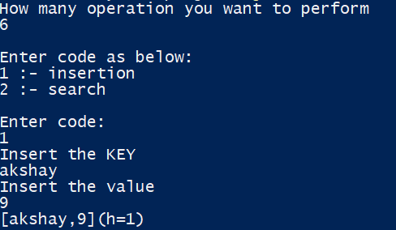

Inserting [bhanderi,99]
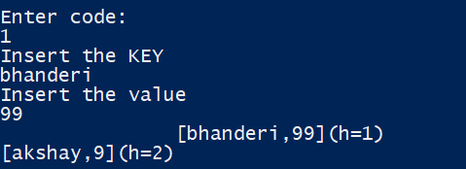
Inserting [shubham,5]
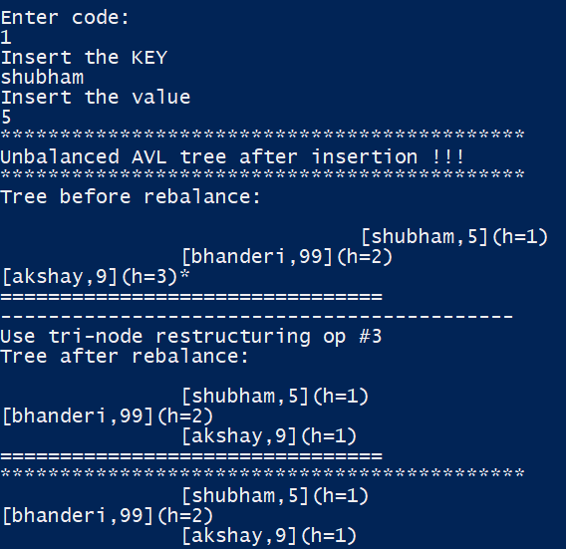

Inserting [baldaniya,55]
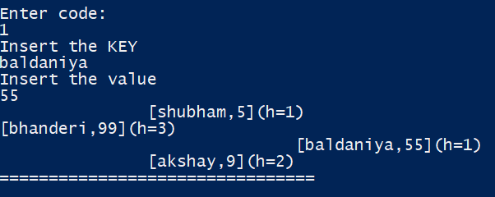
Searching [akshay]
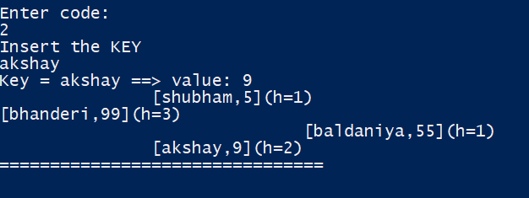
Inseting [jay,8]
