# Introduction {#introduction .unnumbered .unnumbered}

## Review of previous results of Straw Thermal Properties {#review-of-previous-results-of-straw-thermal-properties .unnumbered .unnumbered}

Thermal conductivity for insulations used as construction material for buildings indicates the capability of the material to prevent heat from entering/leaving the indoor space which in turn affects the thermal comfort conditions inside. There exists several methods for evaluation of thermal conductivity for different types of materials which shall be briefly touched upon later. For the case of straw, which can be considered as a fibrous porous material in bulk quantities, an effective thermal conductivity can be measured through these methods. Straw being organic and hygroscopic in nature, its effective thermal conductivity is influenced by an array of factors including type of crop, local climatic conditions, composition, bulk density, moisture content, etc.

Lebed and Augaitis (2017) measured the thermal conductivity of triticale straw samples with varying densities in the range of 80 kg/m and 190 kg/m. Guarded hot plate apparatus was used to measure the thermal conductivity and the tests were conducted at a mean sample temperature of 10 C and ambient conditions of 232 C; 505 % RH. Based on the experimental data, they had arrived at an equation relating thermal conductivity of straw and its density as shown below:

where, is the density of straw infill. The researchers observed an increasing trend in thermal conductivity values when density in increased beyond 120 kg/m.

Costes et al. (2017) begin with a good review of previous measurements of thermal conductivity of straw including its variation with density and orientation. They argue that samples prepared from straw bales may not be representative of the actual material due to changes in orientation and density introduced during the sample preparation process and consequently influencing its thermal conductivity value. Therefore, the authors have designed and developed a Guarded hot plate apparatus capable of measuring thermal conductivity of samples of up to 50 cm thick. The authors prepared 13 straw bale samples of wide varying densities (68.1 kg- 122.7 kg/m) but small variations in thickness (0.3 m - 0.495 m) and measurements were carried out on each sample five times . Regression of the measurement data resulted in the following correlation:

where d is the density in kg/m and t is the thickness in m.

F. D' Alessandro et al. (2017) also used guarded hot plate apparatus to measure the thermal conductivity of straw samples of density 80 kg/m. Two tests conducted resulted in thermal conductivity values of 0.051 W/mK and 0.053 W/mK. The author notes that the straw bales were in flat position meaning the heat flow perpendicular to the straw fiber orientation.

Douzane et al. (2016) reported thermal conductivity values of straw of density 80 kg/m considering different orientations. Guarded hot plate techniques was used to to conduct the measurement. At 10°C and dry conidions, thermal conductivity values of 0.0723 0.0014 W/mK was reported for parallel orientation while 0.0510 0.0010 W/mK was reported for perpendicular orientation. Also measurements performed at various sample mean temperatures revealed a direct linear relation between thermal conductivity and sample mean temperature.

Conti et al. (2016) attempted in building a low-cost system with established standards acting as guidelines to measure thermal conductivity of straw bale with reasonable accuracy. Local agricultural practices and climatic conditions leading to wide variations in the thermal behaviour of straw bale is put forward as the reason behind devising such a system. Thermal conductivities of two straw bale samples of approximate densities of 65 and 85 kg/m were measured to be 0.062 W/mK and 0.070 W/mK respectively.

Walker et al. (2016) reviewed the previous works in which thermal conductivity of straw had been measured. It included measurement of thermal conductivity of 120 kg/m dense straw bale by Shea et al. (2013) who had reported a value of 0.064 W/mK. With regards to orientation of straw sample, the authors cited the results published by the German national organisation of straw bale building (FASBA, 2009) which were equal to 0.067 W/mK for straw oriented parallel to heat flow and 0.043 W/mK for straw oriented perpendicular to heat flow. Further, considering straw moisture content as a parameter, the authors reported the work carried out by a French company CEBTP in 2004 in which a modest increase from 0.064 to 0.072 W/mK was observed when straw relative humidity was increased from 0% to 90%.

Samuel et al. (2015) used a previously designed guarded hot plate apparatus by Dubois and Lebeau (2013) to measure their own sample of straw. They specify a bulk density range of 80-120 kg/m noting that it is impossible to give an exact value of density of the sample under test. The thermal conductivity of dry sample with fibers oriented parallel to heat flow was found to be 0.0682 W/mK at 20C.

Wei et al. (2015) proposed high frequency hot pressing technique instead of the traditional platen-pressing process for fabrication of straw based insulation boards. They went on to study the properties of the straw board manufactured by this technique along with factors affecting the properties. It is worth noting a fundamental difference in the structure of such boards; they are composed of straw particles while conventional straw bales are an aggregate of straw fibers. Also, the straw boards have a higher density range (180 - 360 kg/m). Steady state measurement of thermal conductivity of such a straw board with dimensions 300 mm 300 mm 40 mm was conducted at a mean temperature of 20C. Over a small range of straw particle moisture content - 10% to 18% - only a slight change in thermal conductivity - 0.051 W/mK to 0.053 W/mK correspondingly - was observed. A linear increase in thermal conductivity was reported with increase in the board density. Moreover, the straw boards exhibited increased thermal conductivity when particle size in decreased as well as in conditions of increased ambient temperatures.

Robinson (2014) cited a previous work, Grmela et al. 2010 which could not be accessed for the current review, while reporting a thermal conductivity range from 0.038 W/mK to 0.1 W/mK.

Lee and Yeom (2014) reported a thermal conductivity value of 0.092 W/mK for straw of density, 207.5 kg/m. It is most probably a case a mistaken use of units for density in this paper. For example, in the case of straw, it is mentioned to be having a density of 207.5 g/m which is unlikely.

Thermal conductivity measurement of eight straw bale specimens conducted by Langmans et al. (2014) resulted in values of 0.0589 W/mK for the case of straw fibers perpendicular to heat flow and 0.0667 W/mK for the case of straw fibers parallel to heat flow. All specimens have a density of 88 kg/m.

Shea et al. (2012) put forward a building system utilizing prefabricated timber-framed straw based panels. After a good review of previously reported thermal conductivity values, the authors then tested for the thermal conductivity of their own samples in a heat flow meter. Six wheat straw samples with randomly oriented fibers and densities ranging from 67 kg/m to 112 kg/m were prepared and placed in a controlled in a controlled space of 23C and 50% RH. At mean sample temperature of 10, only a modest rise from 0.0594 W/mK to 0.0636 W/mK in thermal conductivity over the corresponding density range was observed. Further, they reported a 15% increase in thermal conductivity when mean sample temperature was increased from 10C to 30C.

Vėjelienė (2012) studied the effect of structural variation on thermal conductivity of straw, which includes orientation: vertical or horizontal and mode of processing of straw: chopped straw, prepared from rotary milling and defibered straw. Further, the work involved use of additives to straw sample such as graphite particles for improving infrared radiation absorption and flax oil for better binding. The measurement of thermal conductivity was carried out in a guarded hot plate apparatus at a mean sample temperature of 10C and under constant ambient conditions of 232C and 505 % RH. Over a density range between 50 kg/m and 120 kg/m, the author developed correlations for each of the structurally varying straw samples. It was observed that the horizontal oriented straw showed greater variation with density compared to the remaining samples types. The magnitudes of thermal conductivity for the different samples were found to be in the following order: Defibered straw < Chopped straw < Horizontal oriented straw < Vertical oriented straw

Ashour et al. (2010), citing his thesis, presented thermal conductivity values ranging from 0.0414 W/mK to 0.0486 W/mK for Wheat straw and the same ranging from 0.0353 W/mK to 0.0539 W/mK for Barley straw over different temperatures. The author noted a greater increase in thermal conductivity when temperature was raised from 20.7C to 34.2C than when temperature was raised from 10.3C to 20.7C.

In referring to previous works, Pruteanu (2010) listed the thermal conductivity results of by McCabe in 1993 and Eisenberg of Oak Ridge National Laboratory (ORNL) in 1998. The former had reported values ranging from 0.0481 W/mK to 0.0578 W/mK for straw bales of density 133 kg/m while the latter had reported thermal resistance ranging from 6.5175 W/mK to 7.821 W/mK for a 55 cm thick straw bale which translated to a thermal conductivity range of 0.0703 to 0.0844 W/mK. The author then devised a simple technique to measure the thermal conductivity of straw samples. The first sample having a moisture content of around 6 % and density of 51.06 kg/m had a median thermal conductivity value of 0.0614 W/mK and a second sample of 8.25 % moisture content and 76.40 kg/m density had a median thermal conductivity value of 0.053 W/mK. The median values were calculated from ten trials on each sample.\ We now look in to some indirect methods used by researchers and the corresponding results of thermal conductivity obtained.

On the basis previous literature, Chaussinand et al. (2015) provides a range of thermal conductivity values, as given below, which is exhibited for straw owing to its various influencing factors such as composition, density, moisture content, etc.

Further, the authors have taken up an existing straw bale building named ECO46 located in Switzerland for indirect calculation of thermal properties of straw. Using the fuel consumption data of the building heating system as well as the on-site weather data in a building simulation tool, they arrived at a thermal conductivity value of 0.08 0.005 W/mK for the straw used in the construction of the building.

## Review of Measurement Methods {#review-of-measurement-methods .unnumbered .unnumbered}

There are several steady-state and transient techniques available for the measurement of thermal properties. Although not as accurate as steady-state methods such as the Guarded Hot Plate apparatus, transient techniques offer important advantages over steady-state techniques. These include simultaneous measurement of thermal conductivity and thermal diffusivity, significantly shorter duration of experiments and capability of studying moisture effects on thermal properties. Moreover, transient measurement setups are generally simpler and could be built at a lower cost compared to the steady-state counterparts.

The transient measurement methods [1]are distinguished by the type (wire, strip or plane) and thermal profile (pulse or step) of heat source and the point of temperature measurement (at source or away from the source). One of the first techniques was implemented by Gustafsson [2] in 1991 using a Transient Plane Source element (now known as the \"Gustafsson Probe\") which works as both the heat source and the sensor. Transient method involving step-wise heating was discussed by Kubicar and Bohac [3]. Lei et al. [4] used the transient plane source method with stepwise heating to measure thermal properties of fabrics which are fibrous in nature. Recently, Malinarič [5] carried out a detailed analysis of Step-wise transient method with disk shaped plane heat source.

# Measurement Theory {#measurement-theory .unnumbered .unnumbered}

In the current work, Transient Plane Source (TPS) with a step heat flux is used for the measurement of thermal conductivity and thermal diffusivity. The temperature profile is captured by a sensor positioned at a fixed distance away from the heat source.

## Semi-infinite Model {#semi-infinite-model .unnumbered .unnumbered}

The experimental setup is designed to replicate the 1-D semi-infinite transient model illustrated in Figure [pic:model]{reference-type="ref" reference="pic:model"} during the duration of the experiment. The analytical solution for the model is given by,

$T(x,t) = \frac{2q}{k}\left[ \sqrt{\frac{\alpha t}{\pi}}\exp{\frac{-x^{2}}{4 \alpha t}} - \frac{x}{2}\erfc{(\frac{x}{2 \sqrt{\alpha t}})}\right]$

where q is the heat flux and x is the distance between the sensor and the heat source.

\centering 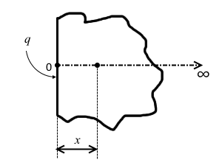

The sample can be approximated as a semi-infinite solid to a certain degree of accuracy if the following criterion is satisfied: where, t is the measurement time and L is the thickness of the sample. An approximate maximum value of thermal diffusivity, (obtained from literature or other sources) for the material of the sample or similar material shall be used in the above condition. By setting a practical value of sample thickness, the maximum duration of the experiment is obtained as follows. $$t*{max} = \frac{0.2 (L/2)^{2}}{\alpha*{max}} \label{eq:semiinf}$$ The side length W of the square shaped sample is fixed to be atleast five times the distance between the heat source and the temperature sensor as suggested by Tye et al. [].

The temperature profile obtained from the experiment is curve-fit to the analytical solution to get k and using non-linear parameter estimation procedure.

## Sensitivity Coefficient Analysis {#sensitivity-coefficient-analysis .unnumbered .unnumbered}

The selection of the time window to be used for the curve fitting procedure depends on the sensitivity of the parameters to the change in temperature as well as the linear dependence of the parameters to each other. Sensitivity coefficient analysis is to be carried out for this purpose.

Sensitivity Coefficient is defined as where p is an unknown parameter. If the sensitivity coefficients are low or linearly dependent on each other, the curve fit may not work properly. Here, the unknown parameters are k and for which the corresponding sensitivity coefficient expressions are given by, $\beta_{k} =\frac{-2q}{k} \left[ \sqrt{\frac{\alpha t}{\pi}}\exp{\frac{-x^{2}}{4 \alpha t}} - \frac{x}{2}\erfc{(\frac{x}{2 \sqrt{\alpha t}})}\right]$

The plot of and against time or Fo indicates the initial period of time during which the properties are not sensitive to the change in temperature because of which their values cannot be estimated accurately. Since the less diffusive materials (low ) tend to take longer to respond to the applied heat flux, we shall consider an approximate value of of the sample under study. To apply the sensitivity analysis for different materials, we make use of the normalized forms of the sensitivity coefficients defined as, where is the sensitivity coefficient value at the start of the measurement (at time ) and and is the same at the end of the measurement (at time )

For a function , the set of parameters are said to be linearly dependent if they satisfy the condition,

For the current case with unknown parameters k and , we can write

By replacing the partial derivate terms with their non-dimensional equivalents,

, and are all constants. Visual inspection of the plot of against the measurement time gives us some idea about the nature of the linear dependence between the two parameters.

## Standard and Difference Analysis {#standard-and-difference-analysis .unnumbered .unnumbered}

The standard analysis is carried out by performing the curve fitting by considering the temperature data for the time interval where t is increased from 0 to . In difference analysis, we consider the time window where is the chosen time window interval and t is again increased from to . The corresponding data is used in the curve fit procedure to obtain k and . By selecting different values of , we can arrive at the desired time window in which the influence of the linear dependence of the parameters is nullified to considerable extent.

Before the start of transient experiments, the standard and difference analyses are carried out using the temperature profile obtained from the theoretical solution (eq. 1) for each sample from which the time window is chosen. However in the actual experiments, random error in the form of noise is inevitably introduced in to the temperature data, the magnitude of which cannot be quantised accurately. Therefore, in addition to performing standard and difference analyses on the ideal temperature profile, we also consider theoretical temperature data in which random error of certain degree is introduced manually. The time window thus obtained from the error-ridden case will be greater than that obtained for the ideal case and more appropriate when planning the experiments.

## Uncertainty Analysis {#uncertainty-analysis .unnumbered .unnumbered}

For calculating the standard deviation of the estimated parameters, the uncertainty analysis method described in Beck and Arnold [7] and subsequently implemented in [5] is followed here.

For the set of parameters , the standard deviation of the least-square estimate is obtained as shown below: where is the standard deviation of the measurement system and X is the sensitivity matrix defined as,

# Experimental Setup {#experimental-setup .unnumbered .unnumbered}

The heating element consisting of a Nickel foil (25 micron thickness), having a square shape and spiral structure with thin layers of kapton on either sides acts as the plane heat source. It is heated by a DC power source supplying constant current. Two identical samples are placed sandwiching the heat source and held under force through a pressing mechanism to ensure good contact between the sample and heating element. Heat conducting paste is also applied on the element to minimize contact resistance existing because of the presence of air gaps.

Temperature is measured using bare wire K-type thermocouples with bead diameter of about 0.5 mm positioned by appropriate methods. For the case of solid samples, a hole is drilled in the radial direction in such a way that the thermocouple is held tightly in the desired position. In the case of fibrous materials, the positioning is more difficult and hence a support made of a similar material to the sample - a thin cylindrical wooden stick with a groove to hold the thermocouple wire - is used to position the thermocouple. Once again, heat conducting paste is used to reduce the contact resistance existing between the tip of the sensor and the contact area in the sample. For all the samples considered for study here, the thermocouples are positioned 1 cm away from the source on both sides.

The entire setup is placed inside a climate chamber in order to study the effects of temperature and relative humidity on the thermal properties of the sample. Two HTU21D temperature-humidity sensors interfaced with Arduino controller are used to monitor the chamber humidity and temperature. Additionally, two thermocouples also monitor the chamber temperature. The temperature data is logged in a desktop computer through the Agilent data acquisition system. Calibration of the thermocouples and the relative humidity sensors were carried out before the start of the experiment.

# Results and Discussion {#results-and-discussion .unnumbered .unnumbered}

Polymethyl Methacrylate (PMMA) and Extruded Polystyrene (XPS) are the reference samples considered for validating the experimental method while the material under study is rice paddy straw. The sample size is determined from the semi-infinite condition mentioned above. The time window ( to ) for curve-fitting is chosen by performing the analyses discussed above for each sample. The values used for the analyses are listed in Table [table:values]{reference-type="ref" reference="table:values"}. Using the semi-infinte condition (eq. [eq:semiinf]{reference-type="ref" reference="eq:semiinf"}), is calculated to be about 390 to 400 s for all three samples. The results of the analyses for the three samples are presented in Figures [pic:pmma1]{reference-type="ref" reference="pic:pmma1"} to [pic:straw2]{reference-type="ref" reference="pic:straw2"}. The difference analysis is performed for three time interval values: 25 s, 50 s and 100 s.

On comparing the sensitivity coefficient curves (Figures [pic:pmma1]{reference-type="ref" reference="pic:pmma1"}a, [pic:xps1]{reference-type="ref" reference="pic:xps1"}a and [pic:straw1]{reference-type="ref" reference="pic:straw1"}a it is clear that a greater portion of initial temperature data needs to be neglected for PMMA (up to 90 s) owing to its lower diffusivity. The data up to about 25 s and 50 s can be neglected for the case of XPS and Straw respectively. Observing the curves of for the three samples, XPS exhibits greater non-linearity than Straw and PMMA samples. As a result the correct values of thermal conductivity and thermal diffusivity are predicted much earlier and with a smaller time window () in the case of XPS as seen in the figures [pic:xps1]{reference-type="ref" reference="pic:xps1"}b and [pic:xps1]{reference-type="ref" reference="pic:xps1"}c.

To study the effects of noise on the curve-fitting procedure, we perform three trials (a,b and c) each for two cases. In the first case, we introduce an average random error of C in to the temperature data while in the second case, a random error of C is introduced. Standard and Difference analysis (with = 100s) are performed for the error-ridden temperature data and the results are presented in figures [pic:pmma2]{reference-type="ref" reference="pic:pmma2"}, [pic:xps2]{reference-type="ref" reference="pic:xps2"} and [pic:straw2]{reference-type="ref" reference="pic:straw2"} for the samples PMMA, XPS and Straw respectively. The curve-fitting is observed to perform much better for XPS and Straw when compared to PMMA sample. As such, we can conclude that it may be necessary to subject PMMA to more number of experimental trials to get an accurate prediction of the thermal properties.

Therefore the final time windows during which the temperature data is selected for curve-fitting are: 100 to 390 s for PMMA, 30 to 390 s for XPS and 50 to 350 s for straw. Since the maximum thermal diffusivity of straw is variable owing to several factors, the maximum time may need to be modified depending up on initial experiment results. For all samples, the final value of thermal conductivity or diffusivity is obtained by averaging the estimations resulting from curve-fitting the data over a range of time windows (say, from - to - during which the results are consistent).

PMMA XPS Straw

L (set) [] W [] (measured) [] [Rides] [Dubois] [Chaussinand] [] - [Al-Ajlan] [Chaussinand] [] [Rides] [Rides] [Dubois] [Chaussinand] [] - [Chaussinand] [] [Rides]

: Parameters considered for measurement analysis for the three different samples[]{label="table:values"}

\centering 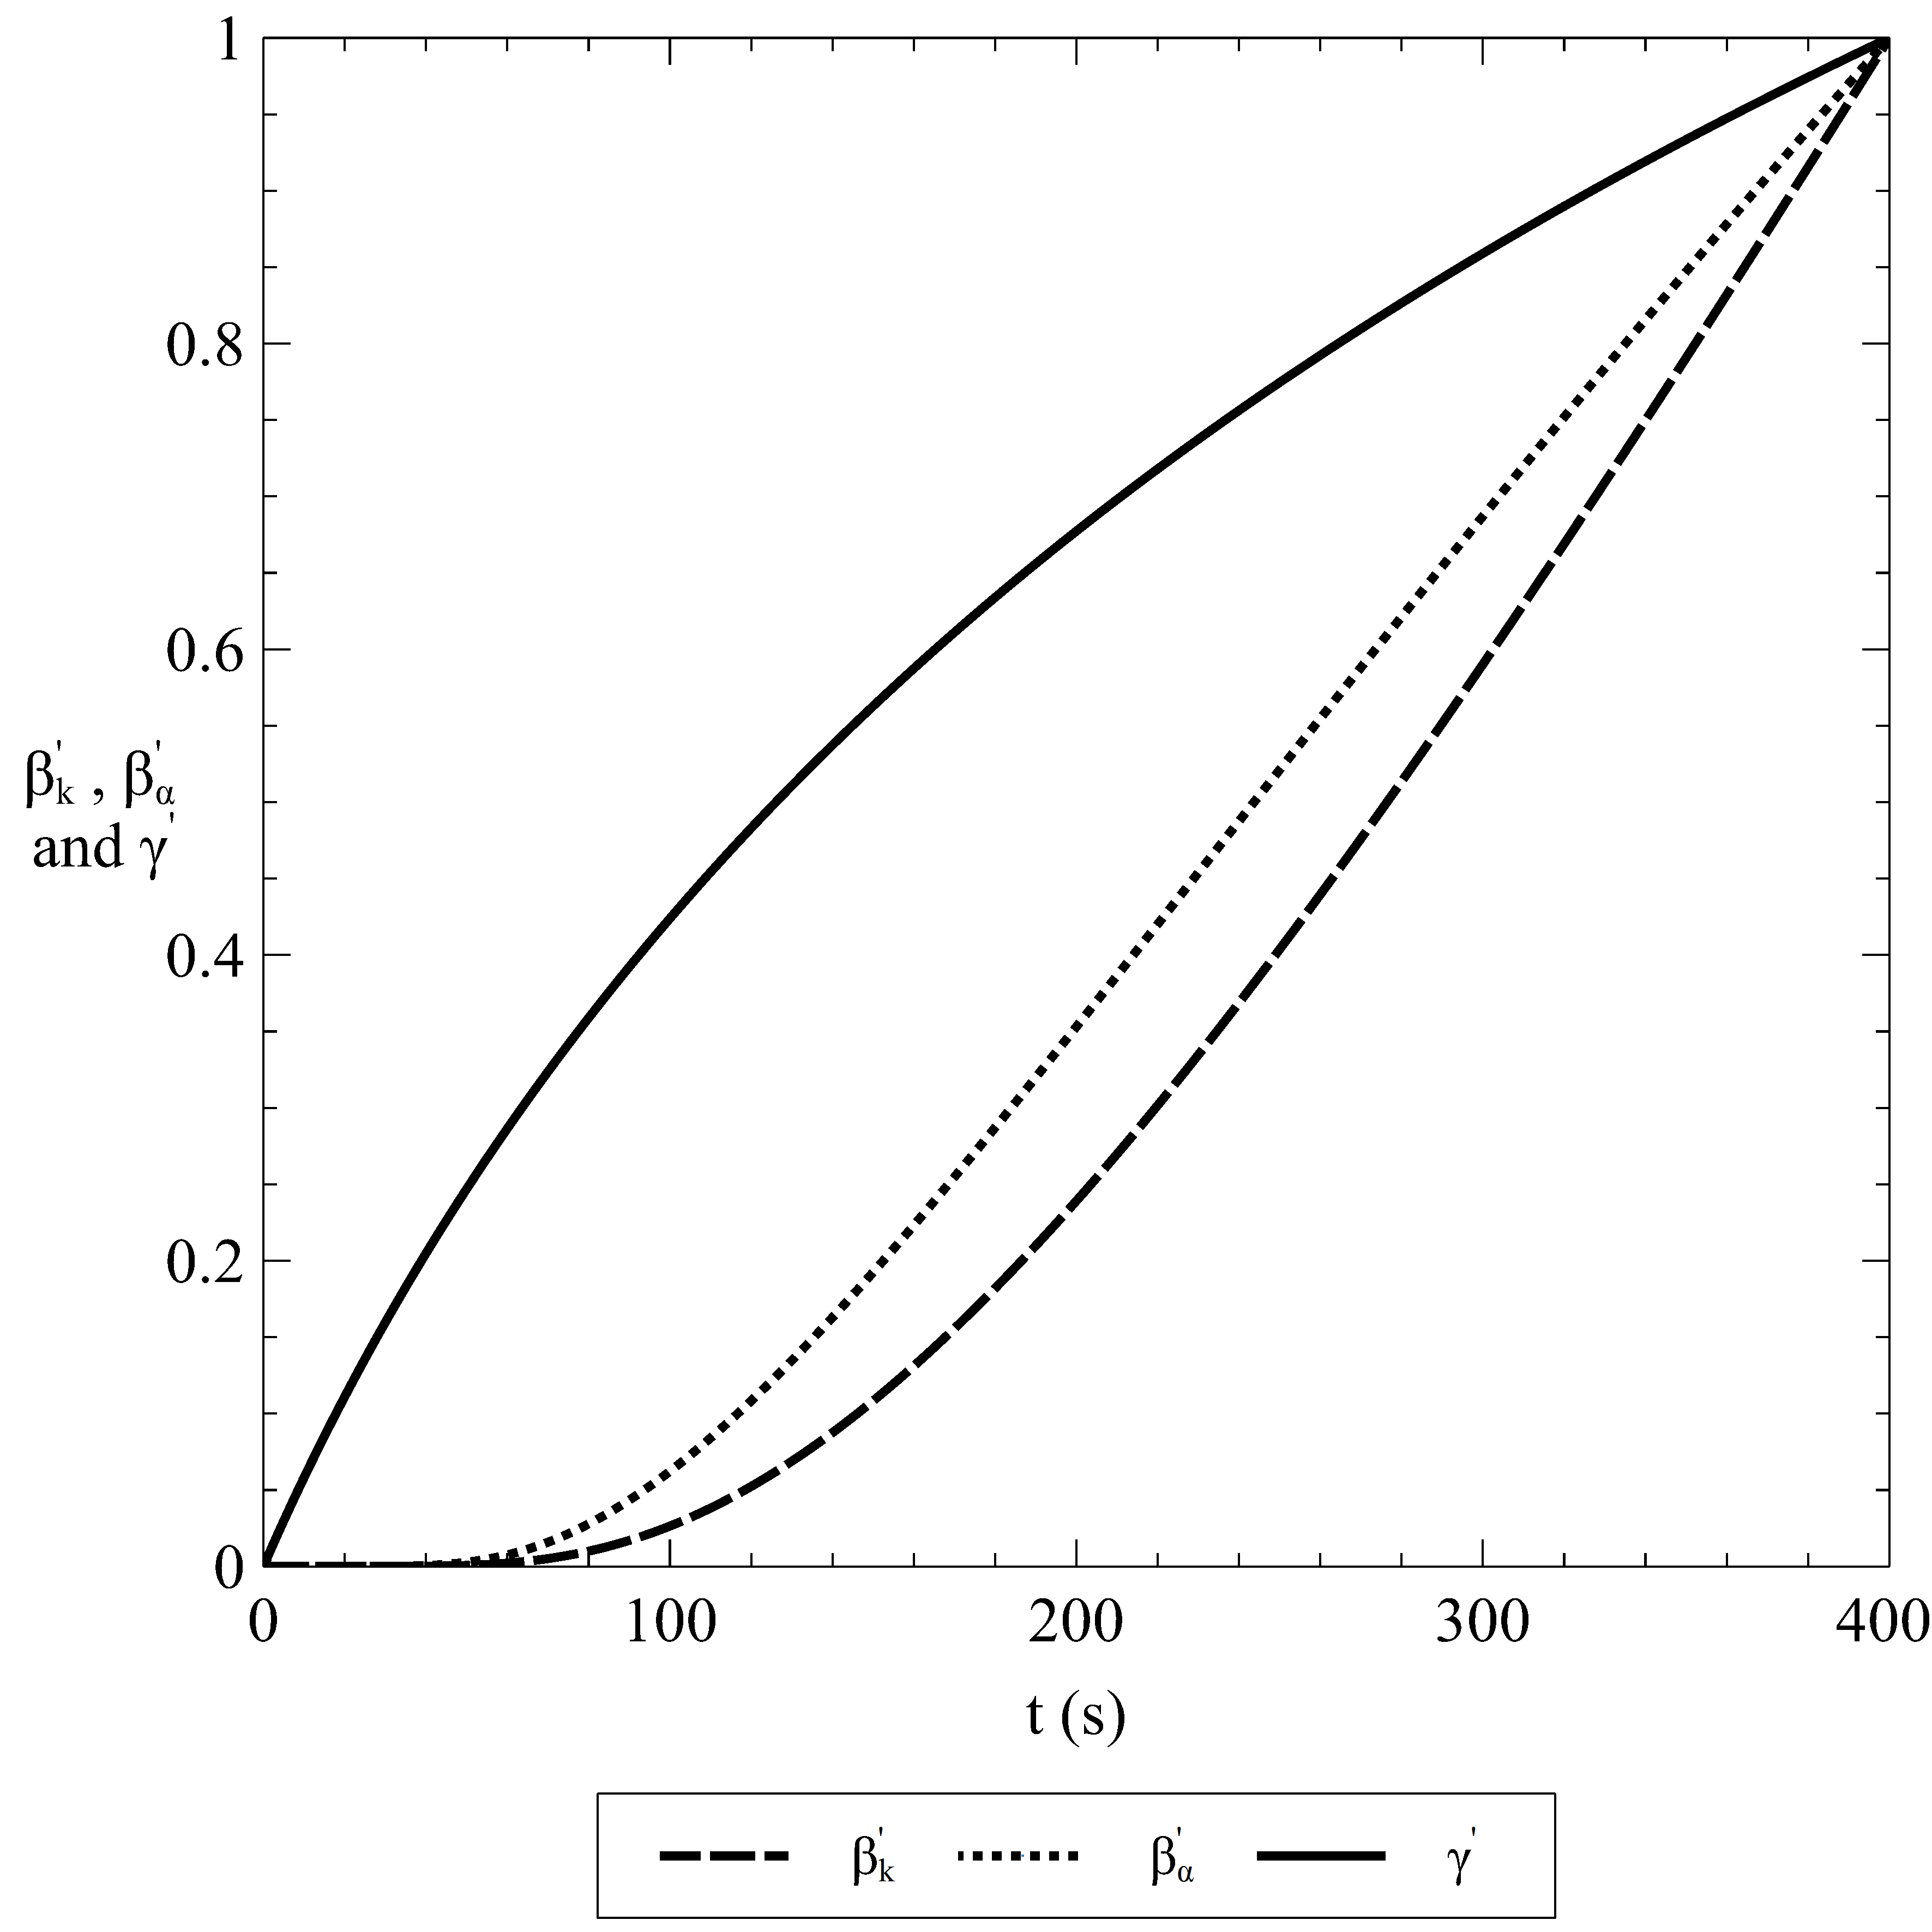

\

\centering 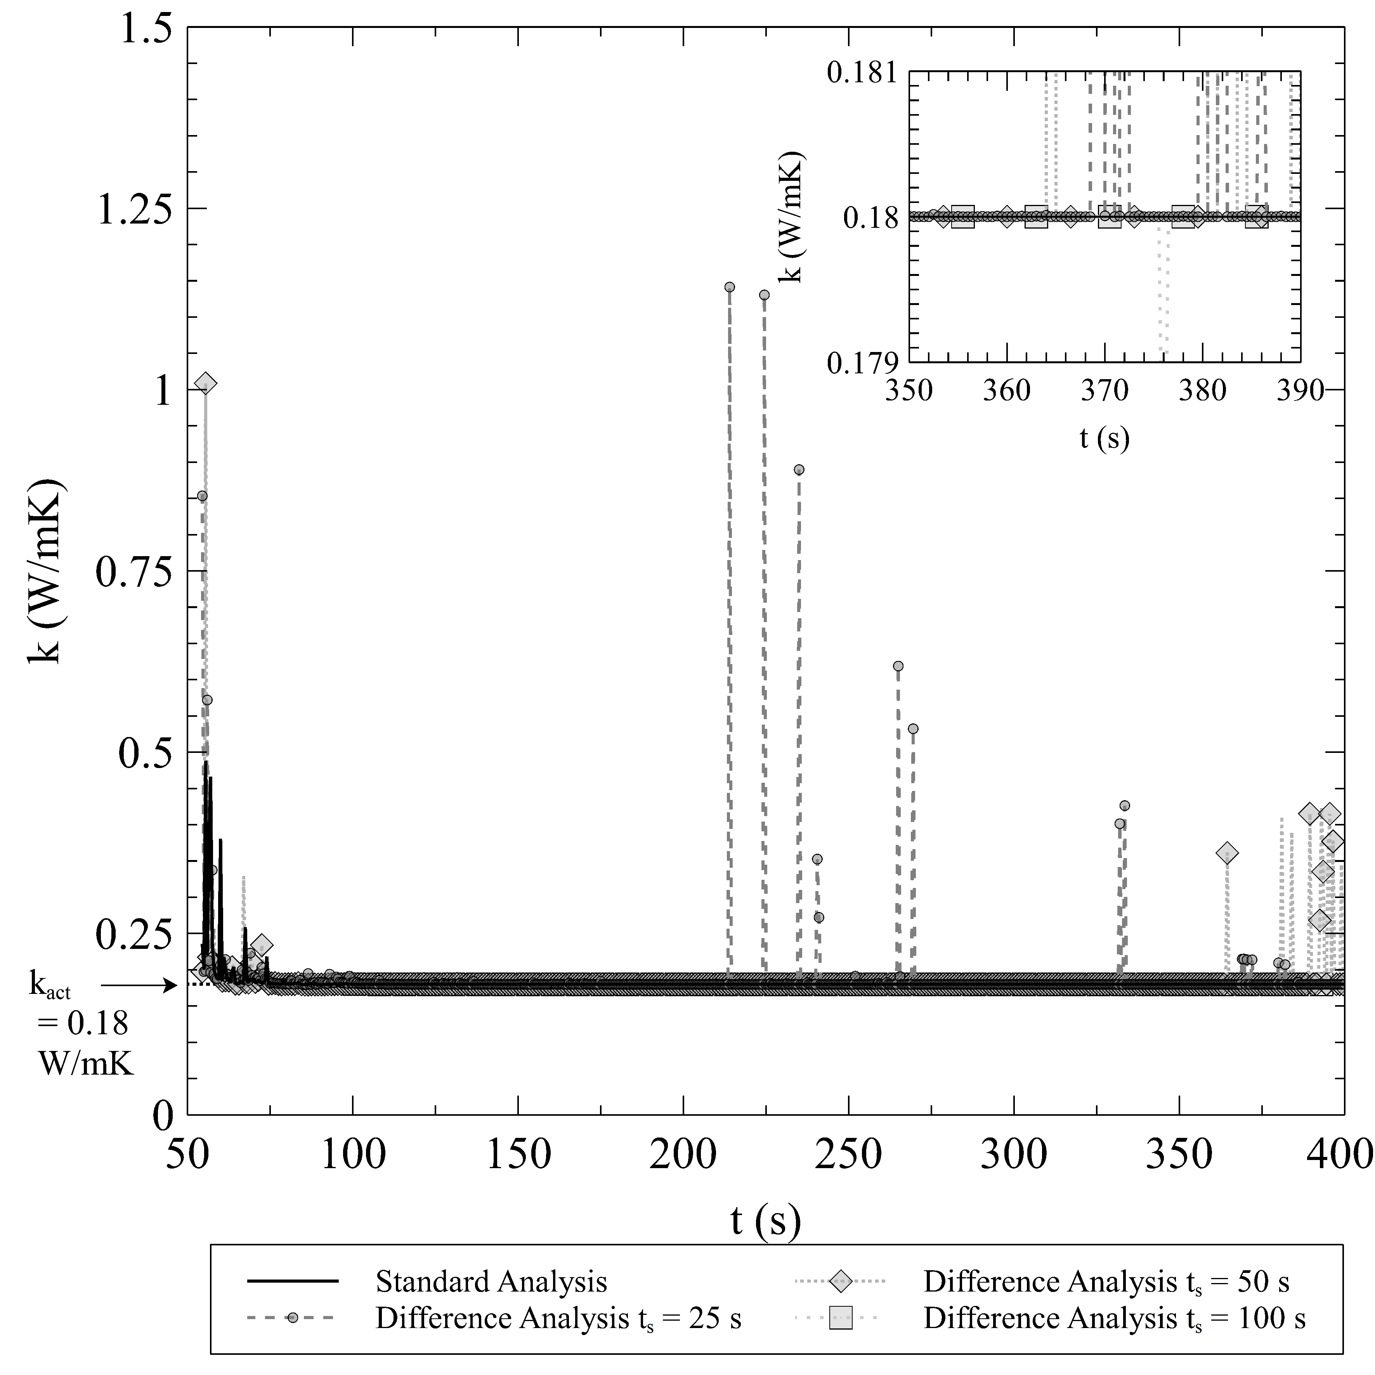

\hfill \centering 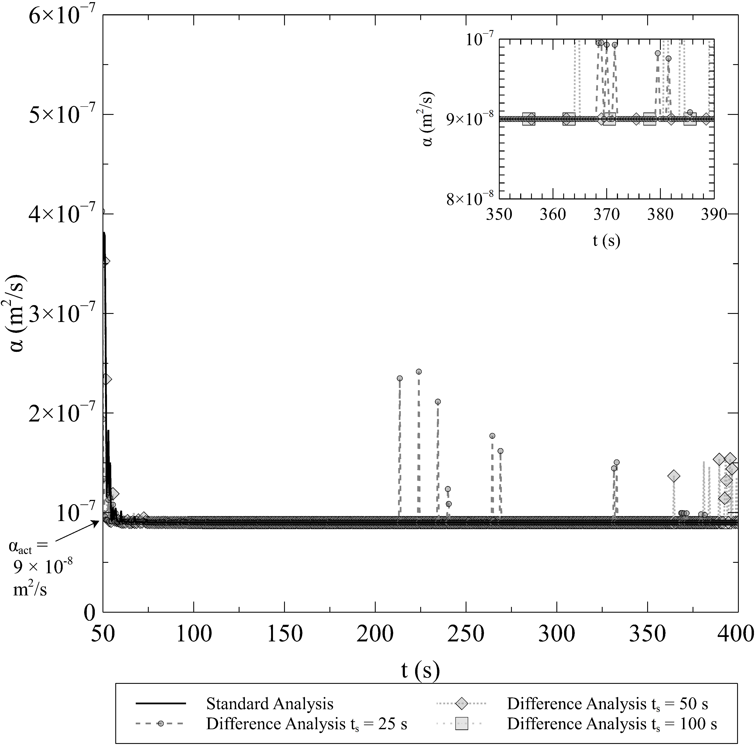

\centering 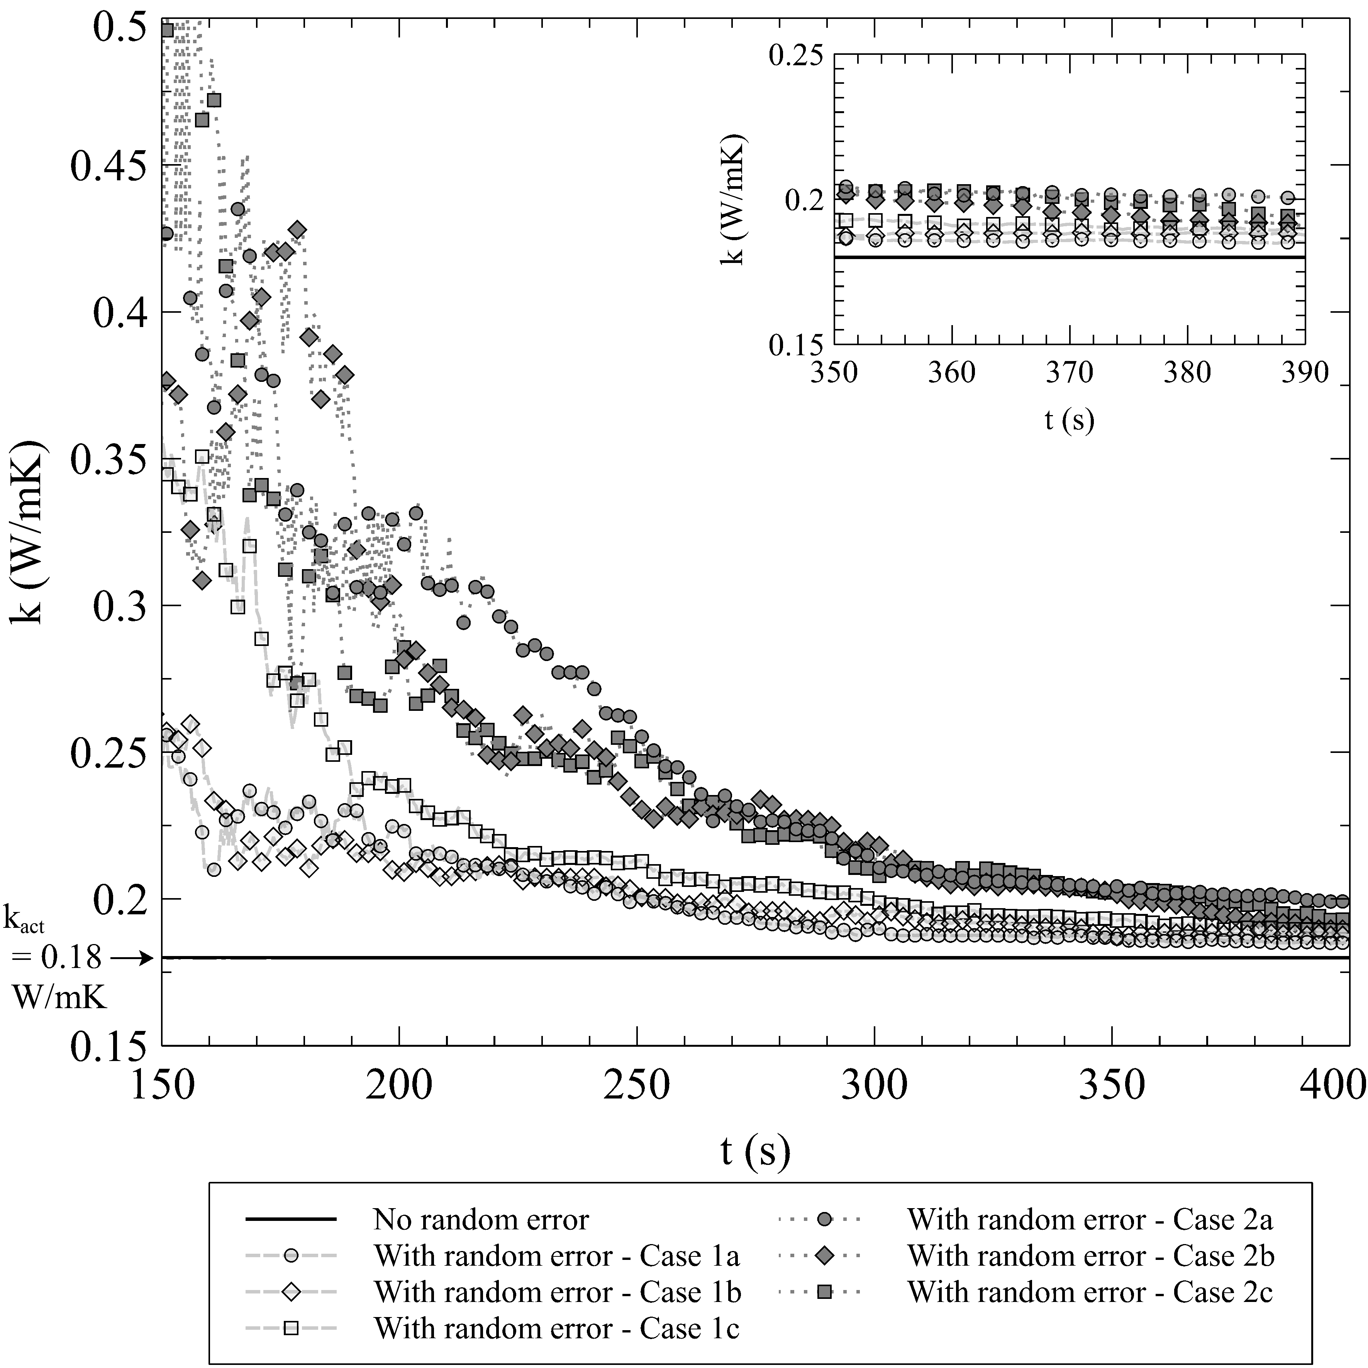

\hfill \centering 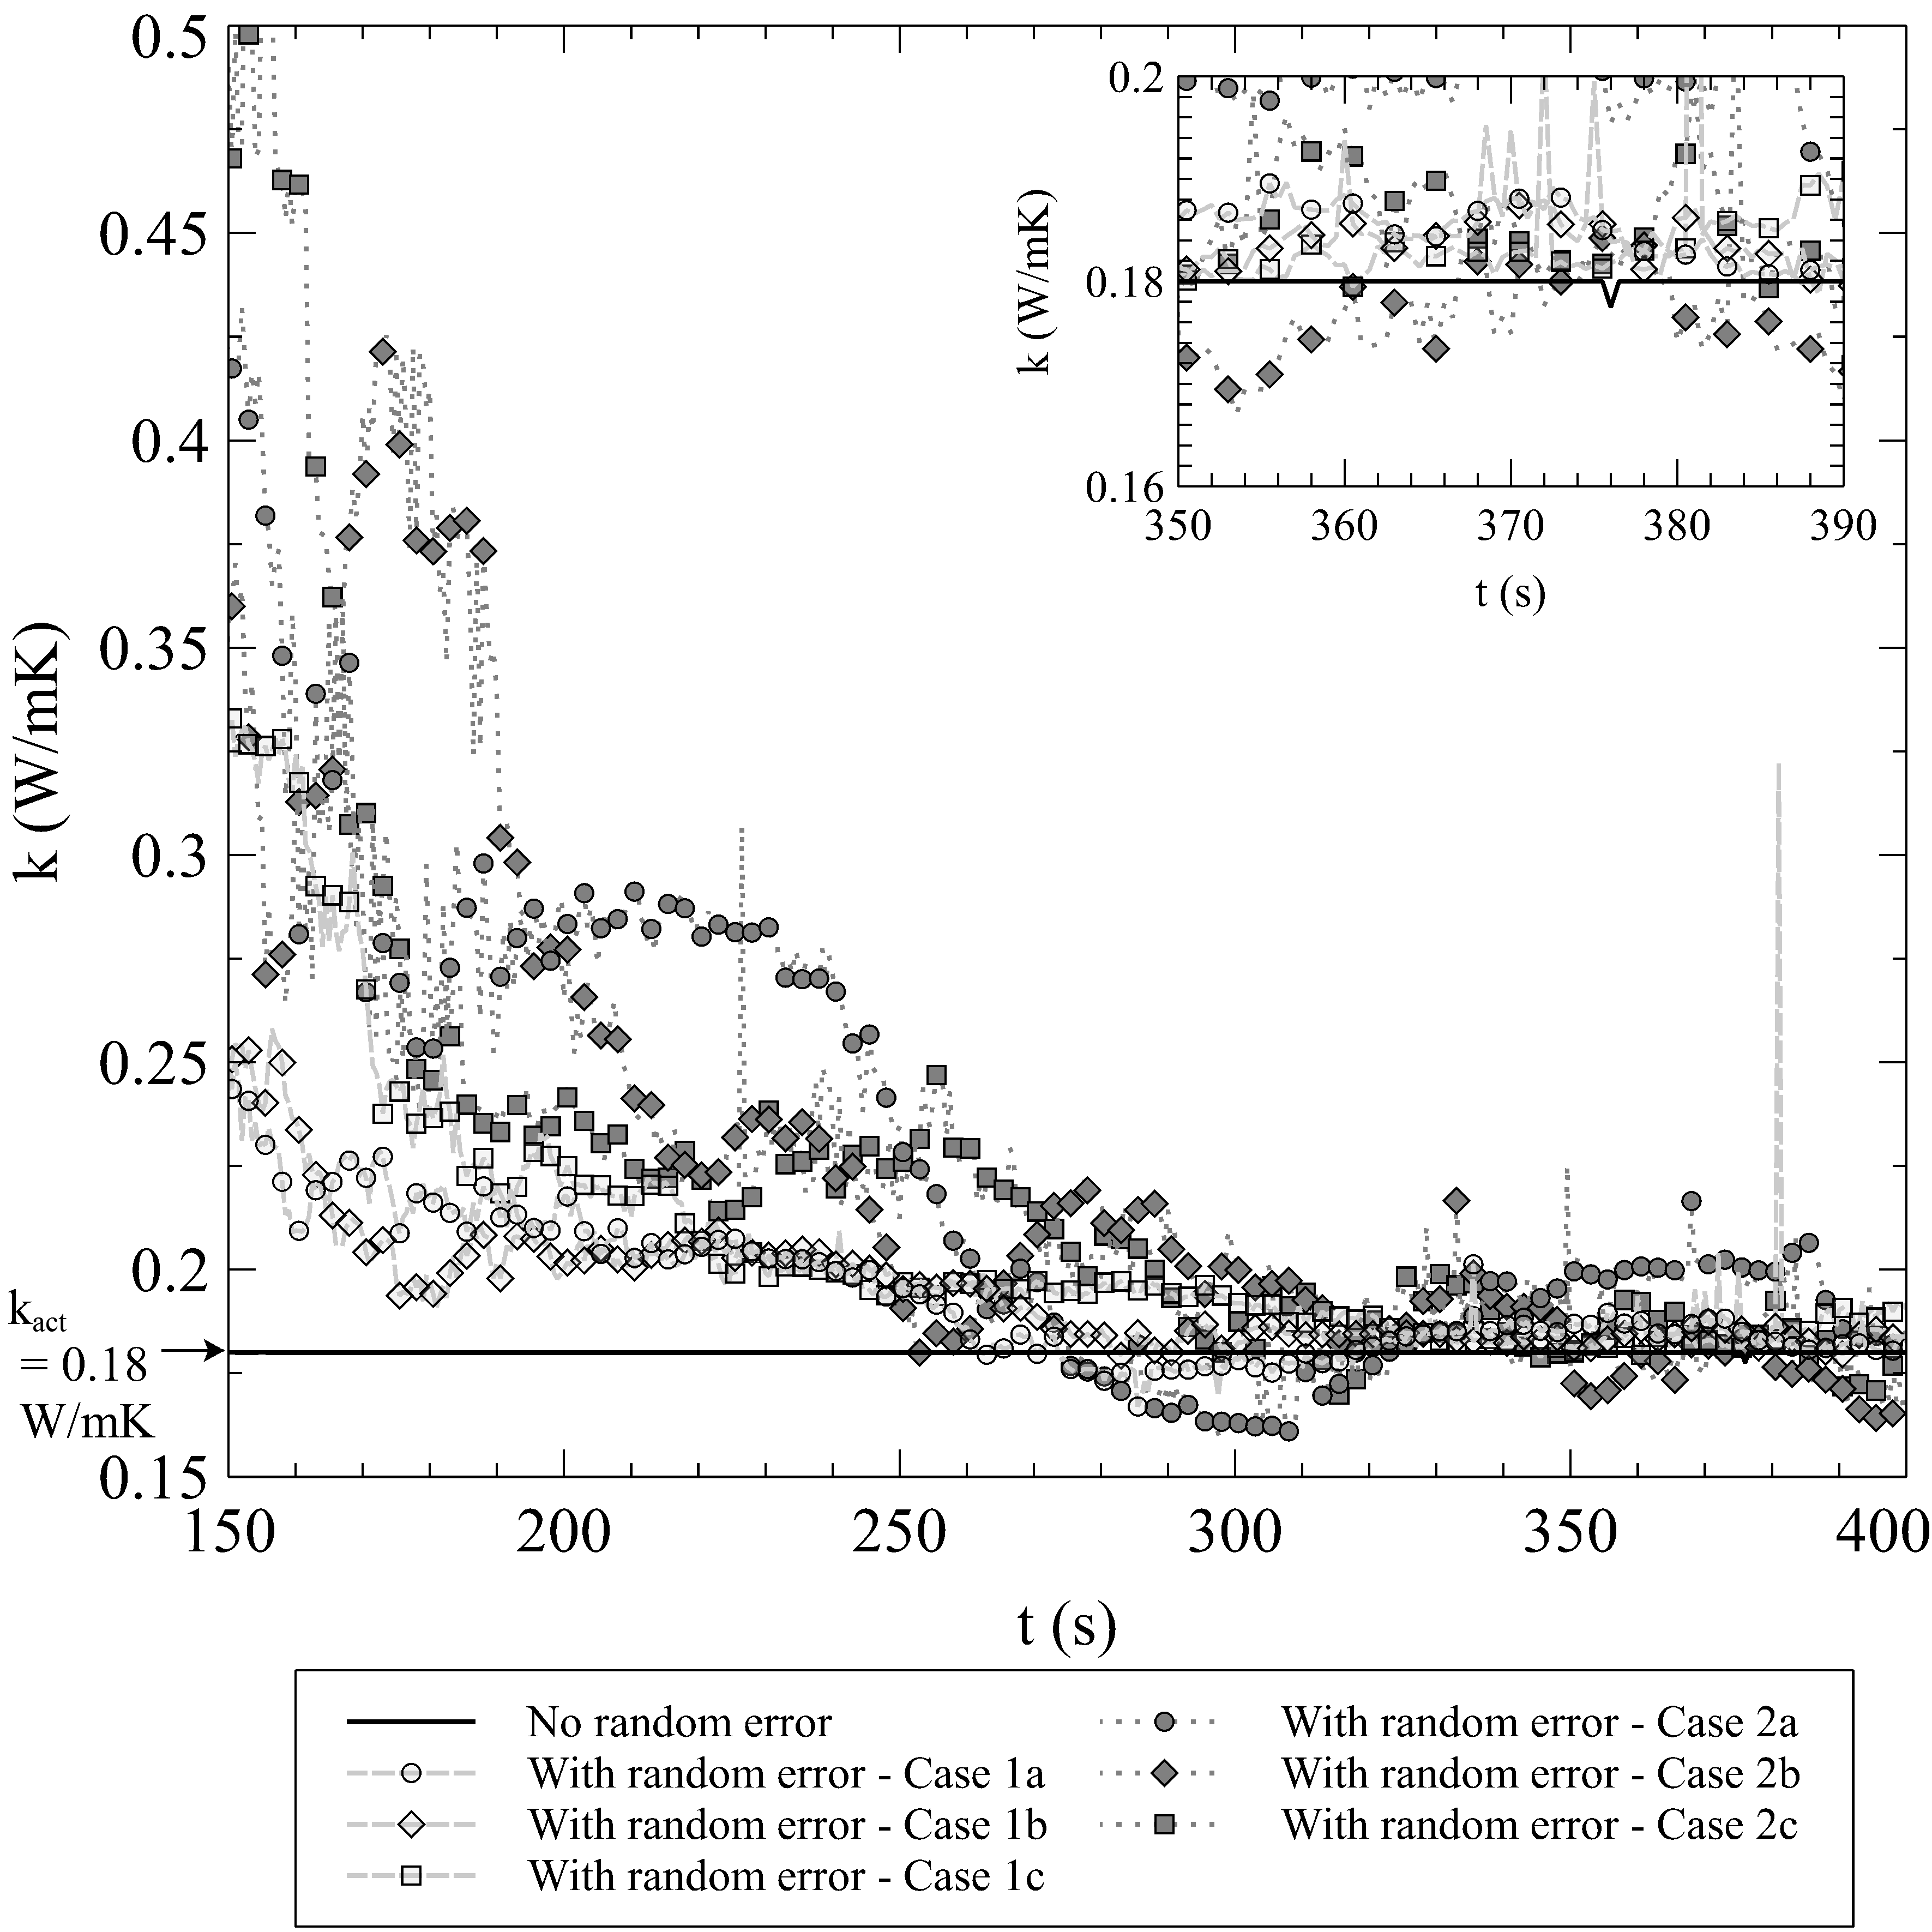

\

\centering 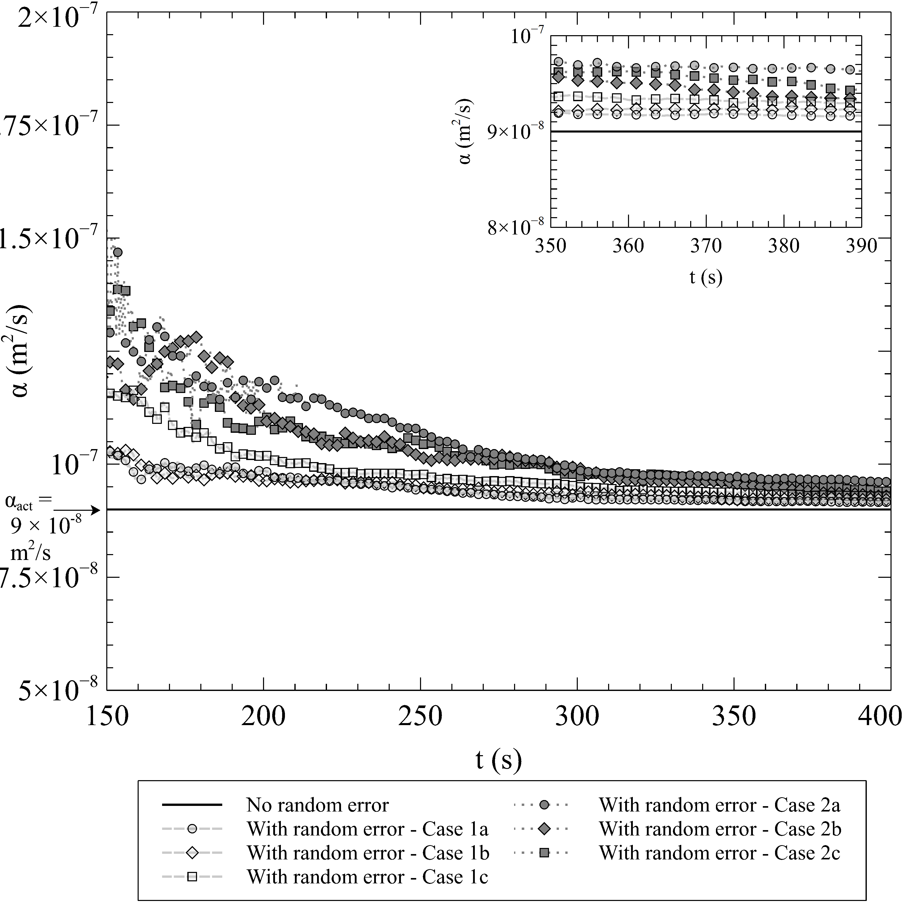

\hfill \centering 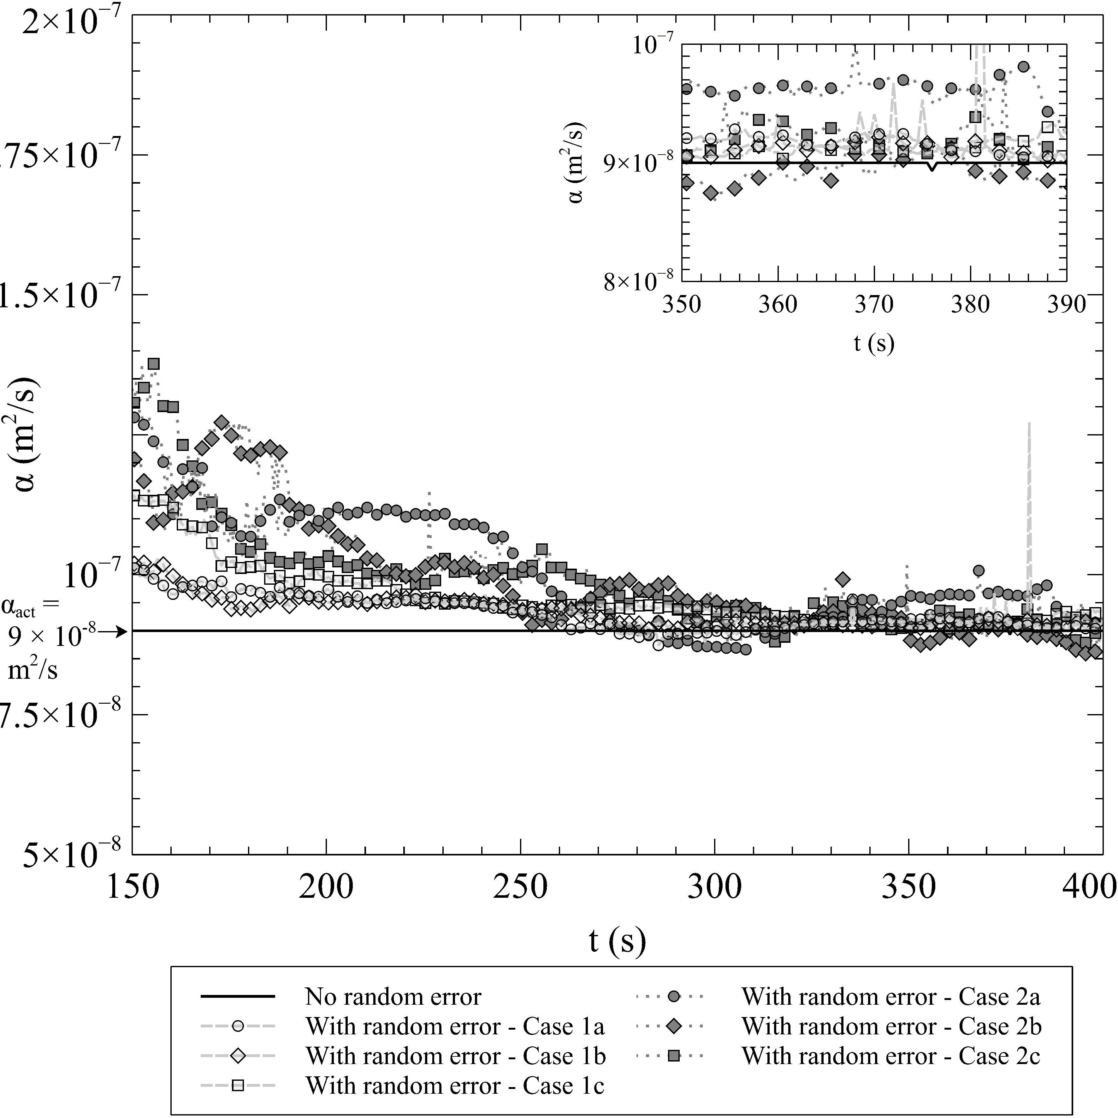

\centering 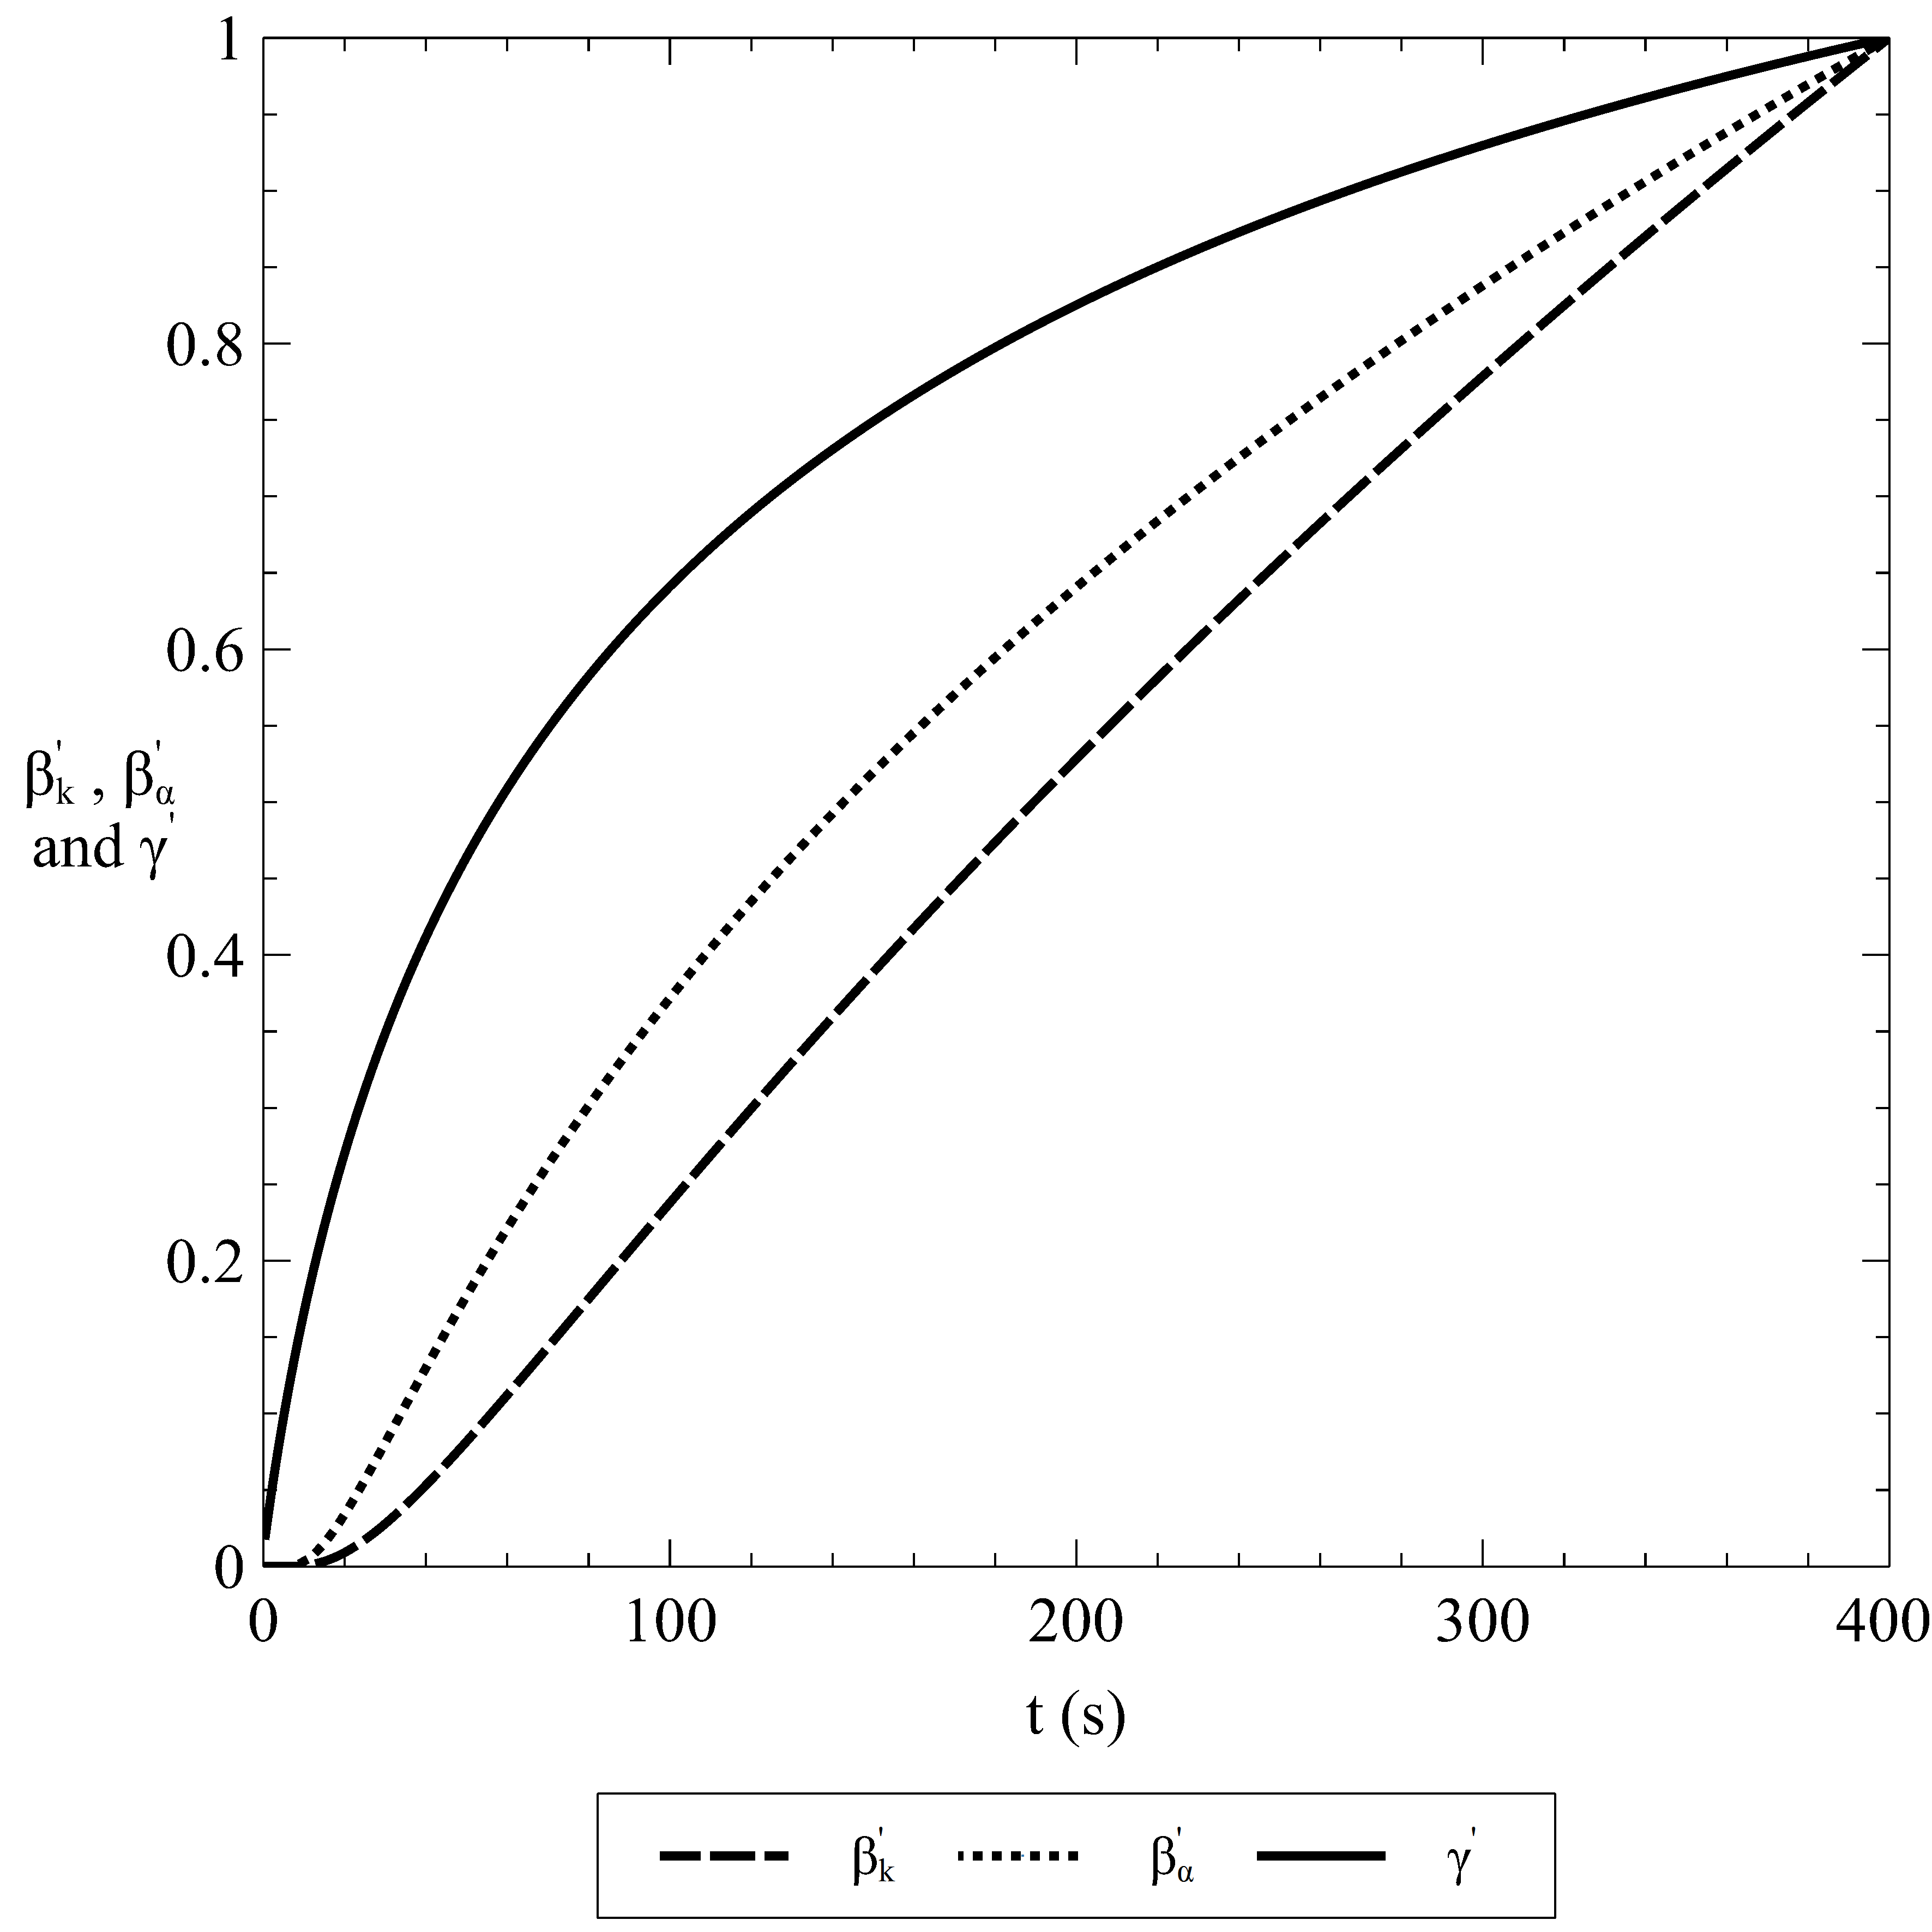

\

\centering 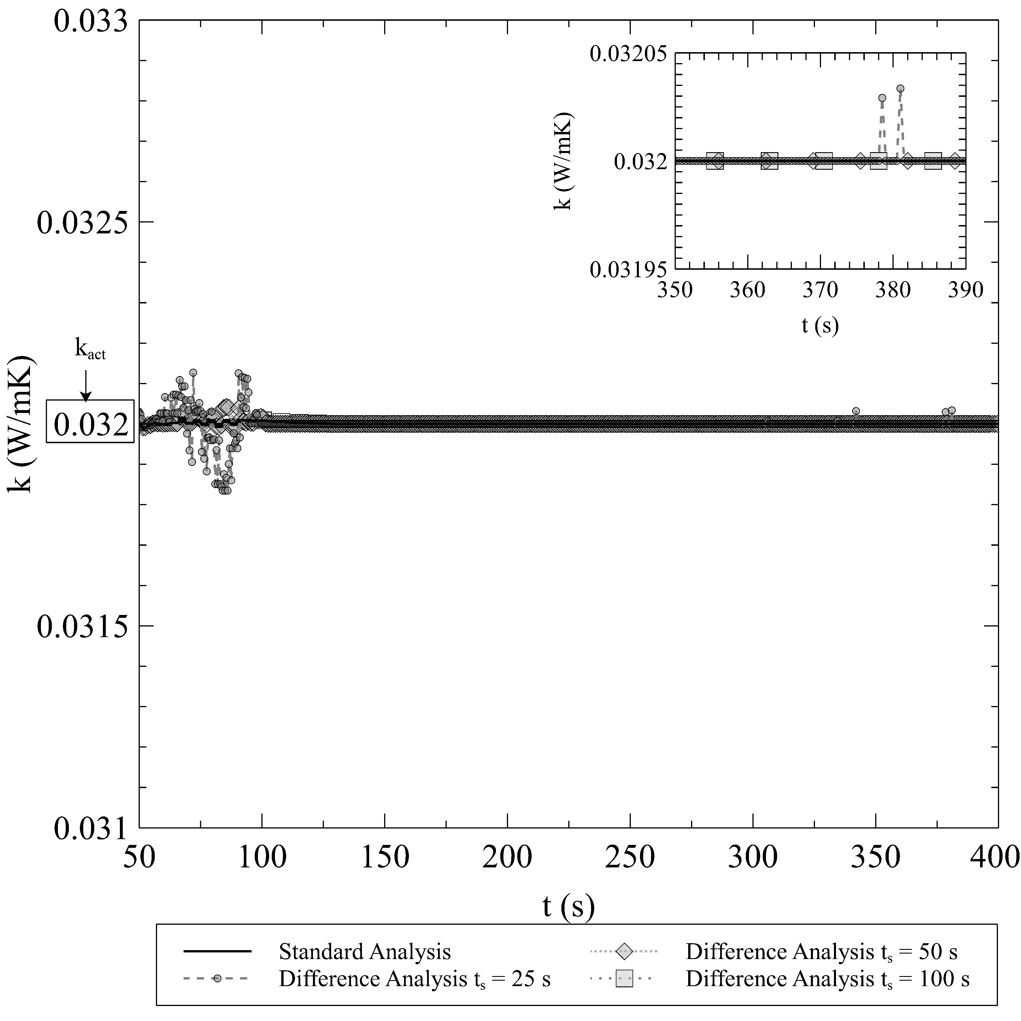

\hfill \centering 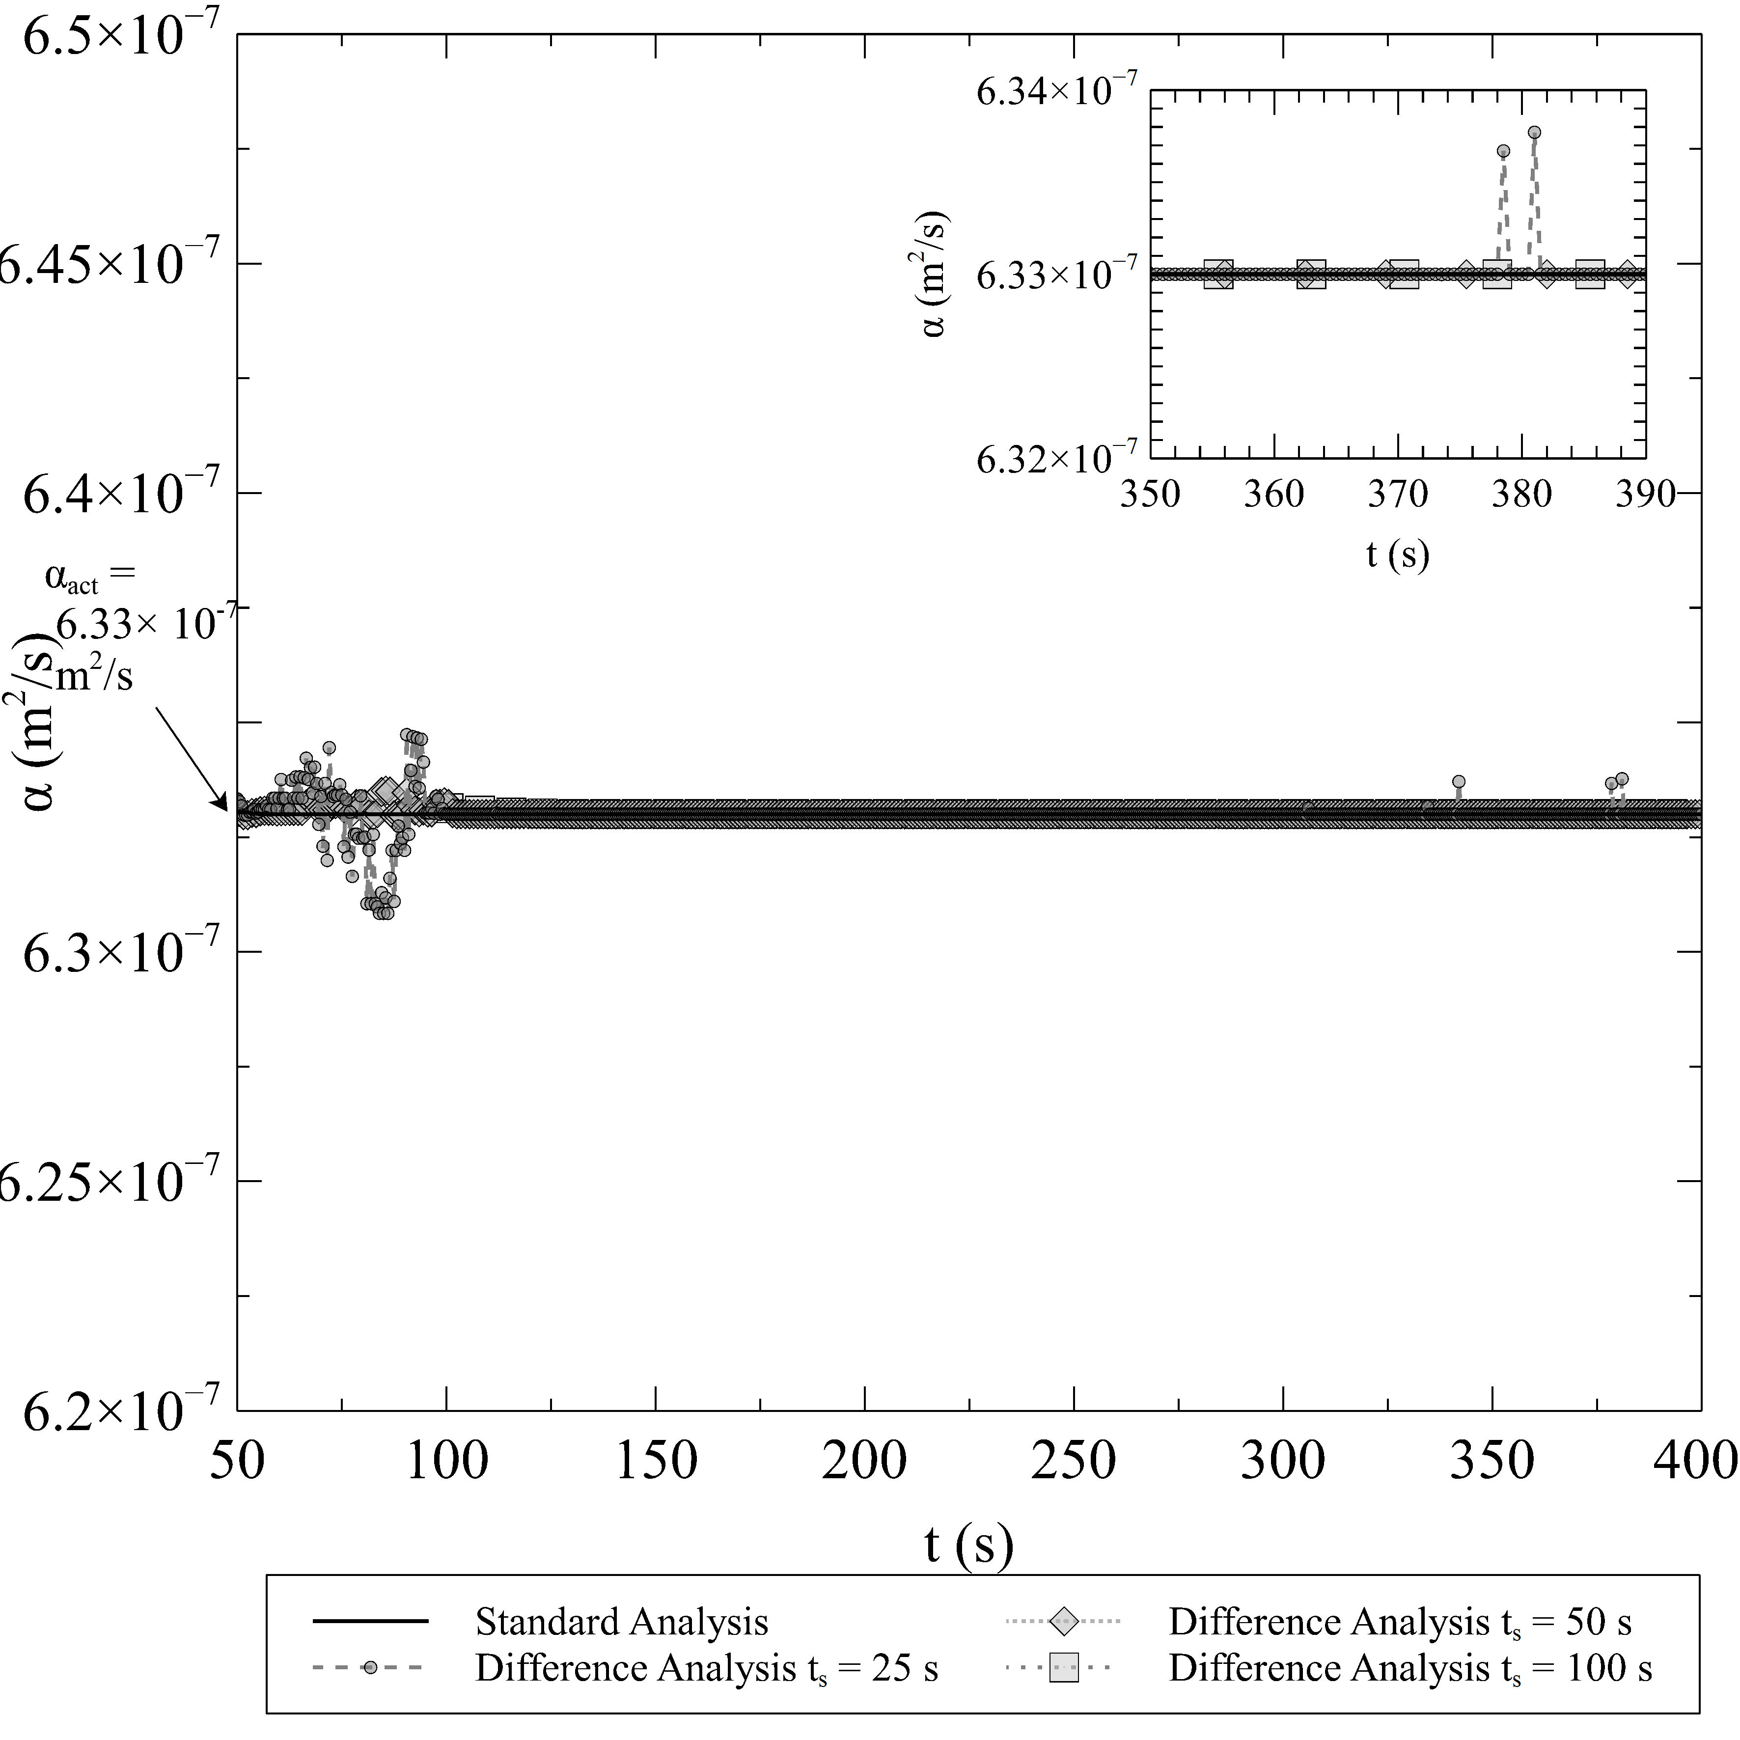

\centering 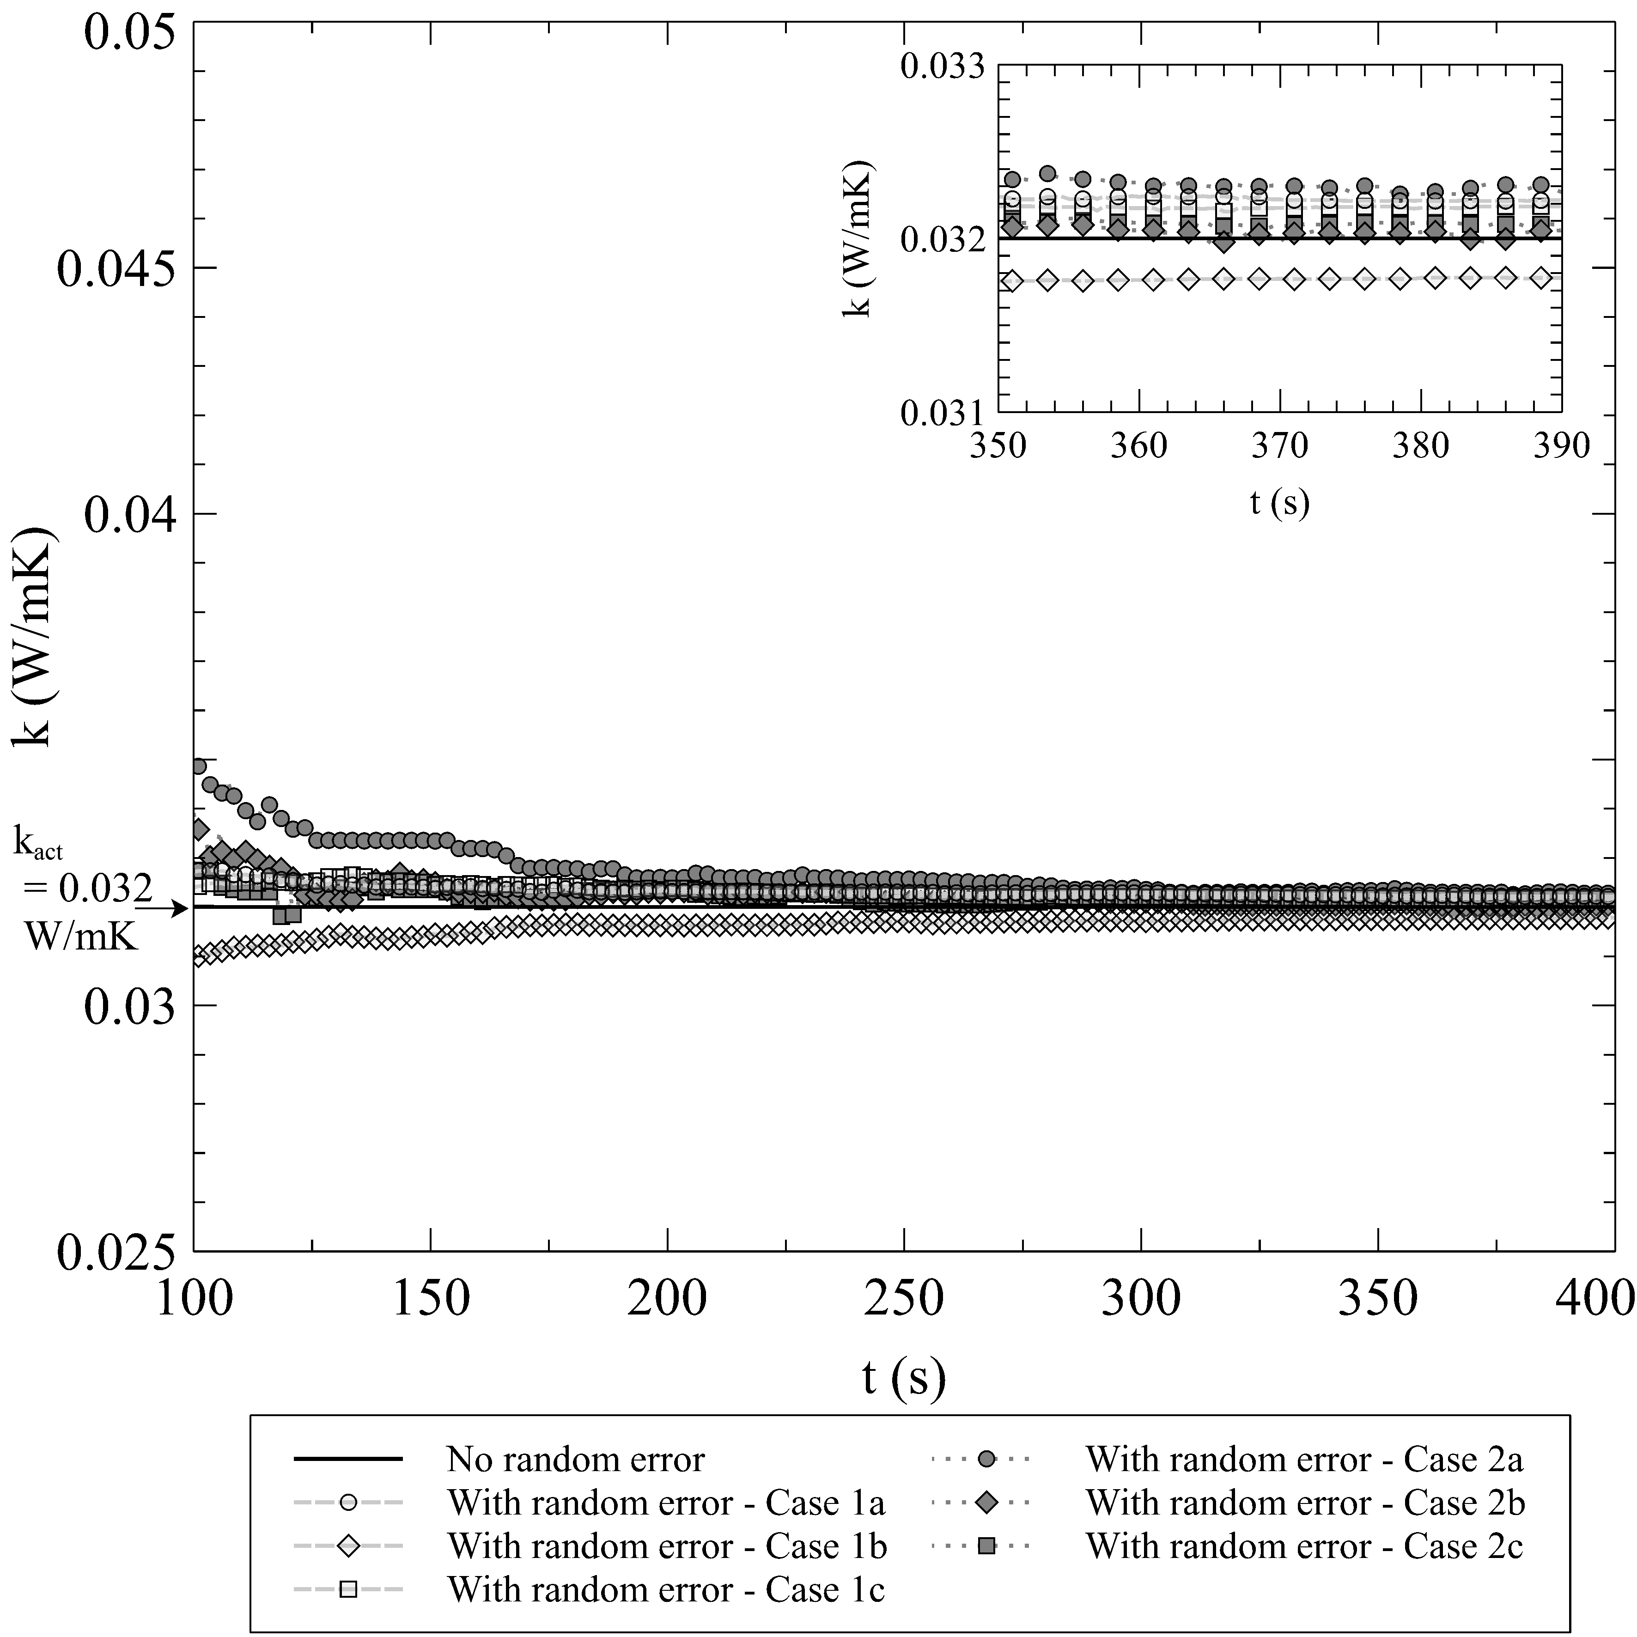

\hfill \centering 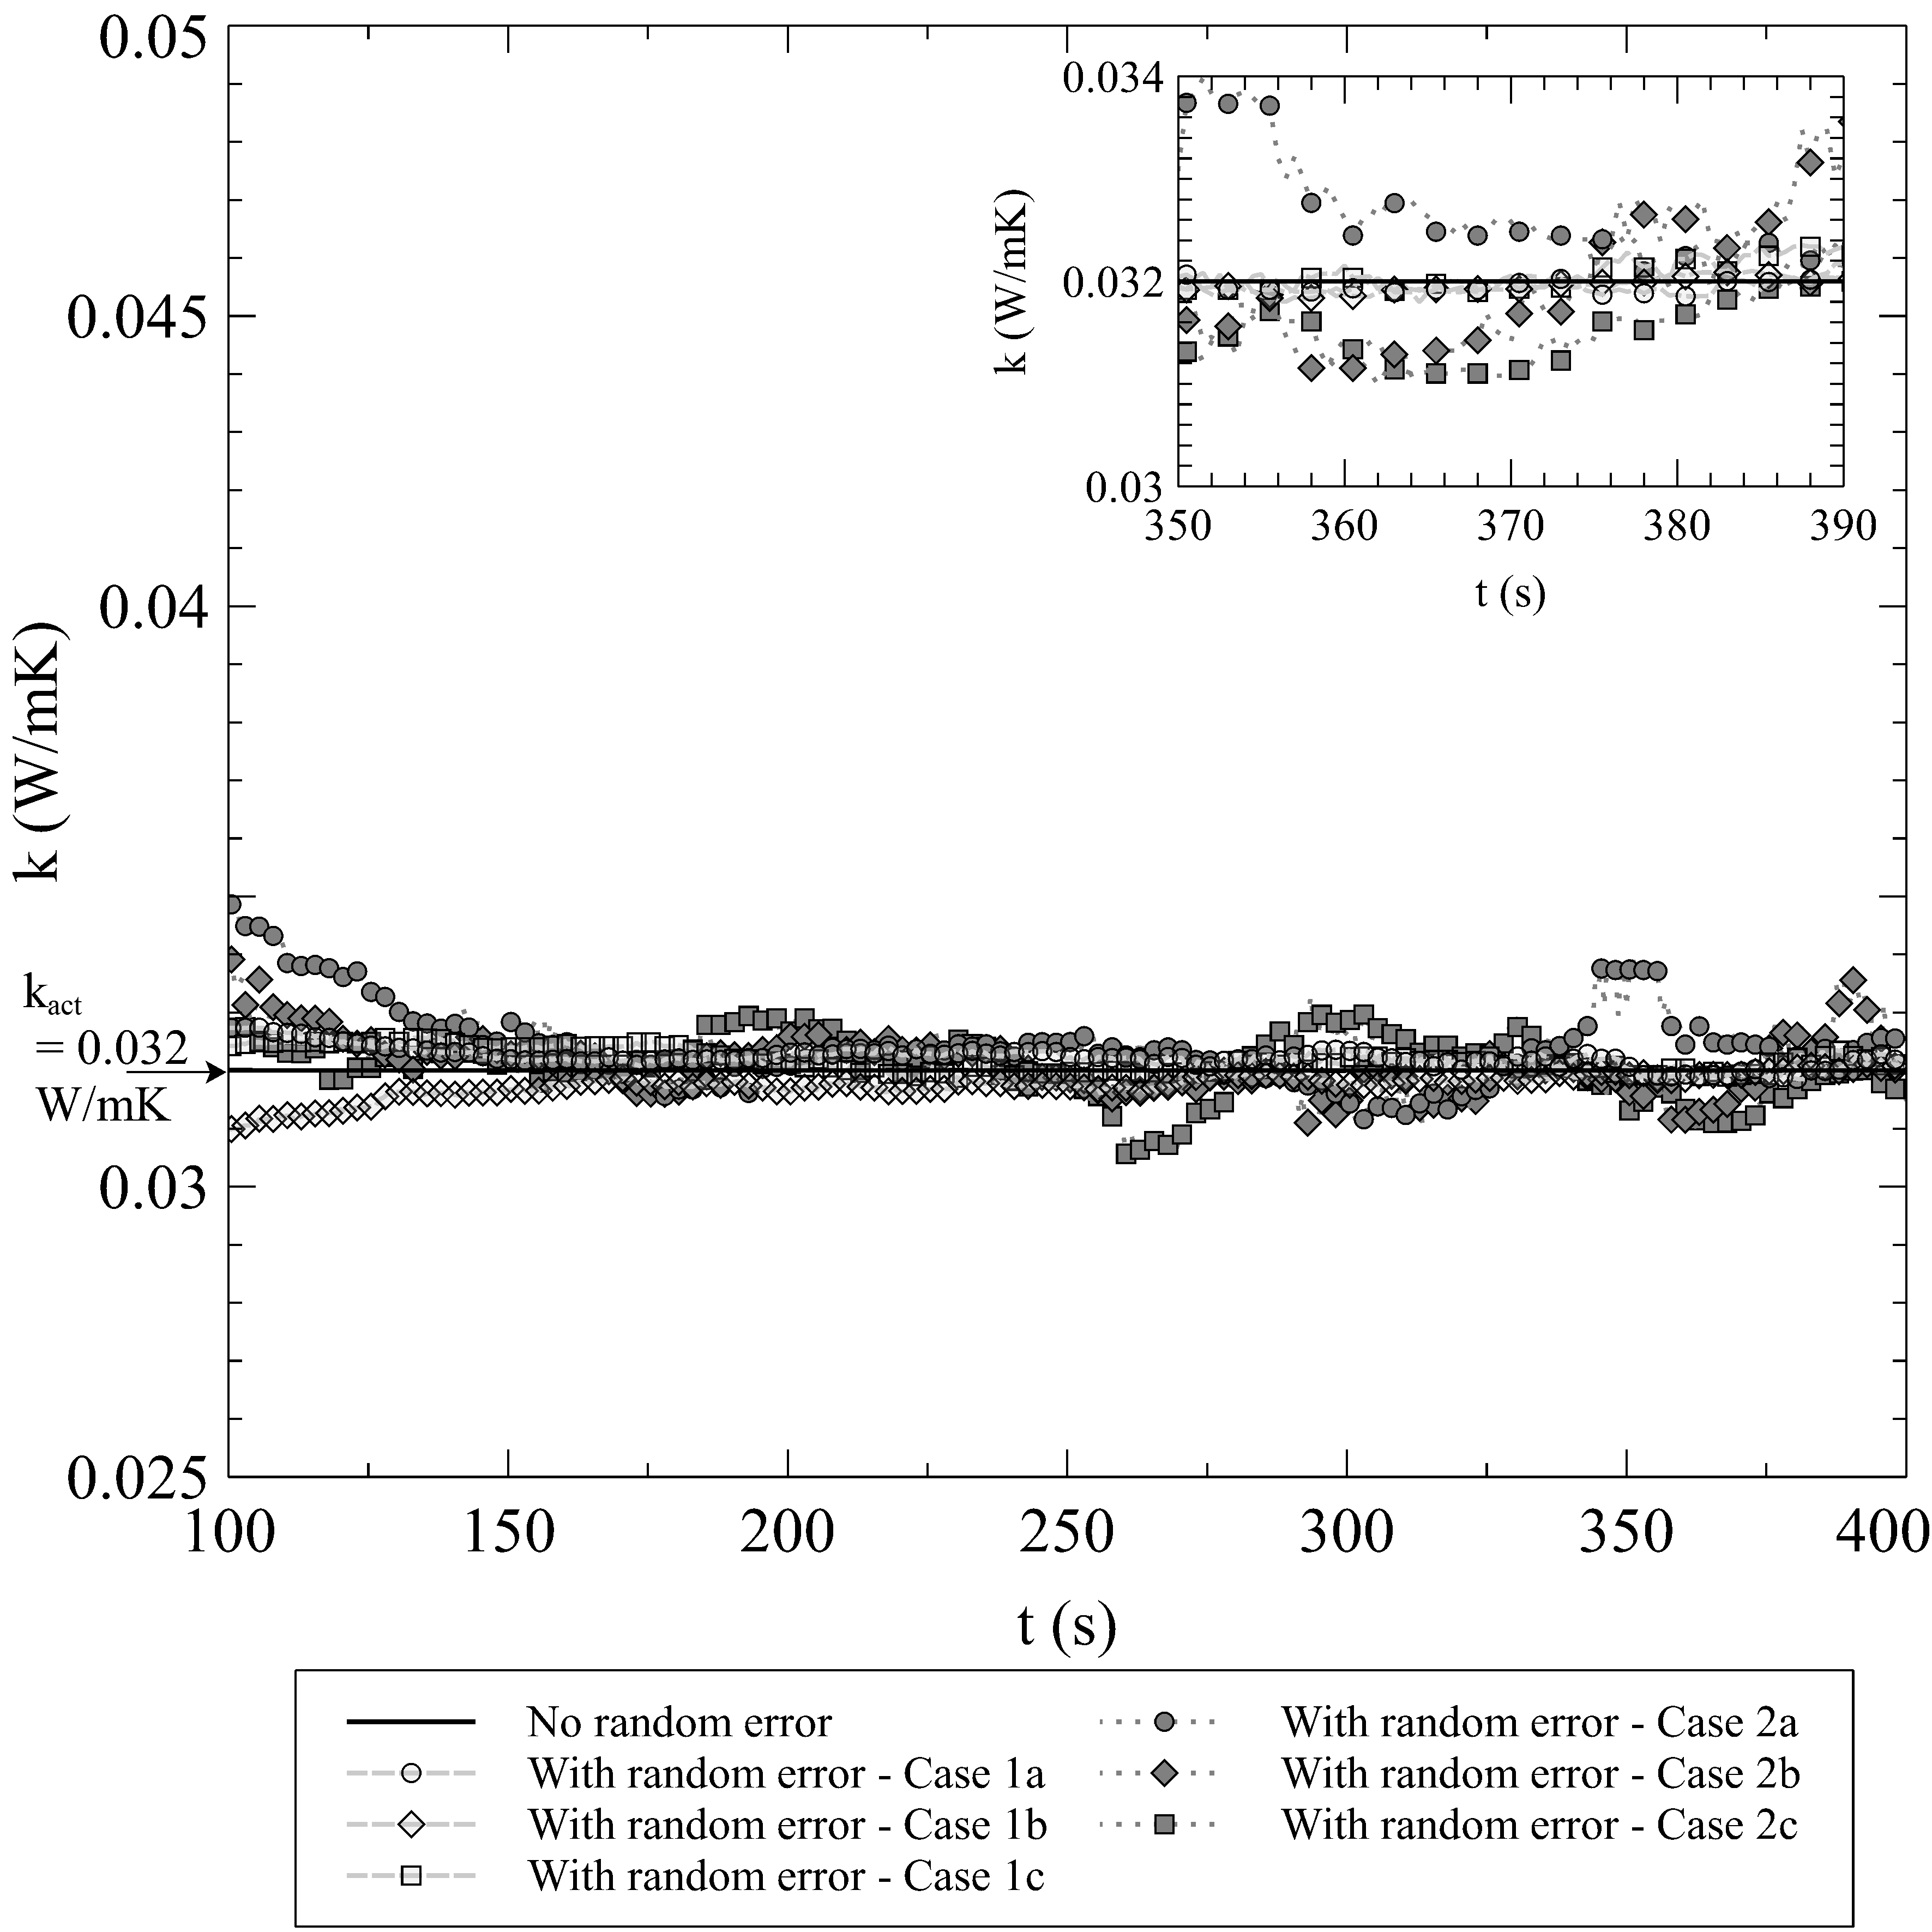

\

\centering 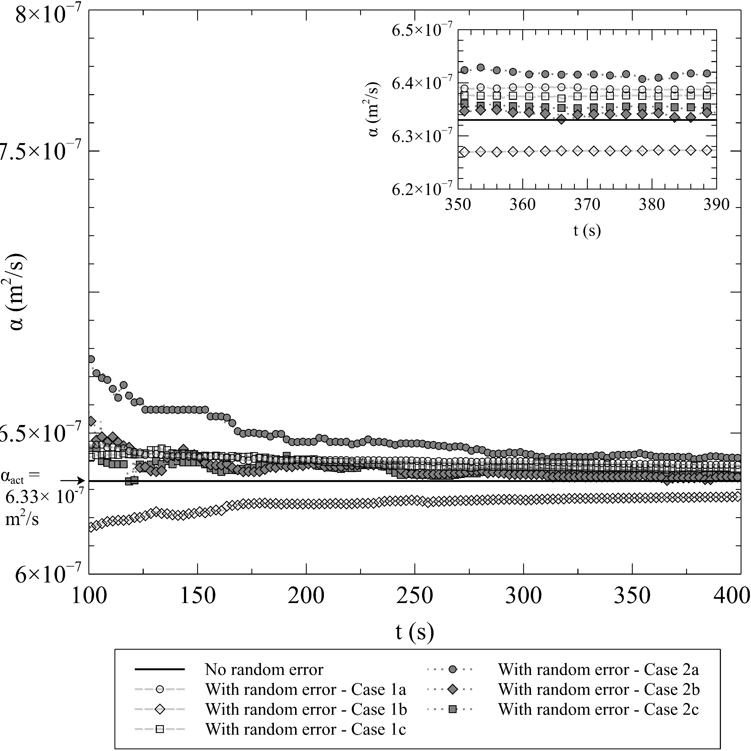

\hfill \centering 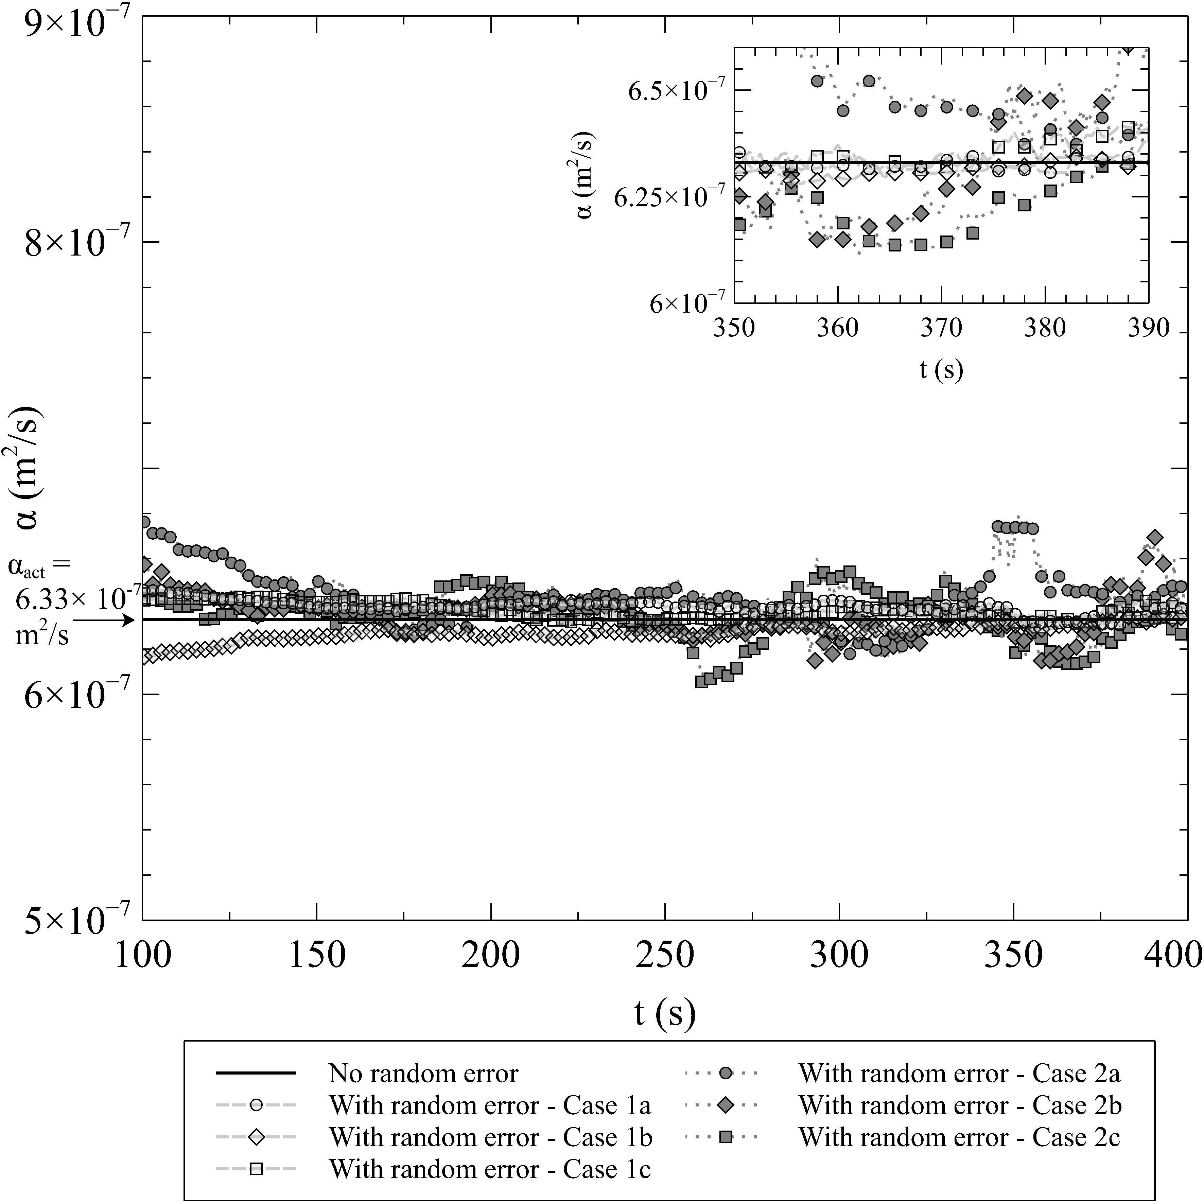

\centering 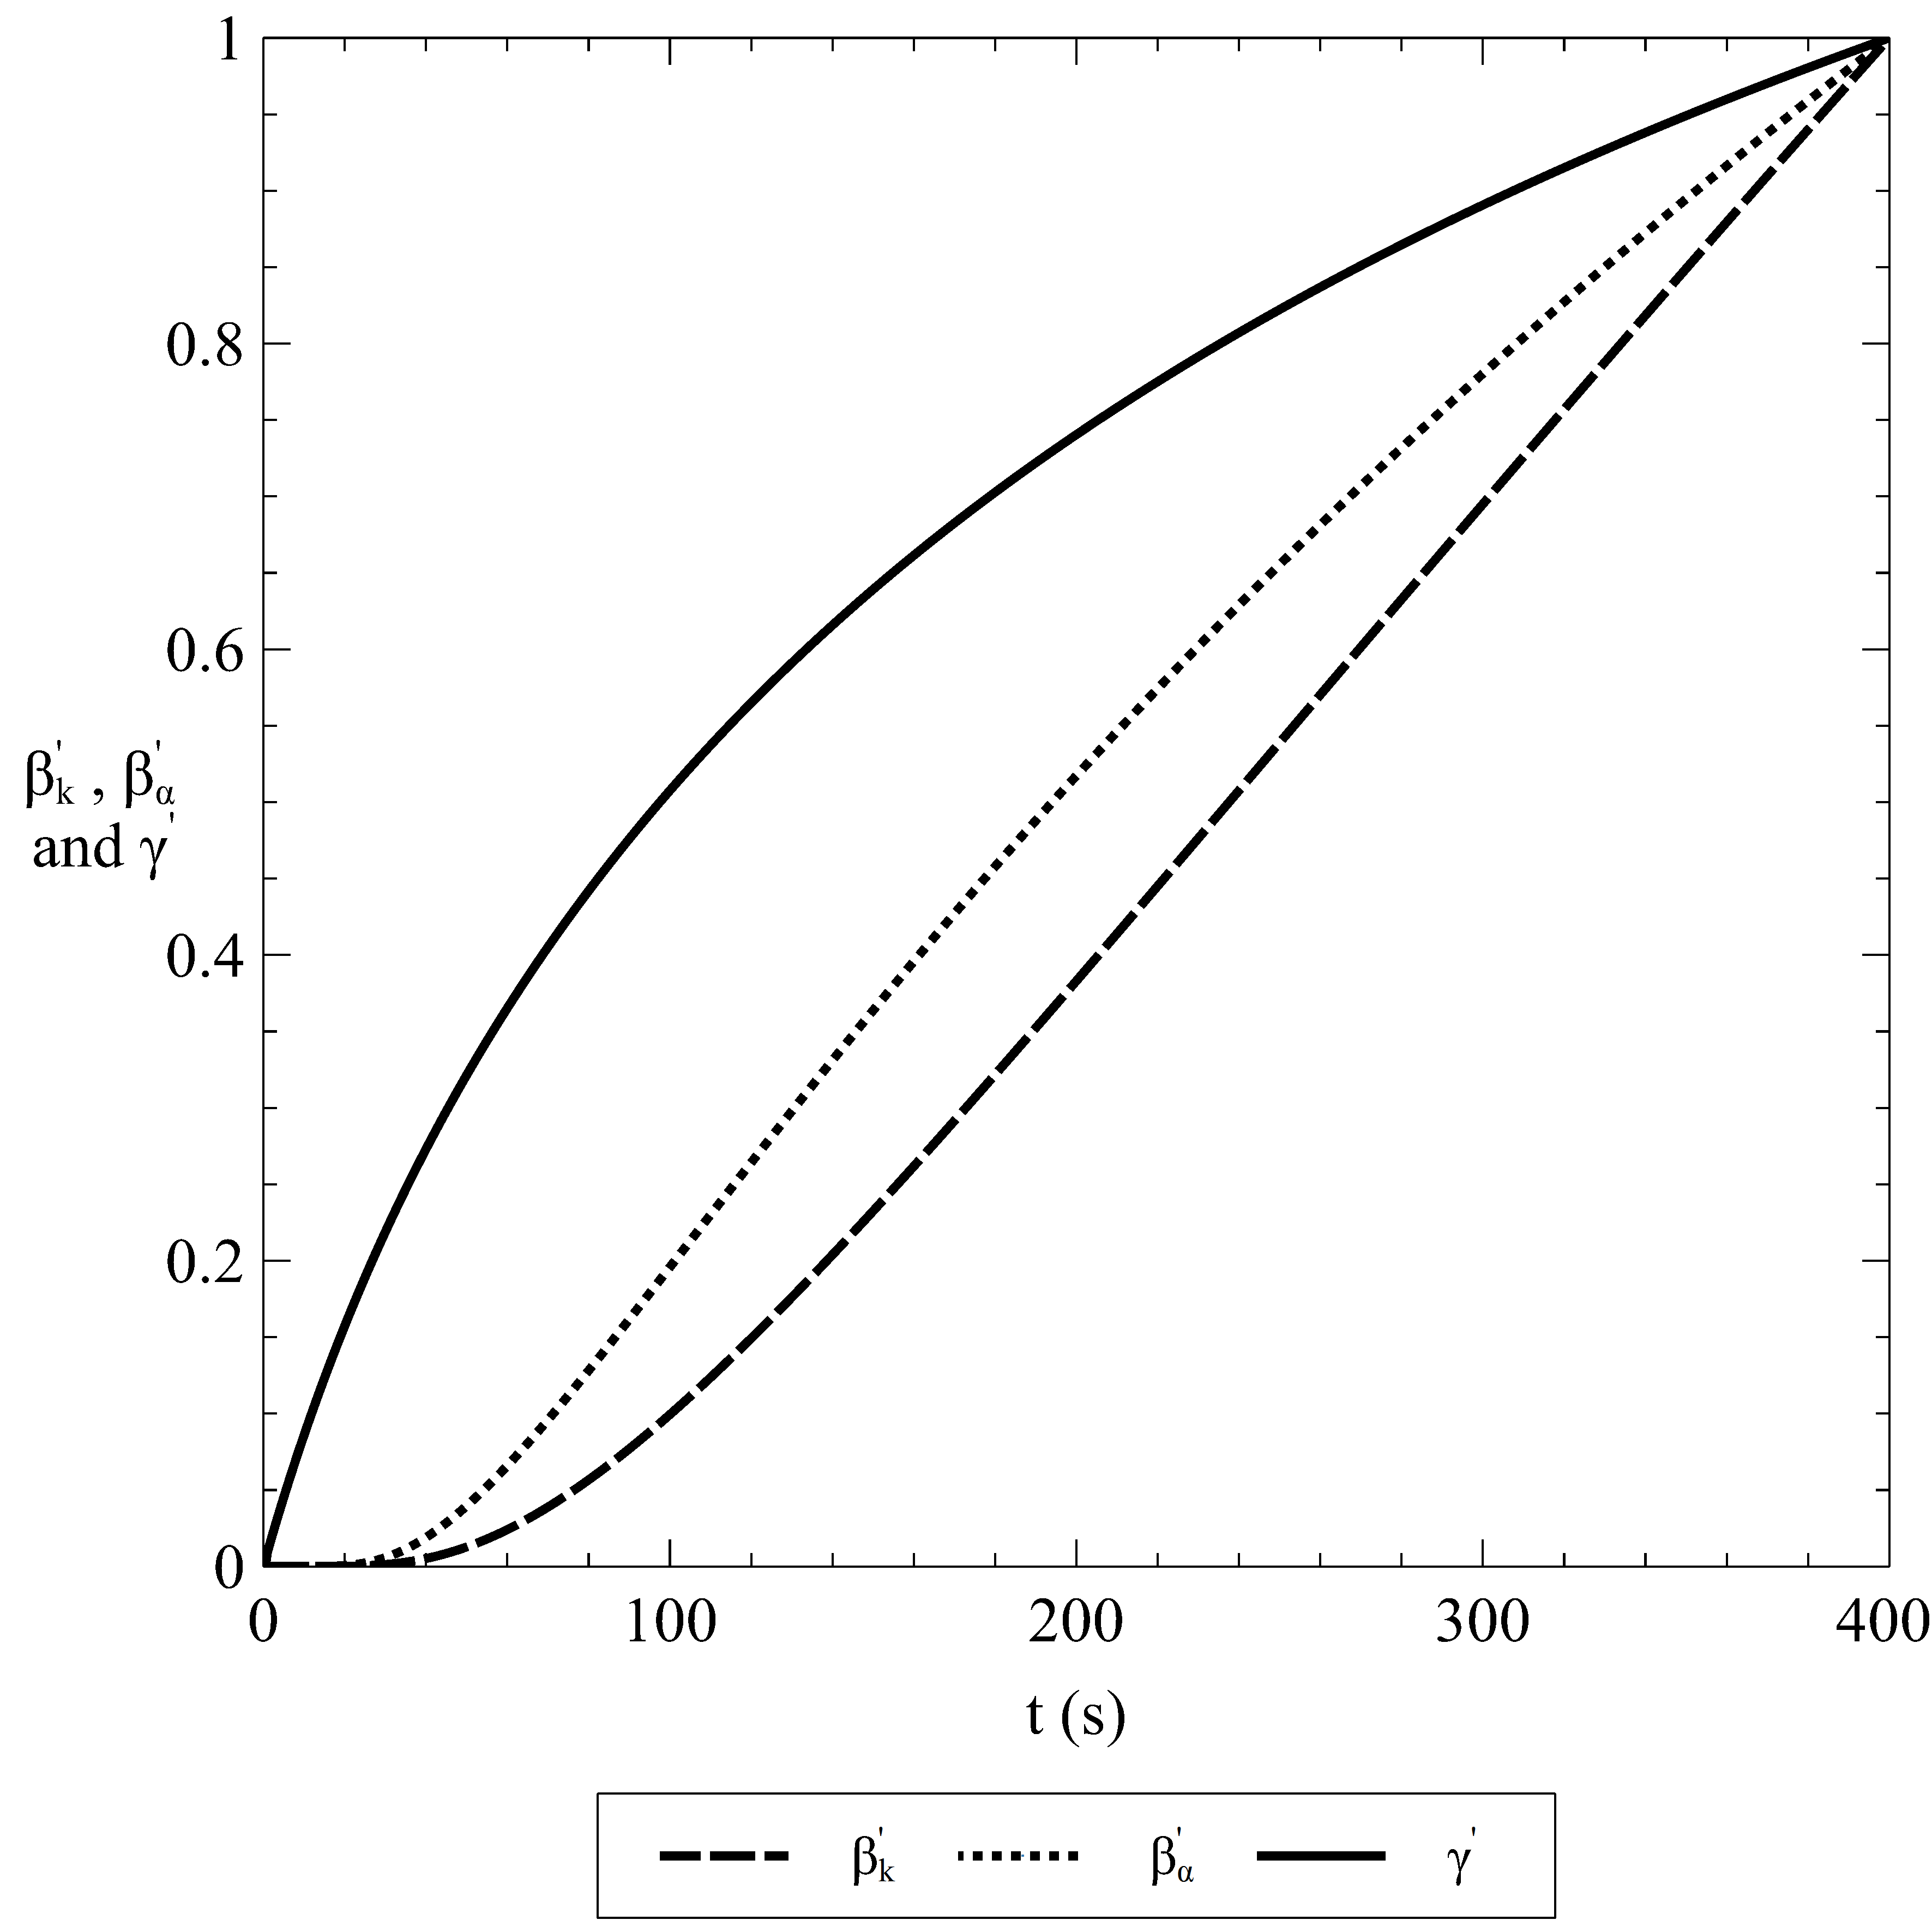

\

\centering 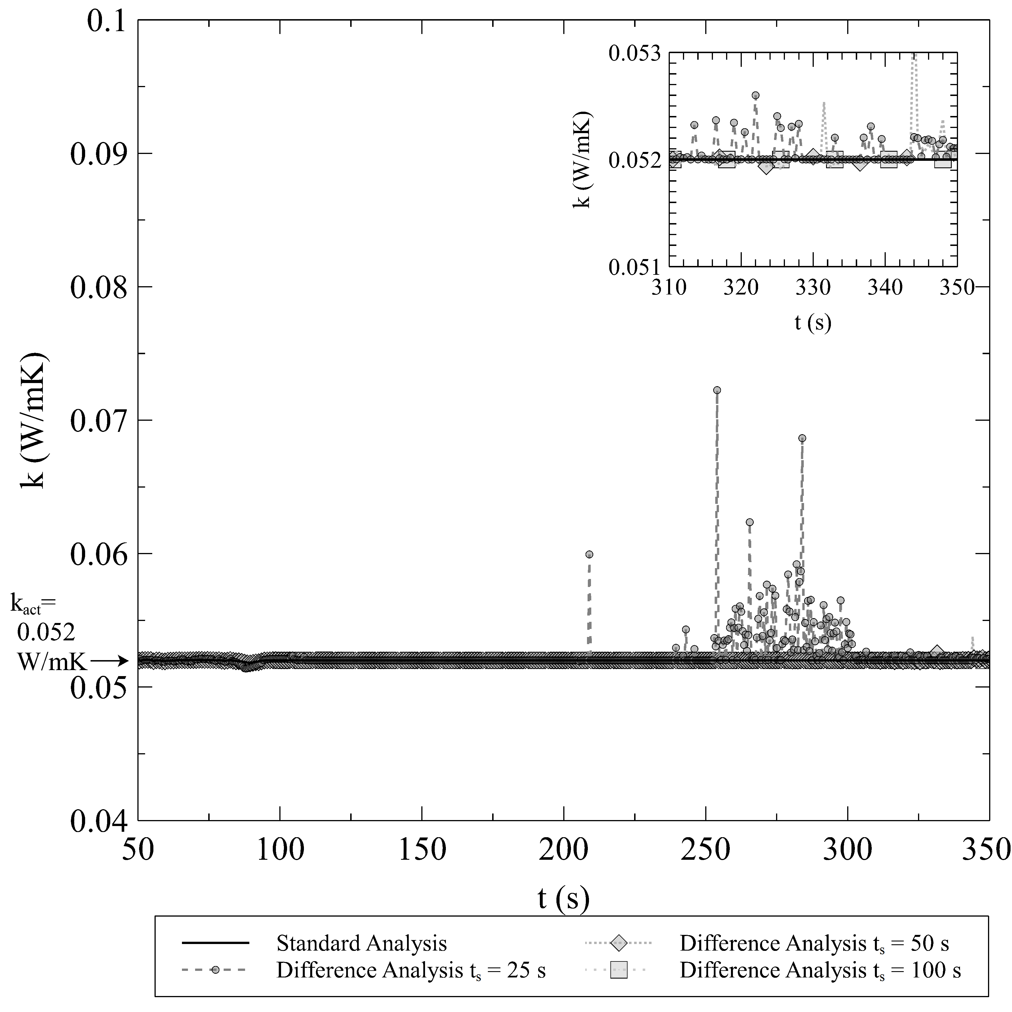

\hfill \centering 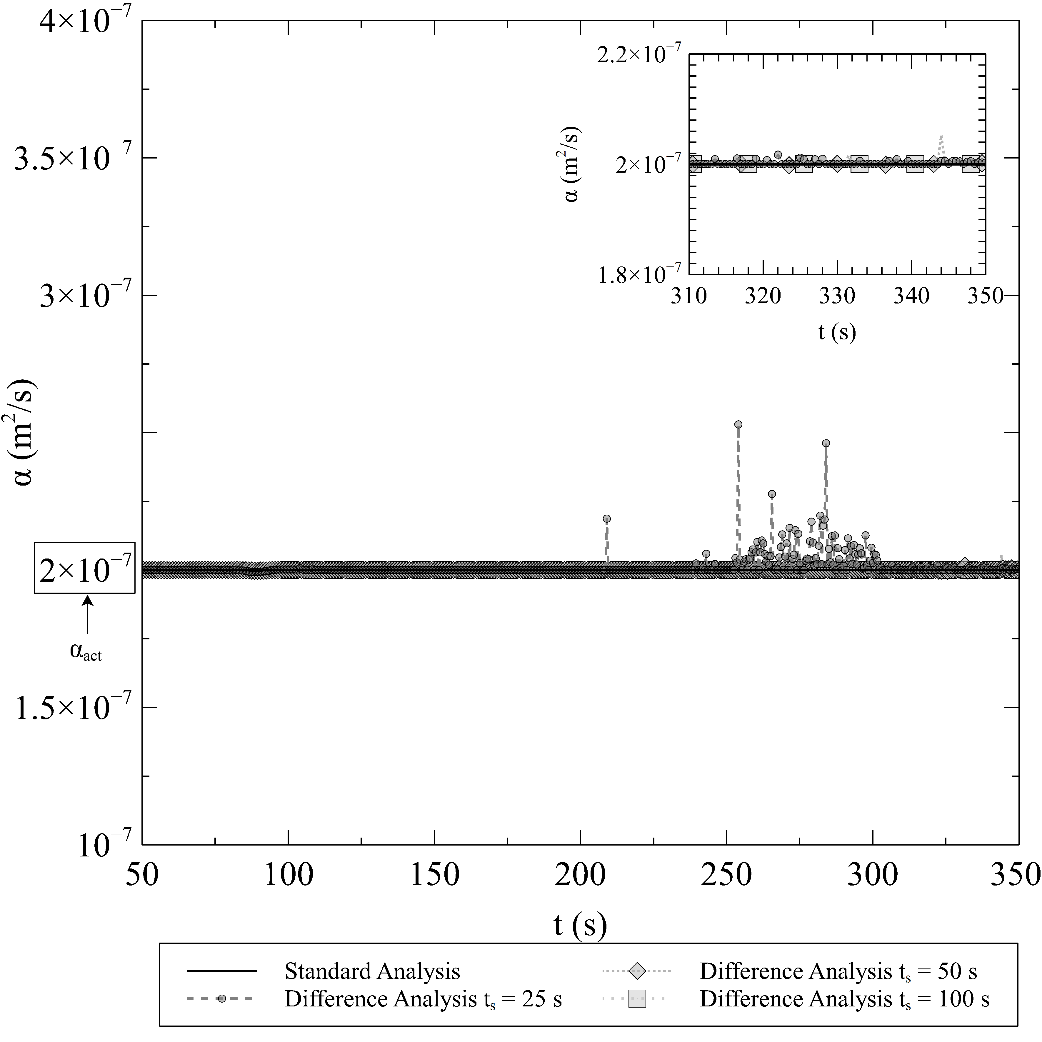

\centering 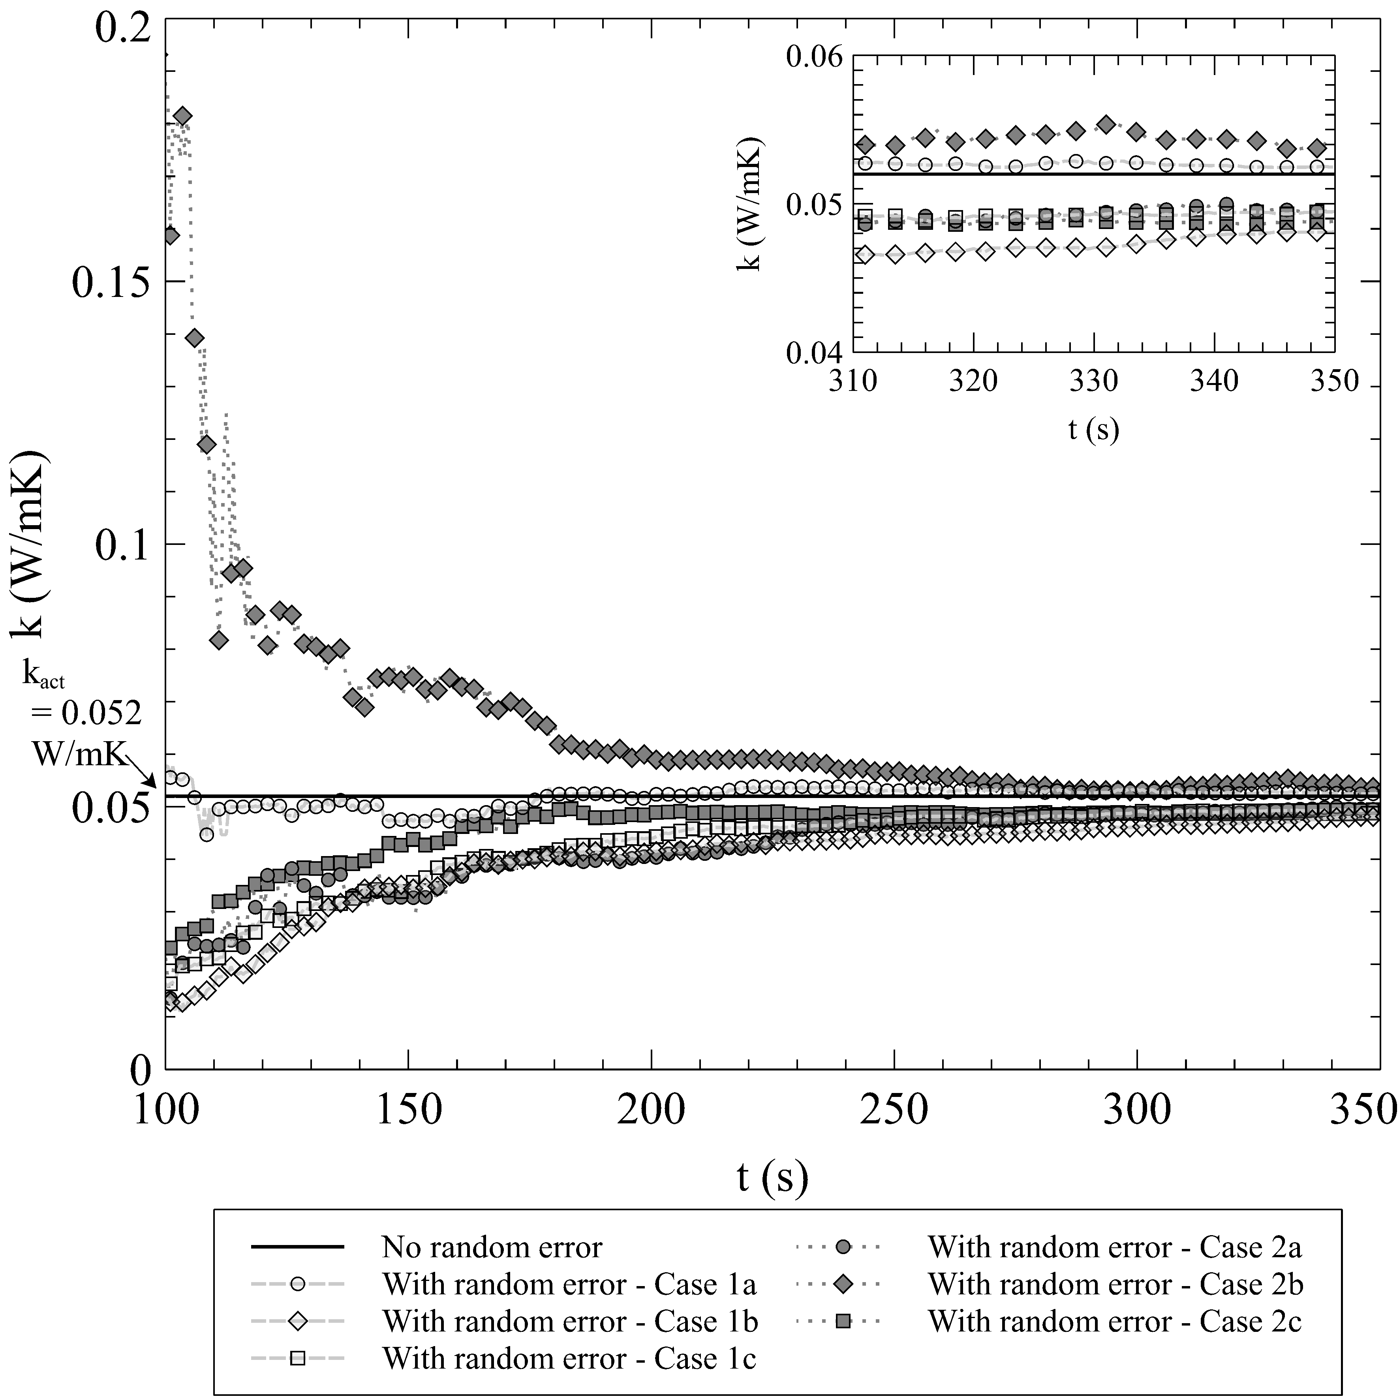

\hfill \centering 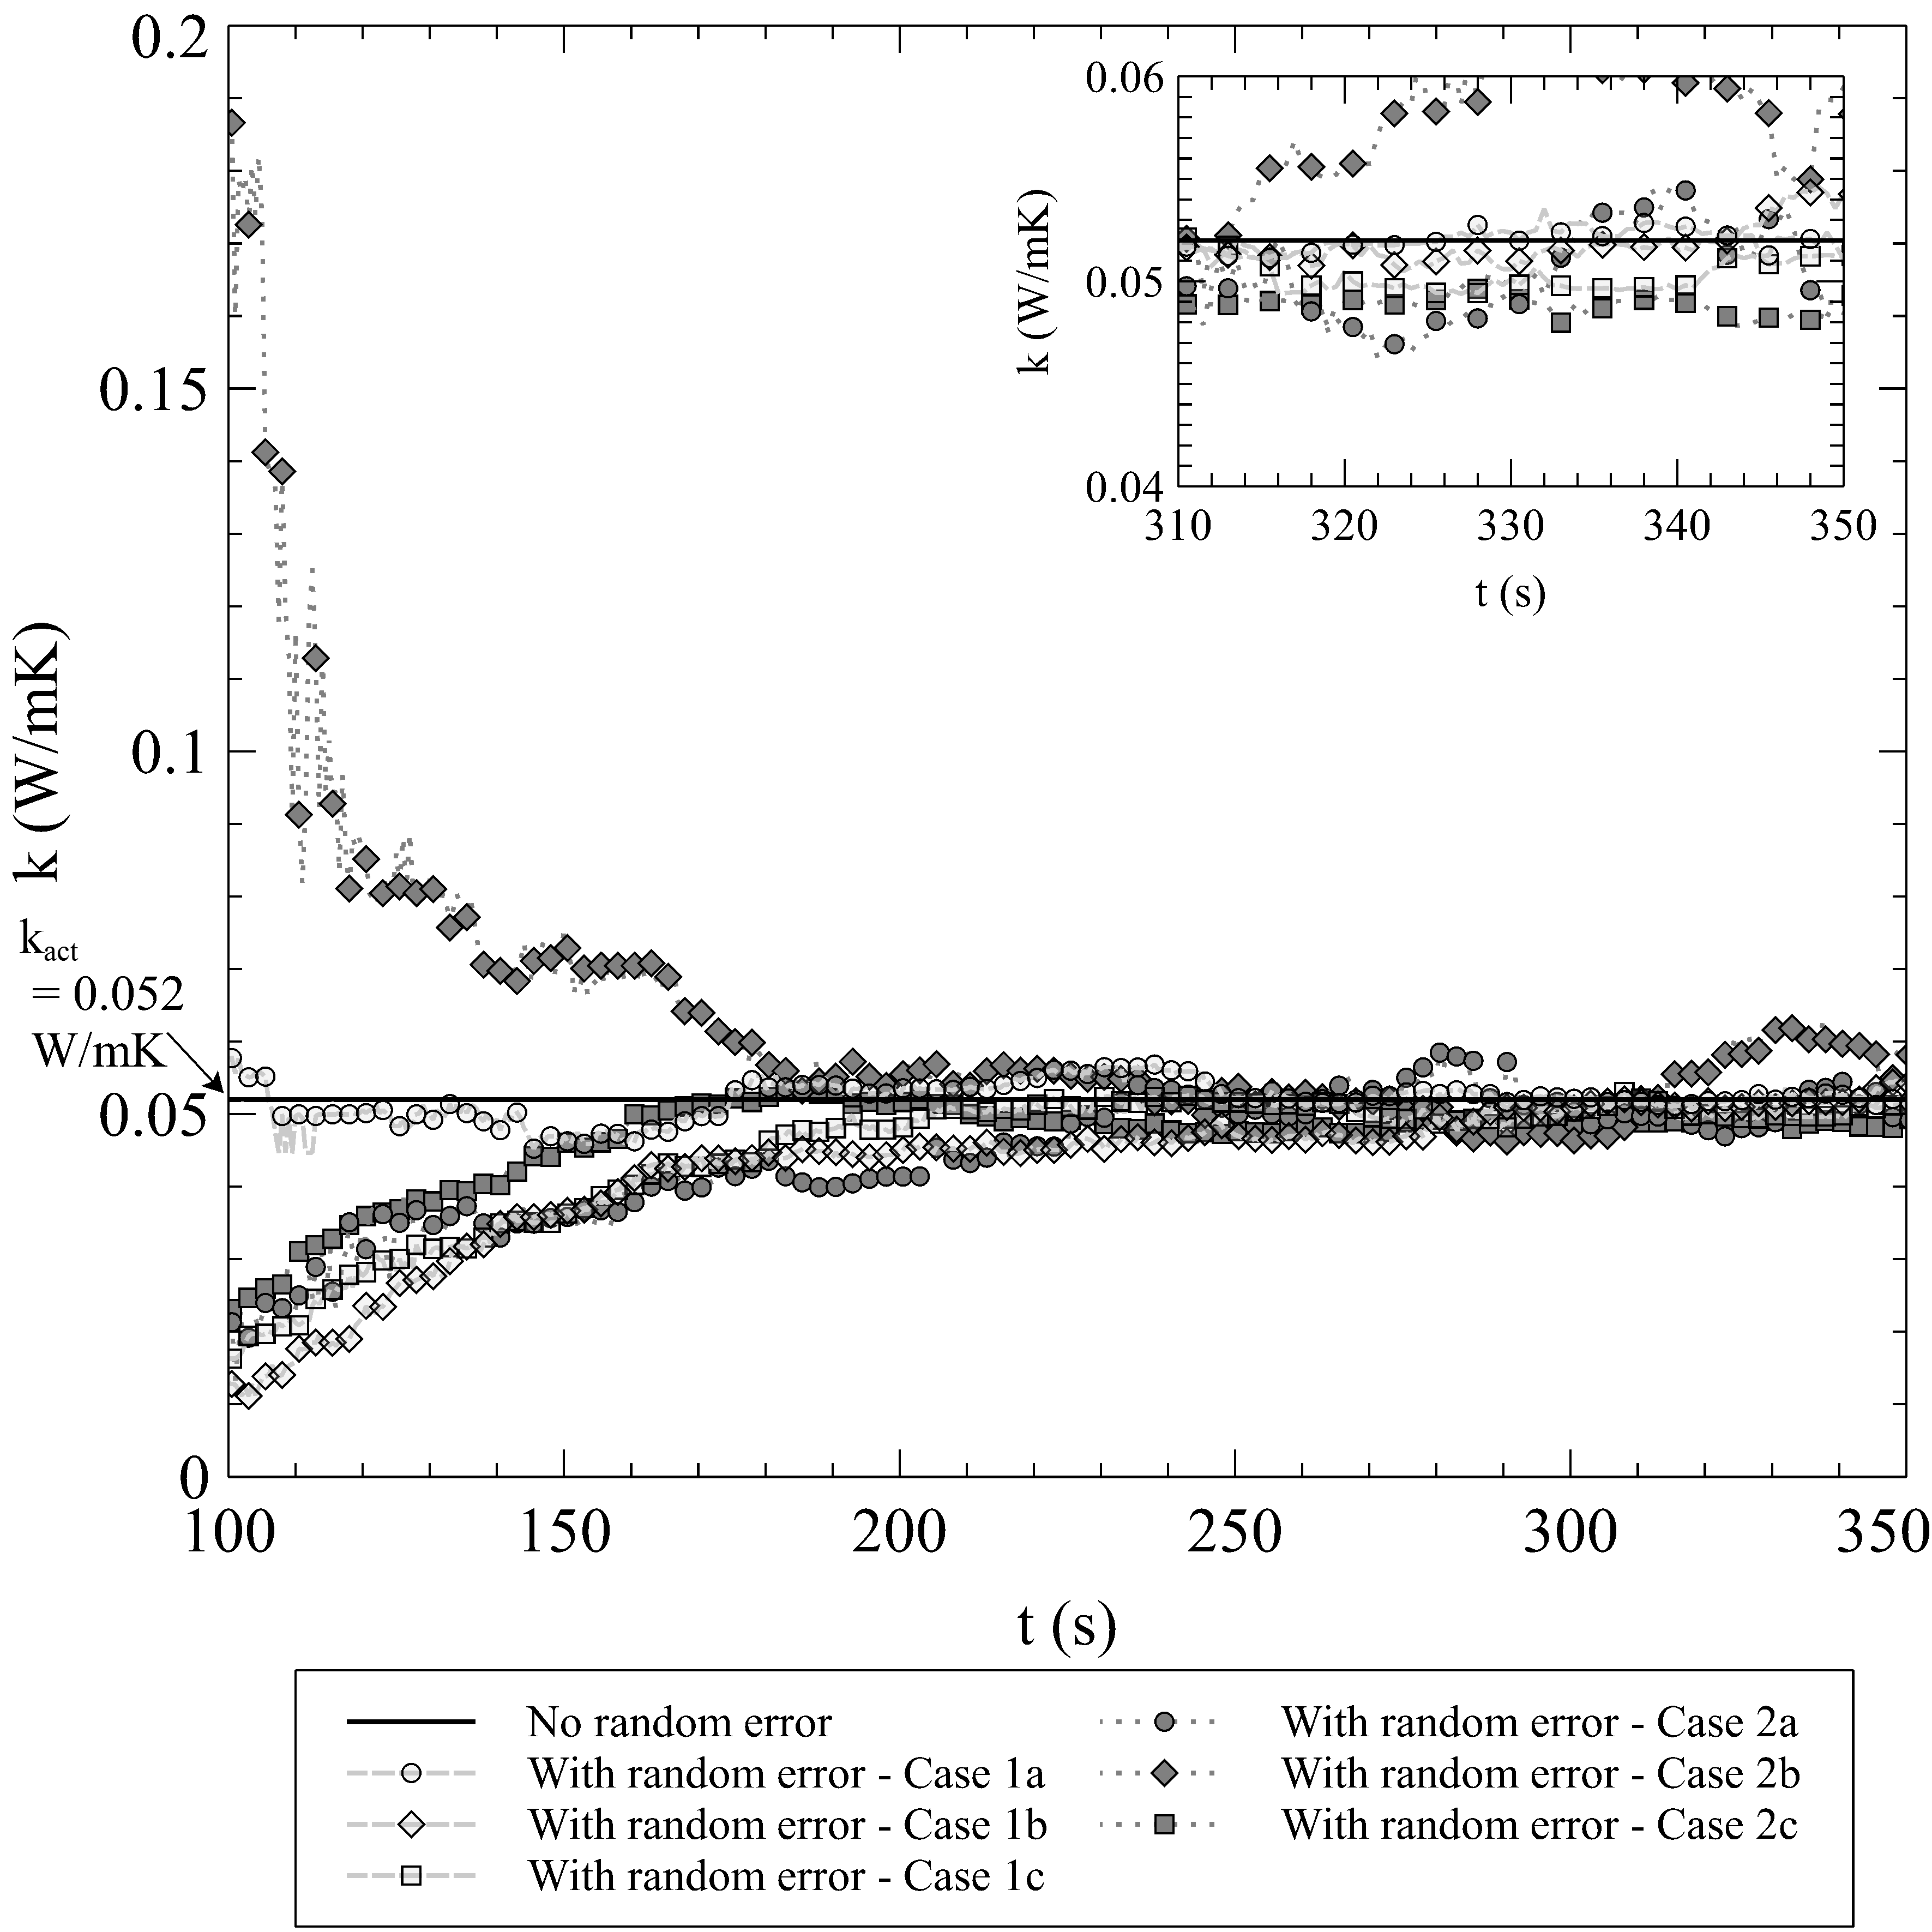

\

\centering 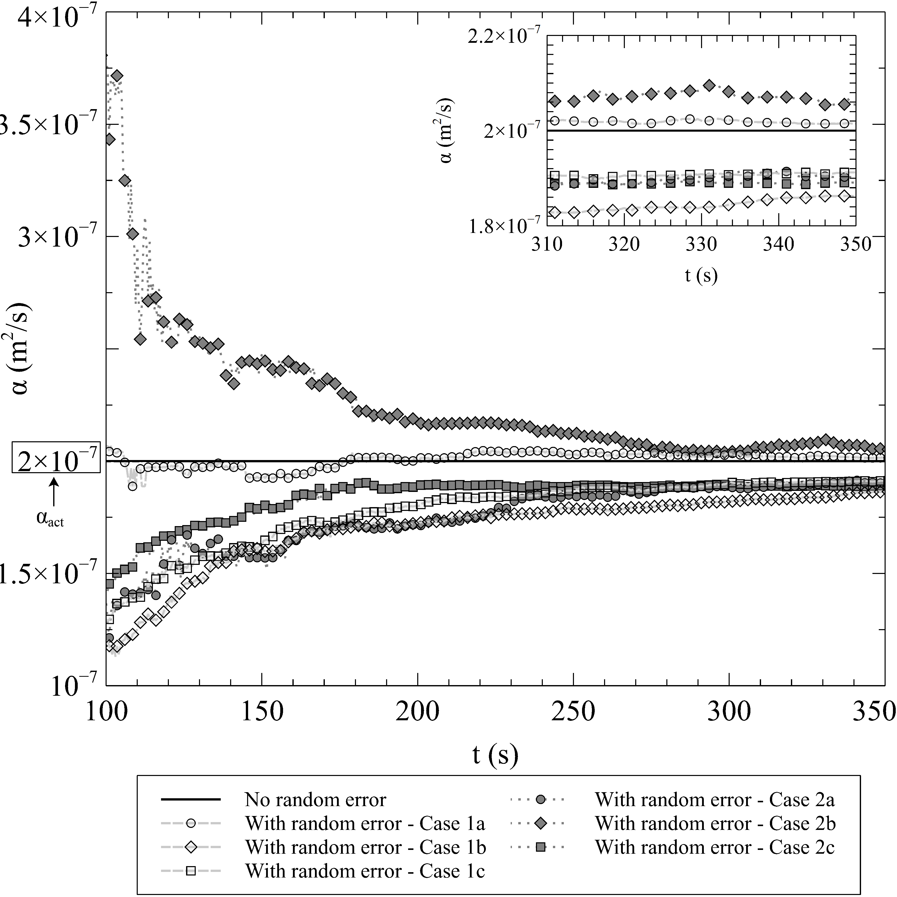

\hfill \centering 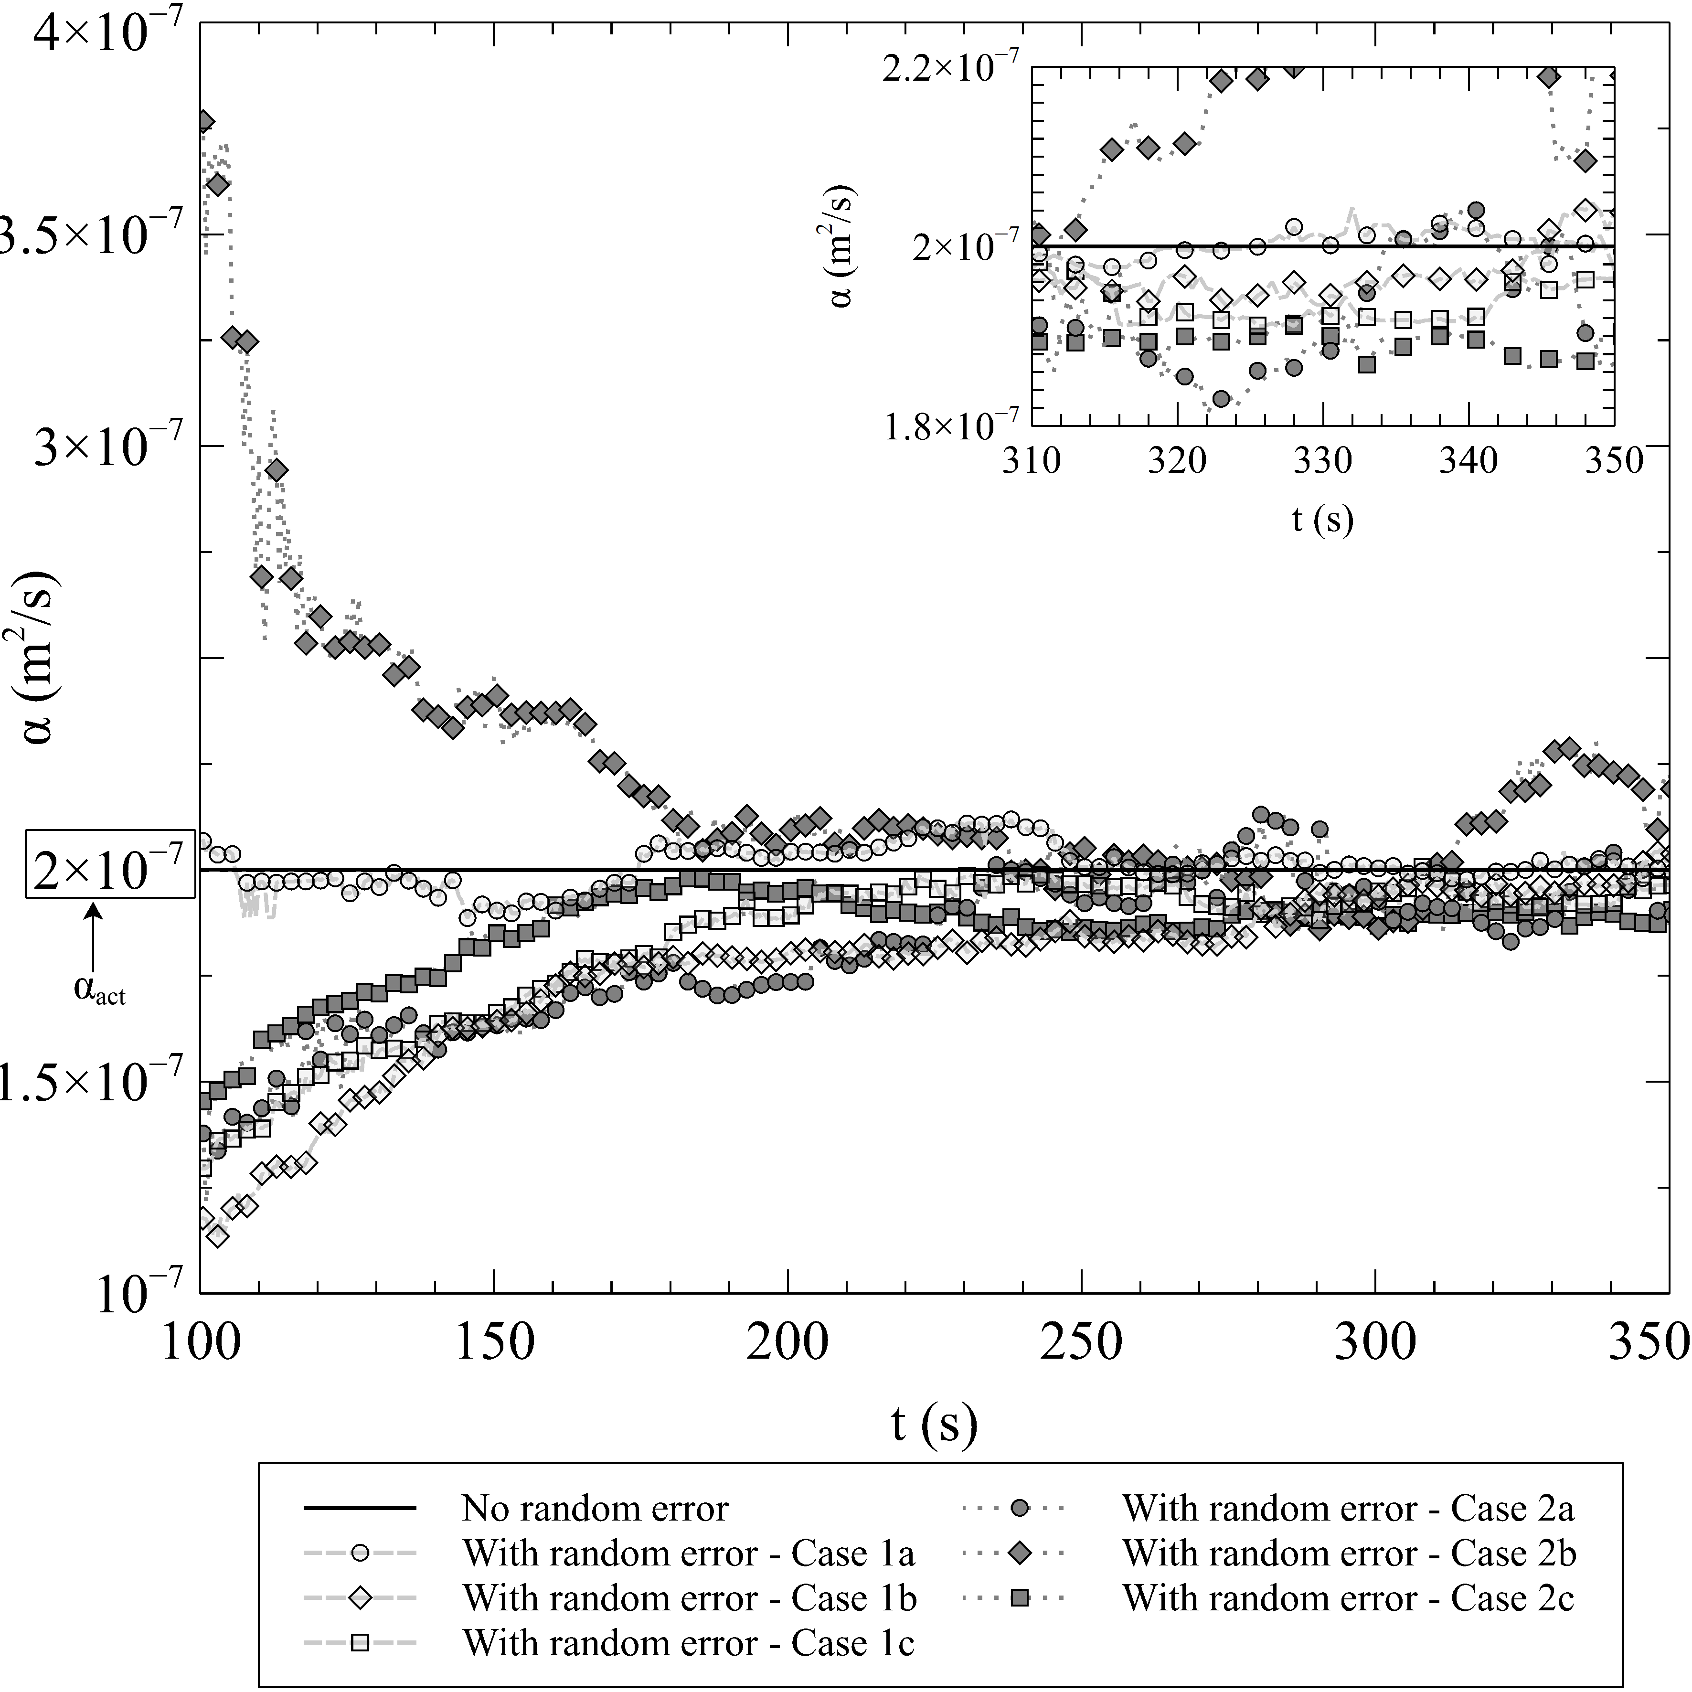

\centering 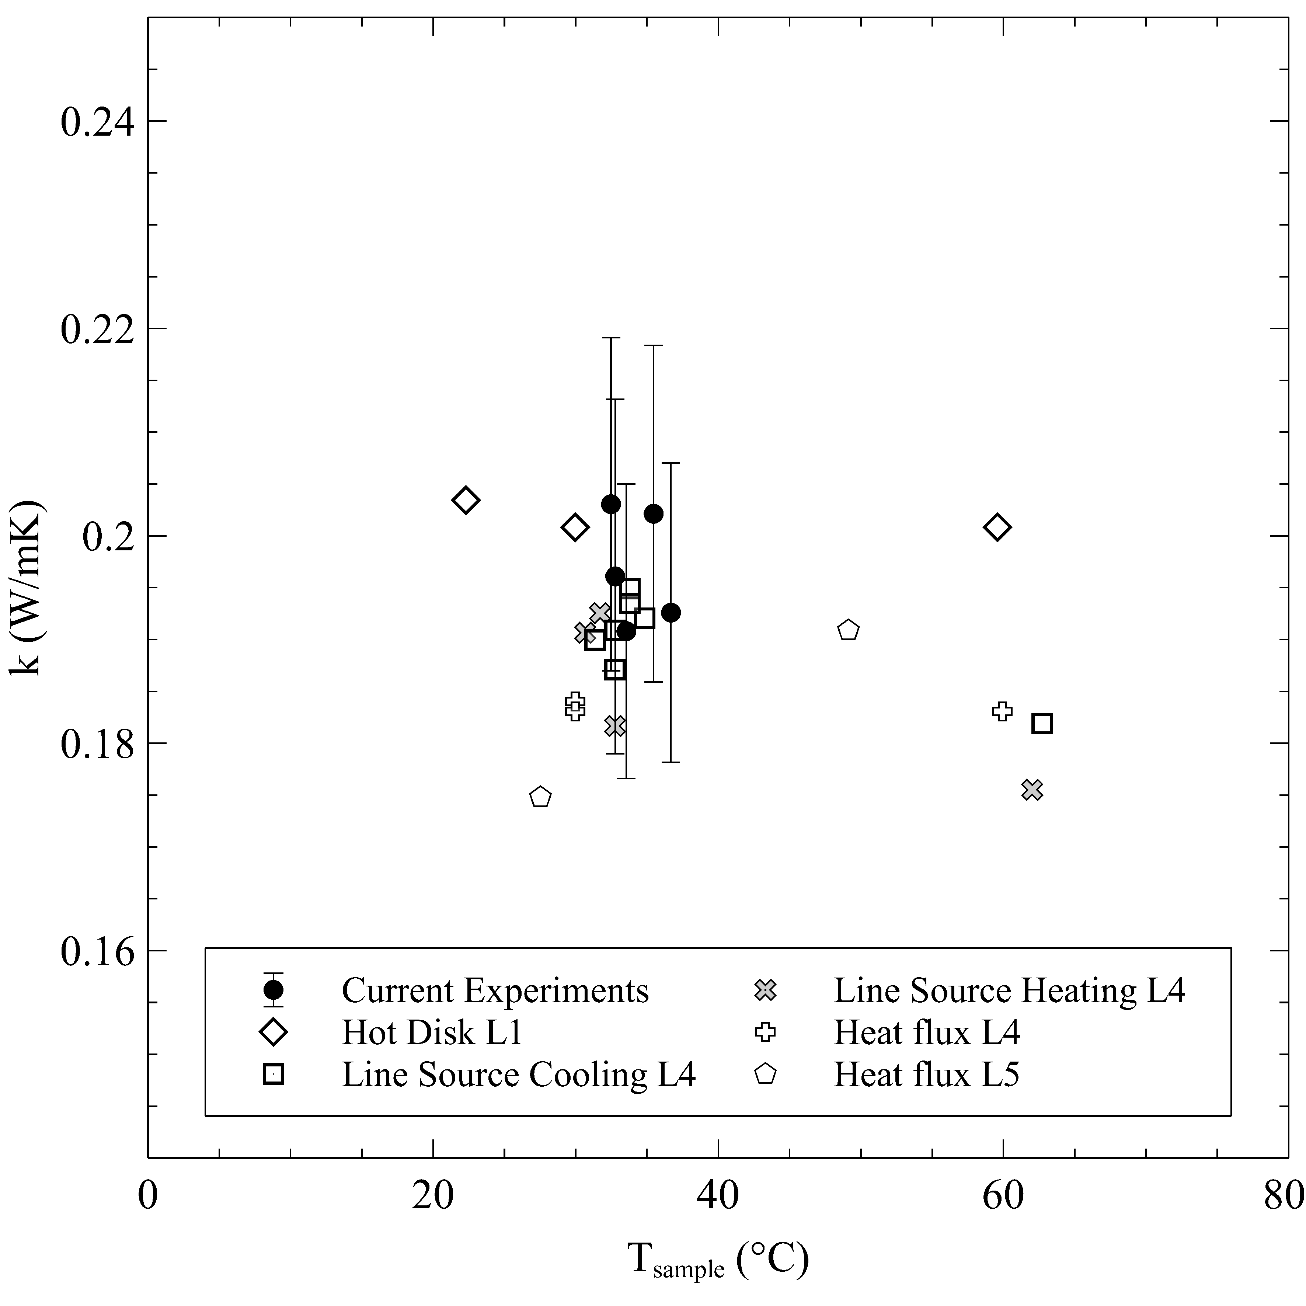

\centering 