网站 主banner 关于我



这种感觉

然后 没一个主题 部分 白色 + 墨绿色底交替

[https://zh.wix.com/website-template/view/html/1722?siteId=73b45f2a-e9a3-4f6d-8b48-1f048f18cd84&metaSiteId=0d0914ab-c028-41b7-9d65-9bed71f79d36&originUrl=https%3A%2F%2Fzh.wix.com%2Fwebsite%2Ftemplates%3Fcriteria%3Dmeditation%26page%3D1](https://zh.wix.com/website-template/view/html/1722?siteId=73b45f2a-e9a3-4f6d-8b48-1f048f18cd84&metaSiteId=0d0914ab-c028-41b7-9d65-9bed71f79d36&originUrl=https://zh.wix.com/website/templates?criteria=meditation&page=1)

[https://zh.wix.com/website-template/view/html/2095?siteId=d9765fb3-9b97-4aa2-9947-ecc5ca6fc6c4&metaSiteId=1075873f-5e01-4eb4-8772-226d97827f65&originUrl=https%3A%2F%2Fzh.wix.com%2Fwebsite%2Ftemplates%3Fcriteria%3Dmeditation%26page%3D1](https://zh.wix.com/website-template/view/html/2095?siteId=d9765fb3-9b97-4aa2-9947-ecc5ca6fc6c4&metaSiteId=1075873f-5e01-4eb4-8772-226d97827f65&originUrl=https://zh.wix.com/website/templates?criteria=meditation&page=1)

Hi, 我Hibi (嗨比)，32岁以前一直是一个从事海外市场的Oversea BD Director/ Marketing Manager. 两年前，一次偶然的机遇接触到了本门派的风水课程，随后在同门师兄的引荐下学习了奇门遁甲诸葛术，从此踏上易学学习推广之路，现在仍在路上。

风水和奇门，这两门课都是我从零基础开始深入学习的，他们逐渐改变了我的生活。

想知道更多背后的故事请点击——————

明师难遇，通过这个平台，我希望给喜欢易学的朋友提供一个指引，同时也乐意分享我一路学习的见闻和心得，共勉，感恩



<https://pixabay.com/zh/vectors/bagua-yin-yang-yang-yin-chinese-1601156/>

<http://www.sccnn.com/shiliangtuku/guanggaosheji/pingmianguanggao/20200618-262551.html>

[https://www.istockphoto.com/jp/%E3%83%99%E3%82%AF%E3%82%BF%E3%83%BC/%E3%82%A6%E3%83%BC%E3%81%AF5%E3%81%A4%E3%81%AE%E8%A6%81%E7%B4%A0%E3%82%92%E3%82%BB%E3%83%83%E3%83%88%E3%83%99%E3%82%AF%E3%82%BF%E3%82%AB%E3%83%A9%E3%83%BC%E3%81%AF%E6%97%A5%E6%9C%AC%E3%81%AE%E8%87%AA%E7%84%B6%E3%81%AE%E3%82%B7%E3%83%B3%E3%83%9C%E3%83%AB%E3%82%92%E5%88%86%E9%9B%A2%E4%B8%AD%E5%9B%BD%E3%81%AE%E6%9B%B8%E9%81%93%E9%A2%A8%E6%B0%B4%E8%B1%A1%E5%BD%A2%E6%96%87%E5%AD%97%E4%B8%AD%E5%9B%BD%E5%B9%B2%E6%94%AF%E5%8D%A0%E6%98%9F%E8%A1%93%E3%81%AE%E3%82%A2%E3%82%A4%E3%82%B3%E3%83%B3%E4%BC%9D%E7%B5%B1%E7%9A%84%E3%81%AA%E3%82%B0%E3%83%A9%E3%83%95%E3%82%A3%E3%83%83%E3%82%AF%E3%83%8F%E3%83%BC%E3%83%A2%E3%83%8B%E3%83%BC%E3%82%A8%E3%83%8D%E3%83%AB%E3%82%AE%E3%83%BC%E3%83%9E%E3%83%B3%E3%83%80%E3%83%A9-gm1148600678-310233984?utm_source=pixabay&utm_medium=affiliate&utm_campaign=SRP_illustration_sponsored&referrer_url=https%3A%2F%2Fpixabay.com%2Fzh%2Fillustrations%2Fsearch%2F%25E9%25A3%258E%25E6%25B0%25B4%2F&utm_term=%E9%A3%8E%E6%B0%B4](https://www.istockphoto.com/jp/%E3%83%99%E3%82%AF%E3%82%BF%E3%83%BC/%E3%82%A6%E3%83%BC%E3%81%AF5%E3%81%A4%E3%81%AE%E8%A6%81%E7%B4%A0%E3%82%92%E3%82%BB%E3%83%83%E3%83%88%E3%83%99%E3%82%AF%E3%82%BF%E3%82%AB%E3%83%A9%E3%83%BC%E3%81%AF%E6%97%A5%E6%9C%AC%E3%81%AE%E8%87%AA%E7%84%B6%E3%81%AE%E3%82%B7%E3%83%B3%E3%83%9C%E3%83%AB%E3%82%92%E5%88%86%E9%9B%A2%E4%B8%AD%E5%9B%BD%E3%81%AE%E6%9B%B8%E9%81%93%E9%A2%A8%E6%B0%B4%E8%B1%A1%E5%BD%A2%E6%96%87%E5%AD%97%E4%B8%AD%E5%9B%BD%E5%B9%B2%E6%94%AF%E5%8D%A0%E6%98%9F%E8%A1%93%E3%81%AE%E3%82%A2%E3%82%A4%E3%82%B3%E3%83%B3%E4%BC%9D%E7%B5%B1%E7%9A%84%E3%81%AA%E3%82%B0%E3%83%A9%E3%83%95%E3%82%A3%E3%83%83%E3%82%AF%E3%83%8F%E3%83%BC%E3%83%A2%E3%83%8B%E3%83%BC%E3%82%A8%E3%83%8D%E3%83%AB%E3%82%AE%E3%83%BC%E3%83%9E%E3%83%B3%E3%83%80%E3%83%A9-gm1148600678-310233984?utm_source=pixabay&utm_medium=affiliate&utm_campaign=SRP_illustration_sponsored&referrer_url=https://pixabay.com/zh/illustrations/search/%E9%A3%8E%E6%B0%B4/&utm_term=%E9%A3%8E%E6%B0%B4)

<https://pixabay.com/zh/vectors/bagua-yin-yang-yang-yin-chinese-1601156/>

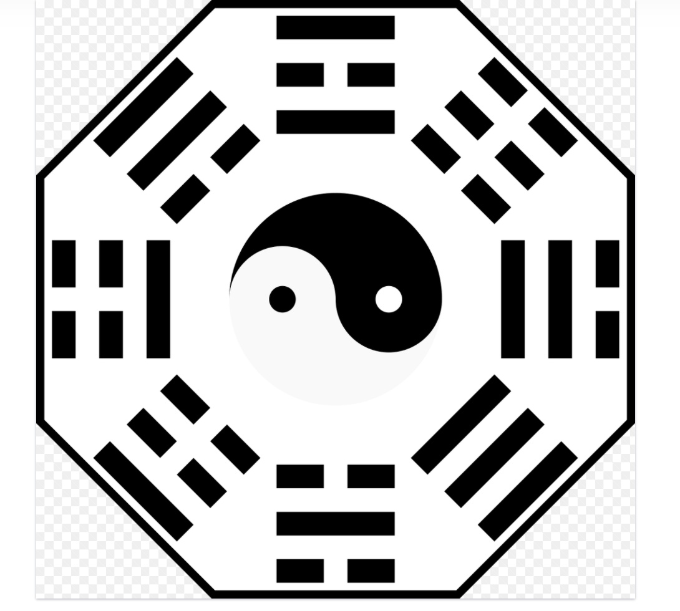

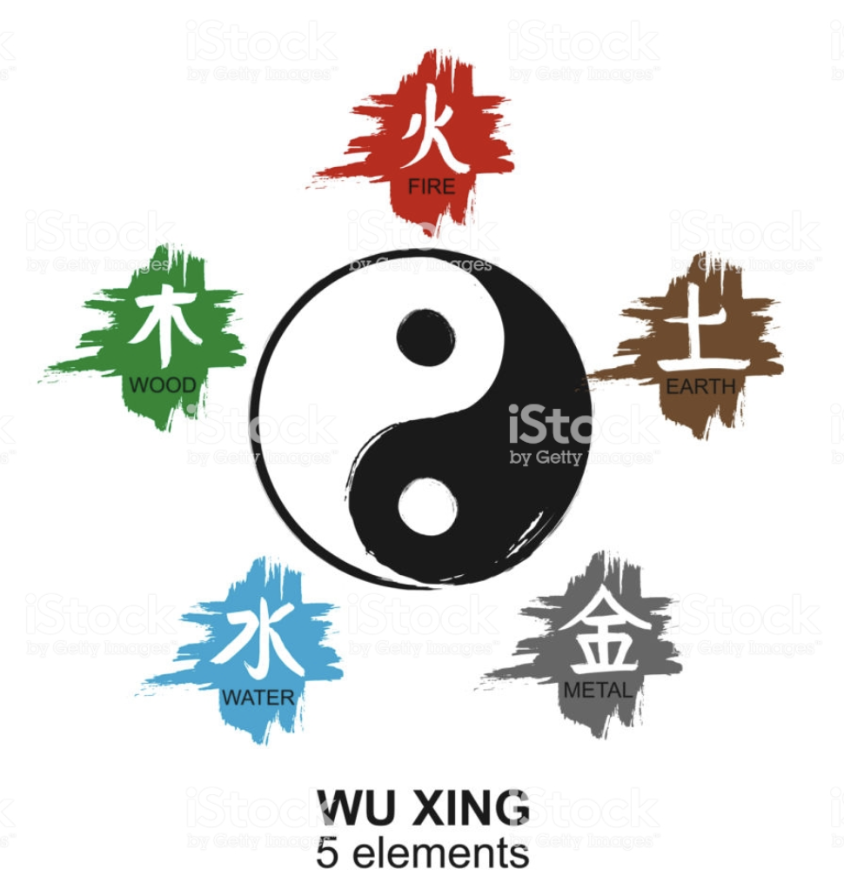

[https://www.istockphoto.com/jp/%E3%83%99%E3%82%AF%E3%82%BF%E3%83%BC/5%E3%81%A4%E3%81%AE%E8%A6%81%E7%B4%A0%E7%90%86%E8%AB%96-gm1175031536-327033892?utm_source=pixabay&utm_medium=affiliate&utm_campaign=SRP_illustration_sponsored&referrer_url=https%3A%2F%2Fpixabay.com%2Fzh%2Fillustrations%2Fsearch%2F%25E9%25A3%258E%25E6%25B0%25B4%2F&utm_term=%E9%A3%8E%E6%B0%B4](https://www.istockphoto.com/jp/%E3%83%99%E3%82%AF%E3%82%BF%E3%83%BC/5%E3%81%A4%E3%81%AE%E8%A6%81%E7%B4%A0%E7%90%86%E8%AB%96-gm1175031536-327033892?utm_source=pixabay&utm_medium=affiliate&utm_campaign=SRP_illustration_sponsored&referrer_url=https://pixabay.com/zh/illustrations/search/%E9%A3%8E%E6%B0%B4/&utm_term=%E9%A3%8E%E6%B0%B4)

针对毫无基础但是有兴趣的年轻用户群

避开凶宅，趋吉避凶调整风水

租房 找商铺店面 买房 风水好坏 不求人

催财 催丁 催桃花 自己就能搞定

化煞为权为贵



<http://www.sccnn.com/gaojingtuku/guanggaosheji/pingmianguanggao/20150202-128913.html>

<https://www.58pic.com/psd/17149238.html>

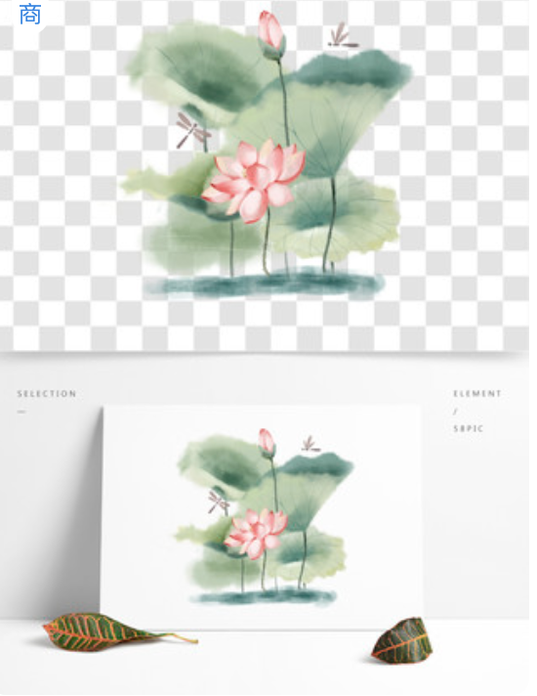

<https://www.58pic.com/newpic/36030573.html>

🌟 Hibi风水奇门工作坊--奇门遁甲简介

1️⃣ 奇门遁甲古时用于布兵打仗称之为帝王之术，现代生活用于生活百事预测，趋吉避凶

2️⃣ 奇门遁甲是一个时空模型，地盘不动，神盘、天盘、人盘每个时辰（每2小时）转动一次，得到的结果即发生变化，发问时间很关键

3️⃣ 奇门遁甲市面上五花八门，真真假假，本门派为诸葛奇门术，市面仅有一家，诸葛亮是本门派的祖师爷，法不轻传

4️⃣ 没有一个门派的占卜术可以做到百分之百准确，《了凡四训》都告诉我们可以改命的道理，当下一个善念都会影响结果和走向，相由心生，境由心造 🥗

冥冥之中天意

开盘即可知吉凶 做出更利于我们的选择

抉择、健康、升迁、感情、投资等生活百事，我都可以

根据您当下的排盘解读冥冥之中的天意，告诉您最有的选择

做抉择的时候，哪个更好？

这次手术会顺利吗？

这段婚姻会离婚收场吗？

公司晋升我有没有希望？

朋友拉我参与一项投资，能不能做？

[https://www.google.com/imgres?imgurl=http%3A%2F%2Ffanblogs.jp%2Fninestareightphenomenon%2Ffile%2FE585ABE99680.png&imgrefurl=http%3A%2F%2Ffanblogs.jp%2Fninestareightphenomenon%2Farchive%2F76%2F0&tbnid=3HijHy2lrSL-4M&vet=10CB8QMygPahcKEwi4xb7_zo3qAhUAAAAAHQAAAAAQAw..i&docid=UHr-Kw6gWbD4QM&w=600&h=595&q=%E5%A5%87%E9%97%A8%E9%81%81%E7%94%B2%E5%85%AB%E9%97%A8&ved=0CB8QMygPahcKEwi4xb7_zo3qAhUAAAAAHQAAAAAQAw](https://www.google.com/imgres?imgurl=http://fanblogs.jp/ninestareightphenomenon/file/E585ABE99680.png&imgrefurl=http://fanblogs.jp/ninestareightphenomenon/archive/76/0&tbnid=3HijHy2lrSL-4M&vet=10CB8QMygPahcKEwi4xb7_zo3qAhUAAAAAHQAAAAAQAw..i&docid=UHr-Kw6gWbD4QM&w=600&h=595&q=%E5%A5%87%E9%97%A8%E9%81%81%E7%94%B2%E5%85%AB%E9%97%A8&ved=0CB8QMygPahcKEwi4xb7_zo3qAhUAAAAAHQAAAAAQAw)

