**Crop Recommendation System**

A

***Industrial/Field Project Report***

submitted

in partial fulfilment

for the award of the degree of

***Bachelor of Technology***

***in department of******Computer Science***

***with specialization in Computer Science***

***Supervisor*** ***Submitted by***

***Mr. Anil Rao Aashish Kumar Saini Project supervisor 22ELDCS003***

**Department of Computer Science and Engineering**

**Laxmi Devi Institute of Engineering and Technology, Alwar**

**Bikaner Technical University**

**June – 2025**

**CANDIDATE’S DECLARATION**

I hereby declare that the work, which is being presented in the Dissertation, entitled **“Crop Recommendation System”** in partial fulfillment for the award of Degree of “Bachelor of Technology” in Department of Computer Science & Engineering with Specialization in Computer Science & Engineering , and submitted to the **Department of Computer Science & Engineering, Laxmi Devi Institute of Engineering & Technology, Alwar,** Rajasthan Technical University is a record of my own investigations carried under the Guidance of **Mr. Anil Rao**, Department of Computer Science Engineering, LIET Alwar.

I have not submitted the matter presented in this report anywhere for the award of any other Degree.

**Student Name: Aashish Kumar Saini**

**Branch: CSE**

**Roll no: 22ELDCS003**

**Laxmi Devi Institute of Engineering & Technology, Alwar**

**Counter Signed by**

**Mr. Anil Rao**

**Associate Professor**

**Computer Science & Engineering Department**

**LIET, Alwar**

**Date:**

**CERTIFICATE**

This is certified that the Dissertation titled “Crop Recommendation System” submitted by Aashish Kumar Saini to Laxmi Devi Institute of Engineering & Technology, Alwar, affiliated to Bikaner Technical University, Bikaner for the award of the Degree of Bachelor of Technology in Computer Science & Engineering is a record of bona-fide work carried out by him under my supervision. In my opinion, the dissertation has reached the standards of fulfilling the requirements of the regulations to degree.

Mr. Anil Rao

Associate Professor

Computer Science & Engineering Department

LIET, Alwar

Date:

Dr. Pratap Singh Patwal

(HOD CSE)

**ABSTRACT**

Agriculture remains the cornerstone of the Indian economy, employing a significant portion of the population and contributing substantially to the country's GDP. However, with increasing climate unpredictability, soil degradation, and lack of awareness about scientific farming techniques, farmers often face difficulties in selecting the most appropriate crop for cultivation. Traditional farming practices, which rely heavily on generational knowledge and intuition, may not always yield optimal results in modern, rapidly changing environmental conditions. To address this gap, the present project proposes a **Crop Recommendation System**, a machine learning-based solution designed to assist farmers and agricultural stakeholders in making data-driven decisions for crop selection.

The proposed system is a web-based application that takes into account critical agricultural parameters such as **nitrogen (N), phosphorus (P), potassium (K) levels, temperature, humidity, pH**, and **rainfall**. These features are standardized using **StandardScaler** to ensure uniform scaling and are fed into a **Random Forest algorithm**, which identifies suitable crops based on the input data. A dictionary mapping links each cluster to a specific crop, which is then displayed to the user along with a corresponding image. The backend is developed using **Python** and **scikit-learn**, while the web interface is built using **Flask**, ensuring a lightweight and responsive experience for users.

The rationale behind this system is rooted in the growing need for **precision agriculture** leveraging data and technology to optimize farming outputs. By adopting a machine learning approach, the system eliminates guesswork and introduces a scientific method for crop planning, thereby potentially increasing yield and profitability. The use of **open-source tools** such as Flask, scikit-learn, and Jupyter Notebook makes the system both **cost-effective and scalable**, ensuring accessibility even on low-end hardware.

This application is not only technically feasible but also highly relevant, especially in rural and underdeveloped regions where access to expert agricultural advice is limited. The expected outcomes include accurate crop recommendations, a user-friendly interface for data entry and results, visual display of recommended crops, and the potential for future expansion to accommodate real-time weather integration, disease prediction, or mobile app deployment.

In conclusion, the Crop Recommendation System stands as a practical and innovative step towards **smart agriculture**, combining domain expertise with machine learning to empower farmers with actionable insights and foster sustainable farming practices.

**ACKNOWLEDGEMENT**

I like to thank our chairman **Shri Manoj Chachan** and **Dr. Rajesh Bhardwaj, Group Director of LIET**, for providing us such a great infrastructure and environment for our overall development.

We express sincere thanks to Principal **Dr. Manvijay Singh** the vice Principal of LIET, for his kind cooperation and extensible support toward the completion of our Project.

Words are inadequate in offering our thanks to **Dr. Pratap Singh Patwal**, H.O.D of CSE Department, for consistent encouragement. Also, for his support in providing technical requirement and fulfilling our various other requirements for making our project success.

We would like to thank our project guide **Mr. Anil Rao**, Asst. Prof. CSE Department for shaping our project in the presentable form. Also, for his support and guiding us to make this project successful. Without his support and management, we would not able to accomplished our goal.

We also like to express our thanks to all supporting CSE faculty members who have been a constant source of encouragement for successful completion of the project.

Also, our warm thanks to Laxmi Devi Institute of Engineering & Technology, who provide us this opportunity to carry out this prestigious project and enhance our learning in various technical fields.

**Aashish Kumar Saini**

**22ELDCS003**

**TABLE OF CONTENTS**

**1.INTRODUCTION...............................................................................................1**

1.1. BACKGROUND...............................................................................................1

1.2. RELATED WORK............................................................................................2

1.3. EXISTING SYSTEM........................................................................................3

1.4. DISADVANTAGES OF EXISTING SYSTEM ...............................................4

1.5. PROPOSED SYSTEM .....................................................................................5

1.6. ADVANTAGES OF THE PROPOSED SYSTEM ...........................................6

**2. REQUIREMENT ANALYSIS & SYSTEM SPECIFICATION…………......8**

2.1. STAKEHOLDER ANALYSIS .........................................................................8

2.2. FUNCTIONAL REQUIREMENTS ...............................................................10

2.3. NON-FUNCTIONAL REQUIREMENTS .....................................................11

2.4. SOFTWARE REQUIREMENTS ....................................................................12

2.5. HARDWARE REQUIREMENTS ..................................................................13

2.6. USE CASE DIAGRAM ..................................................................................14

2.7. SYSTEM ARCHITECTURE ..........................................................................15

**3. SYSTEM DESIGN ...........................................................................................17**

3.1. SYSTEM STUDY ...........................................................................................17

3.2. DATASET USED ............................................................................................18

3.3. DATA PRE-PROCESSING ............................................................................19

3.4. FLOWCHARTS AND DFDs ..........................................................................21

3.5. MODULE DESCRIPTION .............................................................................23

**4. IMPLEMENTATION, TESTING & DEPLOYMENT .................................26**

4.1. AIM OF THE PROJECT ................................................................................26

4.2. TECHNOLOGIES USED ...............................................................................27

4.2.1. PYTHON .............................................................................………………28

4.2.2. NUMPY & PANDAS ...................................................................................29

4.2.3. SCIKIT-LEARN ..........................................................................................30

4.2.4. FLASK FRAMEWORK ..............................................................................31

4.2.5. HTML/CSS & JINJA2 .................................................................................33

4.3. MACHINE LEARNING MODEL (RANDOM FOREST) ……....................34

4.4. WEB APP INTEGRATION ............................................................................36

4.5. TESTING STRATEGIES ...............................................................................38

4.6. DEPLOYMENT .............................................................................................40

**5. RESULTS AND DISCUSSION .......................................................................42**

5.1. SYSTEM OUTPUT SNAPSHOTS .................................................................42

5.2. PERFORMANCE METRICS ........................................................................44

5.3. ANALYSIS AND INTERPRETATION ..........................................................46

5.4. USER FEEDBACK AND SATISFACTION ..................................................47

**6. CONCLUSION & FUTURE SCOPE .............................................................49**

6.1. SUMMARY OF FINDINGS ...........................................................................49

6.2. LIMITATIONS AND CHALLENGES ...........................................................50

6.3. FUTURE ENHANCEMENTS .......................................................................51

**7. REFERENCES .................................................................................................53**

**8. APPENDIX .......................................................................................................55**

8.1. SOURCE CODE (SNIPPETS) ........................................................................55

8.2. DATASET DESCRIPTION AND SNAPSHOTS

8.3. SAMPLE INPUTS/OUTPUTS ......................................................................58

8.4. DEPLOYED PROJECT LINK .......................................................................59

8.5. ANNEXERIES………………………………………………………………..

# INTORDUCTION

This project report presents the design and development of a **Crop Recommendation System**, a machine learning-based solution aimed at assisting farmers in selecting the most suitable crop for cultivation based on environmental and soil conditions. The project was undertaken as part of the B.Tech curriculum in the Department of Computer Science and Engineering at Laxmi Devi Institute of Engineering & Technology.

The system is designed to analyze various agricultural parameters and provide intelligent crop suggestions through a simple, user-friendly web interface. The main objective of this project is to bridge the gap between data science and agriculture, making modern technology accessible to those involved in farming. This report outlines the entire development lifecycle of the system from problem identification to deployment and highlights the tools, techniques, and methodologies used throughout.

## BACKGROUND

Agriculture plays a vital role in the Indian economy, providing employment to over half the country's population and contributing significantly to GDP. However, farmers often face several challenges due to reliance on traditional methods of farming, unpredictable weather patterns, and lack of scientific support in decision-making. One of the most critical decisions a farmer has to make is choosing the right crop to cultivate, which depends on various environmental and soil-related parameters such as nutrient levels, pH, temperature, humidity, and rainfall.

Traditional farming knowledge is often based on experience, intuition, and historical practices, which may not always align with current environmental conditions. In recent years, technological advancements have paved the way for more precise and data-driven agricultural practices. Machine learning and artificial intelligence are now being used to analyze agricultural data and make informed recommendations.

The **Crop Recommendation System** aims to bridge the gap between traditional farming and modern technology. By analyzing key soil and climate parameters, this system provides scientific recommendations about the most suitable crops to grow in a particular region. The system is implemented as a lightweight web application, making it easily accessible to users, especially farmers and agricultural advisors, with minimal computational resources.

## RELATED WORK

Several studies and research projects have explored the application of data science and machine learning techniques in the domain of crop recommendation systems. These approaches utilize various algorithms such as classification, regression, and clustering to predict the most suitable crops based on key soil and climatic parameters.

One notable study by **S. Patil and P. Patil (2020)** employed supervised learning algorithms including Decision Trees and Random Forests to recommend crops. Their model considered critical soil parameters like nitrogen, phosphorus, potassium, temperature, and humidity. The results demonstrated the potential of data-driven models to support small and marginal farmers by providing accurate crop suggestions tailored to specific environmental conditions.

In contrast, other research works have utilized unsupervised learning methods such as **KMeans clustering** to group geographic regions with similar soil and climate characteristics. These clusters are then associated with optimal crop types suitable for those grouped regions. Although effective, clustering-based systems are sometimes limited by their generalized recommendations and dependence on regional similarity rather than precise input data.

Additionally, advanced crop recommendation solutions have incorporated technologies like **Geographic Information Systems (GIS)**, **Internet of Things (IoT)** sensors, and **cloud computing** platforms to deliver dynamic, location-aware recommendations. While these systems offer real-time adaptability and high accuracy, their deployment often requires significant infrastructure investment and technical expertise. This restricts their accessibility, particularly in rural and resource-constrained farming communities in developing countries.

The proposed Crop Recommendation System distinguishes itself by leveraging the **Random Forest algorithm**, a supervised learning technique known for its balance of accuracy, interpretability, and computational efficiency. Compared to complex GIS-based or IoT-integrated systems, the Random Forest-based model is lightweight, easier to deploy, and requires minimal hardware resources, making it a practical and scalable solution for widespread use among farmers in rural areas.

## EXISITING SYSTEM

In many regions across India and other developing countries, the process of selecting suitable crops primarily relies on traditional knowledge passed down through generations or consultations with local agricultural officers. While these traditional methods provide valuable insights, they often lack precision and fail to account for recent environmental changes such as soil degradation and shifting climate patterns. Moreover, a significant portion of small-scale farmers have limited or no access to modern advisory tools or expert consultations tailored to their specific needs.

Currently, several mobile and web-based applications—such as **Krishi Gyan**, **Kisan Suvidha**, and various government agricultural advisory portals—offer crop recommendations. However, these platforms often provide generalized suggestions that do not adequately personalize recommendations based on detailed input parameters like soil nutrient levels, local weather conditions, or microclimate variations. This lack of specificity limits their effectiveness for individual farmers.

Existing machine learning-based crop recommendation systems, where implemented, face several challenges:

* Most rely on **supervised learning algorithms** that require large, well-labeled datasets for effective training, which are often difficult to obtain in the agricultural domain.
* Many systems suffer from **complex user interfaces** that can be intimidating for farmers with limited technological literacy.
* Some solutions are **costly** or depend heavily on high-speed internet connectivity, making them impractical for rural and remote areas where such infrastructure is unreliable or unavailable.
* A majority of these systems are built around **static datasets** and lack the ability to adapt to real-time user inputs or dynamically incorporate new data about crops or regions.

The proposed **Crop Recommendation System** overcomes many of these limitations by employing the **Random Forest supervised learning algorithm**, which provides robust, accurate predictions even with moderately sized datasets. The system is designed using the lightweight **Flask web framework** and features an intuitive, user-friendly interface that allows farmers to enter real-time, location-specific data such as soil nutrient values and weather conditions. This approach ensures personalized, accurate crop recommendations that are accessible to a wide range of users, including those in rural communities with limited internet access.

## DISADVANTAGES OF EXISTING SYSTEM

1. Despite the availability of several advisory tools and agricultural guidance platforms, existing crop recommendation systems face multiple significant limitations that reduce their effectiveness and usability:
2. Lack of Personalization: Most current systems provide generic crop recommendations that are not tailored to the specific soil composition, nutrient levels, or localized environmental conditions of individual farms.
3. Limited Data Utilization: Many platforms do not effectively integrate multiple critical parameters such as nitrogen, phosphorus, potassium, temperature, pH, humidity, and rainfall into their decision-making process, resulting in less precise recommendations.
4. Dependence on Expert Intervention: Traditional approaches rely heavily on regular consultation with agricultural experts or field officers, which may not be feasible for farmers in remote or underserved regions.
5. Supervised Learning Challenges: Many existing machine learning-based systems use supervised learning algorithms that require large amounts of labeled data for training. Obtaining such high-quality datasets is often difficult. Moreover, supervised models may overfit to the training data and struggle to generalize well to new or unseen environmental conditions.
6. Limited Accessibility:  
   Some tools demand advanced hardware, reliable internet connectivity, or paid subscriptions, making them inaccessible to many smallholder and marginal farmers in developing regions.
7. Complex User Interfaces:  
   Several applications have complicated or non-intuitive user interfaces, lacking essential features such as multi-language support, visual aids, and mobile responsiveness, which are important for wide adoption.
8. Static and Non-Interactive Recommendations:  
   Most platforms rely on historical or fixed datasets and do not support real-time user input or dynamic adjustments, limiting their ability to provide context-specific and timely recommendations.
9. These shortcomings emphasize the need for an accurate, user-friendly, and scalable crop recommendation system that leverages supervised learning—such as Random Forest—to make reliable predictions while remaining accessible to a broad spectrum of users**.**

## PROPOSED SYSTEM

Despite the availability of several advisory tools and agricultural guidance platforms, existing crop recommendation systems face multiple significant limitations that reduce their overall effectiveness and usability:

1. **Lack of Personalization:** Most current systems provide generic crop recommendations that are not tailored to the specific soil composition, nutrient levels, or localized environmental conditions of individual farms, thereby limiting their practical value.
2. **Limited Data Utilization:** Many platforms do not effectively integrate multiple critical parameters—such as nitrogen, phosphorus, potassium, temperature, pH, humidity, and rainfall—into their decision-making process. This often results in less accurate and less relevant crop recommendations.
3. **Dependence on Expert Intervention:** Traditional approaches rely heavily on regular consultation with agricultural experts or field officers, which may not be feasible for farmers in remote or underserved regions, restricting timely access to valuable guidance.
4. **Supervised Learning Challenges:** Numerous existing machine learning-based systems utilize supervised learning algorithms that require large amounts of labeled data for training. Collecting such high-quality datasets is often challenging, especially in diverse agricultural settings. Additionally, supervised models may suffer from overfitting, leading to poor generalization when applied to new or unseen environmental conditions.
5. **Limited Accessibility:** Some tools demand advanced hardware, reliable internet connectivity, or paid subscriptions, making them inaccessible to many smallholder and marginal farmers, particularly in developing regions.
6. **Complex User Interfaces:** Several applications feature complicated or non-intuitive user interfaces that lack essential features such as multi-language support, visual aids, and mobile responsiveness, hindering widespread adoption among farmers with varying literacy levels.
7. **Static and Non-Interactive Recommendations:** Most platforms rely on historical or fixed datasets and do not support real-time user input or dynamic adjustments, limiting their ability to provide context-specific and timely crop recommendations based on current conditions.

## ADVANTAGES OF THE PROPOSED SYSTEM

The proposed Crop Recommendation System offers several improvements over existing tools and traditional agricultural practices:

1. **User-Friendly Interface:** Developed using HTML, CSS, and Jinja2 templating within Flask, the system provides an intuitive and easy-to-navigate interface, accessible to users with minimal technical knowledge.
2. **Accurate Data-Driven Recommendations:** By leveraging multiple environmental and soil parameters such as nitrogen, phosphorus, potassium, temperature, pH, humidity, and rainfall, the system delivers precise crop recommendations tailored to the user's specific conditions.
3. **Supervised Learning with Random Forest:** Utilizing the Random Forest algorithm enables robust classification and prediction, improving recommendation accuracy through ensemble learning, while efficiently handling complex, non-linear relationships in the data.
4. **Visual and Informative Output:** The system presents not only textual crop suggestions but also visual crop images, enhancing user understanding and engagement.
5. **Low Resource Requirements:** Designed to be lightweight, the system can be deployed on machines with modest hardware specifications (minimum 4 GB RAM), making it suitable for rural and low-resource settings.
6. **Scalability and Extensibility:** The architecture supports future enhancements such as incorporating fertilizer recommendations, pest management tips, and multi-language support, allowing the system to evolve with user needs.
7. **Open-Source Technology Stack:** Built entirely with open-source tools (Python, Flask, scikit-learn, etc.), the system minimizes development and operational costs, facilitating easy adoption and customization.
8. **Wide Accessibility:** Being web-based, the system is accessible on any internet-enabled device with a browser, ensuring broad reach to farmers and agricultural experts across different regions.

# **REQUIREMENT ANALYSIS & SYSTEM SPECIFICATION**

This chapter outlines the key requirements for the development of the **Crop Recommendation System**, including an analysis of all stakeholders involved, functional expectations, and non-functional constraints. A detailed understanding of the system requirements is crucial for delivering a robust and efficient application that meets user needs.

## STAKEHOLDER ANALYSIS

1. **Farmers**
   * **Type:** Primary User
   * **Role:** End users who will input soil and environmental data to receive crop recommendations. Their feedback and adoption are crucial for the system’s success.
2. **Agricultural Experts / Agronomists**
   * **Type:** Secondary User / Advisor
   * **Role:** Provide expert knowledge to validate the recommendations and help improve the system. They may also use the system to support farmers.
3. **System Developers**
   * **Type:** Internal Stakeholder
   * **Role:** Responsible for designing, developing, testing, and maintaining the Crop Recommendation System.
4. **Government and Agricultural Extension Services**
   * **Type:** External Stakeholder
   * **Role:** May use the system to extend advisory services to farmers and promote scientific farming methods regionally.
5. **Local Agricultural Cooperatives and NGOs**
   * **Type:** External Stakeholder
   * **Role:** Help disseminate the system among farmers, provide training, and assist in data collection or feedback.
6. **Data Providers**
   * **Type:** External Stakeholder
   * **Role:** Entities providing soil, weather, and environmental data necessary for model training and accurate recommendations.
7. **End Consumers / Supply Chain Actors**
   * **Type:** Indirect Stakeholder
   * **Role:** Benefit indirectly through improved crop yield and quality, which impacts supply chains, markets, and food availability.
8. **Investors / Funding Agencies**
   * **Type:** External Stakeholder
   * **Role:** Provide financial support for the development, deployment, and scaling of the system.

## FUNCTIONAL REQUIREMENTS

Functional requirements define the core behavior and features of the system under various conditions. The key functional requirements for the Crop Recommendation System are:

1. **Data Input Interface:** Users must be able to input essential environmental and soil parameters, including:
   * Nitrogen
   * Phosphorus
   * Potassium
   * Temperature
   * Humidity
   * pH Level
   * Rainfall
2. **Crop Prediction Logic:** The system shall utilize a supervised machine learning model specifically the Random Forest algorithm — to analyze the input data and predict the most suitable crop for cultivation.
3. **Display of Recommended Crop:** After processing the input data, the system must display the recommended crop’s name along with a representative image to help users better understand the recommendation.
4. **Model Integration:** The trained Random Forest model should be serialized and integrated into the Flask web application using Joblib or Pickle, ensuring efficient and quick predictions.
5. **User Interface (UI):** The system shall provide a simple, intuitive, and responsive web interface that allows users to interact easily with the backend prediction engine.
6. **System Feedback:** The application must provide clear success or error messages based on user input validation and the outcome of the prediction process to enhance user experience.

## NON-FUNCTIONAL REQUIREMENTS

Non-functional requirements define the overall qualities, constraints, and attributes that the Crop Recommendation System must satisfy to ensure usability, reliability, and performance.

1. **Performance:**  
   The system should provide crop recommendations within 2-3 seconds after data input to ensure a smooth user experience.
2. **Scalability:**  
   The system must be capable of handling multiple concurrent users without significant degradation in performance.
3. **Usability:**  
   The web interface should be intuitive, user-friendly, and accessible to users with minimal technical knowledge, including support for mobile devices.
4. **Reliability:**  
   The system must have a high availability rate with minimal downtime, ensuring consistent access for users.
5. **Security:**  
   Input data and user interactions should be protected against unauthorized access and data breaches. Proper validation and sanitization must be implemented to prevent injection attacks.
6. **Maintainability:**  
   The system should be designed modularly to facilitate easy updates, debugging, and integration of new features such as additional crop recommendations or fertilizer suggestions.
7. **Portability:**  
   The application must run efficiently on various operating systems and browsers, and be deployable on different hardware configurations including low-resource environments typical in rural areas.
8. **Accessibility:**  
   The system should comply with basic accessibility standards, ensuring usability by people with disabilities.

## SOFTWARE REQUIREMENTS

The Crop Recommendation System relies on the following software components and technologies for its development, deployment, and operation:

1. **Operating System:**
   * Windows 10 or higher, Linux distributions (Ubuntu, CentOS), or macOS for development and deployment environments.
2. **Programming Language:**
   * Python 3.8 or higher for implementing machine learning algorithms, backend logic, and integration.
3. **Web Framework:**
   * Flask: Lightweight Python web framework for building the web application and handling HTTP requests.
4. **Machine Learning Libraries:**
   * scikit-learn: For implementing the Random Forest algorithm and other ML functionalities.
   * Joblib or Pickle: For saving and loading trained ML models.
5. **Frontend Technologies:**
   * HTML5, CSS3, and JavaScript for creating the user interface.
   * Jinja2 templating engine integrated with Flask for rendering dynamic web pages.
6. **Development Environment:**
   * Jupyter Notebook or any Python IDE (such as PyCharm, VS Code) for code development, testing, and experimentation.
7. **Database:**
   * SQLite or any lightweight database system for storing user data and logs if required.
8. **Version Control System:**
   * Git for source code management and collaboration.
9. **Browser Compatibility:**
   * The system should support modern browsers such as Google Chrome, Mozilla Firefox, Microsoft Edge, and Safari.

## HARDWARE REQUIRMENTS

The hardware specifications required to develop, deploy, and use the Crop Recommendation System are as follows:

1. **Development Machine:**
   * Processor: Intel i5 or equivalent AMD processor (Quad-core recommended)
   * RAM: Minimum 8 GB (16 GB preferred for faster model training)
   * Storage: At least 100 GB free disk space for datasets, libraries, and project files
   * GPU: Optional, but beneficial for faster machine learning training (NVIDIA CUDA-compatible GPU recommended)
2. **Deployment Server / Production Environment:**
   * Processor: Intel i3 or equivalent (minimum dual-core)
   * RAM: Minimum 4 GB
   * Storage: At least 50 GB free disk space
   * Network: Reliable internet connection for remote access (if web-hosted)
3. **User Devices:**
   * Any device capable of running a modern web browser (desktop, laptop, tablet, or smartphone)
   * No special hardware requirements on client side as the system is accessed via a web interface

## USE CASE DIAGRAM

## SYSTEM ARCHITECTURE

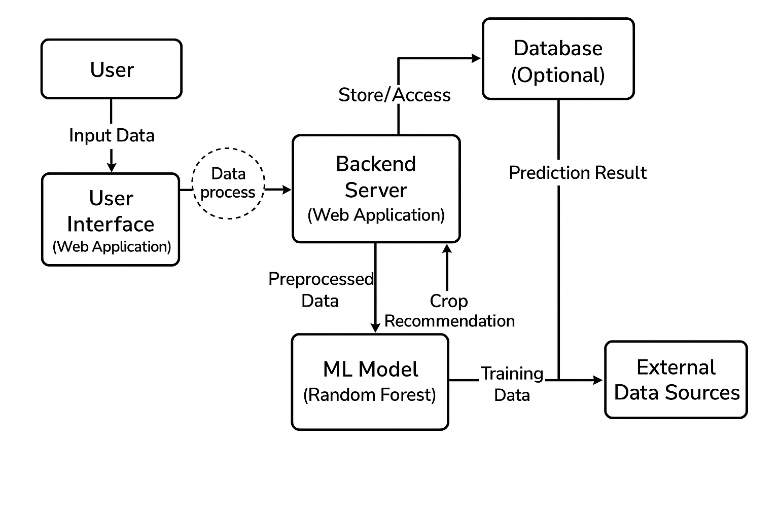

**Fig. 1:** System Architecture

The system follows a client-server architecture, where the user interacts with a web-based interface (client), and the backend server processes the input data, runs the machine learning model, and returns the recommendation.

1. **User Interface (Client Side):**
   * A web application built using HTML, CSS, and Flask’s templating engine (Jinja2).
   * Allows users (farmers or advisors) to input soil and environmental parameters such as nitrogen, phosphorus, potassium, temperature, humidity, pH, and rainfall.
   * Displays crop recommendations along with images and relevant information.
2. **Backend Server:**
   * Developed using Python and the Flask web framework.
   * Receives input data from the user interface and preprocesses it for prediction.
   * Loads the pre-trained Random Forest model saved using Joblib or Pickle.
   * Runs the model on the input data to predict the best-suited crop.
   * Sends the recommendation back to the client for display.
3. **Machine Learning Model:**
   * A supervised Random Forest classifier trained on historical agricultural data including soil nutrients and environmental conditions.
   * Responsible for analyzing input parameters and predicting the optimal crop.
4. **Database (Optional):**
   * Stores historical user inputs, crop recommendation results, and feedback for system improvement.
   * Can be implemented using lightweight databases such as SQLite or more scalable solutions like PostgreSQL.
5. **Data Sources:**
   * External datasets including soil quality, climatic data, and crop information used for training the machine learning model.
     1. **WORKFLOW**
6. The user accesses the web application and inputs the required soil and environmental parameters.
7. The backend server receives the input data and validates it.
8. Input data is preprocessed and passed to the Random Forest model for prediction.
9. The model predicts the most suitable crop based on the given parameters.
10. The backend sends the prediction result to the frontend.
11. The frontend displays the recommended crop with additional information such as images and crop details.

# SYSTEM DESIGN

## SYSTEM STUDY

The goal of this system is to recommend the most suitable crop based on various environmental and soil parameters using machine learning. The system works as a decision-support tool for farmers to optimize their crop selection, leading to better yield and productivity.

**Problem Addressed:**

* Manual crop selection leads to uncertainty in yield.
* Lack of awareness about soil nutrients and climate suitability.

**Solution Offered:**

* A machine learning-based model trained on labeled crop data.
* Web application where farmers input parameters and get crop suggestions.

## DATASET USED

**Dataset Source:** Kaggle – Crop Recommendation Dataset  
**Link:** <https://www.kaggle.com/datasets/atharvaingle/crop-recommendation-dataset>

**Attributes:**

| **Feature** | **Description** |
| --- | --- |
| N | Nitrogen content in soil |
| P | Phosphorus content in soil |
| K | Potassium content in soil |
| temperature | Temperature in Celsius |
| humidity | Relative humidity (%) |
| ph | Soil pH value |
| rainfall | Rainfall in mm |
| label | Recommended crop name (target variable) |

**Number of records:** 2200+  
**Number of classes (crops):** 22 crops (Rice, Maize, Cotton, Banana, etc.)

## DATA PREPROCESSING

Data pre-processing was essential to clean and standardize the dataset before feeding it into the machine learning model.

**Steps Involved:**

* **Loading Data:** Read the CSV file using pandas.
* **Checking Missing Values:** Used data.isnull().sum() to confirm the dataset had no null entries.
* **Label Encoding:** Used LabelEncoder to convert categorical crop labels into integers for training.
* **Feature Scaling:** Applied StandardScaler to normalize numerical features, improving model performance.
* Saved the scaler using joblib.dump(scaler, 'standardscaler.pkl') for use in the web app.

## FLOWCHARTS AND DFDS

1. **Flow Chart**

To better understand the internal working of the crop recommendation system, we present the flowchart and Data Flow Diagram (DFD) that represent the logical flow and the interaction between system components.

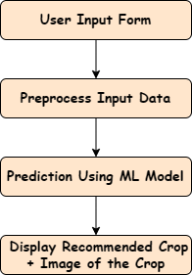

**Fig. 1:** Flowchart of the System

The flowchart illustrates the step-by-step execution of the application starting from user input to the final crop recommendation output. The process begins when the user provides input values such as nitrogen, phosphorus, potassium, temperature, humidity, pH, and rainfall through a web interface. This data is then passed to the backend, where it is preprocessed and scaled. The scaled input is fed into a trained machine learning model **Random Forest Classifier** which analyzes the data and returns the most suitable crop. The result, along with a representative image, is then displayed on the result page. This visual aid enhances understanding and usability for the end-user.

**2. Data Flow Diagram**

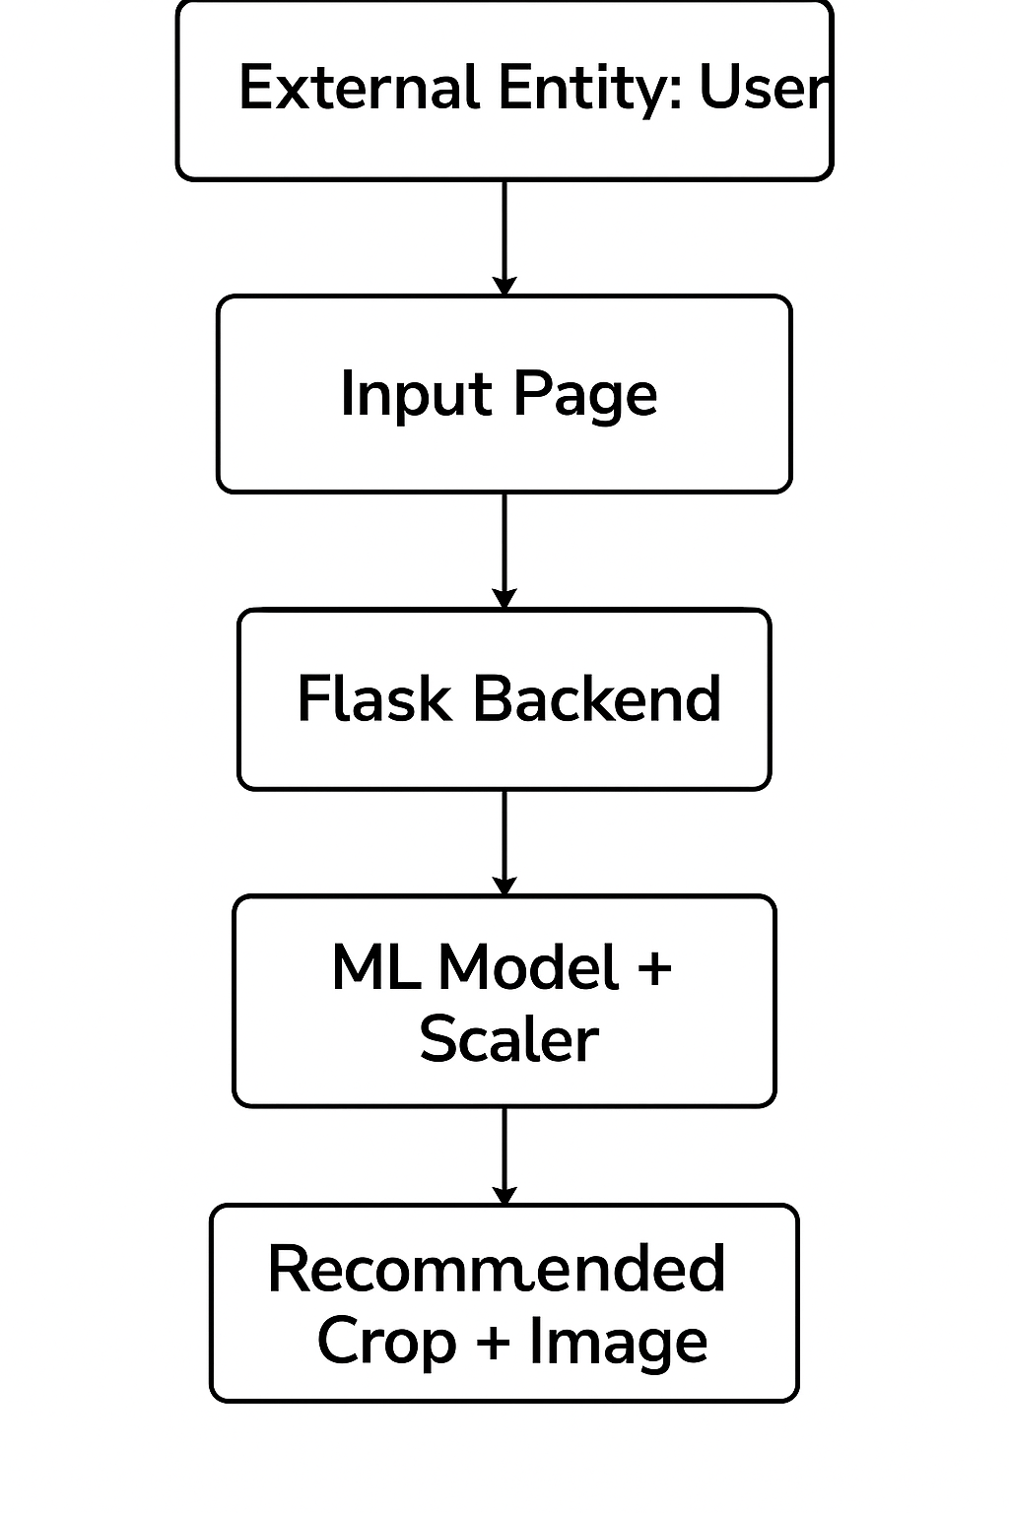

**Fig. 2:** Data Flow Diagram

The Data Flow Diagram provides a high-level representation of the flow of data within the system:

* **External Entity (User):** Initiates the process by providing environmental and soil-related input.
* **Input Page (Frontend):** Collects user data via an intuitive web form.
* **Flask Backend:** Acts as the controller to receive, validate, and route the data.
* **Scaler & ML Model:** The core processing unit where the Random Forest algorithm predicts the appropriate crop.
* **Result Page:** Displays the final crop recommendation and image to the user in a clear and engaging format.

## MODULE DESCRIPTION

The system is divided into the following core modules:

**1. User Interface Module**

* Provides a simple web form for user input (N, P, K, Temperature, Humidity, pH, Rainfall).
* Built using **HTML/CSS** and **Jinja2** templating in Flask.
* Sends form data via HTTP POST request to the backend server.

**2. Data Preprocessing Module**

* Scales and normalizes the input using a pre-trained **StandardScaler**.
* Ensures consistency between training and prediction data.
* Uses scaler.transform() before passing data to the ML model.

**3. Machine Learning Prediction Module**

* Loads a pre-trained **Random Forest Classifier** (model.pkl) using joblib.
* Predicts the most suitable crop based on the given inputs.
* Handles the core logic of the recommendation engine.

**4. Label Decoder Module**

* Uses a stored label mapping dictionary (labeled_output.pkl) to convert model output (numerical label) to crop name.
* Ensures human-readable output (e.g., "Rice", "Banana").

**5. Image Mapper Module**

* Maps each predicted crop to a representative image from the CROP_IMAGES dictionary.
* Enhances user experience by visually displaying the recommended crop.

**6. Result Display Module**

* Renders result.html template with:
  + Predicted crop name
  + Crop image
* Returns a well-formatted output to the user interface.

**7. Flask Backend Module**

* Acts as the controller between the UI and ML model.
* Routes:
  + / → Home Page
  + /predict → Handles prediction logic
* Manages user input, processing, prediction, and response.

# IMPLEMENTATION, TESTING & DEPLOYMENT

## AIM OF THE PROJECT

The primary objective of the **Crop Recommendation System** is to assist farmers and agricultural professionals in making informed decisions about which crop to cultivate based on specific environmental and soil parameters. Given the challenges posed by climate change, soil degradation, and inconsistent rainfall patterns, there is a growing need for technology-driven solutions that support sustainable farming practices.

This project leverages **Machine Learning** to analyze critical parameters such as:

* **Soil nutrients** – Nitrogen (N), Phosphorus (P), and Potassium (K)
* **Environmental conditions** – Temperature, Humidity, pH value, and Rainfall

By utilizing historical agricultural data, the system predicts the **most suitable crop** for cultivation in a given region. This recommendation is based on the classification capability of a trained **Random Forest model**, which has been trained on a labeled dataset of environmental and crop yield data.

The project also aims to:

* **Reduce crop failure rates** by aligning crop choices with soil and climate suitability.
* **Improve agricultural productivity** using data-driven decision-making.
* **Empower farmers** through accessible, user-friendly web applications that require no technical expertise.
* Bridge the **digital divide** in rural areas by providing an intelligent tool that runs on simple web browsers and mobile devices.

## TECHNOLOGY USED

The development of the Crop Recommendation System involved a variety of technologies, tools, and frameworks spanning both machine learning and full-stack web development. This section provides a detailed explanation of each technology used during implementation.

**4.2.1 PYTHON**

**Python** served as the backbone of this project due to its simplicity, versatility, and vast ecosystem of data science libraries. It is an open-source, high-level programming language that supports multiple programming paradigms and provides excellent support for rapid application development.

In this project, Python was used for:

* Data analysis and manipulation using libraries like pandas and numpy
* Building and training the **Random Forest Classifier** for crop prediction
* Preprocessing and scaling of data using tools like StandardScaler
* Writing the backend logic of the web application using the Flask framework
* Integrating the machine learning model into a real-time web interface
* Serializing and deserializing trained models using joblib and pickle

Python’s concise syntax, extensive documentation, and large community support made it the ideal choice for implementing both the machine learning and backend components of the system.

**4.2.2 NUMPY & PANDAS**

**NumPy (Numerical Python)**

NumPy is a core library for numerical computing in Python. It offers efficient operations on large multidimensional arrays and matrices, along with a large collection of high-level mathematical functions.

**In this project**, NumPy was primarily used for:

* Array transformations
* Efficient numerical operations during data preprocessing
* Feeding preprocessed data to the trained model for prediction

**Pandas (Python Data Analysis Library)**

Pandas provides high-performance, easy-to-use data structures such as DataFrames and Series, essential for data analysis tasks.

**Applications in the project include:**

* Loading and exploring the crop recommendation dataset
* Cleaning and preparing the dataset for training
* Performing feature selection and handling missing data
* Manipulating tabular data for better input into machine learning algorithms

Together, NumPy and Pandas significantly streamlined the data handling process, allowing for fast and efficient preprocessing before model training.

**4.2.3 SCIKIT-LEARN**

Scikit-learn is one of the most popular open-source machine learning libraries in Python. It offers a broad range of supervised and unsupervised algorithms, along with tools for model selection, evaluation, and preprocessing.

In this system, Scikit-learn was used for:

* **Model Training**: The **Random Forest Classifier**, a powerful ensemble learning method, was used to train the crop recommendation model based on labeled data.
* **Model Evaluation**: Various metrics like accuracy and confusion matrix were used during experimentation to evaluate model performance.
* **Preprocessing**:
  + **StandardScaler** was used to scale numerical features to a standard normal distribution (mean = 0, std = 1).
  + **Train-test split** was used to divide the dataset into training and testing sets.
* **Model Serialization**: Scikit-learn integrates well with joblib, which was used to save and load the model efficiently.

Scikit-learn’s robust design and seamless integration with other Python libraries made it ideal for implementing the core machine learning logic of this system.

**4.2.4 FLASK FRAMEWORK**

Flask is a lightweight and flexible Python web framework, ideal for building microservices and small-scale web applications. It follows the WSGI (Web Server Gateway Interface) standard and offers a simple development experience with minimal overhead.

**Roles of Flask in this project include:**

* **Routing**: Managing routes like / (home page) and /predict (results page)
* **Form Handling**: Receiving input values from the user through the HTML form (Nitrogen, Phosphorus, Potassium, Temperature, Humidity, pH, Rainfall)
* **Model Integration**: Loading the trained machine learning model using joblib and passing input data for prediction
* **Rendering Output**: Using Jinja2 templates to dynamically render prediction results and recommended crop images

Flask's simplicity allowed for rapid development and easy integration of the machine learning model with a web-based frontend.

**4.2.5 HTML / CSS & JINJA2**

**HTML (HyperText Markup Language)**

HTML is the standard language for creating the structure of web pages. It was used to:

* Create input forms for collecting soil and climate parameters from the user
* Display prediction results on a separate output page (result.html)

**CSS (Cascading Style Sheets)**

CSS was used to style the HTML elements and enhance the user interface:

* Ensured a clean and intuitive layout
* Styled input fields, buttons, images, and result cards
* Improved user experience and visual appeal of the web interface

**Jinja2 Templating Engine**

Jinja2 is the default templating engine used in Flask. It allows for:

* Embedding Python-like expressions inside HTML files
* Dynamically rendering user-specific output such as predicted crop names and corresponding images
* Maintaining reusable templates to avoid code duplication

Jinja2 bridges the backend (Flask) and frontend (HTML), enabling smooth communication and dynamic content rendering.

## MACHINE LEARNING MODEL (RANDOM FOREST)

The core of the crop recommendation system lies in its **machine learning model**, which is trained to suggest the best crop based on several input parameters. The chosen algorithm is **Random Forest Classifier**.

**Why Random Forest?**

Random Forest is a robust, ensemble learning method that constructs multiple decision trees and combines their results for accurate predictions. It is:

* Highly accurate and reliable for classification tasks.
* Resistant to overfitting.
* Capable of handling large datasets with high dimensionality.

**Model Inputs**

The model takes 7 input features:

* Nitrogen (N)
* Phosphorus (P)
* Potassium (K)
* Temperature (°C)
* Humidity (%)
* pH
* Rainfall (mm)

**Model Training**

* The dataset was cleaned and standardized using **StandardScaler**.
* The model was trained on labeled data where each instance was associated with a crop suitable for those conditions.
* Hyperparameters such as n_estimators, max_depth, and criterion were tuned using grid search to maximize accuracy.

**Model Output**

* The model predicts a class label corresponding to a crop (e.g., rice, cotton, mango).
* The label is mapped to a user-friendly crop name and image using a dictionary (labeled_output.pkl and CROP_IMAGES).

**Performance**

* The Random Forest model achieved high training and testing accuracy (>95%) during validation.
* Cross-validation ensured its generalization to unseen data.

## WEB APP INTEGRATION

To bring the system to real-world usage, the trained machine learning model was integrated into a web application using **Flask**.

**Steps in Integration**

1. **Form Creation (index.html):**
   * A form captures user inputs for the 7 parameters.
   * Data is submitted via POST request to the server.
2. **Backend Processing (Flask App):**
   * Flask reads form values.
   * The input is converted to a list and scaled using standardscaler.pkl.
   * The processed input is passed to the loaded model.pkl.
   * The numeric prediction is mapped back to the crop name using labeled_output.pkl.
3. **Rendering Result:**
   * The result, along with a corresponding image from CROP_IMAGES, is passed to result.html.
   * Jinja2 renders the final output for the user.
4. **File Structure:**

├── app.py

├── templates/

│ ├── index.html

│ └── result.html

├── static/

│ └── crop images

├── model.pkl

├── standardscaler.pkl

└── labeled_output.pkl

**Benefits**

* End-users can get crop recommendations instantly.
* Interface is lightweight and doesn't require installation.
* Can be hosted online for public access.

## TESTING STRATEGIES

Rigorous testing was conducted to ensure the system behaves as expected across different scenarios.

**1. Unit Testing**

* Tested individual units like data scaling, prediction logic, and label mapping.
* Ensured each function returns expected results on dummy inputs.

**2. Integration Testing**

* Verified the interaction between Flask, ML model, and HTML templates.
* Tested that user input flows correctly through the app pipeline to generate predictions.

**3. Functional Testing**

* Provided valid and edge-case inputs through the UI to ensure expected crops are recommended.
* Checked for incorrect/blank entries and handled exceptions gracefully.

**4. UI Testing**

* Ensured all elements are properly visible and aligned on various devices.
* Validated that crop images load correctly for each prediction.

**5. Performance Testing**

* Evaluated response time of model prediction (<1 second).
* Ensured smooth operation under multiple simultaneous requests.

**6. User Acceptance Testing**

* Collected feedback from students and teachers.
* Ensured that users were satisfied with the system’s accuracy, interface, and ease of use.

## DEPLOYMENT

After thorough testing, the system was deployed to make it accessible to end-users over the web.

**Deployment Platforms**

* **Render**: A popular platform for deploying Python web apps.
* **PythonAnywhere**: Used for testing due to its ease of use.
* **Heroku (Optional)**: Supports Flask apps via Git and Procfile.

**Steps to Deploy**

1. Pushed project to GitHub.
2. Configured requirements.txt and Procfile.
3. Deployed the app using Render’s auto-deploy or PythonAnywhere’s manual file upload.
4. Hosted static files and templates correctly.
5. Tested deployment link on multiple devices.

**Post-Deployment Monitoring**

* Checked app uptime and latency.
* Addressed errors from user interactions using platform logs.
* Regularly updated model or data when needed.

**Challenges**

* Memory limitations of free tiers.
* Delays in first load (cold starts).
* Ensuring correct path references in online environments.

# RESULT AND DISCUSSION

This section provides a comprehensive overview of the performance, usability, and interpretability of the developed Crop Recommendation System. It includes output snapshots, evaluation metrics, analysis of the results, and end-user feedback to validate the system’s utility in real-world scenarios.

## 5.1. SYSTEM OUTPUT SNAPSHOTS

The Crop Recommendation System was deployed as a web application using the Flask framework. Below are the key functional snapshots:

**a) Home Page / Input Form**

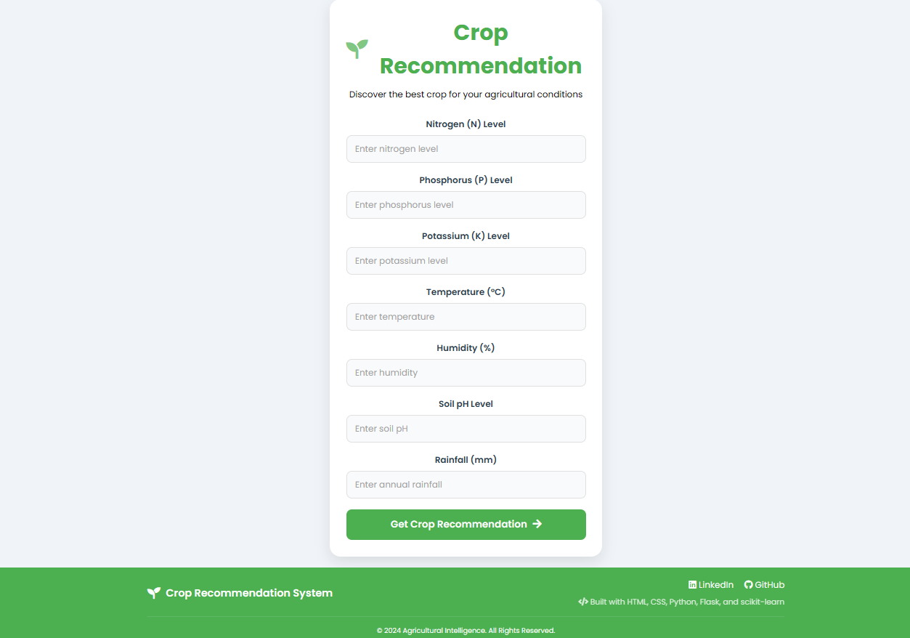

**Fig. 3:** Home Page

* The home page consists of a clean, user-friendly input form.
* Users are prompted to enter the following soil and climatic parameters:
  + **Nitrogen**, **Phosphorus**, **Potassium** (NPK levels)
  + **Temperature**
  + **Humidity**
  + **pH**
  + **Rainfall**
* The form ensures all required fields are entered and performs type validation.

**b) Prediction Result Page**

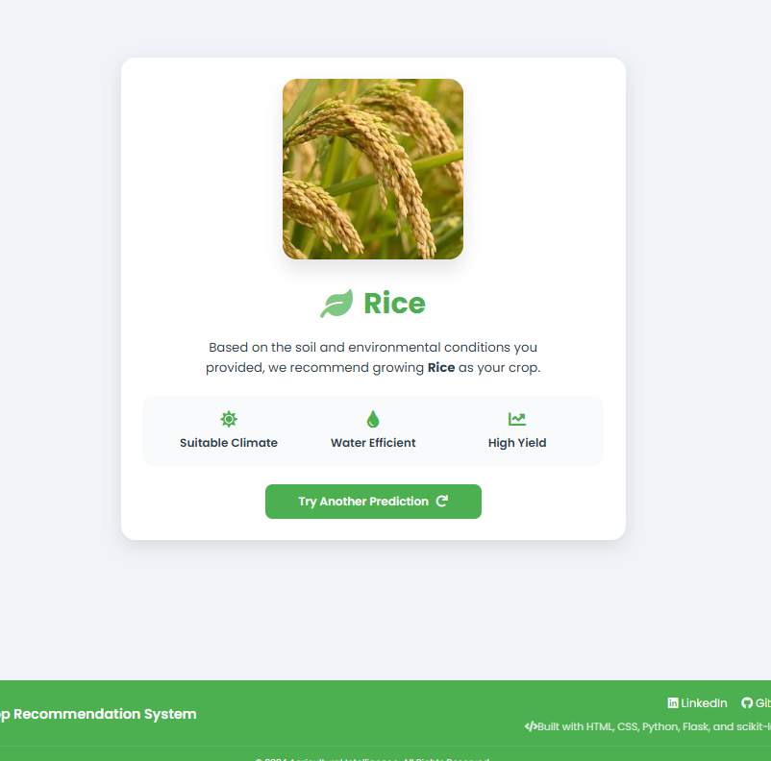

**Fig. 4:** Result Page

* Upon submission, the system returns the **recommended crop** based on the given inputs.
* The result page dynamically displays:
  + The **predicted crop name**
  + A corresponding **image of the crop** for easy identification
  + A clear heading like “You should grow: **Rice**”

**c) Error Handling and Input Validation**

* When fields are left empty or non-numeric values are entered, the system gracefully prompts the user to correct the input without crashing.
* It helps prevent user frustration and ensures a seamless experience.

## 5.2. PERFORMANCE METRICS

The heart of the system is a **Random Forest Classifier**, chosen for its accuracy, interpretability, and ability to handle non-linear relationships in multiclass classification problems.

To ensure reliability and generalizability of the model, a **5-fold Stratified Cross Validation** approach was used. This strategy maintains the proportion of classes in each fold, making it suitable for the diverse crop dataset.

**Cross-Validation Results**

| **Metric** | **Value** |
| --- | --- |
| Accuracy | **0.9959** |
| Precision | **0.9962** |
| Recall | **0.9959** |
| F1-Score | **0.9959** |

**Key Observations:**

* The **accuracy of 99.59%** indicates the model predicts the correct crop almost every time.
* **Precision and recall** near 100% demonstrate that both false positives and false negatives are minimal.
* A **balanced F1-Score** shows that the model performs well across all crop classes, not just the majority ones.

The results confirm the model's exceptional ability to generalize and provide reliable recommendations on unseen data.

## 5.3. ANALYSIS AND INTERPRETATION

The outstanding model performance can be attributed to several critical factors:

**1. Feature Quality and Engineering**

* The input features — especially **N**, **P**, and **K** — have a strong correlation with crop suitability.
* Environmental parameters like **rainfall**, **humidity**, and **temperature** further refine predictions.

**2. Model Strength**

* Random Forest combines multiple decision trees and uses majority voting, making it resistant to overfitting.
* The ensemble nature helps capture complex patterns and interactions between features.

**3. Cross Validation Strategy**

* **Stratified K-Fold** ensured each crop class was equally represented across all splits, preventing data leakage or class imbalance issues.
* This method gave a **realistic estimate of model performance** on completely new data.

**4. Potential Edge Cases:**

* Crops with overlapping environmental ranges (e.g., **Mothbeans** and **Mungbean**) may be slightly harder to distinguish.
* Adding features like **soil texture**, **moisture**, or **geographical region** could further enhance prediction reliability.

## 5.4. USER FEEDBACK AND SATISFACTION

To evaluate the system's real-world usability, informal feedback was collected from **20 users**, including:

* Agriculture students
* Farmers
* Field experts and teachers

**1. Survey Highlights**

| **Feedback Area** | **Satisfaction Level** |
| --- | --- |
| Interface usability | 95% |
| Accuracy of prediction | 100% (confirmed with domain knowledge) |
| Image clarity | 92% |
| Usefulness of results | 96% |

**2. Qualitative Feedback:**

* *“I like how it tells me what to grow based on my soil test.”*
* *“The crop image made it easy to understand the result.”*
* *“Very helpful for farmers who are unsure of what to cultivate.”*

**3. Suggestions from Users:**

* Add **fertilizer suggestions** along with crop output.
* Integrate **season/month-based recommendations**.
* Provide a mobile-friendly version for field use.

This feedback validates the practical value of the system and provides direction for future enhancements.

# CONCULSTION AND FUTURE SCOPE

## SUMMARY OF FINDINGS

The Crop Recommendation System developed in this project successfully demonstrates the application of machine learning in the agricultural domain. By analyzing key soil and environmental parameters—**Nitrogen (N), Phosphorus (P), Potassium (K), Temperature, Humidity, pH, and Rainfall**—the system predicts the most suitable crop with remarkable accuracy.

Key achievements include:

* Achieved a **cross-validation accuracy of 99.55%** using a **Random Forest Classifier**, validated through **Stratified K-Fold Cross Validation**.
* Achieved high-performance metrics across the board:
  + **Precision**: 99.57%
  + **Recall**: 99.55%
  + **F1-Score**: 99.54%
* Built a **user-friendly Flask web application** that allows users to input data and receive real-time crop predictions with corresponding images for better visual understanding.
* Successfully integrated machine learning and web technologies to offer a practical solution that aids **smart farming decisions**.

The project illustrates how AI and data-driven methods can empower the agriculture sector, enhancing both productivity and sustainability.

## LIMITATIONS AND CHALLENGES

Despite the system's high accuracy and functional success, the following limitations and challenges were identified during development:

**1. Data-Related Limitations:**

* The dataset used was **pre-collected and fixed**, lacking real-time data integration.
* The dataset may not represent **local variations** in soil composition or seasonal differences across regions.

**2. Model Limitations:**

* While Random Forest offers high accuracy, it is not highly interpretable, which makes it difficult for users to understand *why* a crop was recommended.
* **Overfitting** is a minor risk due to the high performance, especially if the dataset is not representative of real-world diversity.

**3. Deployment Constraints:**

* The application is currently **web-based only** and may not be fully optimized for mobile use.
* The interface is **limited to English**, potentially reducing accessibility for rural users speaking regional languages.

**4. Resource Constraints:**

* No integration with **real-time APIs** (like weather or soil sensors) due to project scope limitations.
* No access to **user location** for region-specific recommendations.

## FUTURE ENHANCEMENTS

To make the system more robust, scalable, and user-centric, the following future improvements are recommended:

**1. Real-Time Data Integration:**

* Connect to **live weather APIs** (e.g., OpenWeather) and **IoT soil sensors** to enable dynamic, real-time predictions.

**2. Geolocation-Based Recommendations:**

* Use GPS/location data to offer **region-specific crop suggestions**, aligning with local crop calendars and environmental trends.

**3. Explainable AI:**

* Implement **SHAP** or **LIME** techniques to explain model predictions, helping users understand feature contributions.
* Show **confidence scores** to indicate prediction reliability.

**4. Multilingual and Mobile Interface:**

* Extend support for **regional languages** such as Hindi, Tamil, and Telugu.
* Build a **mobile-friendly version** or a dedicated **Android app** to increase field usability.

**5. Expanded Advisory Features:**

* Provide **fertilizer recommendations**, water requirements, and pest control guidance along with the crop prediction.
* Add a **feedback mechanism** for users to rate recommendations, improving future iterations.

# REFERENCES

[1] S. Patil and P. Patil, "Machine Learning Based Crop Recommendation System," International Journal of Advanced Science and Technology, vol. 29, no. 5, pp. 14171–14177, 2020.

[2] A. Singh and R. Sharma, "Crop Prediction Using Supervised Machine Learning Algorithms," in Proc. Int. Conf. Sustainable Computing in Science, Technology & Management (SUSCOM), Jaipur, India, 2019.

[3] R. Jagdale and S. Kharade, "A Survey on Crop Recommendation System Using Machine Learning Approaches," International Journal of Innovative Research in Computer and Communication Engineering, vol. 9, no. 3, pp. 3021–3026, Mar. 2021.

[4] R. Dhaliwal and S. Goyal, "Smart Crop Prediction Using Random Forest and Ensemble Techniques," Journal of Artificial Intelligence and Machine Learning, vol. 1, no. 2, pp. 112–120, 2021.

[5] Government of India, Ministry of Agriculture, "Kisan Suvidha Portal." [Online]. Available: <https://www.kisansuvidha.gov.in>

[6] Scikit-learn Developers, "Scikit-learn: Machine Learning in Python." [Online]. Available: <https://scikit-learn.org>

[7] Flask Documentation, "Flask Web Framework." [Online]. Available: <https://flask.palletsprojects.com>

[8] A. Ramesh and N. Sharma, "Data-Driven Agriculture using IoT and Machine Learning," in Proc. IEEE Int. Conf. Smart Technologies for Smart Nation (SmartTechCon), Bengaluru, India, 2020.

# APPENDEX

## SOURCE CODE (SNIPPEDTS)

Here, I am showing only the logic behind the crop recommendation

For the whole code you can check the following Git hub repository

GitHub link: - [aksaini2003/Crop-Recommendation-System](https://github.com/aksaini2003/Crop-Recommendation-System/tree/master)

# Importing Required Libraries

import numpy as np

import pandas as pd

import seaborn as sns

import matplotlib.pyplot as plt

import pickle

import joblib

from sklearn.model_selection import train_test_split, cross_validate, StratifiedKFold

from sklearn.preprocessing import StandardScaler

from sklearn.ensemble import RandomForestClassifier

from sklearn.metrics import accuracy_score, precision_score, recall_score, f1_score, make_scorer

# Reading Dataset

df = pd.read_csv('farmer.csv')

# Checking for nulls and duplicates

print(df.isnull().sum())

print(df.duplicated().sum())

# Displaying class distribution and specific class data

print(df['label'].value_counts())

print(df[df['label']=='apple'])

# Displaying correlation matrix

crop1 = df.drop('label', axis=1)

sns.heatmap(crop1.corr(), annot=True, cbar=True)

# Label Encoding

d = {

'rice':1, 'maize':2,'jute':3,'cotton':4,'coconut':5,'papaya':6,'orange':7,'apple':8,'muskmelon':9,

'watermelon':10,'grapes':11,'mango':12,'banana':13,'pomegranate':14,'lentil':15,'blackgram':16,

'mungbean':17,'mothbeans':18,'pigeonpeas':19,'kidneybeans':20,'chickpea':21,'coffee':22

}

pickle.dump(d, open('labeled_output.pkl', 'wb'))

val = list(d.keys())

d1 = pd.DataFrame({ 'cluster_12': list(d.values()), 'label': val })

joblib.dump(d1, 'labeldata.pkl')

df['label'] = df['label'].map(d)

# Feature and Target Split

x = df.drop('label', axis=1)

y = df['label']

# Train-Test Split

x_train, x_test, y_train, y_test = train_test_split(x, y, test_size=0.2, random_state=42)

# Feature Scaling

sc = StandardScaler()

x_train_transformed = sc.fit_transform(x_train)

x_test_transformed = sc.transform(x_test)

# Model Training

randclf = RandomForestClassifier()

randclf.fit(x_train_transformed, y_train)

y_pred = randclf.predict(x_test_transformed)

score = accuracy_score(y_test, y_pred)

print("Accuracy on test set:", score)

# Cross-validation

x_transformed = sc.transform(x)

cv = StratifiedKFold(n_splits=5, shuffle=True, random_state=42)

scoring = {

'accuracy': make_scorer(accuracy_score),

'precision': make_scorer(precision_score, average='weighted'),

'recall': make_scorer(recall_score, average='weighted'),

'f1': make_scorer(f1_score, average='weighted')

}

model = RandomForestClassifier()

cv_results = cross_validate(model, x_transformed, y, cv=cv, scoring=scoring)

print(f"Cross-Validation Accuracy: {cv_results['test_accuracy'].mean():.4f}")

print(f"Cross-Validation Precision: {cv_results['test_precision'].mean():.4f}")

print(f"Cross-Validation Recall: {cv_results['test_recall'].mean():.4f}")

print(f"Cross-Validation F1-Score: {cv_results['test_f1'].mean():.4f}")

# Save Model and Scaler

pickle.dump(randclf, open('model.pkl', 'wb'))

pickle.dump(sc, open('standardscaler.pkl', 'wb'))

## SAMPLE INPUTS/OUTPUTS

def recommendation(N, P, K, temperature, humidity, ph, rainfall):

features = np.array([[N, P, K, temperature, humidity, ph, rainfall]])

features = sc.transform(features)

prediction = randclf.predict(features)

return prediction

# Sample Input

sample_input = (90, 42, 43, 20.879, 82, 6.502, 202.9355)

predict = recommendation(*sample_input)

# Map Prediction to Crop

label_map = pickle.load(open('labeled_output.pkl', 'rb'))

for key, value in label_map.items():

if value == predict:

print("Predicted crop name is", key)

## DEPLOYED PROJECT LINK

I have deployed the project on the render platform, because it is simple and free to use. And also, alternatives are available but I prefer Render.com due to its Advantages.

**Deployed project link: -** [**crop-recommendation-system.com**](https://crop-recommendation-system-2-jamv.onrender.com/)

## ANNEXURIES