**Answer 1** :

Code --------

# x1 & x2 in range (0,10)

import math

import numpy as np

import matplotlib.pyplot as plt

def multivariate_gaussian_dist(item, V_inv,log_det):

k = 2 # Rank of matrix

item = item.reshape(2,1)

mgd = ((-k/2)*np.log(2*(np.pi))) - log_det/2 - ((np.matmul(np.matmul(item.T, V_inv), item))/2)

return mgd

def get_log_det(eigenvalues,eigenvectors):

zero_vec = np.zeros([1,2])

count = 0

full_rank_cov_mat = np.empty([0,2])

non_zero_eigenvalues = np.empty([0])

# Reducing the p eigenvectors of dim p, to k eigen.Vecs of dim p.

for i in range(2):

# We take 1 as eigen-values very close to 0 need to be ignored. The rank is also satisfied when we take this condition.

if eigenvalues[i]>1:

non_zero_eigenvalues = np.append(non_zero_eigenvalues,eigenvalues[i])

full_rank_cov_mat = np.append(full_rank_cov_mat,eigenvectors[i].reshape(1,2),axis=0)

D = np.diag(non_zero_eigenvalues)

log_det = 0

for eigenval in non_zero_eigenvalues:

log_det += np.log(eigenval)

V = full_rank_cov_mat.T.dot(D.dot(full_rank_cov_mat))

V_inv = np.linalg.pinv(V)

return log_det, V_inv

def case_1():

u1 = np.array([3,3])

u2 = np.array([7,7])

cov = np.array([[3,0],[0,3]])

classes = []

class_A = []

class_B = []

while len(class_A)<1000:

rand_val = np.random.multivariate_normal(u1, cov)

if rand_val[0]>=0 and rand_val[0]<=10 and rand_val[1]>=0 and rand_val[1]<=10:

class_A.append(rand_val)

class_A = np.asarray(class_A)

classes.append(class_A)

while len(class_B)<1000:

rand_val = np.random.multivariate_normal(u2, cov)

if rand_val[0]>=0 and rand_val[0]<=10 and rand_val[1]>=0 and rand_val[1]<=10:

class_B.append(rand_val)

class_B = np.asarray(class_B)

classes.append(class_B)

classes = np.asarray(classes)

# Plot training data

plt.scatter(class_A[:,0], class_A[:,1], color="black")

plt.scatter(class_B[:,0], class_B[:,1], color="gray")

# 100 samples

test_data_x = []

test_data_y = []

test_data_x = np.random.uniform(0,10,100)

test_data_y = np.random.uniform(0,10,100)

# plt.scatter(test_data_x,test_data_y)

# plt.show()

max_likelihood = np.zeros(shape=(100,2))

for j in range(2):

class_label=float(j)

each_class_mean = np.mean(classes[j], axis=0).reshape([2,1])

eigenvectors, eigenvalues, V = np.linalg.svd(cov, full_matrices=False)

eigenvalues = eigenvalues.reshape(eigenvalues.shape[0],1)

norm_constant = math.sqrt(np.sum((eigenvalues.T).dot(eigenvalues)))

log_det, V_inv = get_log_det(eigenvalues, eigenvectors)

for k in range(len(test_data_x)):

item = np.asarray([test_data_x[k],test_data_y[k]]).reshape([2,1])

multivariate_dist = multivariate_gaussian_dist(item-each_class_mean, V_inv, log_det)

max_likelihood[k][j] = multivariate_dist

max_likelihood = np.asarray(max_likelihood)

max_likelihood_indices = np.unravel_index(np.argmax(max_likelihood, axis=1), max_likelihood.shape)

max_likelihood_indices = np.asarray(max_likelihood_indices)

classA_plot_x = []

classA_plot_y = []

classB_plot_x = []

classB_plot_y = []

for i in range(len(test_data_x)):

if(0==max_likelihood_indices[1][i]):

classA_plot_x.append(test_data_x[i])

classA_plot_y.append(test_data_y[i])

# plt.plot(test_data_x[i],test_data_y[i] ,color="green")

else:

classB_plot_x.append(test_data_x[i])

classB_plot_y.append(test_data_y[i])

# plt.plot(test_data_x[i],test_data_y[i],color="red")

plt.scatter(classA_plot_x, classA_plot_y, color="red")

plt.scatter(classB_plot_x, classB_plot_y, color="green")

plt.show()

def case_2():

u1 = np.array([3,3])

u2 = np.array([7,7])

cov = []

cov.append(np.array([[3,1],[2,3]]))

cov.append(np.array([[7,2],[1,7]]))

classes = []

class_A = []

class_B = []

while len(class_A)<1000:

rand_val = np.random.multivariate_normal(u1, cov[0])

if rand_val[0]>=0 and rand_val[0]<=10 and rand_val[1]>=0 and rand_val[1]<=10:

class_A.append(rand_val)

class_A = np.asarray(class_A)

classes.append(class_A)

while len(class_B)<1000:

rand_val = np.random.multivariate_normal(u2, cov[1])

if rand_val[0]>=0 and rand_val[0]<=10 and rand_val[1]>=0 and rand_val[1]<=10:

class_B.append(rand_val)

class_B = np.asarray(class_B)

classes.append(class_B)

classes = np.asarray(classes)

# Plot training data

plt.scatter(class_A[:,0], class_A[:,1], color="black")

plt.scatter(class_B[:,0], class_B[:,1], color="gray")

# 100 samples

test_data_x = []

test_data_y = []

test_data_x = np.random.uniform(0,10,100)

test_data_y = np.random.uniform(0,10,100)

# plt.scatter(test_data_x,test_data_y)

# plt.show()

max_likelihood = np.zeros(shape=(100,2))

for j in range(2):

class_label=float(j)

each_class_mean = np.mean(classes[j], axis=0).reshape([2,1])

eigenvectors, eigenvalues, V = np.linalg.svd(cov[j], full_matrices=False)

eigenvalues = eigenvalues.reshape(eigenvalues.shape[0],1)

norm_constant = math.sqrt(np.sum((eigenvalues.T).dot(eigenvalues)))

log_det, V_inv = get_log_det(eigenvalues, eigenvectors)

for k in range(len(test_data_x)):

item = np.asarray([test_data_x[k],test_data_y[k]]).reshape([2,1])

multivariate_dist = multivariate_gaussian_dist(item-each_class_mean, V_inv, log_det)

max_likelihood[k][j] = multivariate_dist

max_likelihood = np.asarray(max_likelihood)

max_likelihood_indices = np.unravel_index(np.argmax(max_likelihood, axis=1), max_likelihood.shape)

max_likelihood_indices = np.asarray(max_likelihood_indices)

classA_plot_x = []

classA_plot_y = []

classB_plot_x = []

classB_plot_y = []

for i in range(len(test_data_x)):

if(0==max_likelihood_indices[1][i]):

classA_plot_x.append(test_data_x[i])

classA_plot_y.append(test_data_y[i])

# plt.plot(test_data_x[i],test_data_y[i] ,color="green")

else:

classB_plot_x.append(test_data_x[i])

classB_plot_y.append(test_data_y[i])

# plt.plot(test_data_x[i],test_data_y[i],color="red")

plt.scatter(classA_plot_x, classA_plot_y, color="red")

plt.scatter(classB_plot_x, classB_plot_y, color="green")

plt.show()

case_1()

case_2()

**PLOTS** ----

Case 1 :

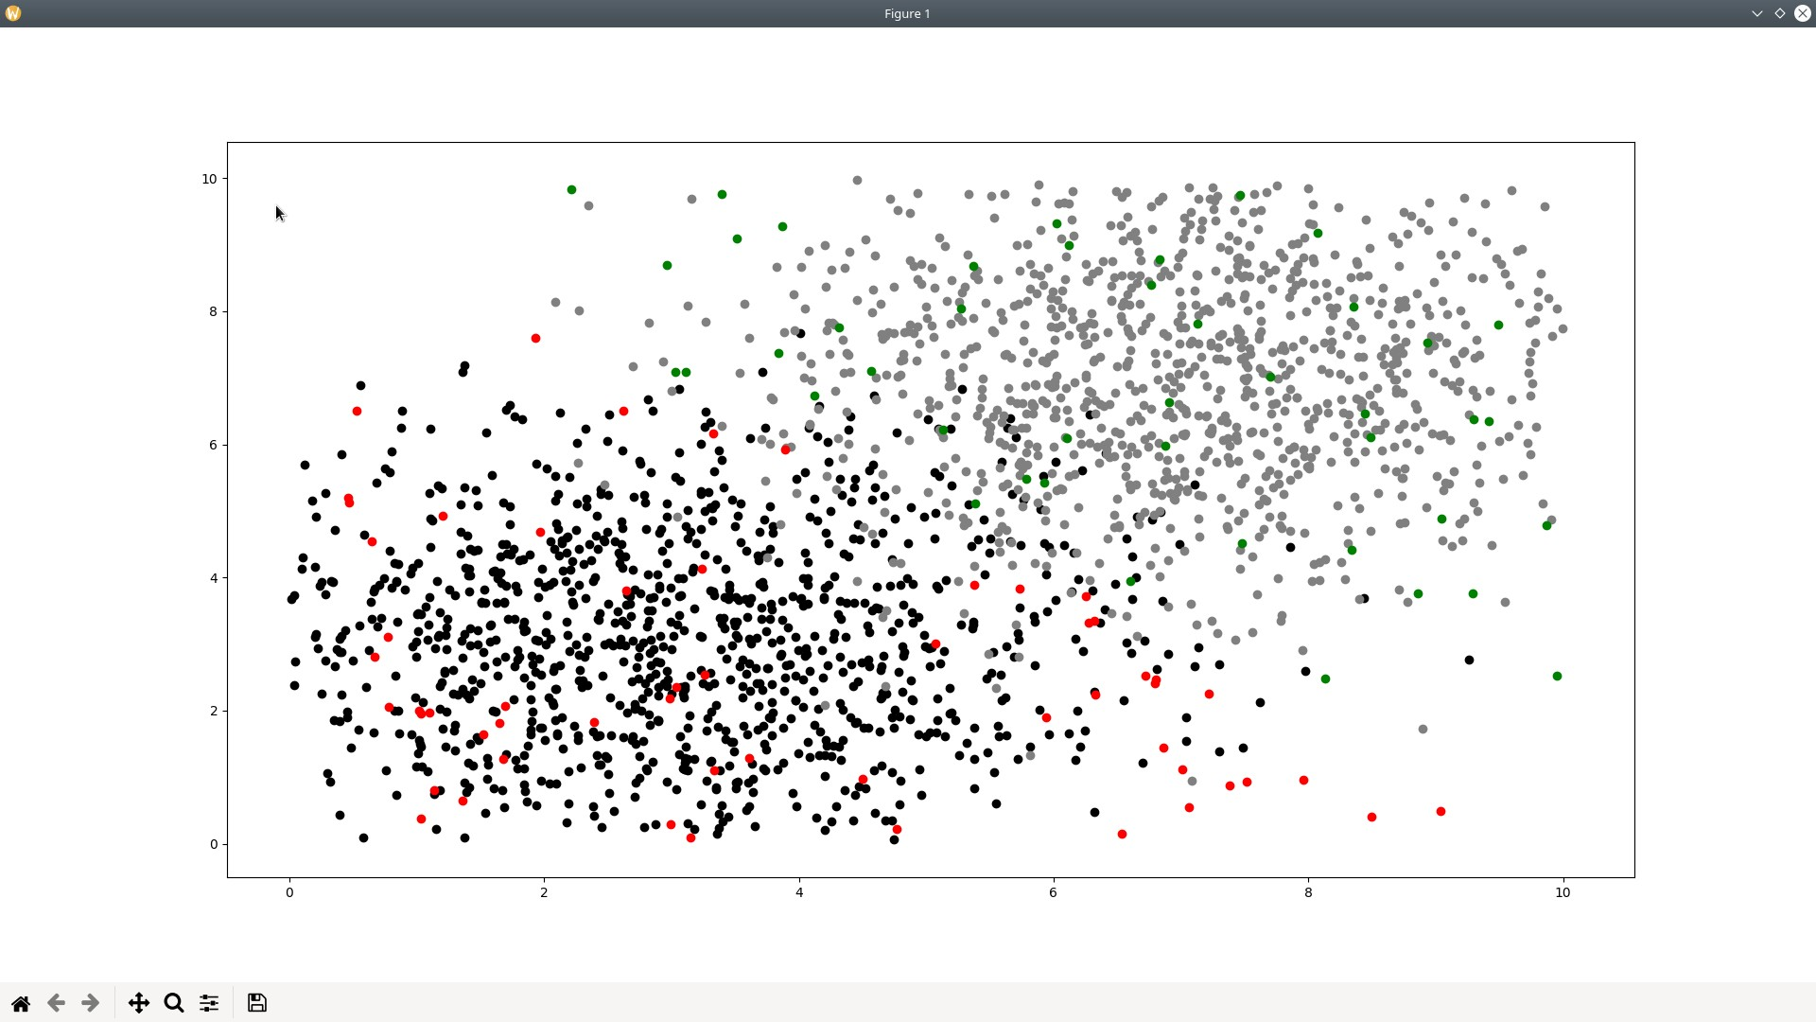

Case 2:

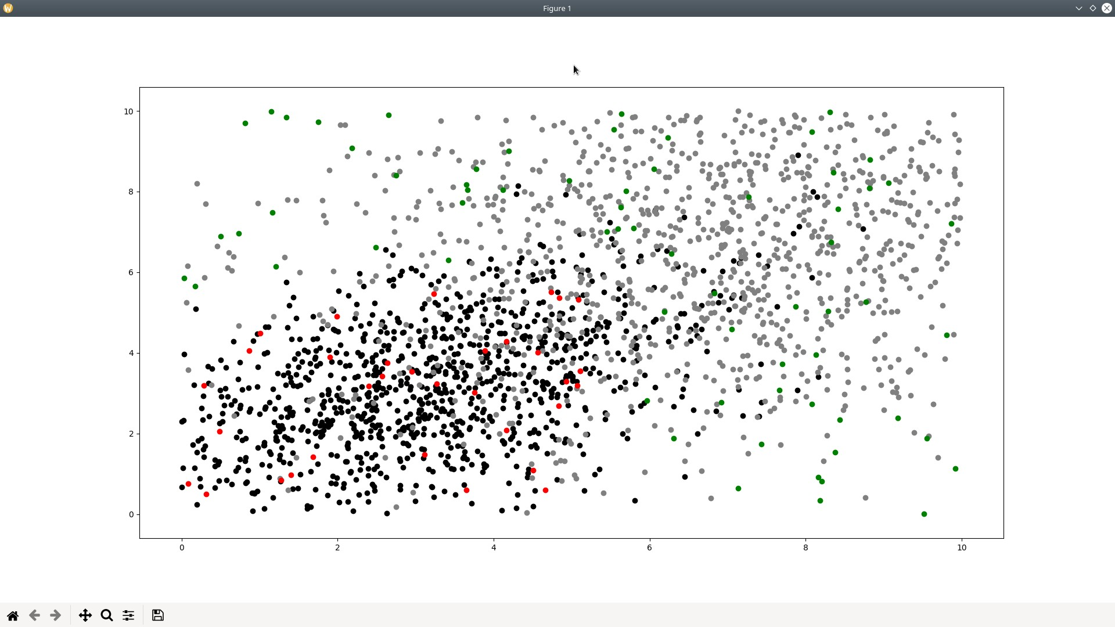

**Answer 3** :

