Answer 1

Mean and variance of K-fold cross validation.
If we have K value to be too high, say a condition where each group has only 1 element, then we would not have enough training data to build a good predictive model. The consequence would be poor generalization and would work well only for the validation set.
If K was to be too low, there wouldn’t be enough cross validation sets which would lead to overfitting.
The ideal K would lie somewhere in between.
To speak of the influence on mean and variance -
When K is low, the variance would be high.
When K is high, the variance would be low as there is a higher probability of finding a training set from K-1, which is closer to the validation set.

Case 1 Means

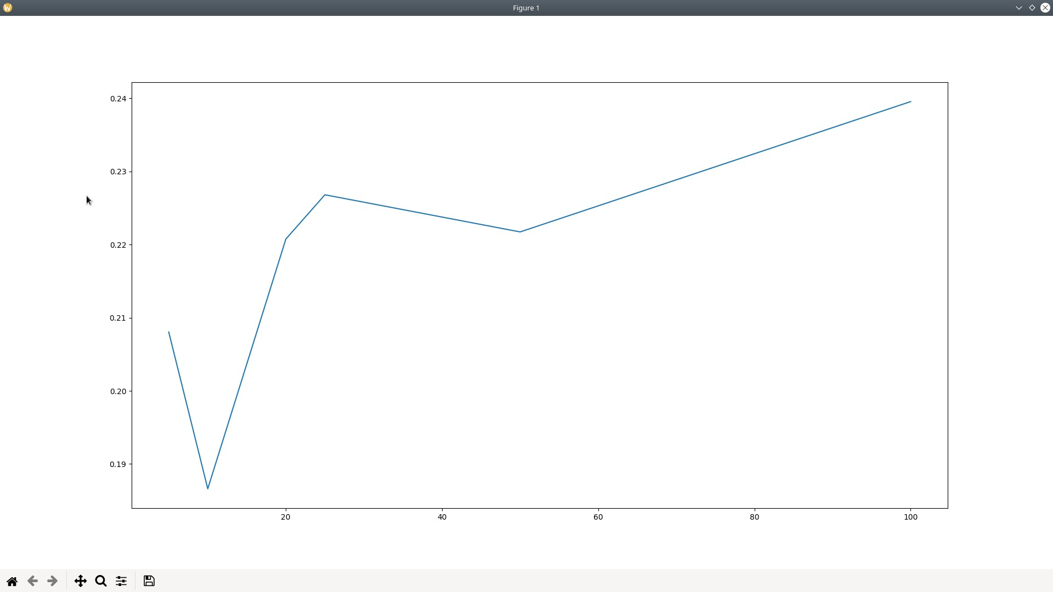

Case 1 Variances
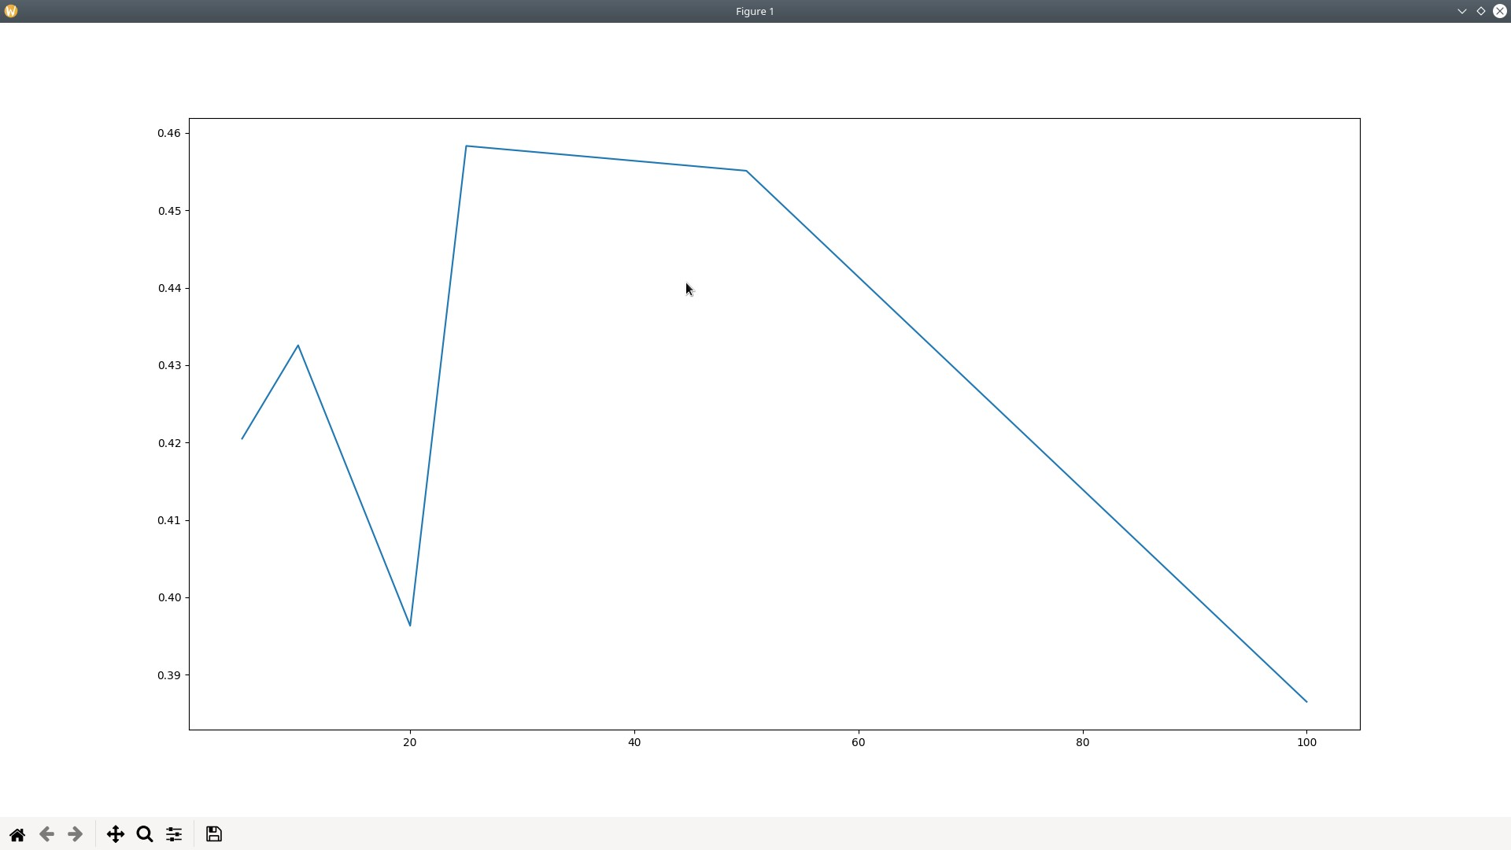

Case 2 Means ::

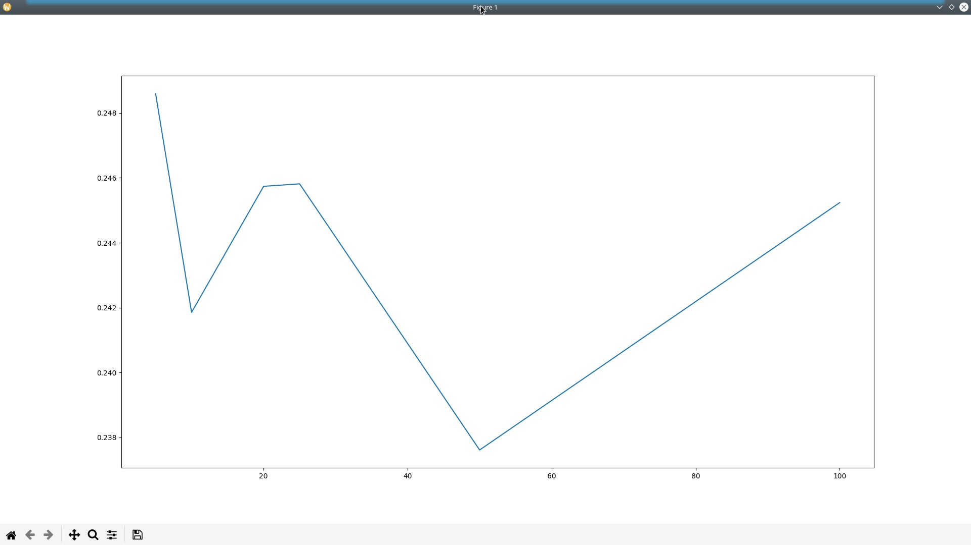
Case 2 Vars ::
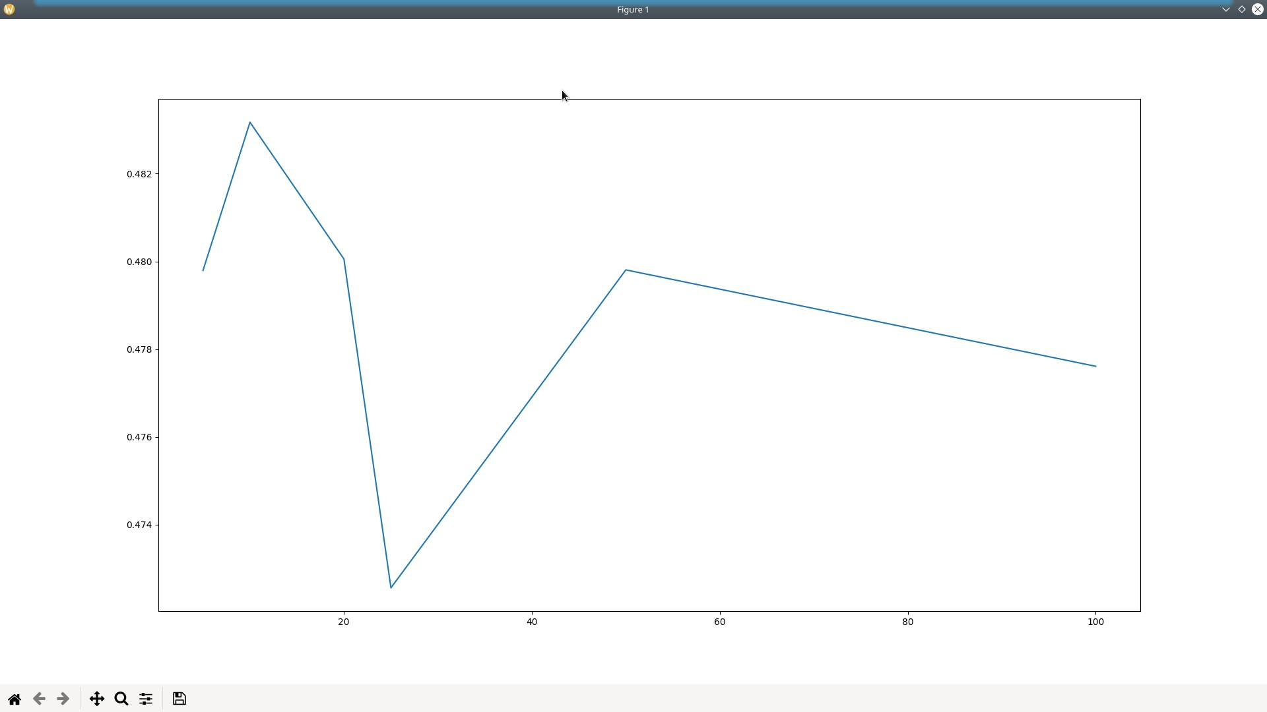

Code ::::

import numpy as np
import math
import matplotlib.pyplot as plt

def generate_samples(n):
return np.random.uniform(0,10,n)

def calculate_y(x,u,var):
return math.sin(x)+np.random.normal(u,var)

def generate_K_folds(samples, k):
n = len(samples)
fold_limit = int(n/k)
k_folds = np.zeros([k,fold_limit],dtype=np.float32)
for sample in samples:
index = np.random.randint(0,k)
while len(np.where(k_folds[index]==0.0)[0])==0:
index = (index+1)%k
print(index)
non_zero_index = np.where(k_folds[index]==0.0)[0][0]
k_folds[index][non_zero_index] = sample
return k_folds

# def get_y(x):
# return m*x+c

# def find_error(x,y,m,c):
# np.sum(np.apply_along_axis(get_y,0,x,m,c),axis=0)

# return err

def find_error(x,y,m,c):
error_sum = 0
for i in range(len(x)):
error_sum += (y[i]-x[i])**2
return math.sqrt(error_sum)

def optimal_K_fold(k_folds):
y_matrix = np.empty([0,k_folds.shape[1]])
for _fold in k_folds:
y = []
for x in _fold:
y.append(calculate_y(x,0.05,0.2))
y_matrix = np.append(y_matrix, [y],axis=0)

min_error = 999999
for i in range(len(k_folds)):
if i ==0 :
training_set = np.append([],k_folds[0:-1])
training_y = np.append([],y_matrix[0:-1])
elif i == len(k_folds)-1 :
training_set = np.append([],k_folds[1:])
training_y = np.append([],y_matrix[1:])
else:
training_set = np.append(k_folds[0:i],k_folds[i+1:])
training_y = np.append(y_matrix[0:i],y_matrix[i+1:])
test_set = k_folds[i]
test_y = y_matrix[i]
m,c = np.polynomial.polynomial.polyfit(training_set,training_y,1)
err1 = find_error(test_set,test_y,m,c)
if err1<min_error:
u = np.mean(training_y, axis=0)
var = np.var(training_y, axis=0)

# return np.asarray(u,var).reshape([1,2])
return u,var

def plot_K_folds(k_vals, y_vals, sample_len):
plt.plot(k_vals, y_vals)
plt.show()

# Case 1
samples = generate_samples(100)
k_vals = [5,10,20,25,50,100]
# mean_var_arr = np.empty([0,2])
means = []
var_list = []
for k in k_vals:
k_folds = generate_K_folds(samples, k)
# mean_var_arr = np.append(mean_var_arr ,optimal_K_fold(k_folds),axis=0)
u,var = optimal_K_fold(k_folds)
means.append(u)
var_list.append(var)
plot_K_folds(k_vals, means, len(samples))
plot_K_folds(k_vals, var_list, len(samples))

# # Case 2
samples = generate_samples(10000)
k_vals = [5,10,20,25,50,100]
# generate_K_folds()
means = []
var_list = []
for k in k_vals:
k_folds = generate_K_folds(samples, k)
# mean_var_arr = np.append(mean_var_arr ,optimal_K_fold(k_folds),axis=0)
u,var = optimal_K_fold(k_folds)
means.append(u)
var_list.append(var)
plot_K_folds(k_vals, means, len(samples))
plot_K_folds(k_vals, var_list, len(samples))

Answer 2 :
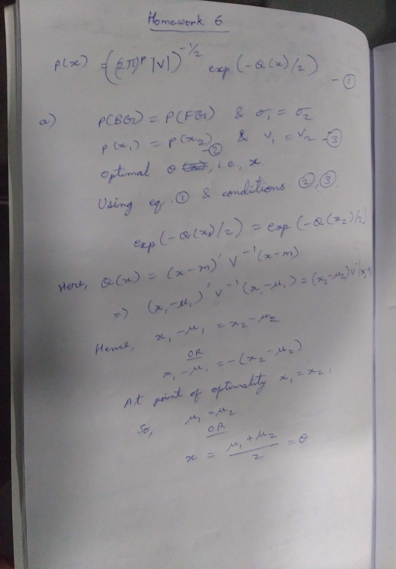
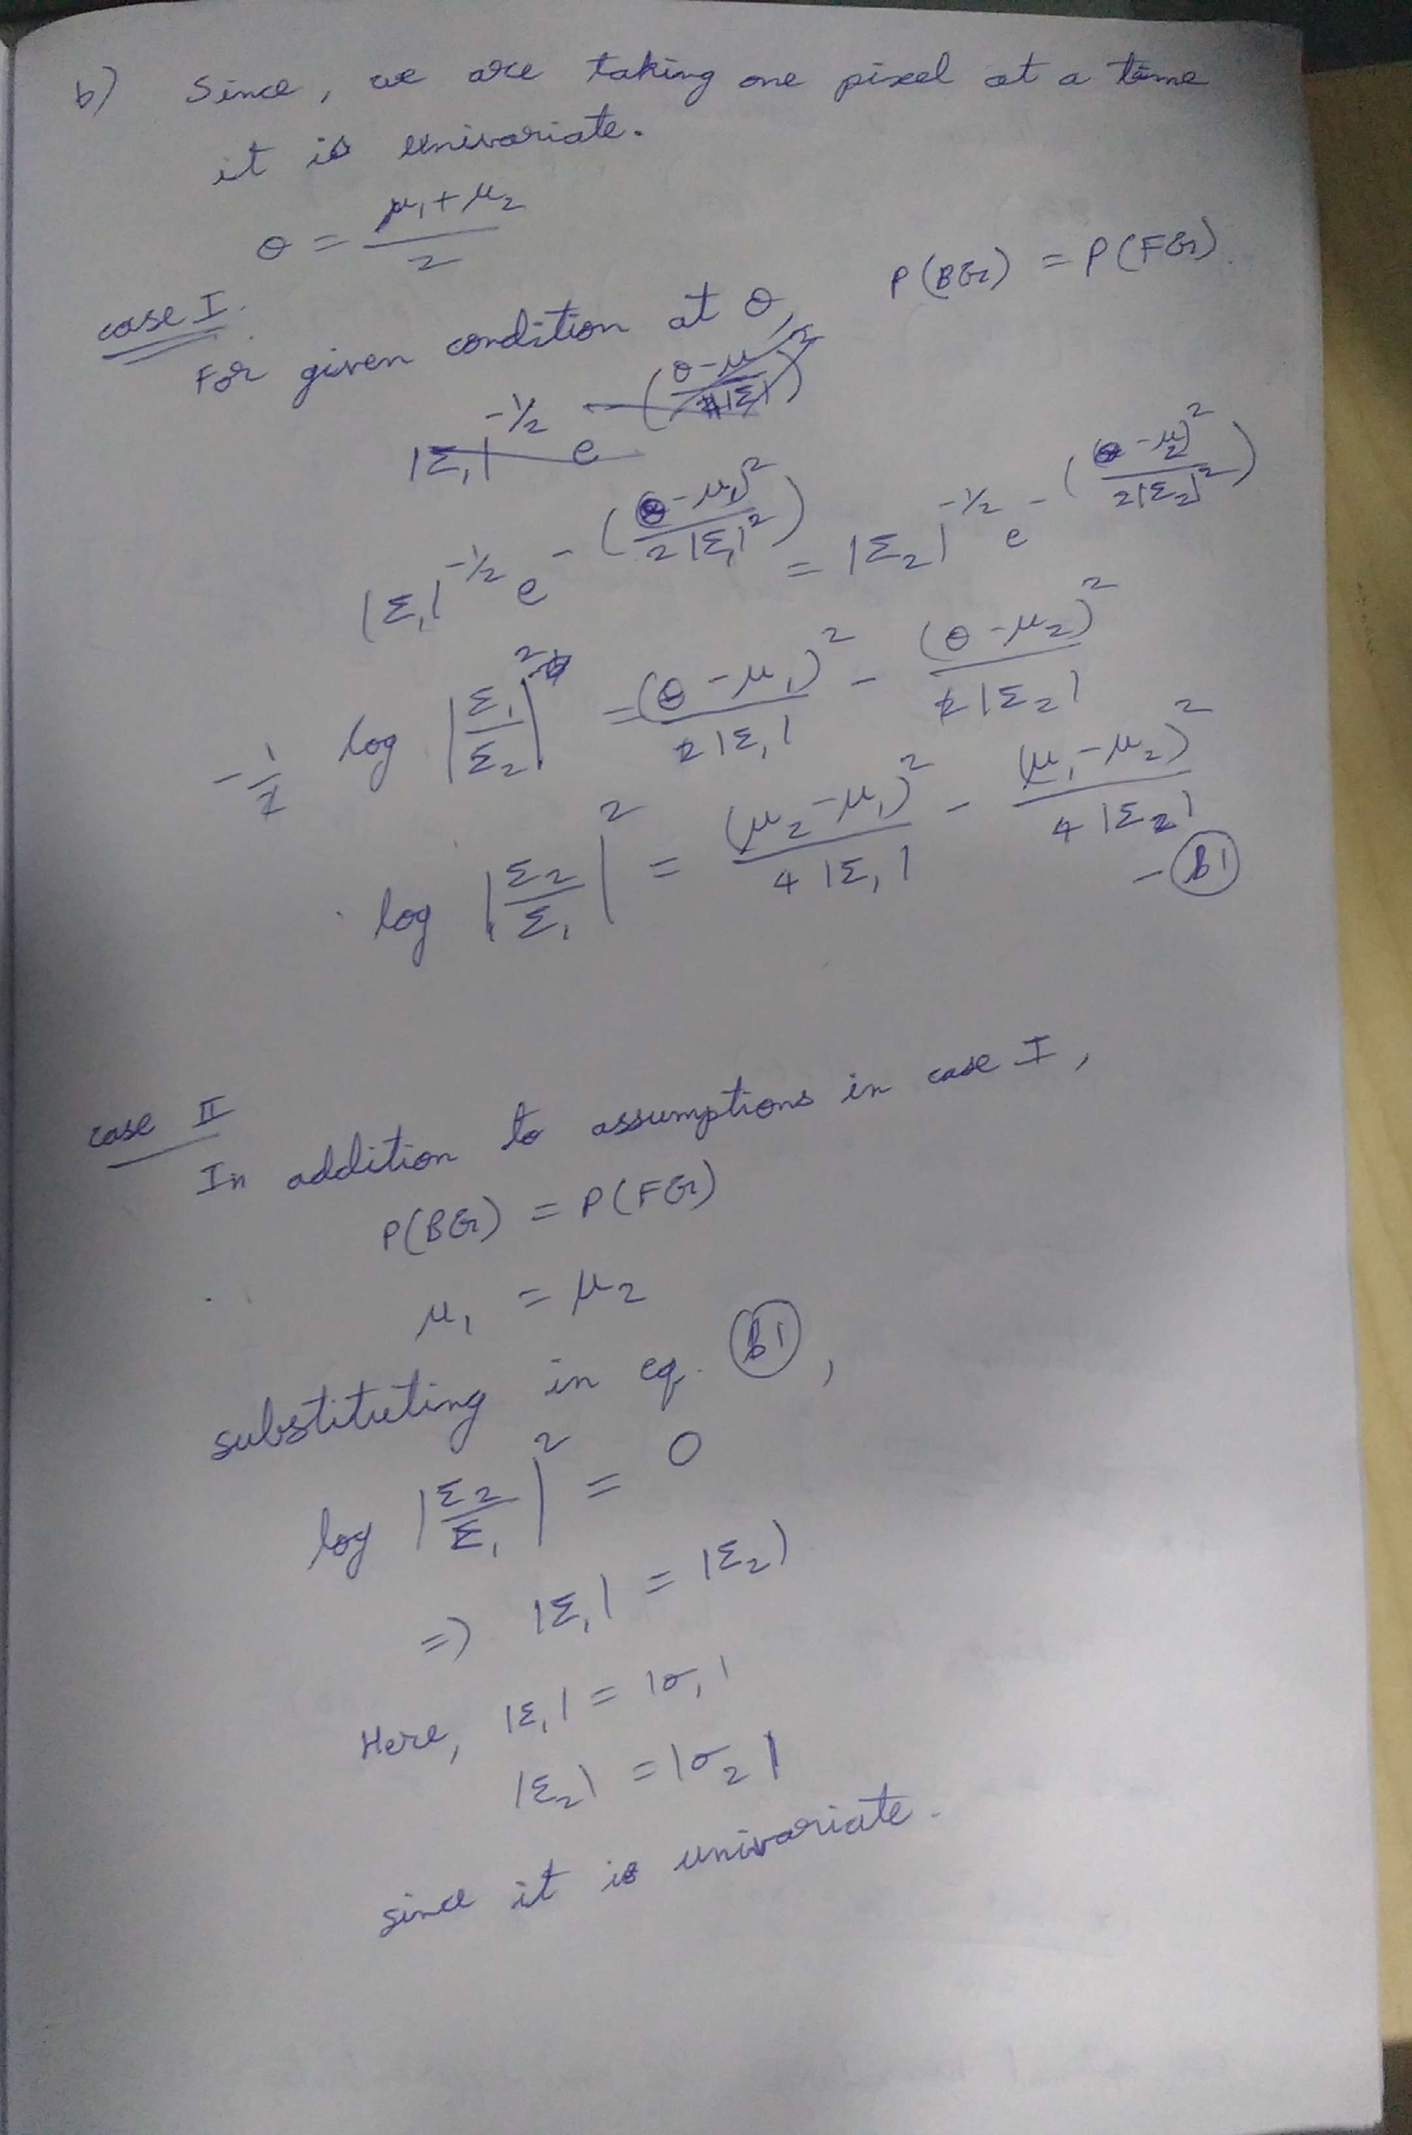
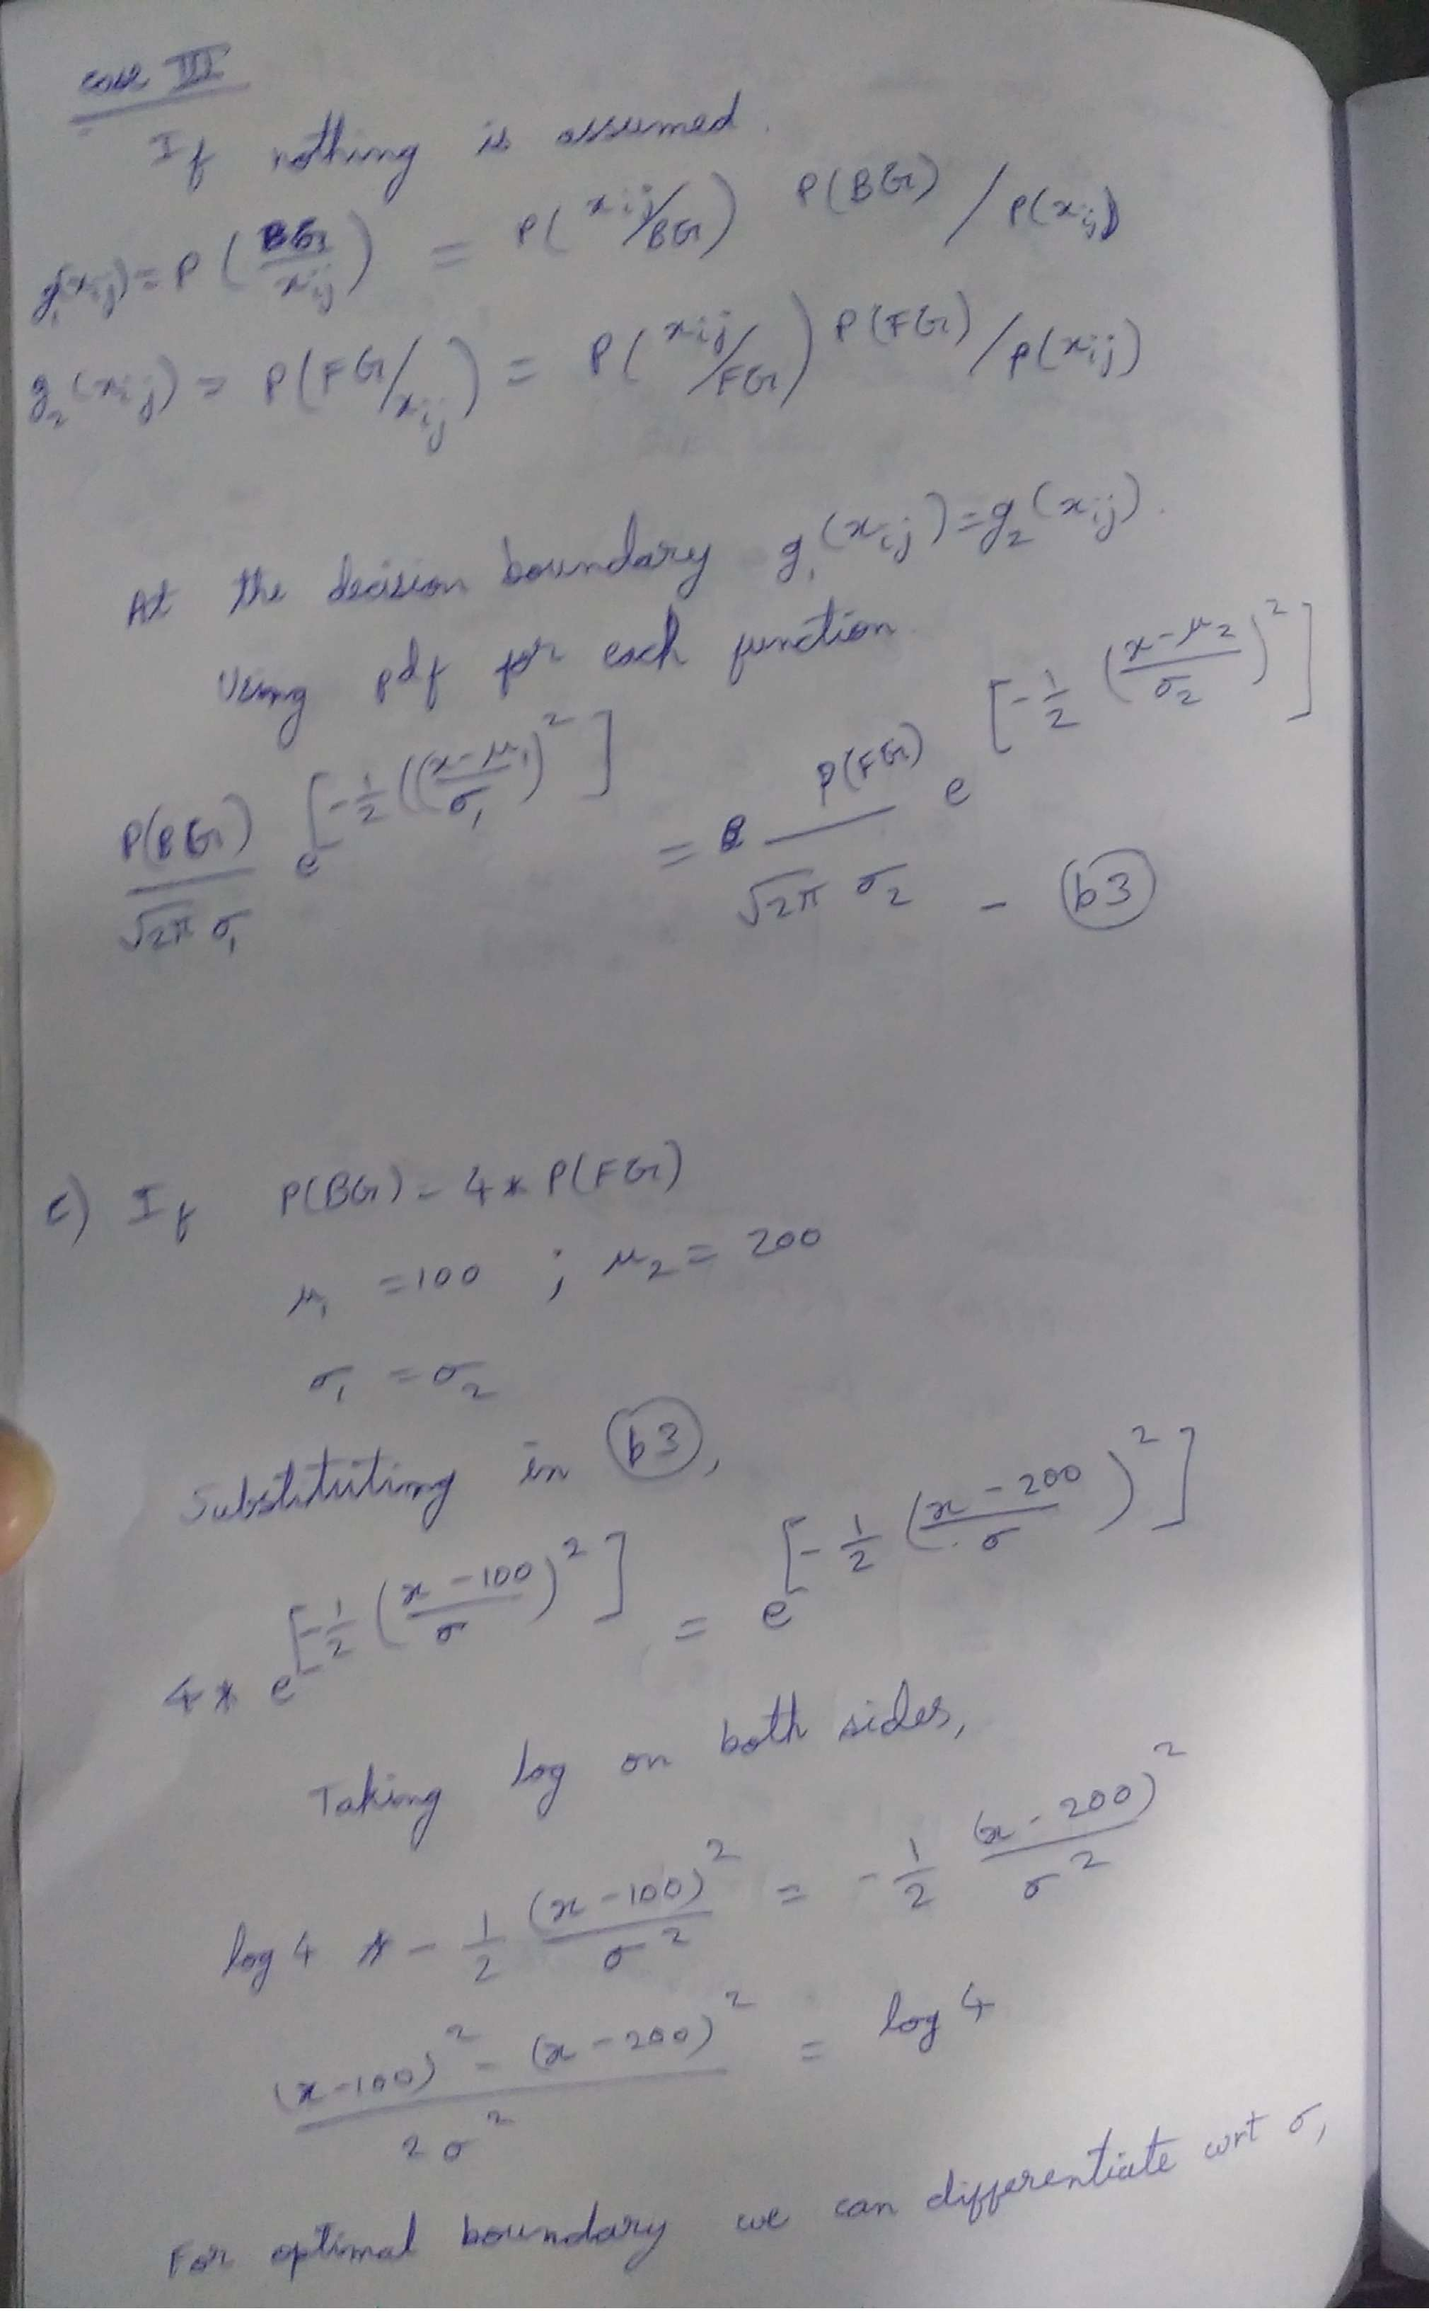

Answer 3 :
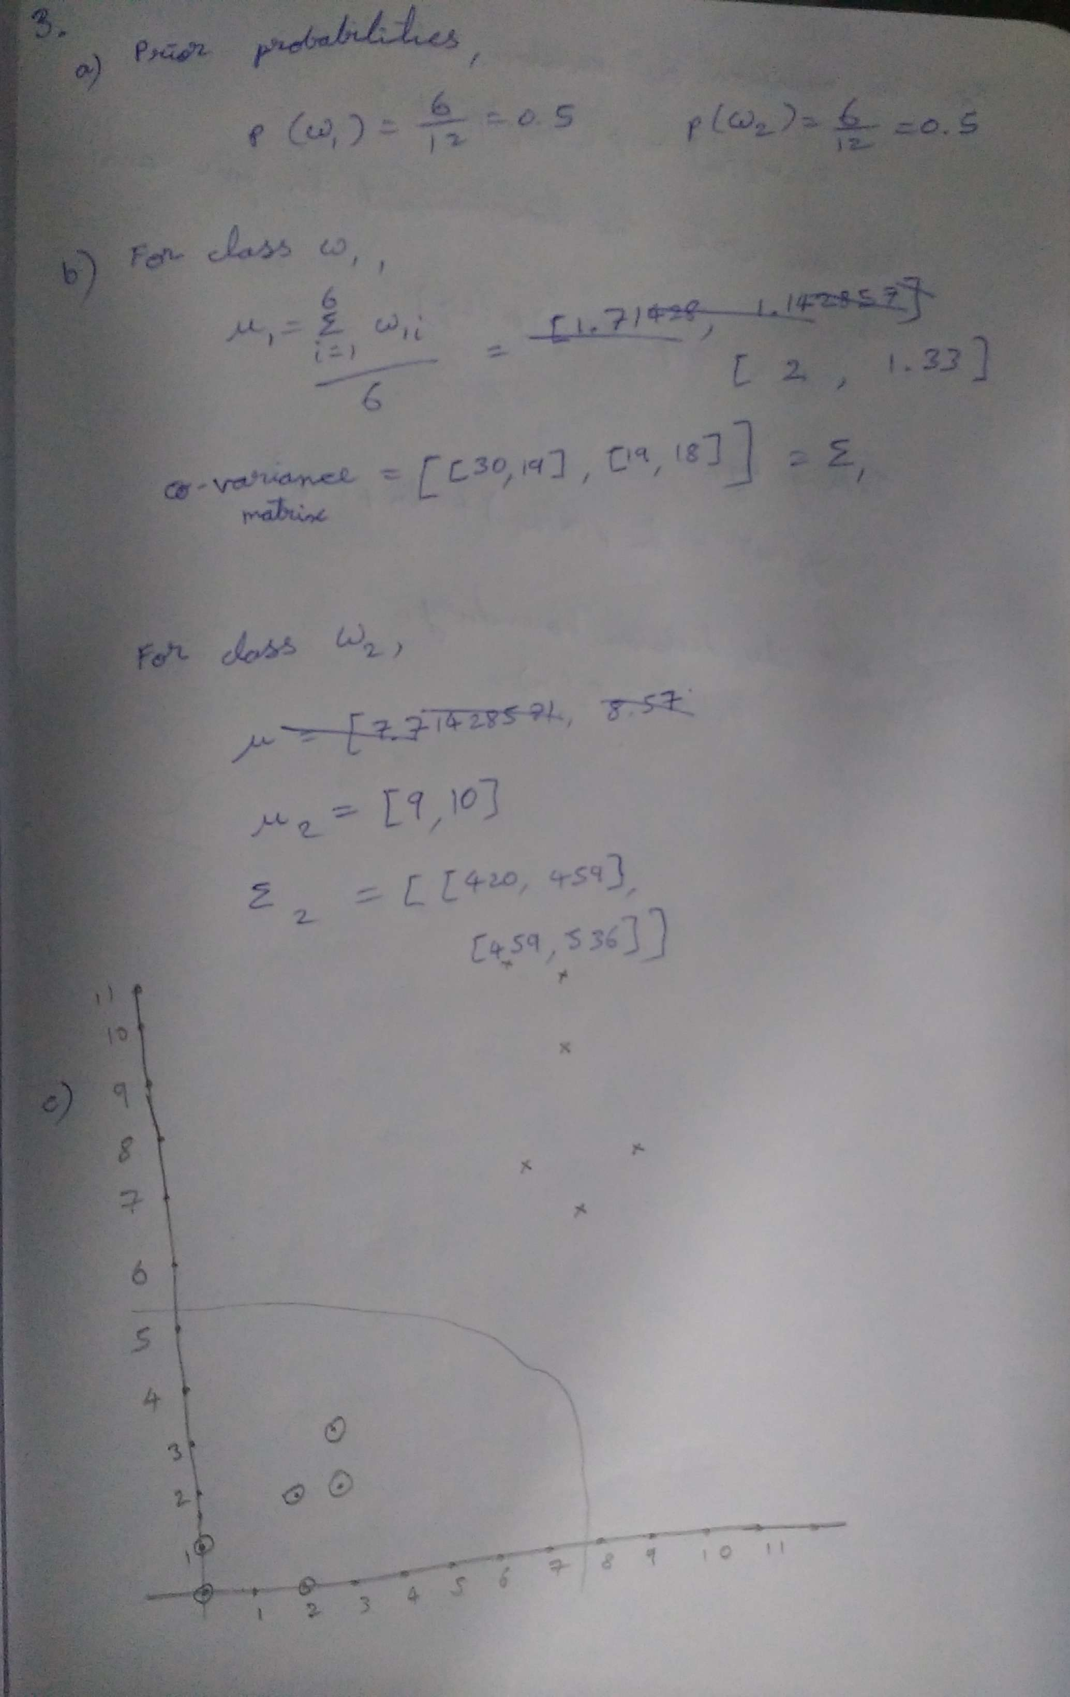

Code :::

import math,random
import numpy as np
from matplotlib import pyplot as plt
from sympy import symbols
from sympy.plotting import plot

Class_w1=np.array([(0,0),(0,1),(2,0),(3,2),(3,3),(2,2),(2,0)])
Class_w2=np.array([(7,7),(8,6),(9,7),(8,10),(7,10),(8,9),(7,11)])
data_set = np.concatenate((Class_w1, Class_w2), axis=0)

Class_w1_mean = np.mean(Class_w1,axis=0)
Class_w2_mean = np.mean(Class_w2,axis=0)
Cov_Class_w1=np.cov(Class_w1.T)
Cov_Class_w2=np.cov(Class_w2.T)

print("Mean of class w1",Class_w1_mean)
print("Mean of class w2",Class_w2_mean)
print("Cov class A",Cov_Class_w1)
print("Cov Class B",Cov_Class_w2)

def MultiVariate_MLE(X,class_mean,sigma):
diff = X-class_mean
p=sigma.shape[0]
Sigma_inv=np.linalg.pinv(sigma)
DetD=np.linalg.det(sigma)
mp = ((-p/2)*np.log(2*(np.pi))) - (np.log(DetD)/2) - ((np.matmul(np.matmul(diff.T, Sigma_inv), diff))/2)
return mp

def line_points(point, Class_A_mean, Class_B_mean, Cov_Class_w1, Cov_ClassB):
g1 = MultiVariate_MLE(point,Class_A_mean,Cov_Class_w1)
g2= MultiVariate_MLE(point,Class_B_mean,Cov_ClassB)
gval=g1-g2
return gval

def line_points_with_cost(point, Class_A_mean, Class_B_mean, Cov_Class_w1, Cov_ClassB, cost):
g1 = MultiVariate_MLE(point,Class_A_mean,Cov_Class_w1)+2*cost
g2= MultiVariate_MLE(point,Class_B_mean,Cov_ClassB)+cost
gval=g1-g2
return gval

x_points = np.arange(-1,11)
y_points=[]
y_points_cost=[]
for point in x_points:
point = np.array([point, point])
y= line_points(point, Class_w1_mean, Class_w2_mean, Cov_Class_w1, Cov_Class_w2)
y_points.append(y)
ynew = line_points_with_cost(point, Class_w1_mean, Class_w2_mean, Cov_Class_w1, Cov_Class_w2, cost=8)
y_points_cost.append(ynew)

#plt.plot(x_points,y_points, color='green' , label='initial_decision_boundary')
plt.plot(x_points,y_points_cost, color='blue', label='decision_boundary_with_cost')
plt.scatter(Class_w1[:,0],Class_w1[:,1], c="gray" )
plt.scatter(Class_w2[:,0],Class_w2[:,1], c="black")
plt.ylim(-20,20)
plt.legend(loc='upper left')
plt.show()

