assignment 1

Aksa Taniya

2022-09-12

<https://www.contextures.com/xlsampledata01.html#data>

sampleData<- read.csv("Copy of SampleData.csv")  
head(sampleData)

## OrderDate Region Rep Item Units Unit.Cost Total  
## 1 1-6-21 East Jones Pencil 95 1.99 189.05   
## 2 1-23-21 Central Kivell Binder 50 19.99 999.50   
## 3 2-9-21 Central Jardine Pencil 36 4.99 179.64   
## 4 2-26-21 Central Gill Pen 27 19.99 539.73   
## 5 3-15-21 West Sorvino Pencil 56 2.99 167.44   
## 6 4-1-21 East Jones Binder 60 4.99 299.40

#Descriptive statistics for Categorical Variables:

freq <- table(sampleData$Region)  
head(freq)

##   
## Central East West   
## 24 13 6

freq <- table(sampleData$Rep,sampleData$Item)  
head(freq)

##   
## Binder Desk Pen Pen Set Pencil  
## Andrews 1 0 0 0 3  
## Gill 2 0 1 0 2  
## Howard 1 0 1 0 0  
## Jardine 2 0 0 1 2  
## Jones 3 0 1 2 2  
## Kivell 1 1 0 2 0

#Plotting of Categorical Variables:

freq <- table(sampleData$Region,sampleData$Item)  
barplot(freq,main="Scatter Plot",xlab="Region",ylab="Item",horiz=TRUE,col="blue",las=1,cex.names = 0.5)

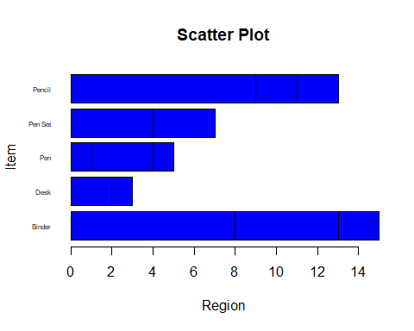 #Descriptive Statistics for Quantitative Variables:

summary(sampleData)

## OrderDate Region Rep Item   
## Length:43 Length:43 Length:43 Length:43   
## Class :character Class :character Class :character Class :character   
## Mode :character Mode :character Mode :character Mode :character   
##   
##   
##   
## Units Unit.Cost Total   
## Min. : 2.00 Min. : 1.29 Length:43   
## 1st Qu.:27.50 1st Qu.: 3.99 Class :character   
## Median :53.00 Median : 4.99 Mode :character   
## Mean :49.33 Mean : 20.31   
## 3rd Qu.:74.50 3rd Qu.: 17.99   
## Max. :96.00 Max. :275.00