IMGC CORPORATION
Policy Administration System
Application Guide

Enterprise Edition | Version 3.2.1
March 2026 | Confidential

India Mortgage Guarantee Corporation
End-to-End Insurance Operations Management Platform

Table of Contents
1. Platform Overview
2. Login & Authentication
3. Executive Dashboard
4. Policy Management
5. Policy Detail & Lifecycle
6. Customer Management
7. Underwriting Engine
8. Claims Management
9. Billing & Payments
10. Task Management
11. Document Management
12. Reports & Analytics
13. Administration & User Management
14. Compliance Management
15. Technology Stack & Architecture
16. User Roles & Permissions
17. Navigation Reference
18. API Endpoints Reference

1. Platform Overview
The IMGC Policy Administration System (PAS) is an enterprise-grade insurance operations management platform developed for India Mortgage Guarantee Corporation. It provides end-to-end policy lifecycle management, claims processing, underwriting, billing, compliance tracking, and comprehensive reporting capabilities.

Platform Highlights
Feature | Details
Modules | 14+ Enterprise Modules
API Endpoints | 150+ RESTful APIs with JWT Authentication
User Roles | 5 Role-Based Access Levels (Admin, Underwriter, Claims, Agent, Auditor)
Security | 256-bit Encryption, SOC 2 Compliant, IRDAI Regulated
Frontend | Next.js 14, React 18, TypeScript, Tailwind CSS
Backend | Express.js, TypeScript, JWT Auth with Refresh Tokens
Charts | Recharts — Interactive bar, pie, donut, horizontal bar charts
Design | Enterprise orange accent theme (30% coverage), responsive design

Core Capabilities
- Policy Lifecycle Management — Quote to issuance, endorsement, renewal, and cancellation
- Claims Automation — FNOL intake through settlement tracking with reserve management
- Risk Intelligence — Real-time underwriting scoring with configurable rules engine
- Billing & Payments — Full invoicing, installment plans, receivables aging, and ledger
- Task Management — SLA-tracked task queues with workflow-driven auto-assignment
- Document Management — Upload, template-based generation, categorization, versioning
- Compliance & Audit — Regulatory requirement tracking with complete audit trails
- Executive Analytics — 7 KPIs, 5+ chart types, role-based dashboards, date-filtered reports

2. Login & Authentication
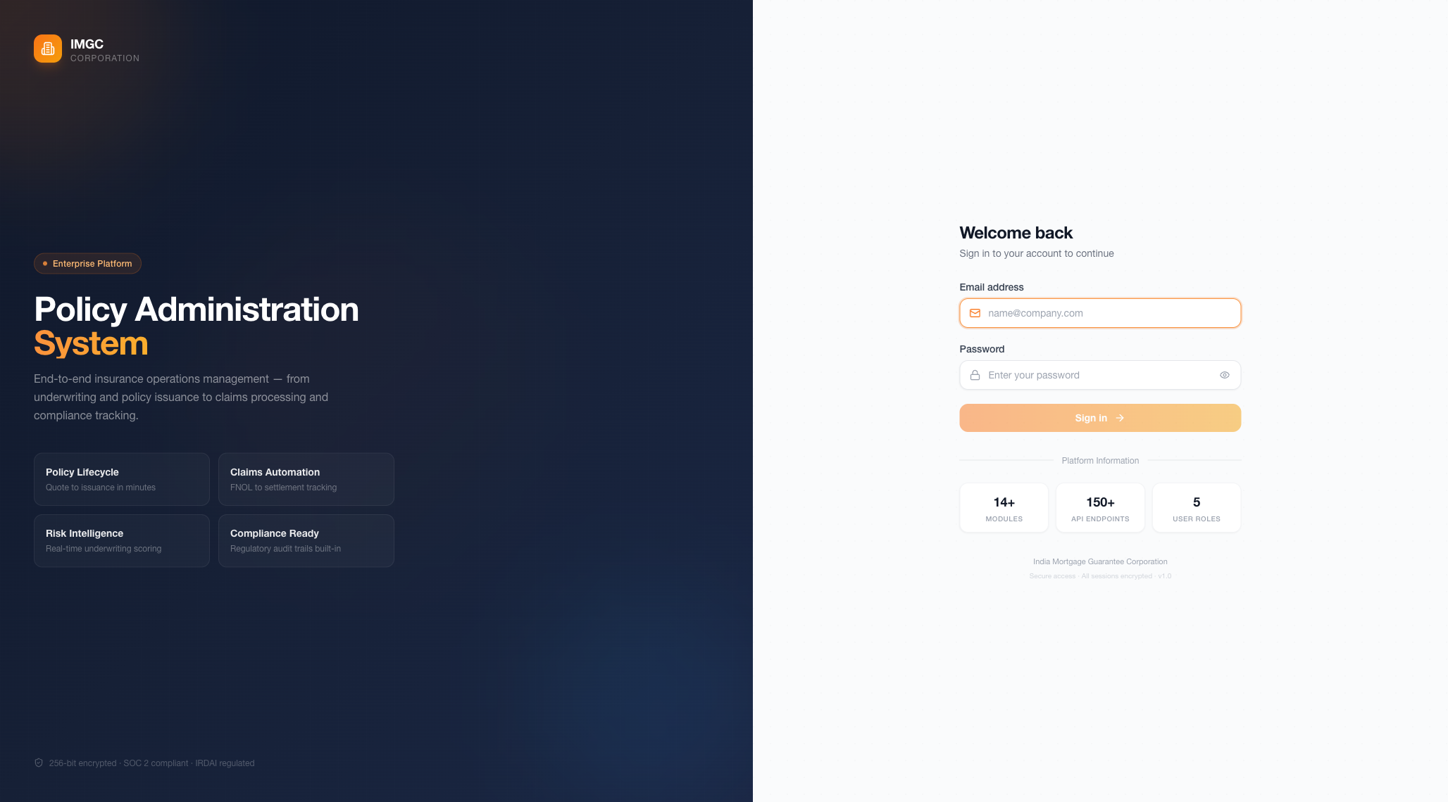

Overview
The login page features a split-screen enterprise design. The left panel showcases the IMGC brand with platform capabilities (Policy Lifecycle, Claims Automation, Risk Intelligence, Compliance Ready). The right panel provides a clean login form with email and password fields.

Authentication Features
- JWT-based authentication with access and refresh token mechanism
- Encrypted password storage using bcrypt hashing algorithm
- Automatic session management with configurable token expiry
- Role-based access control (RBAC) — permissions enforced from login onward
- 256-bit end-to-end encryption for all data in transit
- SOC 2 compliance badge and IRDAI regulatory compliance indicators on login

Security Badges
The login page displays three compliance indicators: 256-bit encrypted, SOC 2 compliant, and IRDAI regulated. Platform statistics are shown — 14+ Modules, 150+ API Endpoints, and 5 User Roles.

Login Credentials (Demo)
Role | Email | Password
Admin | admin@pas.com | password123
Underwriter | underwriter@pas.com | password123
Claims Adjuster | claims@pas.com | password123
Agent | agent@pas.com | password123
Auditor | auditor@pas.com | password123

3. Executive Dashboard
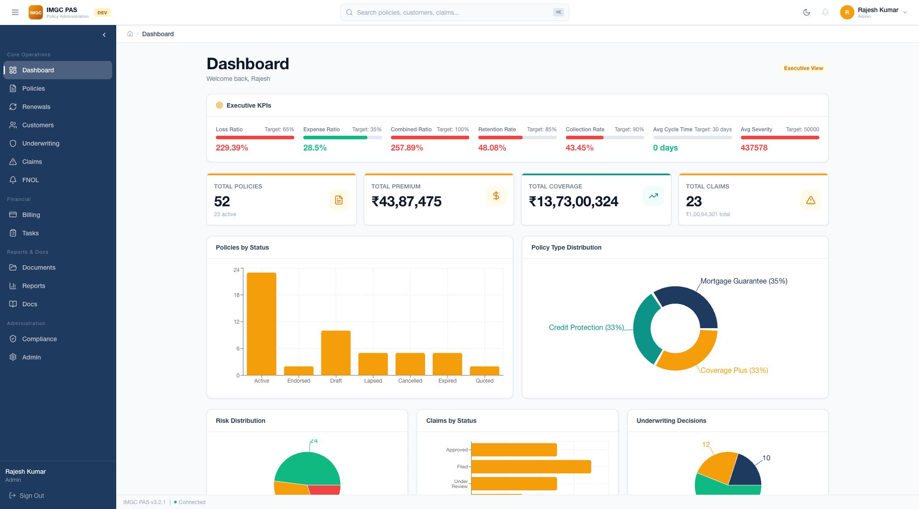

Overview
The Executive Dashboard provides a comprehensive real-time overview of the entire insurance operation. It features role-based views that adapt based on the logged-in user's role. The default Executive View displays 7 KPIs with target tracking, 4 summary cards, and 5+ analytics charts.

Executive KPIs
Seven key performance indicators are displayed at the top with progress bars and color-coded status (green for on-target, red for off-target):
KPI | Target | Description
Loss Ratio | 65% | Claims paid as percentage of premiums earned
Expense Ratio | 35% | Operating costs as percentage of premium income
Combined Ratio | 100% | Sum of loss and expense ratios — overall efficiency
Retention Rate | 85% | Percentage of policies renewed at expiry
Collection Rate | 90% | Premium collection efficiency against invoiced amount
Avg Cycle Time | 30 days | Average time from claim filing to settlement
Avg Severity | 50,000 | Average claim payout amount in INR

KPI Summary Cards
- Total Policies: 52 (23 active) — with orange document icon
- Total Premium: Rs.43,87,475 — with orange currency icon
- Total Coverage: Rs.13,73,00,324 — with orange trend icon
- Total Claims: 23 (Rs.1,00,64,301 total) — with orange alert icon

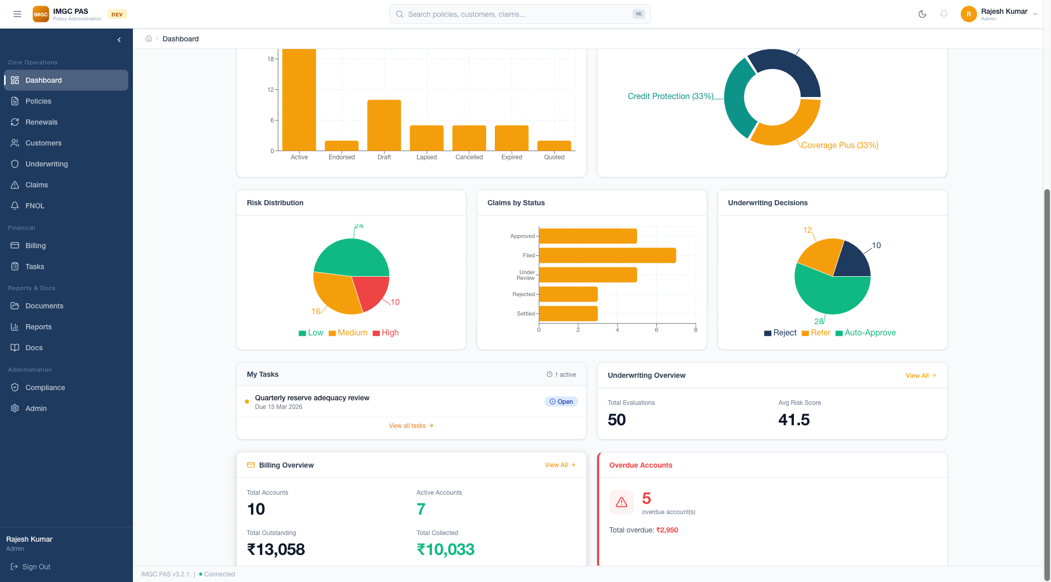

Analytics Charts
- Policies by Status — Vertical bar chart showing Active (24), Endorsed, Draft, Lapsed, Cancelled, Expired, Quoted
- Policy Type Distribution — Donut chart: Mortgage Guarantee (35%), Credit Protection (33%), Coverage Plus (33%)
- Risk Distribution — Pie chart: Low (24), Medium (16), High (10)
- Claims by Status — Horizontal bar chart: Approved, Filed, Under Review, Rejected, Settled
- Underwriting Decisions — Donut chart: Auto-Approve (28), Refer (12), Reject (10)

Dashboard Widgets
- My Tasks — Shows assigned tasks with SLA deadlines and "Open" status badge
- Underwriting Overview — Total Evaluations (50) and Average Risk Score (41.5)
- Billing Overview — Total Accounts (10), Active (7), Outstanding (Rs.13,058), Collected (Rs.10,033)
- Overdue Accounts — Alert widget showing 5 overdue accounts with total overdue Rs.2,950

4. Policy Management
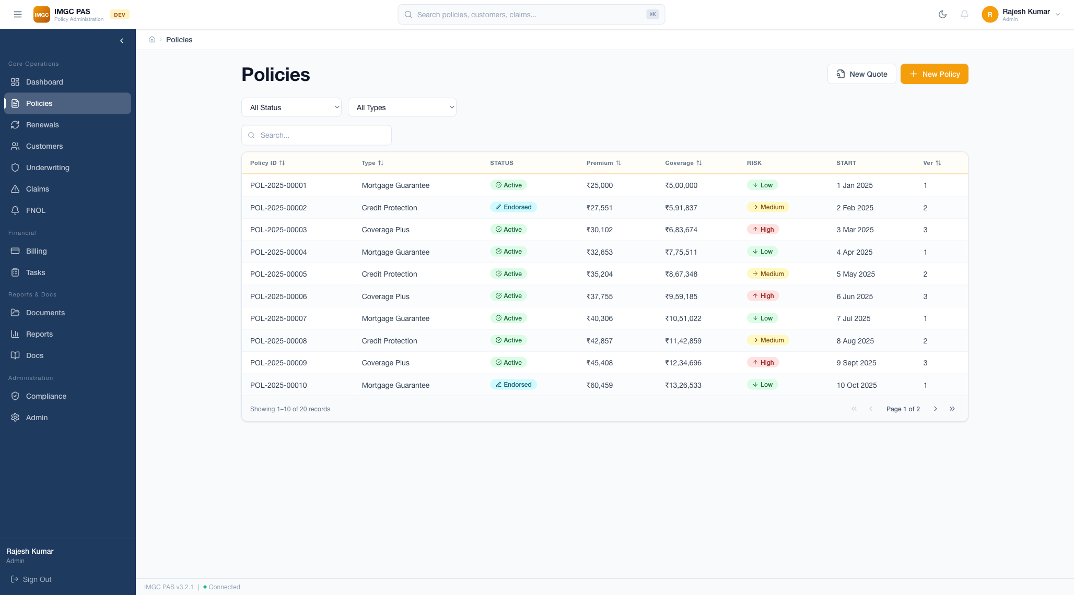

Overview
The Policy Management module is the core of the PAS platform. It provides comprehensive policy listing, creation, filtering, and lifecycle management. Users can create new policies, generate quotes, and manage the entire policy lifecycle from a single interface.

Policy List Features
- Comprehensive data table with 8 columns: Policy ID, Type, Status, Premium, Coverage, Risk, Start Date, Version
- Advanced filtering by 12 statuses: Draft, Quoted, Bound, Issued, Active, Endorsed, Renewal Pending, Reinstated, Lapsed, Cancelled, Expired
- Filter by policy type: Mortgage Guarantee, Credit Protection, Coverage Plus
- Real-time search across all fields with instant results
- Sortable columns — click any header to sort ascending/descending
- Pagination with 10 records per page and full navigation controls (first, prev, next, last)
- Record count display: "Showing 1-10 of 20 records"

Quick Actions
- New Quote — Opens the multi-step quoting wizard (Customer Select -> Coverage Config -> Premium Review -> Bind)
- New Policy — Creates a new policy directly with full form

Policy Status Badges
Status | Badge Color | Description
Active | Green | Policy is in force, coverage is active
Endorsed | Blue | Policy has been modified mid-term (endorsement applied)
Draft | Gray | Initial creation, not yet submitted for quoting
Quoted | Orange | Premium has been calculated, awaiting binding
Bound | Indigo | Quote accepted, awaiting issuance
Issued | Teal | Policy formally issued to policyholder
Renewal Pending | Yellow | Renewal initiated, awaiting underwriting/payment
Reinstated | Cyan | Previously lapsed/cancelled policy restored
Lapsed | Red | Premium overdue beyond grace period, coverage suspended
Cancelled | Red | Terminated by request or non-payment
Expired | Gray | Policy term ended, not renewed

Risk Level Indicators
Risk Level | Color | Indicator
Low | Green | Down arrow — low risk profile
Medium | Yellow | Right arrow — moderate risk profile
High | Red | Up arrow — high risk profile

5. Policy Detail & Lifecycle
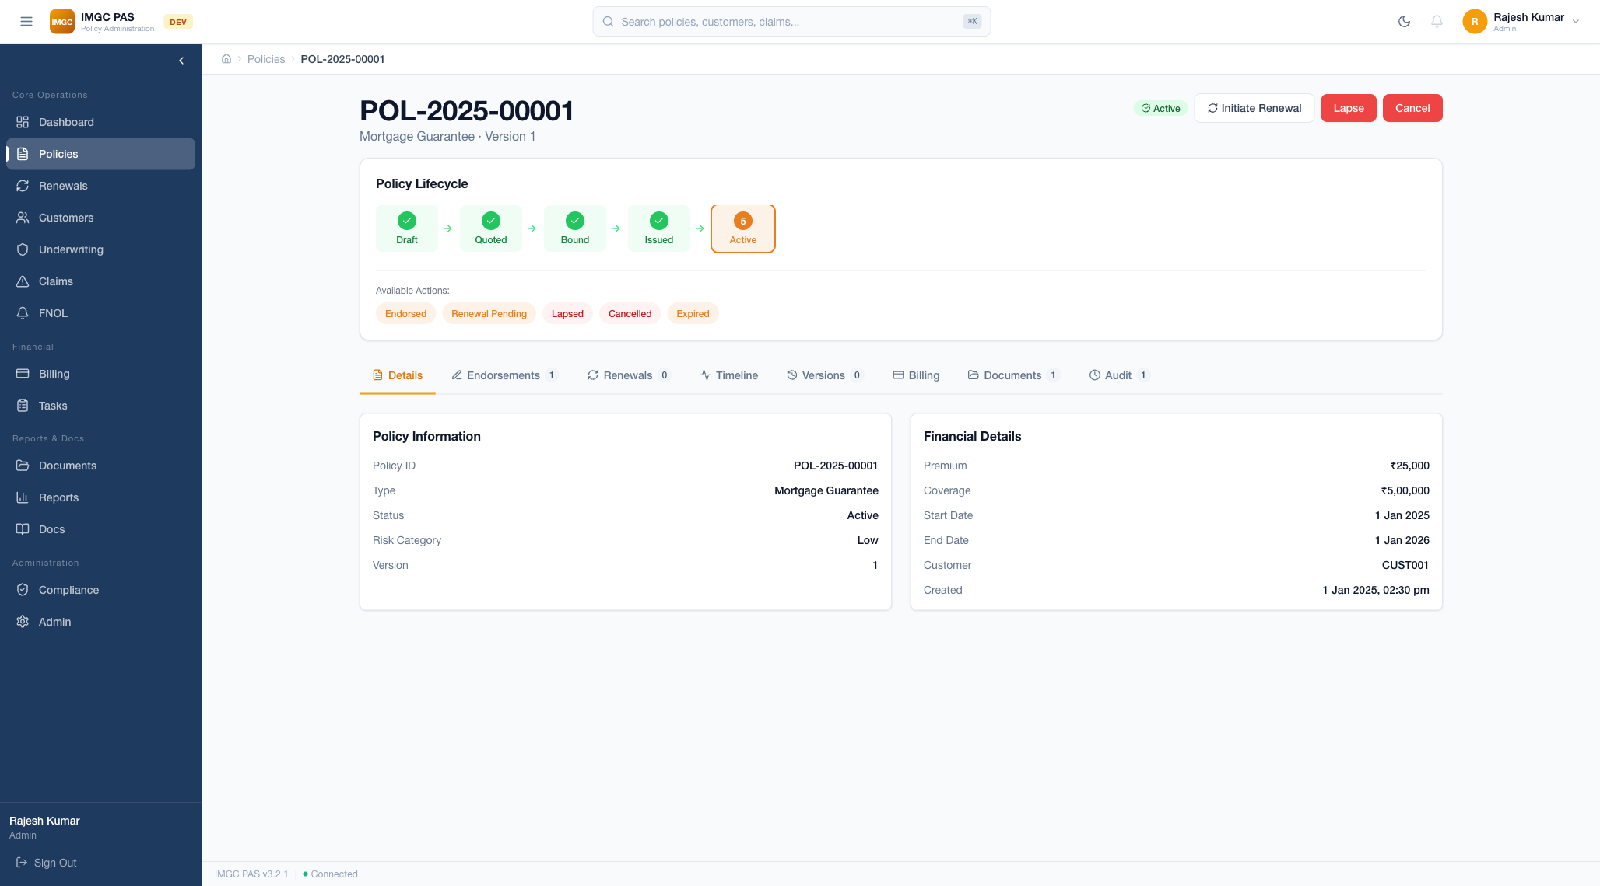

Overview
The Policy Detail page provides a complete view of an individual policy with a visual lifecycle stepper, action buttons, and an 8-tab detail interface. This is the central page for all policy operations including endorsements, renewals, billing, documents, and audit trail.

Policy Lifecycle Stepper
The lifecycle stepper displays the complete journey of a policy through five stages:
- Draft — Initial policy creation (gray circle)
- Quoted — Premium calculation completed (green checkmark when passed)
- Bound — Quote accepted by customer (green checkmark when passed)
- Issued — Policy formally issued (green checkmark when passed)
- Active — Policy in force (orange highlighted circle with step number)
Each completed stage shows a green checkmark. The current stage is highlighted with an orange circle. Arrows connect the stages to show the flow progression.

Available Actions
Based on the current policy status, available transition actions are displayed as clickable orange/red badges below the stepper. For an Active policy:
- Endorsed — Apply a mid-term modification to the policy
- Renewal Pending — Initiate the renewal process
- Lapsed — Mark the policy as lapsed due to non-payment
- Cancelled — Cancel the policy by request
- Expired — Mark the policy as expired (term ended)

Header Action Buttons
- Initiate Renewal — Start the renewal workflow for this policy
- Lapse — Lapse the policy (red button, requires confirmation)
- Cancel — Cancel the policy (red button, requires confirmation)

8-Tab Detail Interface
Tab | Content | Details
Details | Policy & Financial Information | Policy ID, Type, Status, Risk Category, Version, Premium, Coverage, Dates, Customer ID, Created timestamp
Endorsements | Mid-term policy modifications | List of endorsements with effective date, type of change, premium delta, and approval status
Renewals | Renewal history & tracking | Previous renewals, upcoming renewal date, renewal underwriting status, premium changes
Timeline | Chronological event log | Visual timeline of all lifecycle events: creation, status changes, endorsements, payments, documents
Versions | Policy version history | Version number, effective date, changes made, comparison between versions
Billing | Payment information | Linked billing account, installment schedule, payment history, outstanding balance
Documents | Policy documents | Generated documents (declarations, certificates), uploaded documents, download/preview actions
Audit | Complete audit trail | Every user action logged: who, what, when — with before/after values for changes

6. Customer Management
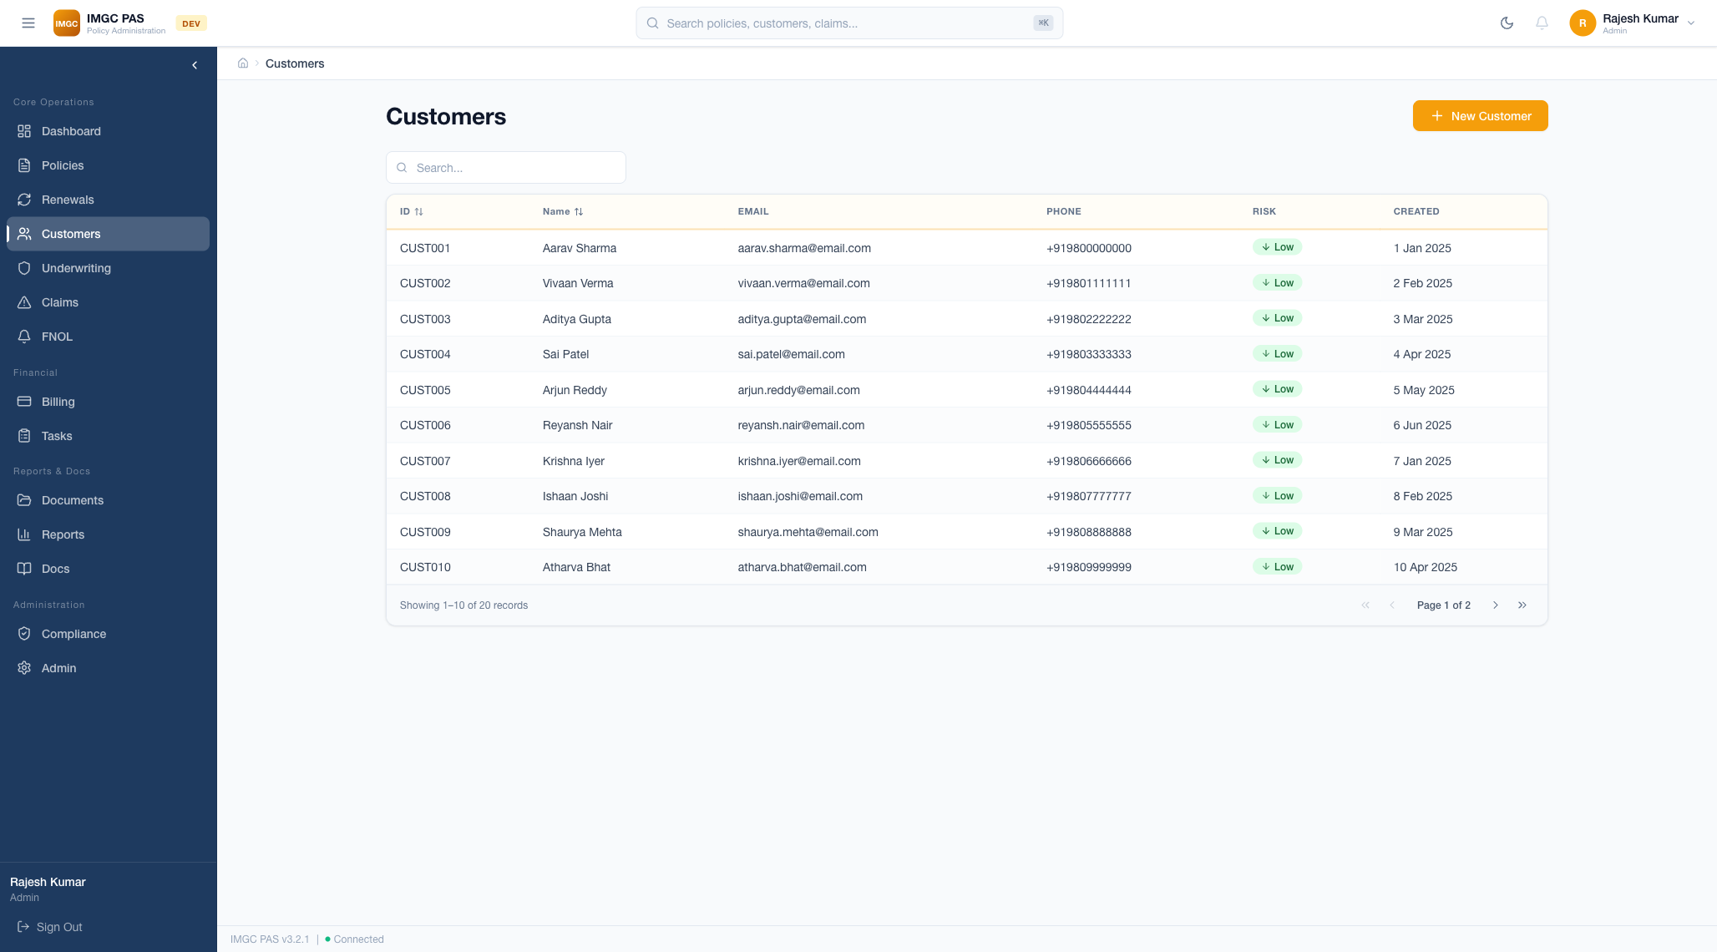

Overview
The Customer Management module provides a centralized view of all customers with their associated policies, risk profiles, and contact information. It supports full CRUD operations and real-time search.

Customer Table
- Customer ID — Unique identifier (e.g., CUST001)
- Name — Full name of the policyholder
- Email — Contact email address
- Phone — Contact phone number
- Status — Active (green badge) or Inactive (gray badge)
- Policies — Number of linked policies with clickable navigation
- Risk Profile — Low (green), Medium (yellow), High (red) risk assessment

Customer Operations
- New Customer — Create a new customer with full profile details
- Edit — Modify existing customer information
- View Details — Navigate to customer detail page with all linked entities
- Search — Real-time search by name, email, or phone number
- Pagination — Navigate through customer records with page controls

7. Underwriting Engine
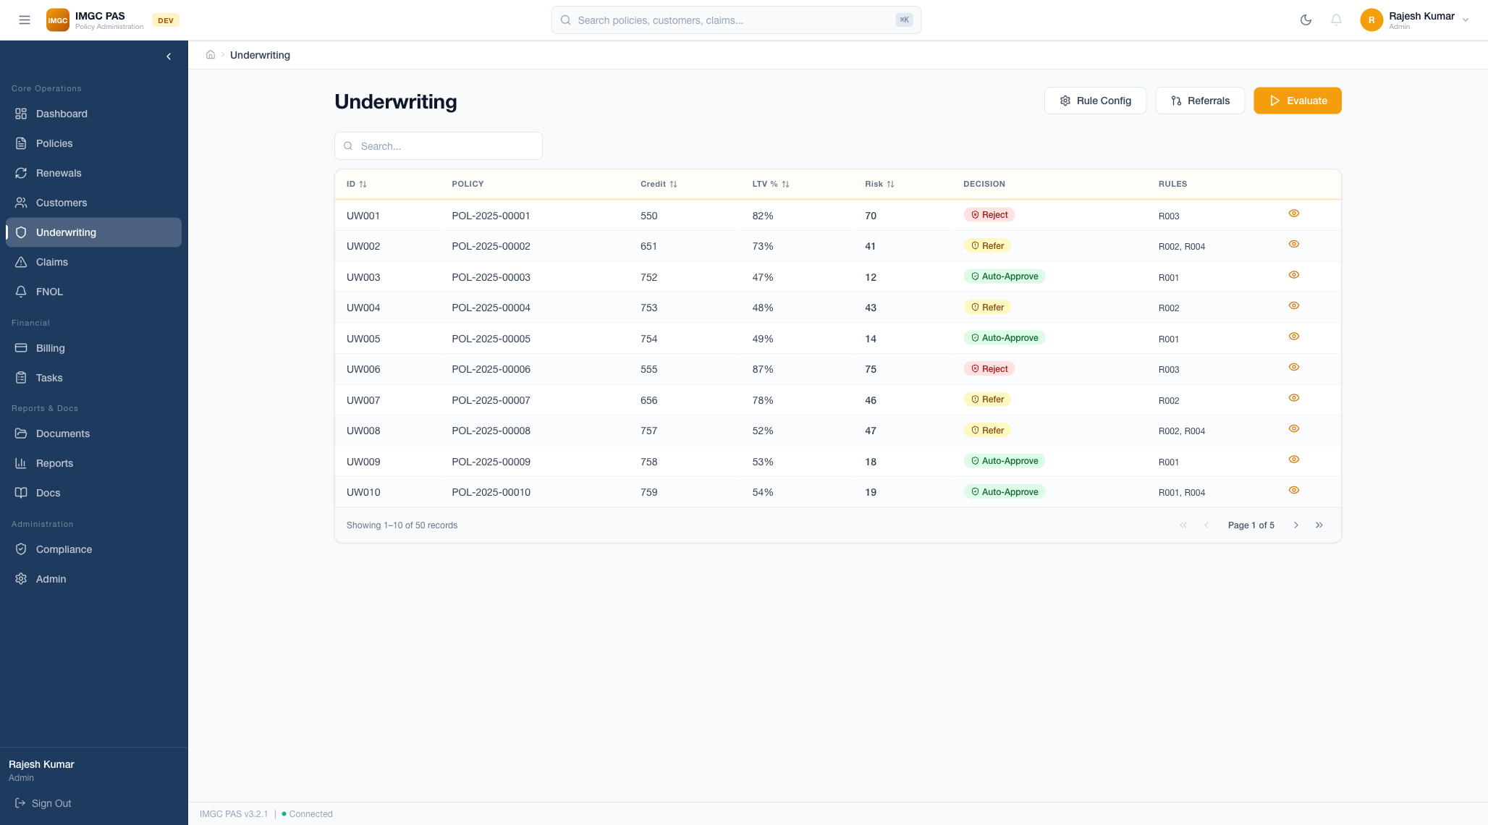

Overview
The Underwriting Engine provides automated risk assessment with a configurable rules engine. It evaluates policies against predefined criteria, generates risk scores (1-100), and makes automated decisions (Auto-Approve, Refer, Reject). Senior underwriters can manually override automated decisions.

Risk Scoring System
Each policy is evaluated against 6 underwriting rules, resulting in a composite risk score from 1 (lowest risk) to 100 (highest risk):
Rule | Criteria | Impact
Property Value Limits | Property value within acceptable range | Rejects if outside bounds
LTV Ratio | Loan-to-Value ratio thresholds | Higher LTV increases risk score
Credit Score | Minimum credit score requirements | Below threshold triggers refer/reject
Employment Verification | Employment status and history | Unverified employment adds risk
Property Type Eligibility | Eligible property categories | Ineligible types auto-rejected
Coverage Ratio | Coverage amount relative to value | Excessive coverage flagged

Decision Categories
Decision | Risk Score Range | Action
Auto-Approve | 1-35 (Low Risk) | Policy automatically approved for binding
Refer | 36-65 (Medium Risk) | Sent to senior underwriter queue for review
Reject | 66-100 (High Risk) | Policy automatically declined with reason codes

Advanced Features
- Rule Configuration (Admin) — Create, edit, and manage underwriting rules with IF/THEN logic
- Referral Queue — Separate queue for cases requiring senior underwriter review with escalation indicators
- Manual Override — Senior underwriters can override automated decisions with mandatory justification
- Delegated Authority — Authority limits per underwriter (maximum coverage amount, maximum risk score)
- Evaluate Button — One-click evaluation with instant risk score calculation and decision
- Risk Scorecard — Visual breakdown by category: Financial, Property, Customer, Compliance

8. Claims Management
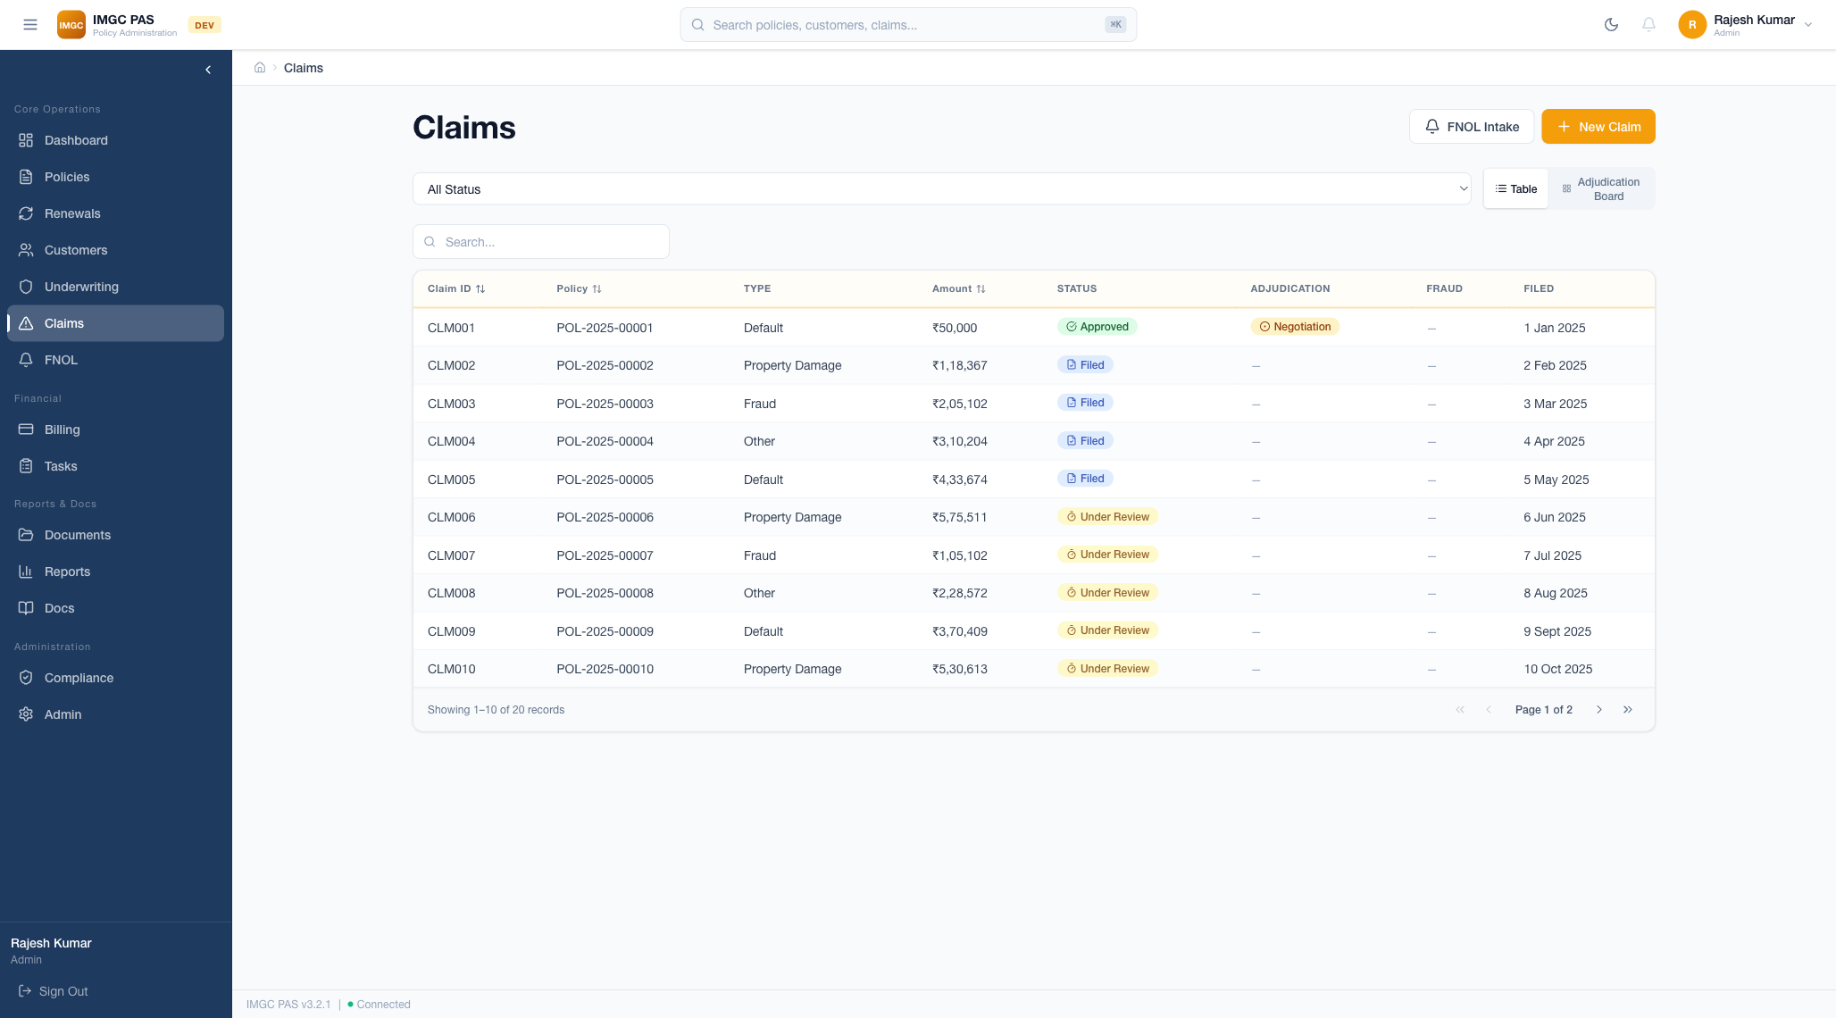

Overview
The Claims Management module handles the complete claims lifecycle from First Notice of Loss (FNOL) intake through investigation, evaluation, and settlement. It includes reserve management, fraud scoring, and loss mitigation tracking.

Claims Table
- Claim ID — Unique identifier (e.g., CLM-2025-00001)
- Policy — Linked policy number for cross-reference
- Type — Claim category (Property Damage, Income Loss, etc.)
- Status — Current claim status with color-coded badge
- Amount — Claimed amount in INR
- Filed Date — Date of FNOL submission

Claims Status Workflow
Claims progress through the following status flow:
Status | Description | Next Actions
Filed | FNOL submitted, claim registered | Assign to adjuster, begin investigation
Under Review | Investigation in progress | Evaluate evidence, assess damage
Approved | Claim validated and approved | Set reserves, initiate settlement
Rejected | Claim denied with reason codes | Send denial letter, close claim
Settled | Payment issued to claimant | Archive documentation, close claim

FNOL Intake Process
The FNOL (First Notice of Loss) wizard guides users through a structured 5-step intake process:
Step | Name | Data Collected
1 | Incident Information | Date, time, location, description of incident
2 | Policy Lookup | Search and link to the insured policy
3 | Damage Details | Type of damage, extent, estimated amount, photographs
4 | Document Upload | Supporting documentation (police reports, medical records, invoices)
5 | Review & Submit | Final review of all information before formal filing

Additional Features
- Reserve Management — Set initial reserves, make adjustments, view reserve history chart
- Fraud Indicator Scoring — Rule-based scoring for duplicate claims, timing patterns, amount thresholds
- Claims Timeline — Visual chronological log of all claim events (FNOL, notes, reserve changes, payments)
- Loss Mitigation — Track workout plans, forbearance status, and loan modification details

9. Billing & Payments
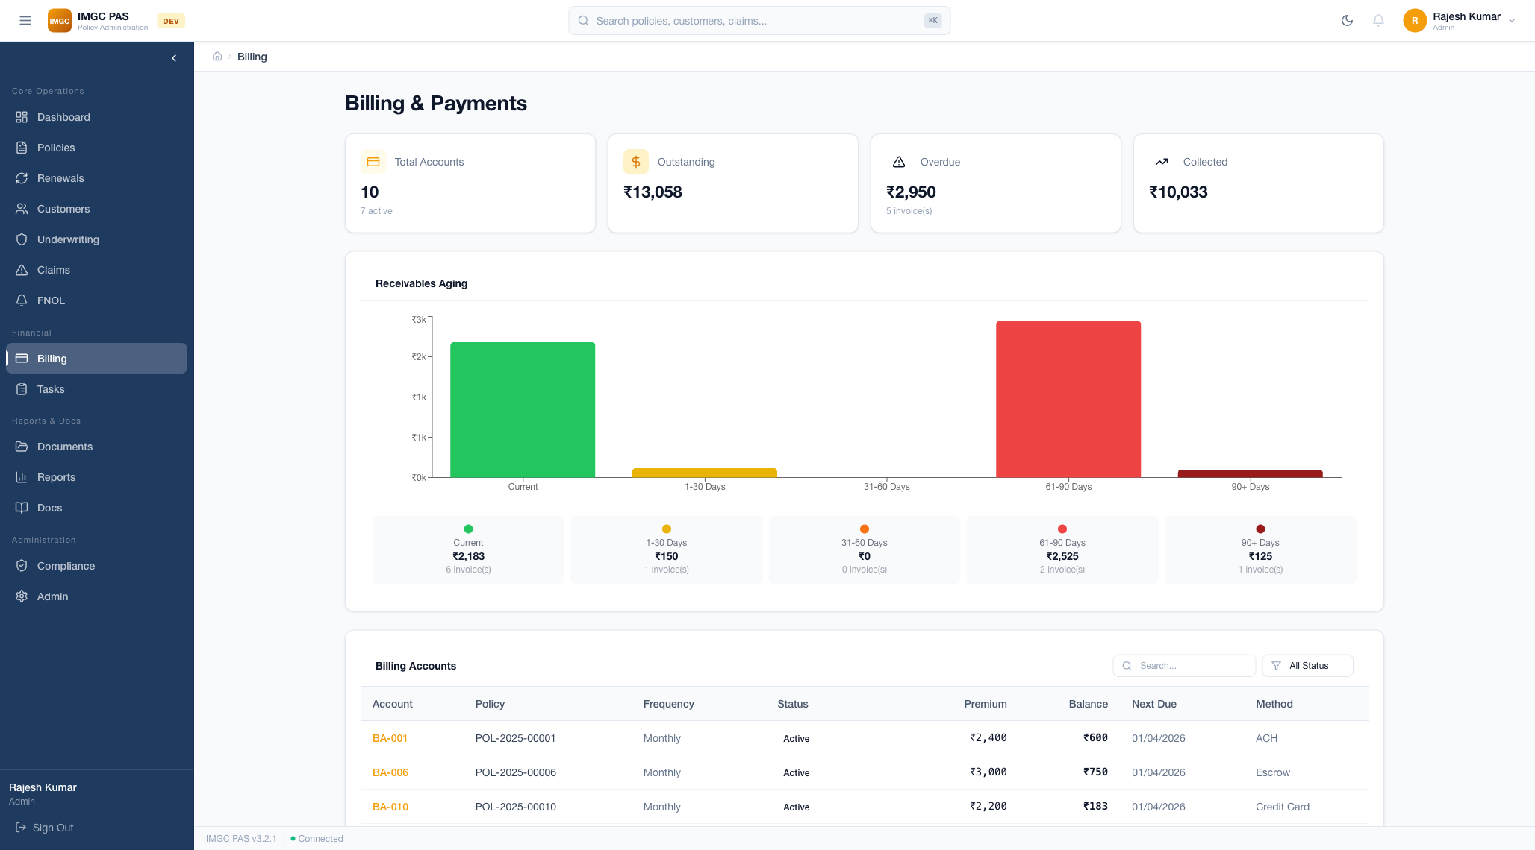

Overview
The Billing & Payments module provides a complete financial lifecycle including invoicing, payment tracking, installment plans, receivables aging, and double-entry ledger accounting. It integrates directly with the policy lifecycle for automated billing and grace period management.

Billing Account Management
- Billing accounts are automatically linked to policies at issuance
- Each account tracks balance, payment plan, installment schedule, and payment history
- Account statuses: Active, Suspended (grace period), Closed
- Quick-view KPI cards: Total Accounts, Active Accounts, Outstanding Amount, Collected Amount

Invoicing
- Auto-generated invoices with detailed line items (premium, fees, taxes)
- Invoice statuses: Pending, Paid, Overdue, Void
- Due date tracking with overdue alerts
- Print and download invoice capability

Payment Tracking
Payment Method | Details
Cash | Cash payments with receipt reference
Check | Check number and bank details
UPI | UPI transaction ID
Bank Transfer | NEFT/RTGS reference number

Installment Plans
- Annual — Single payment for the full premium
- Semi-Annual — Two equal installments, 6 months apart
- Quarterly — Four equal installments, 3 months apart
- Monthly — Twelve equal installments with monthly due dates

Receivables Aging
A visual aging chart displays outstanding receivables categorized by age:
- Current — Invoices within payment terms
- 30-day — 1-30 days past due
- 60-day — 31-60 days past due
- 90-day — 61-90 days past due
- 90+ day — More than 90 days past due (critical)

Grace Period Automation
The system automates the grace period workflow: when an invoice becomes overdue, a grace period timer begins. If payment is not received within the grace period, the linked policy is automatically flagged for lapse processing.

10. Task Management
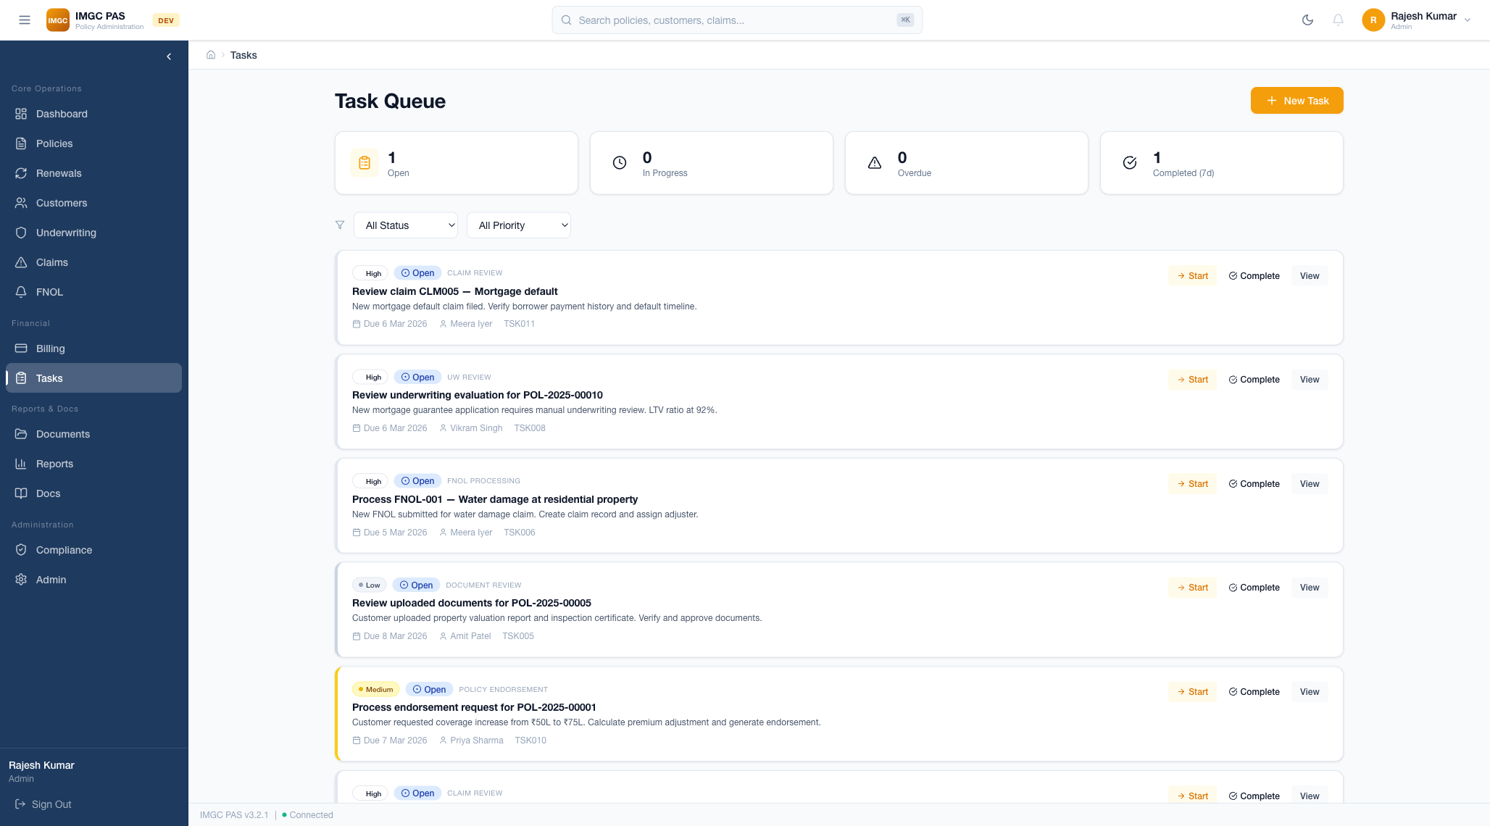

Overview
The Task Management module provides a centralized work queue with SLA tracking, priority management, and automatic task generation from workflow events. It ensures nothing falls through the cracks and all team members have clear work assignments.

Task Queue Features
- Summary Cards — At-a-glance counts for Open, In Progress, Completed, and Overdue tasks
- Task Table — Title, Assignee, Priority, Due Date, Status columns with sorting
- Priority Levels — Urgent (red), High (orange), Medium (yellow), Low (green)
- SLA Tracking — Due date countdown timers with overdue indicators and alerts
- Assignment — Assign or reassign tasks to any team member
- Task Detail Drawer — Side panel with full task details, activity log, and actions

Workflow-Driven Auto-Assignment
Trigger Event | Auto-Created Task | Assigned To
New claim filed | Review and investigate claim | Claims Adjuster
UW referral triggered | Review referred application | Senior Underwriter
Policy renewal due | Process policy renewal | Operations Team
Payment overdue | Follow up on overdue payment | Billing Team
Document required | Collect required documentation | Agent
Compliance deadline | Complete regulatory filing | Compliance Officer

11. Document Management
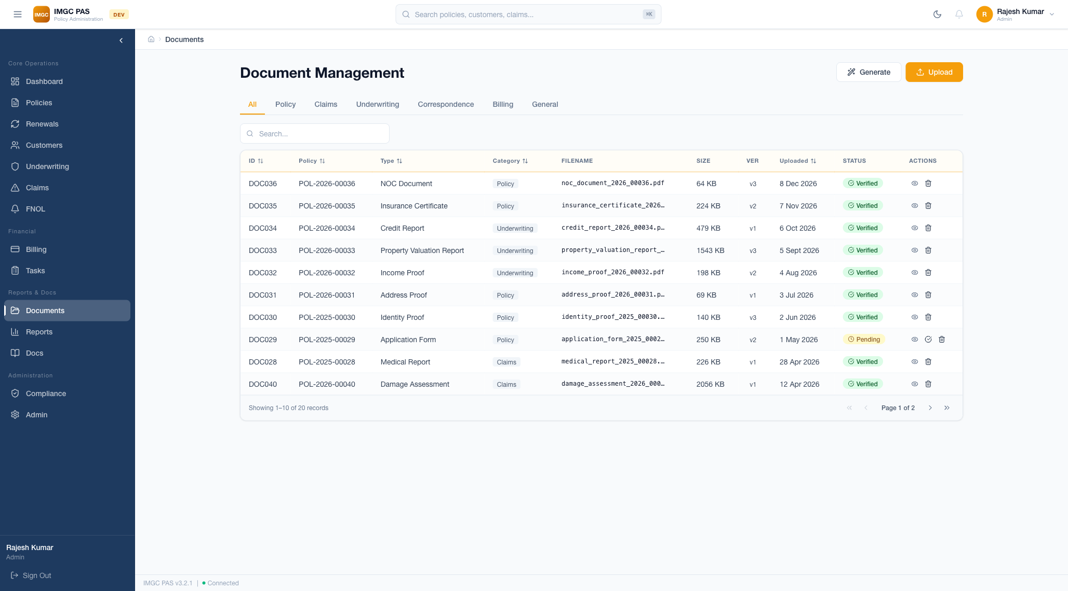

Overview
The Document Management module provides a centralized repository for all policy, claims, underwriting, and correspondence documents. It supports file upload, template-based document generation, categorization, and version control.

Document Categories
Category | Document Types | Description
Policy Documents | Declarations, Certificates, Endorsement Schedules | Official policy documentation issued to policyholders
Claims Documents | FNOL Reports, Investigation Notes, Settlement Letters | Documentation related to claims processing
UW Documents | Risk Assessments, Rule Evaluations, Referral Notes | Underwriting analysis and decision records
Correspondence | Customer Letters, Renewal Notices, Premium Receipts | All customer-facing communications

Key Features
- Drag-and-Drop Upload — File upload with progress bar and size display
- Document Generation — Auto-generate documents from templates (declarations, certificates, invoices)
- In-App Preview — View PDFs and images directly within the application
- Full-Text Search — Search across document names and metadata
- Version Control — Track document versions with history
- Linked Entities — Documents are linked to their parent policy, claim, or customer
- Bulk Download — Select multiple documents for ZIP download

12. Reports & Analytics
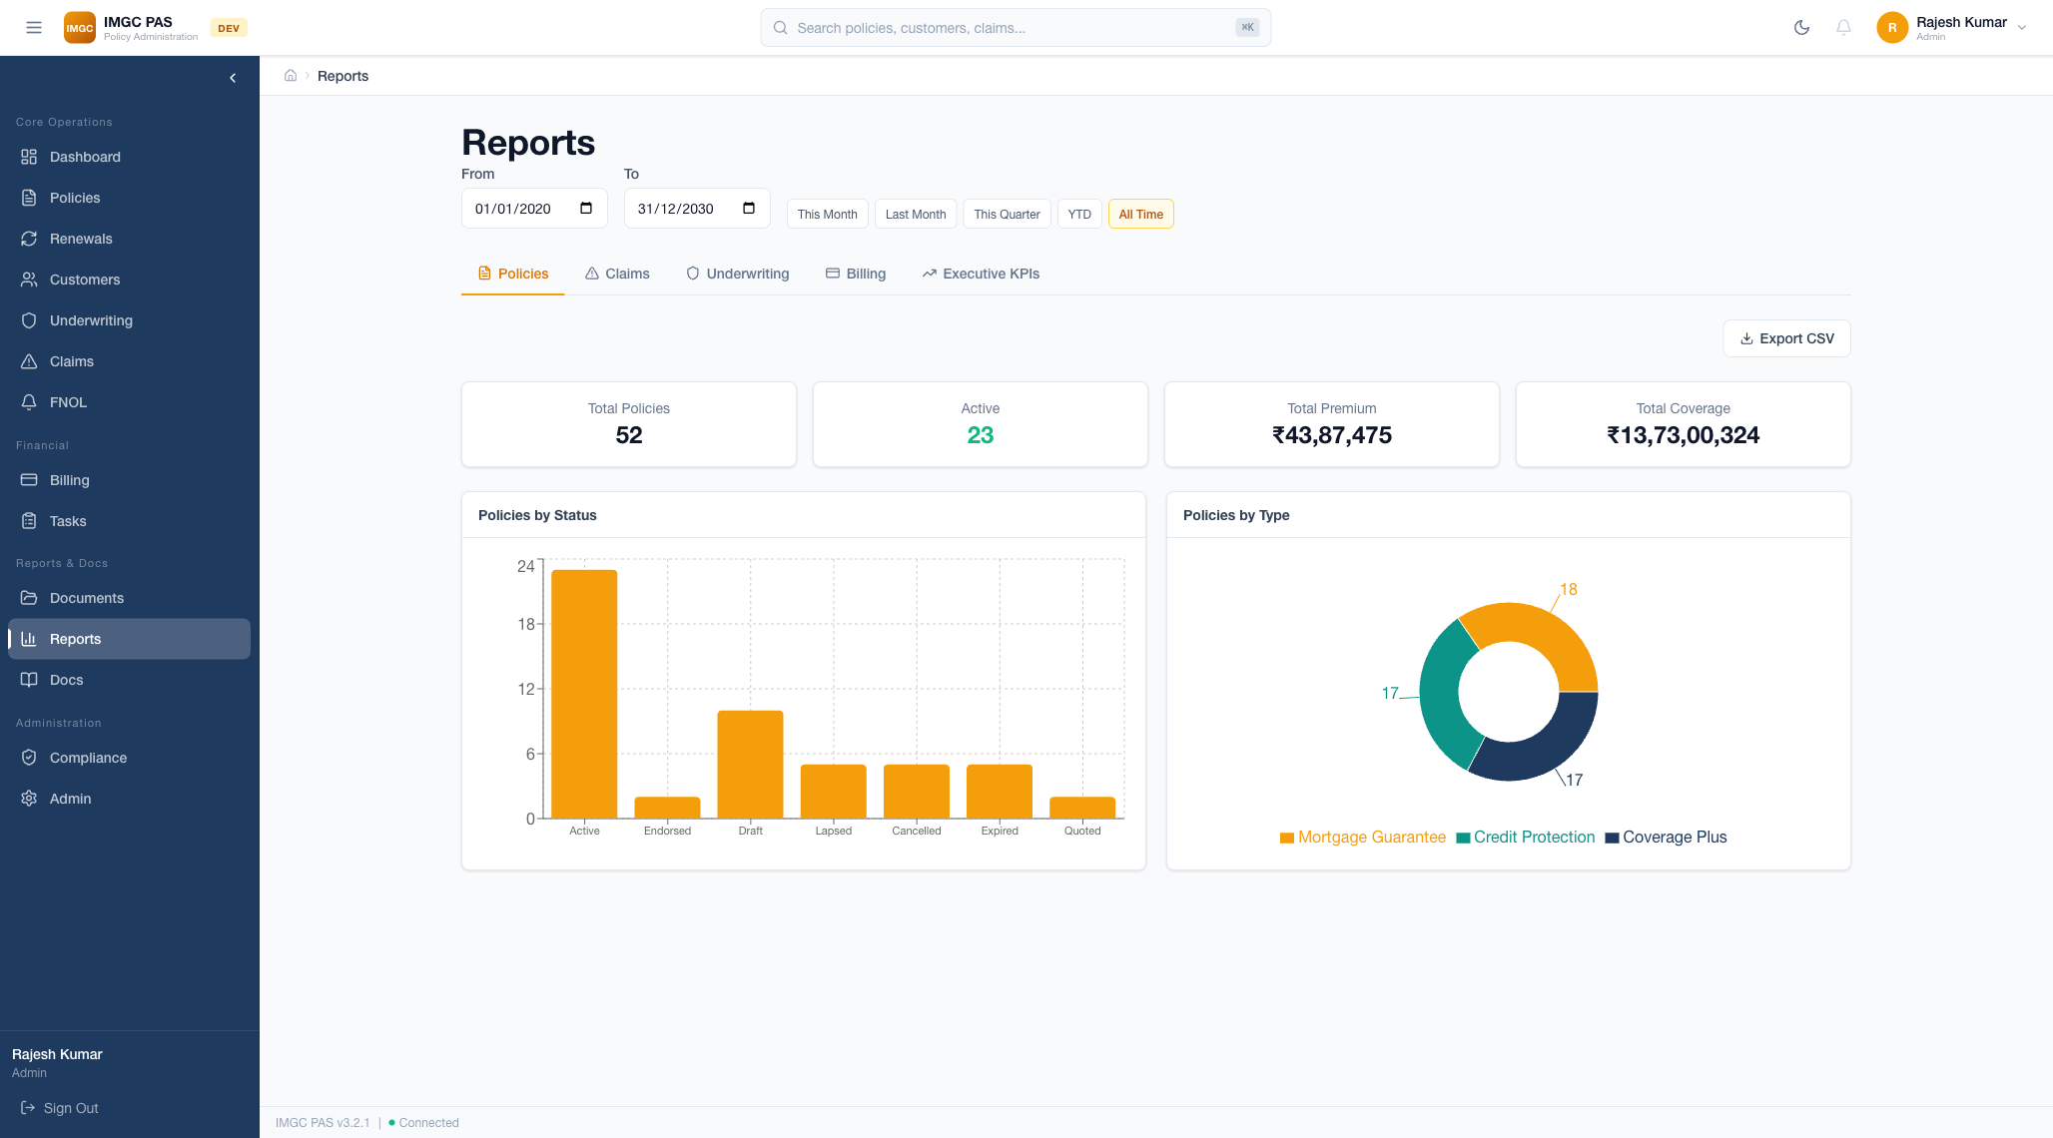

Overview
The Reports module provides comprehensive analytics across policies, claims, and financial metrics. It features interactive charts, date range filtering, and summary metric cards.

Report Types
Tab | Reports | Metrics
Policy Reports | Premium trends, status distribution, type breakdown | Active policies, total premium, avg premium, new policies
Claims Reports | Claims volume, severity trends, cycle time analysis | Total claims, total paid, avg claim amount, open claims
Financial Reports | Revenue tracking, loss ratios, expense analysis | Revenue, expenses, net income, loss ratio trend

Date Range Filtering
- This Month — Current calendar month data
- Last Month — Previous calendar month data
- Last Quarter — Previous 3-month quarter
- Year-to-Date (YTD) — January 1 through today
- Custom Range — Select specific start and end dates

Chart Types
- Vertical Bar Charts — Policy counts, premium trends (orange bars)
- Pie / Donut Charts — Distribution charts for types, statuses, risk levels
- Horizontal Bar Charts — Claims by status comparison
- Summary Cards — Key metrics with trend indicators

13. Administration & User Management
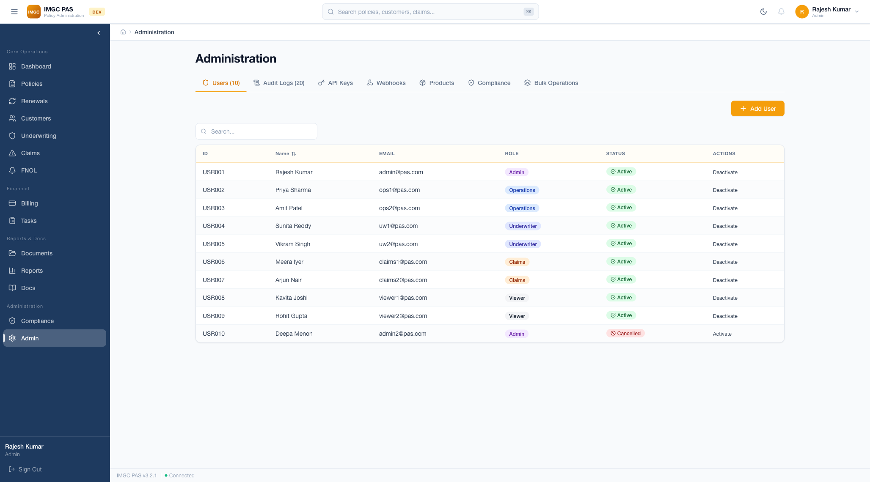

Overview
The Administration module provides user management, role-based access control, and system-wide audit logging. Only Admin-role users have access to this module.

User Management
- User Table — Name, Email, Role, Status, Last Active, Actions columns
- Add User — Create new user accounts with role assignment
- Edit User — Modify user profile, change roles, update permissions
- Activate/Deactivate — Enable or disable user accounts
- Color-coded Role Badges — Visual role identification at a glance
- Search — Find users by name, email, or role

Audit Logging
Every administrative action is logged with: User who performed the action, timestamp, action type, affected entity, and before/after values for data changes. The audit log is immutable and accessible only to Admin and Auditor roles.

14. Compliance Management
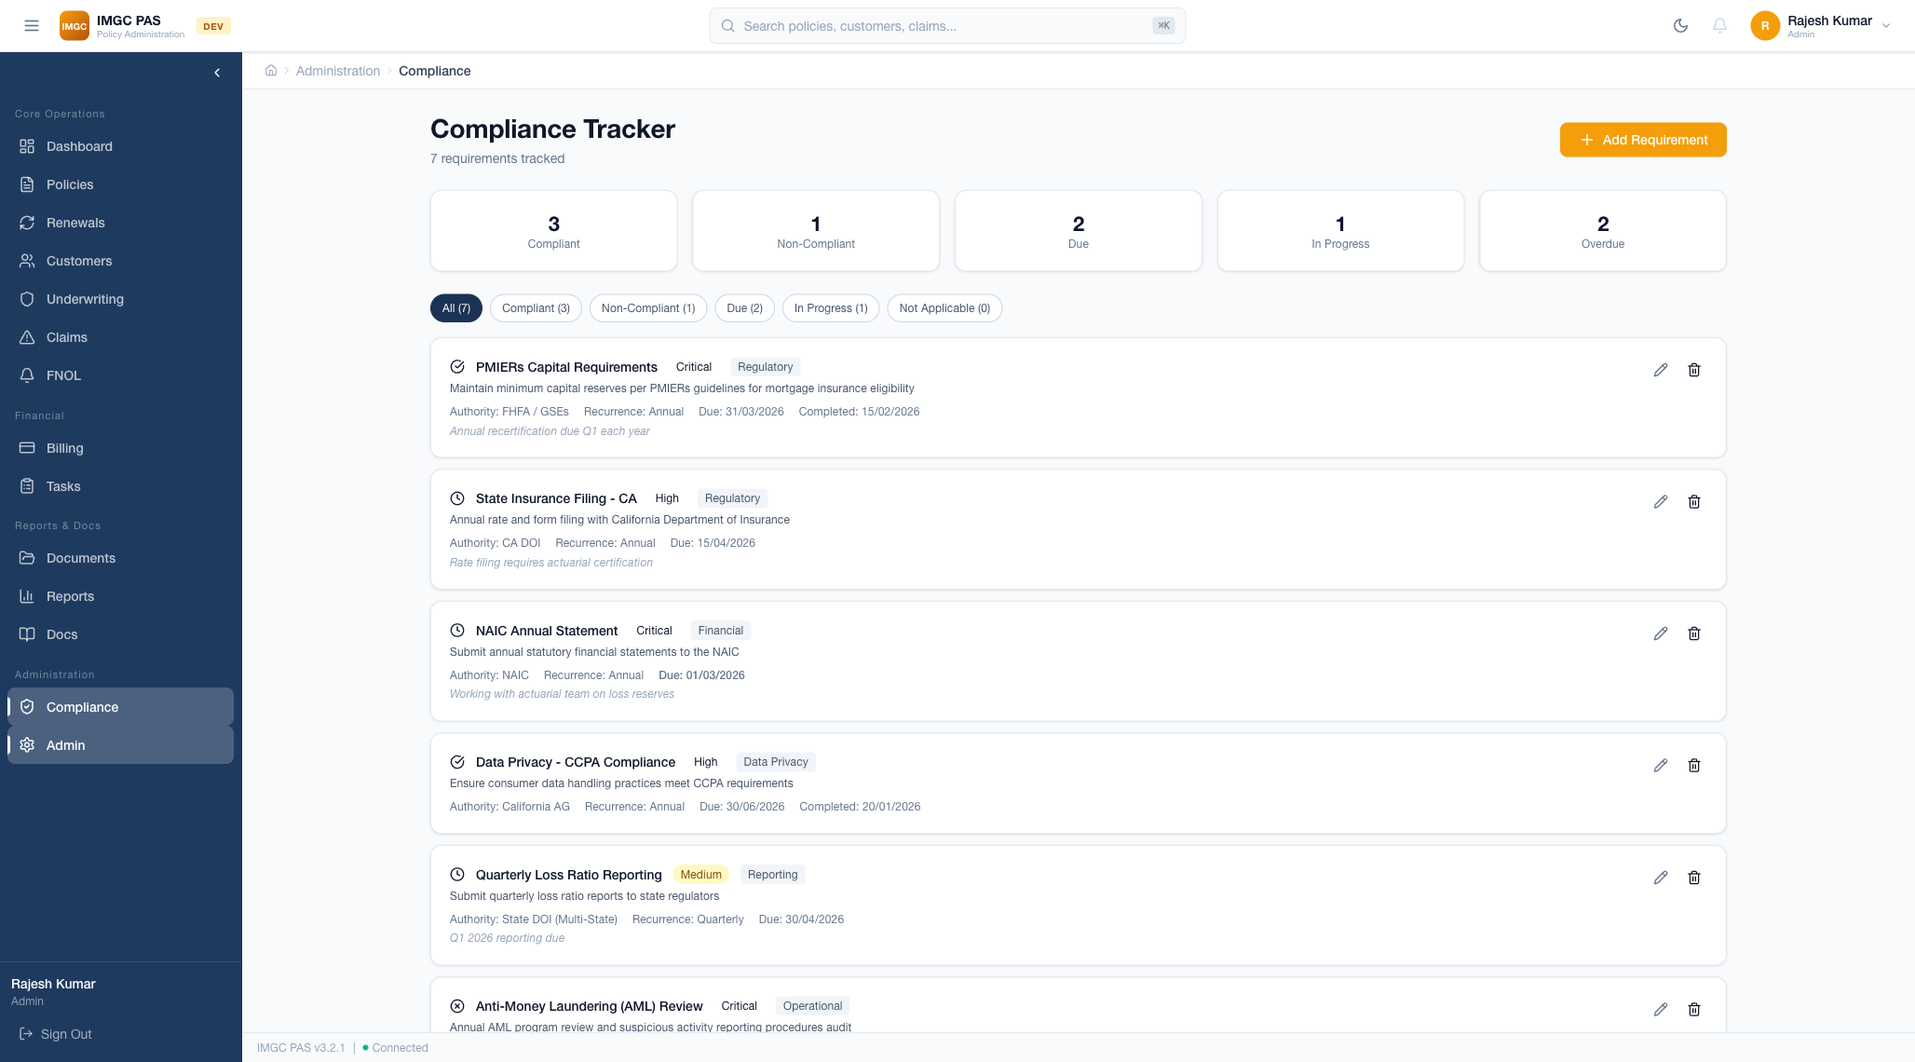

Overview
The Compliance Management module tracks regulatory requirements, filing deadlines, and audit findings. It ensures the organization maintains compliance with IRDAI regulations and internal governance standards.

Compliance Tracking
Status | Badge Color | Meaning
Compliant | Green | Requirement is fully met with documentation
Non-Compliant | Red | Requirement not met — action required
Under Review | Yellow | Compliance review in progress
Due | Orange | Upcoming deadline — attention needed

Features
- Regulatory requirements tracker with status indicators
- Compliance calendar with upcoming regulatory deadlines
- Alert system for approaching and missed deadlines
- IRDAI regulatory filing status and submission tracking
- SOC 2 compliance documentation management
- Compliance report generation for internal and external audits
- Complete audit trail for all compliance-related actions

15. Technology Stack & Architecture

Application Architecture
Layer | Technology | Purpose
Frontend Framework | Next.js 14, React 18 | Server-side rendering, component architecture, routing
Language | TypeScript | Type safety across frontend and backend
Styling | Tailwind CSS | Utility-first CSS with enterprise design system
Icons | Lucide React | Consistent icon set across the application
Charts | Recharts | Interactive data visualizations (bar, pie, donut, line)
Backend | Express.js | RESTful API server with middleware architecture
Authentication | JWT + Refresh Tokens | Stateless, scalable authentication
Authorization | RBAC Middleware | Role-based permission checking on every request
Storage | JSON File Persistence | Rapid prototyping (database-ready architecture)

Non-Functional Features
Feature | Implementation
Responsive Design | Works across desktop (1440px+), tablet (768px), and mobile (375px)
Accessibility | WCAG 2.1 compliant — skip navigation, ARIA labels, keyboard navigation, focus management
Performance | Skeleton loading states, staggered animations, optimistic updates, lazy loading
Security | 256-bit encryption, JWT tokens, bcrypt password hashing, CORS, input sanitization
UX Patterns | Toast notifications, confirmation dialogs, breadcrumb navigation, global search (Cmd+K)
Error Handling | Graceful error boundaries, user-friendly error messages, retry mechanisms
Theme | Light/dark mode support, default light theme, 30% orange accent coverage

16. User Roles & Permissions
The PAS platform implements Role-Based Access Control (RBAC) with 5 predefined roles. Each role has specific permissions that control access to modules and actions.
Module | Admin | Underwriter | Claims Adj. | Agent | Auditor
Dashboard | Full | Full | Full | Full | Read
Policies | Full CRUD | Read | Read | Create/Read | Read
Customers | Full CRUD | Read | Read | Full CRUD | Read
Underwriting | Full | Full | Read | Read | Read
Referrals | Full | Full | None | None | Read
Claims | Full CRUD | Read | Full CRUD | Create | Read
FNOL | Full | None | Full | Create | Read
Billing | Full | Read | Read | Read | Read
Tasks | Full | Assigned | Assigned | Assigned | Read
Documents | Full | Read | Read | Upload | Read
Reports | Full | Full | Full | Limited | Full
Compliance | Full | None | None | None | Read
Admin | Full | None | None | None | None

17. Navigation Reference
The sidebar navigation is organized into 4 sections with role-based visibility:
Section | Module | Route | Access
Core Operations | Dashboard | /dashboard | All roles
Core Operations | Policies | /policies | All roles
Core Operations | Renewals | /renewals | All roles
Core Operations | Customers | /customers | All roles
Core Operations | Underwriting | /underwriting | Admin, UW, Ops, Viewer
Core Operations | Claims | /claims | Admin, Claims, Ops, Viewer
Core Operations | FNOL | /claims/fnol | Admin, Claims, Ops
Financial | Billing | /billing | Admin, Ops, Viewer
Financial | Tasks | /tasks | Admin, UW, Claims, Ops
Reports & Docs | Documents | /documents | Admin, Ops
Reports & Docs | Reports | /reports | All roles
Reports & Docs | Docs | /documentation | All roles
Administration | Compliance | /admin/compliance | Admin only
Administration | Admin | /admin | Admin only

18. API Endpoints Reference
All API endpoints are prefixed with /api/v1/ and require JWT authentication (except /auth/login).
Module | Base Route | Key Endpoints
Authentication | /api/v1/auth | POST /login, POST /refresh, POST /signup, GET /profile
Policies | /api/v1/policies | GET /, POST /, GET /:id, PUT /:id, POST /:id/endorse, POST /:id/renew
Customers | /api/v1/customers | GET /, POST /, GET /:id, PUT /:id, DELETE /:id
Underwriting | /api/v1/underwriting | GET /, POST /evaluate, GET /:id, PUT /:id/override
UW Rules | /api/v1/uw | GET /rules, POST /rules, PUT /rules/:id, DELETE /rules/:id
Claims | /api/v1/claims | GET /, POST /, GET /:id, PUT /:id, POST /fnol, PUT /:id/reserve
Billing | /api/v1/billing | GET /accounts, GET /:id, POST /invoices, POST /payments
Tasks | /api/v1/tasks | GET /, POST /, GET /:id, PUT /:id, PUT /:id/assign
Documents | /api/v1/documents | GET /, POST /upload, GET /:id/download, POST /generate
Reports | /api/v1/reports | GET /policy, GET /claims, GET /executive, GET /financial
Dashboard | /api/v1/dashboard | GET /, GET /:role
Notifications | /api/v1/notifications | GET /, PUT /:id/read, PUT /read-all
Admin | /api/v1/admin | GET /users, POST /users, PUT /users/:id, GET /audit-logs
Compliance | /api/v1/compliance | GET /requirements, PUT /requirements/:id
Activity | /api/v1/activity | GET / (paginated activity feed)
Products | /api/v1/products | GET /, POST /, PUT /:id
Bulk Ops | /api/v1/bulk | POST /:operation, GET /:operationId/status
Integrations | /api/v1/integrations | GET /status, POST /webhooks

API Note: All endpoints return JSON responses. Authentication uses Bearer tokens in the Authorization header. Pagination is supported with ?page= and ?limit= query parameters.

IMGC Corporation
Policy Administration System — Application Guide

Version 3.2.1 | Enterprise Edition | March 2026
Confidential — For authorized recipients only
India Mortgage Guarantee Corporation

