**ALI Interpreter**

The SAL(Simple Assembly Language) interpreter consists of an “input.sal” file in which the user needs to write the SAL commands. The user needs to make sure that there is no typo or syntactical error.

Following are some list of commands

DEC, LDA, LDI, LDB, ST, HLT, ADD, JZS, JMP.

The user has to follow the following commands in GUI:

1. First and foremost the user needs to load the input file which is located in main directory using the ‘i’ command. The user will be prompted once the input are successfully loaded to memory. If the file does not exist or moved to another directory, the user will be prompted that the file is not in the directory.
2. Once successful prompt is shown, the user can now run debug mode using ‘d’ or the complete execution using ‘r’. The user can perform ‘d’ debug till half way of input.sal instructions and then use ‘r’ to get the final state. Once the HLT condition is reached, user can use ‘r’ again. But if user needs to debug ‘d’, the user will be prompted that he has reached the HLT and needs to use ‘i’ again to use debug ‘d’ mode. Memory location till HLT are displayed. But during saving state all location from 0 to 255 are saved.
3. The user can save any output of debug ‘d’ mode by using ‘s’ command and the current state will be stored in the output.txt file in Project 4 directory. The output file will have memory location from 0 to 255.

Following is the test case for project 2 shared on piazza.

DEC X

DEC Y

DEC Z

DEC C

LDI 40

ST X

LDI 12

ST Y

LDI 0

ST Z

ST C

LDA Z

LDB X

ADD

ST Z

LDI -1

LDB C

ADD

ST C

LDB Y

ADD

JZS 23

JMP 11

LDA Z

HLT

Output:

CMD ‘i’ to load instruction instruction from ‘input.sal’.

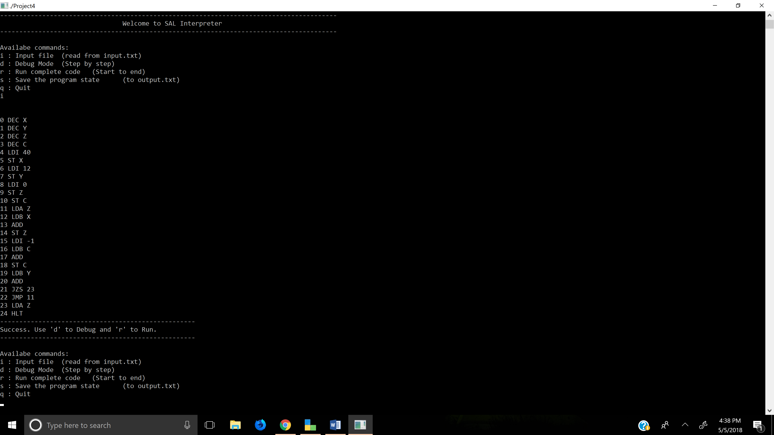

Using debug mode till PC=15 after ‘i’

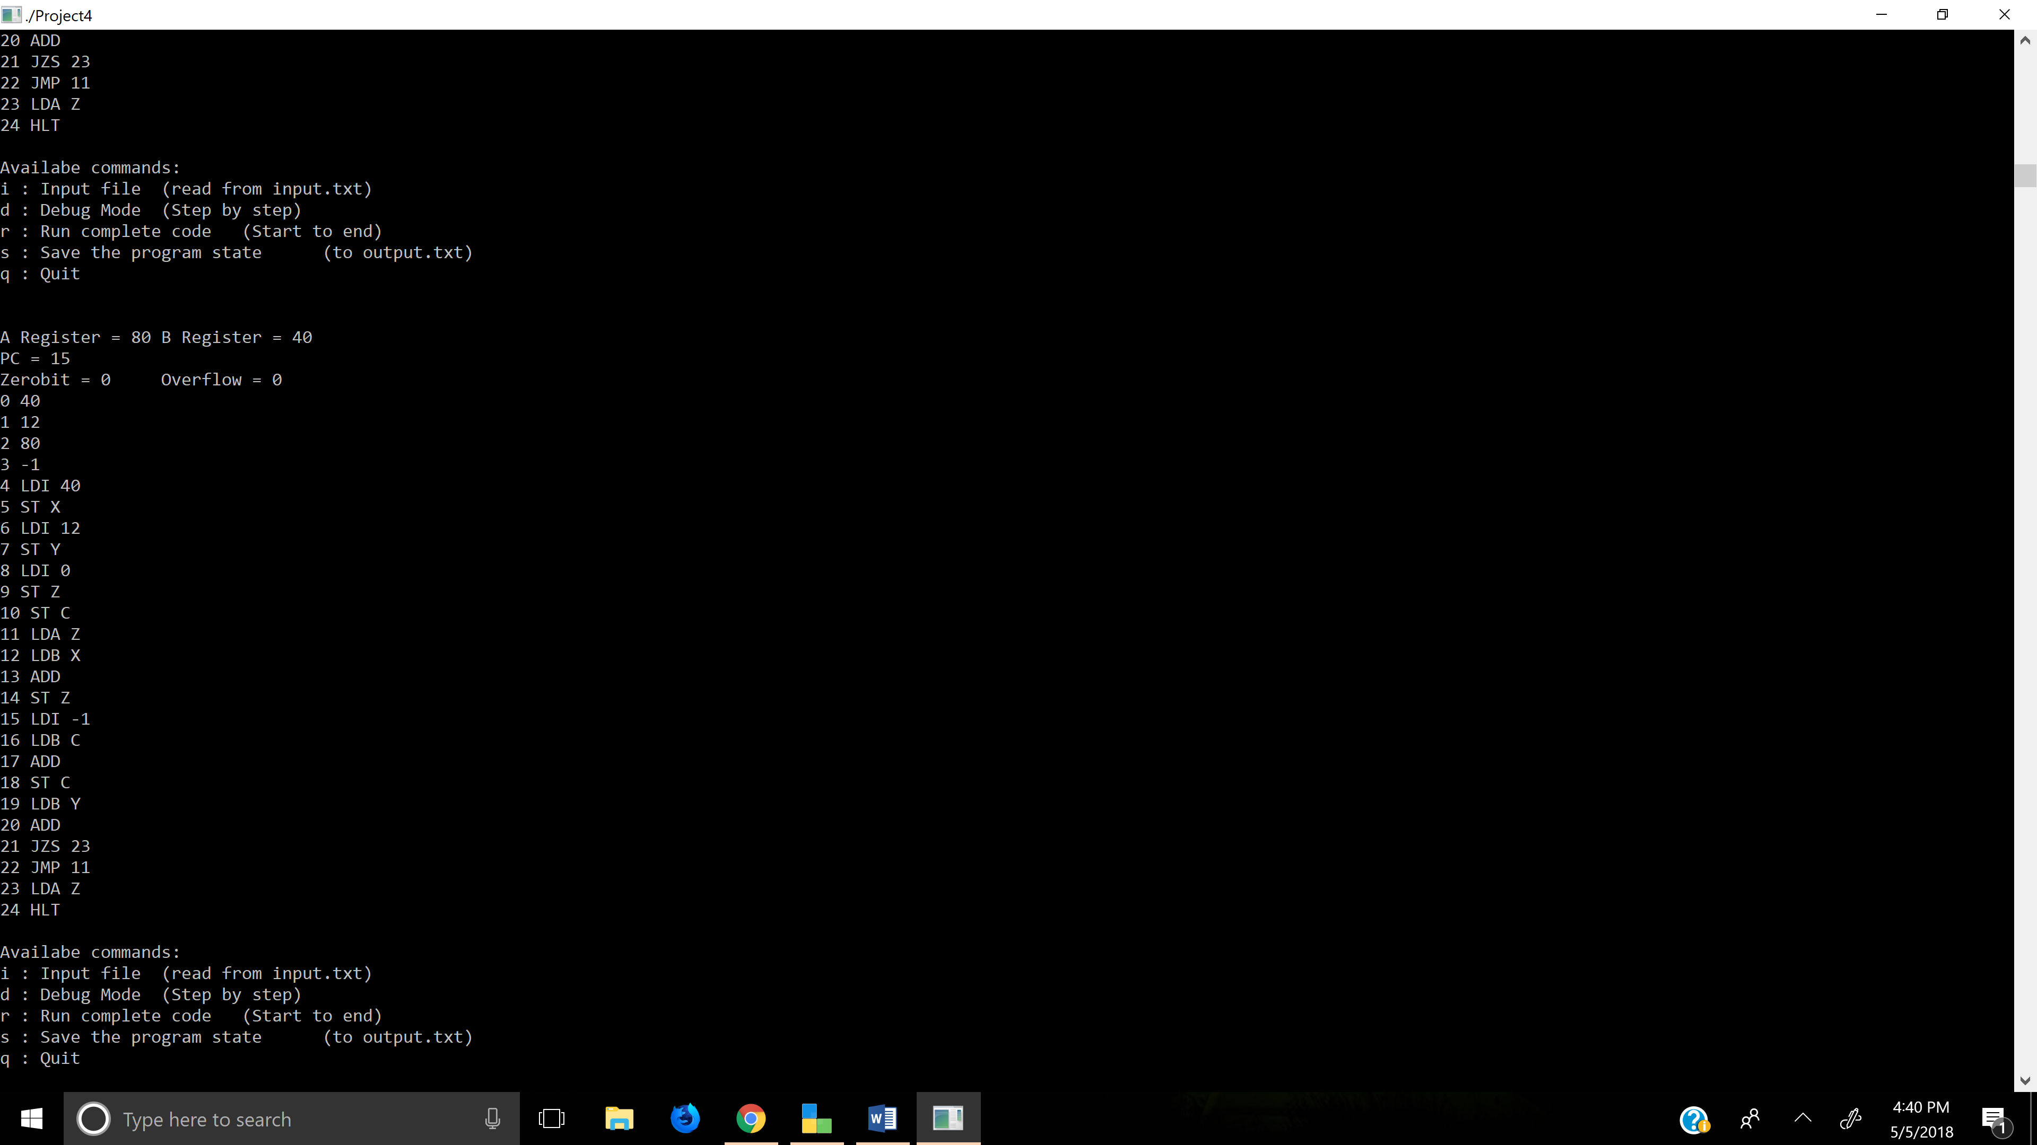

We can use ‘r’ at any point in debug mode to get final memory state

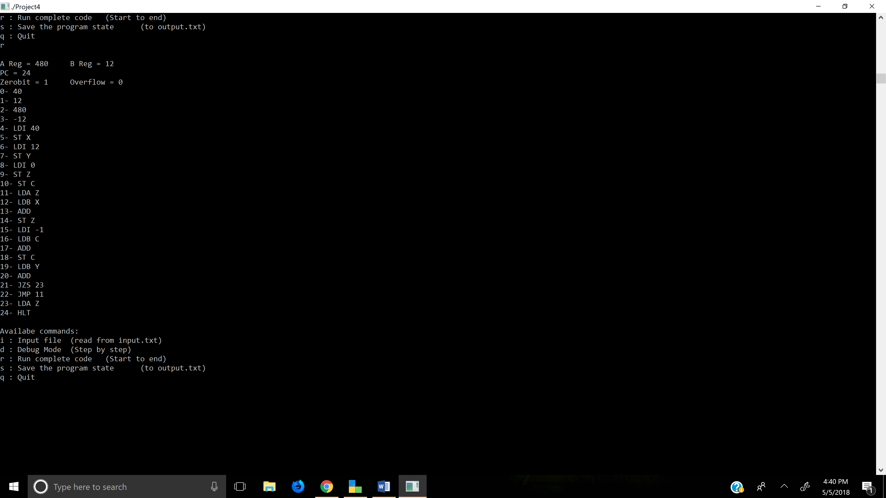

Once HLT is reached we can keep using ‘r’ . Use ‘i’ to load instruction to memory for using debug mode.

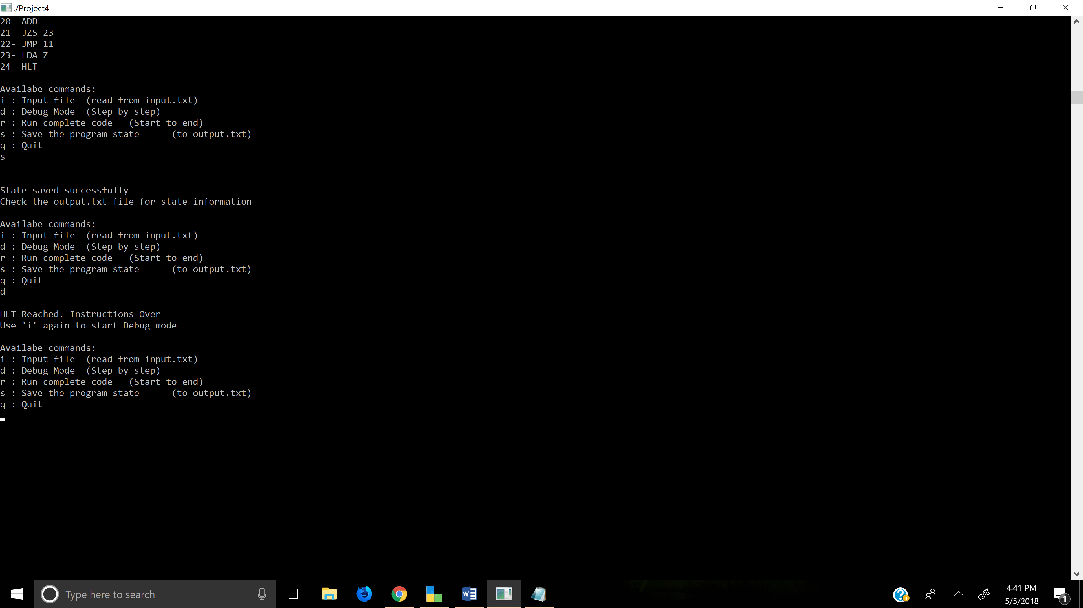

Use ‘s’ at any point after ‘d’ or ‘r’ to save the current memory information to output

The output is available in same directory under output.txt

