**Appliance Manager**

The appliance files are stored in textfile format with name as their ID eg. 0.txt, 1.txt and so on. Once the program is run the user will be asked for various command such as l, 0….9, c, p, s,q. This is the main menu and it will show up after completion of every command except q which tell the program to quit.

**Working of the commands:**

c ---The user **first needs to create an appliance file**, with use of c command. He needs to create appliance before listing.(If during last session files were created/ modified they will exist in the DEBUG folder of the Main Folder. So he need not type them again unless he needs to modify them) After giving the command he will be required to fill various information of appliance as required. Make sure you enter the appropriate data. If the program goes to infinite loop, a wrong input was given. Once the inputs are done, the user can create another appliance file using c.

0…..9 – The id range from 0 to 9. If the user wants to change the price of appliance with id 1, he **first need to load by entering the id** in main menu. Then he needs to use the **command p which will ask for the new price**. Once the price is changed the **user need to use the save s command for the new price to be reflected** in the the DEBUG folder or by using the l command to list the application made during the runtime.

i – Once the user runs the appliance manager and creates/modifies appliance files, he can see all those file by using l. Note the **user need to create at least one new file** to be able to see listing of appliance. A file name 0.txt created last time will need to be created or modified to be listed again.

s – **Use this command after p command**, the user needs to use s to save the change he made to price.

Q – once the user is satisfied and done all he can use q to exit. **All the changes or files he made are available with information in DEBUG folder.**

Test Case:

C --- create

1 ----- id

LG ------ name

100 ----- price

0 -------- type

Asd ------ all paths

Asd

Asd

Asd

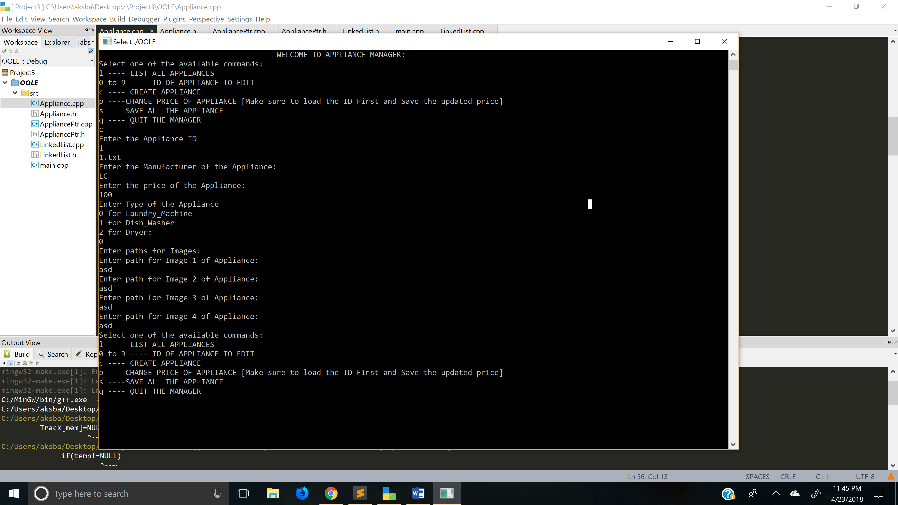

l ---- list appliance this will print the above create appliance.

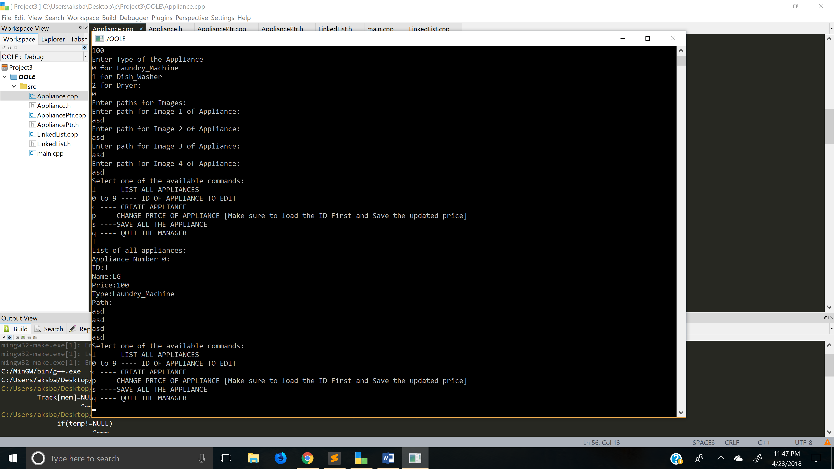

0 ------- to load LG appliance

P ------ change price

999 ----- new price

S ----- save changes

L ------- update change reflect

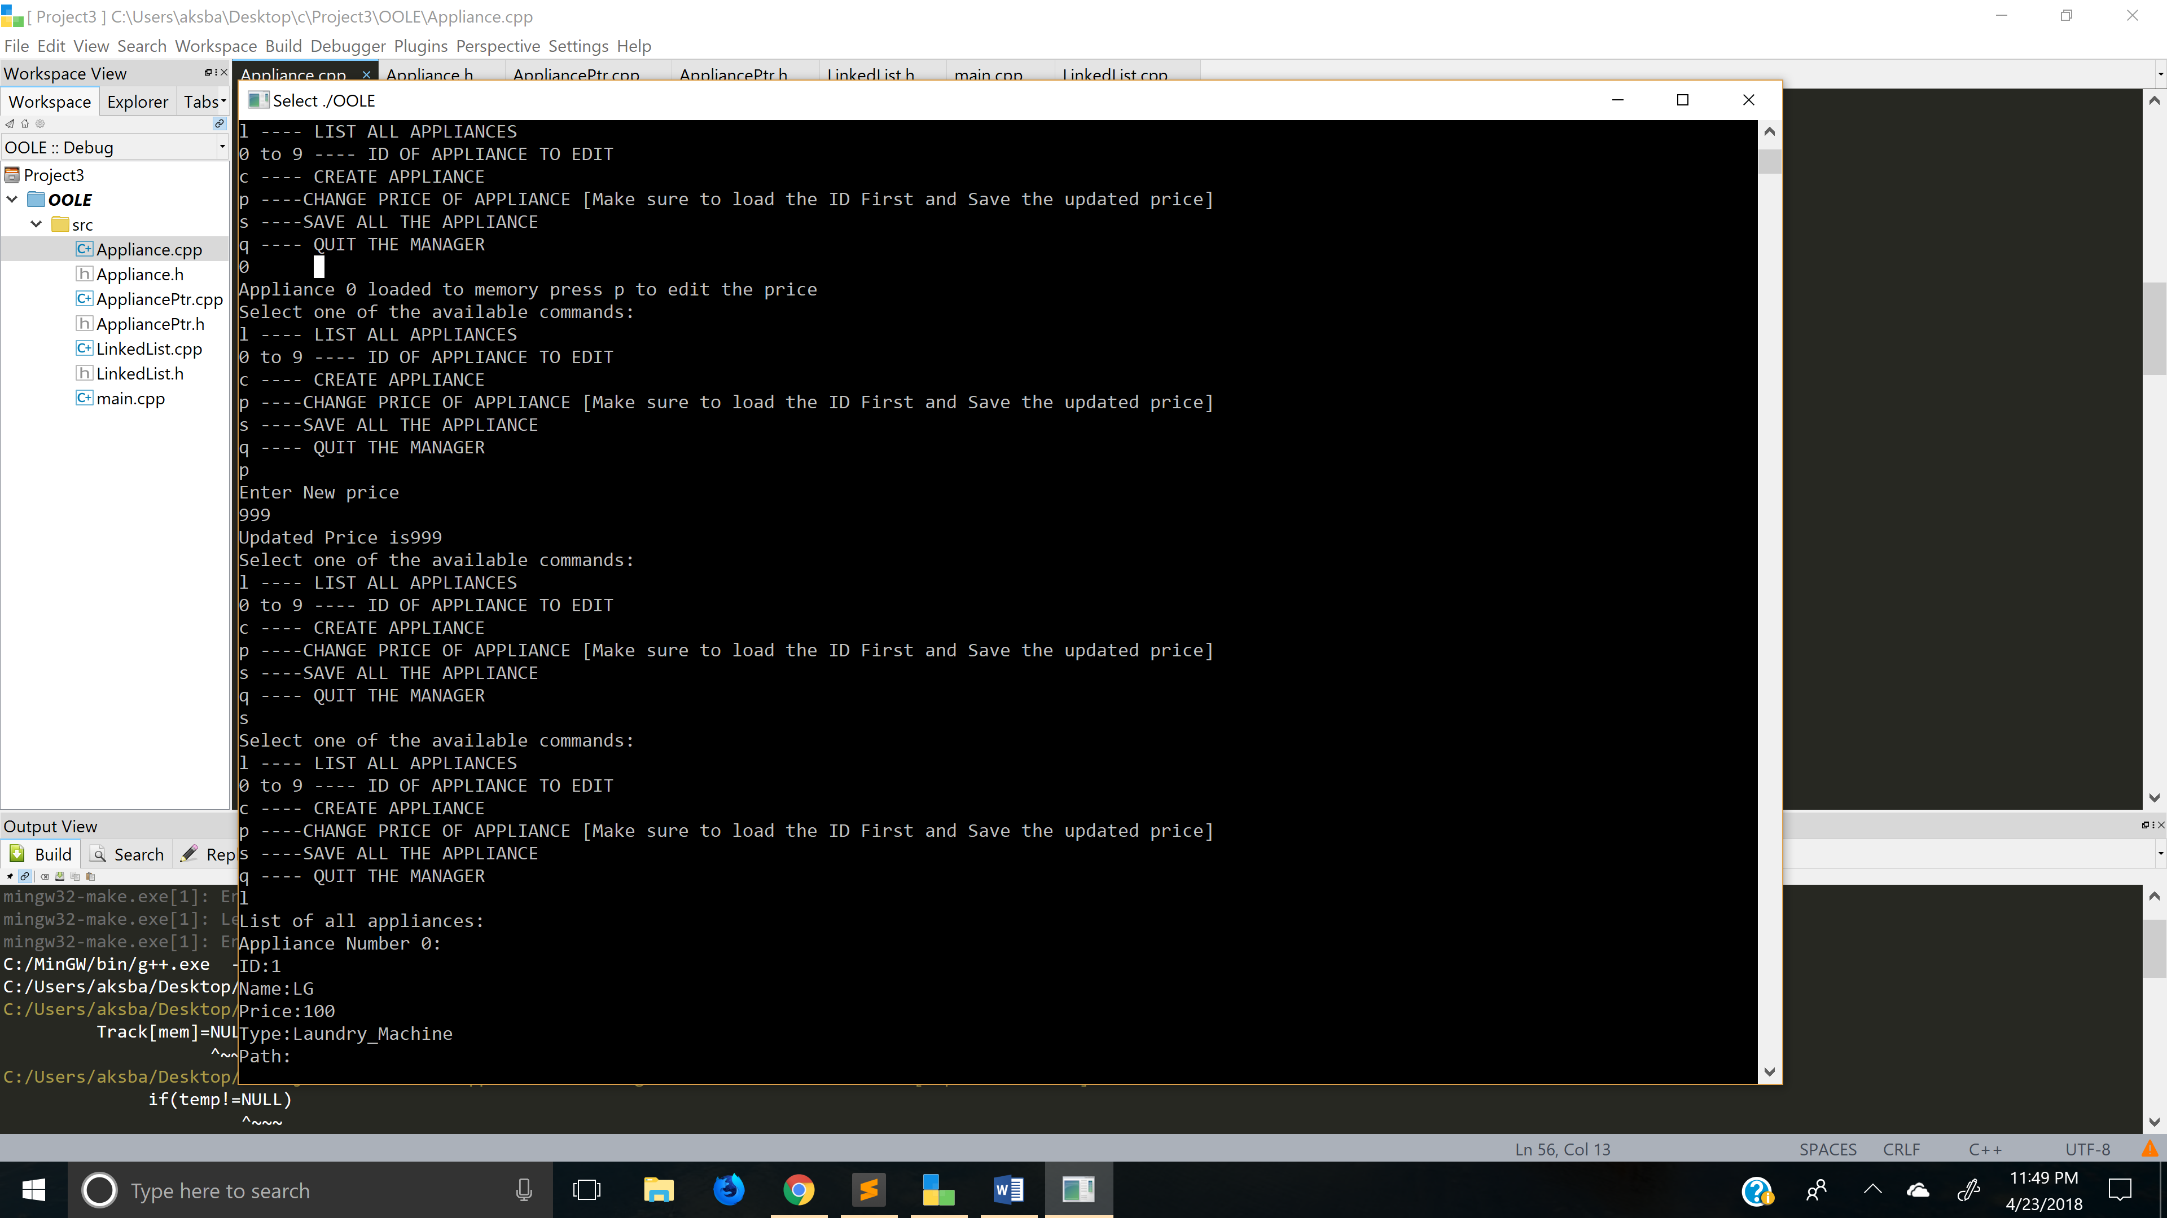

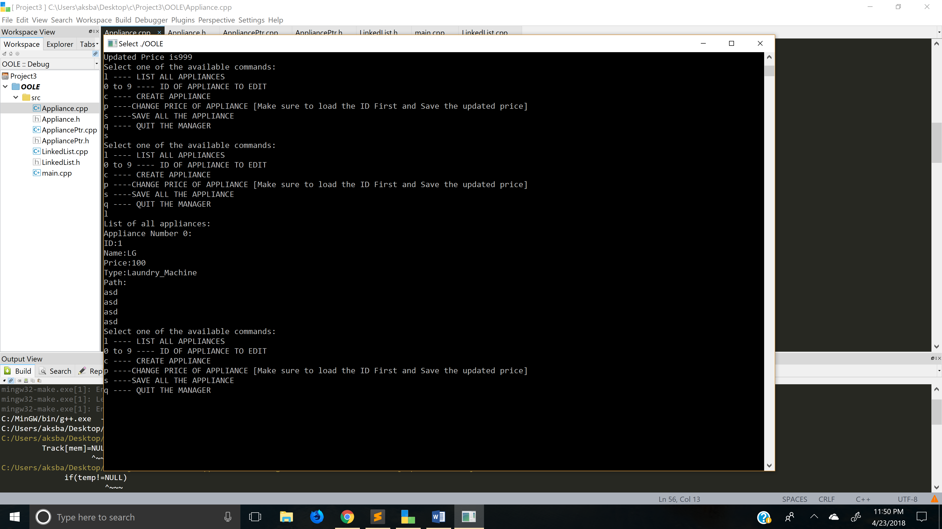

Q --- quit the manager.

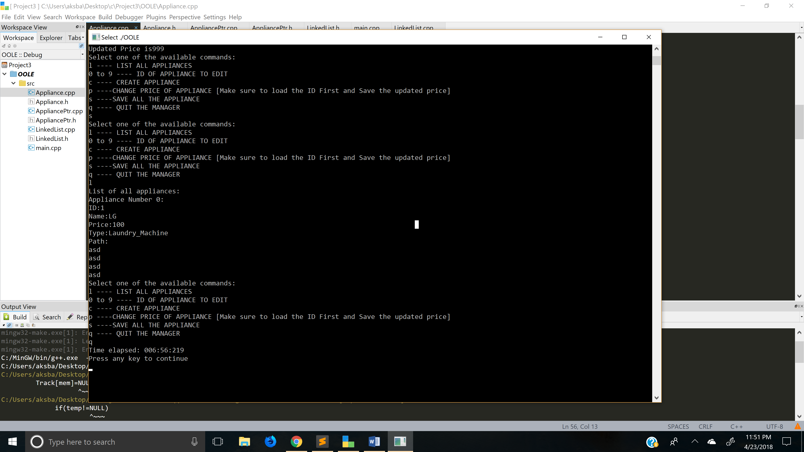

We can go to Debug and see that the changes are shown.

