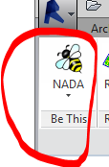

The BeThis add-in is available on the WTA Revit ribbon tab “Be This” panel. The BeThis add-in sets the active workset to a pre-set workset when you open every Revit project. The “Bee” button is a “split button” that displays whatever your last split button selection was. BeThis operates only on workshared files.

The control also switches the active workset when you use it. Therefore it can also be used as a workset changer, but keep in mind the button state is not telling you what your active workset currently is.

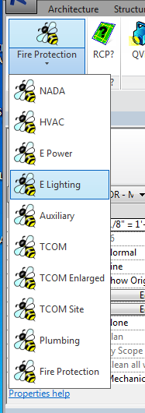

Selecting E Lighting will change the active workset to ELEC LIGHTING for the file you are currently in and will set you to that workset in every file you subsequently open.

Selecting NADA means no workset will be set when you open a Revit file. The active workset will be whatever the last person who saved the file was in.

For every choice but “NADA”, BeThis briefly pops up a small notification window telling you what the workset has been set to. It will tell you it was not successful when your preferred workset does not exist.