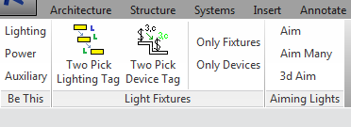

WTA_ELEC add-in is a Revit ribbon tab “WTA_ELEC” intended to provide Electrical related tools organized into various ribbon panels. It currently has tools related to light fixtures and switch devices.

**Words about the Ribbon**

The word “Ribbon” in Windows ribbon nomenclature refers to the entire ribbon apparatus. The ribbon is a collection of “Tabs”. Each “Tab” is a collection of “Panels”. Each panel has “Controls”, like buttons. We naturally think a “Tab” is “the ribbon” since the ribbon can show only one “Tab” at any time. That is wrong and it leads to confusion when following instructions. “The ribbon” is actually the collection of all tabs. There would be a black hole instead of one less tab at the window top if the program’s ribbon were told to be hidden. Another confusing aspect to remember is that a “button” no longer looks like a button. Buttons typically appear as text or a picture but not as raised buttons.

**Panel: Be This**

The “Be This” panel button switches the current workspace to one of three WTA standard electrical workspaces using one single UI press. This is conveniently in context with the heads up WTA_ELEC tab.

**Panel: Light Fixtures**

The Light Fixture panel has tasks primarily related to light fixture and lighting device annotation. The annotation tags show parameter data associated with the tagged lighting or the tagged lighting device.

Specific tag families are involved. These families, with specific family types, need to be present in the Revit project. The add-in tries to find and subsequently load the suitable tag family on the appropriate Revit path version within the WTA network. It loads the file if found and it also checks for the required family type within the family. It informs you if it could not rectify a missing family situation. It has yet a mechanism for setting the required family names and family type names.

The time it takes the add-in to find the necessary family depends on how deep the family is buried in the WTA network. A message form like the one in the following image briefly appears during the network search.

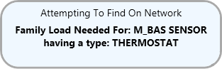

The add-in tool continues with its normal operation after a successful family load.

**Button: Two Pick Lighting Tag**

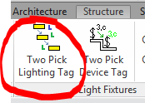

This button starts a lighting/lighting switch device command in context with tagging lighting. The command has both lighting and lighting switch device functionality. This button starts the command ready for tagging light fixtures according to the settings currently displayed on a control form as shown here.

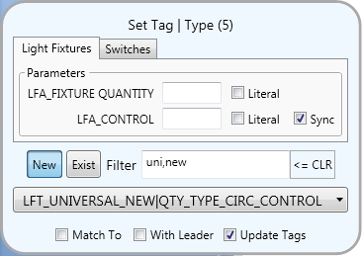

**It is important to understand that Revit will be always asking for a selection whenever the control form is on the screen.** In fact if that is not the case, then an error has occurred and the control form is essentially a zombie on the screen. Click on the Revit icon in the bottom task bar and close out “TwoPicktag” if that happens.

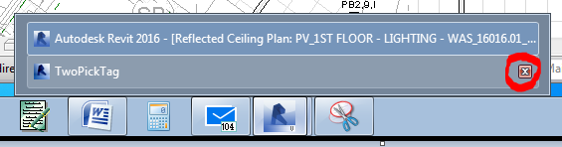

Revit will always be asking for a Revit LightFixture or a Revit LightFixtureTag selection when the context is lighting. Only Revit LightFixtures or Revit LightFixtureTags will be selectable. Pressing the ESC key will cancel out the command and its control form.

The following images outline functions on the control form.

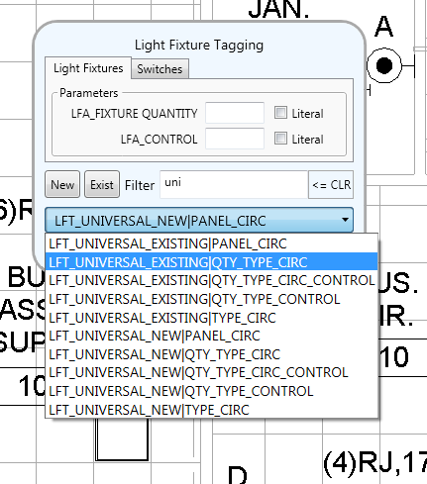

Toggle buttons that add or remove ‘new’ and ‘exist’ at the filter string.

The tag placed or updated to be will be this family name | type name.

The light fixture’s parameters will not be blanked out unless ‘Literal’ is checked.

The pull down tag list is filtered to include only names that contain this text.

If there are values entered, then the light fixture’s parameters will be set to these values. Otherwise they are not affected.

Use a comma to separate the family selection list filter criteria. Here the list will show only items containing both ‘uni’ and ‘new’ text.



Matches *the other* context control values with the visible context control values. Does nothing when blank.

Reverses the selection action. The control form’s parameters and family settings will match to whatever was selected.

This is also used to flip the command context.

Causes an existing tag to update to the controls’ settings. (You’ll be selecting the tag, not the light.)

Tags placed or updated will have or have not a leader.

One Of Two Actions happen When A Light Fixture is Selected

1. When “Match To” **is not checked**  - A tag placement operation starts. The next prompt will be for the tag’s location. The tag family and its type will be whatever is currently selected in the family selector. The selected light fixture will have its two parameters filled in according to the control form entries.
2. When “Match To” **is checked**  - The selected light fixture’s two parameters will be entered into the control form’s two lighting fixture parameter entry boxes.

After which, the selection loop restarts according to the current command context.

Pressing the ESC key cancels the command loop and closes out the control form. **The mouse pointer must be outside the control form for Esc to work.** The tool’s settings will have been saved.

**Tags are placed ( *but not type updated* ) in multiple views**

This tool places the annotation tags in more than one view at a time when the views are named “PV_”<name> and “WV_”<name> where the <name> text is identical.

**Button: Two Pick Device Tag**

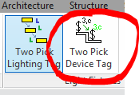

This button starts a lighting/lighting switch device command in context with tagging lighting switch devices. The command has both lighting and lighting switch device functionality. This button starts the command ready for tagging switches according to the settings currently displayed an a control form as show in this image.

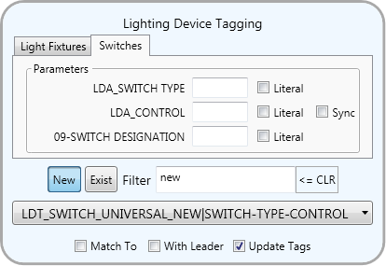

**It is important to understand that Revit will be always asking for a selection whenever the control form is on the screen just like as explained for lighting tags.**

The following images outline functions on the control form.

If there are values entered, then the device’s parameters will be set to these values. Otherwise they are not affected.

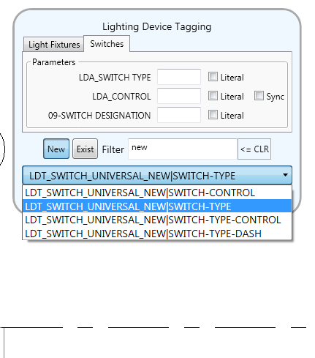

The pull down tag list is filtered to include only names that contain this text.

The device’s parameters will not be blanked out unless ‘Literal’ is checked.

Use a comma to separate the family selection list filter criteria. Here the list will show only items containing both ‘new’ and ‘con’ text.

Toggle buttons that add or remove ‘new’ and ‘exist’ at the filter string.



The tag placed or updated to be will be this family name | type name.

Matches *the other* context control values with the visible context control values. Does nothing when blank.

Reverses the selection action. The control form’s parameters and family settings will match to whatever was selected.

This is also used to flip the command context.

Tags placed or updated will have or have not a leader.

Causes an existing tag to update to the controls’ settings. (You’ll be selecting the tag, not the device.)

One Of Two Actions happen When A LightingDevice is Selected

1. **When Match To is not checked**  - A tag placement operation starts. The next prompt will be for the tag’s location. The tag family and its type will be whatever is currently selected in the family selector. The selected device will have its parameters filled in according to the control form entries.
2. **When Match To is checked**  - The selected lighting device’s parameters will be entered into the control form’s two lighting device parameter entry boxes.

After which, the selection loop restarts according to the current command context.

Pressing the ESC key cancels the command loop and closes out the control form. **The mouse pointer must be outside the control form for Esc to work.** The tool’s settings will have been saved.

**Tags are placed ( *but not type updated* ) in multiple views**

This tool places the annotation tags in more than one view at a time when the views are named “PV_”<name> and “WV_”<name> where the <name> text is identical.

**Switching Context Between Lighting and Devices**

The easiest way to switch context is to simply escape out of the current context. Then pick the other panel button at the ribbon tab. You can switch the context without having to close out, but to do so you have to fully understand what is going on.

As previously mentioned, Revit is always in a selection mode when this tool is running. Again, ***Revit is always in a selection mode when this tool is running. In that state Revit can only respond to a selection input.***

That input can be either a user input selection or a user input cancel. It is not possible for the control form on the screen to issue a cancel. Other than forcing Windows to shutdown Revit, Revit will respond to only you picking the type of item it is currently asking for or to you issuing an input cancel.

The add-in orchestrates what happens to whatever you select and also orchestrates what the Revit selection will be for. The add-in can react to you wanting to switch the context after you have selected an item. Therefore using a “Match To” selection, which does nothing to the project, will make a context change when you have first signaled your context change intention by selecting the other context tab on the control form. The add-in automatically checks the “Match To” checkbox when you switch tabs. The prompt will be asking for a selection that will always seem opposite, because Revit has yet to know about the change.

The add-in uses a visual devices to get you to do the proper step involved for on the fly context switching. Here is an example of switching from Light Fixtures to Switches:

Revit is asking to pick lighting.

Press the Switches tab.

You want to switch from lighting to switches.

The add-in will show this heads-up reminder.

(The reminder goes away on its own or when you do make the dummy selection.)

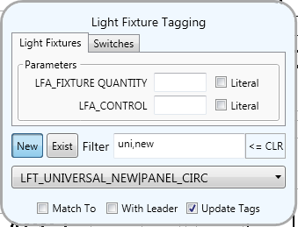 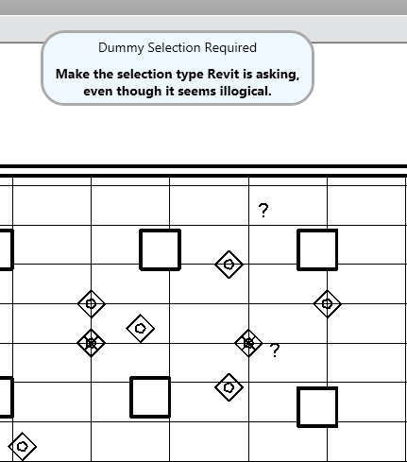

The tab changes to switches **and** “Match To” got checked. The form color changes. Note that “Match To” is dimmed because you cannot uncheck it.

Revit is still asking to pick lighting.

Pick a **light** or **lighting** tag.

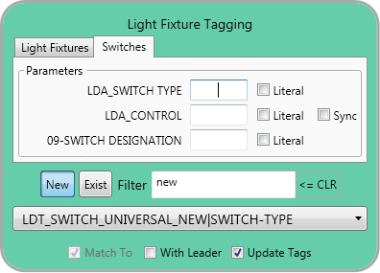

**Buttons: Only Fixtures and Only Devices**

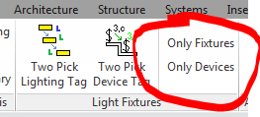

The Only Fixtures and the Only Devices buttons are category specific versions of the Pick Only add-in available on the WTA Revit ribbon tab “Misc Utils” panel. These buttons set a “pick only of this type” selection filter for a selection. Only light fixture elements or lighting device elements will be selectable. You will not need to worry about other items selected by accident that ruin your next category only operation.

One of the following forms appear depending which button you select.

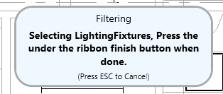 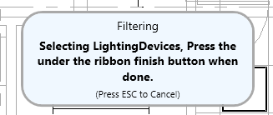

At this point you can select only the category indicated.

The following image shows the “Finish” button Revit requires you to press to signal you have completed a multiple selection.

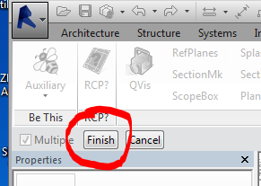

As you might expect, the items you selected remain selected after pressing the “Finish” button.

**Panel: Aiming Lights**

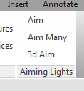

The Aiming Lights buttons perform two click light aiming tasks. One click selects the light fixture or fixtures as in the Aim Many case. The second click identifies the target. The light fixture will be rotated to aim toward the target.

Currently only non-hosting light fixture families can be rotated. Few are and so these tools have limited use.