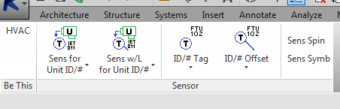

WTA_MECH add-in is a Revit ribbon tab “WTA_MECH” intended to provide Mechanical/HVAC related tools organized into various ribbon panels. It currently has tools related to sensors.

**Words about the Ribbon**

The word “Ribbon” in Windows ribbon nomenclature refers to the entire ribbon apparatus. The ribbon is a collection of “Tabs”. Each “Tab” is a collection of “Panels”. Each panel has “Controls”, like buttons. We naturally think a “Tab” is “the ribbon” since the ribbon can show only one “Tab” at any time. That is wrong and it leads to confusion when following instructions. All the tabs together is actually the ribbon. There would be a black hole instead of one less tab at the window top if the program’s ribbon were told to be hidden. Another confusing aspect to remember is that a “button” no longer looks like a button. Buttons typically appear as text or a picture but not as raised buttons.

**Panel: Be This**

The “Be This” panel button switches the current workspace to the WTA standard “MECH HVAC” in one single UI press. This is conveniently in context with the heads up WTA_MECH tab.

**Panel: Sensor**

The Sensor panel has tasks related to sensors. Sensors are often temperature sensors, which is why the graphics in the ribbon panel show a T in a circle.

Sensors are model families placed in the Revit file. They have symbolic components to the family in addition to model components. The circle with what looks like the letter T is the symbolic component. In some circumstances that symbolic component needs to be rotated. In another circumstance, called “Offset” circumstance, that symbolic component needs to be hidden. Offset means what appears like the sensor family’s symbolic component, i.e. the circle and “T”, is shown graphically offset from the sensor’s model location with a leader line. An additional Revit family, a special tag, is required in the “Offset” circumstance.

Sensors are often accompanied on plans with text indicating the name for what piece of mechanical equipment the sensor reports to. That text is another tag, leaderless, linking to parameter data from the mechanical equipment. The mechanical equipment tag is placed at the sensor location instead of at the “tagged” mechanical equipment element. The text information appearing for the sensor is automatically synchronized with changes to the mechanical equipment’s linked parameter. A downside is that the text moves with the equipment.

Controls on the Sensor panel manage the tasks described above, including setting and getting what Revit family is to be used in each function.

Specific families, including tags, are involved. These families, with specific family types, need to be present in the Revit project. The add-in has a mechanism for setting the required family names and family type names. The add-in tries to find the file on the appropriet Revit path version within the WTA network when a family and specific type is not present in the project file. It loads the file if found and it also checks for the required family type within the family. It informs you if it could not rectify a missing family situation.

The time it takes the add-in to find the necessary family depends on how deep the family is buried in the WTA network. A message form like the one in the following image appears during the network search.

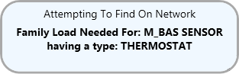

The add-in tool continues with its normal operation after a successful family load. The add-in terminates otherwise.

**Button: Sens for Unit ID/# , Sens for Unit #**

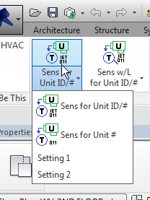

This button is a “stack button”. This one displays in its rolled up state the last selection out of the top two selections. The top two selections manage the entire process for sensor placement linked to a mechanical equipment piece. The difference between the two is the tag family used for the mechanical equipment piece. One tag, ”Unit #”, shows the mechanical equipment’s number parameter only. The other tag, “Unit ID/#”, shows the mechanical equipment’s number parameter and its ID parameter.

The last two selections, “Setting 1” and “Setting 2”, manage the family names used for the first and second button selections. Go to this document’s end for more information regarding the Settings.

**Example: Sens for Unit #**

**Step 1:** A status prompt appears informing what user input is currently needed. Here you are to pick the location for the Revit M_BAS SENSOR family in its THERMOSTAT family type.

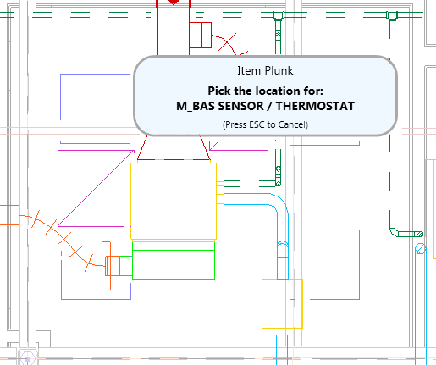

**Step 2:** The sensor family has been placed at the picked location. This sensor family has an orientation parameter that controls the visibility for two versions of the circle and T. The correct parameter has been automatically chosen. The status prompt changes to ask for selecting the Mech Unit. This will be the mechanical equipment that provides the Unit # tag information.

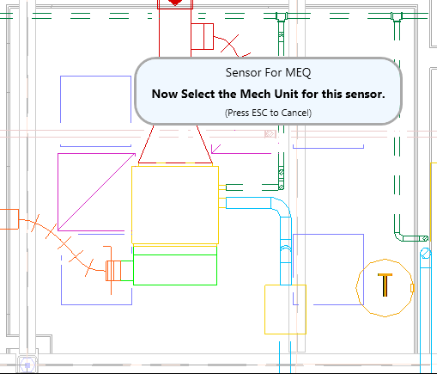

**Step 3:** The status prompt changes to ask for unit text location. The status prompt can be moved at any time during the process to get it out of the way if need be.

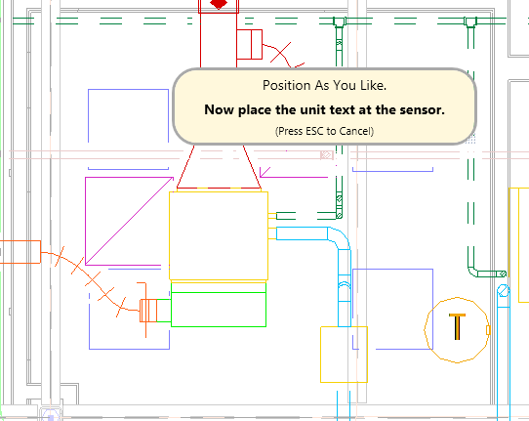

**Next:** The mechanical equipment tags has now been placed and the process starts again for placing more sensors linked to more mechanical equipment. Pressing ESC cancels the process.

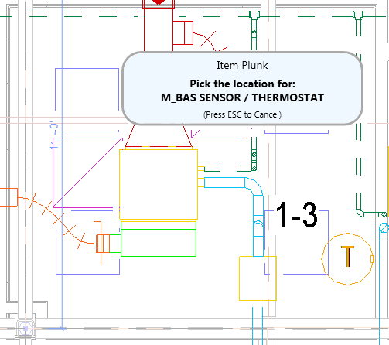

**Tags are placed in multiple views**

This tool places the annotation tags in more than one view at a time when the views are named “PV_”<name> and “WV_”<name> where the <name> text is identical. This previous image is from view “WV_First Floor – Mech”. This next view image is from view “PV_First Floor-Mech”.

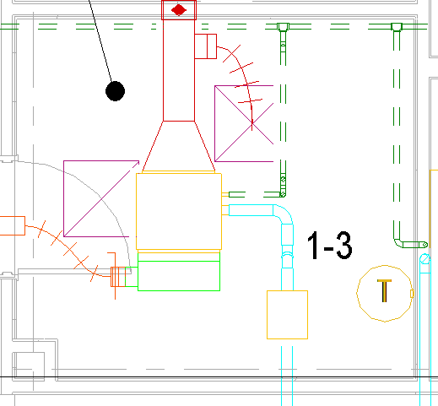

The annotation appears in all views as long as the views are correctly named to satify the match logic. For dependent views the parent view name that matters. Therefore the process works perfectly fine in dependent views where the dependent view names have to be different. It does not matter in which view, PV_ or WV_ , the process is performed. Use the View Wizzs panel Manager for renaming views to match properly. The auto selection feature in that tool will show you whether or not views have matching <name> patterns.

If the annotation does not appear in all the intended views then there is a visibility graphics setting hiding the annotation or there is a subtle difference in the view names that you have yet to notice.

**The Sens for Unit ID/#** process is identical to Sens for Unit # process. The tag for Sens for Unit ID/# uses shows both the Unit ID text in addition to the Unit # text as shown in this next image.

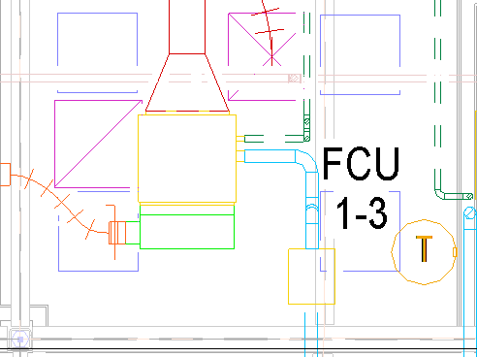

**Button: Sens w/L for Unit ID/# , Sens for w/L for Unit #**

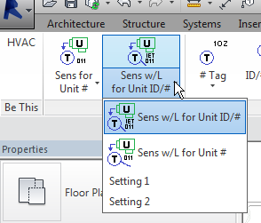

This button is a “stack button”. This button is similar in operation to the previous button except that it handles the “Offset” circumstance. For button space purposes “w/L” refers to “Offset” . It means “with leader”.

The last two selections, “Setting 1” and “Setting 2”, manage the family names used for the first and second button selections. The settings control is separately explained in this document.

**Example: Sens w/L for Unit # (This is the “Offset” )**

**Step 1:** A status prompt appears asking you to pick the location for the Revit M_BAS SENSOR family in its THERMOSTAT family type.



**Step 2:** The sensor family has been placed at the picked location. The “Offset” or “w/L” circumstance involves placing an additional tag family and turning off the symbolic elements to the sensor family. The prompt asks to pick the offset symbol location.

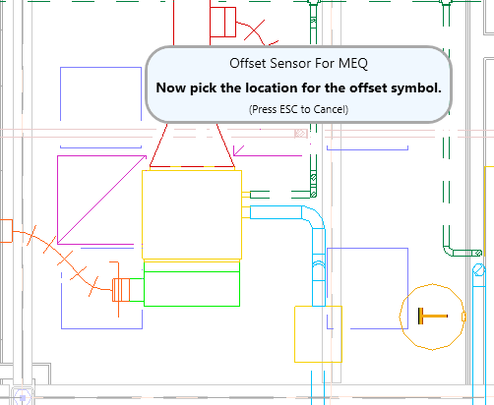

**Step 4:** The sensor family and its offset tag has been placed at the picked location. The visibility for sensor’s own symbolic elements have been turned off. The status prompt changes to ask for selecting the Mech Unit. This will be the mechanical equipment that provides the Unit # tag information.

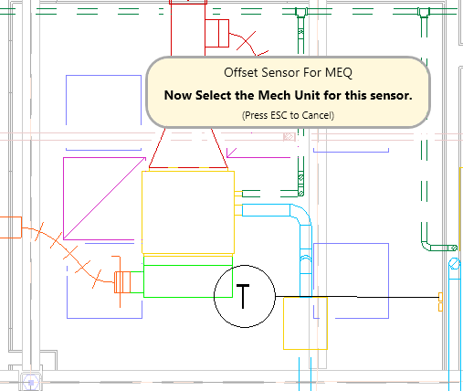

**Step 5:** The status prompt changes to ask for unit text location. The status prompt can be moved at any time during the process to get it out of the way if need be.

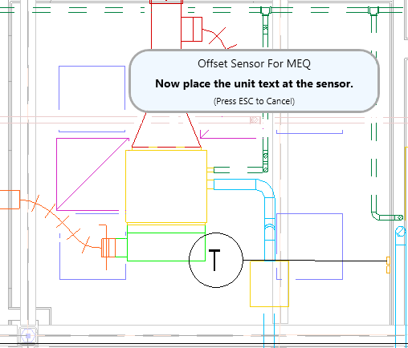

**Next:** The mechanical equipment tags has now been placed and the process starts again for placing more sensors linked to more mechanical equipment. Pressing ESC will cancel the process. All the previously mentioned incidental information also applies.

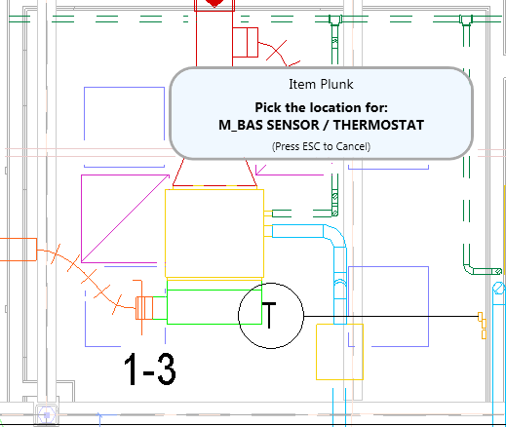

**Button: ID/# Tag and # Tag**

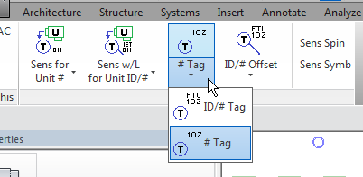

This button is a “stack button”. The buttons here place the tags when the sensor family has already been placed. This button is similar in operation to the previous stack button except that there are no buttons for the settings. The tag families named in the sensor placement settings apply to these tag only button.

**Example: # Tag**

**Step 1:** When the sensor family already exists in the file but does not have its associated text, then only the

associated mechanical equipment parameter # extracting tag needs to be placed. The status prompt asks for selecting the Mech Unit. This will be the mechanical equipment that provides the Unit # tag information.

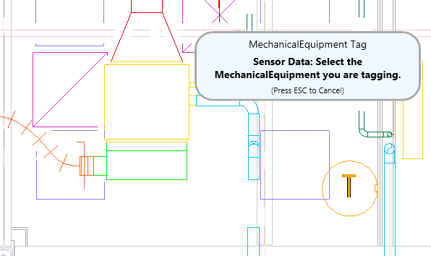

**Step 2:** The status prompt changes to ask for unit text location. The status prompt can be moved at any time during the process to get it out of the way if need be.

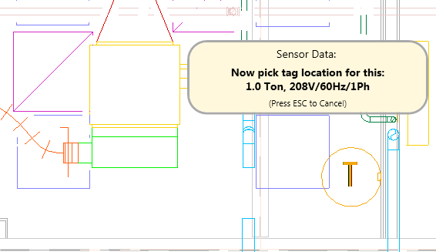

Next: The mechanical equipment tags has now been placed and the process starts again for placing more sensors linked to more mechanical equipment. Pressing ESC will cancel the process.

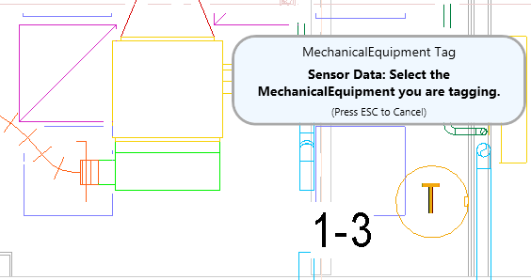

This tool places the annotation tags in more than one view at a time when the views are named “PV_”<name> and “WV_”<name> where the <name> text is identical.

**Example: # Offset**

**Step 1:** For the “offset” condition the sensor already exists in the file but does not have its associated text and the existing sensor’s symbolic elements need to be turned off. That adds an identify-existing-sensor step that is not required for the no-offset condition.

The status prompt asks for selecting the existing sensor. Here you can select either existing sensor’s model or symbolic graphic. The prompt uses the sensor’s Revit true category “DataDevice”.

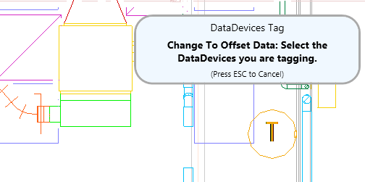

Step 2: The same as the previous example Step 1.

Step 3: The same as the previous example Step 2.

**Buttons: Sens Spin and Sens Symb**

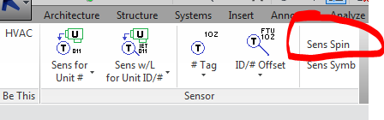 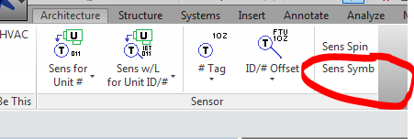

Button **Sens Spin** changes the orientation for the sensor’s symbolic elements by toggling the “VERTICAL” and “HORIZONTAL” parameter values. These two parameters in the sensor family control the visibility for a straight up sensor symbol and a 90 degree rotated sensor symbol. The message form prompts for a sensor selection. You can select either the sensor’s model or symbolic elements.

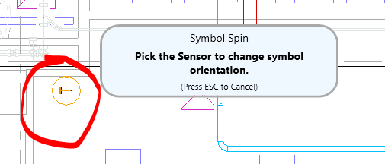

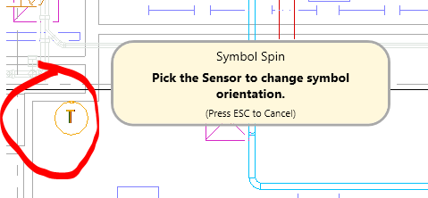

Button **Sens Symb** changes the visibility for the sensor’s symbolic elements by toggling the “SHOW SYM” parameter value. The message form prompts for a sensor selection. You can select either the sensor’s model or symbolic elements.

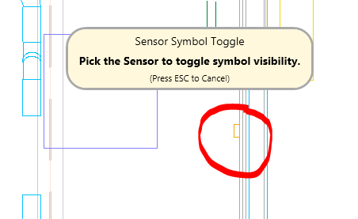 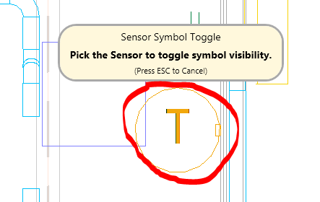

**Sensor Tool Settings**

The “Settings 1” button brings up the following settings form. The settings shown here apply to the “ST1” tool and the “ST2” tool. “ST1” refers to “Sensor Tool 1”, which is the “Sens for Unit ID/#” tool version. “ST2” refers to “Sensor Tool 2”, which is the “Sens for Unit #” tool version.

In this case the two settings are identical except for the “SensorTagFamilySymbol” value. Revit refers to what we know as “Family Types” to be “Family Symbols” instead. The SensorTagFamily, “M_EQIP_BAS_SENSOR_TAG”, has at least two “symbols” (think types) defined. One is used for ST1 and the other is used for ST2.

Settings can be changed by directly editing the SettingValue entry. The setting is saved only on your computer. The “Reset To Defaults” button changes the setting, for this tool only, back to the “factory” WTA setting.

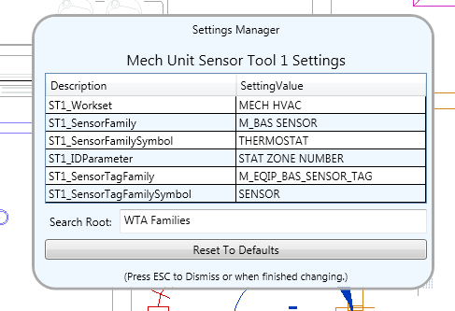

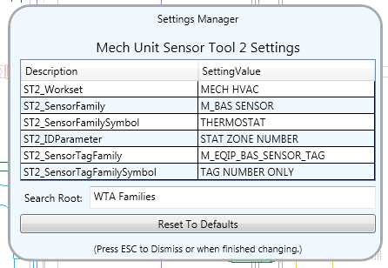

The Sensor tools have the ability to find families that have yet to be loaded into project files. It does this by combining the current Revit vesion number with the “Search Root” value into a directory path used as the starting point for a dig into all nested folders files. It finds the file, or files, that match the SettingValue.

The Workset SettingValue is used regardless of the current active workset.