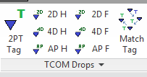

WTA_TCOM add-in is a Revit ribbon tab “WTA_MECH” intended to provide TCOM related tools organized into various ribbon panels. It currently has tools related to TCOM drops.

**Important - Tag annotation placed by these tools happens in more than one view.**

The tag is placed in both the active view and the active view’s parent companion view where the “companion” view is either the working view or plotting view having the same purpose as the active view . The companion view determination is based upon the WTA standard view name scheme. No other Tag is placed when the companion view cannot be determined. A user setting controls this behavior. The option to change that setting is also made available whenever a tool is in a mode that places tags.

BTW: In the rest of this document you will not see this checkbox whenever it should be there. That is because the images are out of date.

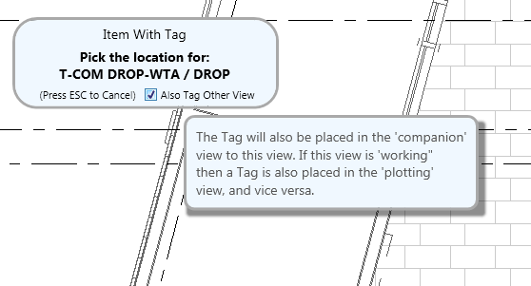

Your input focus is in Revit when you see this. You will loose that focus when operating this checkbox. An additional touch into Revit is required to continue the TCOM tool.

Your user setting for automatically tagging other views is set by that checkbox. The TCOM settings control also manages that setting.

Find the TCOM setting control in the slideout panel.

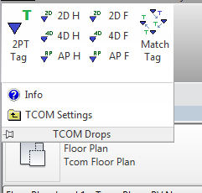 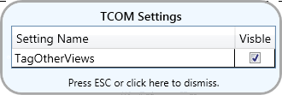

**Panel: TCOM Drops**

The TCOM Drops panel has tasks related to TCOM drops. The Match Tag tool is not TCOM drop specific.

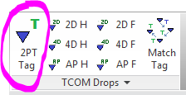

**2PT Tag**

The single button control “2PT Tag” runs a tool for placing the specific WTA Tag family used for WTA TCOM communication devices, using the correct type within the tag family and does this without a tag leader. It does this in a two pick continuous running mode where only communication devices are selectable. It also finds and loads the correct tag family/type from the WTA library if the correct tag family/type is not present in the Revit project.

Note that “2PT Tag” is for TCOM drops that have not already been tagged in the view. Other tools on the TCOM Drops panel actually place both the drop and its tag, sets the correct tag value and makes sure the active workset was TCOM during that operation in one sequenced step. The tag is placed in both the active view and the active view’s parent companion view where the “companion” view is either the working or plotting view. If you start seeing duplicate tags, this might be the reason.

When running “2PT Tag” there is prompting form that always explains the currently required user input. Only Revit Communication Devices can be selected at this point. The prompting form can be moved anywhere on the screen at any time. Pressing ESC will cancel “2PT Tag”.

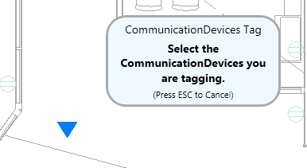

The prompting form’s color changes whenever the required user input changes step. In this image you are to select the point where the Tag will be dropped. The Tag’s drop point depends on how the Tag family was setup.

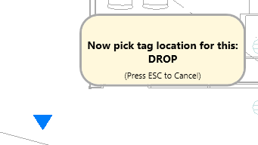

The images are out of date. The checkbox for tagging other views is missing.

The prompting form’s color changes again after dropping the Tag because the “2PT Tag” command is repeating itself. Note that the Tag is placed without needing to make a leader setting. If the project’s views are named according to the standard then two Tags are placed. One Tag is in the active view and the other Tag is in the companion view type. Tags placed in a WV view are also placed in PV views and Tags placed in PV views are also placed in WV views. If you place a Tag and then move it a bit, only that Tag is moved.

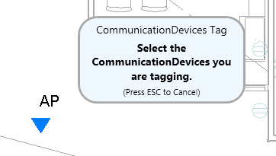

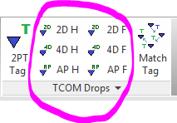

**Hosted and Free Drops**

Each of the hosted and free TCOM Drops controls places the indicated drop type, assigns the parameter used for the Tag and then Tags the drop. The process is identical to that of the “2PT Tag” command with the added first step inclusion for picking the drop’s location. Both the drop family and the tag family are loaded automatically if they are not present in the project. Two tags might be paced as described with the “2PT Tag” command. The items will be in the TCOM workset.

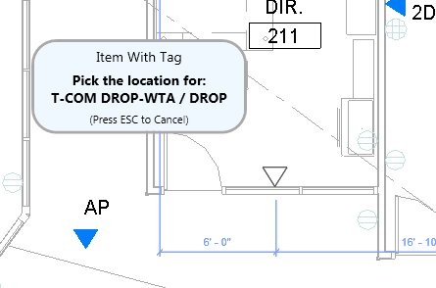

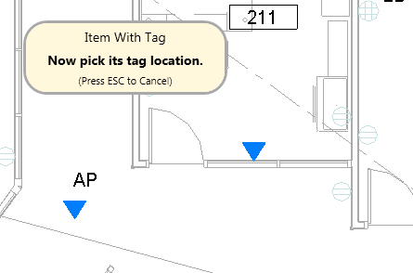

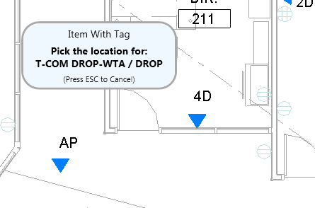

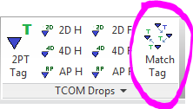

**Match Tag**

Match tag is a point and shoot parameter matching tool that affects a Tag match because Tags are linked to parameters.

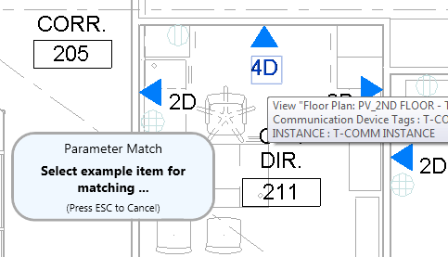

First to select the **Tag** that represents what the other Tags are to match.

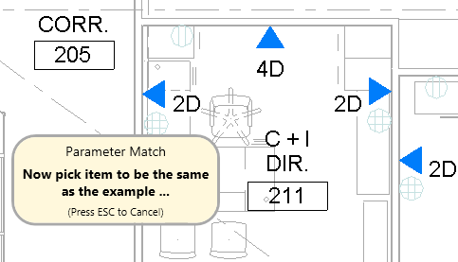

Then you select **either the Tag or the tagged item** that is supposed to change.

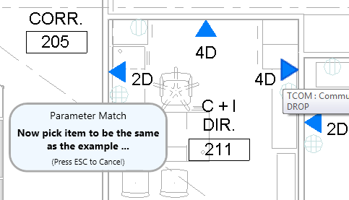

You can continue to select **either Tag or tagged items** that are supposed to change.