**DIFFERENTIAL PERDIZ POINT MORPHOLOGY AMONG CADDO SITES IN EAST TEXAS**

Robert Z. Selden, Jr.

DO NOT CITE IN ANY CONTEXT WITHOUT PERMISSION OF THE AUTHOR

**Robert Z. Selden, Jr.** Heritage Research Center, Stephen F. Austin State University, USA and Cultural Heritage Department, Jean Monnet University, FR. PO Box 13028, SFA Station, Nacogdoches, Texas 75962 ([zselden@sfasu.edu], corresponding author)

Sixty-four Perdiz arrow points from six Caddo sites were used in a two-dimensional comparison of projectile morphology. Results illustrate some significant differences in Perdiz projectile shape among the sites.

Morphology is among the principal attributes employed in typological assignments. The Perdiz type is well-established, and occurs across a broad geography.

METHODS

Two-dimensional (2D) images were collected at a 1200dpi resolution using a Hewlett Packard Scanjet G4050 to produce uncompressed tiff files. These were then masked in Adobe Photoshop 2020 (v. 21.2.3), and exported as jpegs. The jpegs were imported to R, where the Momocs library was used for the subsequent elliptical Fourier analysis.

An outline was rendered for each specimen, which was subsequently normalized, scaled, aligned, and centered (Figure X).

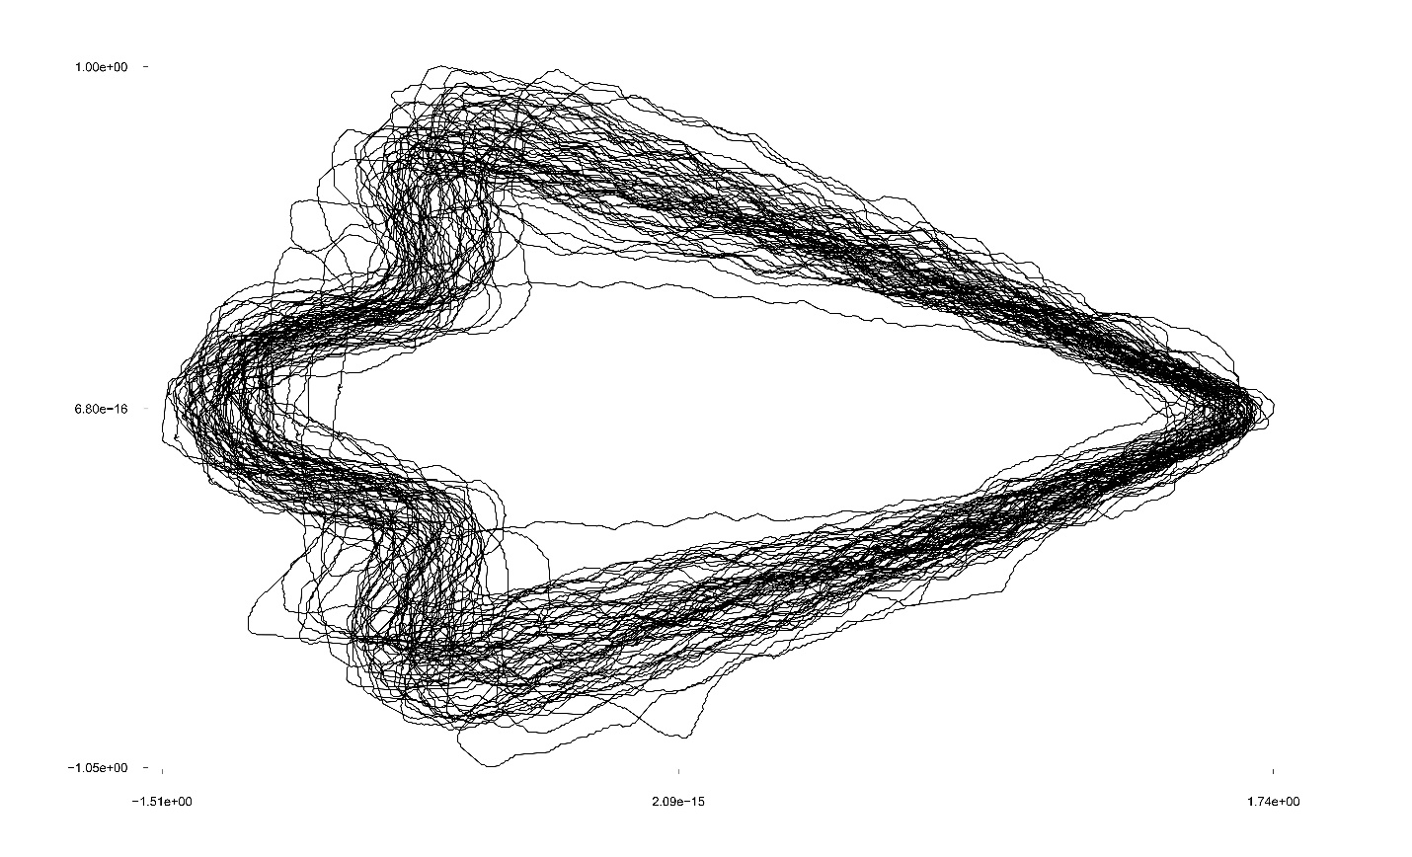

Figure X.