**A**

**PROJECT REPORT**

(Size 16 Times New Roman, Bold) (Line space= 1 line)

ON

(Size 16 Times New Roman, Bold )

(Line space=5 line)

**E-ANTIQUE(Online Auction System)**

Submitted in partial fulfillment for the award of

**Post Graduate Diploma in Advance Computing**

**(PG-DAC) from**

**INSTITUTE OF EMERGING TECHNOLOGIES**

**Authorized Training Centre**



**Under the Guidance of**

**Name of the Guide**

(Size 16 Times New Roman, Bold )

(Line space=5 line)

**BY**

**Name of student/s and Prn**

( Size 16 Times New Roman, Bold)

(Line space=4 line)



**CERTIFICATE**

(Line space=1 line)

(Size 16 Times New Roman, Bold)

(Line space=4 line)

This is to certify that the project report entitled **E-ANTIQUE(Online Auction System)** is a bonfire work carried out by **Name of the Students** ( Bold, Block) andsubmitted in partial fulfilment ofthe requirement for the C-DAC ACTS, DAC course in Institute of Emerging Technology in the batch of Aug 2019.

**Course Coordinator** **External Examiner**

(Size 14 Times New Roman,bold )

**ACKNOWLEDGEMENT**

This project **E-ANTIQUE(Online Auction System)** was a great learning experience for us and we are submitting this work to Advanced Computing Training School (CDAC).

We are very glad to mention the **Mrs.Savita mam** for her valuableguidance to work on this project. Her guidance and support helped us to overcome various obstacles and intricacies during the course of project work.

Our most heart full thanks goes to ***Mr. Sangram Patil*** **(Director ,IET)**who gave all the required support and kind coordination to provide all the necessities like required hardware , internet facility and extra lab hours to complete the project and throughout the course up to the last day here in C-DAC ACTS, Pune.

Sign of student

**Atish B. Walunj**

**230945920115**

**Abstract**

An online auction is an auction which is held over the internet. It is a popular method for buying and selling products. Online Auction Systems helps to customer to sell and buy product in best price. It is developed with the objective of making the system reliable, easier and fast. This website is used to sell the anything antique items on the website from home.The application is made as simple as surfing a website. There by non-technical persons can also interact with the processing on the website easily.

**Index**

|  |  |  |
| --- | --- | --- |
| **Sr. No.** | **Title** | **Page No.** |
| **1** | Introduction |  |
| **2** | Problem Definition & Scope |  |
| **2.1** | Problem Definition |  |
| **2.2** | Goals & Objectives |  |
| **2.3** | Major Constraints& Outcomes |  |
| **3** | Software Requirement Specification |  |
| **3.1** | Purposed System |  |
| **3.2** | Scope |  |
| **4** | System Modules |  |
| **5** | Performance-Requirements |  |
| **5.1** | H/W Requirements & S/W Requirements |  |
| **6** | UML Diagram |  |
| **6.1** | DFD |  |
| **6.2** | ERD |  |
| **6.3** | Use case diagram |  |
| **6.4** | Class Diagram |  |
| **6.5** | Sequence diagram |  |
| **6.6** | Activity Diagram |  |
| **6.7** | Deployment diagram |  |
| 6.8 | System Architecture |  |
| **7** | Test Cases |  |
| **8** | Screenshots |  |
| **9** | References |  |

**1.Introduction:**

An online auction is a type of auction that’s held over the internet, unlike in-person auctions. The best part of holding an online auction is the freedom of bidding from any location with bidders connected through the internet. Ebay is a fine example of this types of auction. Apart from eBay, our E-ANTIQUE Online Auction system is used for online antique products auction. Anyone can use the portal and browse the available products, but in order to make a purchase or place an order, a user needs to log in using their unique userId and password. The default role is "User" when a user registers with the website.

This proposed system can be used by any naïve users and does not require any educational level, experience, or technical expertise in the computer field. However, it will be of good use if the user has good knowledge of how to operate a computer. Online Auction System is the public web application. There are mainly two types of users. One is the Buyer or Bidder and other is Seller.

**2.Problem Definition & Scope:**

**2.1** **Problem Definition:**

Creating an online auction system involves building a website or app where people can sell and buy items through bidding. Users should be able to register, list their products for auction, and others can place bids. The system needs to handle secure payments, provide real-time updates on ongoing auctions, and have a way to resolve disputes. It's important to make it user-friendly, secure, and able to handle a large number of users and items.

**2.2 Goals & Objectives:**

The main objective of this project is building a website which will help buyers and sellers to participate in auction. Here if suppose some seller or buyer want to use this facility and learn how is it possible and how they can use Online Auction System to buy or sell the products(antique items ), they must have knowledge of computer then they can directly register in the site and sell or buy the products online.

* 1. **Major Constraints& Outcomes:**

This system is designed as an online web-based application which shall be accessed by any device, either a computer, tablet, iPad, iPhone, mobile phone or PDAs. Compared to traditional auctions, online auctions can be more efficient. They reduce the time and geographical constraints associated with physical auctions. Online auctions generate a wealth of data that can be analysed to understand buyer behaviour, market trends, and the performance of different items. This information can be valuable for sellers and the auction platform.

**3 Software Requirement Specification:**

* 1. **Purposed System:**
* Our System contain three actors – Admin , Seller , Buyer .
* Admin have control over system. First seller/Buyer need to register on portal . Seller will add product for auction. Seller need to set start and end date of auction as well as base price of product.
* Admin will verify every product before it goes for auctioning.
* If Admin approve product to place for auction then product will be place for auction.Otherwise it will not placed for auction. Now Buyers will Bid on product.
* At the end of auction highest bidder will win auction .Bidder can rate for the product and seller .
* This system allows multiple bids by single users.

| **Test Case ID** | **Test Case Description** | **Test Steps** | **Expected Result** | **Pass/Fail** |
| --- | --- | --- | --- | --- |
| TC001 | User Registration | 1. Navigate to the registration page. 2. Enter valid user details. 3. Submit the registration form. | User is successfully registered, and a confirmation message is displayed. | Pass |
| TC002 | User Login | 1. Navigate to the login page. 2. Enter valid credentials. 3. Click on the login button. | User is successfully logged in, and the system redirects to the user's dashboard. | Pass |
| TC003 | Create Auction Listing | 1. Log in as a seller.  2. Fill ADD FORM | Request is successfully sent to admin | Pass |
| TC004 | See All Ongoing Auction which seller created | 1. Log in as a seller . 2. Navigate to an “Ongoing Auction ”. | List of ongoing auctions display | Pass |
| TC005 | See all sold products  Of seller | 1. Log in as a selle.r 2. Navigate to an “Product Sold ”. | List of all sold products display | Pass |
| TC006 | Place Bid on Auction | 1. Log in as a bidder 2. . 2. Navigate to an product .   3. Click On BID button. | Bid is successfully placed, and the bid amount is updated in real-time. | PASS |
| TC007 | See all purchase products | 1. Log in as a bidder 2. . 2. Navigate to an product purchased.   3. Click On BID button. | List of all purchased product will be shown | PASS |
| TC008 | Approve User | 1. Log in as a admin 2. . 2. Navigate to an User Approval   3. Click On Approve button. | User is approved | PASS |
| TC009 | Approve Product | 1. Log in as a admin 2. . 2. Navigate to an Product Approval   3. Click On Approve button. | Product is approved | PASS |
| TC010 | LOGOUT | Navigate to LOGOUT | USER IS Logout | PASS |
|  |  |  |  |  |
|  |  |  |  |  |
|  |  |  |  |  |
|  |  |  |  |  |
|  |  |  |  |  |
|  |  |  |  |  |
|  |  |  |  |  |
|  |  |  |  |  |
|  |  |  |  |  |

**3.2 Scope:**

The scope of this application to build a user friendly auctioning website, where user will be able to auctioned any product which is available nearby or anywhere in the world. By using Online Auction management system it will be easy for seller to make an auction and time saving also.Bidders/Buyers can search for the products available in the auction and even the information about the seller.Online Auction System provides the functions which connect the sellers and the bidders efficiently. Online auctions allow sellers to reach larger audiences, in different locations and geographical areas. The competitive nature of online auctions can result in higher prices for sellers. Bidders compete with each other, driving the final bid closer to the true market value of the item.

**4. System Modules:**

Online Auction System consists of three modules described as below:

* Seller Module
* Bidder Module
* Admin Module

4.1 Seller Module

* Seller can register and create his own account.
* Online Auction System provides the function which allows Sellers to add their products for auction.
* Seller can set base price for the product added.
* The Seller can end the auction.
* The Seller can see the current bid price on the product added. seller can give answers of buyer questions

4.2 Bidder Module

* Bidder can register and create his own account.
* Online Auction System provides the function which allow buyers to bid on product and see the description of product.
* Bidder can see sellers rating for authenticity
* Bidder can rate the product and seller
* Buyer can ask questions

4.3 Admin Module

* Online Auction System should provide all functions to admin how to handle the System.
* Admin can check KYC and authorize bidder/buyers and sellers based on Government Identity proof.
* Admin can verify every product before it goes for auctioning.
* Admin can remove fraud Sellers and Buyers.

**5. Performance-Requirements**

**5.1 H/W Requirements:**

* Processor: Minimum 1 GHz; Recommended 2GHz or more
* Ethernet connection (LAN) OR a wireless adapter (Wi-Fi)
* Hard Drive: Minimum 32 GB; Recommended 64 GB or more
* Memory (RAM): Minimum 1 GB; Recommended 4 GB or above

**5.2. S/W Requirements:**

* Firefox browser
* Chrome browser
* Front End Technologies: 1. React.js · 2.Bootstrap · 3. HTML5 · 4. CSS ·

5. JavaScript

* Backend Technologies : 1. Java · 2. Spring Boot· 3. Hibernate · 4. MySql·

**6 UML Diagram**

**6.1 DFD:**

DFD LEVEL 0

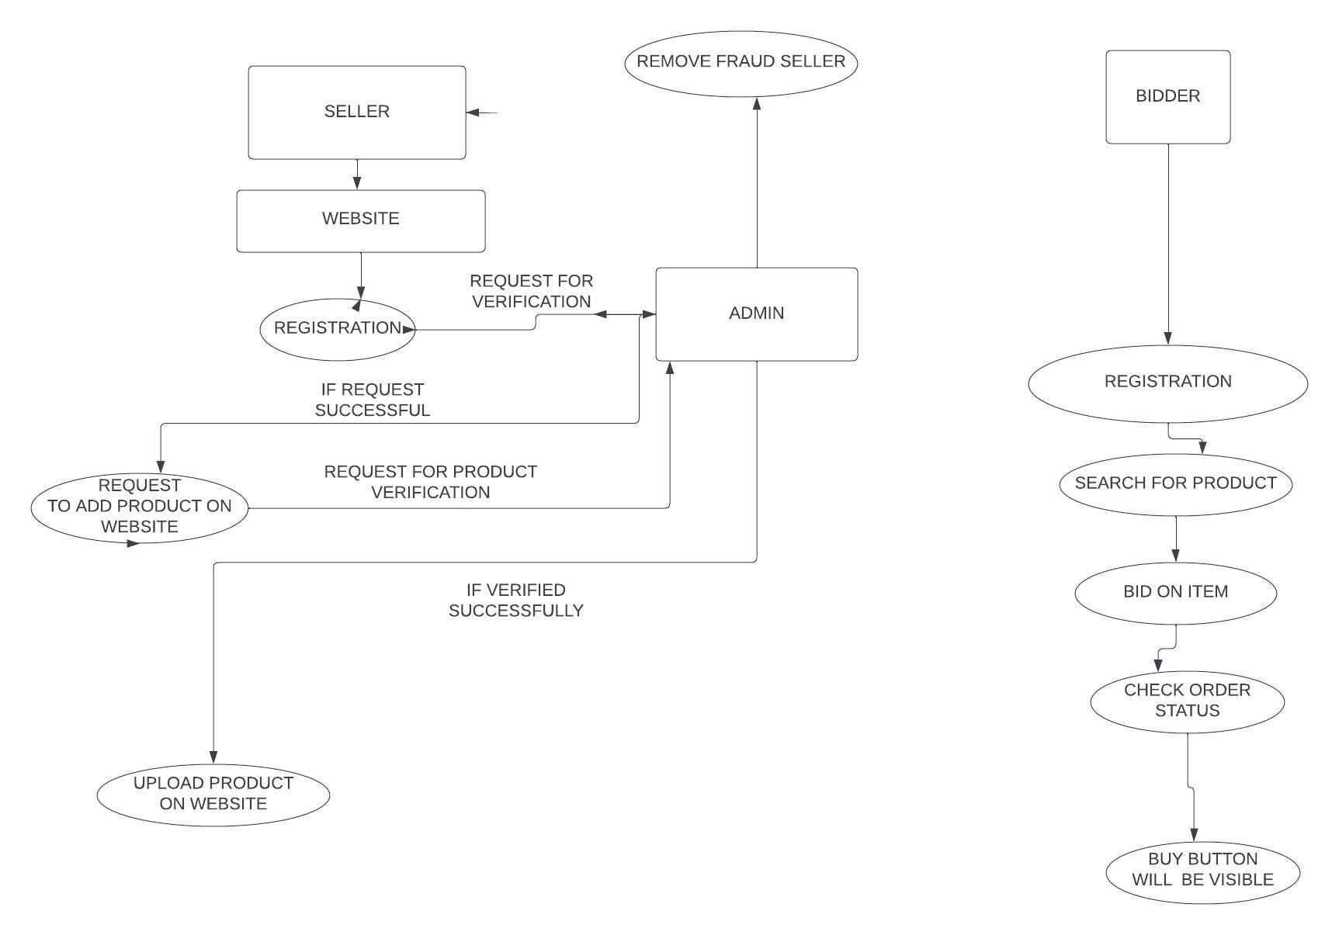

**DFD LEVEL 1**

**6.2 ERD :**

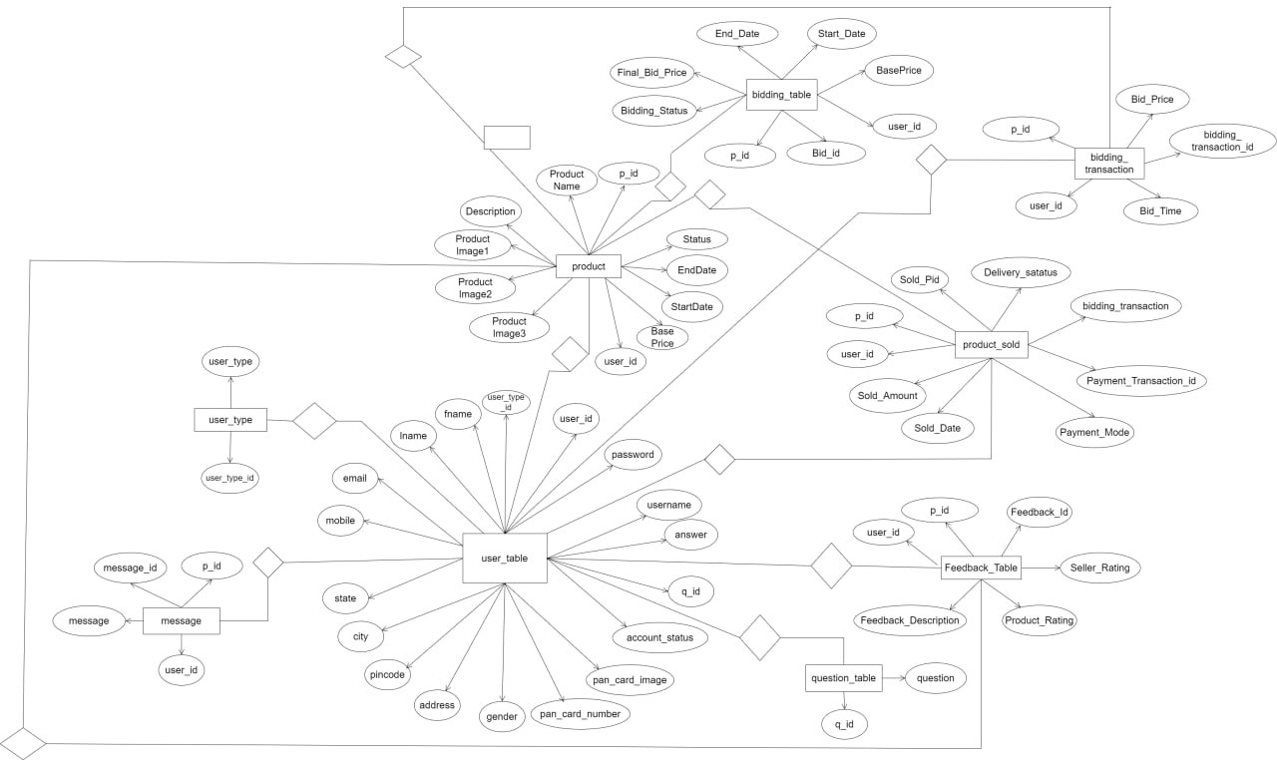

**6.3 Use case diagram:**

**6.4 Class Diagram:**

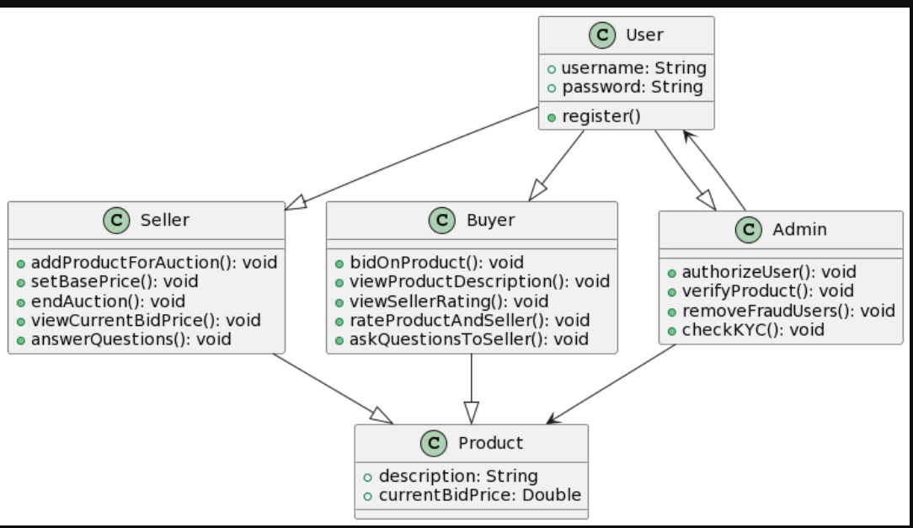

**6.5 Sequence diagram:**

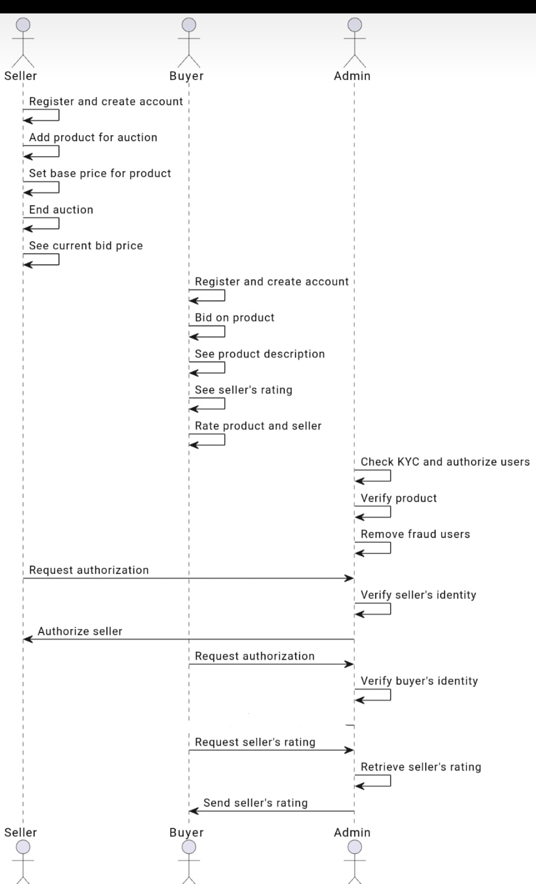

**6.6 Activity Diagram:**

* **SELLER ACTIVITY DIAGRAM :**

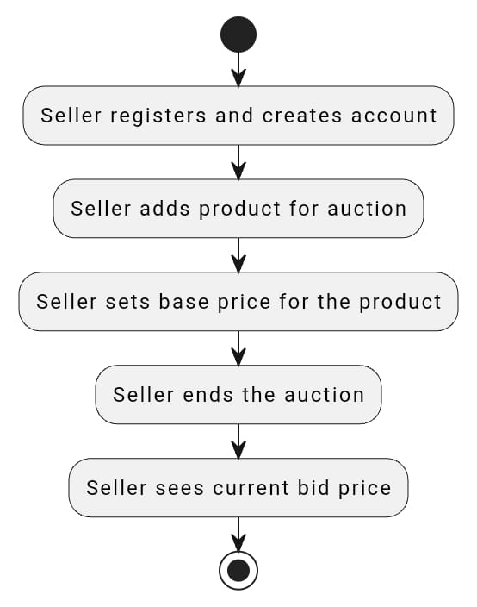

* **BUYER ACTIVITY DIAGRAM:**

* **ADMIN ACTIVITY DIAGRAM:**

**6.7. Deployment diagram**

**6.8. System Architecture**

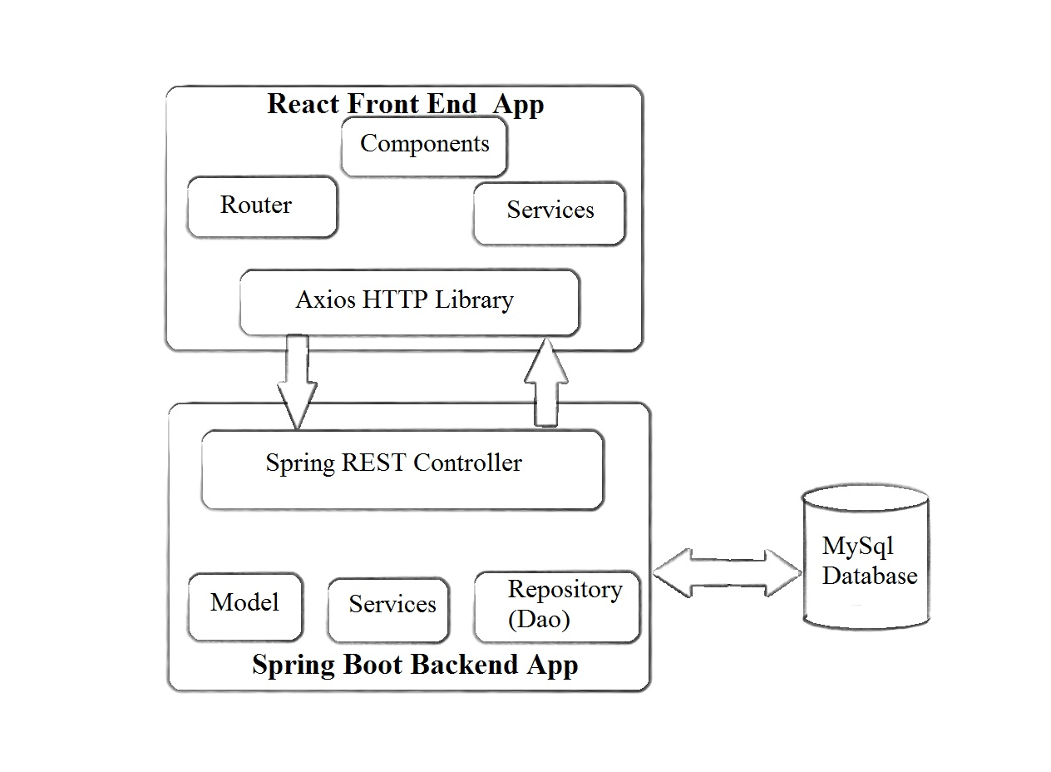

**7. Test Cases:**

Mainly 3 actors (Admin, Bidder and Seller) will be interacting with the proposed system; each one can do the following:

**Admin:**

* Admin can manage products
* Admin can manage Seller
* Admin can manage users
* Admin can manage bidding
* Admin can create reports.

**Bidder:**

* Bidder can search for a product
* Bidder can view product details
* Bidder can make a bid for product

**Seller:**

* Seller can post a product
* Seller can specify time and price of the bidding
* Seller can view bidding information

**8 Screenshots**

**9 References**