**Task - 1**

**Install OpenSSH -** The ssh command is used from logging into the remote machine, transferring files between the two machines, and for executing commands on the remote machine.

sudo apt-get install openssh-client

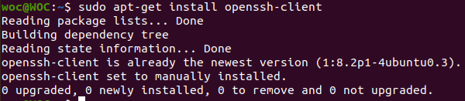

**Install nano -** Nano is a friendly and convenient text editor

sudo apt install nano

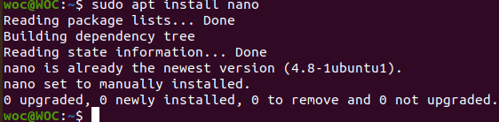

**Install htop -** that allows the user to interactively monitor the system’s vital resources or server’s processes in real time.

sudo apt install htop

**To install the latest version of htop -**

snap install htop



**Launch htop -** htop



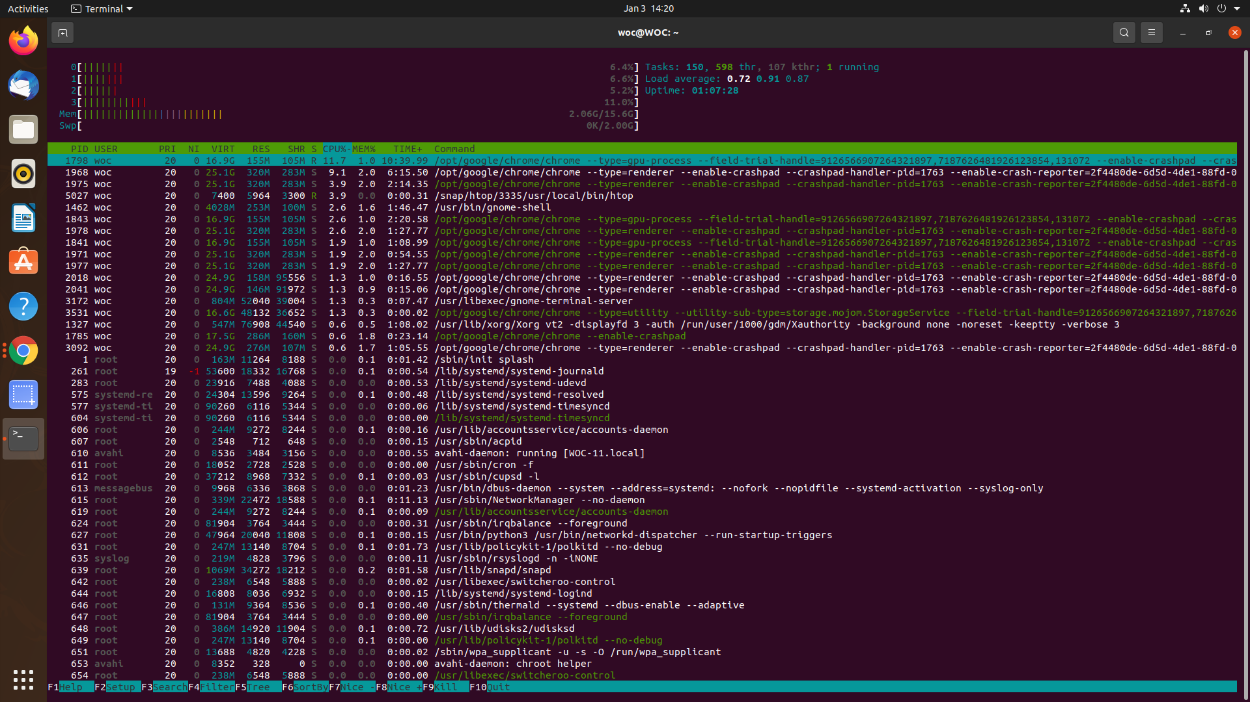

**Create a folder -** mkdir

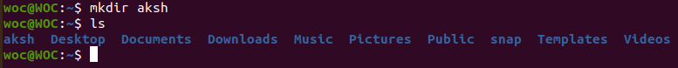

**Create one file add 100’s of lines inside -**

cat command allows us to write some texts into a file and read this file

cat > aksh.txt

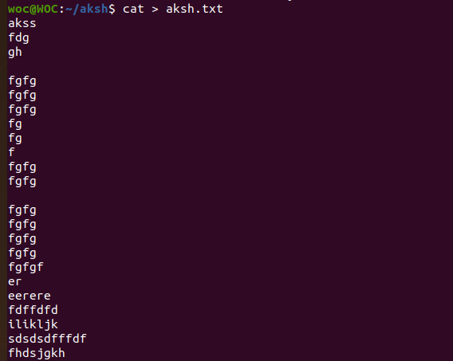

**Create a copy of the file with _copy.txt in name -** cp filename newfilename

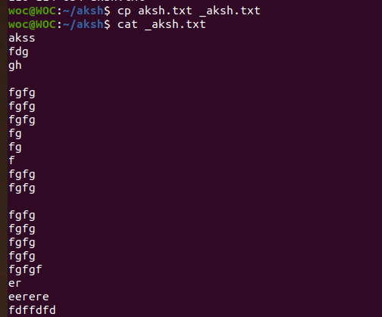

**Try head and tail -** head/tail filename

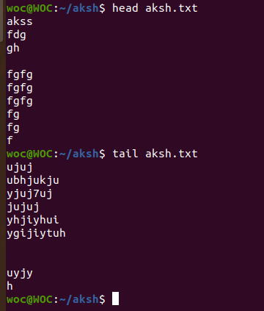

**Add current path of inside file inside Task 3 file at the end -**

vi filename

Press i

Add last line

Press ESC and :wq

Check using tail filename



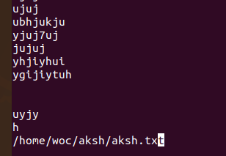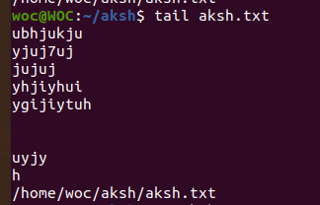

**Second method ->>**

Echo “text” >> filename

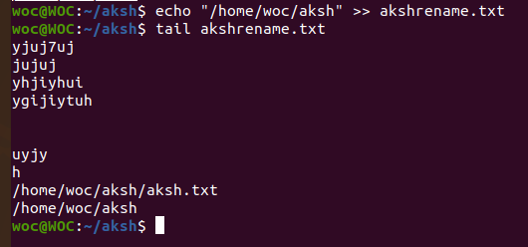

**Create a file without opening -**

touch filename



**Rename all 3 files -** mv filename copyfilename

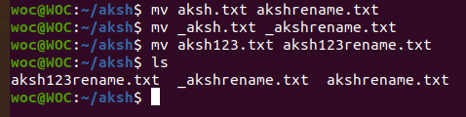

**Delete all the files containing _copy.text at the end -** rm *_copy.txt

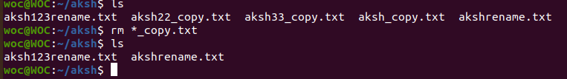

**Check all the running processes -** htop



**Find the location of the python -**

Sudo apt install mlocate

locate python

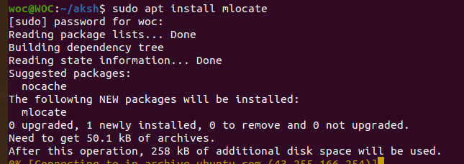



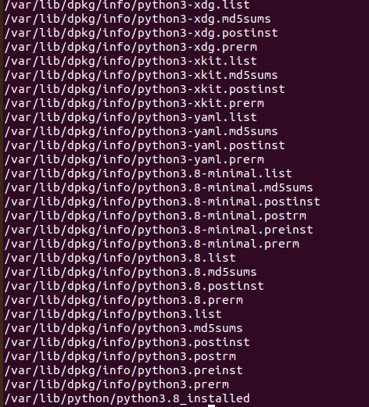

**Check your current IP address and share it to a friend -**

hostname -I

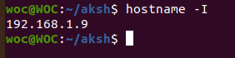

sudo apt-get install openssh-server

sudo apt-get install openssh-client

ssh 192.168.1.24

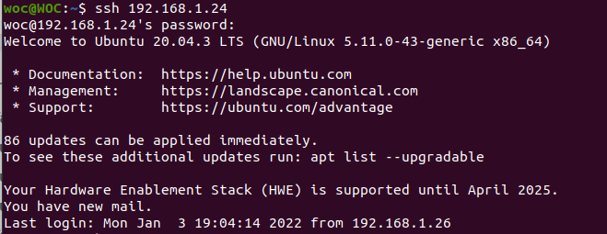

**Check IP address of** [**weboccult.com**](http://weboccult.com/) **-**

host [weboccult.com](http://weboccult.com/)

