# Executive Summary

This report presents insights derived from the Airbnb project, focusing on pricing strategies, location-based performance, and listing attributes. The analysis highlights trends in average price per bedroom, geographic price distribution, and revenue patterns to provide actionable recommendations for stakeholders.

# Key Insights

## 1. Average Price Per Bedroom

The analysis shows a positive correlation between the number of bedrooms and the average price. Properties with more bedroom’s command higher prices, with one-bedroom units averaging $97.3 and seven-bedroom units averaging $533.2.

## 2. Price Distribution by Zip code

Price variations across zip codes reveal significant geographic pricing trends. Zip codes such as 98199 and 98110 show higher average prices, reflecting premium locations.

## 3. Revenue Trends

Revenue trends indicate steady growth over the analyzed year, with a marked increase in weekly revenue starting in February and continuing through the year.

# Visual Representations

## Figure 1: Average Price Per Bedroom

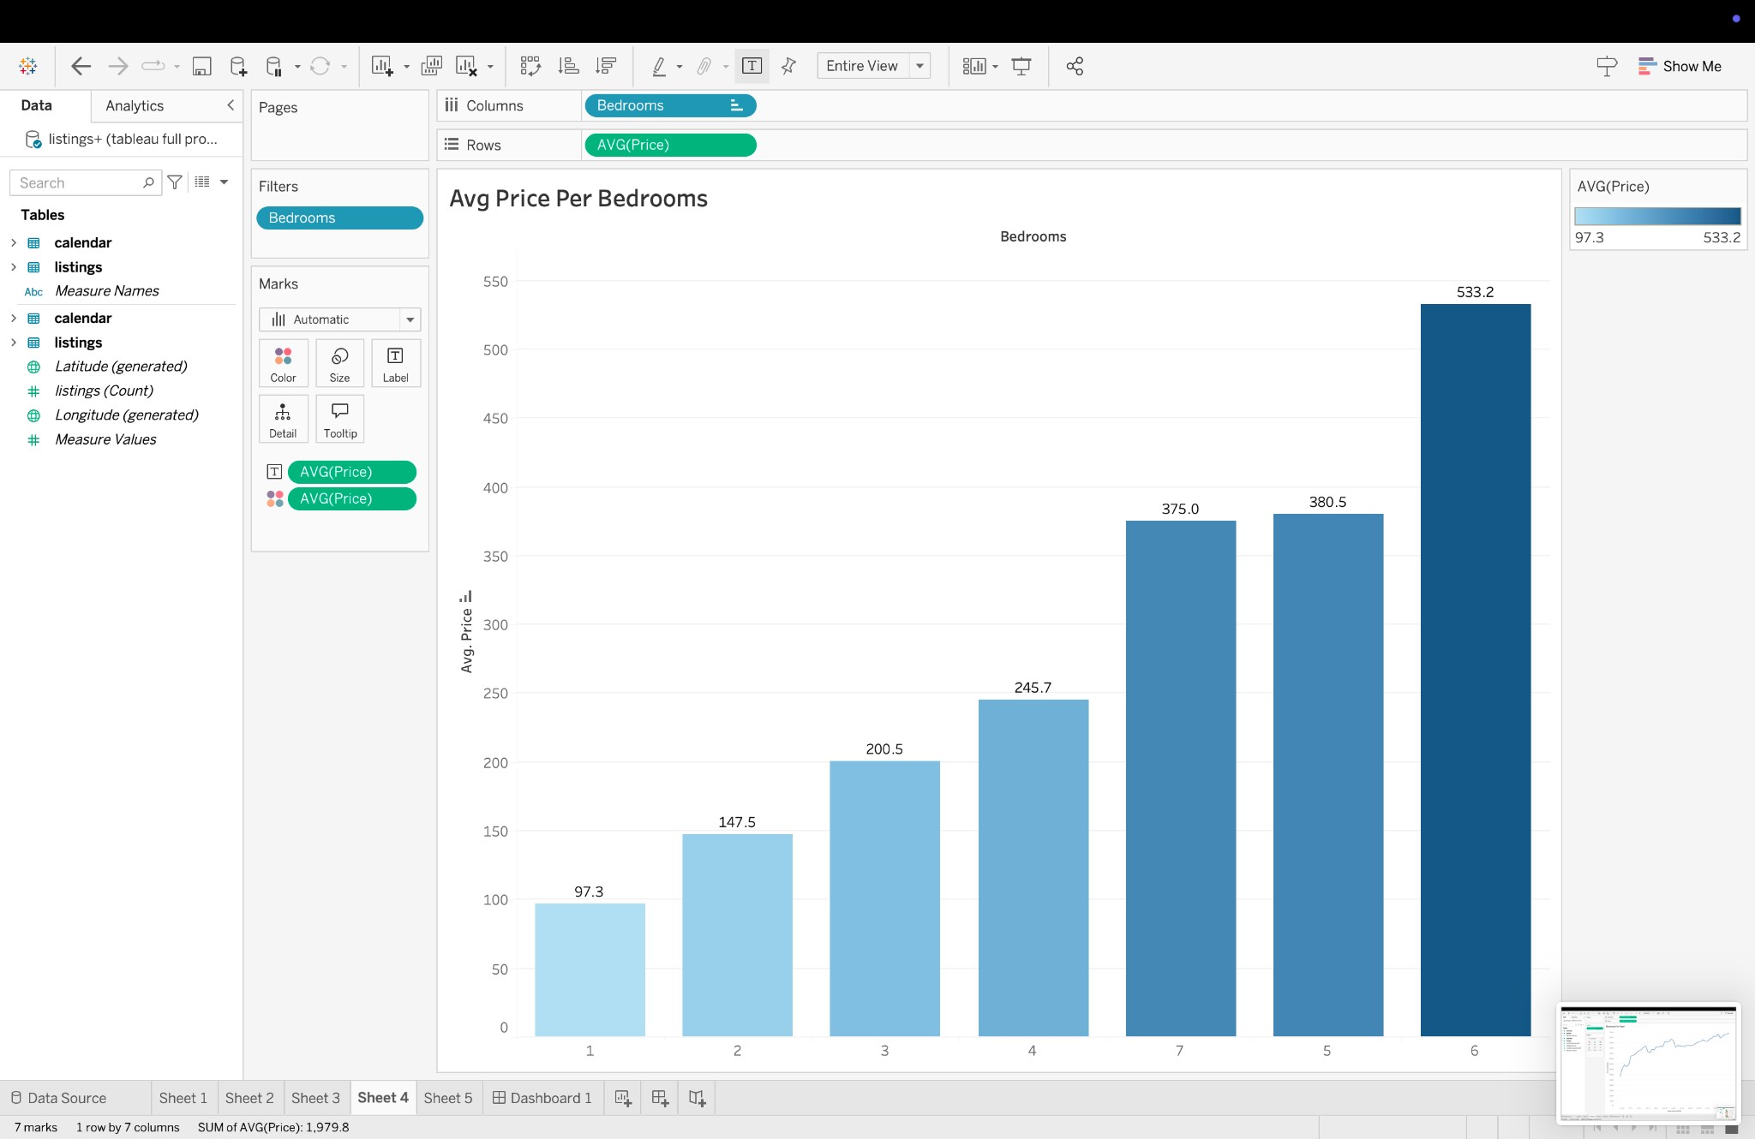

## Figure 2: Price by Zipcode

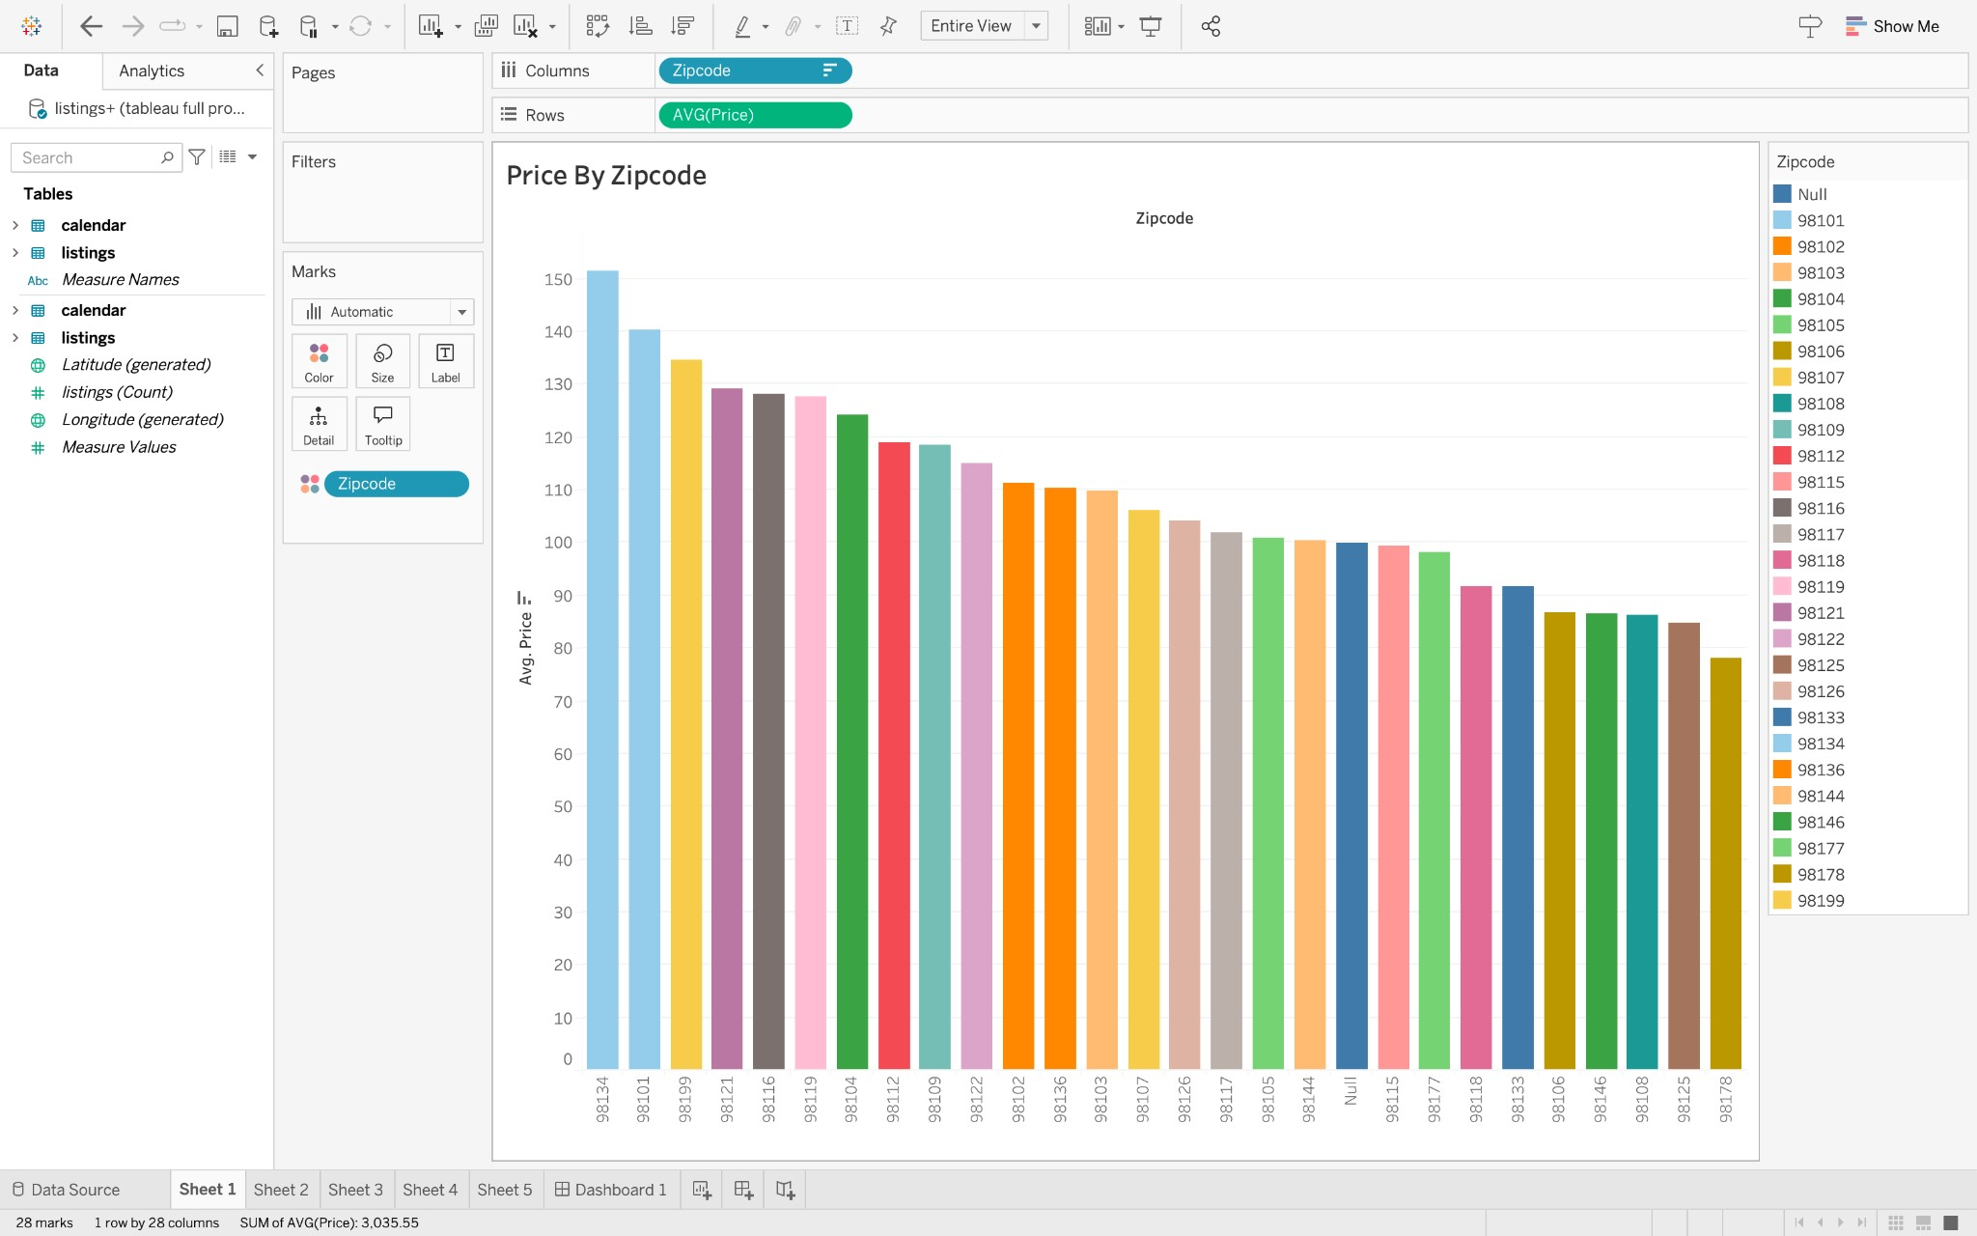

## Figure 3: Price by Zipcode (Geographical)

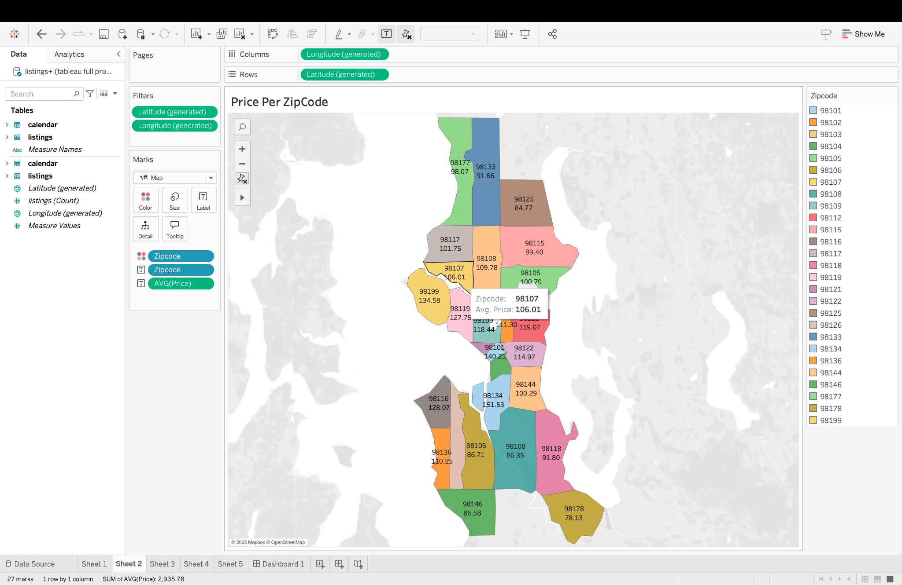

## Figure 4: Revenue for the Year

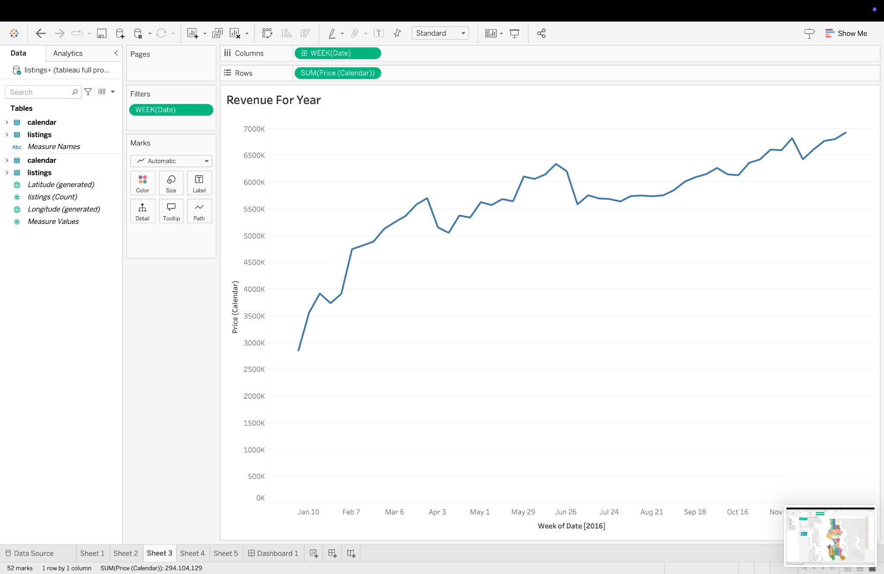

# 

# Strategic Recommendations

1. Target high-demand zip codes (e.g., 98199, 98110) with premium listings to maximize revenue.
2. Optimize pricing for properties with higher bedroom counts to reflect their market value.
3. Use seasonal revenue patterns to enhance marketing campaigns during peak periods.
4. Develop promotional packages for one- and two-bedroom properties to improve occupancy rates.