# AUTOMETA

### Slogan: Automate location-based tasks

Description: Autometa is an app that triggers reminders and automates text-based events based on the user’s location and radius and optionally, the time of day. Users can snooze or delay events and also cancel them within a specified duration of the trigger.

The app is targeted at users aged 13 and above. Although the app is simple, it allows for users to control sensitive actions such as auto-texting which would not be apt for children.

Autometa helps solve memory related problems such as forgetting to notify family and friends of your arrival, forgetting to email peers about delays in meetings due to locational unavailability and forgetting to pick up grocery even while near a grocery store.

Closest competitors on the Play Store and why Autometa will be better than them: -

* Task Nearby: Location Reminder – Need to provide specific location and date and time to get an alert when near the location. Autometa needs no specific location, just a category (e.g. gas station) and date and time range are optional parameters.
* Reminders - Task reminder app – Only provides specific location-based reminders while Autometa will let you carry out automated events such as send a text or email as well apart from reminders. Reviews claim location-based reminders are buggy. Also, contains ads while Autometa is ad-free.
* Beep Me! – Again, only provides specific location-based reminders and no other functionality. Supports only GPS and no other means of geofencing. Autometa will support GPS, Wi-Fi and cellular scanning for location.
* NearMinder | Contacts & Locations Reminders – This app also requires specific location to be entered by users, but it has the advantage of proximity as well. Autometa will make use of proximity too and also let users choose location categories apart from specific locations.
* Location Alarm – Just triggers an alarm based on a specific location provided. Autometa will trigger a reminder and also give users the option to carry out automated events.

What is innovative about Autometa is that while some apps do exist which provide location-based reminders, there’s no app which carries out automation such as texting or sending an email based on location. Autometa would not only provide an existing feature in a better form but also provide additional useful features in one single app.

Autometa has the potential to be used by users for a long time as short-term memory loss is a natural occurrence and occurs in almost all humans. Autometa aims to solve some of the problems related to exactly that. Short term memory loss in humans will never go away and so the app will always remain useful until an advanced innovation takes place.

The top potential weakness of Autometa is perhaps the location and battery of the phone.

Location service is the key to this app’s successful execution and if that doesn’t work, then the app’s functionality is lost. To resolve this, Autometa will make use of not just GPS but also Wi-Fi, Bluetooth and cellular scanning for location.

A switched off phone will lead to users missing reminders. In cases of time-based reminders, Autometa will alert users of upcoming reminders (within the next 6 hours) when the battery is low. Users can toggle this feature in the settings if they wish to switch it off/on.

Yes, I would be able to design, build and test this app before the final project is due for the class.

# Mock UI sketches

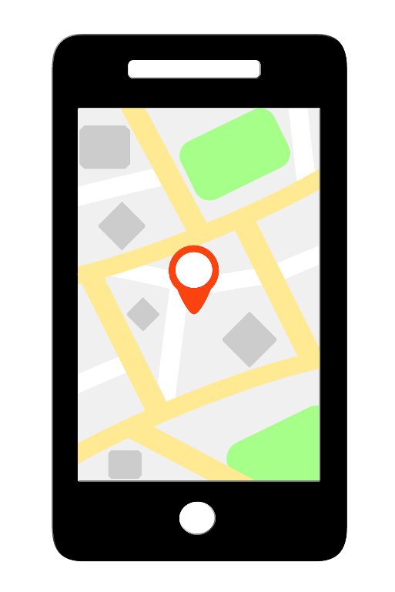

Fig 1: Sample location UI

A picture containing electronics

Description generated with high confidence

Fig 2: Automated SMS being sent based on location trigger

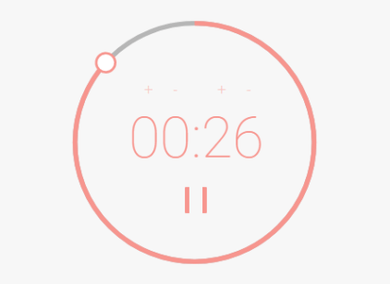

Fig 3: Countdown to snooze/cancel automation