My SQL – Table Creation

CREATE TABLE product (
id int IDENTITY(1,1) PRIMARY KEY,
name VARCHAR(255) NOT NULL,
category VARCHAR(255) NOT NULL,
price DECIMAL(10,2) NOT NULL,
last_updated Datetime2
);

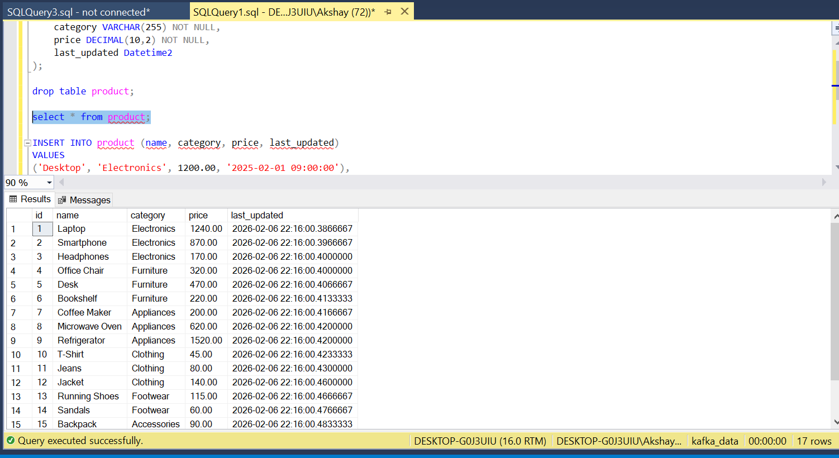

Kafka Config
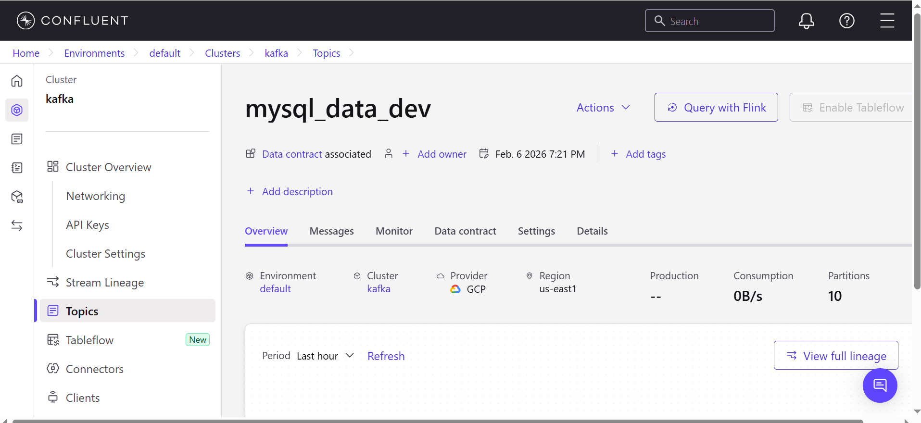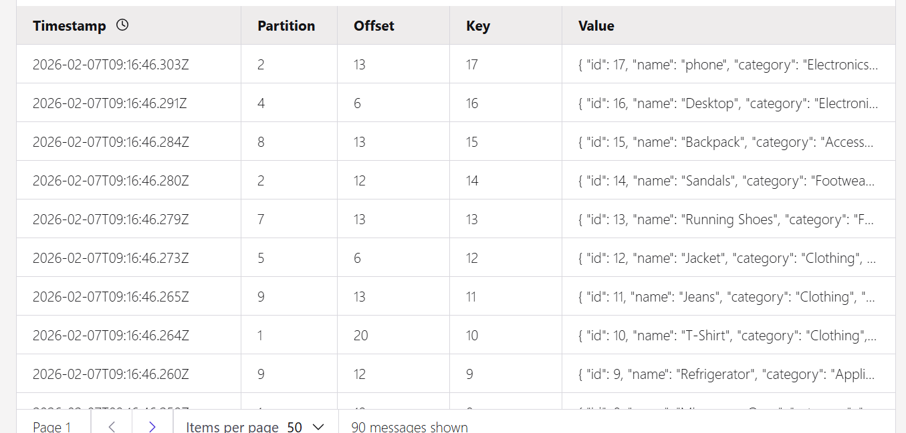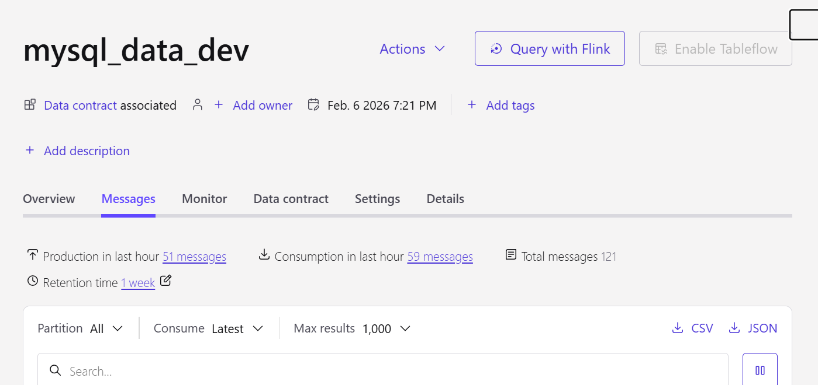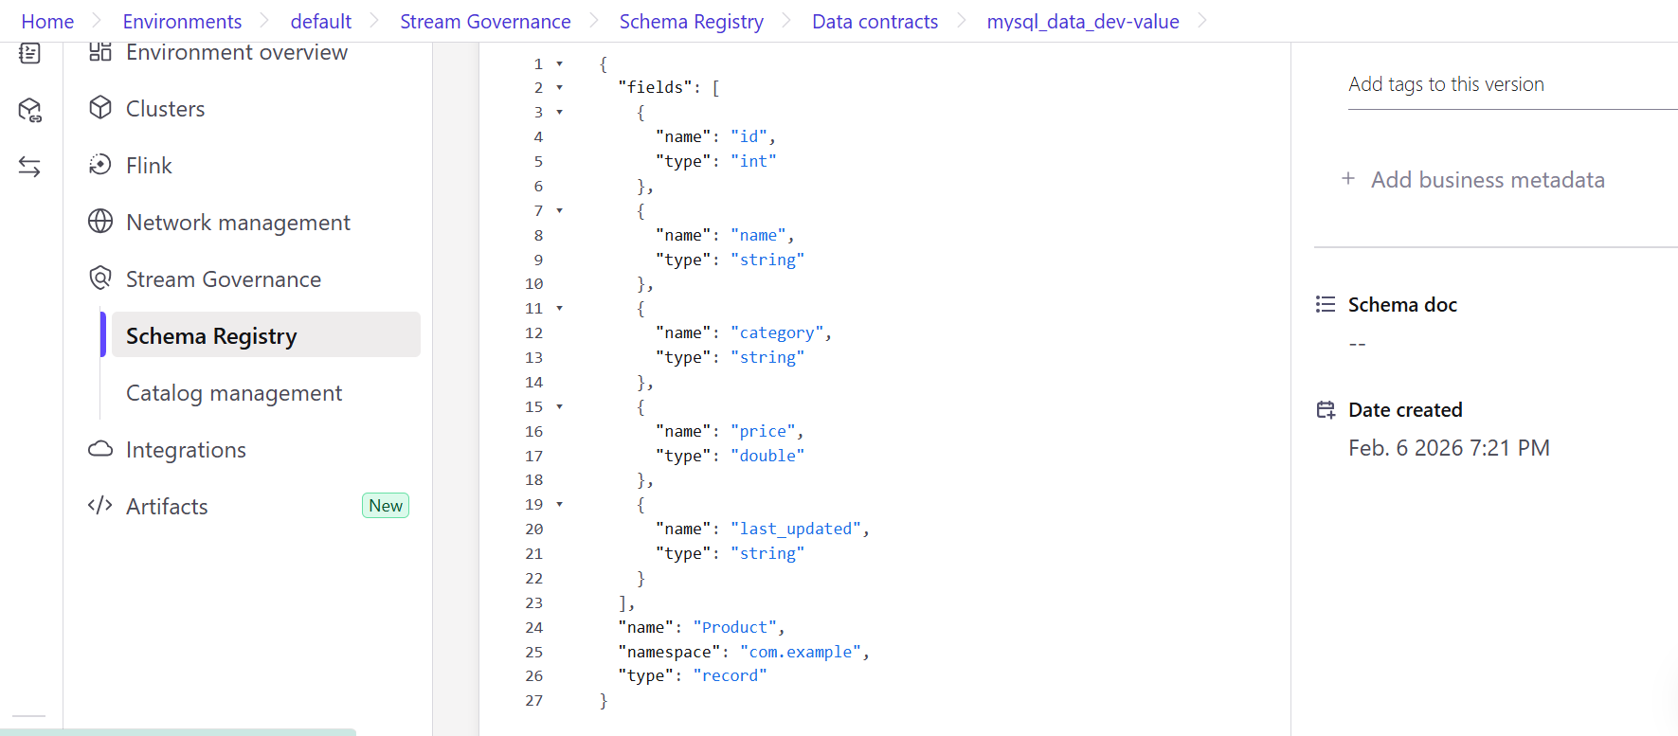

Producer Code -
import pyodbc
from confluent_kafka import SerializingProducer
from confluent_kafka.schema_registry import SchemaRegistryClient
from confluent_kafka.schema_registry.avro import AvroSerializer
from confluent_kafka.serialization import StringSerializer
from datetime import datetime, timedelta

# --------------------------
# SQL Server Connection
# --------------------------
conn = pyodbc.connect(
'DRIVER={ODBC Driver 17 for SQL Server};'
'SERVER=DESKTOP-G0J3UIU;'
'DATABASE=kafka_data;'
'Trusted_Connection=yes;'
)
cursor = conn.cursor()

# --------------------------
# Kafka / Schema Registry Config
# --------------------------
kafka_config = {
'bootstrap.servers': 'pkc-619z3.us-east1.gcp.confluent.cloud:9092',
'sasl.mechanisms': 'PLAIN',
'security.protocol': 'SASL_SSL',
'sasl.username': 'KW3HHT7XAFE7FHBE',
'sasl.password': 'cfltoaO1qt5yPU7hLG56iwBqFasfQ79kuQaQjw7HOwxwRXto/5pHj/Hhw98osfXw'
}

schema_registry_client = SchemaRegistryClient({
'url': 'https://psrc-1dx7926.us-east1.gcp.confluent.cloud',
'basic.auth.user.info': '{}:{}'.format(
'7U7CPJIPQULCKCPC',
'cflt7j6HxFi97/nwJG6rnhOKKyxnGmAw9vhDge05B256qUwE0pSJmypUjzirk0Lw'
)
})

# --------------------------
# Delivery report
# --------------------------
def delivery_report(err, msg):
if err is not None:
print(f"Delivery failed for record {msg.key()}: {err}")
else:
print(f"Record {msg.key()} delivered to {msg.topic()} [{msg.partition()}] at offset {msg.offset()}")

# --------------------------
# Track last read timestamp
# --------------------------
try:
with open("last_read_timestamp.txt", "r") as f:
last_read_ts = datetime.fromisoformat(f.read().strip())
except FileNotFoundError:
last_read_ts = datetime.now() - timedelta(days=1) # default: last 1 day

# --------------------------
# Avro serialization
# --------------------------
def product_to_avro(row, ctx):
"""Convert SQL row to Avro dict"""
return {
"id": int(row["id"]),
"name": str(row["name"]),
"category": str(row["category"]),
"price": float(row["price"]),
"last_updated": row["last_updated"].isoformat() # convert datetime to string for Kafka
}

subject_name = 'mysql_data_dev-value'
schema_str = schema_registry_client.get_latest_version(subject_name).schema.schema_str
print("Schema from Registry:")
print(schema_str)
print("=====================")

key_serializer = StringSerializer('utf_8')
avro_serializer = AvroSerializer(schema_registry_client, schema_str, product_to_avro)

producer = SerializingProducer({
'bootstrap.servers': kafka_config['bootstrap.servers'],
'security.protocol': kafka_config['security.protocol'],
'sasl.mechanisms': kafka_config['sasl.mechanisms'],
'sasl.username': kafka_config['sasl.username'],
'sasl.password': kafka_config['sasl.password'],
'key.serializer': key_serializer,
'value.serializer': avro_serializer
})

# --------------------------
# Fetch new product records
# --------------------------
query = """
SELECT id, name, category, price, last_updated
FROM product
WHERE last_updated >= ?
ORDER BY last_updated ASC, id ASC
"""
cursor.execute(query, (last_read_ts - timedelta(milliseconds=1),))
columns = [column[0] for column in cursor.description]
rows = [dict(zip(columns, row)) for row in cursor.fetchall()]

print("Last read timestamp:", last_read_ts)
print("Number of rows fetched:", len(rows))

if rows:
for row in rows:
key = str(row['id'])
producer.produce(
topic='mysql_data_dev',
key=key,
value=row,
on_delivery=delivery_report
)
print(f"Producing Product ID: {row['id']}")
producer.poll(0) # serve delivery callbacks

# Flush **once** after all messages
producer.flush()

# Update last_read_timestamp.txt with the max last_updated
latest_ts = max(row["last_updated"] for row in rows)
with open("last_read_timestamp.txt", "w") as f:
f.write(latest_ts.isoformat())

print("All new records sent to Kafka successfully!")

# --------------------------
# Clean up
# --------------------------
cursor.close()
conn.close()

Output
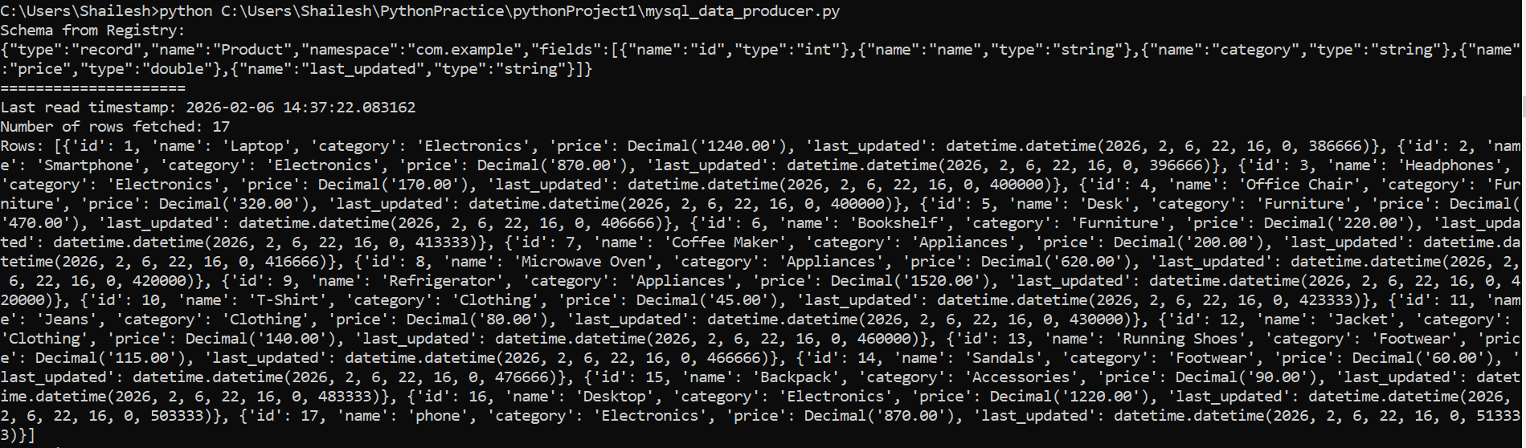
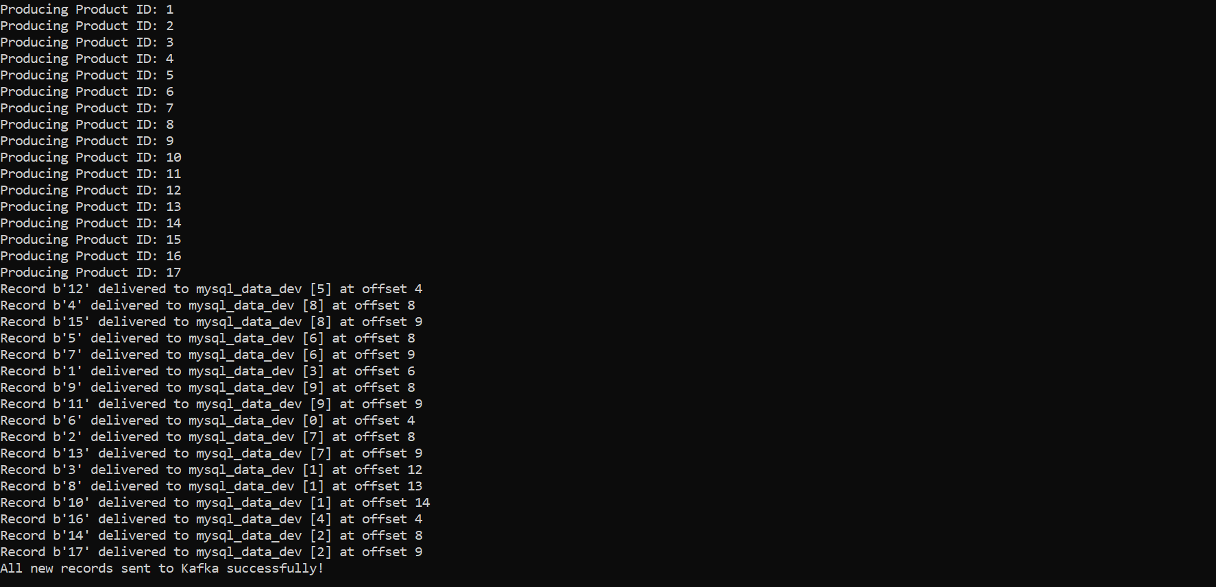

Consumer Code -
import json
from confluent_kafka import DeserializingConsumer
from confluent_kafka.schema_registry import SchemaRegistryClient
from confluent_kafka.schema_registry.avro import AvroDeserializer
from confluent_kafka.serialization import StringDeserializer

# --------------------------
# Kafka / Schema Registry Config
# --------------------------
kafka_config = {
'bootstrap.servers': 'pkc-619z3.us-east1.gcp.confluent.cloud:9092',
'sasl.mechanisms': 'PLAIN',
'security.protocol': 'SASL_SSL',
'sasl.username': 'KW3HHT7XAFE7FHBE',
'sasl.password': 'cfltoaO1qt5yPU7hLG56iwBqFasfQ79kuQaQjw7HOwxwRXto/5pHj/Hhw98osfXw',
'group.id': 'my_test_group',
'auto.offset.reset': 'latest' # read messages from beginning
}

schema_registry_client = SchemaRegistryClient({
'url': 'https://psrc-1dx7926.us-east1.gcp.confluent.cloud',
'basic.auth.user.info': '{}:{}'.format(
'7U7CPJIPQULCKCPC',
'cflt7j6HxFi97/nwJG6rnhOKKyxnGmAw9vhDge05B256qUwE0pSJmypUjzirk0Lw'
)
})

# --------------------------
# Fetch latest schema
# --------------------------
subject_name = 'mysql_data_dev-value'
latest_schema = schema_registry_client.get_latest_version(subject_name).schema
schema_str = latest_schema.schema_str

# --------------------------
# Avro Deserializer
# --------------------------
def avro_to_dict(obj, ctx):
return obj # Avro → Python dict

avro_deserializer = AvroDeserializer(
schema_registry_client,
schema_str,
avro_to_dict
)

key_deserializer = StringDeserializer('utf_8')

# --------------------------
# Consumer Configuration
# --------------------------
consumer_conf = {
'bootstrap.servers': kafka_config['bootstrap.servers'],
'security.protocol': kafka_config['security.protocol'],
'sasl.mechanisms': kafka_config['sasl.mechanisms'],
'sasl.username': kafka_config['sasl.username'],
'sasl.password': kafka_config['sasl.password'],
'group.id': 'product_consumer_group_1',
'auto.offset.reset': 'earliest',
'key.deserializer': key_deserializer,
'value.deserializer': avro_deserializer
}

consumer = DeserializingConsumer(consumer_conf)

# --------------------------
# Business Transformation Logic
# --------------------------
def transform_record(record: dict) -> dict:
if not record:
return record

# Convert category to uppercase
category = record.get("category")
if category:
category = category.upper()
record["category"] = category

# Apply discount rules
price = record.get("price")
if price is not None:
if category == "ELECTRONICS":
record["price"] = round(price * 0.90, 2)
elif category == "CLOTHING":
record["price"] = round(price * 0.95, 2)

return record

# --------------------------
# File to append JSON records
# --------------------------
OUTPUT_FILE = "transformed_products.json"

# --------------------------
# Subscribe & Consume
# --------------------------
consumer.subscribe(['mysql_data_dev'])

print("Listening for messages on topic 'mysql_data_dev'...")

try:
while True:
msg = consumer.poll(1.0)

if msg is None:
continue

if msg.error():
print(f"Consumer error: {msg.error()}")
continue

key = msg.key()
value = msg.value()

# Transform record
transformed_value = transform_record(value)

# Convert to JSON string
json_record = json.dumps({
"product_id": key,
"data": transformed_value
})

# Append JSON string to file
with open(OUTPUT_FILE, "a") as f:
f.write(json_record + "\n")

print(f"Appended record for Product ID={key}")

except KeyboardInterrupt:
print("Consumer stopped manually.")

finally:
consumer.close()
Consumer Output
Consumer – 1
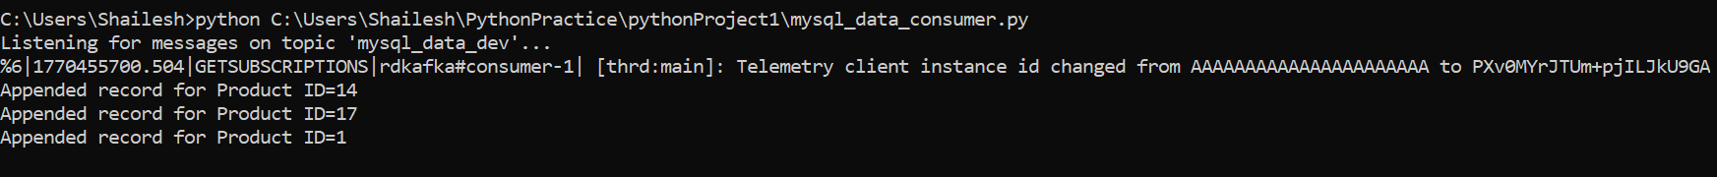
transformed_products.json
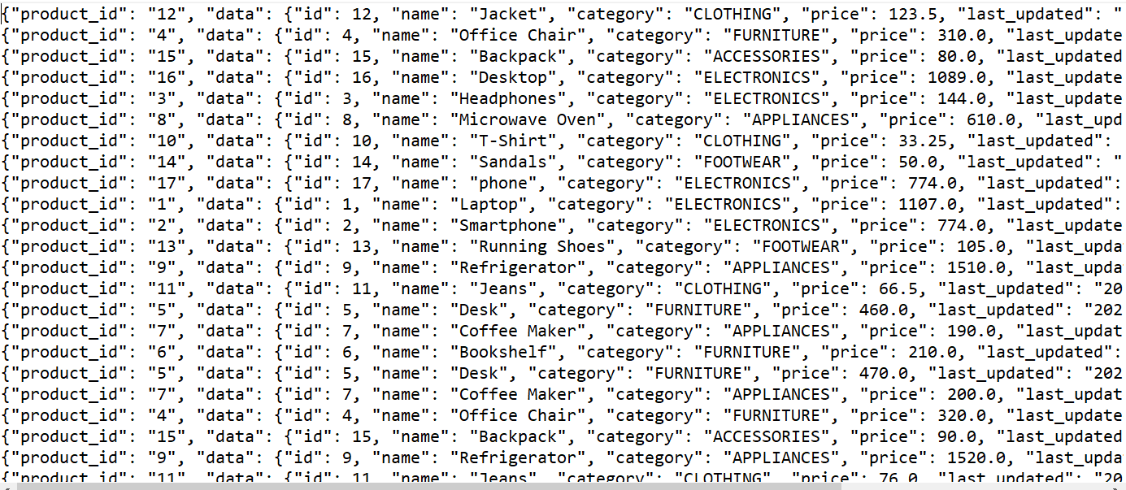

Consumer 2
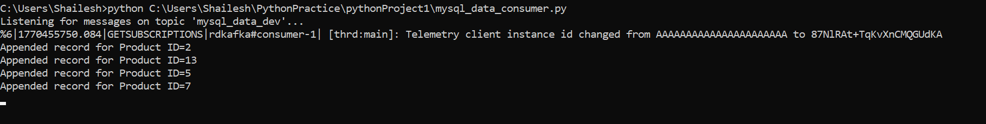
Consumer -3
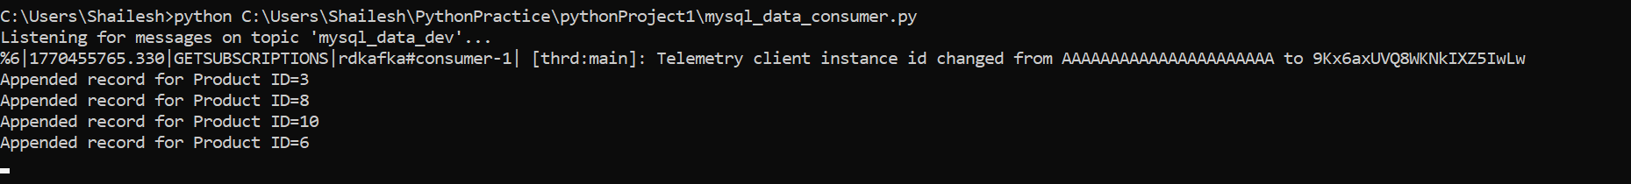
Consumer -4
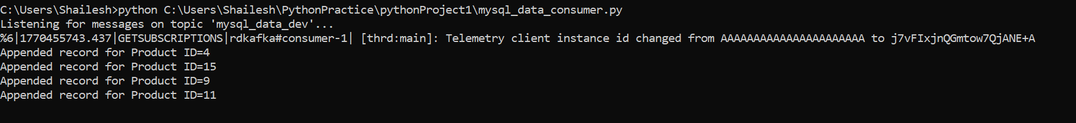
Consumer -5
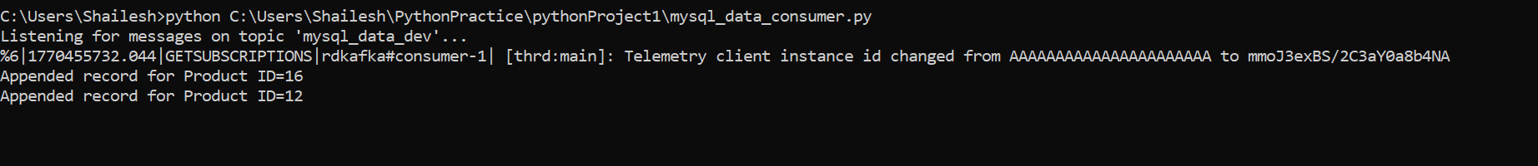

The resulting JSON files with appended records

