Questions:
1. Load ad_campaigns_data.json, user_profile_data.json and store_data.json files in
HDFS
2. Write PySpark code in Jupyter notebook to solve below mentioned analytical
problems
3. Store processed json data of each problem statement into different HDFS output
directory
4. Once output data is available into HDFS, create external Hive tables on top of it
using Json Serde

- File Load in HDFS Location
From GCS Home Location
- hdfs dfs -put store_data.json /tmp/data
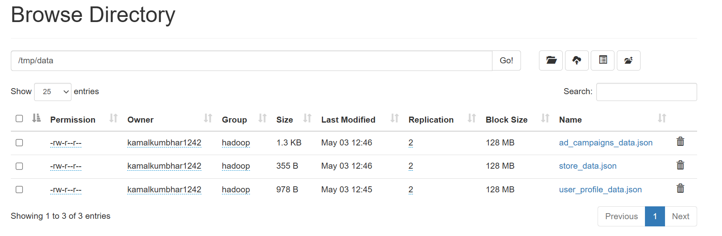
Run Spark code
Create Spark Session
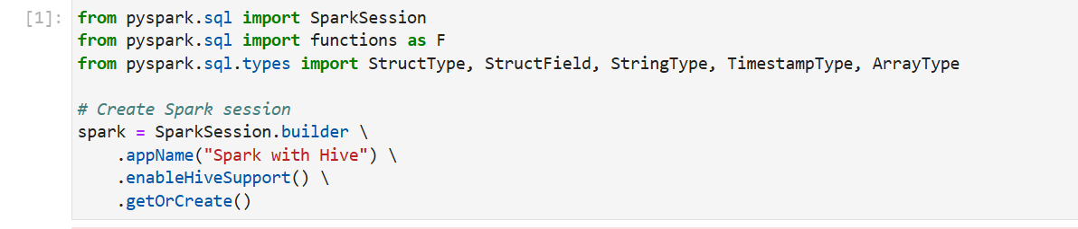
Define Scema
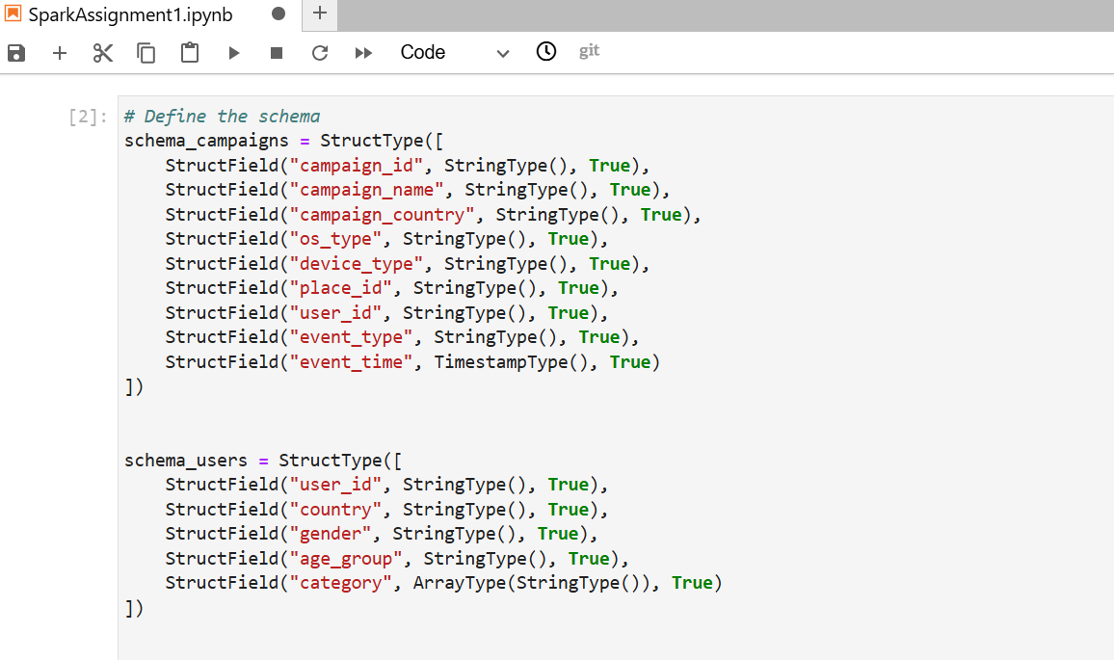
Read the file
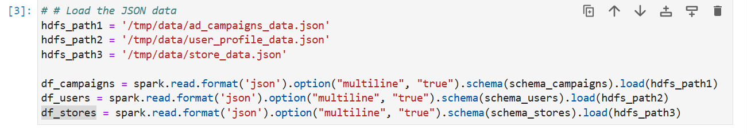
+-----------+--------------------+----------------+-------+-----------+---------+-------------------+----------+-------------------+
|campaign_id| campaign_name|campaign_country|os_type|device_type| place_id| user_id|event_type| event_time|
+-----------+--------------------+----------------+-------+-----------+---------+-------------------+----------+-------------------+
| ABCDFAE|Food category tar...| USA| ios| apple|CASSBB-11|1264374214654454321|impression|2018-10-12 13:10:05|
| ABCDFAE|Food category tar...| USA|android| MOTOROLA|CADGBD-13|1674374214654454321|impression|2018-10-12 13:09:04|
| ABCDFAE|Food category tar...| USA|android| SAMSUNG|BADGBA-12| 5747421465445443| video ad|2018-10-12 13:10:10|
| ABCDFAE|Food category tar...| USA|android| SAMSUNG|CASSBB-11|1864374214654454132| click|2018-10-12 13:10:12|
+-----------+--------------------+----------------+-------+-----------+---------+-------------------+----------+-------------------+

+-------------------+-------+------+---------+--------------------+
| user_id|country|gender|age_group| category|
+-------------------+-------+------+---------+--------------------+
|1264374214654454321| USA| male| 18-25| [shopper, student]|
|1674374214654454321| USA|female| 25-50| [parent]|
| 5747421465445443| USA| male| 25-50|[shopper, parent,...|
|1864374214654454132| USA| male| 50+| [professional]|
| 14537421465445443| USA|female| 18-25| [shopper, student]|
| 25547421465445443| USA|female| 50+|[shopper, profess...|
+-------------------+-------+------+---------+--------------------+

+-------------+--------------------+
| store_name| place_ids|
+-------------+--------------------+
| McDonald|[CASSBB-11, CADGB...|
| BurgerKing| [CASSBB-11]|
| Macys|[BADGBA-13, CASSB...|
|shoppers stop| [BADGBA-12]|
+-------------+--------------------+

df_campaigns.show()
df_users.show()
df_stores.show()
+-----------+--------------------+----------------+-------+-----------+---------+-------------------+----------+-------------------+
|campaign_id| campaign_name|campaign_country|os_type|device_type| place_id| user_id|event_type| event_time|
+-----------+--------------------+----------------+-------+-----------+---------+-------------------+----------+-------------------+
| ABCDFAE|Food category tar...| USA| ios| apple|CASSBB-11|1264374214654454321|impression|2018-10-12 13:10:05|
| ABCDFAE|Food category tar...| USA|android| MOTOROLA|CADGBD-13|1674374214654454321|impression|2018-10-12 13:09:04|
| ABCDFAE|Food category tar...| USA|android| SAMSUNG|BADGBA-12| 5747421465445443| video ad|2018-10-12 13:10:10|
| ABCDFAE|Food category tar...| USA|android| SAMSUNG|CASSBB-11|1864374214654454132| click|2018-10-12 13:10:12|
+-----------+--------------------+----------------+-------+-----------+---------+-------------------+----------+-------------------+

+-------------------+-------+------+---------+--------------------+
| user_id|country|gender|age_group| category|
+-------------------+-------+------+---------+--------------------+
|1264374214654454321| USA| male| 18-25| [shopper, student]|
|1674374214654454321| USA|female| 25-50| [parent]|
| 5747421465445443| USA| male| 25-50|[shopper, parent,...|
|1864374214654454132| USA| male| 50+| [professional]|
| 14537421465445443| USA|female| 18-25| [shopper, student]|
| 25547421465445443| USA|female| 50+|[shopper, profess...|
+-------------------+-------+------+---------+--------------------+

+-------------+--------------------+
| store_name| place_ids|
+-------------+--------------------+
| McDonald|[CASSBB-11, CADGB...|
| BurgerKing| [CASSBB-11]|
| Macys|[BADGBA-13, CASSB...|
|shoppers stop| [BADGBA-12]|
+-------------+--------------------+

Extract the Date and hr from event time and Create new column as date and Hour
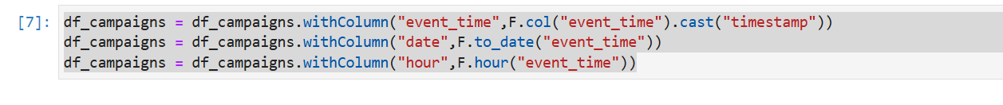
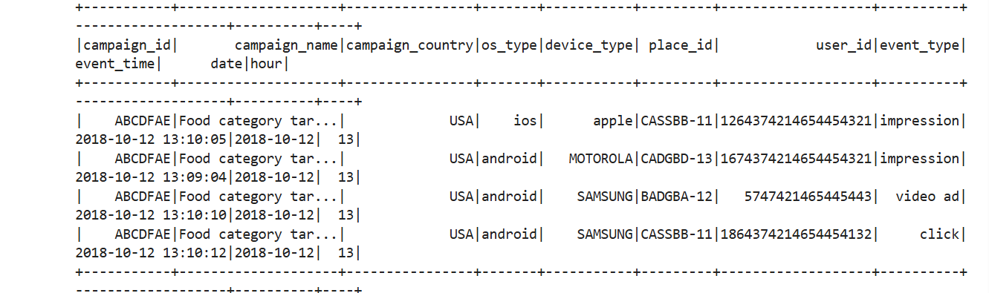

Q1. Analyse data for each campaign_id, date, hour, os_type & value to get all the
events with counts
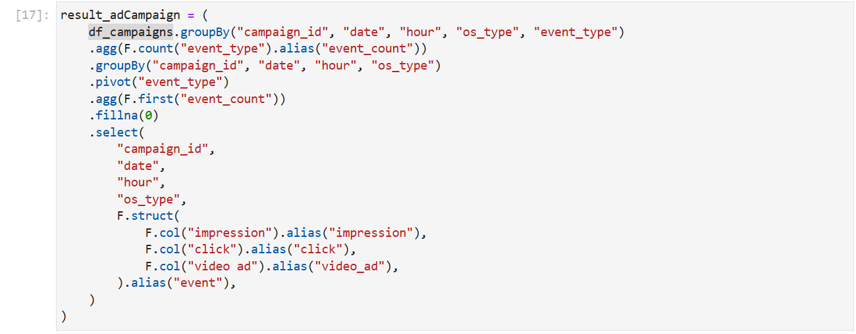
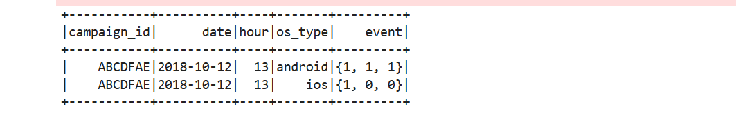

Q2.Analyse data for each campaign_id, date, hour, store_name & value to get all the
events with counts
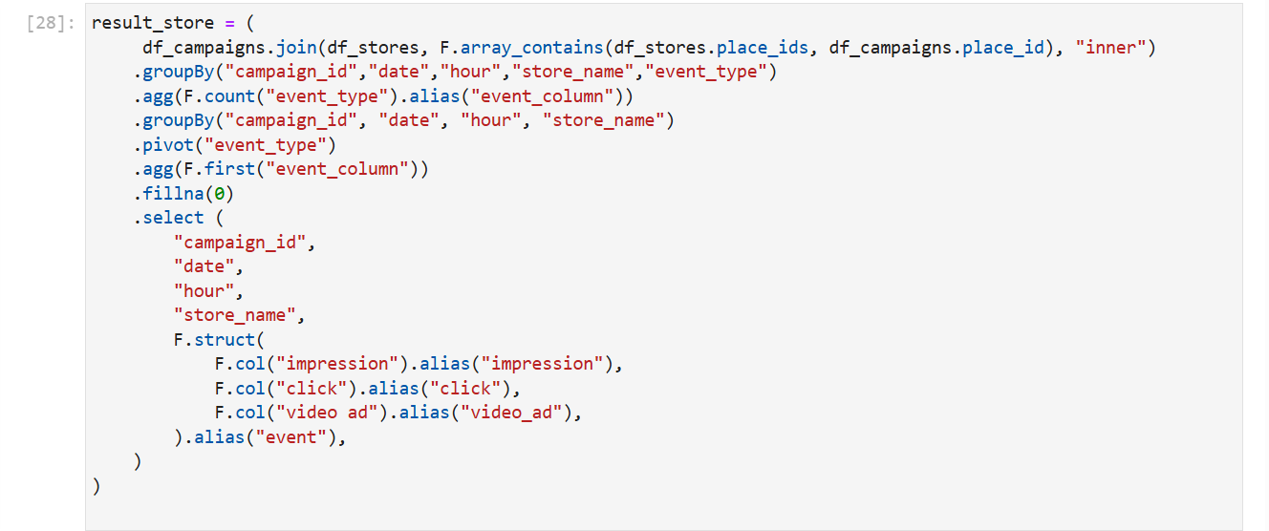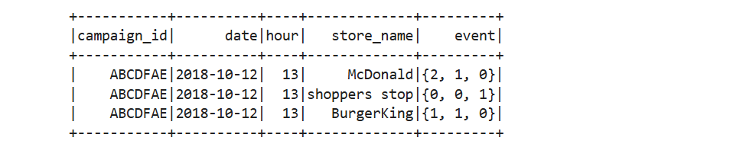
Q3.Analyse data for each campaign_id, date, hour, gender_type & value to get all the
events with counts
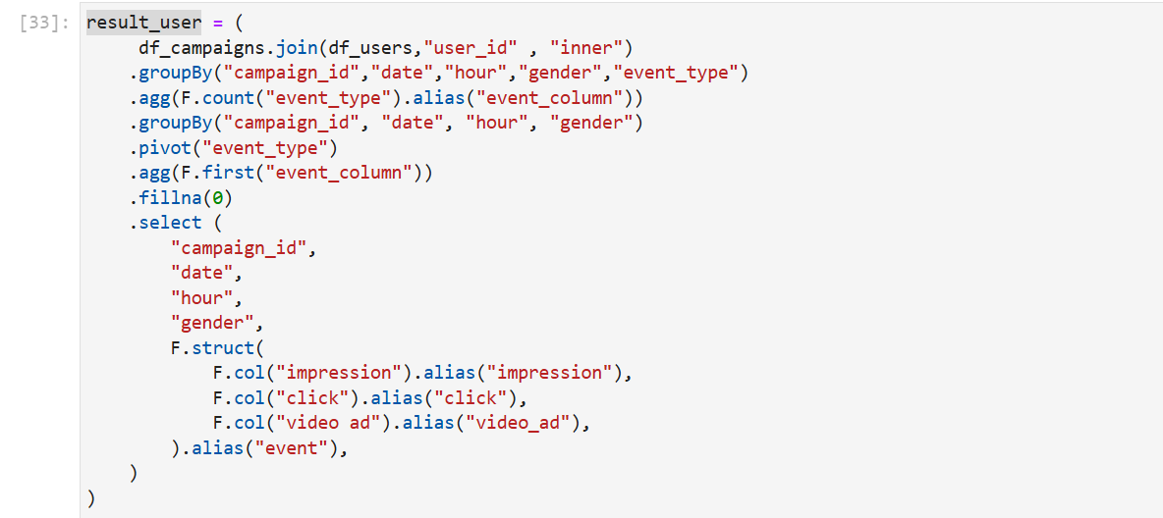
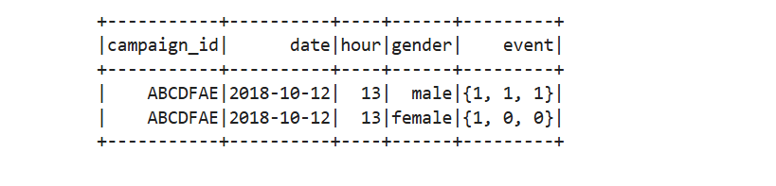
Write as json

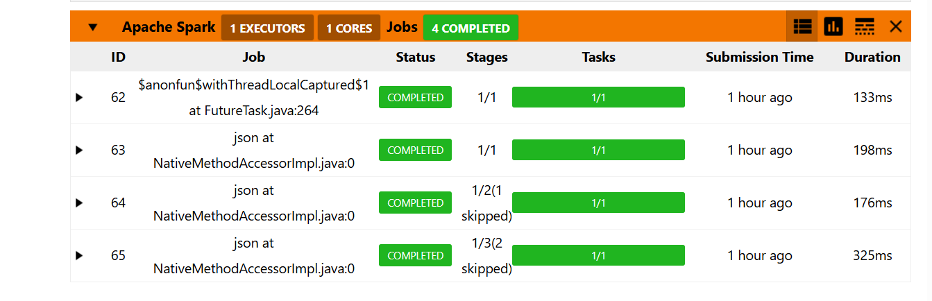
Result Output
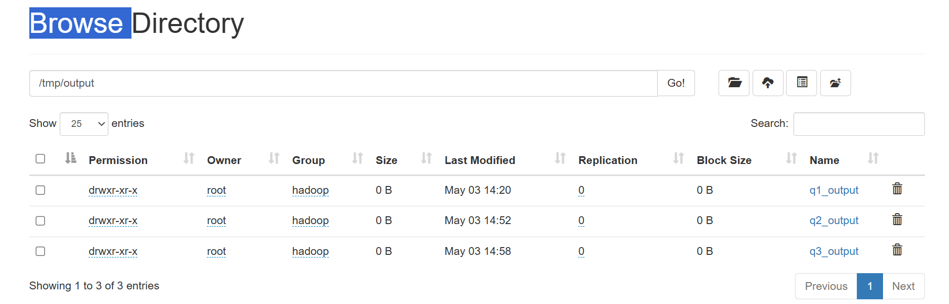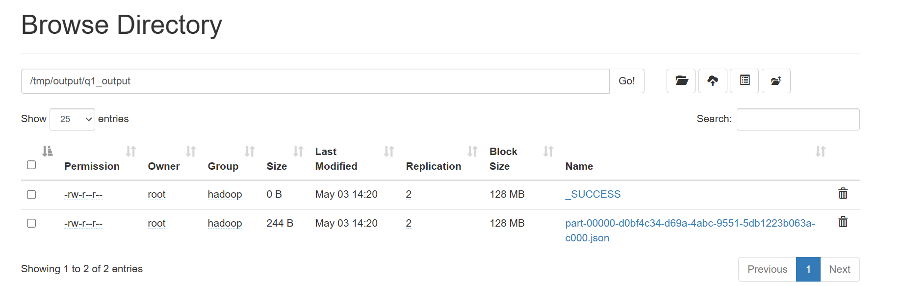

Creating Hive Table
