Zoom Car Data Processing Pipeline
Create GCP Bucket for External Location
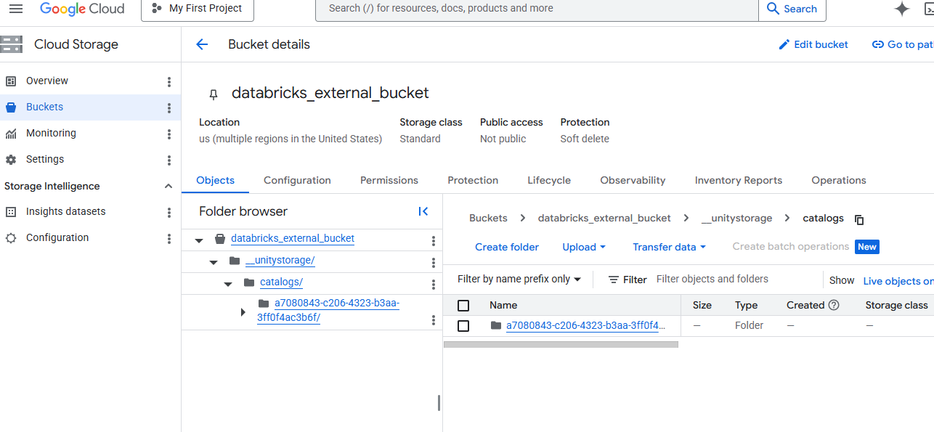
Set External location and Created Service account will be attached with permission for bucket
Catalog ->Connect ->External Location – Credentials -
db-uc-credential-06f074h81o-dk@uc-uscentral1.iam.gserviceaccount.com
attached this cred to bucket – Permission -> Add policies and Provide Role Storage admin and Storage Object Admin,
Create Catalog with External location

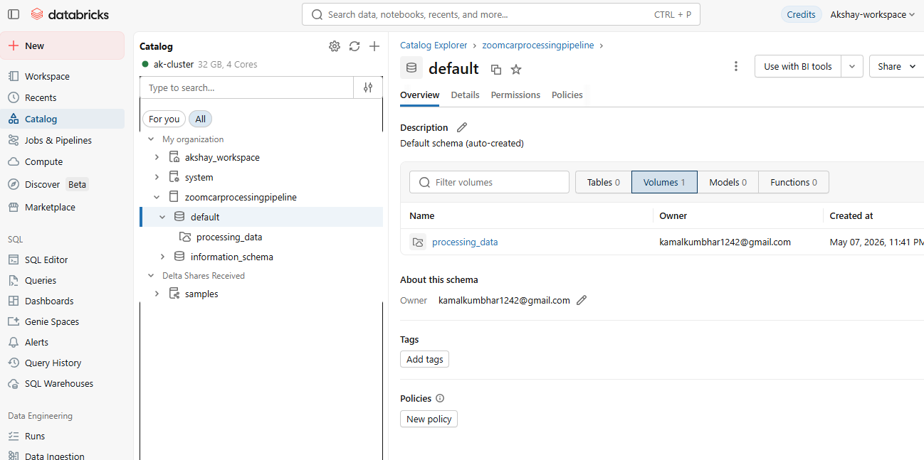
Create volumes -> (It will Create Subfolder and unity catlog metadata under bucket)
Create Directory – And place JSON files
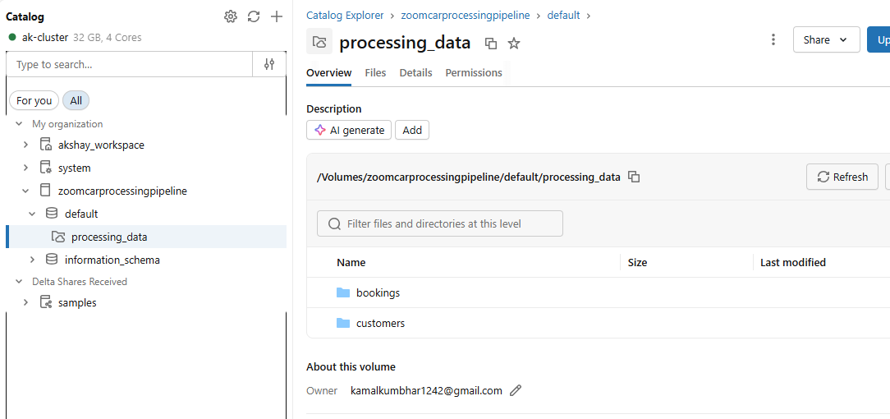
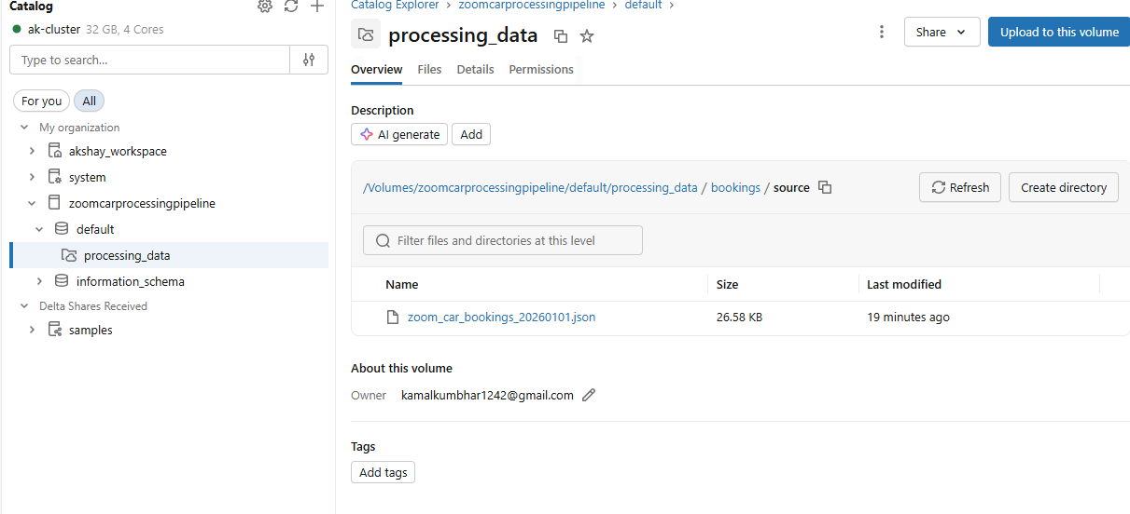
Creat Workspace -> Notebook 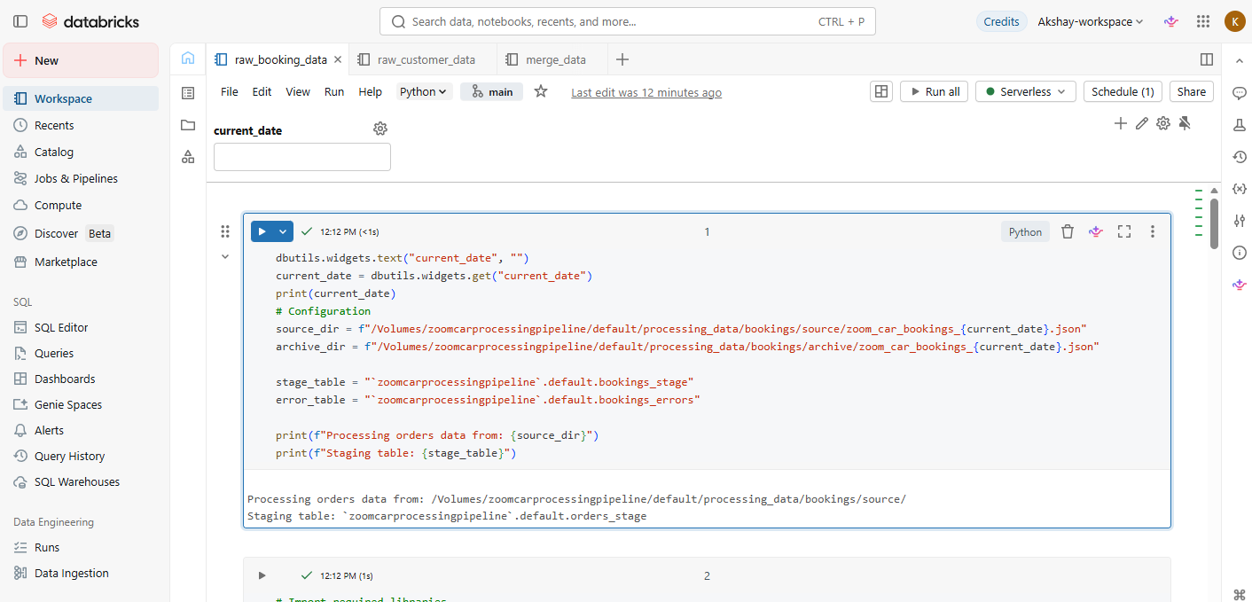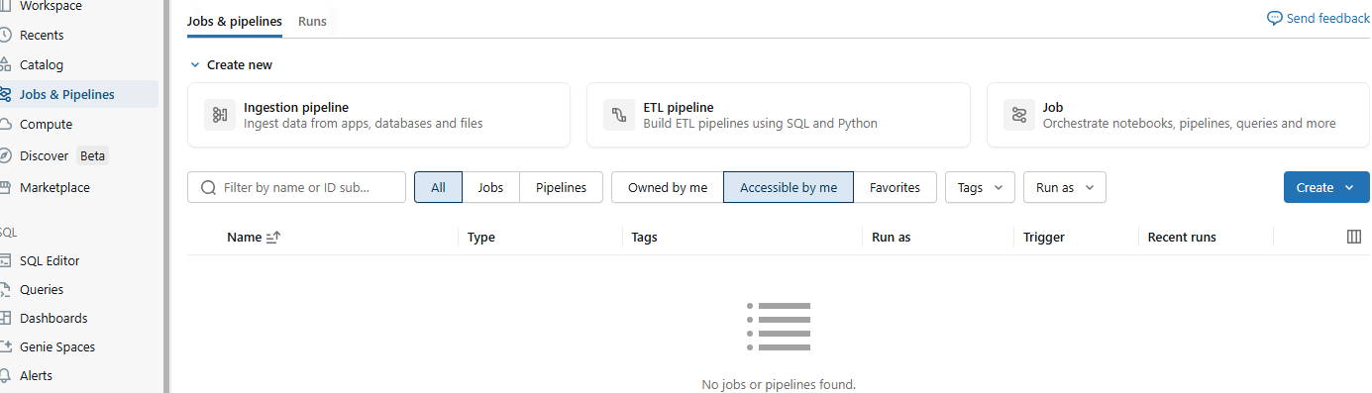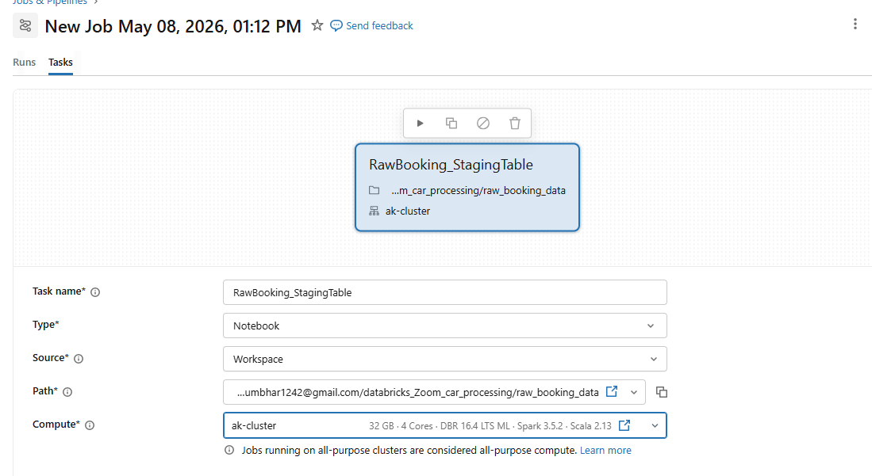
Parameterized PySpark Notebooks
○ Both notebooks should accept the current date as a parameter and
read the corresponding file: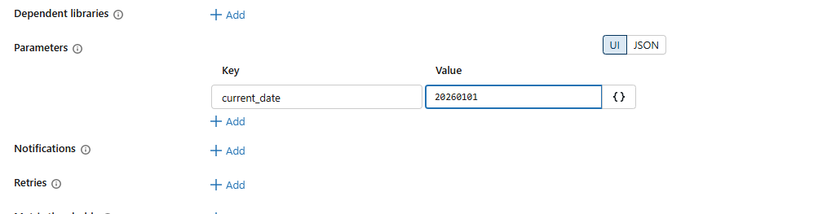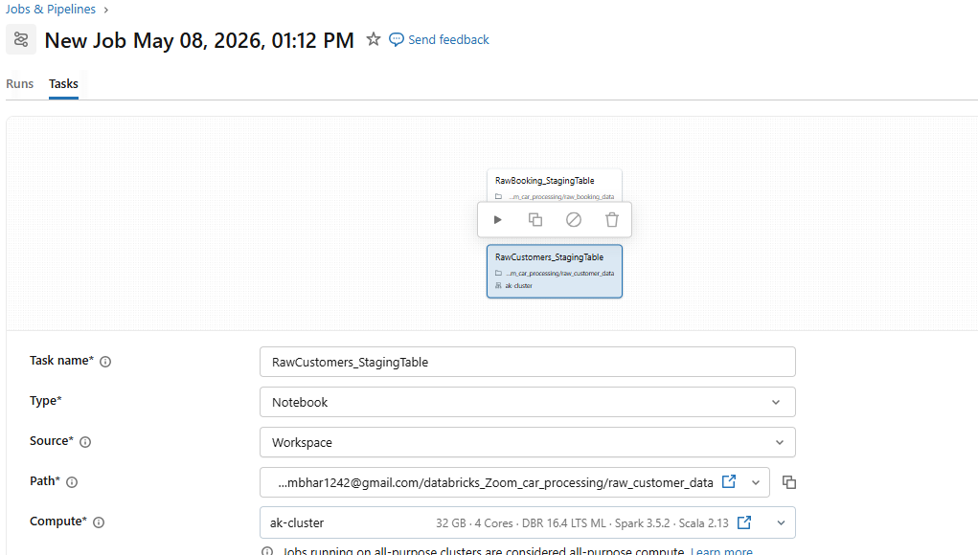

Create Job and Add Task for Each Notebook and Add dependecy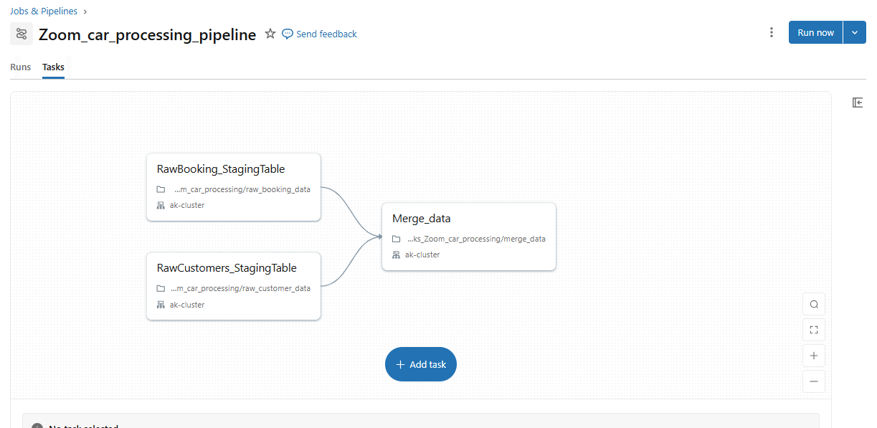
Run the Job 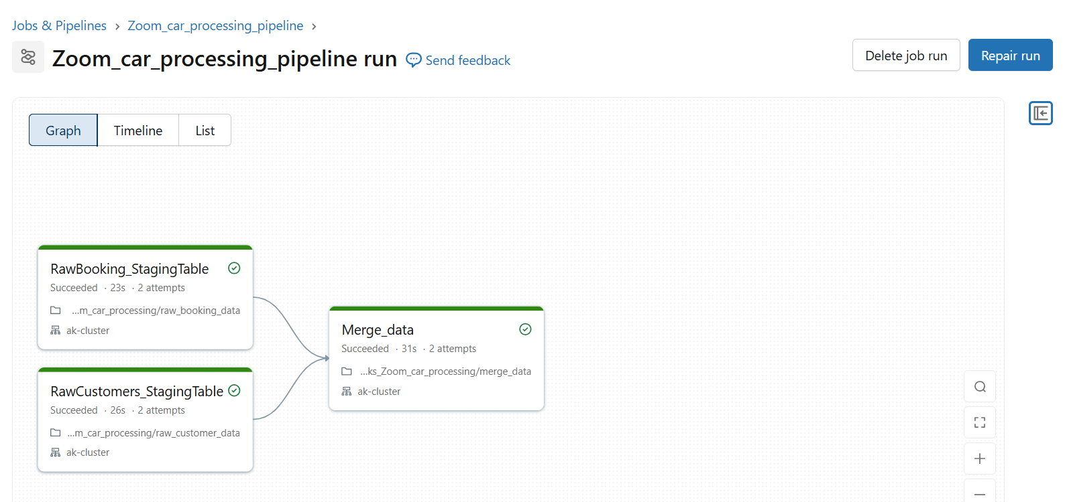
Verify Staging delta table and Target delta tables are created
Delta table = Parquet files + transaction log + data management features
Upserts & Deletes (MERGE support)