CO PROJECT REPORT

SafeFirst

*(A Women Safety Device)*



Aakash Deep (2015001)

Akarsha Sehwag (2015010)

Anannya Uberoi (2015014)

Y S Ramya (2015117)

Sarthak Jindal (2015169)

# 

# 

# PROJECT SCOPE

When you are faced with immediate danger, you need more than one way of alerting your close ones that you need help. And when you are in panic dealing with getting out of the situation , you don’t have time finding the phone or when you are in face to face with the person putting you in danger, you cannot access your phone.

Security Devices like this are more than just a panic button, your alert can be sent discreetly just by the push of a button.

# COMPONENTS

The components used are:

* 8051 Microcontroller
* MAX-232
* GPS Module
* GSM Module
* Push Button
* Power Supply

The project uses an 8051 microcontroller as the main hardware component. Within it, the various architectural components are:

* Interrupts
* TX/RX pins
* Data Bus
* Address Bus
* Timer Delay
* Crystal Oscillator
* CPU

# 

# 

# DESIGN

The project aims to implement a personal protection device which can be used particularly by women or children to enforce safety in case of emergency situations. The device prototype could be extended to a miniature safety gizmo which could be clipped to jeans, belts or handbags when it is difficult and time consuming to access the phone.

Intruder → Tap the device (or carry out a pre-defined custom gesture) → Signal sent to app → Message sent to 5 emergency contacts or 5 nearest police stations

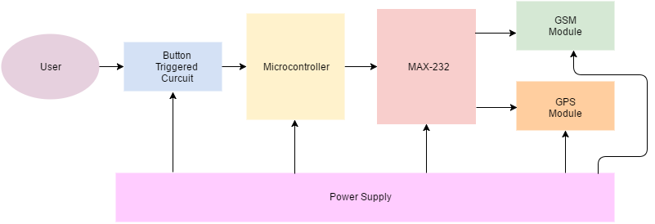

(Block Diagram Interface)

# 

# 

# 

# INTERFACING DIAGRAM

# 

# MILESTONES

Milestones of our project:

1. Firstly, figuring out how should we go about the project, all the steps and components which would be needed to make it upto our expectations.
2. Making the GSM module work.
3. Debugging our code.
4. Setting up Baud-rate for GPS receiver.

# SOURCE CODE

#include <reg51.h>

unsigned char *command_CMGF="AT+CMGF=1\r",*command_CMGS;

unsigned char *message="SAFETY BUTTON PRESSED!!!\n\n";

unsigned char CTRLZ =0x1A,ch,LAT[82];

sbit led_pin=P2^0;

void delay(unsigned int msec)

{

int i,j ;

for(i=0;i<msec;i++)

for(j=0;j<1200;j++);

}

void sendcommandcharbychar(unsigned char ch)

{

SBUF=ch;

while(TI==0); //wait until the char is sent and TI is set to 1

TI=0; // set TI back to 0

}

void sendcommand(unsigned char *p)

{

unsigned char *temp=p;

while(*temp!=0x00)

{

sendcommandcharbychar(*temp);

temp++;

}

}

void GSM_write(unsigned char *command_CMGS)

{

sendcommand(command_CMGF);

delay(1000);

sendcommand(command_CMGS);

delay(1000);

sendcommand(message);

sendcommand("GPS Location in NMEA Sentence:\n\n ");

sendcommand(LAT);

delay(100);

sendcommandcharbychar(CTRLZ);

delay(1000);

}

void send_messages()

{

command_CMGS="AT+CMGS=\"+919654309726\"\r"; //aakash

GSM_write(command_CMGS);

command_CMGS="AT+CMGS=\"+919958221803\"\r"; //sarthak

GSM_write(command_CMGS);

command_CMGS="AT+CMGS=\"9971408507\"\r"; //akarsha

GSM_write(command_CMGS);

command_CMGS="AT+CMGS=\"+918375895350\"\r"; //ramya

GSM_write(command_CMGS);

}

void init_gps()

{

TMOD=0x20; //Timer select mode2 (8 bit auto-reload)

TH1=0xfd; //the higher byte of timer1 is set for 9600 baud_rate

SCON=0x50; //mode1 8-bit UART to enable receiving of serial data;

TR1=1; //enable timer 1

IE=0x91;

EA=1;

}

void init_reset(){

TMOD = 0x20;

TH1 =0x00;

SCON= 0x00;

TR1 = 1;

IE=0x00;

EA = 1; //Enable Interrupt

EX0 = 1; //Enable External Hardware 0 Interrupt

IE0 = 0; //Clear ExHW0 Flag

IT0 = 1; //Choose Interrupt Type 0 for ExHW0

}

unsigned char recieve_data()

{

while(RI == 0);

ch = SBUF;

RI=0;

return ch;

}

void gps () {

unsigned char i,Temp;

Temp=recieve_data();

for(i=0;i<81 && Temp!=0x00 ;i++ ){

LAT[i]=Temp;

Temp=recieve_data();

}

LAT[i]=0x00;

}

void Interrupt_Service_Routine(void) interrupt 0

{

led_pin = ~led_pin;

init_gps();

gps();

TH1=0xf4;

send_messages();

init_reset();

}

void main(void)

{

init_reset();

while(1);

}

# CO CONCEPTS USED

* Hardware Interrupts
* Polling
* Flags
* Interrupt Service Routine (ISR)
* Timers
* Reset(Non maskable interrupt)
* Delay subroutines
* Direct Addressing
* Serial Communication
* Setting Baud Rate for different modules used(GPS,GSM)
* 8051 microcontroller

# RESULTS

Our code has been tested successfully. We were able make a prototype of the device which sends messages to the listed contacts just on the push of a button.

It was really fun working on the project. We got to learn about many things, GSM, GPS, interrupts and of course our 8051 microcontroller.