**COMPUTER ORGANISATION**

**EXPERIMENT 2  
ASSIGNMENT 1 (QUES 2)**

Aakash Deep (2015001)

Anannya Uberoi (2015014)

Akarsha Sehwag (2015010)

YS Ramya (2015117)

Sarthak Jindal (2015169)

# **OBJECTIVE**

To write a program to demonstrate the register banks and distinguish between byte addressing and bit addressing.

# **SOFTWARE REQUIREMENTS**

Keil Version 5.20.0.39

# **HARDWARE REQUIREMENTS**

None

**DESCRIPTION**

ORG 0000

MOV R0, #15H ; Stores 15H in R0 of Bank 0, byte addressing

SETB PSW.3 ; Switch to Bank 1

MOV R1, #10H ; Stores 10H in R1 of Bank 1

CLR PSW.3 ; Demonstrates bit addressing

SETB PSW.4 ; Switch to Bank 2

MOV R0, #20H ; Stores 20H in R0 of Bank 2

SETB PSW.3 ; Switch to Bank 3

MOV R0, #25H ; Stores 25H in R0 of Bank 3

END

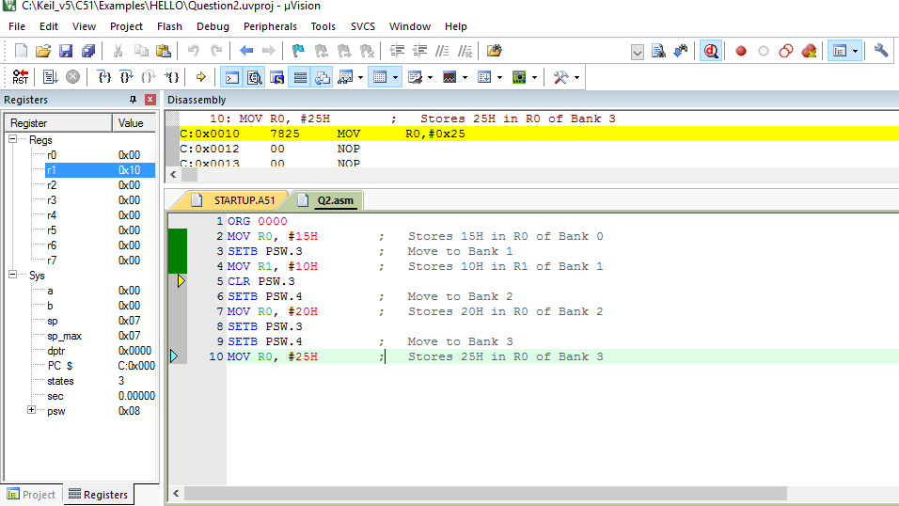

**BLOCK DIAGRAM / SCHEMATIC DIAGRAM**

None

**COMPONENTS**

None

**RESULT**

Register banks have been successfully demonstrated through a program.

**CONCLUSION**

We practically learnt that RAM has 4 register banks and 1 RAM which is Bit-Addressable. And register banks can be switched by changing the values of PSW.3 and PSW.4.

**REMARKS**

Different programs should be written and tested using assembly/C language for better understanding of the tool.