**COMPUTER ORGANISATION**

**EXPERIMENT 5  
ASSIGNMENT 1 (QUES 5)**

Aakash Deep (2015001)

Anannya Uberoi (2015014)

Akarsha Sehwag (2015010)

YS Ramya (2015117)

Sarthak Jindal (2015169)

# **OBJECTIVE**

To write a program to implement the arithmetic, logical and relational calculations by using 8051.

# **SOFTWARE REQUIREMENTS**

Keil Version 5.20.0.39

# **HARDWARE REQUIREMENTS**

None

**DESCRIPTION**

ORG 0000 ; Arithmetic Operations:

MOV A,#2H

MOV R0,#5

ADD A,R0

ADD A,#3

MOV B,#4

MUL AB ; The lower byte is stored in A and upper byte if any is stored in B otherwise B is cleared

SUBB A,#1 ;Value stored in A is subtracted by 1

INC A ;Value stored in A in incremented by 1

;Logical Operations:

CLR A

MOV A,#20H

ORL A,#21H ; OR operation

ANL A,#30H ; AND operation

CLR PSW.3

;Relational Operations:

MOV R1, #25H EQ #50H ; Boolean evaluates to 0 (FALSE). So 0 gets stored in R1

MOV R2, #22H <= #32H ; Boolean evaluates to 1 (TRUE). So 1 gets stored in R2

END

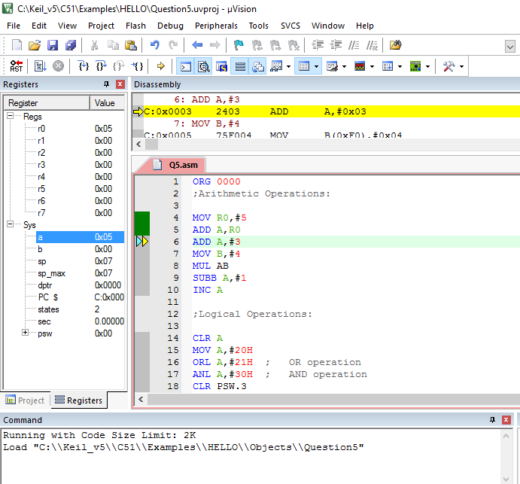

**BLOCK DIAGRAM / SCHEMATIC DIAGRAM**

None

**COMPONENTS**

None

**RESULT**

Arithmetic, logical and relational calculations have been demonstrated.

**CONCLUSION**

Different programs can be written, debugged and simulated using IDE. We learnt how to write a program implementing arithmetic and logical operations using a microcontroller.

**REMARKS**

Different programs should be written and tested using assembly/C language for better understanding of the tool.