**COMPUTER ORGANISATION**

EXPERIMENT 1  
ASSIGNMENT 1 (QUES 1)

Aakash Deep (2015001)

Anannya Uberoi (2015014)

Akarsha Sehwag (2015010)

YS Ramya (2015117)

Sarthak Jindal (2015169)

# OBJECTIVE

To demonstrate the organization of memory of 8051 with a program accessing every type of memory like stack, bit addressable memory, byte addressable memory, and special function registers etc.

# SOFTWARE REQUIREMENTS

Keil Version 5.20.0.39

# HARDWARE REQUIREMENTS

None

**DESCRIPTION**

ORG 0000

MOV R0, #20 ; Register access

MOV R1, #10 ; Byte addressable memory access

PUSH 00 ; Stores the decimal value 20 in the stack: stack

access

PUSH 01 ; Stores the decimal value 10 in the stack

POP 03 ; Stores the top of the stack (10) to R3

SETB 2AH ; Sets the D2 (2nd bit) of 25th register in the bit-addressable

; RAM to 1- Example of bit addressable

CLR P0.1 ; Puts 0 at 81 (of the bit addressable port 0)- Example of SFR

MOV DPTR, #4223H ; Moves the hex value 4223 to the DPTR (Which is an SFR):

; Example of SFR

MOV 31H, #50 ; Moves the decimal value 50 to 31H (A location in the

; scratch pad RAM)- Example of scratch pad RAM

SETB PSW.3 ; Accessing Bank 1 (Stack memory)

CLR PSW.4

MOV R3,#30 ; Stores the decimal value of 30 in R3 of bank 1

END

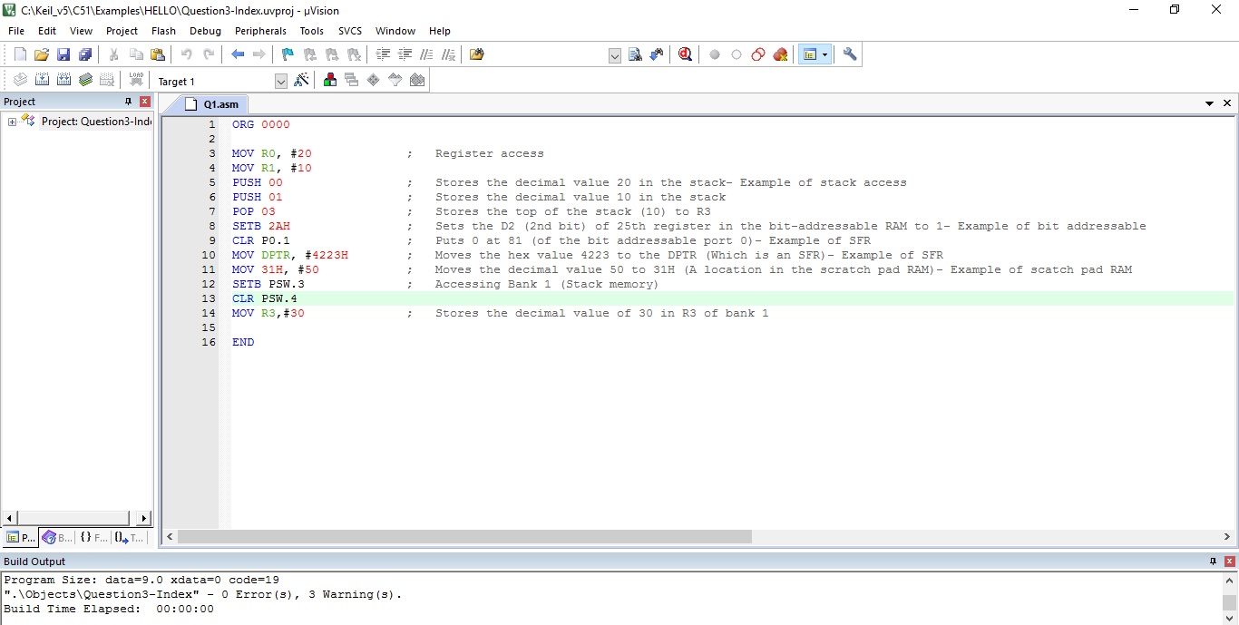

**BLOCK DIAGRAM / SCHEMATIC DIAGRAM**

None

**COMPONENTS**

None

**RESULT**

The organization of memory of 8051 has been successfully demonstrated with a program accessing various types of memory.

**CONCLUSION**

We learnt to write a program implementing byte addressable memory allocation , bit addressing memory allocation , stacks and special function register.

**REMARKS**

Different programs should be written and tested using assembly/C language for better understanding of the tool.