**COMPUTER ORGANISATION**

**EXPERIMENT 3  
ASSIGNMENT 1 (QUES 3)**

Aakash Deep (2015001)

Anannya Uberoi (2015014)

Akarsha Sehwag (2015010)

YS Ramya (2015117)

Sarthak Jindal (2015169)

# **OBJECTIVE**

To explain the use of various addressing modes with example programs.

# **SOFTWARE REQUIREMENTS**

Keil Version 5.20.0.39

# **HARDWARE REQUIREMENTS**

None

**DESCRIPTION**

**Immediate Addressing**

ORG 0000

MOV R3,#30H

MOV A,#51

**Indexed Addressing**

ORG 0000

MOV DPTR,#20H ;Direct addressing

MOVC A,@A+DPTR ;Indexed addressing

END

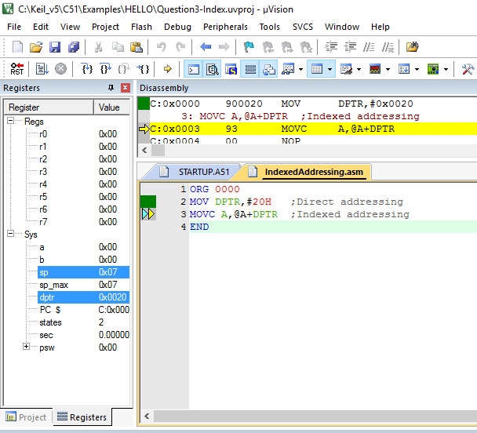

**Indirect Addressing**

ORG 0000

MOV R0,#20

MOV A,00

MOV R1,0E0H

END

**Direct Addressing**

ORG 0000

MOV R0,#20

MOV A,00

MOV R1,0E0H

END

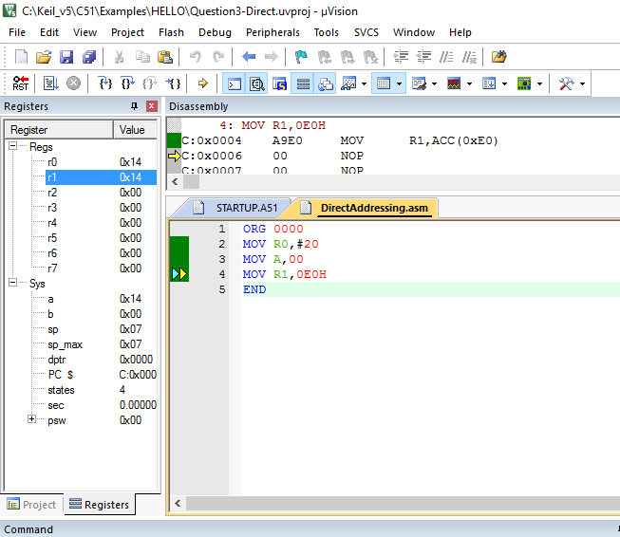

**Register Addressing**

ORG 0000

MOV A,#20H ;Direct addressing

MOV R4,#10H ;Direct addressing

MOV R3,A ;Register Addressing

MOV B,R4 ;Register Addressing

END

**BLOCK DIAGRAM / SCHEMATIC DIAGRAM**

None

**COMPONENTS**

None

**RESULT**

Various addressing modes have been demonstrated with example programs.

**CONCLUSION**

We learnt and practically implemented Register , Indexed and Immediate addressing modes. We learnt that in Register addressing a register contains the operand. In Indexed Addressing , we need to specify a base address then use the index to to access individual elements. In Immediate Addressing, the operand has a constant value or an expression.

**REMARKS**

Different programs should be written and tested using assembly/C language for better understanding of the tool.