LAB 9

BookMyShow

DESIGN PATTERNS

short line

# 

# System Functional Requirements

1. Visitor can Search Movies
2. Visitor can see the Movie Details
3. Visitor can see all the Show Details
4. Visitor can Sign Up
5. User can LOGIN
6. User can specify Number of Seats
7. User can Choose Seat Numbers
8. Payment and Ticket Booking should be done only after Login/Signup
9. Ticket Confirmation should be sent after payment.

# 

# 

# UML DIAGRAMS

Complete UML Diagram:

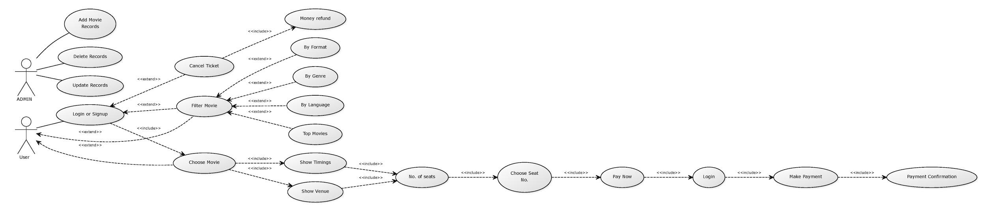

contd.



UML diagram for FilterMovie:

UML diagram for Choose Movie: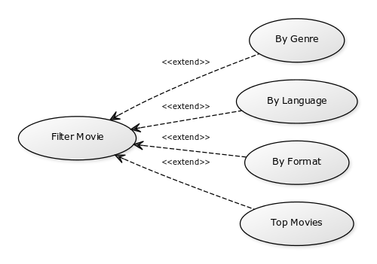

UML Diagram for Admin: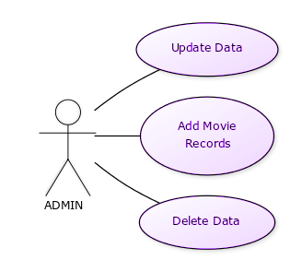

# CLASS DIAGRAM:

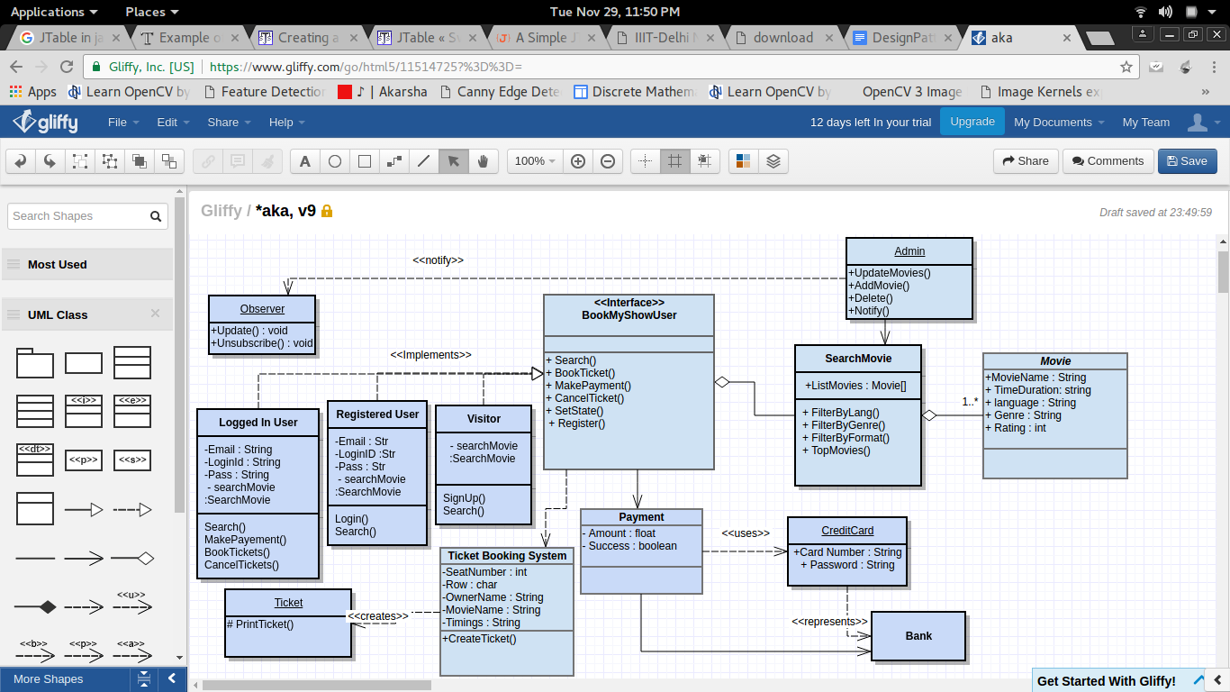

## 

## Design Patterns Used :

State Pattern : The states of the user

1. Logged In

2.Registered

3.Visitor

has been described using State patterns.

Observer Pattern : The User can subscribe onto a particular Movie, and whenever the movie is showing on the specified movie hall or on the specified timings, the observer will get notified by the admin.

Factory Pattern : The Ticket the user gets is being constructed by the constructor which is acting as a Black Box which on being specified with the Show timings, Date, and Movie Name gives you the ticket with the specified amount. It can be decoupled from the implementing system.

Proxy Pattern : For payment using the credit cards/ debit cards/ net Banking, the card acts as a proxy to the bank.

## 

short dash