SmartDoc Vision
  - A Computer Vision Based Document Scanner for Student Notes and Assignment Sheets
Bring Your Own Project (BYOP) - Computer Vision
Course | Computer Vision
Project Type | Classical Computer Vision Mini-Product
Tools Used | Python, OpenCV, NumPy, Pillow, Streamlit
Primary Use Case | Scanning notes, assignment sheets, and printed pages
This report documents the design, implementation, results, and reflections for a practical document scanning system built using core computer vision techniques.
Abstract
SmartDoc Vision converts casual photos of notebook pages, printed handouts, and assignment sheets into clean scan-like images. The system automatically detects the page boundary, corrects perspective distortion, enhances readability, and can merge multiple scanned pages into a PDF. The project deliberately uses explainable classical computer vision methods instead of heavyweight deep learning so that it remains lightweight, fast, and easy to demonstrate in an academic setting.

1. Introduction
Students frequently take photos of notes and assignment sheets instead of using dedicated scanners. Those photos often suffer from tilt, perspective distortion, background clutter, and uneven illumination. As a result, the images are difficult to read, archive, or submit online.
This project builds an end-to-end document scanner using classical computer vision. The aim is not to create a flashy demo only, but to solve a repeated and realistic problem from student life with a system that is understandable, efficient, and purposeful.

2. Problem Statement
The core problem addressed in this project is: how can a raw mobile image of a document be converted automatically into a cleaner, top-down, scan-like digital page?
The solution must detect the document, rectify the camera viewpoint, improve readability, and support practical usage such as multi-page PDF export.

3. Motivation and Real-World Relevance
The project is motivated by an everyday need. Students capture notebook pages, lab records, assignments, and printed notices using mobile cameras. A practical document scanner helps create better archives, cleaner submissions, and more readable study material.
This problem is also ideal for a Computer Vision BYOP because it combines image preprocessing, geometry, contour analysis, and enhancement in a single coherent pipeline.

4. Objectives
- Automatically detect the document boundary from an input image.
- Correct perspective distortion to obtain a top-down page view.
- Enhance the warped page so the output resembles a scanned document.
- Support both single-image and batch workflows.
- Export scanned pages into a single PDF for convenience.
- Keep the solution lightweight, explainable, and easy to run.

5. Mapping to Computer Vision Course Concepts
Course Concept | How it is used | Project Value
Preprocessing | Grayscale conversion and Gaussian blur reduce noise before detection. | Improves stability of the pipeline.
Edge detection | Canny highlights strong page boundaries. | Provides document evidence.
Thresholding | Otsu separates bright paper regions from darker backgrounds. | Adds robustness when edges alone are weak.
Contours | Contours are ranked and approximated to quadrilaterals. | Helps localize the page.
Perspective transform | Four detected corners are mapped to a rectangle. | Creates a scan-like top-down view.
Morphology + enhancement | Adaptive thresholding, CLAHE, and closing clean the output. | Improves readability and presentation quality.

6. System Pipeline
The complete workflow is shown below. The scanner combines edge-based and threshold-based document evidence, then rectifies and enhances the page.
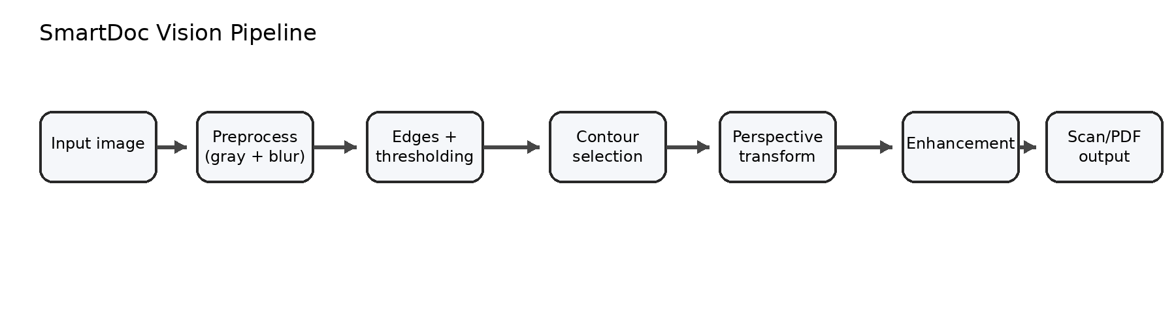
Figure 1. High-level processing pipeline for SmartDoc Vision.

7. Methodology
Each input image is first resized to a fixed height while preserving aspect ratio. This reduces computation and keeps contour analysis predictable.
The resized image is converted to grayscale and blurred. Two parallel signals are then produced: a Canny edge map and an Otsu-thresholded bright-region mask. Candidate contours from both representations are collected and ranked by area. The best document candidate is chosen by searching for a sufficiently large quadrilateral.
After the four page corners are identified, they are ordered consistently and passed through a perspective transform. The warped page is then enhanced using grayscale conversion, mild smoothing, CLAHE, adaptive thresholding, and morphological closing.

8. Design Decisions
A classical CV pipeline was chosen over deep learning because the problem is strongly geometric, the project must remain lightweight, and the resulting code should be easy to explain during evaluation or viva.
Combining edges and thresholding made the detector more stable. In early tests, edges alone sometimes captured text or noise, while thresholding alone could fail under poor contrast. The hybrid design improved overall reliability.

9. Implementation
The project is implemented in Python. OpenCV is used for image processing, NumPy for numeric operations, Pillow for PDF export, and Streamlit for an optional browser-based interface.
The main logic is separated into reusable modules. `document_scanner.py` holds the scanning pipeline, `pdf_utils.py` handles multi-page PDF export, `app.py` provides a command-line interface, and `streamlit_app.py` offers a simple user-facing demo interface.

10. Demonstration Results
The figure below shows a sample photographed page and the corresponding scan-like output produced by the system.
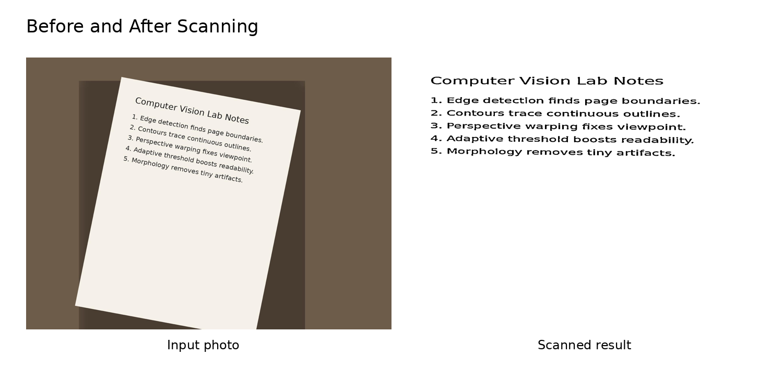
Figure 2. Example input image and output generated by the scanner.
Observed behavior
The system works well when the document occupies a clear region of the image, the page edges are visible, and the background contrasts reasonably with the paper. The debug mode saves intermediate outputs such as the edge map, contour overlay, warped page, and final binary scan, which are helpful for evaluation and explanation.

11. Challenges Faced
- False contour selection from text regions or textured backgrounds.
- Sensitivity to lighting and shadows in some images.
- Minor border artifacts introduced during perspective warping.

12. Limitations
- Assumes the target document is roughly rectangular.
- Can fail for extreme blur, occlusion, or very cluttered backgrounds.
- Does not yet perform OCR or page dewarping for curved sheets.

13. Future Improvements
- Manual corner correction UI for failure cases.
- OCR integration for searchable PDF output.
- Real-time webcam scanning and mobile deployment.
- Deep learning based document detector for harder scenes.

14. Learning Outcomes
- Built a complete vision pipeline instead of isolated experiments.
- Strengthened understanding of contours, homography, and enhancement.
- Learned how to balance robustness, simplicity, and usability in a real project.

15. Conclusion
SmartDoc Vision demonstrates that classical computer vision can still solve practical real-world problems elegantly. The system detects a photographed document, rectifies perspective distortion, enhances readability, and supports PDF export in a lightweight and explainable workflow.
This project is well aligned with the goals of BYOP because it addresses a real need, applies course concepts meaningfully, and produces a usable software artifact rather than a purely theoretical exercise.

16. References
Richard Szeliski, Computer Vision: Algorithms and Applications.
Rafael C. Gonzalez and Richard E. Woods, Digital Image Processing.
OpenCV documentation for contour detection, thresholding, and geometric transforms.

