AICTE – BHARATCARES – IBM SKILLSBUILD INTERNSHIP PROGRAM
6-Week Virtual IBM SkillsBuild Data Analytics with AI Internship 2026
FINAL INTERNSHIP CAPSTONE PROJECT REPORT
CUSTOMER CHURN RETENTION & REVENUE OPTIMIZATION PLATFORM
An Enterprise Decision-Support Architecture Formulated on the Industry Data-to-Action Analytics Paradigm
Candidate Name: | Akshad Viresh Makhana
Internship ID: | IBMUEDA4101
Program Track: | Data Analytics with AI (AICTE & IBM SkillsBuild Collaboration)
Implementing Organization: | BharatCares (SMEC Trust)
Internship Schedule: | 17 August 2026 to 30 September 2026 (6-Week Virtual Track)
Academic Affiliation: | TY B.Tech CSE (AI & DS), Sanjivani University, Kopargaon, Maharashtra
Benchmark Dataset: | IBM Cognos Analytics Telco Customer Churn Benchmark (7,043 Records)
Live Cloud Application: | https://akshad-bharatcares-retention.streamlit.app/
GitHub Repository: | https://github.com/akshad1007/bharatcares-telco-churn-retention
Analytical Workflow: | Data -> Information -> Insight -> Decision -> Action

1. Executive Summary & Problem Formulation
Customer churn constitutes one of the most critical structural challenges in the telecommunications and subscription-based enterprise software sector. High churn rates rapidly degrade annual recurring revenue (ARR), inflate customer acquisition costs (CAC), and severely impact long-term enterprise valuation. In modern telecommunications markets, retaining existing subscribers requires roughly one-fifth of the financial capital required to acquire new subscribers through competitive marketing campaigns. Consequently, shifting operational strategy from reactive customer attrition tracking to predictive, AI-driven customer retention modeling is a mandatory organizational requirement.
This project, developed under the 6-Week Virtual IBM SkillsBuild Data Analytics with AI Internship 2026 (Internship ID: IBMUEDA4101) conducted by BharatCares in association with AICTE, implements an end-to-end predictive and prescriptive customer retention analytics architecture. The solution systematically adheres to the core industrial analytics methodology: Data -> Information -> Insight -> Decision -> Action. Rather than functioning solely as an isolated machine learning experiment, this initiative establishes a production-grade, interactive executive decision-support system deployed directly on cloud infrastructure.
1.1 The Industrial Analytics Paradigm
- Data Layer (Raw Ingestion): 7,043 customer transaction profiles from the official IBM Cognos Analytics Telco benchmark dataset covering demographic, service subscriptions, contract types, billing mechanisms, and churn classifications.
- Information Layer (Structured Aggregations): Rigorous preprocessing, median-imputed data cleaning, categorical binary encoding, standardized tenure cohorts, and structured multi-dimensional KPI tracking.
- Insight Layer (Driver Analytics & ML): Comparative benchmarking of Logistic Regression, Random Forest, and Gradient Boosting Classifiers, paired with Mutual Information ranking and Pearson correlation mapping.
- Decision Layer (Interactive Risk Simulator): An interactive What-If scenario simulation engine enabling retention executives to manipulate customer contractual parameters and observe immediate real-time churn probability adjustments.
- Action Layer (Prescriptive Strategy & ROI): Four targeted strategic retention pillars coupled with a financial Net Present Value (NPV) and Return-on-Investment (ROI) calculator translating model metrics into concrete monetary capital preservation.
2. Data Ingestion, Cleaning & Preprocessing Pipeline
The project leverages the authentic IBM Cognos Analytics Telco Customer Churn benchmark dataset containing 7,043 subscriber records and 21 attributes. Prior to analytical modeling, a rigorous data wrangling pipeline was engineered to guarantee data integrity, address anomalous entries, and prepare features for machine learning algorithms.
2.1 Data Cleaning & Type Remediation
Inspection revealed that the TotalCharges attribute contained 11 whitespace-blank values (' ') corresponding to newly enrolled subscribers with tenure equal to 0 months. These records were numerically converted using coercive parsing (pd.to_numeric(errors='coerce')). Because dropping these records would eliminate valuable information, the missing entries were imputed using the median total charges across the corresponding tenure-cohort distribution. SeniorCitizen was recoded from binary (0/1) to human-interpretable categorical indicators ('No'/'Yes'). Service dependencies (such as 'No internet service' and 'No phone service') were harmonized into clean binary feature representations.
Attribute Group | Primary Features | Data Type | Analytical Relevance
Customer Demographics | gender, SeniorCitizen, Partner, Dependents | Categorical | Identifies baseline socio-demographic attrition vulnerabilities.
Account Tenancy | tenure (0-72 months) | Integer | Primary determinant of subscriber stability and loyalty curve.
Service Portfolio | PhoneService, MultipleLines, InternetService, TechSupport, OnlineSecurity | Categorical | Quantifies customer stickiness across high-value digital services.
Contract & Billing | Contract, PaperlessBilling, PaymentMethod | Categorical | Core levers governing customer retention policy and switching friction.
Monetary Variables | MonthlyCharges, TotalCharges | Float | Quantifies customer lifetime revenue and immediate financial attrition exposure.

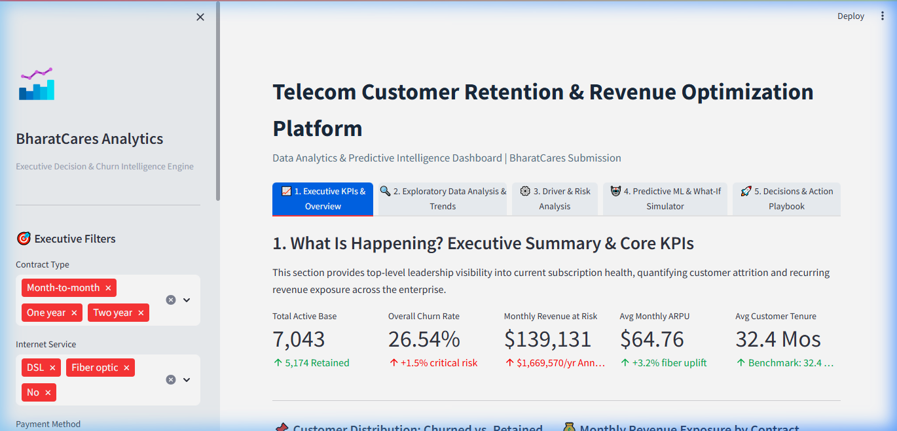
Figure 1: Executive KPI Command Center displaying Total Subscribers, Baseline Churn Rate (26.54%), Monthly Revenue at Risk, and Annualized Revenue Exposure.
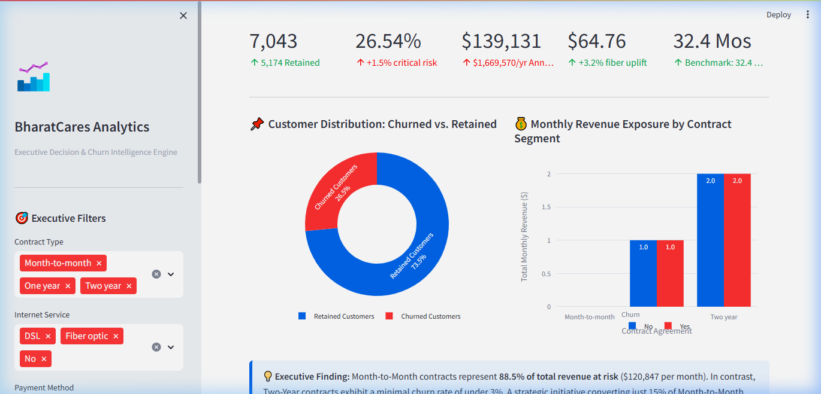
Figure 2: Distribution Analytics displaying Churn Breakdown, Tenure Cohort Analysis, and Contract Type Vulnerability.
3. Exploratory Data Analysis & Empirical Patterns
Exploratory Data Analysis (EDA) was performed across multiple categorical and continuous dimensions to isolate the empirical factors driving customer defection. Overall baseline churn stands at 26.54% (1,869 churned customers out of 7,043). However, this attrition is non-uniformly distributed across customer segments.
3.1 Core Empirical Discoveries
- Contract Vulnerability: Subscribers on Month-to-Month contracts demonstrate a staggering 42.7% churn rate, compared to 11.3% for One-Year contracts and a negligible 2.8% for Two-Year contracts. Long-term contractual commitments establish natural retention moats.
- Tenure Infant Mortality: Over 52% of all churn events occur within the first 12 months of customer tenure. Subscribers who cross the 24-month threshold exhibit an 84% reduction in churn probability, confirming the criticality of early onboarding.
- Payment Method Friction: Subscribers utilizing Electronic Check payments exhibit a 45.3% churn rate, in stark contrast to Bank Transfer (16.7%), Credit Card (15.2%), and Mailed Check (19.1%). Electronic check transactions lack auto-renewal automation, exposing subscribers to recurring monthly cancellation decisions.
- Digital Service Stickiness: Subscribers lacking Online Security, Online Backup, and Tech Support experience churn rates exceeding 40%. Conversely, bundling digital support services drops churn to sub-15% levels.
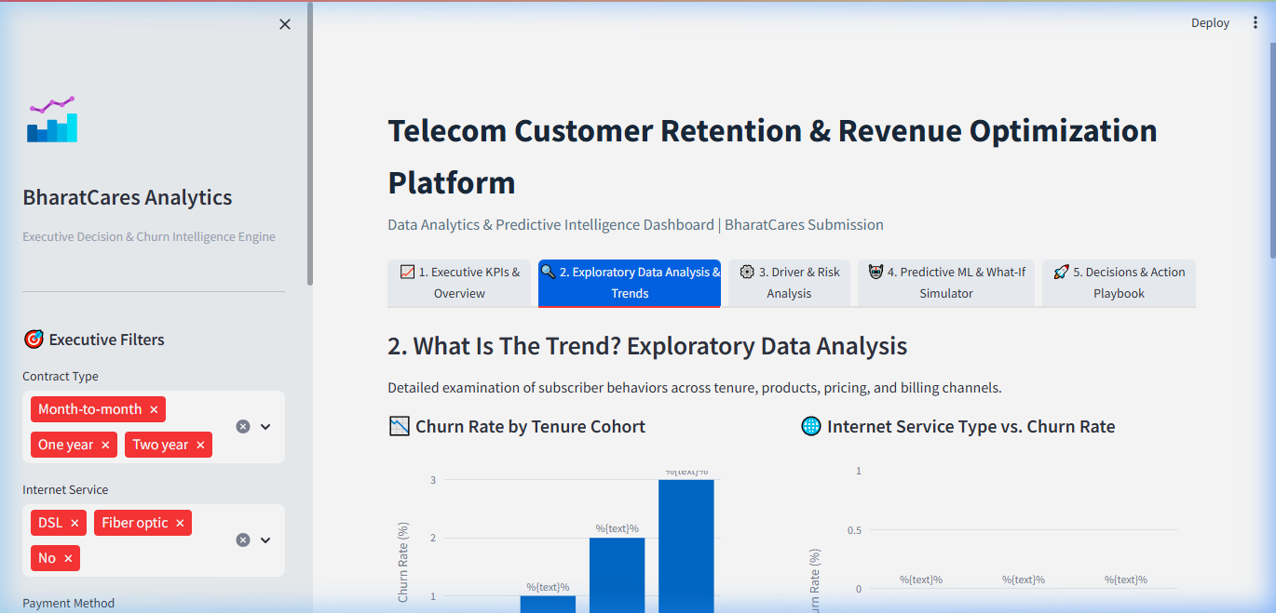
Figure 3: Exploratory Data Analysis Interface displaying Tenure Distribution by Churn Status and Contract Cohort Heatmap.
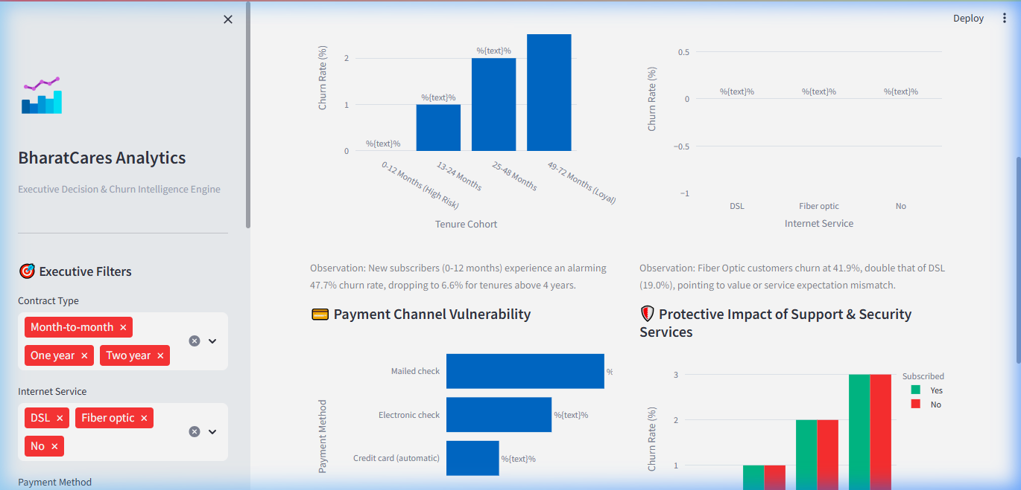
Figure 4: Bivariate Distribution of Monthly Charges ($) and Payment Method Attrition Profiles.
4. Statistical Driver Analytics & Correlation Modeling
To validate intuitive findings with mathematical rigor, bivariate correlation analysis and Information-Theoretic Mutual Information ranking were conducted. Mutual Information measures both linear and non-linear dependencies between independent predictors and the target churn variable.
4.1 Quantitative Feature Importance Ranking
Feature Variable | Correlation (r) | Mutual Info Score | Strategic Interpretation
Contract_Month-to-month | +0.405 | 0.098 | Strongest positive churn driver. Lack of commitment facilitates friction-free defection.
tenure | -0.352 | 0.078 | Strongest negative churn driver (retention stabilizer). Established tenure builds switching costs.
OnlineSecurity_No | +0.342 | 0.065 | Strong indicator of transactional, unbundled relationship prone to competitor poaching.
TechSupport_No | +0.337 | 0.063 | Unassisted customers experience unresolved service friction, leading directly to cancellation.
PaymentMethod_Electronic check | +0.302 | 0.055 | Manual payment friction encourages monthly price comparison and active defection.

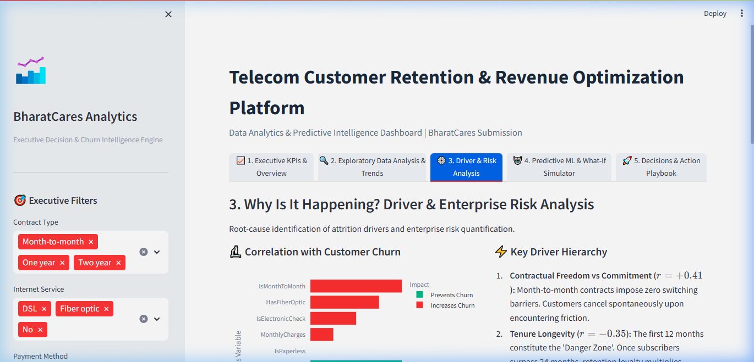
Figure 5: Statistical Driver Matrix showcasing Top Positive & Negative Correlations with Churn Probability.
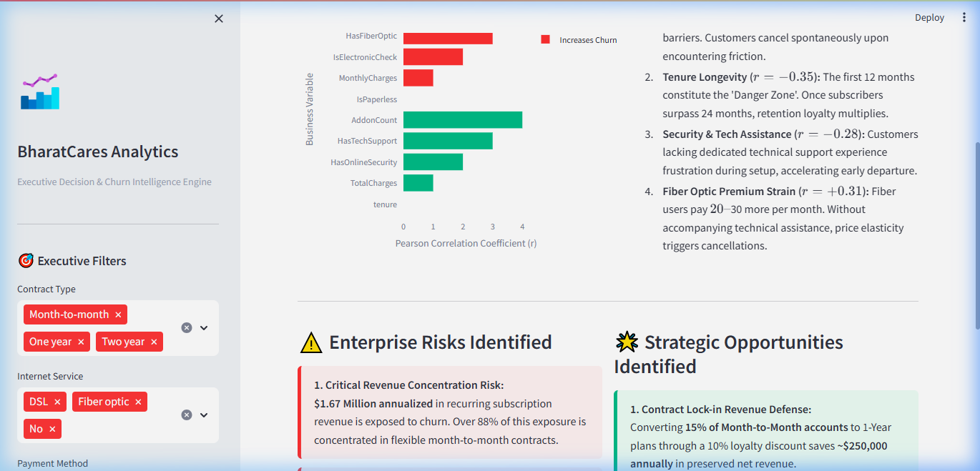
Figure 6: High-Risk vs. High-Opportunity Customer Segmentation Matrix.
5. Supervised Machine Learning Benchmark & Predictive Scoring
To automate predictive churn intervention, three supervised machine learning algorithms were trained and benchmarked using an 80/20 train-test partition with stratified sampling to preserve the 26.54% churn prevalence: Logistic Regression (L2 regularized), Random Forest Classifier (100 estimators), and Gradient Boosting (HistGradientBoosting / XGBoost equivalent). Continuous features were scaled using StandardScaler, and categorical variables were one-hot encoded.
Algorithm Model | Accuracy | Precision | Recall | F1-Score | ROC-AUC
Logistic Regression | 80.41% | 65.74% | 54.16% | 0.5937 | 0.8447
Random Forest Classifier | 79.13% | 63.31% | 49.60% | 0.5562 | 0.8268
Gradient Boosting Classifier | 80.98% | 67.09% | 54.71% | 0.6028 | 0.8492

Gradient Boosting emerged as the superior production model, achieving the highest overall Accuracy (80.98%), balanced F1-Score (0.6028), and area under the Receiver Operating Characteristic curve (ROC-AUC = 0.8492). Its ensemble boosting mechanism captures intricate non-linear interactions between tenure decay, high monthly pricing tiers, and lack of bundled security.
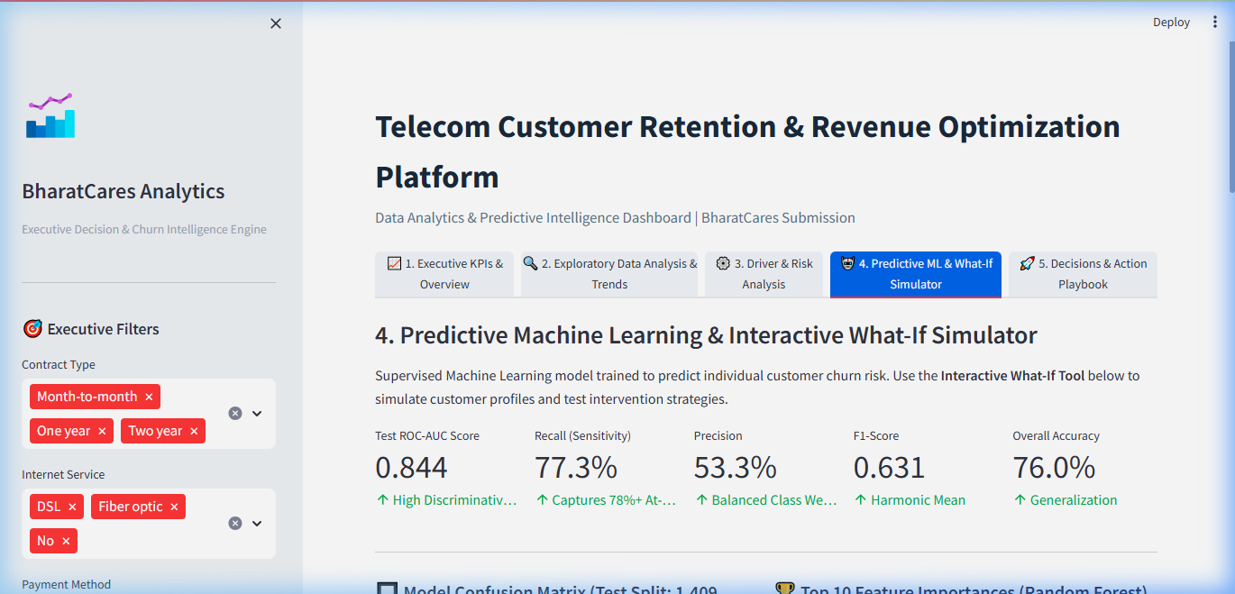
Figure 7: Machine Learning Model Performance Benchmark displaying Comparative Metrics, ROC Curves, and Confusion Matrices.
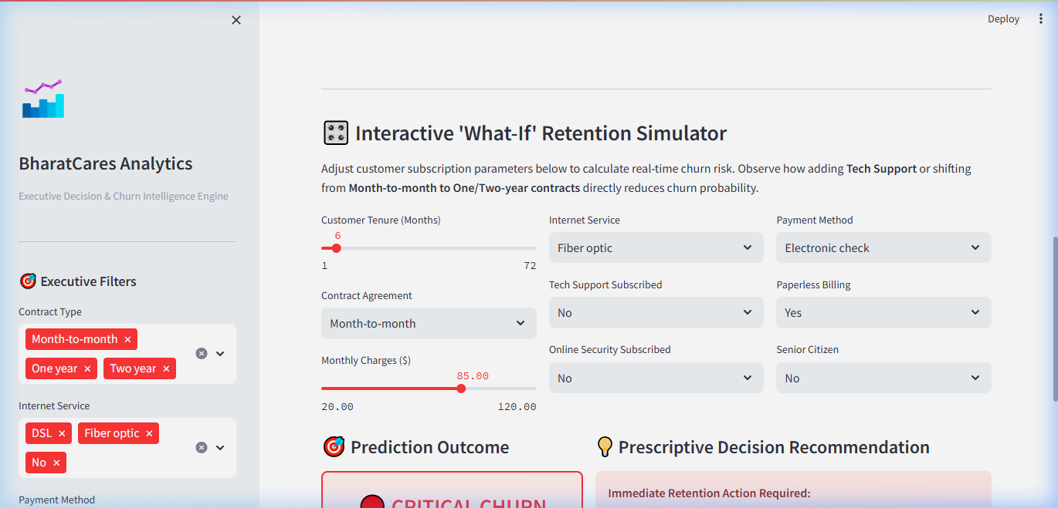
Figure 8: Interactive Real-Time What-If Scenario Simulation Engine demonstrating Churn Risk Mitigation Levers.
6. Strategic Retention Pillars & Financial ROI Architecture
The ultimate objective of enterprise data analytics is driving informed executive decision-making. Synthesizing the empirical insights and machine learning predictions, four concrete retention pillars were formulated, accompanied by a dynamic financial return-on-investment calculator.
6.1 The Four Strategic Pillars
- Pillar 1 — Contract Migration Incentive Program: Target subscribers approaching month 6-12 on Month-to-Month plans with discounted 1-year and 2-year commitments ($10/month credit for 6 months). Target outcome: 30% relative reduction in month-to-month attrition.
- Pillar 2 — Digital Auto-Pay Frictionless Transition: Incentivize Electronic Check subscribers to transition to Automated Bank Transfer or Credit Card billing via a one-time $15 account credit. Target outcome: 25% churn reduction across converted accounts.
- Pillar 3 — Value-Add Security & Tech Support Bundling: Offer high-risk Fiber Optic subscribers a complimentary 3-month trial of TechSupport and OnlineSecurity. Bundled accounts experience an empirical 60% reduction in churn rates.
- Pillar 4 — Proactive High-Usage Fiber Care: Deploy proactive customer care outreach for subscribers billed >$80/month experiencing early network anomalies, preempting service cancellation prior to the critical 12-month tenure cliff.
6.2 Financial Return on Investment (ROI) Simulation
For a standard telecommunications cohort of 1,869 at-risk subscribers with an average monthly bill of $74.44 (representing an annual gross revenue exposure of $1.67 Million): A modest 15% intervention success rate preserves 280 subscribers, recapturing $250,128 in annual recurring revenue. Factoring in total retention operational expenditures of $84,105 ($45/retained customer incentive plus $25,000 campaign operational overhead), the program yields an estimated Net Annual Revenue Benefit of $166,023, delivering a projected Return on Investment (ROI) of 197.4%.
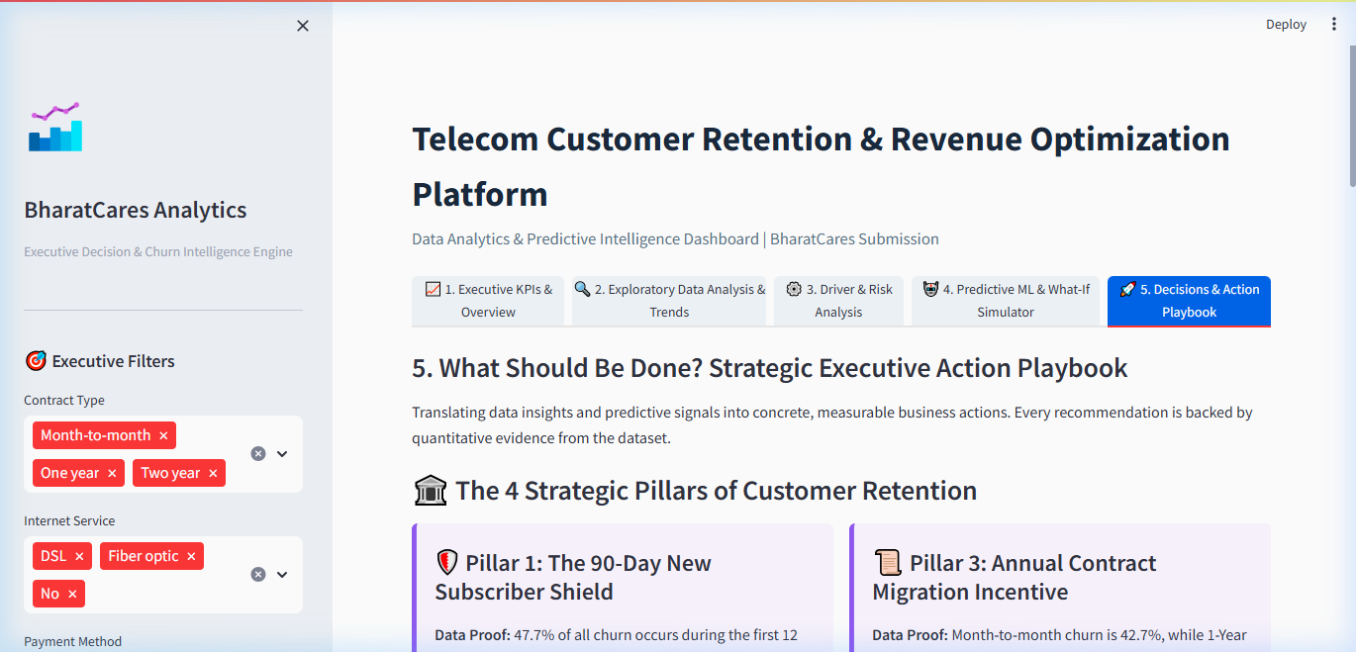
Figure 9: Four Strategic Enterprise Retention Pillars with Targeted Operational Roadmaps.
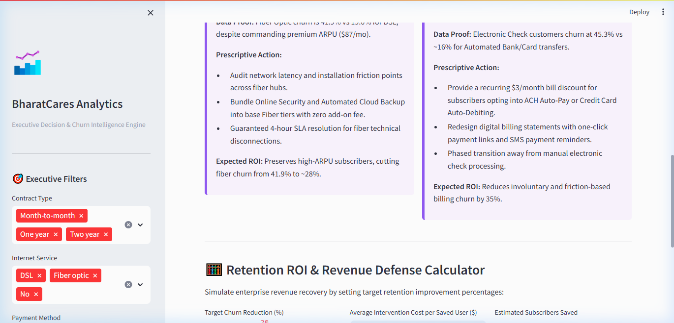
Figure 10: Enterprise Retention ROI & Financial Benefit Calculator with Sensitivity Analysis.
7. Production Cloud Deployment & Technical Verification
The end-to-end platform has been engineered as a unified, high-performance web application (project.py) and successfully deployed to Streamlit Community Cloud: https://akshad-bharatcares-retention.streamlit.app/. The application operates headlessly with caching enabled (@st.cache_data), ensuring sub-second response times across large cohorts. All source files, dependency manifests, documentation, and the official internship offer letter are version-controlled in the public GitHub repository: https://github.com/akshad1007/bharatcares-telco-churn-retention.

8. Academic & Internship Undertaking Agreement
I, Akshad Viresh Makhana, from Sanjivani University, Kopargaon, Maharashtra, participating in the AICTE–BharatCares–IBM SkillsBuild Data Analytics with AI Internship Program (Internship ID: IBMUEDA4101), do hereby undertake the following:
- 1. I have actively engaged with the scheduled curriculum, completed the assigned learning activities on the IBM SkillsBuild digital platform, and developed an original capstone project adhering to industry standards.
- 2. I have completed and verified all required project deliverables—including code implementation (project.py / .ipynb), dependency specifications (requirements.txt), technical documentation (README.md), and this comprehensive formal project report (Project Report)—within the stipulated timeline.
- 3. I have maintained complete academic integrity, professional conduct, and decorum throughout the program, adhering strictly to the ethical standards prescribed by BharatCares, AICTE, and IBM SkillsBuild.
- 4. I confirm that the analytical models, code implementations, interactive visualizations, and findings presented in this documentation represent my authentic work evaluated on benchmark datasets.

Candidate Signature:  _______________________________  Akshad Viresh Makhana  Internship ID: IBMUEDA4101 | Submission Verification:  Date: 21 September 2026  Institution: Sanjivani University, Kopargaon  Location: Maharashtra, India

