ARC – ADAPTIVE RETAIL COMPANION: DESIGN AND SIMULATION-BASED EVALUATION OF A RETROFIT AUTONOMOUS SHOPPING CART

Project report submitted
in partial fulfilment of the requirements for the degree of

Bachelor of Technology in Mechatronics and Automation Engineering

by
Akshada Raghuvanshi (23BMH1110)
Manav Harish Kriplani (23BMH1084)



SCHOOL OF MECHANICAL ENGINEERING
VELLORE INSTITUTE OF TECHNOLOGY
CHENNAI

October, 2026



DECLARATION

We, Akshada Raghuvanshi (23BMH1110) and Manav Harish Kriplani (23BMH1084), B Tech Mechatronics and Automation Engineering, VIT Chennai, hereby declare that the work being presented in the dissertation entitled “ARC – ADAPTIVE RETAIL COMPANION: DESIGN AND SIMULATION-BASED EVALUATION OF A RETROFIT AUTONOMOUS SHOPPING CART” is an authentic record of the work that has been carried out at VIT, Chennai under the guidance of Dr. T. Christo Michael, School of Mechanical Engineering, VIT Chennai.

We hereby declare that the entire work embodied in this dissertation has been carried out by us and no part of it has been submitted for any degree or diploma of any institution previously.

Place: Chennai
Date:

Akshada Raghuvanshi (23BMH1110):

Manav Harish Kriplani (23BMH1084):

CERTIFICATE

This is to certify that the project report entitled “ARC – ADAPTIVE RETAIL COMPANION: DESIGN AND SIMULATION-BASED EVALUATION OF A RETROFIT AUTONOMOUS SHOPPING CART” submitted by Akshada Raghuvanshi (23BMH1110) and Manav Harish Kriplani (23BMH1084), for the award of the degree of Bachelor of Technology is a record of bonafide work carried out by them under my supervision, as per the VIT code of academic and research ethics. The contents of this report have not been submitted and will not be submitted either in part or in full, for the award of any other degree or diploma in this institute or any other institute or university. The report fulfils the requirements and regulations of VIT and in my opinion meet the necessary standards for submission.

Signature of the Guide:
Name: Dr. T. Christo Michael
Date:

Signature of the Examiner-1 Signature of the Examiner-2
Name: Name:
Date: Date:

Approved by
Head of the Department

ABSTRACT

ARC (Adaptive Retail Companion) is a modular kit that retrofits a conventional supermarket cart into an assistive robot for elderly and mobility-impaired shoppers. This project evaluated ARC's ROS 2 navigation stack (RTAB-Map with lidar ICP odometry, a Dijkstra global planner, a TEB-like local controller and a behaviour tree) in a Gazebo store model under a baseline-first protocol. The median localisation error was 2–3 cm. The original stack completed 29 of 30 shopping missions but needed 97 recoveries; all 62 controller aborts came from Nav2's default progress check, which a kinematic calculation shows a slow cart cannot always satisfy after an in-place turn. Ordering the list by path cost with the exact Held–Karp solver cut driving time by 25–41%. Relaxing the progress check to 0.25 m in 20 s together with exact ordering completed all 30 lists in 26% less time and 38% less distance than the original stack (Wilcoxon p = 5.1×10⁻⁷). In a bench hardware-in-the-loop test, person detection on a Raspberry Pi 5 drove the behaviour tree and two real drive motors, and the wheels stopped within one 1 s telemetry period of every switch to WAIT. A web shopping interface was connected to the stack through a new ROS 2 bridge. A structural check of the CAD drive mount showed that its wheel bracket must be stiffened. Unmapped obstacles, a goal-reached race and cart-level testing remain open.

Keywords: Assistive robotics, Autonomous shopping cart, ROS 2 navigation, Route optimisation, Hardware-in-the-loop

ACKNOWLEDGEMENT

It is our pleasure to express with deep sense of gratitude to Dr. T. Christo Michael, <Designation>, School of Mechanical Engineering, Vellore Institute of Technology, Chennai, for his constant guidance, continual encouragement and understanding; more than all, he taught us patience in our endeavour. Our association with him is not confined to academics only, but it is a great opportunity on our part to work with an intellectual and expert in the field of autonomous mobile robotics.
It is with gratitude that we would like to extend our thanks to the visionary leader Dr. G. Viswanathan our Honorable Chancellor, Mr. Sankar Viswanathan, Dr. Sekar Viswanathan, Dr. G V Selvam Vice Presidents, Dr. Sandhya Pentareddy, Executive Director, Ms. Kadhambari S. Viswanathan, Assistant Vice-President, Dr. V. S. Kanchana Bhaaskaran Vice-Chancellor, Dr. T. Thyagarajan Pro-Vice Chancellor, VIT Chennai and Dr. P. K. Manoharan, Additional Registrar for providing an exceptional working environment and inspiring all of us during the tenure of the course.
In a jubilant state, we express our whole-hearted thanks to Dr. Karunamurthy K., Dean of School of Mechanical Engineering, Vellore Institute of Technology, Chennai, for spending their valuable time and efforts in sharing their knowledge and helping us in every aspect. Special mention also goes to Dr. Saravanakumar D, Head of the Department, B.Tech. Mechatronics and Automation Engineering and the Project Coordinators for their valuable support and encouragement to take up and complete the thesis.
My sincere thanks to all the faculties and staffs at Vellore Institute of Technology, Chennai who helped us acquire the requisite knowledge. We would like to thank our parents for their support. It is indeed a pleasure to thank our friends who encouraged us to take up and complete this task. We also acknowledge the open-source ROS 2, Nav2, RTAB-Map, Gazebo and Ultralytics communities. An AI assistant (Claude, Anthropic) helped write test software, analyse logs and draft text; all results come from our own logged experiments.
Place: Chennai
Date: Akshada Raghuvanshi (23BMH1110)
Manav Harish Kriplani (23BMH1084)
TABLE OF CONTENTS

Declaration i
Certificate ii
Abstract iii
Acknowledgement iv
List of Figures vii
List of Tables ix
List of Nomenclature x
List of Acronyms and Keywords xii
CHAPTER 1 1
INTRODUCTION
  - BACKGROUND 1
  - THE PROBLEM 1
  - THE PROPOSED SOLUTION 1
CHAPTER 2 3
REVIEW OF LITERATURE
  - ASSISTIVE SHOPPING ROBOTS AND RETROFIT PLATFORMS 3
  - MAPPING AND LOCALISATION 3
  - PLANNING, CONTROL AND ROUTE ORDERING 3
  - PERSON PERCEPTION AND BEHAVIOUR COORDINATION 4
  - RESEARCH GAP 4
  - SOCIETAL AND INDUSTRY SIGNIFICANCE 4
  - ALTERNATIVE TECHNOLOGIES AND PRELIMINARY COST-BENEFIT 5
CHAPTER 3 6
PROBLEM DEFINITION AND OBJECTIVE
  - PROBLEM DEFINITION 6
  - OBJECTIVES 6
  - SUSTAINABILITY GOAL 6

CHAPTER 4 8
METHODOLOGY
  - MATERIALS AND EQUIPMENT 10
  - SYSTEM ARCHITECTURE 11
  - SIMULATION ENVIRONMENT AND TEST PROTOCOL 13
  - MATHEMATICAL MODELS 16
  - SHOPPING INTERFACE AND UI–ROS BRIDGE 20
  - PERCEPTION AND HARDWARE-IN-THE-LOOP METHOD 20
  - MECHANICAL DESIGN AND STRUCTURAL ANALYSIS 20
CHAPTER 5 26
RESULTS AND DISCUSSION
  - LOCALISATION ACCURACY (A1) 26
  - MISSION RELIABILITY AND THE PROGRESS CHECK (A2) 27
  - LOCAL CONTROLLER COMPARISON (A3) 29
  - UNMAPPED OBSTACLES (A4) 30
  - WHEEL-ONLY ODOMETRY (B1) 30
  - SHOPPING-LIST ORDERING (C1, C2) 31
  - PHASE 2: PROGRESS CHECK AND EXACT ORDERING 33
  - BENCH HARDWARE-IN-THE-LOOP TEST 34
  - SHOPPING INTERFACE AND ROS LINK 37
  - PERSON DETECTION AND TARGET LOCK 38
  - MECHANICAL DESIGN AND STRUCTURAL CHECK 39
  - INTEGRATION-LEVEL FINDINGS 47
  - INNOVATION AND TECHNICAL DEPTH 47
  - COST-BENEFIT AND SUSTAINABILITY IMPACT 48
  - ENVIRONMENTAL AND SOCIETAL IMPACT 48
CHAPTER 6 50
CONCLUSION

REFERENCES 51
APPENDIX 57
LIST OF FIGURES

Figure No. | Title | Page No.
4.1 | Flow chart of methodology | 9
4.2 | ARC navigation pipeline; shaded boxes are ARC's own planning, control and mission components | 11
4.3 | Transform (TF) tree of the running stack, recorded with view_frames | 12
4.4 | ROS 2 node and topic graph of the running stack, recorded with rqt_graph | 13
4.5 | The compact store in Gazebo: three gondola units, produce display, tea and coffee shelf, dairy fridge, checkout counter and a shopper | 15
4.6 | Map built by RTAB-Map during the mapping drive, with the chain of map nodes along the driven route | 15
4.7 | Navigation view in RViz: inflated costmap, item locations by aisle and the planned path (yellow) to the current goal | 16
4.8 | CAD assembly of the ARC retrofit cart with the two drive modules at the front wheels | 21
4.9 | Quick-release drive mount: sleeve with the two spring latches (top), slider plate and wheel bracket (bottom) | 22
5.1 | Localisation error per configuration with ICP odometry (samples every 2 s) | 26
5.2 | Displacement achievable after an in-place turn at 0.10 m/s against the default and relaxed progress checks | 27
5.3 | Interactive shopping run: (a) planned path from the produce display to gondola 2 in RViz; (b) shopping manager log, from the second goal to 'shopping complete' | 28
5.4 | First localisation loss with wheel-only odometry (B1) | 31
5.5 | Offline route length relative to the exact optimum (C1, 50 lists per size) | 32
5.6 | Median mission time by ordering strategy and list size (C2) | 32
5.7 | Original stack (A2) and phase-2 variants on the same 30 lists: (a) first-attempt stops, (b) recoveries, (c) mission time | 34
5.8 | List-by-list mission time of each variant against the original stack | 34
5.9 | Bench set-up: laptop running the stack, Raspberry Pi 5 with webcam, Arduino Uno, two SmartElex drivers and two encoder motors | 35
5.10 | Bench session logged by the motor bridge (1 s samples): behaviour-tree mode, PWM and right-wheel speed | 36
5.11 | Shopping interface linked to the robot: live route order, behaviour-tree mode and event log (browser test against a simulated robot) | 38
5.12 | Perception bridge driving the simulated robot: (a) target locked, mode FOLLOW; (b) target left the camera view, lock lost, mode WAIT | 39
5.13 | Plan view of the retrofitted cart from the CAD assembly, with the measured dimensions, the centre of mass of the cart model and the spin envelope about the drive axle | 40
5.14 | SimScale von Mises stress in the slider and wheel bracket (legend in Pa) | 43
5.15 | The SimScale result re-plotted with the colour scale capped at 4.5 MPa, showing the peak at the root fillet and the support singularity | 44
5.16 | Independent finite-element model of the wheel bracket under the design wheel load (181 N at 71.7 mm offset) | 46

LIST OF TABLES

Table No. | Title | Page  No.
2.1 | Alternative technologies considered and the reason for ARC's choice | 5
4.1 | Equipment and software with specifications | 10
4.2 | Simulation test configuration | 13
4.3 | Navigation evaluation programme | 14
4.4 | Principal dimensions of the retrofitted cart, measured from the CAD assembly | 21
4.5 | Parts of one quick-release drive mount, from the STEP files | 23
5.1 | Controller comparison on 20 identical start–goal pairs (A3) | 29
5.2 | Outcome by number of boxes on the path (A4) | 30
5.3 | Original stack and phase-2 variants on the 30 A2 lists | 33
5.4 | Bench HIL measurements (16 October 2026) | 36
5.5 | Static wheel loads and stability of the loaded cart (m = 50 kg at the centre of mass of the cart model) | 41
5.6 | Store-map footprint check with the measured cart dimensions | 42
5.7 | Bracket under the SimScale load (10 N normal to the plate and 10 N in its plane) | 45
5.8 | Wheel bracket under the design wheel load (scikit-fem; stresses are the same in aluminium and steel) | 46
5.9 | Preliminary cost-benefit assessment | 48
A.1 | Parameters used in the calculations (M = measured or configured, A = assumed) | 59
A.2 | Mapping of the 60 interface products to store items | 59

LIST OF NOMENCLATURE

v, ω | Linear (m/s) and angular (rad/s) velocity of the robot
vᵣ, vₗ | Right and left wheel linear speeds (m/s)
B | Track width: distance between the driven wheels (m)
D, r_{w} | Wheel diameter and radius (m)
P_{w} | Encoder pulses per wheel revolution
s_{p} | Wheel travel per encoder pulse (mm)
N | Encoder pulses counted in one telemetry period
Δt | Telemetry period (s)
g(n) | Least accumulated path cost from the start cell to cell n (m)
c(p, n) | Cost of the grid edge from cell p to cell n (m)
d(Pᵢ, Pⱼ) | Shortest-path distance between stops i and j (m)
J(π) | Route cost of visiting order π (m)
C(S, j) | Held–Karp cost: least cost from P₀ through set S ending at j (m)
r, T | Progress-check radius (m) and time allowance (s)
ω_{max}, α_{max} | Turn-rate (rad/s) and angular-acceleration (rad/s²) limits
t_{delay} | Sensing, processing and actuation delay (s)
a_{b} | Braking deceleration (m/s²)
d_{stop} | Stopping distance (m)
m, g | Total moving mass (kg); gravitational acceleration (9.81 m/s²)
C_{rr} | Rolling-resistance coefficient
θ | Floor slope angle (°)
F, τ | Tractive force (N); wheel torque (N·m)
W_{pos}, W_{neg} | Wilcoxon signed-rank sums of positive and negative differences
|ω̇| | Mean absolute angular acceleration (rad/s²), a smoothness measure
b, t | Width and thickness of the bracket plate (mm)
Z, I | Section modulus (mm³) and second moment of area (mm⁴)
M, e | Bending moment (N·mm); lateral offset of the wheel load (mm)
F_{v} | Vertical wheel load on the drive mount (N)
K_{t} | Stress-concentration factor at the root fillet
c_{s}, θ_{p} | Guide clearance per side (mm); resulting rotational play (rad)
R | Turning radius of the drive-axle midpoint (m)
L_{wb}, B_{d} | Wheelbase and track of the drive wheels (mm)
l_{r}, h | Centre of mass ahead of the rear axle; height above the floor (mm)
φ_{lat}, a_{tip} | Sideways tipping slope (°); lateral acceleration to tip (m/s²)
l_{s}, d | Shaft overhang from the bracket face; shaft diameter (mm)
σ_{s} | Bending stress in the motor shaft (MPa)

LIST OF ACRONYMS AND KEYWORDS
ARC | Adaptive Retail Companion
BT | Behaviour tree
CAD | Computer-aided design
FEA | Finite-element analysis
HIL | Hardware-in-the-loop
ICP | Iterative closest point (lidar scan matching)
Nav2 | ROS 2 navigation framework
OSNet | Omni-scale network (person re-identification)
PWM | Pulse-width modulation
RPP | Regulated Pure Pursuit controller
ROS 2 | Robot Operating System 2
RTAB-Map | Real-Time Appearance-Based Mapping
SDG | Sustainable Development Goal
SLAM | Simultaneous localisation and mapping
STEP | Standard for the Exchange of Product model data (ISO 10303)
TEB | Timed elastic band
TF | ROS transform tree
UDP | User Datagram Protocol
UI | User interface
YOLO | You Only Look Once (object detector)

KEYWORDS
Assistive robotics, Autonomous shopping cart, ROS 2 navigation, Route optimisation, Hardware-in-the-loop

CHAPTER 1

INTRODUCTION

1.1 Background
Shopping is a routine task that many elderly and mobility-impaired people find tiring: pushing a loaded cart, walking between distant shelves and backtracking through aisles [47]. Service robots that anticipate the needs of older users are an active research area [41], and robotic shopping carts have been demonstrated for visually impaired [50] and elderly shoppers [32]. Most of these systems are purpose-built platforms. A retrofit kit, which adds drive, sensing and computing to the carts a store already owns, is attractive because it keeps the existing fleet and can be serviced as a module [49, 53]. Open-source robotics software now makes such a kit feasible for a student team: ROS 2 [17] and its navigation framework Nav2 [52] provide mapping, planning and control components, and lightweight detectors such as YOLOv8 run on single-board computers.
1.2 The Problem
Joining these components into a reliable assistive robot is harder than choosing each one. A shopping trip is a chain of goals: the item list must be turned into store locations, ordered, driven leg by leg and confirmed on arrival, while the robot keeps its position, avoids shelves and people, and stops when it loses its user. A fault at any interface, such as a default parameter, a missing recovery or a stale message, can stall the trip even when every module works on its own. These faults are rarely measured, because published shopping robots report demonstrations rather than repeated trials. The ARC cart hardware was also not complete during this project, so the navigation software had to be validated before it could be deployed. The problem is therefore to establish, with repeatable measurements, how reliably ARC's integrated software completes shopping trips, which parts limit it, and whether its commands drive real motors safely.
1.3 The Proposed Solution
ARC is a modular retrofit concept: a detachable two-wheel drive module mounted under a standard cart, with a lidar, a camera, an embedded computer and a touch interface. This project (i) designed the cart retrofit and a quick-release drive mount in CAD and checked them structurally; (ii) evaluated the complete ROS 2 navigation stack in a Gazebo model of a store under a baseline-first protocol, in which the unchanged stack is measured first and every candidate fix is then run on the same tasks and random seeds; (iii) derived engineering models (kinematics, encoder resolution, progress-check timing, stopping distance, drive torque and route-ordering complexity) and checked them against the measurements; (iv) tested the command chain on a bench with real drive motors and on-board person detection; and (v) connected the web shopping interface to the stack. The novelty is not a new algorithm but measured evidence: the faults that limit the system are traced to specific code and configuration, and the recommended fix is shown to complete every test list in about a quarter less time.
CHAPTER 2

REVIEW OF LITERATURE

The review covered four themes that ARC combines: shopping and retrofit robots, mapping and localisation, planning and route ordering, and person perception with behaviour coordination. Sources were peer-reviewed journal and conference papers, with preference for work published from 2019 onwards.
2.1 Assistive Shopping Robots and Retrofit Platforms
RoboCart guided visually impaired shoppers through a grocery store [50]; later carts added ROS-based deep-learning perception [58] and customer-oriented services [46]. Dedicated platforms carry the strongest field evidence: CompaRob assisted elderly users in real grocery stores [32], and Yao et al. tracked shoppers under shelf occlusion in a real supermarket with intersection-aware following [40]. Retrofit carts are older but less developed. Nishimura et al. attached a detachable drive and stereo sensor module to an ordinary cart [53], and Kohtsuka et al. added a driving unit and laser-based following [49]; neither reports map-based navigation of a shopping list. Retrofit autonomy is better established on wheelchairs, for example the modular RTAB-Map-based shared-control system of Ramaraj et al. [28] and detachable propulsion units for manual wheelchairs [11].
2.2 Mapping and Localisation
RTAB-Map is a graph-based SLAM library that supports lidar and visual inputs and long-term operation [13]. Lidar scan matching by ICP gives drift-limited odometry [25], whereas wheel odometry accumulates error without bound [65]. Reviews of localisation [24], visual SLAM [21, 35] and long-term mapping [33] stress re-localisation in changing, repetitive environments such as supermarket aisles. Lidar-inertial odometry [57] and multi-sensor 2D mapping [1] are the main alternatives.
2.3 Planning, Control and Route Ordering
Surveys of mobile-robot navigation separate global planning on a map from local control near obstacles [15, 16, 27, 39]. Dijkstra search returns a least-cost path on a weighted graph [6]. Nav2 provides the controller server, costmaps and behaviour-tree orchestration [18, 52]. Timed-elastic-band control optimises a short trajectory under kinematic limits [31, 55] and has been extended for cluttered spaces [38]; Li et al. fused Dijkstra with an improved TEB and reported a smaller turning radius [14]. Common alternatives are the dynamic window approach [8], its fuzzy variants [54] and Regulated Pure Pursuit [19]. Visiting a shopping list is a sequencing problem related to warehouse order picking [5, 29]. Nearest-neighbour ordering is not optimal in the worst case [30], 2-opt improves a tour without guaranteeing the optimum [4], and the Held–Karp dynamic program is exact for short lists [9]. Closest to this work, Choi et al. ordered supermarket items by Dijkstra distance with a genetic algorithm, in simulation and outside ROS [3].
2.4 Person Perception and Behaviour Coordination
Person-following robots have used stereo detection [56], RGB-D tracking [45, 51] and learned detectors with fuzzy or vision-based control [44, 59]. YOLO detectors are reviewed in [2, 7, 34, 42]; ARC uses YOLOv8n [70] with ByteTrack association [60] and OSNet appearance embeddings [61] for re-identification, a problem surveyed by Wei et al. [36]. Behaviour trees organise such reactive modes [10, 26, 43, 63]. Human-aware and crowd navigation remain open problems [12, 20, 22, 23], and safety requirements for personal care robots are set out in ISO 13482 [64].
2.5 Research Gap
Neither the retrofit cart nor shopping-list ordering is new, so this project claims measured evidence rather than a first. Within the literature reviewed, no study measures, inside a ROS 2 navigation stack, how reliably a retrofit cart completes shopping lists, how far simple ordering rules fall from the optimum, and whether the planned savings survive execution by the local controller. Integration-level faults, which decide whether a trip finishes, are also rarely reported.
2.6 Societal and Industry Significance
Retailers already own large cart fleets. A retrofit module that can be fitted to existing carts and serviced separately would let a store offer assisted shopping without buying new vehicles, and gives older and mobility-impaired customers more independence. Commercial smart carts such as Caper focus on item recognition and checkout rather than autonomous assistance, and are priced by quotation [67].
2.7 Alternative Technologies and Preliminary Cost-Benefit
Table 2.1 compares the alternatives considered for each subsystem. The chosen options are open source, run on low-cost hardware and can be tested in simulation before the cart is built, which suited a project whose sensors arrived late. A numerical cost comparison with commercial carts is not possible yet because ARC's bill of materials is not final and commercial prices are not public; the cost-benefit evaluation in Chapter 5 is therefore limited to measured benefits and qualitative costs.
Subsystem | Alternatives | ARC choice | Reason
Localisation | Gmapping & AMCL; ORB-SLAM2; LIO-SAM | RTAB-Map & lidar ICP | Open source; lidar and visual inputs; map locking and re-localisation
Global planning | A*; sampling planners | Dijkstra, 8-connected grid | Exact least-cost path; simple and transparent
Local control | DWA; RPP; MPC | TEB-like controller (Nav2) | Handles narrow aisles; 19/20 goals vs 13/20 for RPP
Route ordering | Typed order; nearest-next; genetic algorithm | Exact Held–Karp | Optimal; ≤ 4.8 ms for 12 stops
Person perception | Colour tracking; RGB-D tracking | YOLOv8n & ByteTrack | Runs on a Raspberry Pi 5 with a USB webcam
Mission logic | Finite-state machine | Behaviour tree | Modular reactive modes: LEAD, FOLLOW, WAIT
Table 2.1 : Alternative technologies considered and the reason for ARC's choice
CHAPTER 3

PROBLEM DEFINITION AND OBJECTIVES

3.1 Problem Definition
ARC's navigation software was assembled from separately developed modules, and its end-to-end reliability on shopping trips was unknown. The review shows that shopping robots are usually reported through demonstrations, that shopping-list ordering has not been measured inside a ROS 2 stack, and that integration faults are rarely traced. The cart hardware was also incomplete. The problem addressed is therefore: measure, repeatably and before deployment, how accurately ARC localises, how reliably it completes shopping lists, how its controller and route ordering perform, and how its commands act on real drive motors; identify the causes of failure; and test candidate fixes on the same tasks so that the recommendation rests on paired evidence.
3.2 Objectives
The objectives achieved through this project were:
- Evaluate ARC's ROS 2 navigation stack in simulation with a baseline-first protocol (localisation, mission reliability, controller, obstacles, odometry, route ordering).
- Diagnose integration-level faults, derive supporting engineering calculations, and test fixes on the same tasks and seeds.
- Validate the command chain on a bench with real motors and on-board person detection, and link the shopping interface to the stack.
- Design a quick-release drive mount for a standard cart, verify its strength and fit, and check the cart footprint against the store aisles.
3.3 Sustainability Goal
The objectives align with the United Nations Sustainable Development Goals [69] as follows. These are intended outcomes; only the route-distance saving has been measured, in simulation.
- SDG 3 – Good health and well-being: the cart reduces the physical effort of shopping for elderly and mobility-impaired users.
- SDG 9 – Industry, innovation and infrastructure: a retrofit kit upgrades existing carts instead of replacing the fleet.
- SDG 10 – Reduced inequalities: assisted shopping supports independent access to stores.
- SDG 12 – Responsible consumption and production: reusing carts avoids new vehicles, and optimised routes cut driven distance by 38% per trip in simulation, reducing drive energy.

CHAPTER 4

METHODOLOGY

The project followed the methodology shown in Figure 4.1. Work began with the problem definition and literature review, then split into a mechanical stream and a software stream. The software stream was evaluated in three phases: the unchanged stack was measured first, candidate fixes were then run on identical tasks, and the results were compared pair by pair. Perception, the bench hardware-in-the-loop test and the user-interface link were developed in parallel.
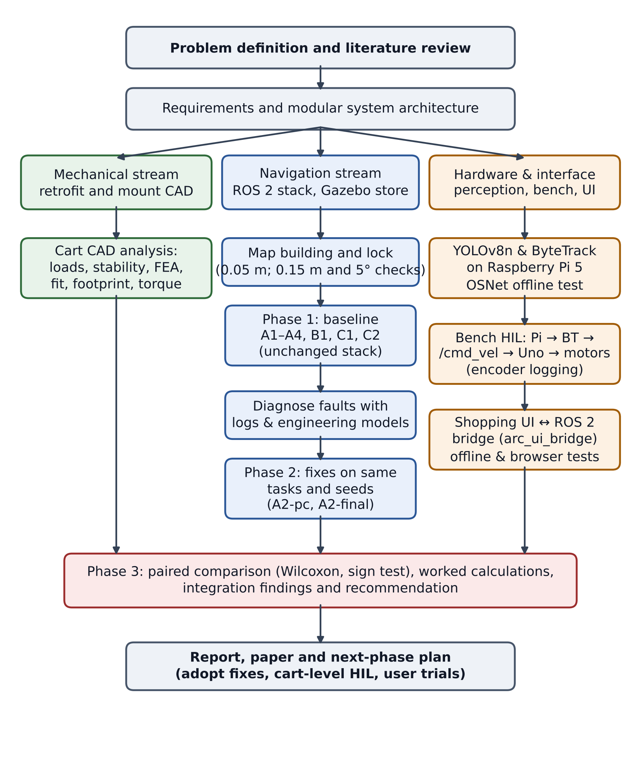
Figure 4.1 : Flow chart of methodology
4.1 Materials and Equipment
The materials and equipment used are listed in Table 4.1. The cart itself was a standard 180 L supermarket trolley (1000 × 610 mm); its retrofit was designed in CAD (Section 4.7). The drive motors were tested on 3D-printed bench mounts.
Item | Specification | Use
Navigation laptop | HP 14s, Ubuntu 24.04, ROS 2 Jazzy, Gazebo Harmonic | Simulation, stack, motor bridge, UI bridge
Embedded computer | Raspberry Pi 5, USB webcam, 5 V / 2.4 A supply | YOLOv8n & ByteTrack person detection
Microcontroller | Arduino Uno, 115 200 baud serial, 300 ms watchdog | PWM to drivers, encoder counting, E-stop input
Motor drivers | 2 × SmartElex 15S, PWM limited to ±60 of 255 | Drive the two DC motors
Drive motors | 2 × DC gear motor, Hall encoder, 7 pulses/rev, 30:1 | Bench drive with speed feedback
Bench wheel | Diameter 0.08 m, track 0.16 m | Bench geometry used by the bridge
Simulated robot | TurtleBot3 Burger, 2D lidar, radius 0.105 m | Stand-in for the cart in Gazebo
Software | RTAB-Map, Nav2, Python 3, Ultralytics YOLOv8n | Mapping, control, perception, analysis
CAD and FEA | SolidWorks 2026 (STEP AP214); SimScale linear static | Retrofit design; bracket stress
Geometry and FEA scripts | gmsh 4.15 (OpenCASCADE), scikit-fem 12, Python | Measurements, interference, bracket FEA
Table 4.1 : Equipment and software with specifications
4.2 System Architecture
Figure 4.2 shows the navigation pipeline. A 2D lidar feeds ICP scan-matching odometry [25], and RTAB-Map [13] builds a map and then localises against it. The Dijkstra planner computes the global path on the occupancy grid and replans every 2 s. A hand-over node passes the path to Nav2's controller server, which runs ARC's TEB-like controller. A motion gate scales the velocity command by the behaviour-tree mode (FOLLOW, WAIT, LEAD or emergency stop). The shopping manager sends one goal per item and waits for a 'goal reached' message.
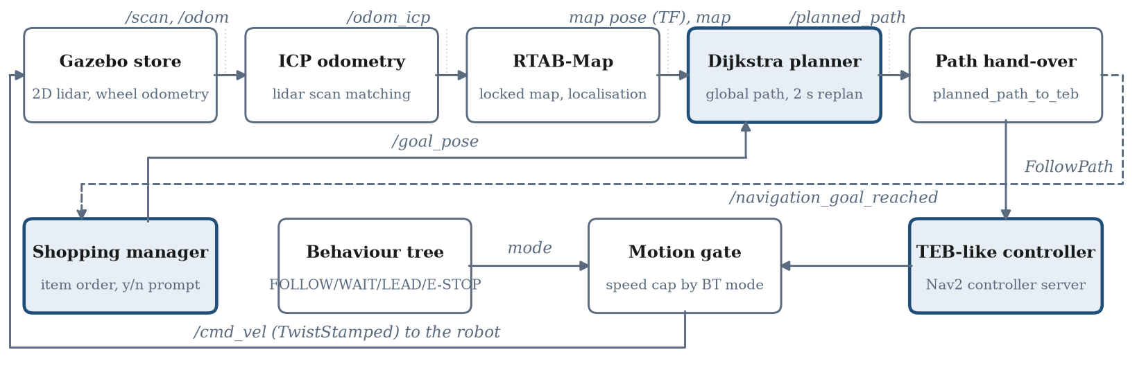
Figure 4.2 : ARC navigation pipeline; shaded boxes are ARC's own planning, control and mission components
Figure 4.3 shows the transform tree recorded with view_frames on the running stack. The chain runs map → icp_odom → odom → base_footprint → base_link, and the two wheel links, the caster, the IMU and the lidar frame (base_scan) hang from base_link. The map → icp_odom transform was published at about 20 Hz, icp_odom → odom at about 5 Hz and odom → base_footprint at about 50 Hz; the wheel links were updated at about 18 Hz, and the caster, IMU and lidar frames are static.
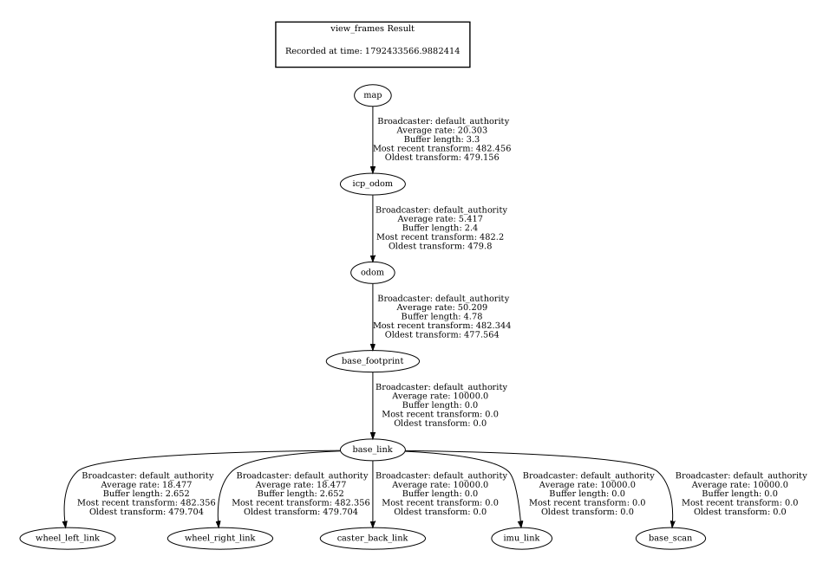
Figure 4.3 : Transform (TF) tree of the running stack, recorded with view_frames
Figure 4.4 shows the node and topic graph recorded with rqt_graph during a simulated run. It confirms the data flow of Figure 4.2: /scan feeds /icp_odometry and RTAB-Map; the Dijkstra planner reads /rtabmap/map, /tf and /shopping_goal and publishes /planned_path; planned_path_to_teb sends the path to the controller server through the follow_path action and publishes /navigation_goal_reached to the shopping manager; the controller's /cmd_vel_nav passes through arc_motion_gate, which publishes /cmd_vel to the Gazebo bridge. On the behaviour side, person_assistant_bt reads the person topics (/person_state, /person_moving, /person_confused, /emergency_stop) and publishes /arc/behavior_mode, /wait_for_person and /emergency_stop_active. In this run the person topics came from a test input node (person_state_input) rather than the camera.
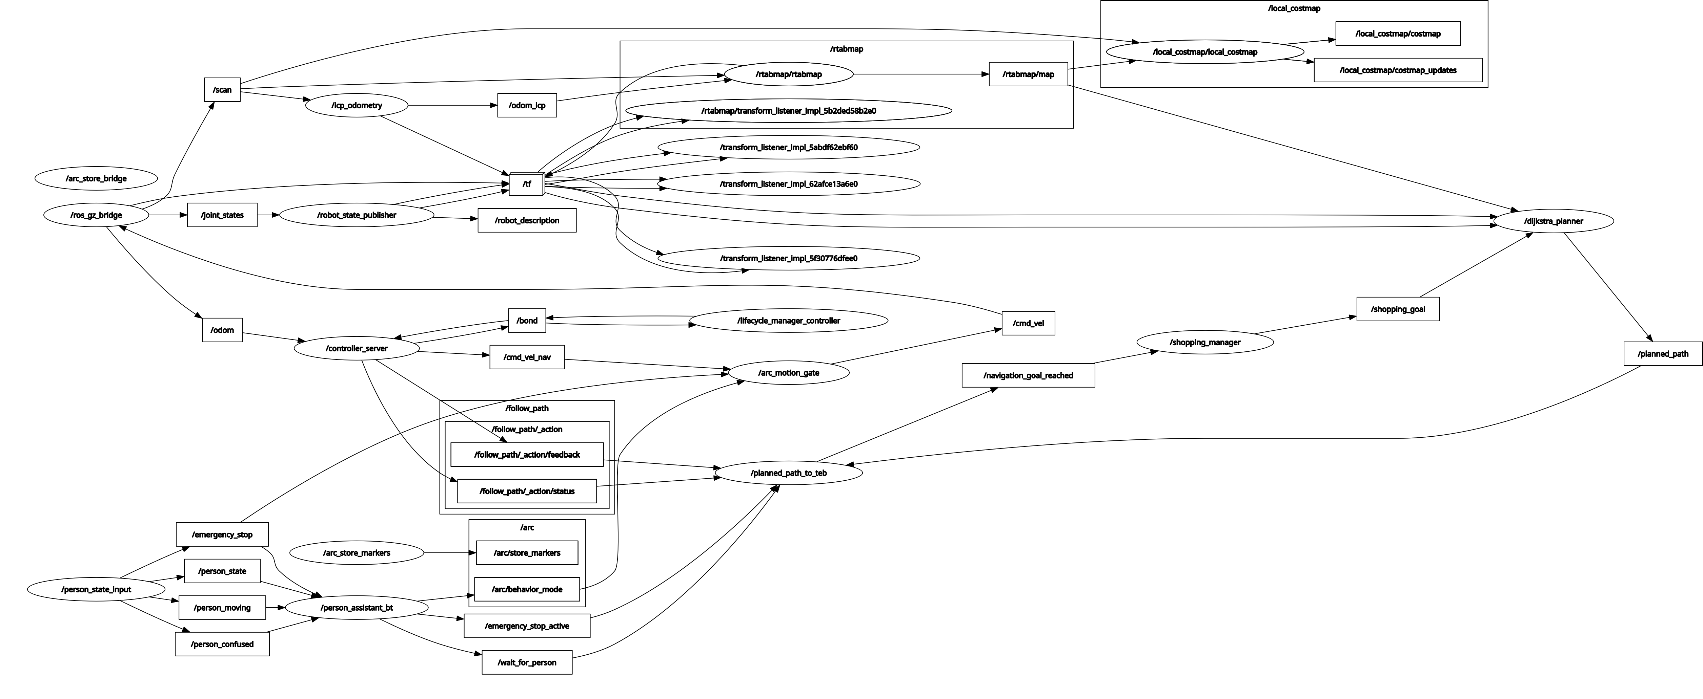
Figure 4.4 : ROS 2 node and topic graph of the running stack, recorded with rqt_graph
4.3 Simulation Environment and Test Protocol
All tests ran in Gazebo [48] in a compact store with three gondola units, a checkout, a tea shelf, a fridge and a produce area: 29 item locations grouped into 9 driving stops. The configuration is given in Table 4.2. ARC's files were not modified, except that the controller's maximum turn rate was lowered from 1.0 to 0.5 rad/s after a fast turn caused an ICP jump in a pilot run. Each session began with an automated 11-waypoint mapping drive, and a map was locked only if the map pose agreed with the true pose within 0.05 m at the start, and then within 0.15 m and 5° during the drive. The tests are listed in Table 4.3. A separate test kit sent goals exactly as the shopping manager does and logged every leg.
Component | Configuration
Map | 0.05 m grid, about 180 × 160 cells, rebuilt each session
Localisation | RTAB-Map in localisation mode, lidar ICP odometry
Global planner | Dijkstra, 8-connected, 0.20 m inflation, unknown cells cost ×5, replan every 2 s
Local controller | TEB-like (Nav2): v_{max} = 0.15 m/s, ω_{max} = 0.5 rad/s, α_{max} = 1.0 rad/s²
Behaviour | LEAD mode; motion gate caps speed at 0.10 m/s
Table 4.2 : Simulation test configuration
Test | Task | Trials (seed)
A1 | Localisation error, logged in all tests | All samples
A2 | Random shopping lists of 3–12 items, typed order | 30 (7)
A3 | Start–goal pairs, TEB-like controller vs stock RPP | 20 each (5)
A4 | Pairs ≥ 2.5 m apart, 1–3 boxes placed on the path | 20 (9)
B1 | First 10 A2 lists with wheel odometry only | 10 (7)
C1 | Route length by ordering method, offline | 50 per size
C2 | Lists driven in typed, nearest-next and exact order | 30 × 3 (21)
A2-pc | A2 with relaxed progress check (phase 2) | 30 (7)
A2-final | A2-pc with exact ordering (phase 2) | 30 (7)
Table 4.3 : Navigation evaluation programme
Localisation error was the distance between the map pose and Gazebo's true pose, sampled every 2 s. A leg succeeded when ARC reported 'goal reached' with the robot within 1.0 m of the goal; recoveries counted controller aborts plus goal re-sends (one re-send after an abort or a 40 s stall). Contact was computed from true positions with a 0.105 m robot radius. Paired differences were tested with the Wilcoxon signed-rank test [37], and paired binary outcomes with the sign test.
Figure 4.5 shows the store in Gazebo. Figure 4.6 shows the map RTAB-Map built during the mapping drive: the dotted line is the chain of map nodes along the drive, and the walls, gondolas and produce display appear as closed outlines. Figure 4.7 shows the navigation view used in every test, with the inflated costmap around each fixture, the item locations labelled by aisle and the planned path to the current goal.
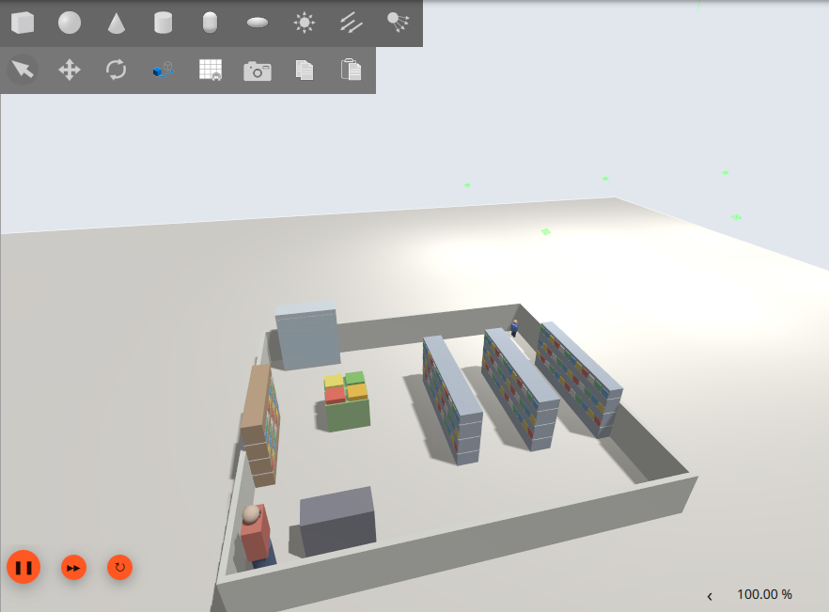
Figure 4.5 : The compact store in Gazebo: three gondola units, produce display, tea and coffee shelf, dairy fridge, checkout counter and a shopper
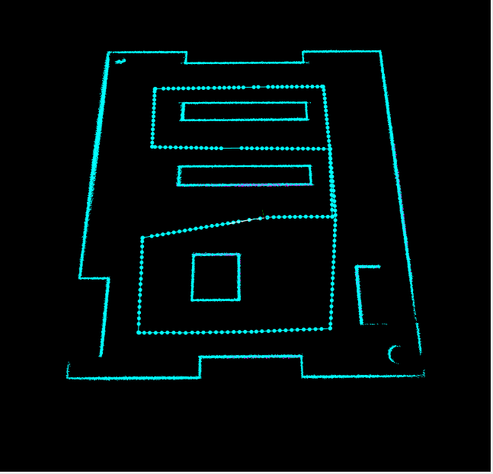
Figure 4.6 : Map built by RTAB-Map during the mapping drive, with the chain of map nodes along the driven route
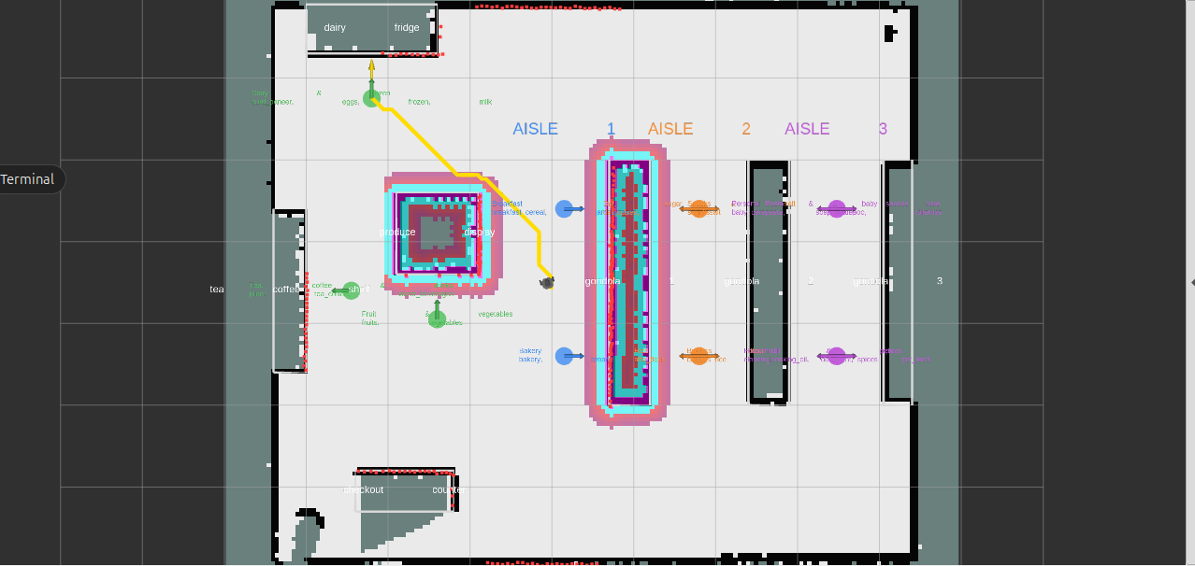
Figure 4.7 : Navigation view in RViz: inflated costmap, item locations by aisle and the planned path (yellow) to the current goal
4.4 Mathematical Models
The following models were used to size the drive, interpret the measurements and choose the fixes. Numerical values are those of the bench hardware or the simulation configuration; assumed values are stated as such.
4.4.1 Differential-drive kinematics
For two driven wheels separated by the track width B, the robot's linear and angular velocities are
$v=\frac{v_{r}+v_{l}}{2}, ω=\frac{v_{r}−v_{l}}{B}$ (4.1)
and the motor bridge inverts them to obtain the wheel targets from the velocity command:
$v_{r}=v+\frac{ωB}{2}, v_{l}=v−\frac{ωB}{2}$ (4.2)
With B = 0.16 m, a pure turn command of ω = −0.5 rad/s gives v_{r} = −0.04 m/s and v_{l} = +0.04 m/s, i.e. ±40 mm/s at each wheel. The cart-level LEAD speed of 0.10 m/s with no turn gives 100 mm/s at both wheels. The turning radius of the midpoint between the driven wheels is
$R=\frac{v}{ω}=\frac{B}{2}⋅\frac{v_{r}+v_{l}}{v_{r}−v_{l}}$ (4.3)
so v = 0.10 m/s with ω = 0.5 rad/s gives R = 0.20 m; equal and opposite wheel speeds give R = 0, a turn on the spot.
4.4.2 Encoder resolution and speed measurement
Each motor's Hall encoder gives 7 pulses per motor revolution, and the 30:1 gearbox gives P_{w} = 210 pulses per wheel revolution. The wheel travel per pulse and the measured speed are
$s_{p}=\frac{πD}{P_{w}}=\frac{π×80 mm}{210}=1.197 mm, v_{meas}=\frac{N s_{p}}{Δt}$ (4.4)
With Δt = 1 s, the speed resolution is one pulse, 1.2 mm/s, which is 1.2% of the 100 mm/s LEAD speed. For example, N = 86.5 pulses in one second corresponds to 86.5 × 1.197 = 103.5 mm/s.
4.4.3 Global path planning
Dijkstra's algorithm [6] keeps, for every grid cell n, the least accumulated cost from the start:
$g\left(n\right)=\min_{p∈N\left(n\right)}\left[g\left(p\right)+c\left(p,n\right)\right], c\left(p,n\right)=\left\{\begin{matrix}0.05 m & \text{straight} \\ 0.05\sqrt{2}=0.0707 m & \text{diagonal}\end{matrix}\right.$ (4.5)
The 180 × 160 grid has V = 28 800 cells and at most E = 8V = 230 400 edges. With a binary heap the search costs O((V + E) log V) ≈ 259 200 × 14.8 ≈ 3.8 × 10⁶ elementary steps, small enough to replan every 2 s on a laptop.
4.4.4 Route cost and exact ordering
For a visiting order π of n stops starting at the cart's position P₀, the route cost is
$J\left(π\right)=\sum_{k=0}^{n−1}{d}​\left(P_{π\left(k\right)},P_{π\left(k+1\right)}\right)$ (4.6)
where d is the Dijkstra path length between stops. The Held–Karp recursion [9] finds the order that minimises J exactly, where C(S, j) is the least cost of a route from P₀ through every stop in S ending at j:
$C\left(S,j\right)=\min_{i∈S, i≠j}\left[C\left(S−\{j\},i\right)+d\left(P_{i},P_{j}\right)\right], C\left(\{j\},j\right)=d\left(P_{0},P_{j}\right)$ (4.7)
Its cost is O(n²2ⁿ). For the largest list, n = 12, this is 12² × 2¹² = 589 824 operations over 12 × 2¹² = 49 152 states, against 12! = 479 001 600 orders for brute force, about 800 times fewer. The measured solve time was at most 4.8 ms.
4.4.5 Progress-check model
Nav2's progress checker aborts a leg unless the robot moves a radius r away from its last reference position within a time T; the default is r = 0.5 m, T = 10 s. The mean speed it demands is r/T = 0.05 m/s, half of the 0.10 m/s LEAD speed. An in-place turn through an angle Δψ moves the robot centre almost nothing. With turn rate ω_{max} and angular acceleration α_{max}, the turn takes
$t_{turn}=\frac{ω_{max}}{α_{max}}+\frac{Δψ}{ω_{max}}$ (4.8)
and the displacement still possible within the check window is
$Δs=v\left(T−t_{turn}\right)$ (4.9)
The fixes were judged against this condition, which requires Δs ≥ r. Worked calculations follow in Section 5.2.
4.4.6 Stopping distance
The stopping distance after a stop request is the travel during the delay plus the braking distance:
$d_{stop}=v t_{delay}+\frac{v^{2}}{2a_{b}}$ (4.10)
4.4.7 Drive force, torque and power
For a cart of mass m accelerating at a on a slope θ with rolling-resistance coefficient C_{rr}, the tractive force, the torque at each of the two driven wheels of radius r_{w}, and the wheel power are
$F=m\left(a+gC_{rr}cosθ+gsinθ\right), τ_{w}=\frac{F r_{w}}{2}, P_{w}=\frac{F v}{2}$ (4.11)
4.4.8 Footprint check
The cart's rectangular footprint (length L = 1.00 m, width W = 0.61 m) was bounded by two circles for driving straight and for turning on the spot, with a clearance margin c = 0.05 m:
$R_{straight}=\frac{W}{2}+c=0.355 m, R_{turn}=\frac{\sqrt{L^{2}+W^{2}}}{2}=0.586 m$ (4.12)
4.4.9 Statistical tests
For paired binary outcomes, the one-sided sign test gives the probability p of k or more 'wins' in n discordant pairs under the null hypothesis of no difference:
$p=\sum_{i=k}^{n}{\left({n \atop i}\right)}{0.5}^{n}$ (4.13)
For paired continuous measures, the Wilcoxon signed-rank statistic W_{pos} is the sum of the ranks R_{i} of the absolute differences that come from positive differences d_{i}; its mean and standard deviation under the null hypothesis, and the normal-approximation score z, are
Wpos=di>0​Ri, μW=nn+14, σW=nn+12n+124, z=Wpos−μWσW (4.14)
4.5 Shopping Interface and UI–ROS Bridge
The browser interface offers a 60-product catalogue, quantities, a shopping list and a route page. A new ROS 2 package (arc_ui_bridge) serves the interface from the laptop and connects it to the stack without modifying any ARC package. It maps the 60 products to 22 of the 29 store items, merges products that share a spot into 9 or fewer stops, orders them by Dijkstra path cost on the live map with the Held–Karp solver, and sends them one at a time on the same topics as the shopping manager. Because 'goal reached' is a latched message, an arrival is accepted only if
$∥p_{robot}−p_{goal}∥≤1.0 m \text{and} t−t_{goal}≥3 s$ (4.15)
where 1.0 m is the planner's goal-snapping radius and 3 s exceeds the planner's 2 s replan period, so a re-sent arrival from the previous goal is never taken. Pause and stop hold the robot at its current pose and cancel the controller's path.
4.6 Perception and Hardware-in-the-Loop Method
Person detection used YOLOv8n with ByteTrack on the Raspberry Pi 5 at a 320-pixel input. Because Debian 13 on the Pi has no ROS 2 packages, the Pi sent person-state flags to the laptop over UDP; both were on a phone hotspot and the Pi was operated over SSH from the laptop. A relay republished the flags for the behaviour tree and held it in WAIT if no data arrived for 1.5 s. A motor bridge converted the velocity command into wheel targets with Eq. (4.2), mapped them to PWM through a per-wheel calibration and logged every encoder report. The Uno firmware limited PWM to ±60 of 255, stopped the motors if no command arrived for 300 ms and refused to drive while the E-stop input was open. The rest of the stack ran in simulation, so the real motors and the simulated robot received the same commands. OSNet re-identification was tested offline on a 31 s recording (465 frames at 15 fps).
4.7 Mechanical Design and Structural Analysis
The retrofit was modelled in SolidWorks 2026 (Figure 4.8). The host cart's basket, frame and handle are unchanged. Two drive modules replace the front wheels and form a differential drive; the two rear wheels remain passive. Each module consists of a quick-release mount, a geared DC motor and a 150 mm wheel. The motor is bolted to the outer face of the mount's wheel bracket, and its 15 mm output shaft passes through the bracket to carry the wheel on the inner side. The overall dimensions of the retrofitted cart are given in Table 4.4.
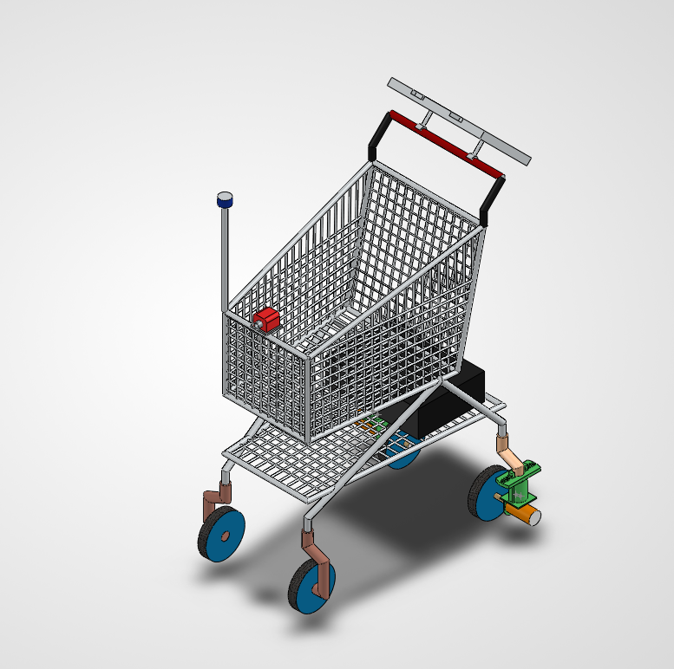
Figure 4.8 : CAD assembly of the ARC retrofit cart with the two drive modules at the front wheels
Quantity | Value | Quantity | Value
Overall length | 904 mm | Wheel diameter | 150 mm
Overall width (motors) | 667 mm | Drive / rear wheel width | 30 / 33 mm
Cart body width | 440 mm | Wheelbase | 680 mm
Overall height | 1 275 mm | Track of the drive wheels | 340 mm
Lowest part above floor | 42.5 mm (bracket) | Wheel offset from bracket | 71.7 mm
Table 4.4 : Principal dimensions of the retrofitted cart, measured from the CAD assembly
The quick-release mount has four parts (Figure 4.9, Table 4.5): a sleeve fixed to the cart through an adaptor plate, made of a top plate and a 50 mm cylinder with two guide slots 15.2 mm wide; a slider, made of a 70 × 70 mm plate and two arc-section guide rails 13 mm wide that run up into the slots; a wheel bracket, a 3.5 mm plate with an 18 mm hole for the motor boss, two 4.2 mm motor-screw holes and 7.5 mm root fillets; and two flat springs that latch the rails at the top plate. To fit the module, the rails are slid up into the sleeve until the springs engage; to remove it, the springs are compressed and the slider is drawn out. The guide rails and sleeve carry the transverse loads and moments, and the wheel's vertical load passes from the bracket into the slider plate, which bears on the base of the sleeve. The springs only retain the module along the removal axis.
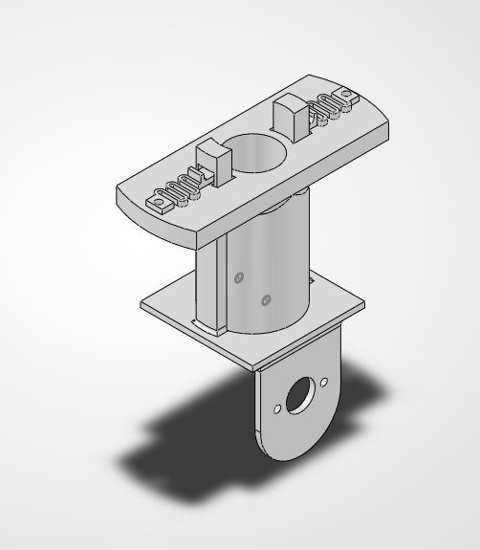
Figure 4.9 : Quick-release drive mount: sleeve with the two spring latches (top), slider plate and wheel bracket (bottom)
Part | Function | Volume (mm³) | Mass Al / steel (g)
Sleeve | Fixed to cart; guide slots | 129 224 | 349 / 1014
Slider | Plate and two guide rails | 39 145 | 106 / 307
Wheel bracket | Carries motor and wheel | 10 761 | 29 / 85
Flat spring (×2) | Latch | 818 each | 2.2 / 6.4 each
Total | Mount without motor and wheel | 180 766 | 488 / 1419
Table 4.5 : Parts of one quick-release drive mount, from the STEP files
The STEP files of the 10 parts (21 instances) and of the two assembly levels were read in code (gmsh with OpenCASCADE). Each part was placed with the transforms stored in the assemblies, and the placed geometry was used to measure the dimensions, wheel positions and offsets, compute volumes and masses (density 2.70 g/cm³ for aluminium and 7.85 g/cm³ for steel), check every pair of parts in a drive module for interference, and measure the fit of the rails in the slots. The measured geometry then fed four analyses: the static wheel loads and tipping limits of the loaded cart; the swept envelope of the cart, which was re-run through the store-map footprint check (Section 4.4.8); the drive torque; and the strength of the wheel bracket.
The bracket was analysed twice. The team's SimScale model of the slider and bracket was a linear static analysis with second-order tetrahedral elements (6 689 elements, 12 446 nodes), the bracket-to-plate interface fixed and a load at the motor hole. Its material and load were recovered from the exported result fields: the ratio of stress to strain gives E = 70 GPa and ν = 0.34, i.e. aluminium, and integrating the internal forces over plate cross-sections gives about 10 N normal to the plate and 10 N in its plane. A second, independent model was then built in Python with scikit-fem: the bracket from its STEP file, meshed with quadratic tetrahedra (96 231 degrees of freedom, and 167 157 for a mesh-convergence check), the base fixed, E = 70 GPa and ν = 0.33. It was first run with the SimScale load to check it against SimScale, and then with the design wheel load, applied as the vertical force on the motor hole together with the moment of its 71.7 mm offset, carried into the plate as a linearly varying pressure under the motor flange. Both models were checked against beam theory using the models below.
4.7.1 Bracket bending
The bracket plate (width b = 50 mm, thickness t = 3.5 mm) was treated as a cantilever from its root. Its section modulus, second moment of area, bending stress and the deflection at a distance L from the root under a force F applied at a distance a are
$Z=\frac{bt^{2}}{6}=102.1 mm^{3}, I=\frac{bt^{3}}{12}=178.6 mm^{4}, σ=\frac{M}{Z}, δ=\frac{Fa^{2}\left(3L−a\right)}{6EI}$ (4.16)
Because the wheel sits beside the bracket on the motor shaft, its vertical load F_{v} acts at a lateral offset e from the plate and bends it with a moment that is the same along the whole plate. The peak stress at the root fillet follows from the stress-concentration factor K_{t} found by the FEA, and the wheel tilt from the plate rotation:
$M=F_{v}e, σ_{peak}=K_{t}\frac{F_{v}e}{Z}, θ=\frac{ML_{h}}{EI}$ (4.17)
where L_{h} = 32.5 mm is the distance from the plate root to the shaft centre.
4.7.2 Guide clearance and alignment
With slot width w_{slot} and rail width w_{rail}, the clearance per side, and the rotation of the module about the sleeve axis that this clearance allows at the mean rail radius r_{m}, are
$c_{s}=\frac{w_{slot}−w_{rail}}{2}, θ_{p}≈\frac{c_{s}}{r_{m}}$ (4.18)
4.7.3 Spring latch
Each flat spring was approximated as a cantilever strip of width w, thickness t, free length L_{s} and modulus E. The force and bending stress at an end deflection δ are
$F≈\frac{Ewt^{3}δ}{4L_{s}^{3}}, σ≈\frac{3Etδ}{2L_{s}^{2}}$ (4.19)
4.7.4 Wheel loads, tipping and swept envelope
With the centre of mass a distance l_{r} ahead of the rear axle on a wheelbase L_{wb}, at a height h above the floor and midway between wheels on a track B_{d}, the static load on each drive wheel, the tipping angles and the lateral acceleration at which the cart would tip are
$F_{v}=\frac{mg}{2}⋅\frac{l_{r}}{L_{wb}}, tanφ_{lat}=\frac{B_{d}/2}{h}, a_{tip}=g\frac{B_{d}/2}{h}$ (4.20)
When the cart turns on the spot about the midpoint of the drive axle, a point of the footprint at plan coordinates (x, z) sweeps a circle of radius
$r=\sqrt{x^{2}+z^{2}}$ (4.21)
4.7.5 Motor shaft bending
The wheel load acts on the 15 mm motor shaft at a lever arm l_{s} from the bracket face; the bending stress in a solid round shaft of diameter d is
$σ_{s}=\frac{32 F_{v}l_{s}}{πd^{3}}$ (4.22)

CHAPTER 5
RESULTS AND DISCUSSION
5.1 Localisation Accuracy (A1)
With ICP odometry the median localisation error was 0.018–0.038 m in every configuration (Figure 5.1), and 91.2–97.9% of samples were inside the 0.15 m and 5° band. Excursions were mostly in heading (median 0.5–1.0°). All large errors came from two events, not gradual drift: lidar odometry failed after contact with boxes in A4 and once with a shelf in A2-pc.
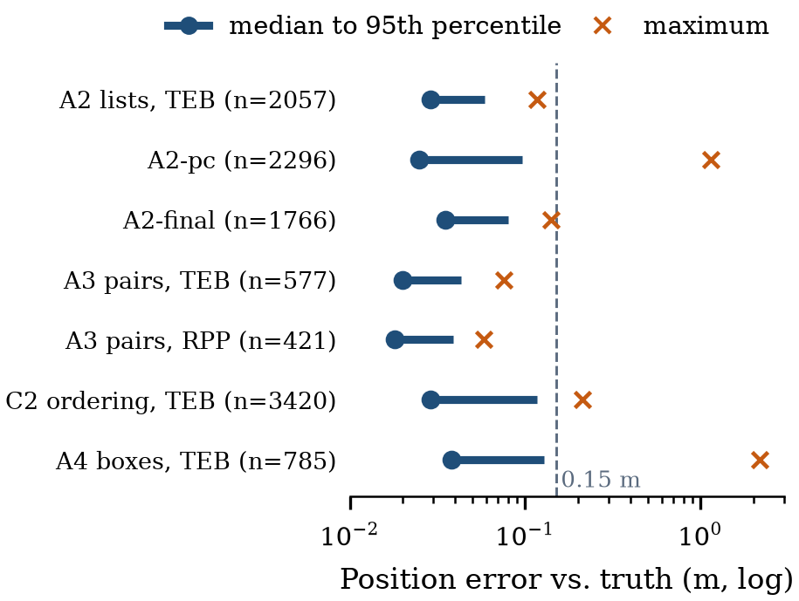
Figure 5.1 : Localisation error per configuration with ICP odometry (samples every 2 s)
5.2 Mission Reliability and the Progress Check (A2)
The original stack completed 29 of 30 missions and reached 143 of 144 stops without contact, but only 96 stops (67%) at the first attempt, and it needed 97 recoveries. All 62 controller aborts were Nav2 code 105, 'failed to make progress'. ARC defines no progress checker, so Nav2's default applies. Applying Eq. (4.8) with ω_{max} = 0.5 rad/s and α_{max} = 1.0 rad/s² explains the aborts:
- A 90° turn takes 0.5 + 1.571/0.5 = 3.64 s, leaving Δs = 0.10 × (10 − 3.64) = 0.64 m ≥ 0.5 m: it passes, but with only 0.14 m to spare, which slowing near an aisle entrance or a goal easily consumes.
- A 180° turn takes 0.5 + 3.142/0.5 = 6.78 s, leaving Δs = 0.10 × (10 − 6.78) = 0.32 m < 0.5 m: an abort is certain even at full LEAD speed.
- With the relaxed check (r = 0.25 m, T = 20 s) the same turn leaves Δs = 0.10 × (20 − 6.78) = 1.32 m, more than five times the radius; the demanded mean speed falls from 0.05 to 0.0125 m/s.
Figure 5.2 shows these budgets. Because the path hand-over has no recovery, each abort would leave the shopping manager waiting indefinitely without the test kit's re-send.
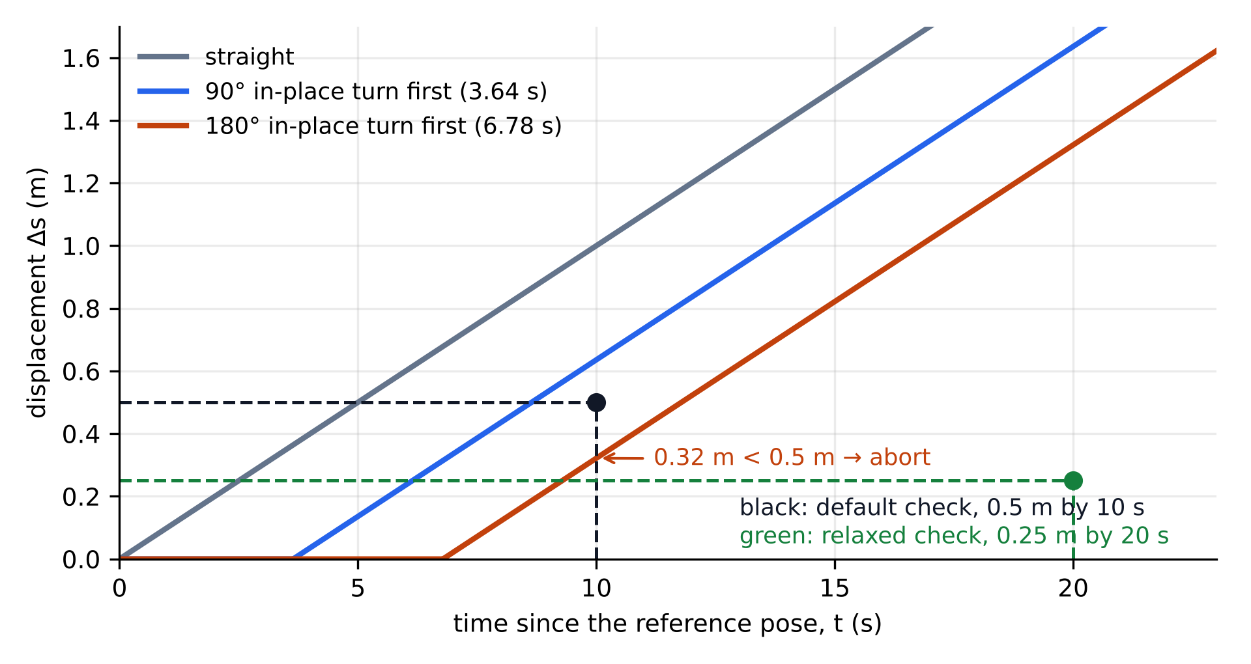
Figure 5.2 : Displacement achievable after an in-place turn at 0.10 m/s against the default and relaxed progress checks
Before the timed tests, the full chain was run interactively with a three-item typed list (tea_coffee, fruits, pasta). The shopping manager published one goal per item, the robot drove from the produce display through the aisles to gondola 2, and all three stops were reached (Figure 5.3).
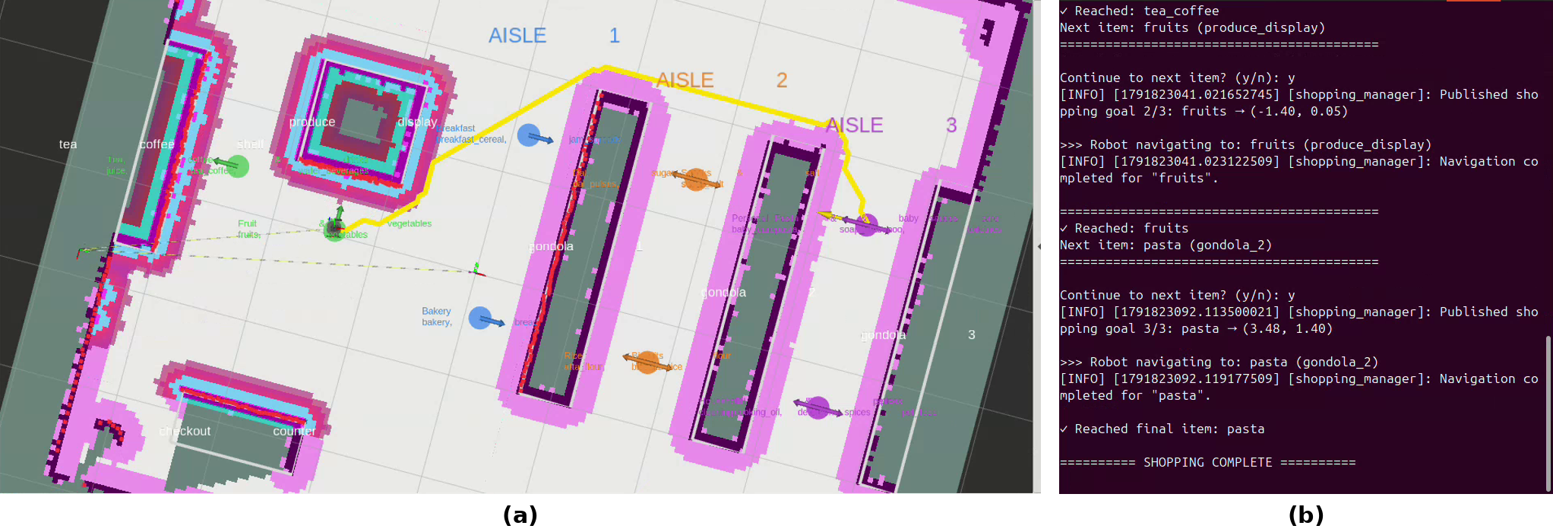
Figure 5.3 : Interactive shopping run: (a) planned path from the produce display to gondola 2 in RViz; (b) shopping manager log, from the second goal to 'shopping complete'
5.3 Local Controller Comparison (A3)
Table 5.1 compares the controllers on the same 20 pairs, with Pure Pursuit limited to the same speed, turn rate and angular acceleration. Pure Pursuit mostly failed by refusing to move, because its collision check found no admissible command in aisles narrowed by the 0.20 m inflation (code 106). The TEB-like controller was more reliable but less smooth: mean |ω̇| was 0.220 against 0.083 rad/s² (Wilcoxon, n = 19, p = 2.7 × 10⁻⁵). On the 12 pairs both completed, time (68.2 vs 62.8 s) and distance (4.73 vs 4.29 m) did not differ significantly (p = 0.23 and 0.38).
Measure | TEB-like | RPP (stock)
Goals reached | 19/20 | 13/20
Reached at first attempt | 12/20 | 10/20
Recoveries | 17 | 24
Dominant abort | 105 (no progress) | 106 (no valid control)
Mean |ω̇| (rad/s²) | 0.220 | 0.083
Steering reversals per m | 1.88 | 0.80
Median localisation error (m) | 0.020 | 0.018
Table 5.1 : Controller comparison on 20 identical start–goal pairs (A3)
5.4 Unmapped Obstacles (A4)
Boxes of 0.20 × 0.20 × 0.35 m were placed on the planned path after planning. The stack reached 3 of the 18 goals with boxes and touched a box in 17 (Table 5.2); the median minimum clearance was −0.027 m. The cause is architectural: the planner uses the locked map and never sees the boxes, and the hand-over ignores new paths while one is being followed, so avoidance is left to the local controller alone. It can bend around one box but not pass two or three. In two 3-box legs ICP odometry failed after contact and never recovered.
Boxes | Legs | Goal reached | Contact
1 | 7 | 3 | 6
2 | 4 | 0 | 4
3 | 7 | 0 | 7
All | 18 | 3 (17%) | 17 (94%)
Table 5.2 : Outcome by number of boxes on the path (A4)
5.5 Wheel-only Odometry (B1)
With wheel odometry in place of ICP, localisation was as accurate as before while it held (median 0.023 m), but it was lost twice, after about 73 m and 48 m of driving (Figure 5.4). RTAB-Map's correction absorbed 1–2 m of wheel drift until it froze; its log shows correct matches rejected as 'wrong loop closure' because they disagreed with the drifted odometry. Lidar odometry therefore protects re-localisation.
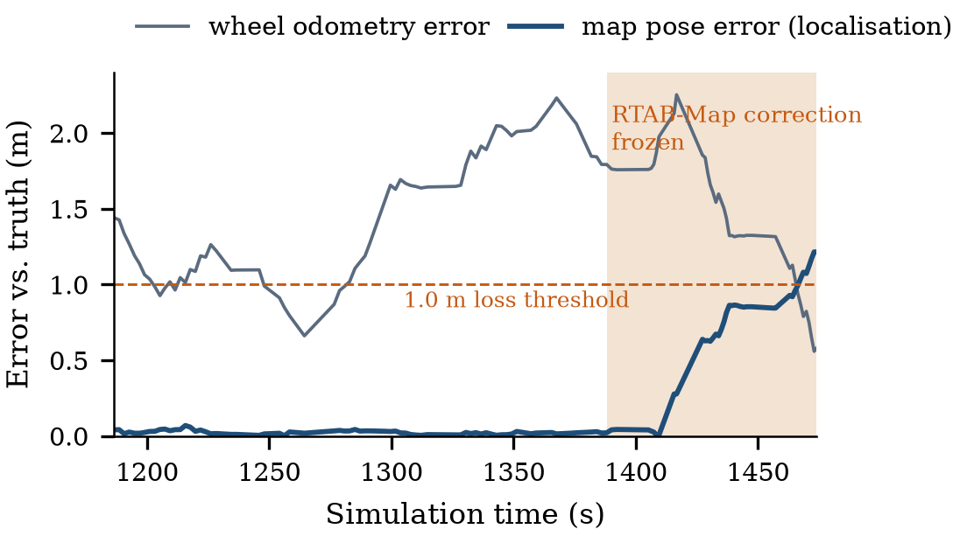
Figure 5.4 : First localisation loss with wheel-only odometry (B1)
5.6 Shopping-List Ordering (C1, C2)
Offline, typed order produced routes 23–94% longer than the optimum for 3 to 12 items (Figure 5.5). Nearest-next on path cost stayed within 1–7%, better than nearest-next on straight-line distance (3–9%), because shelves block the direct line. Driven by the full stack, the exact order was faster than typed order on all 30 lists (Figure 5.6). By the sign test (Eq. (4.13)) with k = n = 30, p = 0.5³⁰ = 9.3 × 10⁻¹⁰. Median route length fell by 32%, 42% and 51%, and time by 25%, 34% and 41%, for 5, 8 and 12 items. Completion did not improve: 19 of 30 missions with typed order, 15 with exact and 13 with nearest-next. For exact against typed there were 7 against 3 discordant lists, so p = 2 × (C(10,0)+C(10,1)+C(10,2)+C(10,3))/2¹⁰ = 2 × 176/1024 = 0.34, not significant. Ordered routes consist of short hops that often start with a turn into an aisle, which is exactly the case that fails the default progress check (Section 5.2).
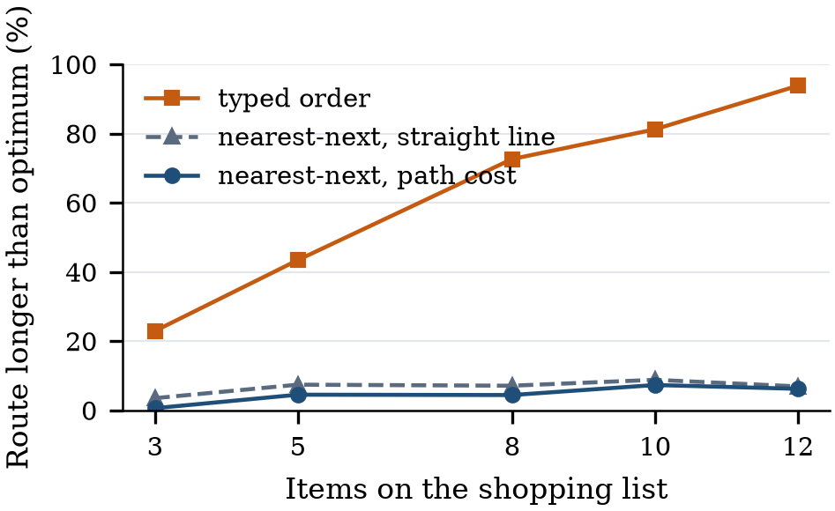
Figure 5.5 : Offline route length relative to the exact optimum (C1, 50 lists per size)
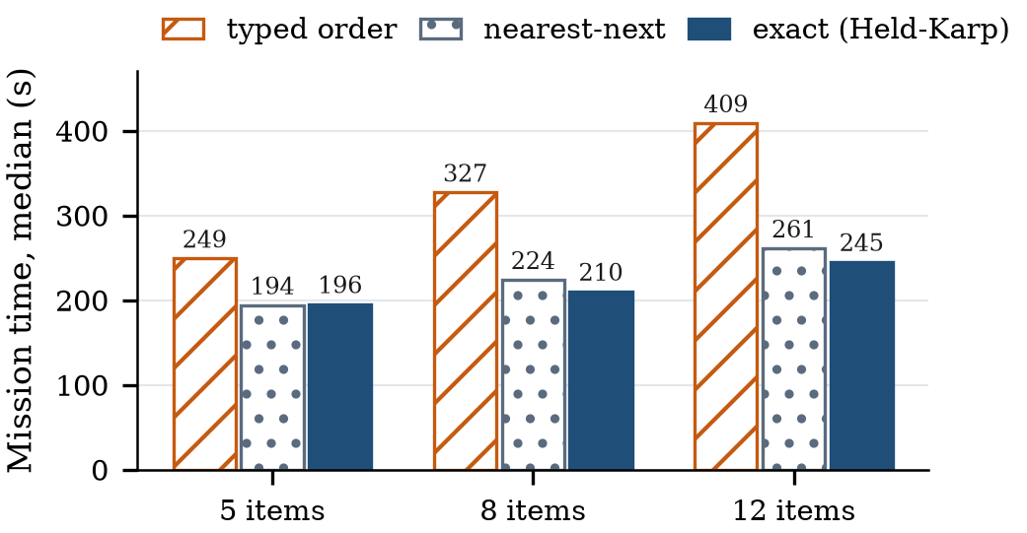
Figure 5.6 : Median mission time by ordering strategy and list size (C2)
5.7 Phase 2: Progress Check and Exact Ordering
Both variants drove the 30 A2 lists (seed 7) on the same stack, changing only a copy of the controller configuration (Table 5.3, Figure 5.7, Figure 5.8). The relaxed check alone removed all 62 aborts and raised first-attempt arrivals from 67% to 96%, but missions took 3.8% longer on the 28 lists both completed ((287.5 − 277.0)/277.0, p = 1.4 × 10⁻⁴), and in one leg the robot pressed against a shelf for 42 s. With exact ordering added, A2-final completed all 30 lists and all 144 stops with no contact.
Measure | A2 | A2-pc | A2-final
Progress check | 0.5 m / 10 s | 0.25 m / 20 s | 0.25 m / 20 s
Visiting order | Typed | Typed | Exact
Missions completed | 29/30 | 29/30 | 30/30
Stops reached | 143/144 | 140/141 | 144/144
Reached at first attempt | 96 (67%) | 136 (96%) | 133 (92%)
Recoveries (aborts) | 97 (62) | 4 (0) | 13 (2)
Median mission time (s) | 255 | 259 | 218
Mean driven distance (m) | 18.6 | 18.9 | 11.6
Shelf contacts | 0 | 1 | 0
Mean |ω̇| (rad/s²) | 0.211 | 0.231 | 0.273
Steering reversals per m | 2.07 | 2.13 | 3.01
Loc. error med./max (m) | 0.029/0.117 | 0.025/1.149 | 0.035/0.140
Table 5.3 : Original stack and phase-2 variants on the 30 A2 lists
Worked significance test. On the 29 lists that both A2 and A2-final completed, the mean time fell from 281.0 s to 207.4 s, a change of (207.4 − 281.0)/281.0 = −26.2%, and the mean distance from 18.6 m to 11.5 m, −38.2%. A2-final was faster on 27 lists. Ranking the 29 absolute time differences gives W_{pos} = 15 and W_{neg} = 420 (check: n(n+1)/2 = 435). From Eq. (4.14), μ_{W} = 29 × 30/4 = 217.5 and σ_{W} = √(29 × 30 × 59/24) = 46.2, so z = (15 − 217.5)/46.2 = −4.38. The exact signed-rank distribution gives p = 5.1 × 10⁻⁷ (the normal approximation gives 1.2 × 10⁻⁵); for distance p = 1.2 × 10⁻⁷. The cost is smoothness: shorter routes contain more turns per metre, so mean |ω̇| rose from 0.211 to 0.273 rad/s² (+29%, p = 8.1 × 10⁻⁴).
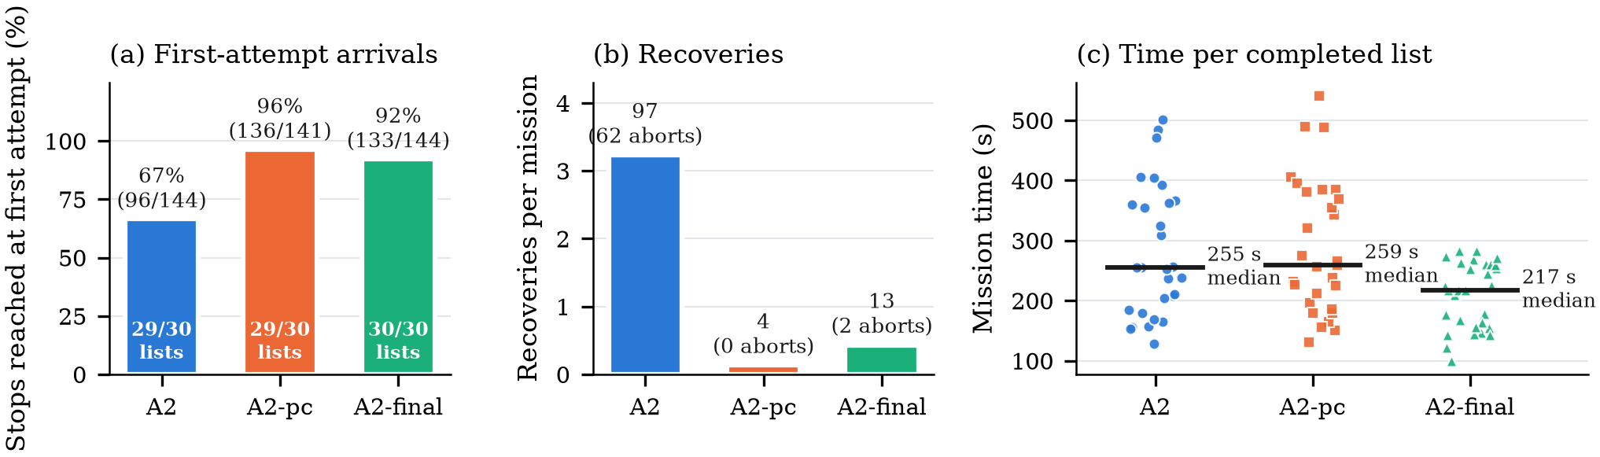
Figure 5.7 : Original stack (A2) and phase-2 variants on the same 30 lists: (a) first-attempt stops, (b) recoveries, (c) mission time
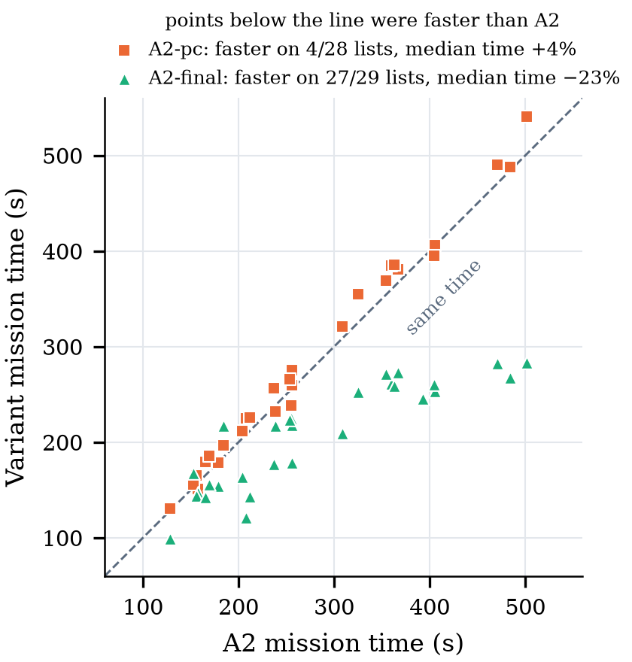
Figure 5.8 : List-by-list mission time of each variant against the original stack
5.8 Bench Hardware-in-the-Loop Test
The bench set-up is shown in Figure 5.9 and a 15-minute session in Figure 5.10; Table 5.4 summarises the measurements. The behaviour tree spent 240 s in LEAD, 29 s in FOLLOW and 616 s in WAIT, with nine starts and seven stops while moving. Over 22 flag changes from the Pi, the tree changed mode a median of 0.12 s after the relay (maximum 0.20 s). Nine times the Pi cleared both flags; each time the PWM was zero in the first WAIT sample, and in the next 1 s the right encoder counted at most one pulse, i.e. ≤ 1.2 mm of wheel travel by Eq. (4.4) (eight pulses, 9.6 mm, once when stopping from 0.15 m/s).
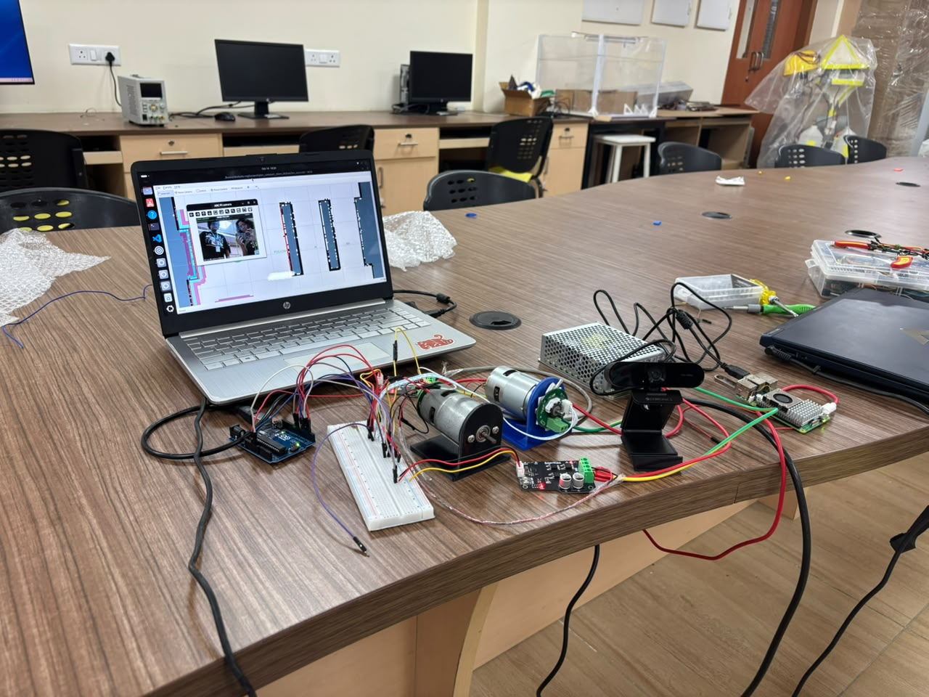
Figure 5.9 : Bench set-up: laptop running the stack, Raspberry Pi 5 with webcam, Arduino Uno, two SmartElex drivers and two encoder motors
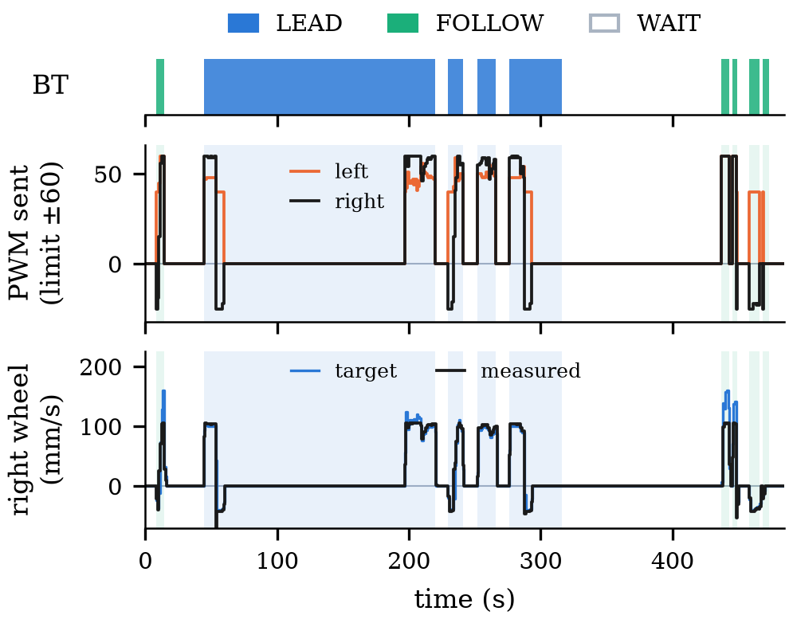
Figure 5.10 : Bench session logged by the motor bridge (1 s samples): behaviour-tree mode, PWM and right-wheel speed
Measurement | Result
Session | 15 min; LEAD 240 s, FOLLOW 29 s, WAIT 616 s
Flag → BT mode | Median 0.12 s, max 0.20 s (22 changes)
Stop on WAIT | PWM 0 in first WAIT sample; ≤ 1 pulse (1.2 mm) in next 1 s
Pi data loss | 1.5 s silence → relay held WAIT
Right-wheel speed | 104 mm/s at 100 mm/s command (97–105)
Left encoder | 1 pulse in session (intermittent connection)
Serial link | 17 660 commands, 881 reports, 0 errors
Watchdog | No pulses from 1.6 s after commands stopped
Goal-reached race | 2 of 4 goals marked complete within 2 ms
Table 5.4 : Bench HIL measurements (16 October 2026)
Speed tracking. At the 0.10 m/s command the right wheel ran at 104 mm/s, a tracking error of (104 − 100)/100 = +4%, about three times the 1.2 mm/s encoder resolution. At 0.15 m/s it was at the ±60 PWM limit and reached about 105 mm/s, so the bench drive cannot yet reach the follower's speed. The left encoder counted one pulse in the session, although it had counted 63–101 pulses/s (75–121 mm/s) in a calibration run 106 minutes earlier, which points to an intermittent connection.
Stopping distance. Taking the software delay as the measured worst case of 0.20 s plus one 0.05 s bridge period, t_{delay} = 0.25 s, and an assumed braking deceleration a_{b} = 0.5 m/s² for the loaded cart, Eq. (4.10) gives d_{stop} = 0.10 × 0.25 + 0.10²/(2 × 0.5) = 0.035 m at 0.10 m/s and 0.06 m at 0.15 m/s. The camera-to-flag delay was not logged, so each 0.1 s of camera latency adds 10 mm at 0.10 m/s; this delay must be measured before the cart is tested with people. The 1.2 mm bench coast is consistent with the model for unloaded motors.
Pi power. The Pi ran from a 5 V, 2.4 A supply (12 W), 47% of the 25.5 W of the official 5.1 V, 5 A supply [68], which is consistent with the restarts seen when YOLO and OSNet ran together and why OSNet was tested offline. Two shopping lists ran in the simulated store during the session, and the goal-reached race was observed directly: after each arrival the planner replanned to the reached goal every 2 s and the hand-over re-published 'goal reached', so 2 of the 4 goals the shopping manager published were marked complete within 2 ms and skipped.
5.9 Shopping Interface and ROS Link
The interface (Figure 5.11) now drives the stack through arc_ui_bridge. The arrival guard (Eq. (4.15)) directly targets the race of Section 5.8. Nine offline tests passed: product-mapping completeness (60 products → 22 store items), merging, ordering (exact cost ≤ typed cost), stale and distant arrivals ignored, a full trip, pause/stop/resume/home, skip, double start and the server API against stand-in ROS objects. An end-to-end browser test against a simulated robot completed a 5-product list in 4 stops, ignored every stale arrival and raised no script errors. The bridge has not yet been run against the real stack; that test is planned before the review.
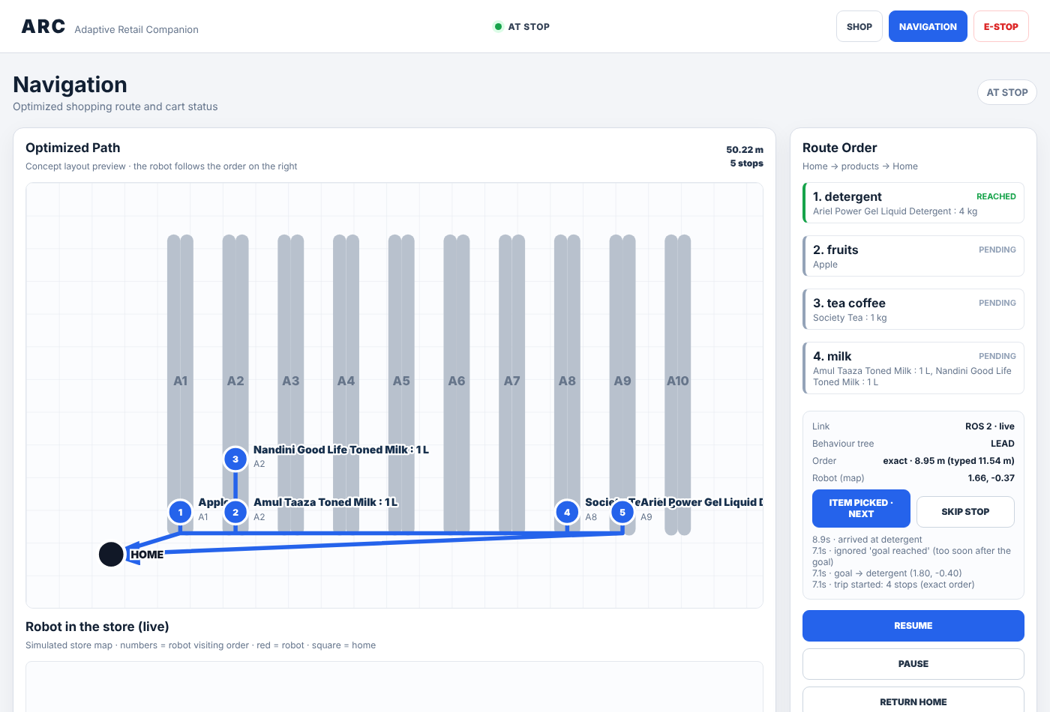
Figure 5.11 : Shopping interface linked to the robot: live route order, behaviour-tree mode and event log (browser test against a simulated robot)
5.10 Person Detection and Target Lock
YOLOv8n and ByteTrack ran live on the Pi in the bench test. In the offline OSNet test the enrolled person changed ByteTrack ID from 1 to 3 after leaving and returning, and the original height-ratio gate (maximum 2.0) rejected the returning target at ratios of 2.56–2.67 despite high appearance similarity. With the gate relaxed to 3.0 the target was re-locked at about 7.7 s, and the lock state was LOCKED for 429 of 465 frames (92.3%). With one person only, this is a diagnostic result, not a re-identification accuracy.
The perception bridge was also run with the laptop webcam against the simulated robot (Figure 5.12). While the target was locked, the bridge reported FOLLOW and the behaviour tree reported the robot as moving; when the target left the camera view, the lock was lost, the mode changed to WAIT and the robot was reported as stopped. This checks the perception-to-behaviour link in the loop with navigation; it gives no timing for the Pi.
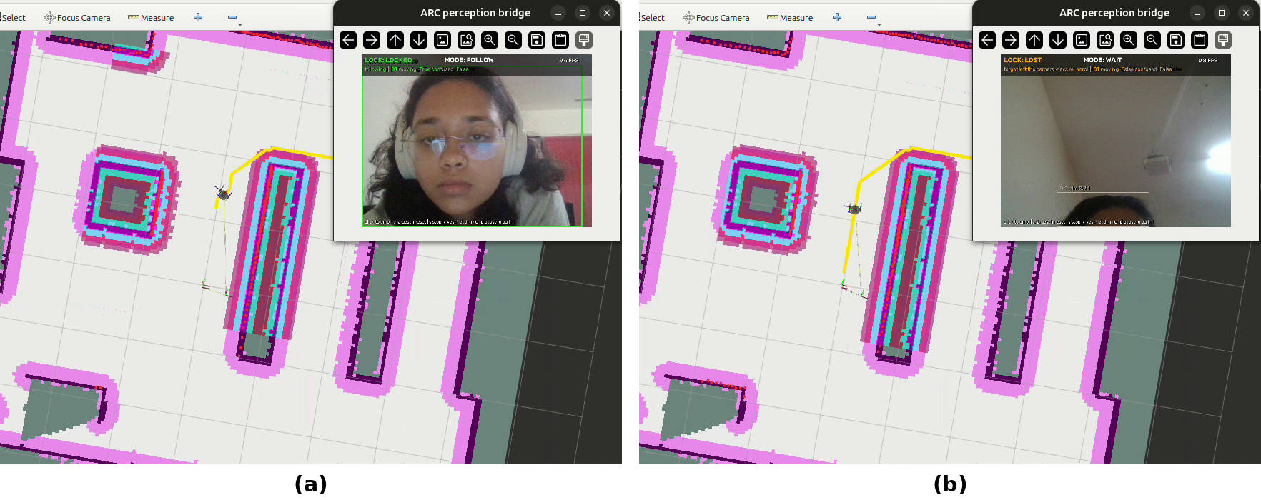
Figure 5.12 : Perception bridge driving the simulated robot: (a) target locked, mode FOLLOW; (b) target left the camera view, lock lost, mode WAIT
5.11 Mechanical Design and Structural Check
5.11.1 Cart geometry, wheel loads and stability
Figure 5.13 shows the measured plan of the retrofitted cart. The modules widen it from the 440 mm body to 667 mm, because each motor projects outboard of its sleeve. A drive module has no interference between any of its parts (adaptor, sleeve, slider, springs, bracket, motor and wheel); the only contact is the slider plate seated flush on the sleeve base. One modelling error was found: the drive wheels reach 36 mm lower than the rear wheels (wheel bottoms at 237.9 mm and 273.9 mm in the model), so as drawn the cart would stand on its drive wheels and pitch back by atan(36/680) = 3.0° until the rear wheels touched. The module height or the rear wheel mounts must be corrected by 36 mm.
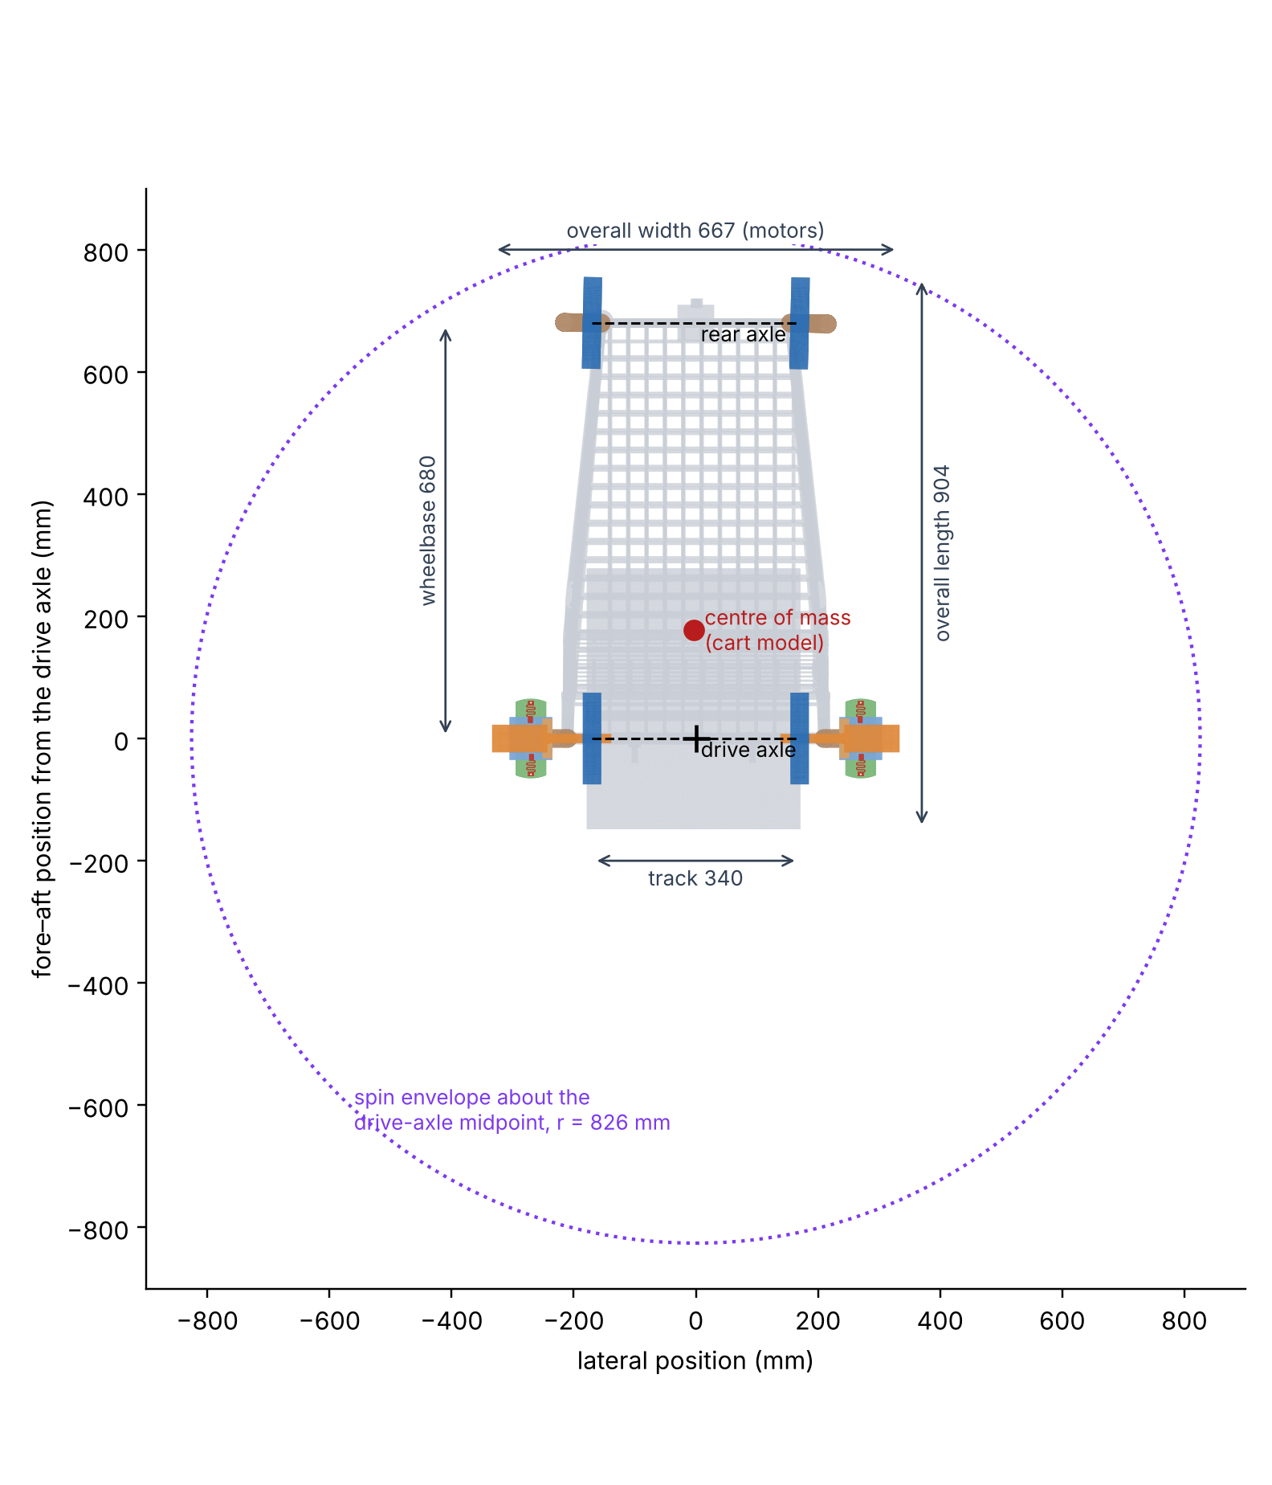
Figure 5.13 : Plan view of the retrofitted cart from the CAD assembly, with the measured dimensions, the centre of mass of the cart model and the spin envelope about the drive axle
The centre of mass of the cart model lies 178 mm behind the drive axle and 502 mm ahead of the rear axle, 600 mm above the floor. Taking a loaded mass of m = 50 kg at that point, Eq. (4.20) gives 73.8% of the weight on the drive axle: F_{v} = 50 × 9.81 × 0.738/2 = 181 N on each drive wheel and 64 N on each rear wheel (Table 5.5). The narrow 340 mm track sets the stability limit: the cart tips sideways at a slope of atan(170/600) = 15.8°, or at a lateral acceleration of 9.81 × 170/600 = 2.78 m/s². At 0.15 m/s on the tightest 0.2 m turn radius the lateral acceleration is only 0.15²/0.2 = 0.11 m/s², a margin of about 25. The 50 kg mass and its position are assumptions; a high or off-centre load in the basket reduces these margins.
Quantity | Calculation | Result
Load on each drive wheel | 50 × 9.81 × (502/680)/2 | 181 N
Load on each rear wheel | 50 × 9.81 × (178/680)/2 | 64 N
Sideways tipping slope | atan(170/600) | 15.8°
Tipping slope over the drive axle | atan(178/600) | 16.5°
Tipping slope over the rear axle | atan(502/600) | 39.9°
Lateral acceleration to tip | 9.81 × 170/600 | 2.78 m/s²
Braking deceleration to tip forward | 9.81 × 178/600 | 2.91 m/s²
Table 5.5 : Static wheel loads and stability of the loaded cart (m = 50 kg at the centre of mass of the cart model)
Braking would tip the cart forward only above 2.91 m/s², nearly six times the 0.5 m/s² assumed for the stopping distance. The traction available at each drive wheel, 0.5 × 181 = 90 N for a friction coefficient of 0.5, is 3.9 times the 23.4 N needed on a 1:20 ramp.
The cart's real footprint was re-run through the store-map footprint check (Table 5.6). With the measured width, driving straight needs a 0.384 m clearance radius; all 9 stops remain reachable and routes are 9.6% longer than on the test grid. A differential-drive cart turns about the midpoint of its drive axle, and from Eq. (4.21) its rear corners sweep r = √(755² + 334²) = 826 mm, a 1.65 m circle. With that radius only 3 of the 9 stops can be reached, so the cart must manoeuvre in the aisles rather than spin on the spot.
Footprint | Radius (m) | Stops reachable | Goal moved (m) | Route longer
TurtleBot stand-in (planner) | 0.200 | 9/9 | 0 | 1.5%
Cart, driving straight | 0.384 | 9/9 | 0 | 9.6%
Cart, turning about its centre | 0.562 | 9/9 | 0.85 | 5.5%
Cart, spin about the drive axle | 0.826 | 3/9 | 0.74 | —
Table 5.6 : Store-map footprint check with the measured cart dimensions
5.11.2 Drive sizing
With the 150 mm wheels, the LEAD and follow speeds of 0.10 and 0.15 m/s need 60v/(πD) = 12.7 and 19.1 rpm at the wheel. Using Eq. (4.11) with m = 50 kg, C_{rr} = 0.02 and a = 0.25 m/s², the tractive force is F = 50(0.25 + 9.81 × 0.02) = 22.3 N on a flat floor and 46.8 N on a 1:20 ramp (θ = 2.86°), shared by the two drive wheels. With r_{w} = 0.075 m the torque per wheel is 0.84 N·m on the flat and 1.75 N·m on the ramp, and the power per wheel at 0.15 m/s is 3.5 W. These are the requirements against which the motor's rated torque and speed must be checked; the bench motors drove smaller 80 mm wheels.
5.11.3 Mount fit and spring latch
Without the motor and wheel, one mount weighs 0.49 kg in aluminium or 1.42 kg in steel (Table 4.5); the sleeve is 72% of it. The guide fit from Eq. (4.18) is loose: the slots are 15.2 mm wide and the rails 13.0 mm, so c_{s} = (15.2 − 13.0)/2 = 1.1 mm per side, and the slot floor (radius 19.5 mm) sits 1.0 mm inside the rails (radius 20.5 mm). At the mean rail radius r_{m} ≈ 25 mm this lets the module rotate by θ_{p} ≈ 1.1/25 = 0.044 rad, about 2.5°, about the vertical axis. For a driven wheel that is a steering error, so the clearance should be reduced once the manufacturing tolerances are known; 0.2 mm per side would limit the rotation to about 0.5°.
For an illustrative stainless-steel strip (E = 193 GPa, w = 10 mm, t = 0.5 mm, L_{s} = 30 mm) deflected by 1.5 mm, Eq. (4.19) gives F = 193 000 × 10 × 0.5³ × 1.5/(4 × 30³) = 3.35 N per spring and σ = 3 × 193 000 × 0.5 × 1.5/(2 × 30²) = 241 MPa. These dimensions are examples, not taken from the spring model. The stress exceeds the yield strength of annealed austenitic stainless steel, so a spring-temper grade is needed. Two springs give about 6.7 N, less than the weight of a module with its motor and wheel when the cart is lifted, so the latch must hold by a positive catch that the springs keep engaged, not by spring force or friction.
5.11.4 Finite-element validation
SimScale reported a maximum von Mises stress of 14.6 MPa (Figure 5.14). That value is a single node at the corner of the fixed support; the next five highest values, 6.6–10.2 MPa, are also at that constraint corner, where a rigid support produces an artificial stress singularity. Away from the support the peak is 4.25 MPa, at the plate-root fillet, the stress at the plate root is typically 2.4–2.8 MPa (Figure 5.15), and the maximum displacement is 0.020 mm, at the free end of the bracket.
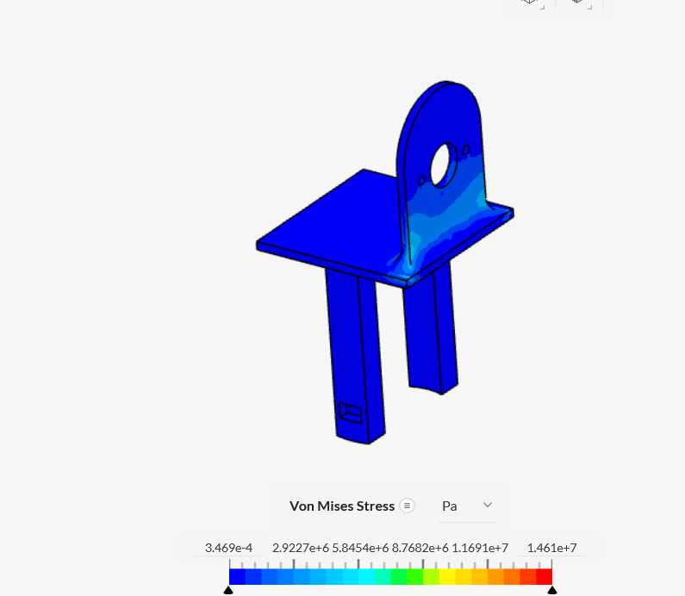
Figure 5.14 : SimScale von Mises stress in the slider and wheel bracket (legend in Pa)
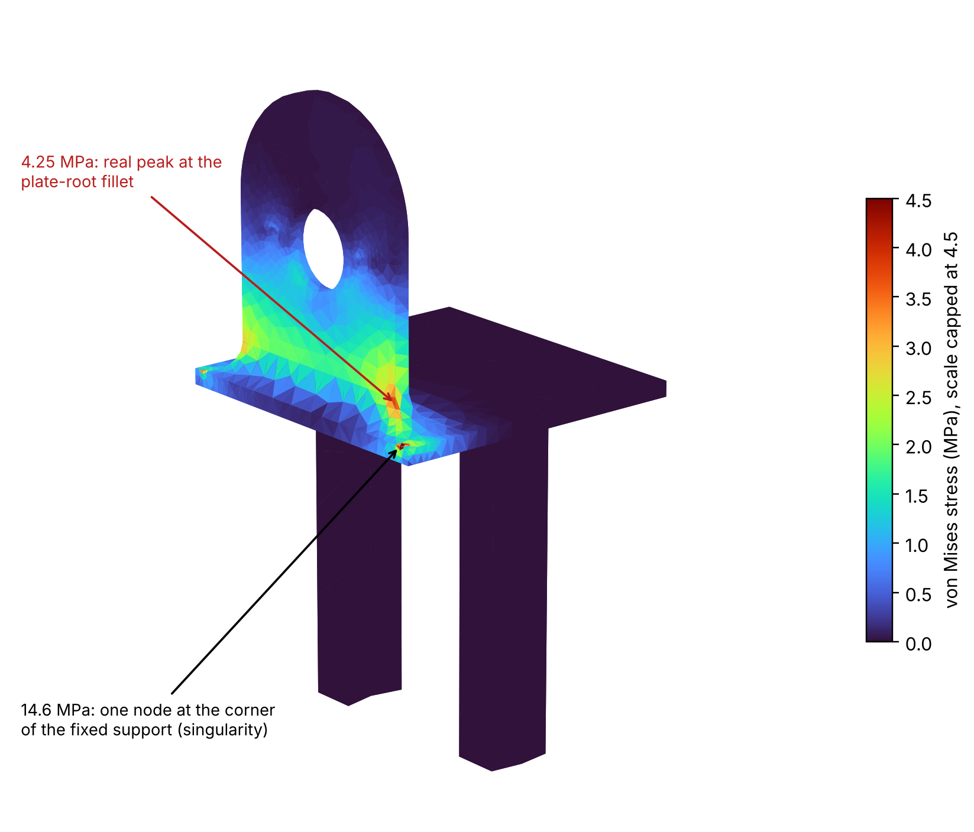
Figure 5.15 : The SimScale result re-plotted with the colour scale capped at 4.5 MPa, showing the peak at the root fillet and the support singularity
Beam theory (Eq. (4.16)) and the independent scikit-fem model reproduce this result (Table 5.7). At the end of the root fillet, 25 mm from the load, σ = 10 × 25/102.1 = 2.45 MPa. With the load at a = 32.5 mm and the free end at L = 65 mm, δ = 10 × 32.5² × (3 × 65 − 32.5)/(6 × 70 000 × 178.6) = 0.023 mm; the beam model ignores the stiffening of the root fillets and so slightly over-predicts. The scikit-fem model gives 0.017 mm and a root stress of 2.1–2.5 MPa. The three methods agree on the stress at the root to within about 15%; the higher SimScale peak at the fillet corner depends on how the 10 N load was distributed over the hole, which is not stored in the exported results.
Quantity | SimScale | scikit-fem | Beam theory
Root stress | 2.4–2.8 MPa | 2.1–2.5 MPa | 2.45 MPa
Free-end deflection | 0.020 mm | 0.017 mm | 0.023 mm
Peak at root fillet | 4.25 MPa | 2.5 MPa | —
Reported maximum | 14.6 MPa (singularity) | — | —
Table 5.7 : Bracket under the SimScale load (10 N normal to the plate and 10 N in its plane)
5.11.5 Bracket under the design wheel load
In service the bracket carries the wheel load F_{v} = 181 N at the measured 71.7 mm offset, a moment of M = 181 × 71.7 = 12 978 N·mm, 40 to 50 times the moment in the SimScale case. Beam theory gives a nominal stress of 12 978/102.1 = 127 MPa along the whole plate. The scikit-fem model under this load (Figure 5.16, Table 5.8) gives 139 MPa at the root fillet and 246 MPa in the narrow ligament between the motor hole and a motor-screw hole, where the holes remove more than half of the 50 mm plate width. Refining the mesh from 96 231 to 167 157 degrees of freedom changed the peak by 0.1% and the root stress by 2.6%, so the result is mesh-converged. The plate rotates by 1.59° under the motor in aluminium (beam theory: 1.93°), which tilts the wheel by the same angle, and the free end deflects by 1.5 mm.
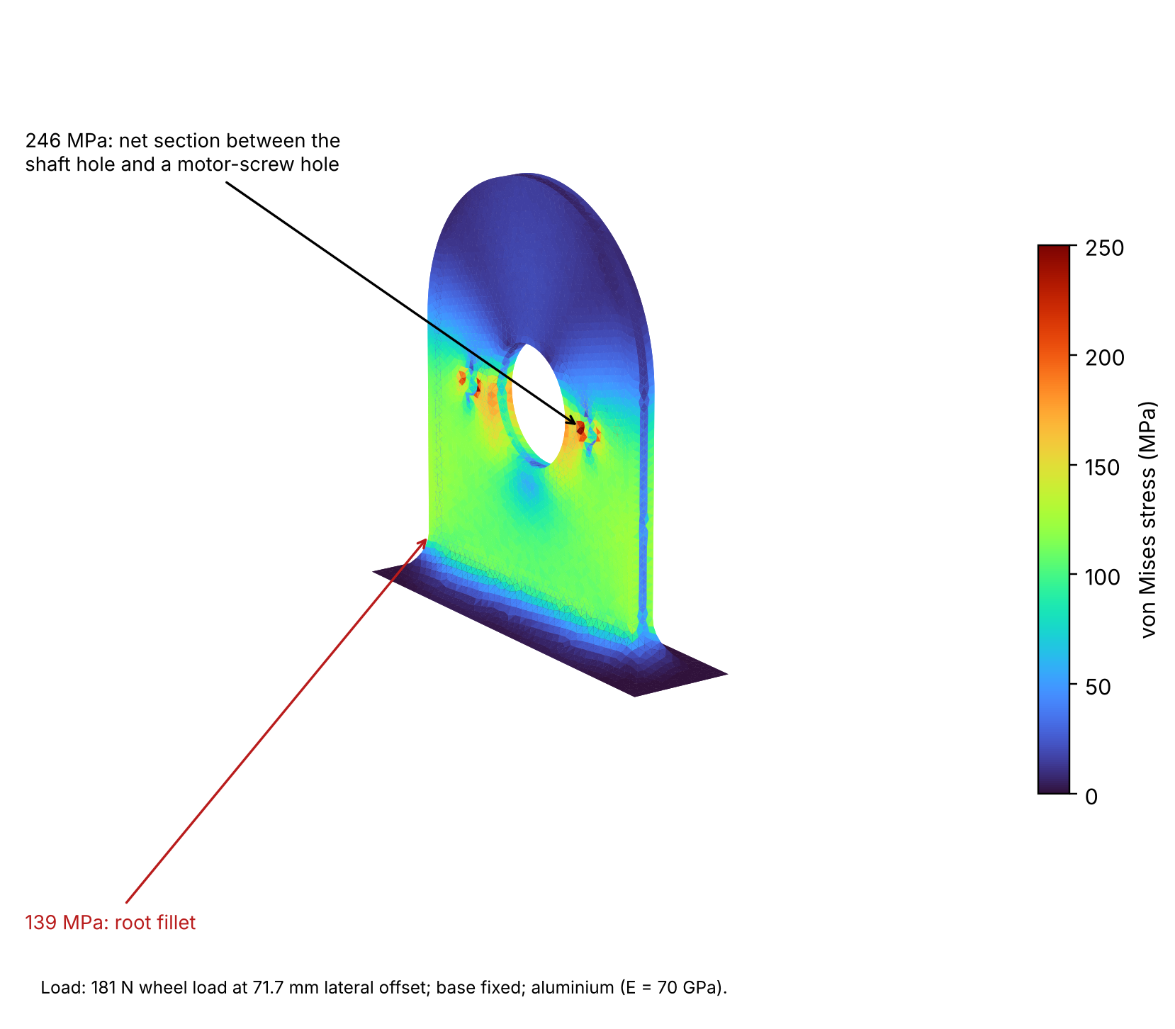
Figure 5.16 : Independent finite-element model of the wheel bracket under the design wheel load (181 N at 71.7 mm offset)
Quantity | Result | SF Al 6061-T6 | SF steel E250
Nominal bending stress (beam) | 127 MPa | 2.2 | 2.0
Root fillet (FEA) | 139 MPa | 2.0 | 1.8
Ligament at motor holes (FEA) | 246 MPa | 1.1 | 1.0
With bump factor 2 | 493 MPa | 0.6 | 0.5
Wheel tilt, Al / steel | 1.59° / 0.56° | — | —
Table 5.8 : Wheel bracket under the design wheel load (scikit-fem; stresses are the same in aluminium and steel)
Against the 276 MPa yield strength of 6061-T6 aluminium [66] and 250 MPa for E250 steel [62], the bracket as drawn has a safety factor of only about 1 at the motor holes, would yield under a bump load, and is far above the 96.5 MPa fatigue strength of the aluminium. The 3.5 mm bracket is therefore not adequate for the measured wheel offset. The stress scales with the moment and with 1/t², so the options compare as follows (same hole pattern, factors from the FEA): a 6 mm plate lowers the peak to 84 MPa (safety factor 3.3 in aluminium); moving the wheel to 20 mm from the plate lowers it to 69 MPa (4.0); both together give 23 MPa (11.8); and a fork that supports the shaft on both sides of the wheel removes the moment, leaving an in-plane stress of about 181/(23.6 × 3.5) = 2.2 MPa. A 6 mm steel plate with the wheel closer to it is the simplest change.
5.11.6 Motor attachment and shaft
Two further points follow from the measured geometry. First, the two motor screws sit fore and aft of the motor hole, on the axis about which the wheel-load moment acts, so they have no lever arm to resist it; the moment is carried only by the motor flange bearing on the plate and by the motor boss in its hole. The screw pattern should be turned through 90°, or four screws used. Second, the 15 mm shaft carries the wheel 69.95 mm from the bracket face, so from Eq. (4.22) its bending stress is σ_{s} = 32 × 181 × 69.95/(π × 15³) = 38 MPa, acceptable for a steel shaft, but the 181 N load at that overhang must be within the gearbox's permissible overhung load, which has to be confirmed from the motor datasheet.
5.12 Integration-level Findings
Five integration-level properties mattered more than the choice of any one algorithm: (1) Nav2's default progress check, never overridden by ARC, caused all 62 aborts; (2) the hand-over has no replanning or recovery; (3) a goal-reached race lets a stale arrival skip goals; (4) lidar odometry does not recover from a failed match; and (5) lidar odometry protects re-localisation. The recommendation is to adopt both phase-2 changes together, a progress check of 0.25 m in 20 s and exact path-cost ordering, paired with contact or slip detection on the cart [64].
5.13 Innovation and Technical Depth
ARC's originality lies in the system and the evidence rather than in a new algorithm. The project combined a retrofit concept, a full ROS 2 stack, exact route ordering, on-board person detection, a bench drive and a web interface, and evaluated them with a baseline-first protocol in which every fix was tested on the same tasks and seeds as the original. Faults were traced to specific code and parameters and explained by engineering models: the turn-time calculation predicts the progress-check aborts, the Held–Karp complexity shows the optimum is affordable on board, and the encoder model converts pulses into the measured stop and speed figures. Integrity checks in the test chain (verified obstacle removal, goal-matched arrivals, automatic re-checks) were themselves a technical contribution. The mechanical design was checked in the same way: the CAD assembly was measured in code, and an independent finite-element model, validated against SimScale and beam theory, showed before any part was made that the wheel bracket must be stiffened.
5.14 Cost-Benefit and Sustainability Impact
The measured benefit of the recommended fix is a 26% shorter and 38% less-driven shopping trip with no lost missions. Drive energy scales with distance: at the assumed 50 kg and C_{rr} = 0.02, rolling energy per trip falls from m g C_{rr} d = 50 × 9.81 × 0.02 × 18.6 = 182 J to 114 J, and any constant electronics load is on for 26% less time. The fix costs only configuration and software. ARC's bill of materials is not final, so a price comparison with commercial smart carts, which are quote-priced [67], is not yet possible (Table 5.9).
Option | Benefit | Cost or risk
ARC retrofit kit | Reuses existing carts; module serviced separately | Mount must fit different carts; BOM not final
Phase-2 software fix | −26% time, −38% distance, 30/30 lists | None in hardware; less smooth turning
Commercial smart cart | Item recognition and checkout | Quote-priced; no autonomous assistance
Simulation-first testing | Repeatable, low hardware dependence | Cannot model the real cart, floor and people
Table 5.9 : Preliminary cost-benefit assessment
5.15 Environmental and Societal Impact
Retrofitting extends the life of carts a store already owns, and shorter routes reduce energy per trip. For users, a cart that leads, follows and waits reduces the effort of shopping and supports independent access to stores. These societal benefits are intended outcomes; they require trials with older users, privacy-aware perception and certification against ISO 13482 before they can be claimed.
CHAPTER 6

CONCLUSION
- ARC's navigation stack localised to 2–3 cm and completed 29 of 30 shopping missions in simulation, but needed 97 recoveries; a kinematic calculation showed that Nav2's default progress check cannot be met after a 180° in-place turn at 0.10 m/s.
- Exact path-cost ordering cut driving time by 25–41%. Combined with a progress check of 0.25 m in 20 s it completed all 30 lists in 26% less time and 38% less distance (p = 5.1 × 10⁻⁷), meeting the evaluation objectives.
- On the bench, Pi-based person detection drove the behaviour tree and real motors; the wheels stopped within one 1 s telemetry period of every WAIT, and the shopping interface was linked to the stack through a new ROS 2 bridge.
- A quick-release drive mount was designed in CAD; a structural check showed that the loaded cart is stable but that the 3.5 mm wheel bracket must be thickened, or the wheel moved closer to it, before fabrication.
Scalability. The kit is software-defined: the same stack, test kit and interface apply to any store whose map can be built, and the mount can be adapted to other carts or to hospital and warehouse trolleys. Mass production needs a standard adjustable mount, a costed BOM, an independent motor-power E-stop and certification.
Technical hurdles. First, a goal-reached race: the latched 'goal reached' message and the planner's 2 s replan made stale arrivals skip goals; this was traced event by event and the UI bridge now accepts an arrival only near the goal and at least 3 s after it was sent. Second, the left encoder dropped out during the bench session, so that wheel ran without feedback; it was traced to an intermittent connection by comparison with the earlier calibration. Pi restarts under combined YOLO and OSNet load were traced to a 12 W supply.
Future work. Adopt the progress-check and ordering fixes in ARC; add replanning to the hand-over and odometry recovery after contact; restore left-wheel feedback; measure the camera-to-stop delay and the Pi frame rate; mount a 2D lidar on the cart; run the UI bridge on the real stack; and test two-person re-identification and trials with older users.
REFERENCES
Journal Publications:
- Al-Tawil, B., Candemir, A., Jung, M. and Al-Hamadi, A. (2025), ‘Mobile robot navigation with enhanced 2D mapping and multi-sensor fusion’, Sensors 25(8), Article 2408.
- Arkin, E., Yadikar, N., Xu, X., Aysa, A. and Ubul, K. (2023), ‘A survey: object detection methods from CNN to transformer’, Multimedia Tools and Applications 82, 21353–21383.
- Choi, D., Venepally, J. R. and Kim, D. (2025), ‘Path-planning and navigation for robots considering human–robot–environment interactions in supermarket environments’, Electronics 14(11), Article 2111.
- Croes, G. A. (1958), ‘A method for solving traveling-salesman problems’, Operations Research 6(6), 791–812.
- de Koster, R., Le-Duc, T. and Roodbergen, K. J. (2007), ‘Design and control of warehouse order picking: A literature review’, European Journal of Operational Research 182(2), 481–501.
- Dijkstra, E. W. (1959), ‘A note on two problems in connexion with graphs’, Numerische Mathematik 1, 269–271.
- Diwan, T., Anirudh, G. and Tembhurne, J. V. (2023), ‘Object detection using YOLO: challenges, architectural successors, datasets and applications’, Multimedia Tools and Applications 82, 9243–9275.
- Fox, D., Burgard, W. and Thrun, S. (1997), ‘The dynamic window approach to collision avoidance’, IEEE Robotics & Automation Magazine 4(1), 23–33.
- Held, M. and Karp, R. M. (1962), ‘A dynamic programming approach to sequencing problems’, Journal of the Society for Industrial and Applied Mathematics 10(1), 196–210.
- Iovino, M., Scukins, E., Styrud, J., Ögren, P. and Smith, C. (2022), ‘A survey of behavior trees in robotics and AI’, Robotics and Autonomous Systems 154, Article 104096.
- Kang, D., Kang, E., Park, J. and Eun, S.-D. (2026), ‘Universal bidirectional wheelchair propulsion system: Design and development of a detachable mechanism for manual wheelchair users with spinal cord injury’, Applied Sciences 16(5), Article 2505.
- Kruse, T., Pandey, A. K., Alami, R. and Kirsch, A. (2013), ‘Human-aware robot navigation: A survey’, Robotics and Autonomous Systems 61(12), 1726–1743.
- Labbé, M. and Michaud, F. (2019), ‘RTAB-Map as an open-source lidar and visual simultaneous localization and mapping library for large-scale and long-term online operation’, Journal of Field Robotics 36(2), 416–446.
- Li, B., Ni, K., Zhou, F., Li, Y., Huang, W., Jiang, H. and Liu, F. (2025), ‘Research on robot path planning based on fused Dijkstra and TEB algorithms’, Journal of Mechanical Science and Technology 39(8), 4651–4660.
- Liu, L., Wang, X., Yang, X., Liu, H., Li, J. and Wang, P. (2023), ‘Path planning techniques for mobile robots: Review and prospect’, Expert Systems with Applications 227, Article 120254.
- Loganathan, A. and Ahmad, N. S. (2023), ‘A systematic review on recent advances in autonomous mobile robot navigation’, Engineering Science and Technology, an International Journal, Article 101343.
- Macenski, S., Foote, T., Gerkey, B., Lalancette, C. and Woodall, W. (2022), ‘Robot Operating System 2: Design, architecture, and uses in the wild’, Science Robotics 7(66), Article eabm6074.
- Macenski, S., Moore, T., Lu, D. V., Merzlyakov, A. and Ferguson, M. (2023), ‘From the desks of ROS maintainers: A survey of modern & capable mobile robotics algorithms in the robot operating system 2’, Robotics and Autonomous Systems 168, Article 104493.
- Macenski, S., Singh, S., Martín, F. and Ginés, J. (2023), ‘Regulated pure pursuit for robot path tracking’, Autonomous Robots 47, 685–694.
- Mavrogiannis, C., Baldini, F., Wang, A., Zhao, D., Trautman, P., Steinfeld, A. and Oh, J. (2023), ‘Core challenges of social robot navigation: A survey’, ACM Transactions on Human-Robot Interaction 12(3), 1–39.
- Mur-Artal, R. and Tardós, J. D. (2017), ‘ORB-SLAM2: An open-source SLAM system for monocular, stereo, and RGB-D cameras’, IEEE Transactions on Robotics 33(5), 1255–1262.
- Möller, R., Furnari, A., Battiato, S., Härmä, A. and Farinella, G. M. (2021), ‘A survey on human-aware robot navigation’, Robotics and Autonomous Systems 145, Article 103837.
- Pan, J., Li, W., Liu, W., Islam, I., Guo, K., Yang, Y., Zhang, S., Ji, X. and Wang, D. (2026), ‘Mixed crowd navigation: Perception, interaction, planning, and control’, Annual Review of Control, Robotics, and Autonomous Systems 9, 325–349.
- Panigrahi, P. K. and Bisoy, S. K. (2022), ‘Localization strategies for autonomous mobile robots: A review’, Journal of King Saud University – Computer and Information Sciences 34(8), 6019–6039.
- Pomerleau, F., Colas, F., Siegwart, R. and Magnenat, S. (2013), ‘Comparing ICP variants on real-world data sets’, Autonomous Robots 34(3), 133–148.
- Punter, T. (2022), ‘Behavior trees for smart robots: Practical guidelines for robot software development’, Journal of Robotics 2022, Article 3314084.
- Rafai, A. N. A. et al. (2022), ‘A review on path planning and obstacle avoidance algorithms for autonomous mobile robots’, Journal of Robotics 2022, Article 2538220.
- Ramaraj, V., Paralikar, A., Lee, E. J., Anwar, S. M. and Monfaredi, R. (2024), ‘Development of a modular real-time shared-control system for a smart wheelchair’, Journal of Signal Processing Systems 96(3), 203–214.
- Ratliff, H. D. and Rosenthal, A. S. (1983), ‘Order-picking in a rectangular warehouse: A solvable case of the traveling salesman problem’, Operations Research 31(3), 507–521.
- Rosenkrantz, D. J., Stearns, R. E. and Lewis, P. M. (1977), ‘An analysis of several heuristics for the traveling salesman problem’, SIAM Journal on Computing 6(3), 563–581.
- Rösmann, C., Hoffmann, F. and Bertram, T. (2017), ‘Integrated online trajectory planning and optimization in distinctive topologies’, Robotics and Autonomous Systems 88, 142–153.
- Sales, J., Martí, J. V., Marín, R., Cervera, E. and Sanz, P. J. (2016), ‘CompaRob: The shopping cart assistance robot’, International Journal of Distributed Sensor Networks 12(2), Article 4781280.
- Sousa, R. B. et al. (2023), ‘A systematic literature review on long-term localization and mapping for mobile robots’, Journal of Field Robotics 40(5), 1245–1322.
- Terven, J., Córdova-Esparza, D.-M. and Romero-González, J.-A. (2023), ‘A comprehensive review of YOLO architectures in computer vision: From YOLOv1 to YOLOv8 and YOLO-NAS’, Machine Learning and Knowledge Extraction 5(4), 1680–1716.
- Tourani, A., Bavle, H., Sanchez-Lopez, J. L. and Voos, H. (2022), ‘Visual SLAM: What are the current trends and what to expect?’, Sensors 22(23), Article 9297.
- Wei, W., Yang, W., Zuo, E., Qian, Y. and Wang, L. (2022), ‘Person re-identification based on deep learning — An overview’, Journal of Visual Communication and Image Representation 82, Article 103418.
- Wilcoxon, F. (1945), ‘Individual comparisons by ranking methods’, Biometrics Bulletin 1(6), 80–83.
- Wu, J., Ma, X., Peng, T. and Wang, H. (2021), ‘An improved timed elastic band (TEB) algorithm of autonomous ground vehicle (AGV) in complex environment’, Sensors 21(24), Article 8312.
- Yang, L., Li, P., Qian, S., He, Q., Miao, J., Liu, M., Hu, Y. and Memetimin, E. (2023), ‘Path planning technique for mobile robots: A review’, Machines 11(10), Article 980.
- Yao, H., Peng, J., Dai, H., Li, F. and Lueth, T. C. (2026), ‘A shopping service robot framework with visual-WEM tracking and intersection-aware following’, IEEE Robotics and Automation Letters 11(4), 4889–4896.
- Yueh, H.-P., Lin, W., Chen, C.-H., Chang, F.-H. and Fu, L.-C. (2026), ‘From automation to cognition: A contextual design approach for enhancing elderly patron services with proactive and memory-aware library robots’, The Electronic Library 44(1), 204–226.
- Zaidi, S. S. A., Ansari, M. S., Aslam, A., Kanwal, N., Asghar, M. N. and Lee, B. (2022), ‘A survey of modern deep learning based object detection models’, Digital Signal Processing 126, Article 103514.
- Ögren, P. and Sprague, C. I. (2022), ‘Behavior trees in robot control systems’, Annual Review of Control, Robotics, and Autonomous Systems 5, 81–107.
Conference Proceedings:
- Aye, Y. Y., Thiha, K., Pyu, M. M. M. and Watanabe, K. (2019), A deep neural network based human following robot with fuzzy control, in ‘Proceedings of the IEEE International Conference on Robotics and Biomimetics (ROBIO)’, pp. 720–725.
- Basso, F., Munaro, M., Michieletto, S., Pagello, E. and Menegatti, E. (2012), Fast and robust multi-people tracking from RGB-D data for a mobile robot, in ‘Proceedings of the International Conference on Social Robotics (ICSR)’, Springer.
- Chiang, H.-H., You, W.-T., Lin, S.-H., Shih, W.-C., Liao, Y.-T., Lee, J.-S. and Chen, Y.-L. (2016), Development of smart shopping carts with customer-oriented service, in ‘Proceedings of the International Conference on System Science and Engineering (ICSSE)’.
- Estember, R. D. and Berdan, M. H. P. (2017), Ergonomic assessment and design improvement of shopping carts for the satisfaction of buyers in grocery stores and supermarkets, in ‘Proceedings of the IEEE International Conference on Industrial Engineering and Engineering Management (IEEM)’.
- Koenig, N. and Howard, A. (2004), Design and use paradigms for Gazebo, an open-source multi-robot simulator, in ‘Proceedings of the IEEE/RSJ International Conference on Intelligent Robots and Systems (IROS)’, pp. 2149–2154.
- Kohtsuka, T., Onozato, T., Tamura, H., Katayama, S. and Kambayashi, Y. (2011), Design of a control system for robot shopping carts, in ‘Knowledge-Based and Intelligent Information and Engineering Systems (KES 2011)’, LNCS 6881, pp. 280–288.
- Kulyukin, V., Gharpure, C. and Nicholson, J. (2005), RoboCart: Toward robot-assisted navigation of grocery stores by the visually impaired, in ‘Proceedings of the IEEE/RSJ International Conference on Intelligent Robots and Systems (IROS)’.
- Luber, M., Spinello, L. and Arras, K. O. (2011), People tracking in RGB-D data with on-line boosted target models, in ‘Proceedings of the IEEE/RSJ International Conference on Intelligent Robots and Systems (IROS)’.
- Macenski, S., Martín, F., White, R. and Ginés Clavero, J. (2020), The Marathon 2: A navigation system, in ‘Proceedings of the IEEE/RSJ International Conference on Intelligent Robots and Systems (IROS)’, pp. 2718–2725.
- Nishimura, S., Takemura, H. and Mizoguchi, H. (2007), Development of attachable modules for robotizing daily items — Person following shopping cart robot, in ‘Proceedings of the IEEE International Conference on Robotics and Biomimetics (ROBIO)’, pp. 1506–1511.
- Rachman, F. I. (2025), Improved dynamic window approach using Sugeno fuzzy logic for mobile robot collision avoidance, in ‘Proceedings of the IEEE International Conference on Computer Engineering, Network, and Intelligent Multimedia (CENIM)’.
- Rösmann, C., Feiten, W., Wösch, T., Hoffmann, F. and Bertram, T. (2012), Trajectory modification considering dynamic constraints of autonomous robots, in ‘Proceedings of the 7th German Conference on Robotics (ROBOTIK)’.
- Satake, J. and Miura, J. (2009), Robust stereo-based person detection and tracking for a person following robot, in ‘Proceedings of the IEEE ICRA Workshop on People Detection and Tracking’, Kobe, Japan.
- Shan, T., Englot, B., Meyers, D., Wang, W., Ratti, C. and Rus, D. (2020), LIO-SAM: Tightly-coupled lidar inertial odometry via smoothing and mapping, in ‘Proceedings of the IEEE/RSJ International Conference on Intelligent Robots and Systems (IROS)’, pp. 5135–5142.
- Su, H., Zhang, Y., Li, J. and Hu, J. (2016), The shopping assistant robot design based on ROS and deep learning, in ‘Proceedings of the 2nd International Conference on Cloud Computing and Internet of Things (CCIOT)’, pp. 173–176.
- Yong, C. L., Kwan, B. H., Ng, D. W. K. and Sim, H. S. (2022), Human tracking and following using machine vision on a mobile service robot, in ‘Proceedings of the IEEE 10th Conference on Systems, Process and Control (ICSPC)’, pp. 274–279.
- Zhang, Y., Sun, P., Jiang, Y., Yu, D., Weng, F., Yuan, Z., Luo, P., Liu, W. and Wang, X. (2022), ByteTrack: Multi-object tracking by associating every detection box, in ‘Proceedings of the European Conference on Computer Vision (ECCV)’, pp. 1–21.
- Zhou, K., Yang, Y., Cavallaro, A. and Xiang, T. (2019), Omni-scale feature learning for person re-identification, in ‘Proceedings of the IEEE/CVF International Conference on Computer Vision (ICCV)’, pp. 3702–3712.
Books:
- Bureau of Indian Standards (2011), ‘IS 2062:2011 Hot rolled medium and high tensile structural steel — Specification’, BIS, New Delhi.
- Colledanchise, M. and Ögren, P. (2018), ‘Behavior Trees in Robotics and AI: An Introduction’, CRC Press.
- International Organization for Standardization (2014), ‘ISO 13482:2014 Robots and robotic devices — Safety requirements for personal care robots’, ISO, Geneva.
- Thrun, S., Burgard, W. and Fox, D. (2005), ‘Probabilistic Robotics’, MIT Press.
Websites:
- ASM Aerospace Specification Metals Inc. (n.d.). Aluminum 6061-T6; 6061-T651 material data sheet. MatWeb. Retrieved 19 October 2026 from https://asm.matweb.com/search/SpecificMaterial.asp?bassnum=ma6061t6
- Caper. (n.d.). Smart shopping carts | AI shopping cart technology. Retrieved 17 October 2026 from https://www.caper.ai/
- Raspberry Pi Ltd. (n.d.). Raspberry Pi 27W USB-C Power Supply. Retrieved 19 October 2026 from https://www.raspberrypi.com/products/27w-power-supply/
- United Nations. (n.d.). The 17 Goals: Sustainable Development. Retrieved 19 October 2026 from https://sdgs.un.org/goals
- Yaseen, M. (2024). What is YOLOv8: An in-depth exploration of the internal features of the next-generation object detector [Preprint]. arXiv. Retrieved from https://arxiv.org/abs/2408.15857

APPENDIX A
This appendix lists the parameters used in the calculations of Chapters 4 and 5 and the mapping from interface products to store items used by the UI bridge.
A.1 Parameters Used in the Calculations
Parameter | Value | Source
Wheel diameter D | 0.08 m | M (bench)
Track width B | 0.16 m | M (bench)
Pulses per wheel revolution P_{w} | 7 × 30 = 210 | M (motor, gearbox)
Telemetry period Δt | 1 s | M (firmware)
LEAD / follow speed | 0.10 / 0.15 m/s | M (configuration)
ω_{max}, α_{max} | 0.5 rad/s, 1.0 rad/s² | M (configuration)
Progress check r, T | 0.5 m, 10 s → 0.25 m, 20 s | M (Nav2 default, phase 2)
Software stop delay | ≤ 0.20 s + 0.05 s | M (logs, bridge rate)
Braking deceleration a_{b} | 0.5 m/s² | A
Mass m | 50 kg | A
Rolling resistance C_{rr} | 0.02 | A
Acceleration a | 0.25 m/s² | A
Ramp | 1:20 (2.86°) | A
Gearbox efficiency | 80% | A
Bracket plate b × t | 50 × 3.5 mm | M (CAD)
Root to shaft L_{h} | 32.5 mm | M (CAD)
Guide slot / rail width | 15.2 / 13.0 mm | M (CAD)
Wheel offset e | 71.7 mm | M (CAD)
Wheelbase / drive track | 680 / 340 mm | M (CAD)
Centre-of-mass height | 600 mm | M (CAD cart model)
Loaded mass m | 50 kg | A
Wheel load F_{v} | 181 N | M (CAD) with m = 50 kg
Wheel radius r_{w} | 75 mm | M (CAD)
Friction coefficient | 0.5 | A
E aluminium / steel | 70 / 200 GPa | M (FEA) / A
Table A.1 : Parameters used in the calculations (M = measured or configured, A = assumed)
A.2 Interface Product to Store Item Mapping
Product IDs | Store item
FP001–003 / FP004–006 | fruits / vegetables
DY001–004 / DY005–006 | milk / curd_paneer
BK001 / BK002–005 / BK006 | bakery / biscuits / breakfast_cereal
GR001–004, GR006 / GR005 | atta_flour / rice
GS001–003 / GS004 / GS005–006 | dal_pulses / cooking_oil / sauces
PF001 / PF002 / PF003, 004, 006 / PF005 | pasta / biscuits / jam_spreads / bakery
SN001–006 | snacks
BV001, 002, 004 / BV003 / BV005–006 | tea_coffee / juice / water_beverages
HC001–003 / HC004–006 | detergent / cleaning
PC001, 003, 004, 006 / PC002, 005 | toiletries / soap_shampoo
Table A.2 : Mapping of the 60 interface products to store items

