**QUESTION 1:**

Original code:

Vector3f pixelCenter = (this->upperLeft  + this->pixelDeltaU*(x+0.5f) + this->pixelDeltaV*(y+0.5f));

Vector3f direction = Normalize((pixelCenter- this->from));

Fixed code:

Vector3f pixelCenter = (this->upperLeft - this->from + this->pixelDeltaU*(x+0.5f) + this->pixelDeltaV*(y+0.5f));

Vector3f direction = Normalize((pixelCenter));

In the original code, the shift is being added after computation of the pixel center — i.e., the pixel center is first calculated in camera space, and then the shift is performed. In the second code, first the shift is applied (in world space) and then the pixel center is computed in camera space, then normalized. This prevents the error/shift from blowing out of proportion in the camera space. The precision error was minimized by applying the shift early on, before transforming and normalizing.

**QUESTION 2:**

CornellBox/scene_lo_poly.json:

Timings:

* 0(default): 38308.449219 ms
* 1(aabb): 10330.414062 ms
* 2(bvh): 4454.729980 ms
* 3(bvh on triangles): 506.368988 ms

0:

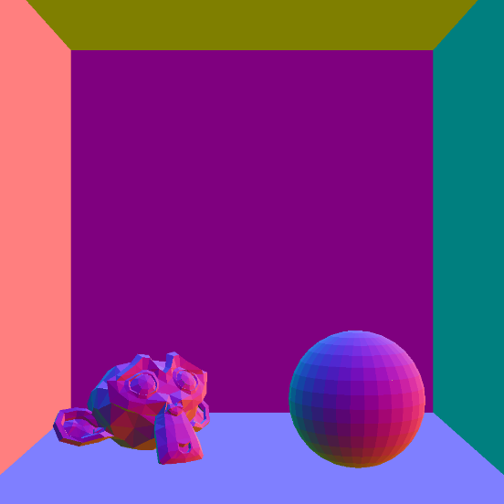

1:

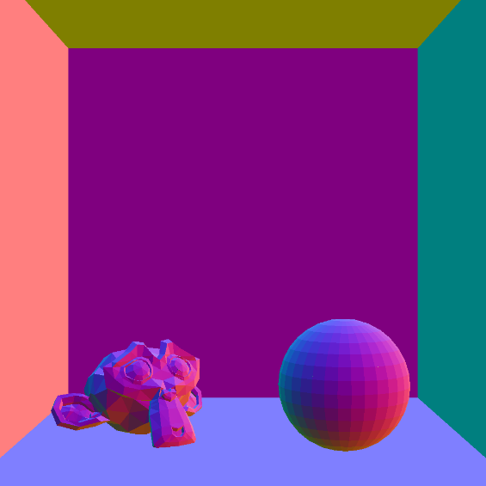

2:



3:



CornellBox/scene_hi_poly.json:

Timings:

* 0(default): 158341.703125 ms
* 1(aabb): 49222.769531 ms
* 2(bvh): 20022.216797 ms
* 3(bvh on triangles): 1044.665039 ms

0:

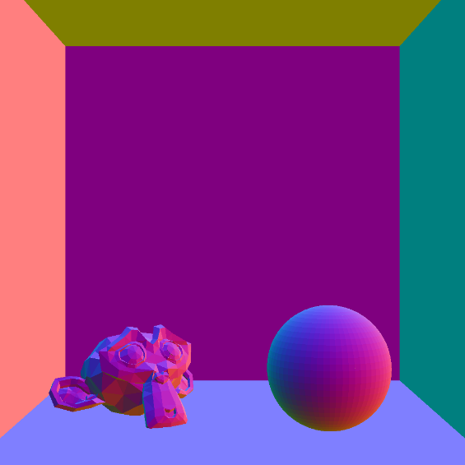

1:



2:



3:



Donuts/scene.json:

Timings:

* 0(default): 50378.10156 ms
* 1(aabb): 17525.640625 ms
* 2(bvh): 6317.578125 ms
* 3(bvh on triangles): 354.872009 ms

0:

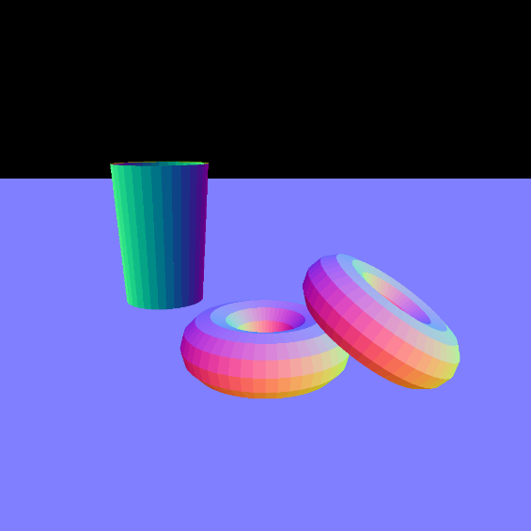

1:



2:



3:



TableTop/scene.json:

Timings:

* 0(default): 51562.226562 ms
* 1(aabb): 11247.865234 ms
* 2(bvh): 10425.087891 ms
* 3(bvh on triangles): 446.325012 ms

0:

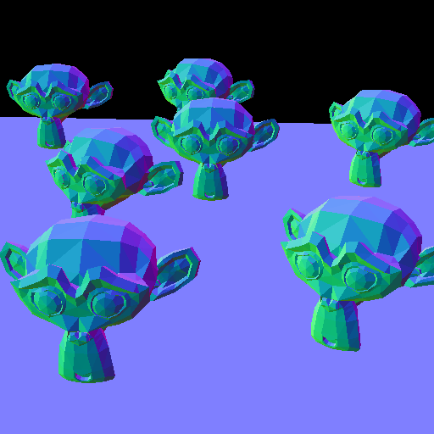

1:



2:



3:

