**End to End Process: [Cleaning, Data transformation, Data Modelling & Data Visualization**

* Data: LondonHousePrices
* We had Borough names as column header & dates as row in our initial data frame - properties
* We transposed this data & formatted it using melt
* We got Boroughs, dates & their values in a dataframe
* Then kept only the required Boroughs in the dataframe (removed nonBoroughs from the dataframe)
* Extracted the Year column from Date column
* Removed the null values
* We then used groupby (borough & Year) to calculate the average price of each borough
* We then made a function that calculate the ratio to compare, 1999 prices to 2018 prices
* Then we created the dataframe df1_ratios, containing Boroughs & ratios
* Then plotted a bar graph containing highest ratios, high growth in prices

**Insights:**

* During our 1st line graph – for only Camden Borough, we saw that it had increasing trend for its average price through out the period from 1999 – 2015, then the prices are pretty stagnant till 2024
  + Similar plots can be observed for other boroughs too by selecting the required borough in the dropdown

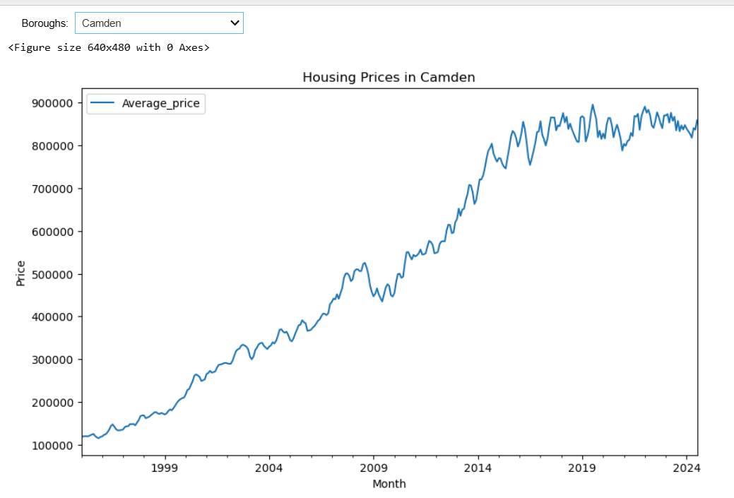

* Top 15 Boroughs are, highest growth in house prices in last 2 decades
  + Text(0, 0, 'Hackney'),
  + 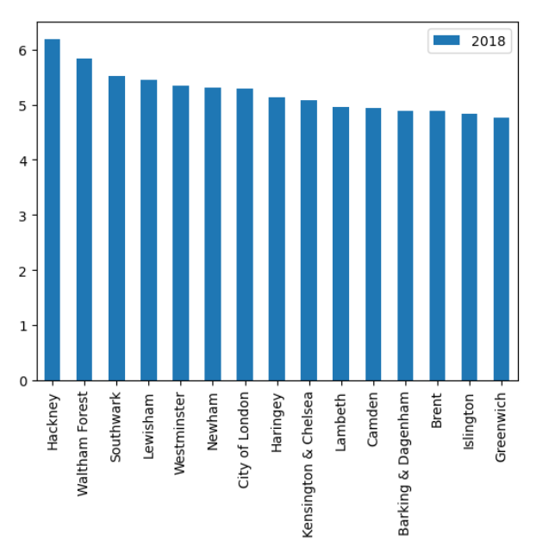 Text(1, 0, 'Waltham Forest'),
  + Text(2, 0, 'Southwark'),
  + Text(3, 0, 'Lewisham'),
  + Text(4, 0, 'Westminster'),
  + Text(5, 0, 'Newham'),
  + Text(6, 0, 'City of London'),
  + Text(7, 0, 'Haringey'),
  + Text(8, 0, 'Kensington & Chelsea'),
  + Text(9, 0, 'Lambeth'),
  + Text(10, 0, 'Camden'),
  + Text(11, 0, 'Barking & Dagenham'),
  + Text(12, 0, 'Brent'),
  + Text(13, 0, 'Islington'),
  + Text(14, 0, 'Greenwich')]
* the lowest 15 are
  + Text(0, 0, 'Hounslow'),
  + 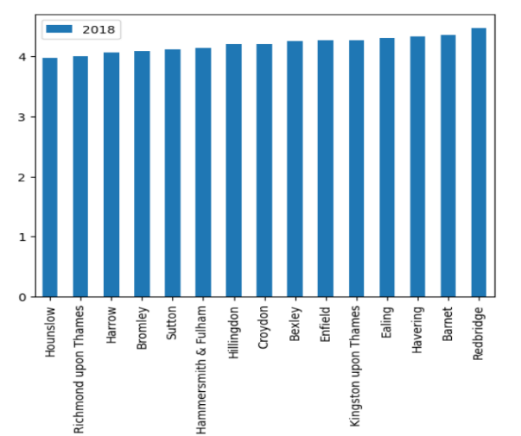Text(1, 0, 'Richmond upon Thames'),
  + Text(2, 0, 'Harrow'),
  + Text(3, 0, 'Bromley'),
  + Text(4, 0, 'Sutton'),
  + Text(5, 0, 'Hammersmith & Fulham') ,
  + Text(6, 0, 'Hillingdon'),
  + Text(7, 0, 'Croydon'),
  + Text(8, 0, 'Bexley'),
  + Text(9, 0, 'Enfield'),
  + Text(10, 0, 'Kingston upon Thames'),
  + Text(11, 0, 'Ealing'),
  + Text(12, 0, 'Havering'),
  + Text(13, 0, 'Barnet'),
  + Text(14, 0, 'Redbridge')