MOVIE RECOMMENDATION SYSTEM
Project Report
Submitted by:
Akshada Wankhede
Course:
B.Sc. Computer Science – Third Year
Project Title:
Movie Recommendation System

1. Introduction
In today's digital world, users have access to a very large number of movies through different online platforms. Because of the huge amount of available content, users may find it difficult to decide which movie to watch.
A Movie Recommendation System helps users discover movies according to their interests. This project develops a content-based Movie Recommendation System using Python and machine learning techniques.
The system takes a movie selected by the user and recommends the top five movies that are similar to it. The system also displays useful information such as the movie poster, IMDb rating, release year, genre, and plot.

2. Problem Statement
Users often spend a lot of time searching for movies that match their interests. A large movie collection makes it difficult to manually find similar movies.
Therefore, there is a need for a system that can automatically recommend movies based on the characteristics of a movie selected by the user.

3. Objectives
The main objectives of this project are:
- To develop a movie recommendation system using Python.
- To recommend movies similar to a selected movie.
- To use movie information such as genres, keywords, cast, and director.
- To apply machine learning techniques for calculating movie similarity.
- To provide an easy-to-use web interface using Streamlit.
- To display additional movie information such as posters, ratings, genre, year, and plot.

4. Technologies Used
Technology | Purpose
Python | Main programming language
Pandas | Data loading and preprocessing
NumPy | Numerical operations
Scikit-learn | Machine learning and similarity calculation
Streamlit | Web application interface
OMDb API | Movie details, posters and ratings
Jupyter Notebook | Data analysis and model development

5. Dataset
The project uses movie and credits datasets.
The movie dataset contains information such as:
- Movie ID
- Movie title
- Overview
- Genres
- Keywords
The credits dataset contains information such as:
- Movie ID
- Cast
- Crew
- Director
These features are processed and combined to identify similarities between movies.

6. Data Preprocessing
Before building the recommendation system, the data is cleaned and prepared.
The main preprocessing steps include:
- Loading the movie and credits datasets.
- Selecting the required columns.
- Combining the movie and credits datasets using the movie ID.
- Handling missing values.
- Extracting information from genres, keywords, cast, and crew.
- Identifying the movie director.
- Combining important information into a single tags feature.
The tags feature is then used to calculate similarity between movies.

7. Recommendation Methodology
This project uses a content-based filtering approach.
The system recommends movies based on the similarity of their content rather than using ratings from other users.
The main steps are:

Step 1: Select a Movie
The user enters the name of a movie in the search box.

Step 2: Find the Movie
The system searches the movie dataset and identifies the selected movie.

Step 3: Convert Movie Information into Vectors
The movie tags are converted into numerical vectors using CountVectorizer from Scikit-learn.

Step 4: Calculate Similarity
The system uses cosine similarity to calculate how similar movies are to each other.

Step 5: Generate Recommendations
The system sorts the similarity scores and selects the top five similar movies.

8. System Workflow
The overall workflow of the system is:
User enters movie name
↓
Search for movie
↓
Retrieve movie information
↓
Compare movie features
↓
Calculate similarity
↓
Find similar movies
↓
Display top 5 recommendations

9. Web Application
The project uses Streamlit to create a user-friendly web interface.
The application contains:
- Movie search box
- Search button
- Selected movie details
- Movie poster
- IMDb rating
- Release year
- Genre
- Plot
- Five recommended movies
- Dark-themed user interface
The OMDb API is used to retrieve additional movie information and posters.

10. Project Files
The main project files are:
Akshada_MovieRecommendationSystem.py
Contains the Python code used for data preprocessing and building the recommendation model.
requirements.txt
Contains the Python libraries required to run the project.
Akshada_MovieRecommendationSystem_ProjectReport.docx
Contains the documentation and explanation of the project.
README.md
Contains project information, setup instructions, technologies, and usage instructions.
Other supporting files include the Streamlit application, processed movie data, similarity data, and datasets.

11. Results
The developed system successfully recommends movies based on the movie selected by the user.
For example, when a user searches for a movie, the system identifies similar movies using the calculated similarity scores and displays the top five recommendations.
The system also provides additional information about the selected and recommended movies, including posters, ratings, year, genre, and plot.

18. UI Screenshot

Insert a screenshot of the running Streamlit Movie Recommendation System here before

final submission. The screenshot should show the movie search, selected movie details

and recommended movies.

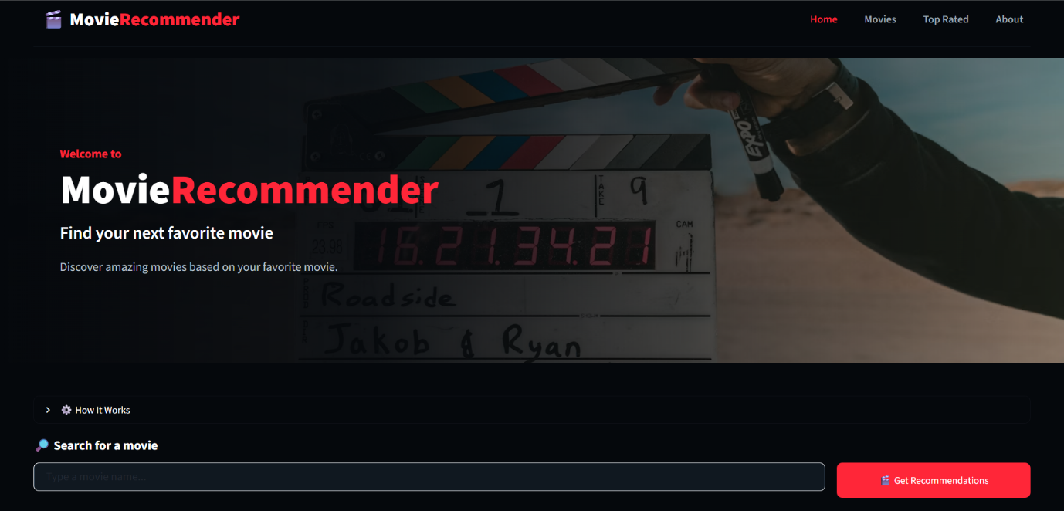

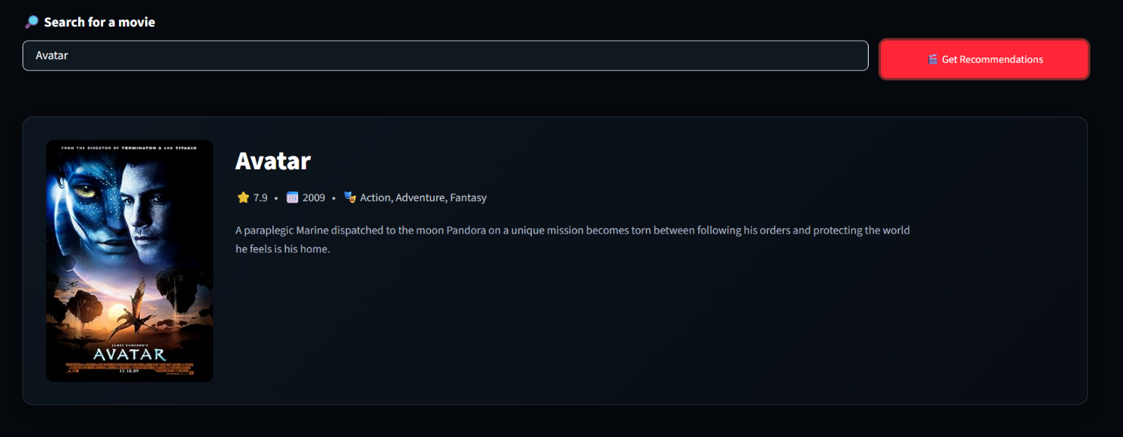

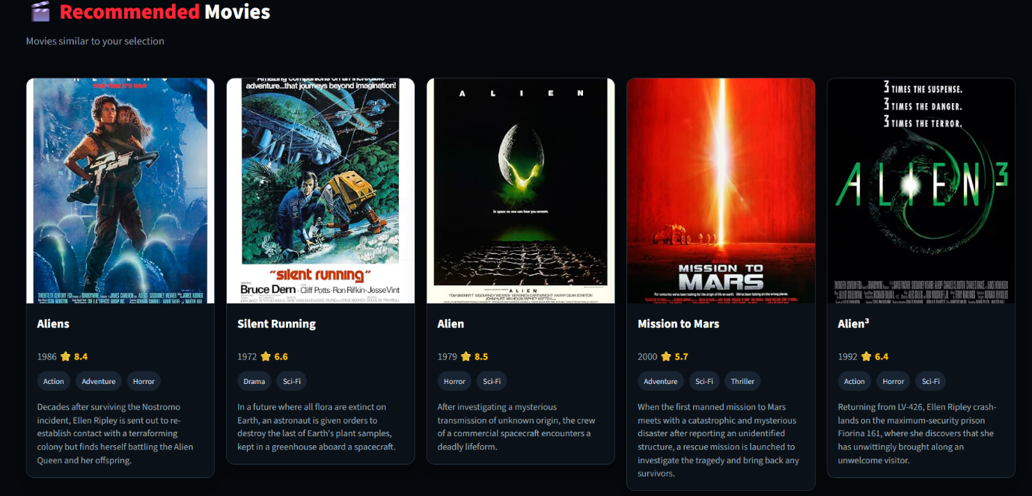

12. Conclusion
The Movie Recommendation System demonstrates how Python and machine learning techniques can be used to recommend movies based on their content.
By using features such as genres, keywords, cast, and director, the system calculates similarity between movies and recommends the top five similar movies.
The Streamlit interface makes the system easy to interact with, while the OMDb API provides additional movie information such as posters, ratings, release year, genre, and plot.
Overall, the project provides a practical example of using data preprocessing, machine learning, content-based filtering, and web application development to solve a real-world recommendation problem.

