FUNCTION BLOCK TYPE: EVENTS

A function block in IEC61499 can be an active or a passive element. A passive element waits for a event to trigger its functionality while an active element is time dependent. As we are migrating from the IEC61131-3 standards to IEC61499 standard, it has become a necessity to have total control over the events in the applications.The “events” type function blocks facilitate the manipulation of various events and process them as per our requirements.

WORKING OF EACH EVENT FUNCTION BLOCK

- E-CTD
- E-CTU
- E-CTUD
- E-CYCLE
- E-D_FF
- E-DELAY
- E-DEMUX-2
- E-FTRIG
- E-LDU *
- E-MERGE
- E-MUX-2
- E-PERMIT
- E-R-TRIG
- E-R-DELAY*
- E_REND
- E_RS
- E_R_TIMEOUT *
- E-SELECT
- E-SPLIT
- E-SR*
- E-SWITCH
- E_TIMEOUT*

E-CTD :
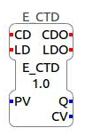
This event type function block is basically a down counter which counts down whenever CD is triggered starting from the preset value (PV). First to initialise we need to trigger the Load event (LD).This will set the Count Value(CV) to PV. Now triggering CD event will make the counter count down from the PV value. For subsequent triggers of CD the CV value becomes 1 value less.

Q becomes true when CV<=0.
CDO event is triggered when CD event is triggered.
LDO event is triggered when LD event is triggered.
PV value can be set using UINT#value.
It can count upto 0.

Ex. Let us Load the PV value of 50 to CV and subsequently trigger the CD event.
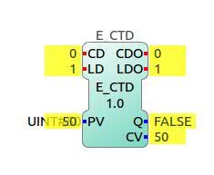
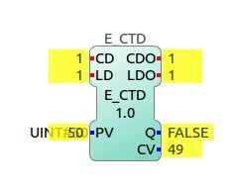
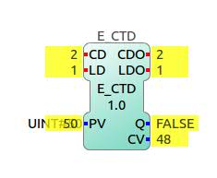

LD is triggered. CD is triggered. CD is again triggered

E-CTU:
This event type function block is basically an up counter which counts up whenever CU is triggered starting from 0. Triggering the Reset(R) event resets the count Value (CV) to zero. For subsequent triggers of CD the CV value becomes 1 value more.
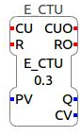
Q becomes true when CV>=PV.
CDO event is triggered when CD event is triggered.
RO event is triggered when R event is triggered.
PV value can be set using UINT#value.

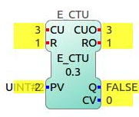
Ex.
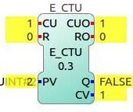
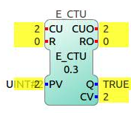
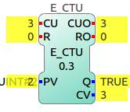

CU is triggered once CU is triggered twice CU is triggered thrice R is triggered

E-CTUD:
This event type function block is basically an up down counter which is capable of counting up as well as down depending upon the event triggered.It counts down whenever CD is triggered and counts up whenever CU is triggered.Triggering R will reset the CV to 0. Triggering LD will set the CV to PV.
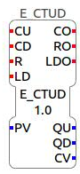
QD becomes true when CV<=0.
QU becomes true when CV>=PV
CO event is triggered when CU or CD event is triggered.
LDO event is triggered when LD event is triggered.
RO is triggered when R is triggered.
PV value can be set using UINT#value.
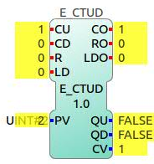
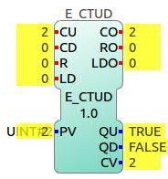
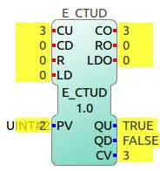

CU is triggered once. CU is triggered twice CU is triggered thrice

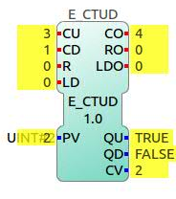
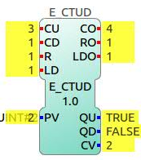
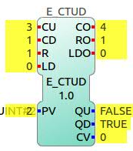

CD is triggered R is triggered LD is triggered

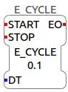
E-CYCLE:
E-CYCLE is an event type function block that is capable of triggering output event EO at intervals of time DT once the START is triggered. This block stops triggering EO when STOP is triggered.
DT can be set using t#time. Ex: t#1000ms or t#2s.

E_D_FF
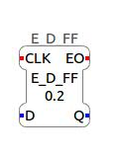
A D_FF block basically works like a D Flipflop. Whenever the Clock is triggered the Input Data D is sent to Output data Q. Output event EO is trigered only when there is a change in the Output Data from TRUE to FALSE or vice versa.

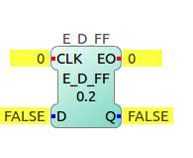
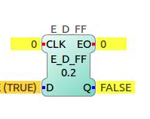
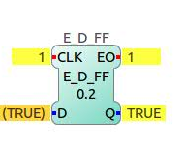

Initial state. D is given TRUE value clock is triggered

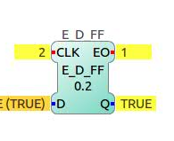
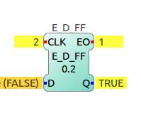
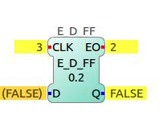

clock is triggered again D is given FALSE value clock is triggered

E_DELAY:
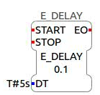
E_DELAY is a function block that triggers the output event after a specified time after the START event is triggered. DT can be set using T#time. Ex. T#5s. In this example if the START eent is triggered at t=0s then the EO will be trigered at t=5s.

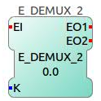
E_DEMUX2
As the name suggests this function block behaves like a demux. K can be assumed to be the selectline which can take UINT value 0 or 1. According to value of K EO1 or EO2 is triggered.
If K=0; EO1 is triggered when EI is triggered.
If K=1; EO2 is triggered when EI is triggered.
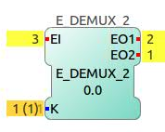
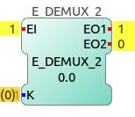
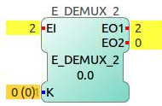

K=0; clock triggered K=0; again clock triggered K=1; clock triggered

E_F_TRIG:
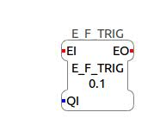
This function block triggers an output event only when it detetects a falling edge in data i.e input event being continuously triggered, output event will be triggered only when QI changes from TRUE to FALSE.
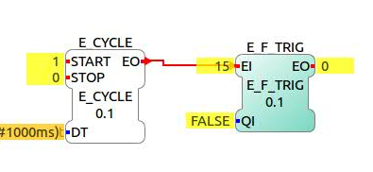
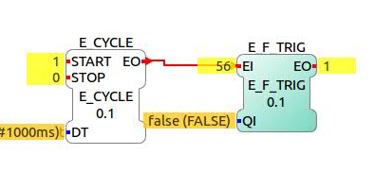

QI=FALSE

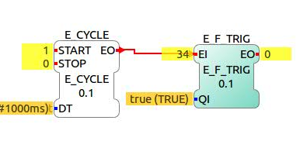

QI is made TRUE

QI is made false; EO detects falling edge and gets triggered.

E_LDU: (TO DO)

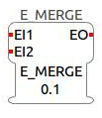
E_MERGE:
This function block essentially works like an OR gate of events.If either of the input events is triggered, the output event is triggered.

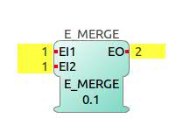
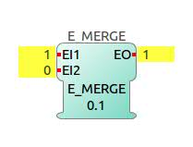

EI1 is triggered EI2 is triggered

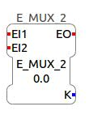
E_MUX_2:
Output event EO is triggered when either
of the two input events EI1 or EI2 is triggered. The output data K gives the input event number that is selected i.e last triggered.
If EI1 is triggered, K=0
If EI2 is triggered, K=1
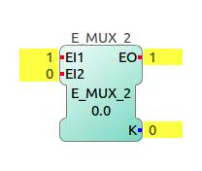
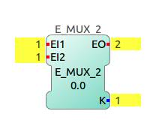

EI1 is triggered EI2 is triggered

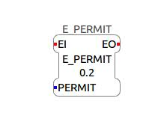
E_PERMIT:
This function block acts like a converter from data to event. The input event is passed as output event only when the PERMIT is TRUE otherwise if the PERMIT is FALSE, then the output event is not triggered even when the input event has been triggered.

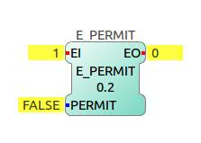
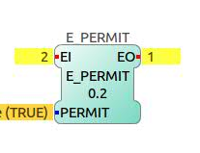

PERMIT=FALSE; EI triggered PERMIT=TRUE; EI triggered

E_R_TRIG:
This function block triggers an output event only when it detetects a rising edge in data i.e input event being continuously triggered, output event will be triggered only when QI changes from FALSE to TRUE.
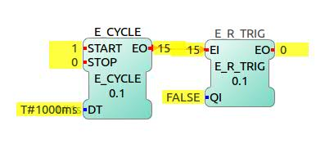

QI=FALSE

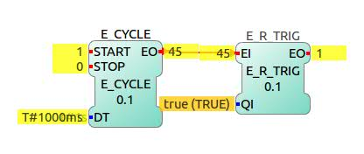

QI is made TRUE; EO gets triggered.
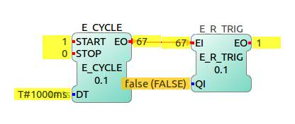

QI is made FALSE;
EO is not triggered.

E_R_DELAY (to do)
(*exactly same as E_DELAY*)
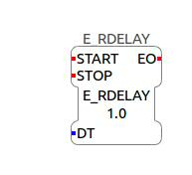
E_DELAY is a function block that triggers the output event after a specified time after the START event is triggered. DT can be set using T#time. Ex. T#5s. In this example if the START eent is triggered at t=0s then the EO will be trigered at t=5s.

E_REND:
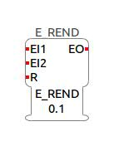
This function block has its functionality like an AND gate.The output event EO is triggered only when both EI1 and EI2 are triggered. If either of the input events is not triggered then the output event is not triggered.
After triggering one input event if reset is triggered then it resets the events and now if the other event is triggered, the output event wont be triggered.

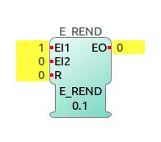
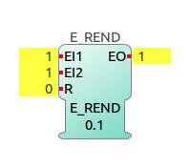

EI1 is triggered EI2 is triggered

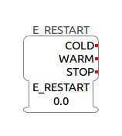
E_RESTART:
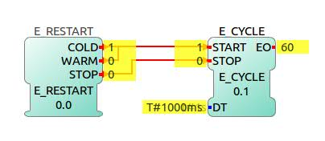
This function block takes in no input event but is resposible for producing events. This is usually used for starting and stopping of applications.On deployment of the application, the cold start occurs automatically. The subsequent starts are warm starts. Stop event intends to stop the application.

Application is deployed
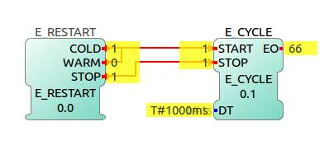

STOP is triggered

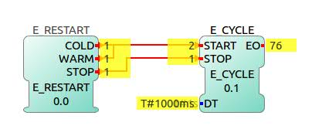

Warm start is triggered.

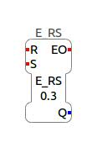
E_RS:
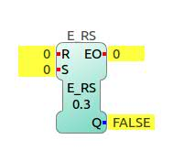
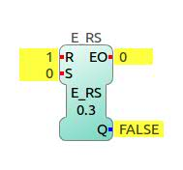
This function block acts like a RS flipflop. The output Data Q is set to 1 when S event is triggered and is reset to 0 when R event is triggered. The output event is triggered only when the output data changes from TRUE to FALSE or vice versa.
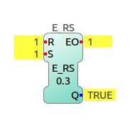

Initial state R is triggered S is triggered

E_R_TIMEOUT: (to do)

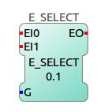
E_SELECT:
This function block allows to select the input event depending on the input data.Only triggering the selected input event will trigger the output event.
If G= FALSE; EI1 is selected.
If G=TRUE; EI2 is selected.
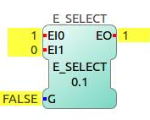
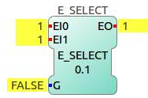

G=FALSE; EI1 triggered G=FALSE; EI2 triggered
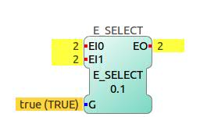

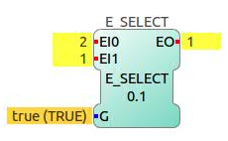

G=TRUE; EI1 triggered G=TRUE; EI2 triggered

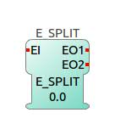
E_SPLIT:
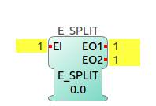
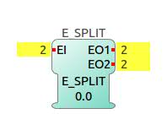
This function block takes in one input event and splits it into two output event. When the input event EI is triggered, both EO1 and EO2 will be triggered.

EI is triggered EI is triggered again

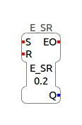
E_SR:
This function block acts like a SR flipflop. The output Data Q is set to 1 when S event is triggered and is reset to 0 when R event is triggered. The output event is triggered only when the output data changes from TRUE to FALSE or vice versa.

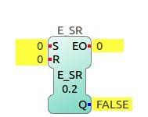
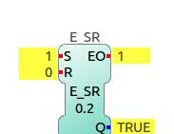
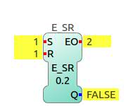

Initial state S is triggered R is triggered

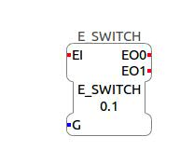
E_SWITCH:
This function block controls the selection of output event using a boolean data input. When input event is triggered, the output event to be triggered is decided by the boolean data.
If G=FALSE; EO1 is triggered;
If G=TRUE; EO2 is triggered.

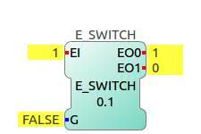
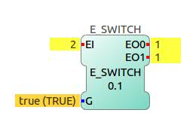

G=FALSE; EI triggered G= TRUE; EI triggered

E_TIMEOUT:(to do)

