SIMPLE EXAMPLE APPLICATIONS USING FBRT FUNCTION BLOCKS:

Now that you are familiar with the functionalities of the FBRT blocks , we can try some simple example applications using FBRT features to either give an input or show an output of the application. You must be familiar with the concept of Subscriber and Publisher. If not then refer to the X+3 default example in 4DIAC-IDE.
We will mostly use FBRT blocks to give an input. This will be published to another resource. This resource will subscribe the data and do the processing required and then will publish the data to the FBRT resource. FBRT resource will now subscribe the data and will show the output in the FBRT window.

1. PROBLEM STATEMENT: To build an application to visualise speed control of an vehicle. The app must be able to take speed as an input and give output to accelerator and brakes. If speed inncreases over 70, acceleration must be stopped and when speed increases over 90, brakes must be applied. The speed input should be given using a slider and output must be shown on the FBRT screen.

SOLUTION:

FUNCTION BLOCKS USED:
- E_CYCLE
- FB_SLIDER
- F_GE
- F_GT
- OUT_BOOL
- FB_BAR
- PUBLISH
- SUBSCRIBE

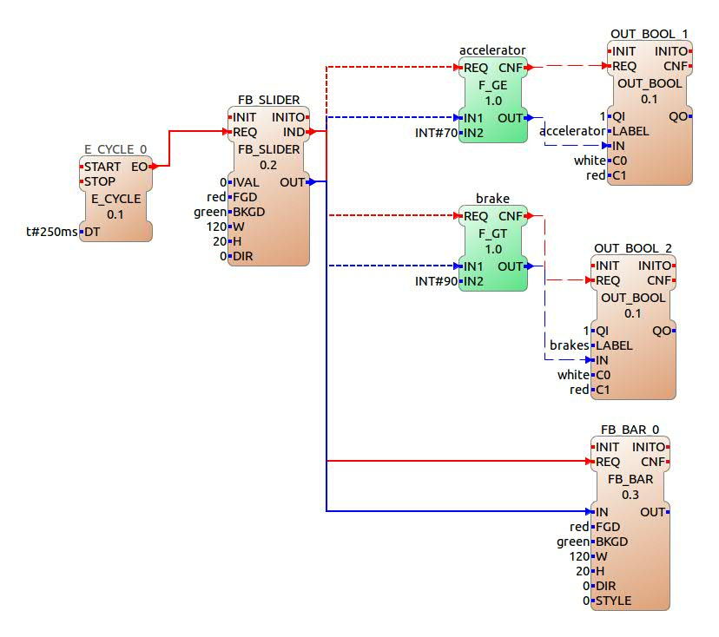
STEPS TO BUILD THE APPLICATION:
    - The E_CYCLE triggers the FB_SLIDER every 250ms.
    - The FB_SLIDER OUT is given to IN 1 of both F_GE and F_GT. It is also given to the FB_BAR.
    - The IN2 of both F_GT is set at 90 and of F_GE is set at 70.
    - Their output is given to the OUT_BOOL_1 and OUT_BOOL_2 respectively.
    - The other parameters of the FBRT blocks like FGD,BKGD,H,W etc. are set according to your wishes.

STEPS TO BUILD THE RESOURCE
We are using two resources in this application. The FBRT system resource and FORTE PC. All the FBRT blocks and E_CYCLE are mapped to the FBRT system resource. And the F_GT and F_GE blocks are mapped to the FORTE PC.

