Atlantic Technological University (ATU)
MSc Business Analytics
Applied Project Report
ATU Galway
Predicting Late Delivery Risk Before Shipment:
A Business Analytics Approach Using Machine Learning on the DataCo Smart Supply Chain Dataset

Student Name: Akshai Reddy Thota
Student ID: G00485821
Supervisor: Shahid Hussain
Academic Year: 2025–2026

Declaration
I declare that this Applied Project Report is my own work and that all sources used have been acknowledged and referenced. This work has not been submitted for any other academic award. The machine learning artefact described in this report was developed by the author, and the analysis, results and conclusions presented are the author's own.
In line with ATU's Academic Integrity Policy, I acknowledge the use of generative AI tools during the preparation of this report. AI assistance was used in developing the machine learning artefact, AI assistance was also used to support my understanding of the models and to assist with the coding work; however, the complete concept, design and development of the artefact are my own. All research decisions — the choice of dataset, the leakage-screening approach, the models trained, the analysis and its interpretation — were made by the author, and the machine learning artefact and its results are the author's own work. Every source has been checked and verified by the author, who takes full responsibility for the accuracy, originality and academic integrity of the final report.
Signed: Akshai Reddy Thota Date: 1-09-2026

Abstract
Late delivery is one of the most visible and costly failures in modern supply chains, damaging customer trust and triggering penalty and recovery costs that often exceed the profit on the original order. This project develops and evaluates a machine learning early-warning system that predicts whether an order will be late using only information available before the order ships, addressing a persistent methodological weakness in the published literature where high accuracy is achieved by including post-shipment variables that leak the outcome.
Using the DataCo Smart Supply Chain dataset of 180,519 orders, of which 54.8 per cent carry a late delivery risk, the study removes all leakage and identifier variables and trains five classifiers — Logistic Regression, Decision Tree, Random Forest, Gradient Boosting and XGBoost — on a strictly pre-shipment feature set. Each model is evaluated using accuracy, precision, recall, F1 score and ROC-AUC on a held-out test set. XGBoost achieved the strongest overall performance, with an accuracy of 0.73, precision of 0.84, recall of 0.62, F1 of 0.72 and ROC-AUC of 0.81, confirming that realistic pre-shipment prediction sits well below the inflated 95–99 per cent figures reported in leakage-affected studies.
Scheduled shipment days and shipping mode dominate the prediction, together accounting for more than 80 per cent of feature importance, indicating that carrier and lead-time decisions are the primary operational levers for reducing delays. The best model is wrapped in a reusable inference function that scores a new order end-to-end, demonstrating practical deployability. The project contributes both a more honest benchmark for the DataCo dataset and a transferable template for building order-level delay early-warning systems in retail and e-commerce.
Keywords: supply chain analytics; late delivery prediction; machine learning; XGBoost; data leakage; class recall; early-warning system.

Acknowledgements
I would like to express my sincere gratitude to my supervisor, Shahid Hussain, whose guidance and constructive feedback shaped this project at every stage. In particular, his early feedback on the framing of the research problem and the structure of the literature review prompted me to strengthen the methodological focus of the work, and I am grateful for the time he gave to reviewing my drafts.
I would also like to thank the teaching staff of the MSc Business Analytics programme at Atlantic Technological University, Galway, whose modules provided the foundation in machine learning, data preparation and research methods on which this Applied Project is built. My thanks go, too, to the wider open-source and research community: this project relies on publicly available tools and on the DataCo Smart Supply Chain dataset, and it was made possible by the many researchers whose published work is reviewed and built upon here.

Table of Contents
Declaration ii
Abstract iii
Acknowledgements iv
List of Figures and Tables vi
1 Introduction 1
1.1 Background and Context 1
1.2 Conventional Approaches to Delivery Management and Their Limitations 2
1.3 Machine Learning for Order-Level Delay Prediction 3
1.4 Research Problem and Gap 3
1.5 Research Questions and Objectives 4
1.6 Intended Beneficiaries and Contribution 5
1.7 Structure of the Report 5
2 Literature Review 6
2.1 Predictive Analytics in Supply Chain Management 6
2.2 Machine Learning Techniques for Delivery Risk Prediction 7
2.3 Tree-Based Ensemble Models and XGBoost Applications 8
2.4 Data Leakage and Validity in Predictive Modelling 9
2.5 Prior Work on the DataCo Smart Supply Chain Dataset 10
2.6 Synthesis and Research Gap 11
3 Research Methodology 13
3.1 Research Design 13
3.2 Dataset and Target Variable 14
3.3 Exploratory Data Analysis 15
3.4 Data Preparation and Leakage Screening 15
3.5 Feature Engineering 17
3.6 Models and Training Protocol 17
3.7 Evaluation Strategy 18
3.8 Ethical and Data-Protection Considerations 19
3.9 Tools and Reproducibility 19
4 Design Specification 20
4.1 Solution Architecture 20
4.2 Functional and Non-Functional Requirements 20
4.3 Choice of Models 20
4.4 Design Decisions 21
5 Implementation 22
5.1 Implementation Environment 22
5.2 Pipeline Implementation 22
5.3 Inference Function 23
5.4 Outputs Produced 23
6 Results and Critical Analysis 25
6.1 Model Performance 25
6.2 Error Structure of the Best Model 26
6.3 Drivers of Late Delivery (RQ3) 27
6.4 Answering the Research Questions 28
6.5 Comparison with Prior DataCo Studies 29
6.6 Business and Operational Implications 29
6.7 Discussion 30
7 Conclusions and Future Work 31
7.1 Summary of Findings 31
7.2 Contributions 31
7.3 Limitations 32
7.4 Future Work 32
References 34

List of Figures and Tables
Figure 1. Class distribution of the Late_delivery_risk target.
Figure 2. Comparison of the five classifiers across all metrics.
Figure 3. ROC curves for the five classifiers.
Figure 4. Confusion matrix for the XGBoost model on the test set.
Figure 5. Top 15 feature importances for the XGBoost model.
List of Tables
Table 1. Feature groups retained and removed after leakage screening.
Table 2. Performance of the five classifiers on the pre-shipment feature set.
Table 3. Comparison with prior DataCo studies.

1 Introduction

1.1 Background and Context
A supply chain is the connected network of organisations, people, activities, information and resources involved in moving a product or service from its point of origin to the final customer. It spans sourcing and procurement, manufacturing, warehousing, distribution and last-mile delivery, and its central purpose is to make sure the right goods reach the right customer at the right time and at an acceptable cost (Wang et al., 2016). Because almost every business that sells physical goods depends on this flow, the performance of the supply chain is directly tied to business performance: it shapes cost, working capital, customer satisfaction and, ultimately, competitiveness. In an era of global sourcing, compressed delivery windows and rising customer expectations, supply chains have become larger, faster and far more complex to manage (Hasan et al., 2024).
The growth of e-commerce has intensified these pressures. Shipment volumes have risen sharply, delivery promises have shortened from weeks to days and, in some markets, to hours, and supply chains have become more geographically dispersed and more exposed to disruption — a fragility made highly visible during the COVID-19 pandemic and the subsequent period of volatile demand. The combination of higher volumes, shorter promised windows and greater exposure to disruption has made delivery reliability harder to guarantee at precisely the moment when customers expect it most.
Within this wider process, delivery reliability is one of the most closely watched measures of performance. Customers now treat fast and dependable delivery as a baseline expectation rather than a premium service, and a single late delivery can damage trust, trigger contractual penalties and generate recovery costs that often exceed the profit earned on the original order. When a delivery slips, the cost is felt immediately and is difficult to undo. This makes on-time delivery both a service-quality issue and a financial one, and it explains why delivery risk has become a priority area for operations managers and supply chain analysts alike.
The financial consequences of late delivery are more significant than they first appear. Direct costs include contractual penalties, expedited re-shipping and the labour of handling complaints and returns, while the larger indirect costs — eroded customer trust, lost repeat business and reputational damage — are harder to measure. Because acquiring a new customer is generally far more expensive than retaining one, a late delivery that drives a customer away can cost many times the margin on the original order. It is this asymmetry between the small profit on a single order and the large potential cost of a delay that makes early identification of at-risk orders so valuable, and it explains why, later in this report, catching late orders is treated as more important than raw accuracy.

1.2 Conventional Approaches to Delivery Management and Their Limitations
Traditionally, companies have managed delivery performance using rule-based planning, fixed lead-time buffers and statistical forecasting methods. Lead times are often set from historical averages, safety margins are added to scheduled shipping dates, and demand is projected using time-series techniques such as moving averages, exponential smoothing and ARIMA models (Seyedan and Mafakheri, 2020). These methods are transparent and easy to implement, and they remain useful for stable, slow-moving environments. However, they share important limitations. They assume that past patterns will repeat, they treat orders in aggregate rather than scoring the risk of each individual order, and they struggle to combine the many interacting factors — shipping mode, scheduled lead time, market, product category, order timing — that jointly determine whether a specific order will arrive on time.
These limitations have become more serious as supply chain data has grown in scale, speed and complexity. Modern order-management and logistics systems capture rich, high-volume, transaction-level data, and the relationships within that data are non-linear and change over time (Hasan et al., 2024). Conventional statistical methods were not designed to exploit data of this kind. They can describe what usually happens on average, but they are poorly suited to predicting the outcome of a single order from dozens of interacting attributes. This gap between the richness of available data and the limited predictive power of conventional methods is precisely what motivates the move towards machine learning.
A further limitation is that conventional approaches are essentially reactive. Fixed buffers and aggregate forecasts describe expected behaviour but do not warn about an individual order that is unusually likely to be late; by the time a delay is detected, the order has shipped and the chance to intervene has passed. What operations managers increasingly need is a proactive capability — a way to score each order for risk at the moment it is placed, so that mitigating action can be taken before the order leaves the warehouse — and this is exactly what a well-constructed classifier offers and what this project aims to provide.

1.3 Machine Learning for Order-Level Delay Prediction
Machine learning offers a natural response to these limitations because it can learn complex, non-linear relationships directly from historical order data and produce a risk score for each new order individually. Predicting late delivery is a well-defined binary classification problem: every order carries a set of attributes known at the time it is placed — shipping mode, scheduled lead time, payment type, customer location, market, order quantity and product category — and a known outcome of either on-time or late. A classifier trained on past orders can score a new order at the moment it is placed, and the orders with the highest predicted risk can be flagged for action, such as switching to a faster carrier or warning the customer in advance (Baryannis, Dani and Antoniou, 2019).
The appeal of this framing is that it turns a diffuse operational problem into a concrete, measurable prediction task. Because every historical order already carries its true outcome, the data needed to train and honestly evaluate a classifier is readily available, and the task fits the structured, tabular data that order-management systems produce — a setting in which tree-based ensemble methods perform particularly well. The main design decision is therefore not whether machine learning can be applied, but how to apply it in a way that is honest about what information is genuinely available before shipment and that reflects the real operational priorities of the business.
The DataCo Smart Supply Chain dataset used in this project illustrates why this matters. It contains 180,519 orders, and 54.8 per cent of them are flagged as carrying a late delivery risk. A failure rate of this size shows that late delivery is not a rare edge case but a systematic problem, and that there is clear value in being able to identify high-risk orders before they ship rather than reacting after the delay has already occurred. The scale of the dataset also makes it well suited to machine learning, since there are enough examples of both late and on-time orders for a classifier to learn the patterns that distinguish them.

1.4 Research Problem and Gap
Although a substantial body of work now applies machine learning to delivery prediction, several challenges remain unresolved, and these define the problem this project addresses. The overarching difficulty is that existing approaches have struggled to combine three things at once: realistic predictive performance, an operational focus on catching late orders rather than maximising headline accuracy, and a demonstrated path to practical use. These challenges surface in the literature in three recurring ways.
First, many studies report predictive performance that does not reflect what a model would actually see in operation. A recurring methodological weakness — especially pronounced in work using the DataCo dataset — is the inclusion of variables that only become known after an order has shipped, such as the actual number of shipping days or the final delivery status. Feeding these variables to a model effectively gives it the answer in advance, producing accuracies above 95 per cent that collapse once the leakage is removed (Ahmed et al., 2025; Burova, 2023). This undermines the credibility and generalisability of published results and, more importantly, means the models cannot support real pre-shipment decisions.
Second, most studies optimise for accuracy and under-report recall, even though the two errors are not equally costly. In a flagging task, failing to catch a late order (a false negative) is usually more damaging to the business than raising a false alarm (a false positive), because the missed order incurs the full penalty and recovery cost. Yet recall on the late class is frequently 10 to 20 percentage points behind accuracy and is often not discussed at all, meaning a large fraction of late shipments would still be missed in practice.
Third, very few studies close the loop from model to decision support. The published pipelines typically stop at a comparison table, without showing how the model would be embedded in an operational workflow — for example, as a function that takes a new order and returns a risk score. This limits the practical, decision-support value of the work and leaves a gap between analytical research and operational deployment.

1.5 Research Questions and Objectives
Framed against the challenges above, this project is guided by three research questions:
- RQ1. How accurately can pre-shipment features alone predict whether a DataCo order will be late, once outcome-leaking variables are removed?
- RQ2. Which classifier offers the best balance of predictive performance, recall on the late class and interpretability on a strictly pre-shipment feature set?
- RQ3. Which order attributes most strongly drive late delivery risk, and what does this imply for where a business should focus to reduce delays?
To answer these questions, the project pursues the following objectives:
- To review the literature on predictive analytics, machine learning for delivery risk, and prior work on the DataCo dataset, and to identify the methodological weaknesses that motivate this study.
- To construct a strictly pre-shipment feature set by identifying and removing all outcome-leaking and identifier variables.
- To train and compare five classifiers using accuracy, precision, recall, F1 and ROC-AUC, giving explicit attention to recall on the late class.
- To analyse feature importance in order to explain the drivers of delay and translate them into operational insight.
- To wrap the best model in a reusable inference function that scores a new order end-to-end, demonstrating practical deployability.

1.6 Intended Beneficiaries and Contribution
Two groups benefit from this work. The first is industry — supply chain analysts and operations managers in retail and e-commerce — who gain a working, honestly benchmarked example of an order-level delay early-warning system built with standard Python libraries. The second is academic, because the project provides a leakage-free benchmark for the widely used DataCo dataset and a template for the disciplined evaluation of similar prediction pipelines. The contribution is therefore methodological as much as algorithmic: it demonstrates how removing leakage, foregrounding recall and closing the loop to an inference function together produce results that are both credible and usable.

1.7 Structure of the Report
The remainder of the report is organised as follows. Chapter 2 reviews the related work on predictive analytics in supply chains, machine learning techniques for delivery risk, tree-based ensemble models and prior studies on the DataCo dataset, and synthesises the gaps. Chapter 3 sets out the research methodology. Chapter 4 describes the design of the analytical solution. Chapter 5 details the implementation, including the inference function. Chapter 6 presents and critically evaluates the results against the research questions and prior work. Chapter 7 concludes, discusses limitations and proposes future work.

2 Literature Review
This chapter reviews the work most relevant to predicting late deliveries in supply chains using machine learning. It moves from the broad domain of predictive analytics in supply chain management (Section 2.1), to machine learning techniques for delivery risk prediction (Section 2.2), to tree-based ensemble models and XGBoost applications (Section 2.3), to the cross-cutting problem of data leakage and validity (Section 2.4), before examining prior work on the DataCo dataset specifically (Section 2.5). Each thematic section closes with a critical assessment of the limitations of the studies reviewed. Section 2.6 synthesises these threads and states the research gap. The review draws primarily on peer-reviewed studies published from 2020 onwards; the small number of openly available Kaggle and GitHub projects included in Section 2.5 are discussed there because they work directly with the same dataset and are relevant to the leakage problem this project addresses.

2.1 Predictive Analytics in Supply Chain Management
The idea that data analytics is now a core capability for supply chains is well established. Wang et al. (2016) set out an early framework showing how big data analytics could be applied across procurement, manufacturing, distribution and customer relationships, arguing that firms could only remain competitive by making proper use of the data their systems already generate. More recent work confirms and extends this trajectory: Hasan et al. (2024) critically analyse the impact of big data analytics on supply chain operations, noting the growing prevalence and hybridisation of predictive models and the shift from descriptive reporting towards advanced decision support.
This evolution can be understood as a progression through the familiar hierarchy of analytics maturity, from descriptive reporting, through diagnostic and predictive analytics, towards prescriptive analytics that recommends action. Seyedan and Mafakheri (2020) document this shift in demand forecasting, concluding that machine learning methods outperform traditional statistical techniques once the available data is sufficiently large. The present project sits at the predictive stage — producing a risk score for each order — while gesturing towards the prescriptive stage through an inference function designed to support a concrete flagging decision. Within this broad domain, order-level risk and disruption prediction has emerged as one of the most valuable applications, because it turns aggregate analytics into a signal that can inform a specific operational decision before an order ships.
Critical assessment. This body of work convincingly establishes that predictive analytics has matured from a research topic into an operational expectation, and that order-level risk prediction is among its most valuable applications. However, much of it remains conceptual or aggregate in focus: reviews describe capabilities and case studies report firm-level outcomes, but relatively few provide reproducible, order-level evaluation protocols. A further limitation is that the strongest evidence for the value of predictive analytics tends to come from large organisations with mature data infrastructure, which raises a question, largely unanswered in the literature, about how readily these gains transfer to smaller firms working with standard tools and openly available data — the very setting this project targets.

2.2 Machine Learning Techniques for Delivery Risk Prediction
Within supply chain analytics, late delivery prediction has attracted particular attention because the outcome is a clean binary label, the label is easy to derive from transactional data, and the business cost of a miss is felt immediately. Baryannis, Dani and Antoniou (2019), in a widely cited study, examined the trade-off between predictive performance and interpretability. They found that tree-based ensembles were more accurate than linear models, but that this advantage narrowed once the model was also required to be explainable, and they argued that managers will not act on predictions they cannot understand. This tension between accuracy and interpretability recurs throughout the delivery-prediction literature.
The range of algorithms applied to delivery prediction spans the full spectrum of supervised learning. At the simpler end, Logistic Regression provides a transparent linear baseline whose coefficients are directly interpretable, which is why it remains a common point of comparison even when it is not the final chosen model. Single decision trees offer a similarly interpretable but non-linear alternative, at the cost of a tendency to overfit. The bulk of recent applied work, however, uses ensemble methods — Random Forests, which average many de-correlated trees to reduce variance, and gradient-boosting methods, which build trees sequentially so that each corrects the errors of its predecessors. These ensembles consistently top comparative studies on tabular delivery data, and the progression from a linear baseline through a single tree to several ensembles is exactly the comparison structure adopted in this project, so that the marginal value of added model complexity can be observed directly.
A number of studies frame delay prediction as an imbalanced-learning problem and apply resampling techniques such as the Synthetic Minority Over-sampling Technique (SMOTE) introduced by Chawla et al. (2002). The consensus is that SMOTE is most valuable when the minority class is very small; where the classes are close to balanced, as in the DataCo dataset, its benefit is marginal, and applying it can even distort the decision boundary if performed carelessly across the train-test split. A recurring observation across this applied literature is that evaluation practice is inconsistent: many studies report only a single headline metric, typically accuracy, and give little attention to how well a model catches the late orders it is meant to flag.
Critical assessment. The techniques reviewed here are well suited to the delivery-prediction task, but two weaknesses are common. First, evaluation is frequently dominated by accuracy, with recall on the late class — arguably the metric that matters most operationally — under-reported or omitted, so the practical usefulness of a model for catching late orders often cannot be judged from the results presented. Second, generalisability is limited: many studies use a single proprietary dataset and do not test whether feature relationships transfer to other settings. The recurring accuracy–interpretability trade-off identified by Baryannis, Dani and Antoniou (2019) also remains only partially resolved, since few applied pipelines pair a strong model with a usable explanation of its predictions.

2.3 Tree-Based Ensemble Models and XGBoost Applications
Tree-based ensembles have become the default choice for tabular supply chain problems, and they are central to this project. Park (2024) compared fourteen models for supply chain prediction, including several deep learning architectures, and found that XGBoost and Random Forest performed best, largely because they handled tabular data and missing values more robustly than the deep learning alternatives. This finding reflects a broader and consistent pattern in the literature, in which gradient-boosted trees match or exceed deep neural networks on structured supply chain data while using less computation.
XGBoost itself, introduced by Chen and Guestrin (2016), is a regularised form of gradient boosting that handles missing values internally, scales efficiently to large datasets and provides feature-importance scores that are relatively easy to read. Since 2016 it has become a standard baseline for tabular problems and a frequent winner in applied machine learning, and it is routinely used as the benchmark against which newer methods are measured, underlining its status as the reference point for tabular delay prediction.
Two practical limitations of XGBoost are relevant here. First, although it handles missing values, it does not deal well with high-cardinality categorical variables when they are label-encoded, which matters for DataCo fields such as Order Country and Order City that contain hundreds of unique values. Second, its default feature-importance scores are gain-based and tend to favour high-cardinality variables, so importance rankings should be read as indicative rather than exact. Permutation importance or SHAP values (Lundberg and Lee, 2017) provide more reliable attributions when feature importance is a primary output.
Critical assessment. The evidence strongly supports tree-based ensembles as the appropriate default for tabular delivery prediction, and XGBoost in particular offers a good balance of accuracy, efficiency and interpretability. However, the reliance on default gain-based importance in many applied pipelines is a genuine weakness, because it can mislead when features differ in cardinality, and comparatively few studies pair the model with a robust interpretation method such as permutation importance or SHAP. Deployment considerations — how the trained model would be operated in practice — are also seldom addressed, leaving the ensembles as strong analytical artefacts rather than decision-support tools.

2.4 Data Leakage and Validity in Predictive Modelling
A theme that cuts across all of the work reviewed above, and one that is central to this project, is the problem of data leakage. Data leakage occurs when information that would not be available at the moment of prediction is used, directly or indirectly, to train a model. A model built with leakage typically shows excellent performance during validation but fails when deployed, because at prediction time the leaked information is simply not there. Kapoor and Narayanan (2023), in a systematic survey published in Patterns, found evidence of leakage across seventeen scientific fields, collectively affecting nearly three hundred papers and, in several cases, producing wildly overoptimistic conclusions; they introduce a taxonomy of eight distinct types of leakage, ranging from elementary errors to open research problems. Their central finding is sobering for applied machine learning: when leakage was corrected in a case study of civil-war prediction, the apparent superiority of complex machine learning models over simple statistical models disappeared entirely.
The most relevant form of leakage for the present project is target leakage, in which a feature acts as a proxy for the outcome because its value is only determined after, or at the same time as, the outcome itself. A textbook example is using a record of antibiotics prescribed to predict whether a patient has an infection: the prescription follows the diagnosis, so including it leaks the answer. The delivery-prediction analogue is direct — using the actual number of shipping days, or the final delivery status, to predict whether an order was late. These variables only exist once the order has been delivered, so a model that relies on them is not predicting late delivery at all; it is merely reading off an outcome that has already occurred. A closely related pitfall, also documented in the leakage literature, is performing preprocessing steps such as scaling or imputation on the full dataset before splitting into training and test sets, which allows information from the test set to influence the model.
Critical assessment. The leakage literature provides the strongest theoretical justification for the methodological stance taken in this project. It establishes that leakage is not a niche concern but a widespread and well-documented failure mode, that target leakage in particular can inflate reported performance dramatically, and that the correct response is a disciplined, explicit screening of features by availability at prediction time. Crucially, it also shows why removing leakage is expected to reduce headline accuracy: the inflated figures were never real. This reframes the comparatively modest accuracy reported later in this project not as a shortcoming but as the expected and correct consequence of a valid evaluation, and it directly informs the leakage-screening procedure described in Chapter 3.

2.5 Prior Work on the DataCo Smart Supply Chain Dataset
The DataCo Smart Supply Chain dataset, available on Kaggle, has become one of the most widely used datasets in supply chain machine learning, which makes it a useful common benchmark but also a place where methodological weaknesses have propagated. Al-Saghir (2022), in a Master's thesis, cleaned the data, engineered features and trained a panel of classifiers, concluding that ensembles outperformed single trees and linear models. Ahmed et al. (2025) proposed a hybrid model combining Self-Organising Maps, PCA and neural networks for shipping-time and delay prediction on the same dataset and reported accuracy around 96 per cent, ahead of XGBoost and Random Forest; however, inspection of their feature set shows it still draws on post-shipment information, so the very high accuracy is not a like-for-like pre-shipment result. Burova (2023), in a publicly available Kaggle and GitHub project, reported accuracies above 97 per cent for XGBoost, Random Forest and Logistic Regression, but the feature set again includes the actual shipping days, which are only known after the order has shipped and therefore leak the outcome.
This pattern of inflated accuracy is the central weakness in the DataCo literature and the specific problem this project targets. Across many DataCo studies, accuracy figures between 95 and 99 per cent are common, but they depend on features that are unavailable at the time a prediction would need to be made. Once the leakage columns are removed and only genuine pre-shipment features are retained, accuracy on the same dataset falls to roughly 75 to 85 per cent — consistent with the results reported later in this report. A secondary weakness is that few DataCo studies examine precision and recall in detail, despite their importance for a flagging task; where recall on the late class is reported, it typically trails accuracy substantially.
Critical assessment. The DataCo studies are directly comparable to the present work and are therefore revisited in the results discussion of Chapter 6. Judged against consistent criteria — dataset handling, feature engineering, model interpretability, generalisability and deployment readiness — their principal shortcomings are the widespread use of leakage features, which compromises the validity of the headline results; limited treatment of recall; reliance on default feature importance; and the absence of any operational inference step. These are precisely the weaknesses the methodology in Chapter 3 is designed to avoid, and the comparison in Table 3 makes the differences explicit.

2.6 Synthesis and Research Gap
Five conclusions can be drawn from the literature reviewed above. First, predictive analytics for supply chain risk is now a mature field, and there is broad agreement that machine learning, and gradient boosting in particular, is the appropriate default for tabular delivery prediction (Park, 2024; Chen and Guestrin, 2016). Second, and more critically, the field is weakened by a widespread data-leakage problem — documented in general terms by Kapoor and Narayanan (2023) and highly visible in DataCo-based studies — where reported accuracies above 95 per cent are typically produced by including post-shipment features, undermining the validity and generalisability of results. Third, although models such as XGBoost perform well on raw accuracy, what matters operationally is recall on the late class, and this has been consistently under-reported. Fourth, interpretation tools and, above all, a demonstrated path to operational use are increasingly seen as necessary before managers will act on these models, yet most published pipelines stop short of either. Fifth, the evidence base is skewed towards large organisations and proprietary datasets, leaving a shortage of honest, reproducible benchmarks built on openly available data with standard tools.
Taken together, these point to a research gap that is broader than any single dataset. The gap is the difficulty existing approaches have in delivering delivery-risk predictions that are simultaneously valid (free from outcome leakage and therefore reflective of real pre-shipment conditions), operationally meaningful (evaluated on recall for the late class, not just accuracy), interpretable (able to explain which factors drive risk), and deployable (embedded in a workflow that scores a new order). Framed this way, the gap concerns model validity, generalisation, interpretability and operational deployment in complex supply chain environments — challenges that persist across the field and are sharply visible in the DataCo literature.
This project addresses that gap directly and its contribution is methodological as much as algorithmic. It identifies and removes the leakage variables that have inflated previous DataCo results; it evaluates five classifiers on a strictly pre-shipment feature set and reports the full set of accuracy, precision, recall, F1 and ROC-AUC with explicit attention to recall; it interprets the drivers of delay through feature importance; and it wraps the best model in a reusable inference function that scores a new order end-to-end. The result is both a more honest benchmark for the DataCo dataset and a practical template for analysts building similar early-warning systems. The methodology used to produce these results is described in the next chapter.

3 Research Methodology
This chapter describes how the project was conducted. It states the research design and philosophy, describes the dataset and target variable, explains the data preparation and — critically — the leakage-screening procedure that defines the pre-shipment feature set, sets out the models trained and the evaluation strategy, and notes the tools used. The methodology is described in sufficient detail to allow the work to be understood and reproduced.

3.1 Research Design
The project follows a quantitative, experimental research design centred on supervised machine learning. The task is framed as binary classification: for each order, predict whether it carries a late delivery risk (1) or not (0). The methodological philosophy is deliberately conservative on the question of information availability — only features that would be known before an order ships are permitted as inputs, so that the reported performance reflects what a model could achieve in genuine operational use rather than in hindsight. Five candidate models are trained under identical conditions and compared on a common set of metrics, and the strongest is carried forward into an inference function. This design directly serves the three research questions: the model comparison answers RQ1 and RQ2, and the feature-importance analysis answers RQ3.
The design follows the standard CRISP-DM phases — business understanding, data understanding, data preparation, modelling, evaluation and deployment — which map onto the chapters of this report, from the problem framing in the introduction through to the lightweight deployment realised by the inference function in Chapter 5. Structuring the work this way ensures that each analytical decision is traceable and that the pipeline as a whole is reproducible.
A central concern of the design is validity — specifically, that the reported performance should be a truthful estimate of what the model would achieve in deployment. Two threats to validity are addressed directly. The first is target leakage, which is controlled by the feature-screening procedure described below and which distinguishes this study from much of the prior DataCo work. The second is optimistic evaluation caused by information from the test set influencing training; this is controlled by performing the train-test split before fitting any model and by fitting the feature scaler on the training partition only. Together these choices mean that the test-set metrics reported in Chapter 6 can be interpreted as honest estimates of out-of-sample performance rather than as artefacts of the evaluation procedure.

3.2 Dataset and Target Variable
The study uses the DataCo Smart Supply Chain dataset, obtained from Kaggle. It contains 180,519 order records described by 53 columns spanning order, customer, product, shipping and financial attributes. The target variable is Late_delivery_risk, a binary flag indicating whether an order was at risk of late delivery. The target is close to balanced: 54.8 per cent of orders are flagged as late (class 1) and 45.2 per cent as on-time (class 0), as shown in Figure 1.
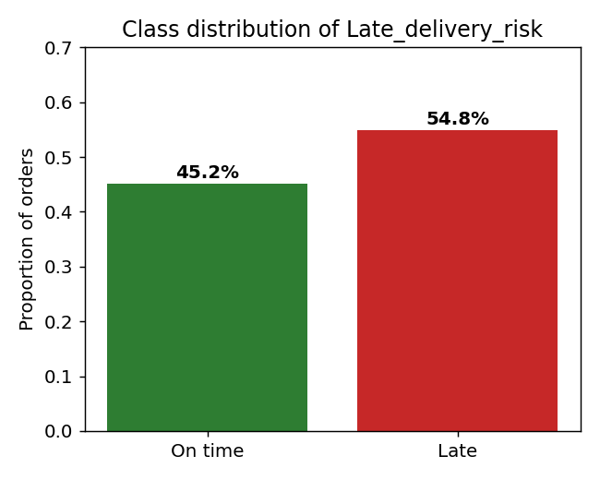
Figure 1. Class distribution of the Late_delivery_risk target (54.8% late, 45.2% on time).
The dataset is well suited to this study for several reasons. Its size — over 180,000 orders — provides ample data for both training and honest evaluation, and its breadth of attributes spans the order, customer, product, shipping and financial dimensions that a real order-management system would capture. Because it is openly available, it also supports the project's secondary aim of providing a reproducible benchmark that other analysts can replicate and extend. The columns fall into natural groups: shipping attributes such as shipping mode and scheduled shipment days; order attributes such as quantity, discount and sales value; customer attributes such as segment and country; product attributes such as category and department; a timestamp for each order; and a set of financial and status fields. As Section 3.4 explains, only a subset of these — the attributes genuinely known before shipment — is admissible as model input.
Because the classes are close to balanced, the dataset does not present a severe class-imbalance problem, and synthetic oversampling techniques such as SMOTE were judged unnecessary. This is a meaningful methodological point: applying SMOTE to an already-balanced dataset would add complexity and risk introducing its own form of leakage if performed before the train-test split, without any compensating benefit. Recall on the late class is nonetheless tracked explicitly, since the operational cost of a missed late order exceeds that of a false alarm, and a near-balanced target does not guarantee that a model will achieve high recall.

3.3 Exploratory Data Analysis
Exploratory analysis was carried out to understand the structure of the data and to surface relationships with the target before modelling. The first step was to characterise data quality. Missing values were concentrated in a small number of columns: Order Zipcode was missing for the large majority of records, Product Description was entirely empty, and Customer Lname and Customer Zipcode had only a handful of missing values. The columns with pervasive missingness were, in any case, identifiers scheduled for removal, so the missing-data problem in the modelling features was mild and could be handled by simple imputation.
The analysis then examined how the late-delivery rate varied across candidate predictors. Shipping mode showed the clearest relationship with the target: the different shipping classes carried markedly different late-delivery rates, with the faster, more tightly scheduled services behaving differently from standard shipping. Scheduled shipment days also differed systematically between late and on-time orders, indicating that the promised lead time carries genuine predictive signal. Market and order region showed moderate variation, suggesting a geographic component to delay risk, while temporal patterns by order month and day of week were present but comparatively mild. These exploratory findings were valuable in two ways. Substantively, they pointed to shipping mode and scheduled lead time as the most promising predictors — an expectation later confirmed by the feature-importance analysis in Chapter 6. Methodologically, they helped guide the feature-engineering choices, for example the decision to derive explicit temporal features from the order timestamp so that any weekly or seasonal effect could be captured.

3.4 Data Preparation and Leakage Screening
Data preparation was the methodologically decisive stage of the project, because it is where the leakage that inflates other DataCo studies is removed. Columns were placed into three groups: leakage variables, identifier or personally identifiable variables, and retained pre-shipment features. Leakage variables are those whose values only become known after an order has shipped or been delivered, and which therefore could not be used to make a genuine pre-shipment prediction. Identifier and PII variables carry no generalisable predictive signal and raise data-protection concerns. The remaining pre-shipment features form the model input. Table 1 summarises the grouping.
Group | Example columns | Action
Leakage (post-shipment) | Days for shipping (real), Delivery Status, Order Status, shipping date (DateOrders), Benefit per order, Order Profit Per Order, Order Item Profit Ratio | Removed
Identifiers / PII | Customer Email, Password, Fname, Lname, Street, Zipcode, City, State; various Ids; Product Name/Image/Description; Order City/State/Zipcode; Latitude/Longitude | Removed
Pre-shipment features | Days for shipment (scheduled), Order Item Quantity, Order Item Discount (Rate), Order Item Product Price, Product Price, Sales, Order Item Total, Type, Shipping Mode, Customer Segment/Country, Market, Order Region/Country, Category/Department Name, order date (DateOrders) | Retained
Table 1. Feature groups retained and removed after leakage screening.
The leakage-screening decisions were made on a clear principle: a feature is admissible only if its value would be known at the moment an order is placed, before it ships. Applying this test, the actual number of shipping days and the delivery and order status fields are inadmissible because they describe what happened during or after fulfilment. The financial outcome fields — benefit per order, order profit per order and order item profit ratio — are similarly inadmissible, because profit is only fully determined once the order has been completed and any returns or adjustments have been processed; including them would let the model infer the outcome from a correlated financial result. The shipping date field is inadmissible for the same reason as actual shipping days. By contrast, the scheduled shipment days field is admissible, because the promised lead time is set at the time of ordering. This principled screening is the single most important methodological step in the project and is what separates it from the leakage-affected studies reviewed in Chapter 2.
After screening, the working dataset comprised the retained pre-shipment columns plus the target. Missing values were then imputed — the median for numeric columns and a constant "Unknown" category for text columns. Median imputation was preferred to mean imputation for numeric fields because it is robust to the skew and outliers typical of monetary and quantity variables, and a dedicated "Unknown" category was used for text fields so that missingness is treated as its own signal rather than being silently merged into an existing category. After imputation the modelling data contained no missing values.

3.5 Feature Engineering
Feature engineering was used to expose latent structure in the raw pre-shipment fields, particularly around timing and order value. The order timestamp was decomposed into order year, month, day, day-of-week and hour, and two binary indicators were added for weekend orders and for the November–December holiday season. This temporal decomposition is important because a single timestamp is opaque to a model, whereas its components can capture distinct effects: the day-of-week and weekend indicators can reflect weekly operational rhythms such as reduced weekend dispatch capacity, while the month and holiday-season indicators can capture the demand surges around peak retail periods, when carriers are most congested and delays most likely.
A small number of business flags were also created to encode domain knowledge directly. An order-value field was computed as quantity multiplied by unit price; a discount-amount field was retained; and binary indicators were added for large orders, high-value orders and heavily discounted orders, each defined relative to the upper quartile of its distribution or a fixed threshold. The rationale is that unusually large, valuable or heavily discounted orders may be handled differently in the warehouse or may correlate with promotional periods that strain fulfilment, so making these conditions explicit gives the model a cleaner signal than the raw continuous values alone.
Categorical fields were converted to numeric form using label encoding. This applied both to high-cardinality geographic fields such as Order Country and Order Region, which contain hundreds of unique values, and to lower-cardinality fields such as shipping mode, payment type, customer segment and product category. Label encoding rather than one-hot encoding was chosen deliberately. One-hot encoding of the high-cardinality geographic fields would have produced hundreds of sparse binary columns, greatly increasing dimensionality and memory use for little benefit. Label encoding keeps the feature space compact, and although it imposes an arbitrary ordinal ordering on the categories, this is not a problem for the tree-based models that are the focus of the study, since a decision tree can isolate any individual category through a sequence of splits. The one model for which this ordering is less appropriate is Logistic Regression, which is one reason it is included only as a baseline rather than as a candidate for deployment.

3.6 Models and Training Protocol
Five classifiers were trained and compared: Logistic Regression as a linear baseline, a Decision Tree, and three ensembles — Random Forest, Gradient Boosting and XGBoost. This progression from a simple linear model, through a single non-linear tree, to three increasingly sophisticated ensembles allows the marginal benefit of model complexity to be assessed directly on this task, rather than assumed. Logistic Regression establishes what a transparent linear model can achieve; the Decision Tree shows the effect of allowing non-linear splits; and the three ensembles show what is gained by combining many trees, whether through bagging (Random Forest) or boosting (Gradient Boosting and XGBoost).
Each model was configured with sensible, widely used hyperparameters rather than being exhaustively tuned, so that the comparison reflects typical out-of-the-box behaviour and the models are compared on an equal footing. The tree-based models were given moderate depth limits to guard against overfitting, and the ensembles were built from a few hundred trees. The data was split into training and test sets using an 80/20 stratified split, which preserved the class balance in both partitions (training mean 0.548, test mean 0.548) and produced a training set of 144,415 orders and a test set of 36,104 orders. Features were standardised for Logistic Regression, which is sensitive to feature scale, using a scaler fitted on the training partition only and then applied to the test partition; the tree-based models were trained on the unscaled features, since monotonic scaling does not affect their splits. A fixed random seed was used throughout so that the split, the model fitting and the results are reproducible. Every model was trained on the training set and evaluated on the held-out test set only, so that no test-set information influenced training.

3.7 Evaluation Strategy
Each model was evaluated using five metrics computed on the test set: accuracy, precision, recall, F1 score and ROC-AUC. Reporting all five, rather than accuracy alone, is a deliberate methodological choice that responds directly to the under-reporting of recall identified in Chapter 2. Accuracy measures overall correctness but can be misleading on its own; precision measures how many of the orders flagged as late are genuinely late, and therefore reflects the false-alarm rate; recall measures how many of the genuinely late orders are caught, and therefore reflects the miss rate; F1 is the harmonic mean of precision and recall, summarising the balance between them; and ROC-AUC measures how well the model ranks orders by risk, independently of any particular decision threshold.
Because the operational cost of a missed late order exceeds that of a false alarm, recall on the late class is given particular weight when interpreting the results, and ROC-AUC is used as the primary criterion for selecting the best model because it captures ranking quality without committing to the default 0.5 threshold. This matters for a flagging system, where the threshold can be tuned after the fact to achieve a desired balance between catching late orders and limiting false alarms. To make the error structure and threshold behaviour of the leading models concrete, confusion matrices and ROC curves were produced. Finally, gain-based feature importance was extracted from the best model to address RQ3, interpreted with the caveats about high-cardinality bias noted in Chapter 2.

3.8 Ethical and Data-Protection Considerations
Although the project uses a public dataset and does not involve human participants, two ethical considerations were addressed. The first is data protection. The raw dataset contains fields that are personally identifiable, such as customer names, email addresses, street addresses and a password field. These fields were removed during the screening stage, both because they carry no generalisable predictive value and because retaining them would be inconsistent with good data-protection practice. Removing them means the modelling dataset contains no direct personal identifiers. The second consideration is the responsible framing of the model's outputs. A late-delivery risk score is a decision-support signal, not a determination; it is intended to prompt a human operator to consider a mitigating action, not to take an automatic action against a customer. Presenting the model in this way, and being explicit about its recall limitations, guards against the risk of over-reliance on an imperfect prediction.

3.9 Tools and Reproducibility
The analysis was implemented in Python using pandas and NumPy for data handling, scikit-learn for the baseline models, preprocessing, splitting and metrics, the xgboost library for the gradient-boosted model, and matplotlib and seaborn for visualisation. These are mature, widely used open-source libraries, which supports the project's aim of providing a template that other analysts can adopt without specialised or proprietary tooling. All steps — from data ingestion through leakage screening, feature engineering, model training, evaluation and the final inference function — are contained in a single Jupyter notebook, executed top to bottom, and a fixed random seed ensures the results can be reproduced exactly. In line with the programme guidelines, extensive code listings are not reproduced in this report; the notebook is provided separately as the project artefact, and a short configuration note describes how to run it.

4 Design Specification
This chapter describes the design of the analytical solution: its overall architecture, the pipeline stages and the design decisions that shape it. The solution is designed as a linear, reproducible pipeline that takes raw order data as input and produces, at one end, a comparative evaluation of candidate models and, at the other, a single deployable function that scores a new order.

4.1 Solution Architecture
The architecture is organised as a sequence of well-defined stages, each consuming the output of the previous one. The stages are: (1) data ingestion, which loads the DataCo CSV; (2) exploratory analysis, which characterises the data and its relationship to the target; (3) leakage screening and cleaning, which removes post-shipment and identifier columns and imputes missing values; (4) feature engineering, which derives temporal, value and flag features and label-encodes categoricals; (5) splitting and scaling, which produces stratified train and test partitions; (6) model training and evaluation, which fits five classifiers and computes the metric suite; and (7) model selection and inference, which selects the best model and exposes it through a scoring function. Designing the workflow as discrete stages keeps the leakage-screening step explicit and auditable, which is central to the project's contribution.

4.2 Functional and Non-Functional Requirements
The functional requirements of the solution are to: ingest and clean the DataCo dataset; enforce a strictly pre-shipment feature set; train and evaluate the five classifiers on a common protocol; report accuracy, precision, recall, F1 and ROC-AUC; identify the drivers of delay; and score a new order through a single function call. The non-functional requirements are reproducibility (fixed random seed, single notebook), transparency (an auditable leakage-screening step and readable feature importance), efficiency (training completes on a standard machine using CPU-based libraries), and transferability (the pipeline relies only on standard open-source Python libraries so it can be adapted to other order datasets).

4.3 Choice of Models
The five models were chosen to represent a deliberate spectrum of complexity and interpretability, so that the comparison would be informative rather than a contest between arbitrary algorithms. Logistic Regression is a linear model that estimates the log-odds of late delivery as a weighted sum of the features; it is fast, fully interpretable through its coefficients, and serves as the baseline against which the value of more complex models is judged. A single Decision Tree partitions the feature space through a hierarchy of if-then splits; it captures non-linear relationships and interactions and is easy to visualise, but a single deep tree is prone to overfitting.
The three ensembles address that weakness in different ways. Random Forest builds many decision trees on bootstrapped samples of the data and random subsets of the features, then averages their predictions; this bagging approach reduces variance and generally produces a robust, well-calibrated model. Gradient Boosting instead builds trees sequentially, with each new tree fitted to the errors of the current ensemble, which can achieve high accuracy but is more sensitive to its settings. XGBoost is a regularised, highly optimised implementation of gradient boosting (Chen and Guestrin, 2016) that adds explicit penalties against complexity, handles missing values internally and scales efficiently; for the reasons set out in Chapter 2, it was expected to be the strongest performer, and the results in Chapter 6 confirm this. Including all five models means the study can report not only which model wins, but by how much complexity improves on the simpler alternatives.

4.4 Design Decisions
Three design decisions are worth highlighting. First, leakage screening is treated as a first-class pipeline stage rather than an incidental cleaning step, because it is the decision that most affects the validity of the results. Second, the metric suite is fixed in advance to include recall and ROC-AUC alongside accuracy, so that model selection cannot be driven by accuracy alone. Third, the pipeline terminates in an inference function rather than a results table, embedding the analytical work in a form that mirrors operational use. These decisions collectively translate the gaps identified in Chapter 2 into concrete design choices, and they are what allow the project to claim a methodological contribution alongside its empirical results.

5 Implementation
This chapter describes the final implemented solution, the tools and technologies used, and the outputs produced. In line with the programme guidelines, extensive code listings are not reproduced here; the complete implementation is provided in the accompanying Jupyter notebook.

5.1 Implementation Environment
The solution was implemented in Python 3 within a Jupyter notebook. Data manipulation used pandas and NumPy; modelling used scikit-learn for Logistic Regression, Decision Tree, Random Forest and Gradient Boosting, together with preprocessing, the stratified train/test split and the metric functions, and the xgboost library for the XGBoost classifier. Visualisations were produced with matplotlib and seaborn. The dataset was retrieved programmatically and read using Latin-1 encoding to handle non-ASCII city names correctly.

5.2 Pipeline Implementation
The pipeline follows the design of Chapter 4 and is implemented as a linear sequence of notebook cells. After loading the data with the appropriate encoding, the target balance and missing-value profile were checked, and a set of exploratory plots was generated to characterise the relationships between candidate predictors and the target. The leakage and identifier columns listed in Table 1 were then dropped, reducing the fifty-three raw columns to the pre-shipment feature set plus the target. Missing values were imputed using the median for numeric fields and an "Unknown" category for text fields.
The feature-engineering stage derived the temporal components, the order-value and discount fields, and the large-order, high-value and heavily-discounted flags described in Chapter 3, and then label-encoded every categorical field, retaining the fitted encoders so that the identical mapping could be reapplied at inference time. The resulting feature matrix was split 80/20 with stratification on the target, producing the training and test partitions. A standard scaler was fitted on the training features and applied to both partitions for use by the Logistic Regression model, while the tree-based models used the unscaled features. Fitting the scaler on the training partition only, rather than on the full dataset, is a deliberate guard against the preprocessing form of data leakage discussed in Chapter 2.
A single reusable training routine was used for all five models so that they were fitted, applied and scored in exactly the same way, which keeps the comparison fair. For each model the routine fitted the classifier on the training partition, generated predictions and predicted probabilities on the test partition, and computed accuracy, precision, recall, F1 and ROC-AUC. The results were assembled into a comparison table sorted by ROC-AUC, a grouped bar chart and a set of overlaid ROC curves were produced to visualise the comparison, and confusion matrices were generated for the leading models. The best model by ROC-AUC was then selected programmatically and its gain-based feature importances were extracted and plotted.

5.3 Inference Function
The final and most practically significant output of the implementation is a function, predict_new_order, that operationalises the trained pipeline. It accepts a new order as a dictionary of pre-shipment attributes and reproduces, in the same sequence, every transformation applied during training: it derives the temporal features from the order timestamp, computes the order-value and flag features, aligns the columns to the training layout, and applies the stored label encoders to the categorical fields. It then passes the prepared row to the trained model and returns both a discrete prediction — LATE or ON TIME — and a continuous risk probability between zero and one.
Returning a probability as well as a label is an intentional design choice, because it is the probability, not the binary label, that makes the function useful operationally. A probability allows orders to be ranked by risk and allows the flagging threshold to be set wherever the business wants the trade-off between catching late orders and limiting false alarms, exactly as discussed in the evaluation. To demonstrate the function, two contrasting orders were scored. A standard-class order with a comfortable four-day scheduled lead time, placed in ordinary conditions, was scored as ON TIME with a risk probability of about 0.39. A first-class order with a one-day scheduled lead time, placed late at night during the holiday season and carrying a heavy discount, was scored as LATE with a high risk probability. The contrast between these two cases shows the model responding sensibly to the factors that the feature-importance analysis identifies as most influential, and it illustrates concretely how the function would support a pre-shipment flagging decision. This end-to-end scoring capability is what distinguishes the project from studies that stop at a comparison table.

5.4 Outputs Produced
The implementation produced three types of output, mapped to the project's outputs summary. The first is an analytical model: an evaluated, ranked set of five classifiers with XGBoost selected as best, aimed at analysts who need an honest DataCo benchmark. The second is a set of diagnostic visualisations — the class distribution, model comparison, ROC curves, confusion matrix and feature-importance plot — for both technical and managerial audiences. The third is the deployable inference function, aimed at operations managers and the systems that would embed a risk score into an order-management workflow. Together these outputs answer the three research questions and constitute the project's artefact.

6 Results and Critical Analysis
This chapter presents the results, evaluates them against the three research questions, and compares them critically with prior work on the DataCo dataset. All figures are computed on the held-out test set of 36,104 orders.

6.1 Model Performance
Table 2 reports the performance of the five classifiers on the pre-shipment feature set, ordered by ROC-AUC. XGBoost achieved the strongest overall performance, with the highest ROC-AUC (0.808), the highest F1 (0.717), the best recall (0.623) and the best accuracy (0.730). Random Forest achieved marginally higher precision (0.856) but the lowest recall among the ensembles, meaning it caught fewer late orders. Logistic Regression, the linear baseline, trailed the tree-based models on every metric, confirming that the relationships in the data are non-linear and are better captured by ensembles.
Model | Accuracy | Precision | Recall | F1 | ROC-AUC
XGBoost | 0.730 | 0.843 | 0.623 | 0.717 | 0.808
Random Forest | 0.721 | 0.856 | 0.590 | 0.699 | 0.806
Gradient Boosting | 0.722 | 0.852 | 0.598 | 0.702 | 0.794
Decision Tree | 0.723 | 0.837 | 0.614 | 0.708 | 0.787
Logistic Regression | 0.690 | 0.788 | 0.594 | 0.678 | 0.727
Table 2. Performance of the five classifiers on the pre-shipment feature set (test set, n = 36,104).
Three patterns in Table 2 deserve comment. First, the four non-linear models cluster closely together on accuracy, between 0.72 and 0.73, and clearly outperform the linear baseline at 0.69, which confirms that the relationships between the pre-shipment features and the target are non-linear and that a linear model leaves genuine signal on the table. Second, there is a consistent gap between precision, which sits in the mid-0.80s for the tree-based models, and recall, which sits around 0.60; every model is better at avoiding false alarms than at catching late orders. Third, the differences among the four non-linear models are modest, so the choice between them turns less on headline accuracy than on the balance of recall, ranking quality and interpretability — which is precisely why ROC-AUC and recall, rather than accuracy alone, are used to select the best model.
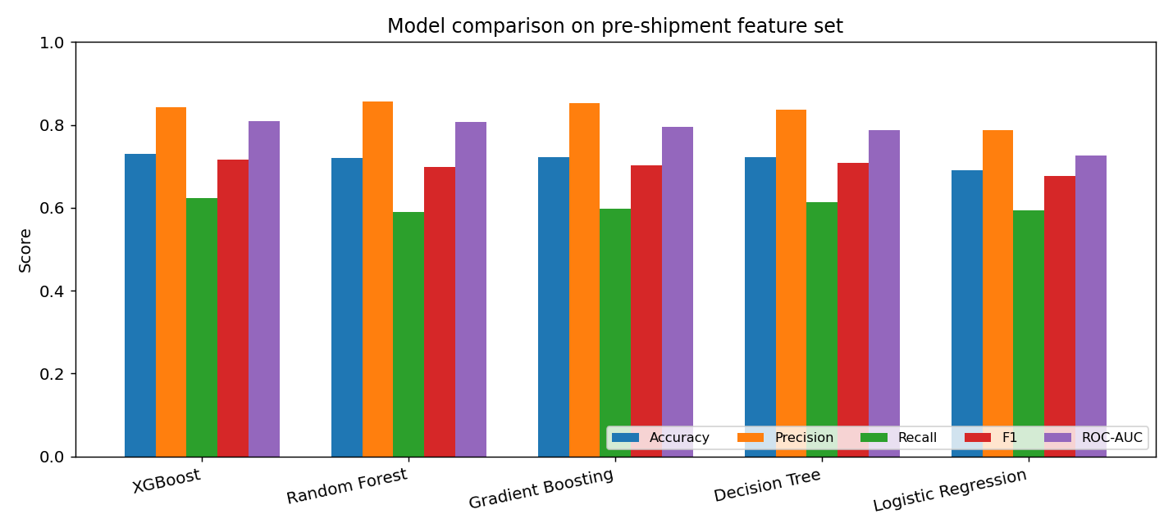
Figure 2. Comparison of the five classifiers across all five metrics.
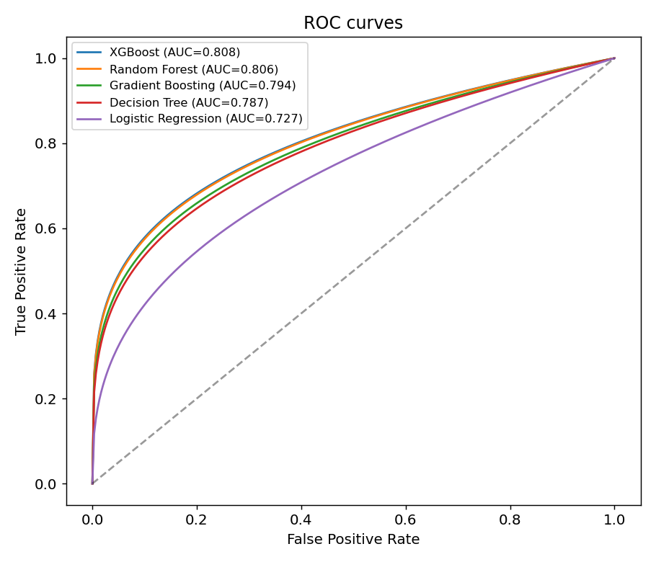
Figure 3. ROC curves for the five classifiers; XGBoost achieves the highest area under the curve.
The ROC curves in Figure 3 reinforce this reading. All four non-linear models bow well above the diagonal chance line, with XGBoost and Random Forest tracing the highest curves and Logistic Regression clearly the lowest. The closeness of the XGBoost and Random Forest curves reflects their near-identical ROC-AUC values of 0.808 and 0.806, while the gap to Logistic Regression at 0.727 is substantial across most of the threshold range. Because the curves are well separated from the diagonal, the models rank orders by risk considerably better than chance, which is the property that makes threshold tuning a viable lever for improving recall.

6.2 Error Structure of the Best Model
Figure 4 shows the confusion matrix for XGBoost on the test set of 36,104 orders. Of the orders that were genuinely late, the model correctly flagged around 12,300 and missed around 7,500; of the orders that were genuinely on time, it correctly cleared around 14,000 and raised a false alarm on around 2,300. Translated into rates, the model's precision of 0.84 means that most orders it flags as late are genuinely late, so false alarms are relatively contained. Its recall of 0.62, however, means that roughly 38 per cent of genuinely late orders are not flagged at the default 0.5 decision threshold.
This asymmetry — high precision but moderate recall — is the operationally important finding, and it follows directly from the shape of the data and the choice of threshold. At the default threshold of 0.5, the model only flags an order when it is fairly confident, which keeps false alarms low but lets a substantial number of genuinely late orders slip through. For a business whose priority is to catch as many late orders as possible, this is the wrong balance, but it is straightforward to correct: because the model outputs a probability and ranks orders well (ROC-AUC 0.81), the decision threshold can be lowered below 0.5, or class weights can be applied during training, to shift the balance towards higher recall at the cost of some precision. The next subsection considers this trade-off explicitly.
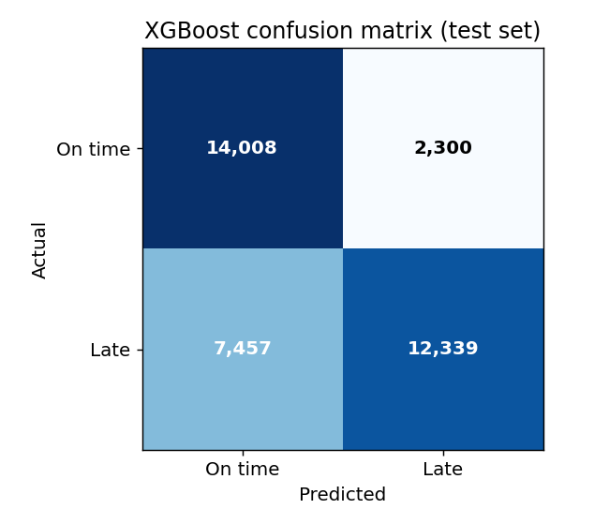
Figure 4. Confusion matrix for the XGBoost model on the test set.

6.3 Drivers of Late Delivery (RQ3)
Figure 5 shows the top fifteen feature importances for XGBoost. Two features dominate: scheduled shipment days (importance 0.52) and shipping mode (0.31), which together account for more than 80 per cent of the model's importance. No other feature exceeds four per cent. Order hour and payment type contribute modestly, and the geographic, temporal and value-based features each contribute little individually. This concentration is operationally meaningful: it indicates that the lead time promised to the customer and the carrier service level chosen are by far the strongest levers on delivery risk, and that a business seeking to reduce late deliveries should focus first on how scheduled lead times are set and how shipping modes are assigned, rather than on customer or product attributes. The caveat from Section 2.3 applies — gain-based importance can favour certain variables — but the dominance of these two operational features is large enough to be robust to that concern, and it aligns with the exploratory findings in Section 3.3.
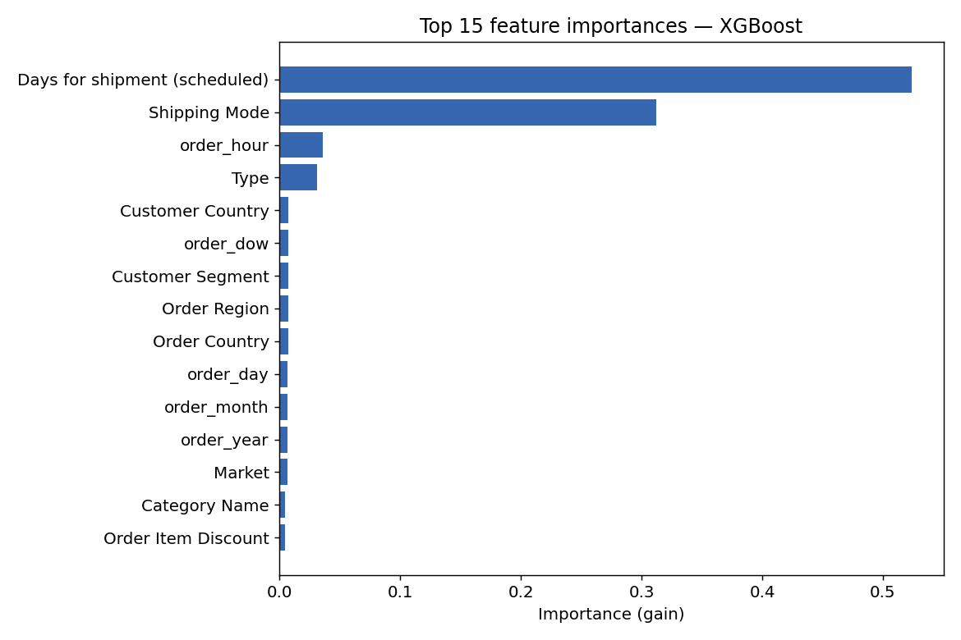
Figure 5. Top 15 feature importances for the XGBoost model (gain-based).

6.4 Answering the Research Questions
RQ1. On a strictly pre-shipment feature set, the best model reaches an accuracy of 0.73 and a ROC-AUC of 0.81. This is a meaningful and useful level of predictive power, but it sits well below the 95–99 per cent accuracies reported in leakage-affected studies, confirming that those figures are artefacts of outcome leakage rather than genuine pre-shipment predictability.
RQ2. XGBoost offers the best balance of performance, recall and interpretability. It leads on ROC-AUC, F1, recall and accuracy while retaining readable feature importances; Random Forest trades recall for slightly higher precision, and the linear baseline is clearly weaker. XGBoost is therefore the model carried into the inference function.
RQ3. Scheduled shipment days and shipping mode are overwhelmingly the strongest drivers of late delivery risk, together exceeding 80 per cent of feature importance. The clear business implication is that lead-time setting and carrier selection are the primary points of intervention for reducing delays.

6.5 Comparison with Prior DataCo Studies
Table 3 situates these results against the prior DataCo work reviewed in Section 2.5. The comparison makes the project's contribution concrete: where earlier studies report very high accuracy, they do so using feature sets that contain post-shipment variables, whereas this project reports lower but leakage-free figures obtained from pre-shipment features only. The drop from roughly 97–99 per cent to roughly 73 per cent is not a weakness of the present models; it is the correction that results from removing the leakage that inflated the earlier numbers, exactly the phenomenon that Kapoor and Narayanan (2023) document across many fields, where removing leakage causes apparent performance to fall to a realistic level. The present work also reports recall explicitly and closes the loop with an inference function, neither of which is standard in the prior studies.
Study | Reported accuracy | Leakage-free? | Recall reported? | Inference step?
Burova (2023) | ~97–99% | No (uses real shipping days) | Limited | No
Ahmed et al. (2025) | ~96% (SOM+ANN) | No (post-shipment vars) | Limited | No
Al-Saghir (2022) | Ensembles best | Partial | Limited | No
This project | ~73% (XGBoost) | Yes (pre-shipment only) | Yes (0.62) | Yes
Table 3. Comparison with prior DataCo studies on validity, recall reporting and deployment.

6.6 Business and Operational Implications
Beyond the headline metrics, the results carry a clear operational message. The dominance of scheduled shipment days and shipping mode in the feature-importance analysis indicates that the two strongest levers on delivery risk are decisions the business already controls: how much lead time it promises the customer and which carrier service level it assigns to an order. This suggests concrete interventions. Orders placed with very short scheduled lead times, or routed through the shipping classes that the exploratory analysis associated with higher late rates, are the natural candidates for pre-emptive action — upgrading the carrier, adjusting the promised delivery date, or warning the customer in advance. Because these are the same factors the model relies on most, a risk score built on them is directly actionable rather than merely descriptive.
The way the model would be embedded also matters. A sensible deployment would score each order at placement, rank the day's orders by predicted risk, and route the highest-risk orders to an analyst for review. Framed this way, the moderate recall is less damaging than it first appears: even a model that catches only part of the late orders adds value if it reliably surfaces the riskiest ones for human attention. The probabilistic output makes this ranking-and-triage use straightforward and keeps a human in the loop rather than automating decisions against customers on the basis of an imperfect prediction.

6.7 Discussion
The results support the central argument of the project. The realistic ceiling for pre-shipment prediction on the DataCo dataset is around 0.73 accuracy and 0.81 ROC-AUC, and the reason earlier studies report far higher figures is outcome leakage rather than superior modelling. This is a constructive rather than a purely negative finding: it replaces a set of implausible benchmarks with a credible one against which future work can be measured honestly. The concentration of predictive signal in scheduled lead time and shipping mode gives a clear, actionable message for operations managers, and it is consistent with domain intuition that the promised delivery window and the carrier service level are the dominant determinants of whether an order arrives on time.
The main practical limitation of the model is its recall: at the default threshold it misses roughly two in five late orders. This is the natural focus for improvement, and the analysis of the confusion matrix and ROC curve shows that the model's good ranking quality makes threshold adjustment and cost-sensitive training promising routes to higher recall, which are revisited as future work in Chapter 7. It is also worth being candid about what the modest accuracy implies: late delivery on this dataset is only partly predictable from pre-shipment information, because much of what determines whether an order is late — carrier performance on the day, weather, congestion, handling errors — is simply not present in the order record at the time of prediction. A ceiling around 0.81 ROC-AUC should therefore be read not as a failure of the models but as an honest reflection of how much of the outcome the available pre-shipment features can explain.

7 Conclusions and Future Work

7.1 Summary of Findings
This project set out to build an honest, deployable machine learning early-warning system for late delivery on the DataCo Smart Supply Chain dataset, addressing the leakage, recall and deployment weaknesses identified in the literature. Working from a strictly pre-shipment feature set, five classifiers were trained and compared, and XGBoost emerged as the strongest, with an accuracy of 0.73, precision of 0.84, recall of 0.62, F1 of 0.72 and ROC-AUC of 0.81. These leakage-free figures establish a realistic benchmark for the dataset that is markedly lower than the inflated results common in prior work. Feature-importance analysis showed that scheduled shipment days and shipping mode together account for more than 80 per cent of the prediction, identifying lead-time setting and carrier selection as the primary operational levers for reducing delays. Finally, the best model was wrapped in a reusable inference function that scores a new order end-to-end, demonstrating that the work is not only an experiment but also a small piece of working decision-support software.
Returning to the three research questions, the project answers each clearly. On RQ1, pre-shipment features alone predict late delivery with an accuracy of about 0.73 and a ROC-AUC of about 0.81 — useful, but far below the leakage-inflated figures in prior work. On RQ2, XGBoost provides the best balance of predictive performance, recall and interpretability, and is the model taken forward. On RQ3, scheduled shipment days and shipping mode are the overwhelming drivers of delay risk, pointing to lead-time setting and carrier selection as the primary operational levers. Taken together, these answers meet the objectives set out in the introduction.

7.2 Contributions
The project makes two main contributions. Methodologically, it demonstrates a disciplined pipeline in which leakage screening is an explicit, auditable stage, recall is reported alongside accuracy, and the model terminates in an operational scoring function — directly addressing the validity, evaluation and deployment gaps of prior DataCo work. This matters beyond the specific dataset, because the same three weaknesses recur across applied machine learning, and the pipeline shows in concrete terms how to avoid them. Substantively, it provides a corrected, leakage-free benchmark for the DataCo dataset — an honest reference point of roughly 0.73 accuracy and 0.81 ROC-AUC against which future studies can be measured — together with a transferable template that supply chain analysts in retail and e-commerce can adapt to their own order data using only standard open-source tools.

7.3 Limitations
Several limitations should be acknowledged. The study uses a single, publicly available dataset, so the specific performance figures may not transfer directly to other supply chains, even if the methodology does. The model's recall of 0.62 means a substantial share of late orders is missed at the default threshold, limiting its immediate operational usefulness without threshold tuning. Feature importance was derived from gain-based scores, which can be biased towards high-cardinality variables, so the importance rankings should be read as indicative rather than exact — although, as noted in Chapter 6, the dominance of the two leading features is large enough to be robust to this caveat.
Two further limitations concern the modelling choices. Hyperparameters were set to sensible defaults rather than exhaustively tuned, so the reported figures are likely a slight underestimate of what each model could achieve with careful optimisation; however, using comparable defaults keeps the comparison between models fair. And no formal cost model was applied to weight false negatives against false positives in monetary terms, which means the choice of operating threshold is discussed qualitatively rather than optimised against a specific business cost function. These are natural extensions rather than flaws in the present design, and they are taken up in the next section.

7.4 Future Work
Several directions would extend the work. First, and most importantly for operational value, the decision threshold could be optimised and class weights or cost-sensitive learning applied, so that recall on the late class is raised to a level appropriate to the business's tolerance for missed orders; pairing this with an explicit cost model for the two error types would turn the qualitative threshold discussion of Chapter 6 into a principled, cost-optimal operating point. Second, model-agnostic interpretation using permutation importance and SHAP values (Lundberg and Lee, 2017) would give more reliable feature attributions than gain-based importance and would strengthen managerial trust in the predictions. Third, hyperparameter tuning and calibration of the predicted probabilities would likely yield modest performance gains and, in the case of calibration, more trustworthy risk scores for threshold setting.
Fourth, validating the pipeline on an additional, independent order dataset would test the generalisability of both the method and the substantive finding that lead time and shipping mode dominate delivery risk; a finding that recurs across datasets would be far stronger evidence for operations managers than one drawn from a single source. Finally, richer features could be incorporated where they are genuinely available before shipment — for example historical on-time performance by carrier and route, or warehouse workload at the time of ordering — since much of the currently unexplained variance in delivery outcomes is likely to live in exactly this kind of contextual information. Together these steps would move the artefact from a validated prototype towards a production-ready early-warning system, while preserving the leakage-free discipline that is the core of the present contribution.

References
Ahmed, K. R., Ansari, M. E., Ahsan, M. N., Rohan, A., Uddin, M. B. and Rivin, M. A. H. (2025) 'Deep learning framework for interpretable supply chain forecasting using SOM, ANN and SHAP', Scientific Reports, 15, article 26355. https://doi.org/10.1038/s41598-025-11510-z
Al-Saghir, R. (2022) Predicting Delays in the Supply Chain with the Use of Machine Learning. Master's Thesis. Rochester Institute of Technology. Available at: https://repository.rit.edu/theses/11492 (Accessed: 1 September 2026).
Baryannis, G., Dani, S. and Antoniou, G. (2019) 'Predicting supply chain risks using machine learning: The trade-off between performance and interpretability', Future Generation Computer Systems, 101, pp. 993–1004. https://doi.org/10.1016/j.future.2019.07.059
Burova, P. (2023) Predicting Delivery Delays in Supply Chain. Kaggle and GitHub project. Available at: https://github.com/PolinaBurova/Predicting-Delivery-Delays-in-Supply-Chain (Accessed: 15 August 2026).
Chawla, N. V., Bowyer, K. W., Hall, L. O. and Kegelmeyer, W. P. (2002) 'SMOTE: Synthetic Minority Over-sampling Technique', Journal of Artificial Intelligence Research, 16, pp. 321–357. https://doi.org/10.1613/jair.953
Chen, T. and Guestrin, C. (2016) 'XGBoost: A Scalable Tree Boosting System', in Proceedings of the 22nd ACM SIGKDD International Conference on Knowledge Discovery and Data Mining. San Francisco, CA: ACM, pp. 785–794. https://doi.org/10.1145/2939672.2939785
Hasan, R., Kamal, M. M., Daowd, A., Eldabi, T., Koliousis, I. and Papadopoulos, T. (2024) 'Critical analysis of the impact of big data analytics on supply chain operations', Production Planning & Control, 35(1), pp. 46–70. https://doi.org/10.1080/09537287.2022.2047237
Kapoor, S. and Narayanan, A. (2023) 'Leakage and the reproducibility crisis in machine-learning-based science', Patterns, 4(9), 100804. https://doi.org/10.1016/j.patter.2023.100804
Lundberg, S. M. and Lee, S.-I. (2017) 'A Unified Approach to Interpreting Model Predictions', in Advances in Neural Information Processing Systems 30. Long Beach, CA, pp. 4765–4774. Available at: https://papers.nips.cc/paper/7062-a-unified-approach-to-interpreting-model-predictions (Accessed: 1 September 2026).
Park, K. (2024) 'Performance comparison of machine learning and deep learning models for supply chain tier order quantity prediction: Emphasis on tree-based and CNN-BiLSTM approaches', Journal of Infrastructure, Policy and Development, 8(14), 9683. https://doi.org/10.24294/jipd9683
Seyedan, M. and Mafakheri, F. (2020) 'Predictive big data analytics for supply chain demand forecasting: methods, applications, and research opportunities', Journal of Big Data, 7, 53. https://doi.org/10.1186/s40537-020-00329-2
Wang, G., Gunasekaran, A., Ngai, E. W. T. and Papadopoulos, T. (2016) 'Big data analytics in logistics and supply chain management: Certain investigations for research and applications', International Journal of Production Economics, 176, pp. 98–110. https://doi.org/10.1016/j.ijpe.2016.03.014

