Outlook Email Organizer documentation

Prerequisites: Python 3.10.9 (can be installed from https://www.python.org/ftp/python/3.10.9/python-3.10.9-amd64.exe)
If you have another version of Python on your device, please upgrade/downgrade to this version by deleting the old version. You can do this by following the steps outlined here: How to Uninstall Python | Python Central

Running the app:
- Install the zip file from: outlook-organizer/outlook-organize-lightbg.zip at main · akshaj-24/outlook-organizer
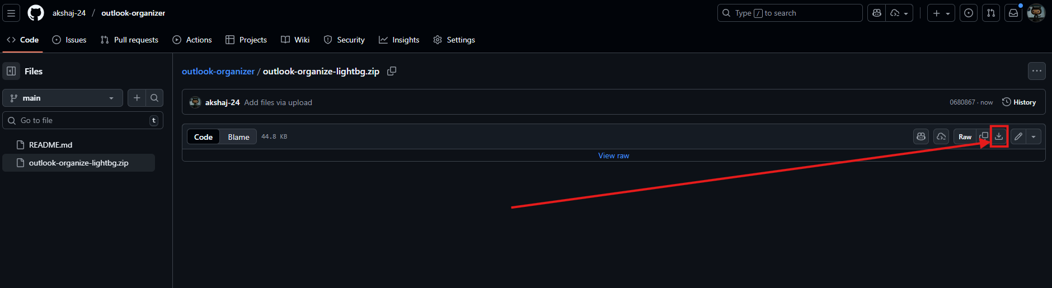
- Unzip the file
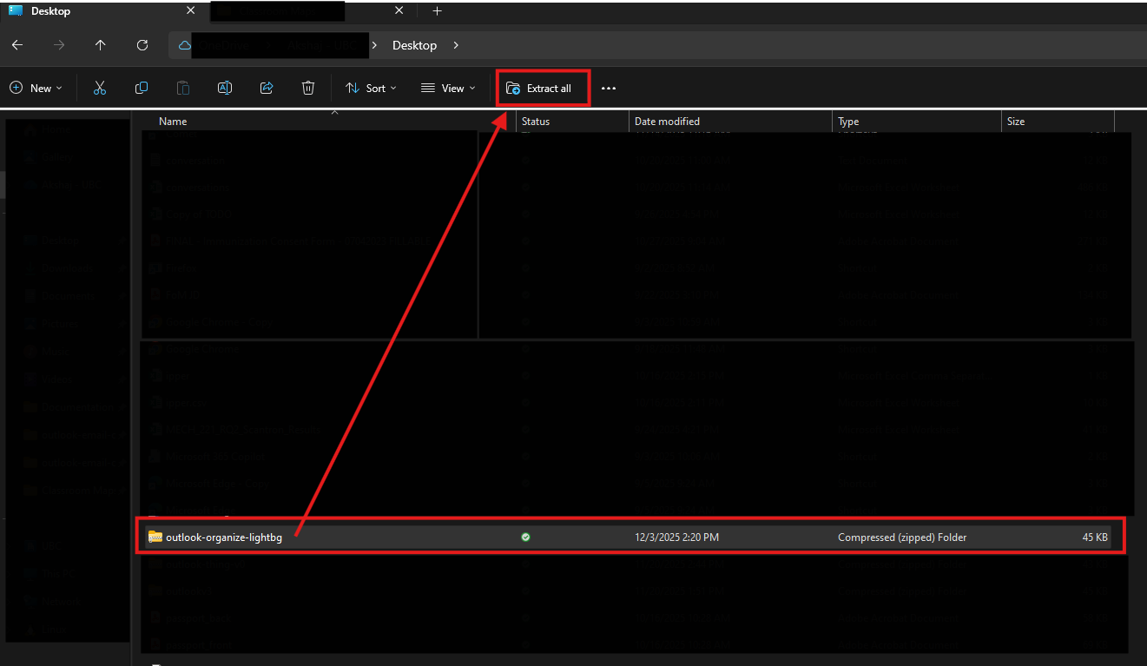

- Launch the app by clicking on run.bat
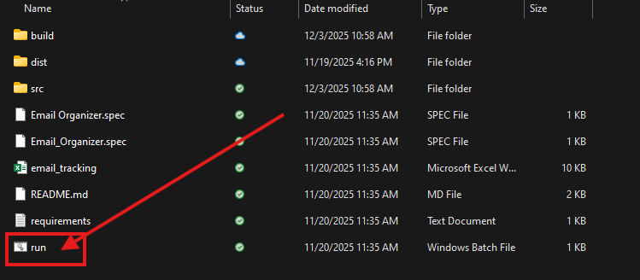
Please note that required libraries will be installed the first time you run the application. This will open a new command prompt window.
- It is recommended to create a new excel file every time you are starting a tracking session. You can include a timestamp in the file name: For example Tracking_03dec1404.

To create a copy with time stamp, click on the email_tracking.xlsx to pre-load the file name and add the date and time.
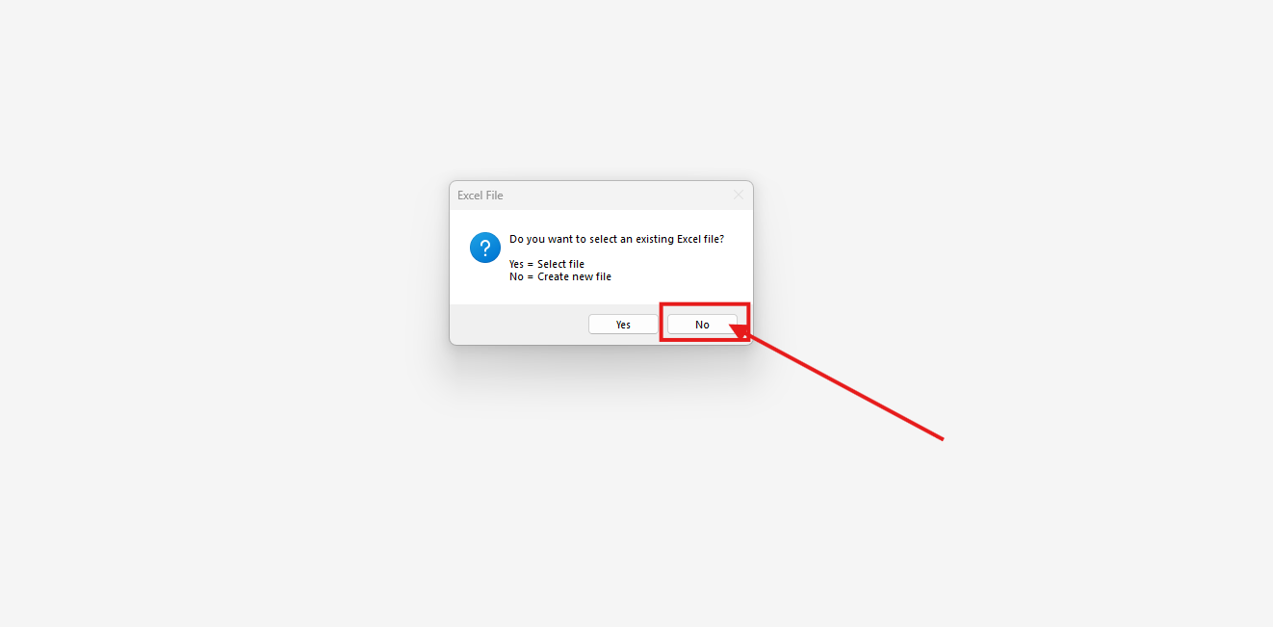
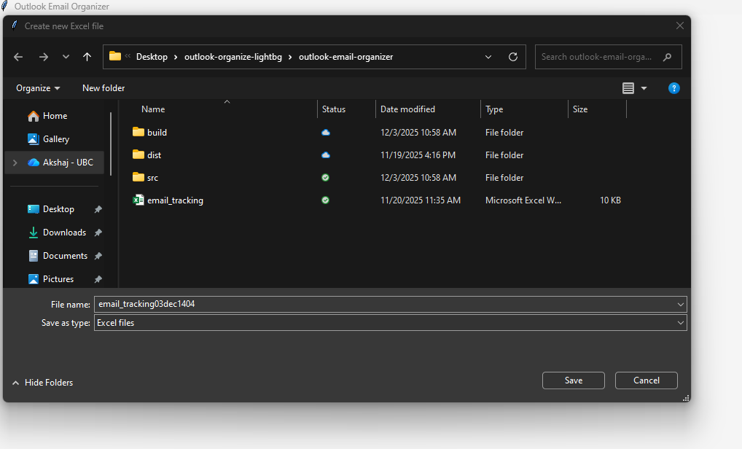

Please ensure that your excel file is closed when you are moving emails as the application cannot write to an open excel file.

App controls:
Emails are displayed in the center of your screen.
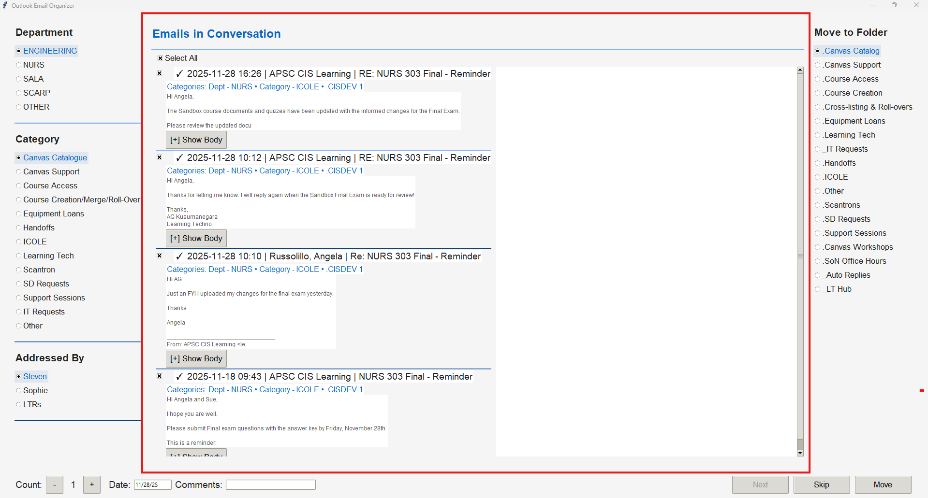
You can select categories here. The folder is mapped to the category field and will be pre-selected. For example Handoff -> .Handoffs
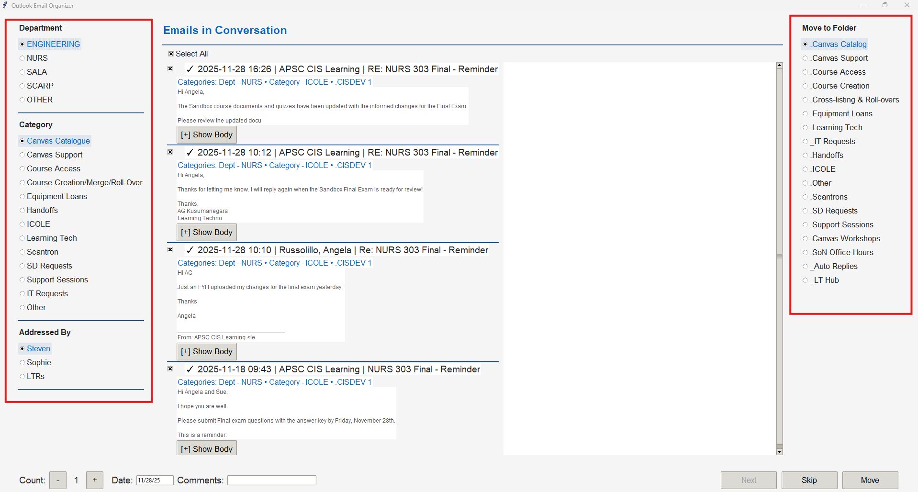

Adjust count, date, and comments here. It is set to default value on every move click. Default date is the date of the latest email in conversation (day it was resolved). If there are multiple dates, please move the latest emails first to pre-load the correct date.
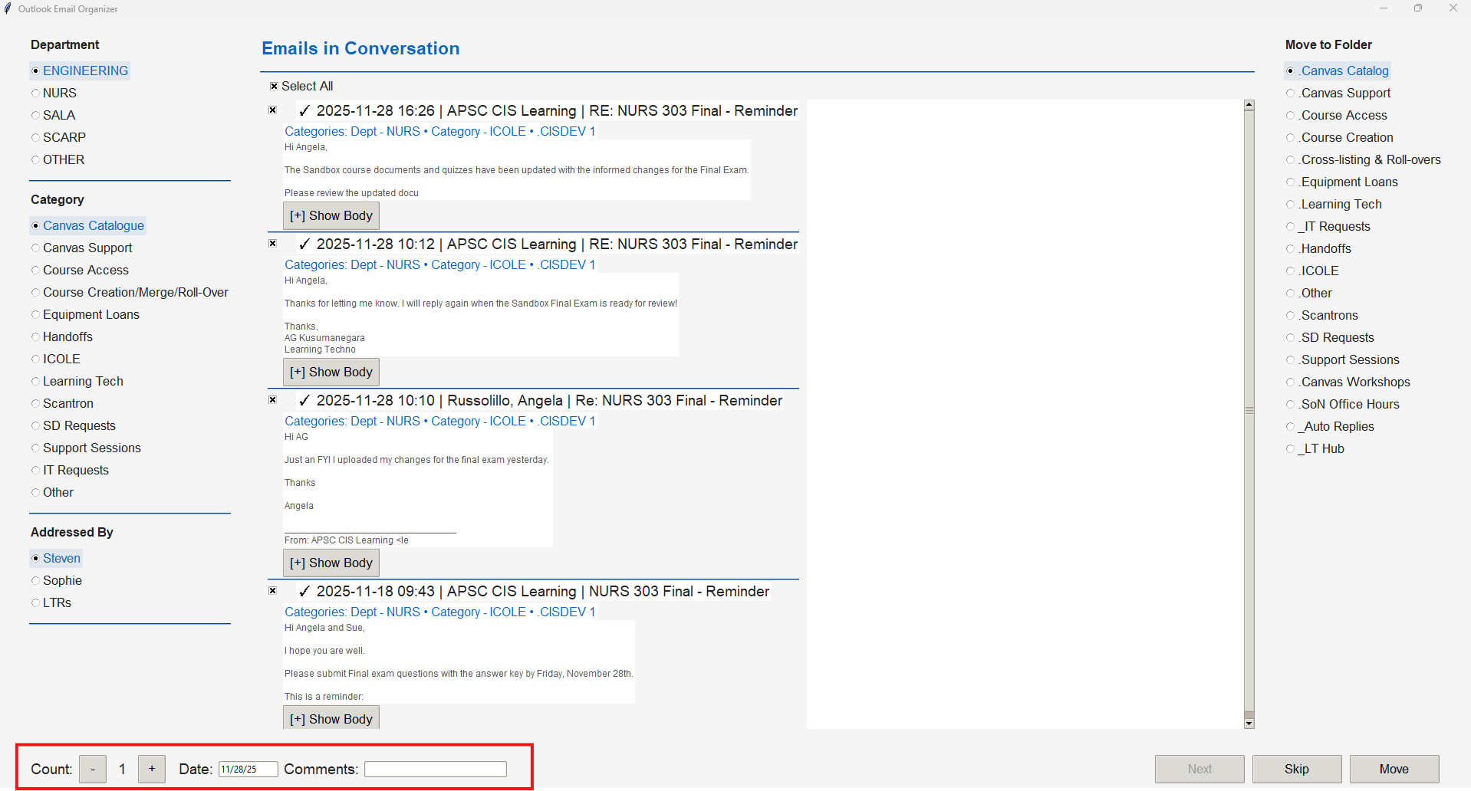
Move/Skip emails here. Next is only available after all emails are moved.
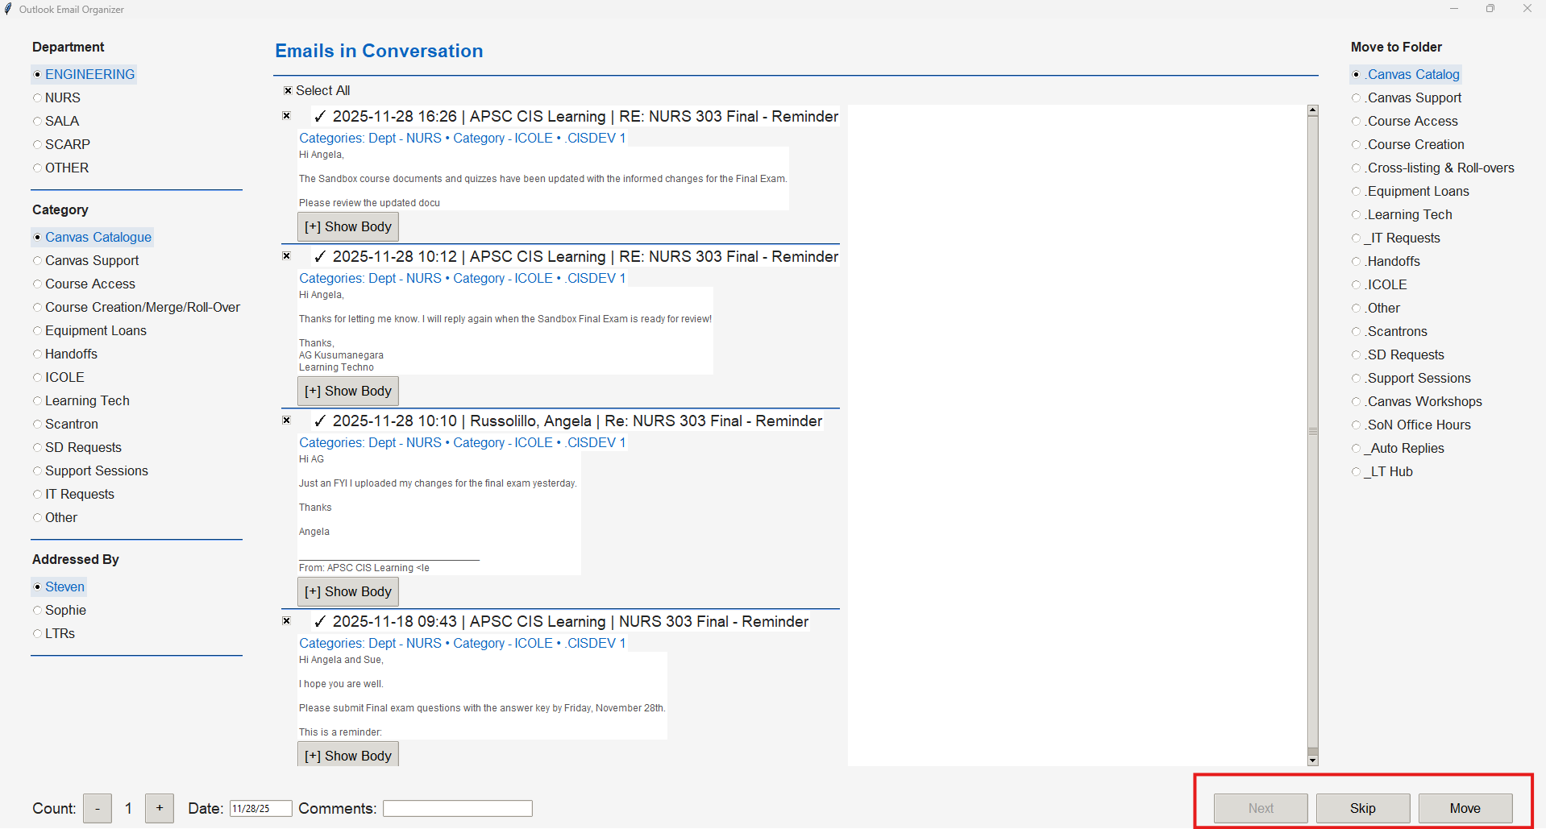

Optional: You can keep the terminal open on another screen to monitor that emails have been moved and data has been logged in Excel.

