Sales Pipeline Command Center
Oct 22, 2026 · @Vitap-Kanixa
One Lightning Web Component gives a sales manager the whole team pipeline on one screen: health KPIs, at-risk and high-value deals, inline updates, list and Kanban views, and live team activity. It runs on standard Opportunity fields only and is deployed in the SalesPipelinePOC Developer org.

The problem it solves
Sales managers lose time every day switching between three places to run their team's pipeline. The command center replaces all three with one screen.
Today the manager uses | To answer | In the command center
List views | Which deals exist, who owns them, what stage they are in | Filterable list and Kanban board on the same screen
Reports and dashboards | How much pipeline, what closes this month, win rate | Live KPI tiles and a stage breakdown that react to filters
Opportunity record pages | Update a stage or date, chase the rep | Inline edits, drag-and-drop, and a side panel with edit, coaching note and follow-up task
Design goals: fast with hundreds of open deals, no custom fields or objects, and usable without training.

What a manager can do
Every feature maps to a question a manager asks during the daily pipeline review.
Manager's question | Feature | How it works
How healthy is my team's pipeline? | KPI tiles | Open pipeline, weighted forecast, closing this month, at risk, past close date, high value, won this quarter with win rate
Where is the money stuck? | Pipeline by stage | One card per open stage with amount, deal count and a relative bar
Which deals need me today? | Health score 0–100 | Every open deal is scored, with the reasons shown (e.g. "Close date passed 12d ago")
Show me only the problems | One-click filters | Click a KPI tile or stage card; chips for "Closing in 30 days" and "No next step"
Find a specific deal | Search and filters | Search across deal, account, owner and next step; filter by owner, status, stage, close period
Whose deals am I looking at? | Scope switch | My team (me + reports up to 3 levels), My deals, All I can see
Fix it now | Inline edit (list) | Edit stage, amount, probability, close date and next step; save many rows at once
Move deals forward | Kanban board | Drag cards between stages, or the → arrow for the next stage; Won/Lost asks to confirm
Get the rep moving | Deal side panel | Full edit form, coaching note posted to Chatter that @mentions the owner, follow-up task assigned to the owner
What did my team just change? | Team activity feed | Changes by teammates appear within a second and the deal is highlighted
Send this to my VP | CSV export | Exports the current filtered list

Screen tour
The screen reads top to bottom: summary first, then filters, then the deals. Open it from App Launcher → Sales Command Center → Pipeline Command Center tab.
Region (top to bottom) | What it shows | What you can do
Header | Title, scope, "Synced 1m ago", Live indicator | Switch scope, open Team activity, export CSV, refresh
KPI tiles | 7 pipeline numbers for the current scope, owner and search | Click a tile to filter the deals; click again to clear
Pipeline by stage | Amount and deal count per open stage | Click a stage to filter; collapse the strip
Filter bar | Search, owner, status, stage, close period, quick chips | Combine any filters; Clear filters resets
Result line | Deal count and total amount of what is shown | Switch List / Kanban; choose Kanban card sort
List view | Deals as rows, 50 at a time (more load on scroll) | Inline edit, sort any column, row actions (details, view, won, lost)
Kanban view | One column per stage, 25 cards per column ("Show more") | Drag to change stage, → to advance, click a card for details
Side panel | Health reasons, key facts, edit form, coaching, tasks | Save changes, post and notify the owner, assign a task
Team activity | Who changed which deal, newest first | Click a deal to open it
KPIs and the stage strip follow scope, owner and search only, so clicking a tile slices the deals without changing the totals you are slicing.

Health score
Every open deal starts at 100 and loses points for each risk signal; below 60 is At risk, below 80 is Watch, otherwise Healthy. Each lost point comes with a readable reason, so the manager sees why, not just a number. Closed deals are not scored.
Signal | Rule (standard fields) | Points
Past close date | CloseDate before today | −30
Closing soon at early stage | Closes within 30 days at under 50% probability | −20
Stale | Last activity older than "stale days" (default 14) | −20
No activity | LastActivityDate is empty | −15
Stuck in stage | Days since LastStageChangeDate over 3 × stale days | −15
Slipping | Close date pushed 2 or more times (PushCount) | −15
Overdue task | HasOverdueTask is true | −10
No next step | NextStep is blank | −10
No amount | Amount is blank or 0 | −5
The score never goes below 0. Rules live in one Apex class, PipelineHealthService, so weights can be tuned in one place or moved to Custom Metadata later. Admins set "stale days" and the high-value threshold (default 100,000) in Lightning App Builder.
On the demo data (My team, 296 deals including 34 closed this quarter): 26 at risk, 73 watch, 163 healthy.

Architecture
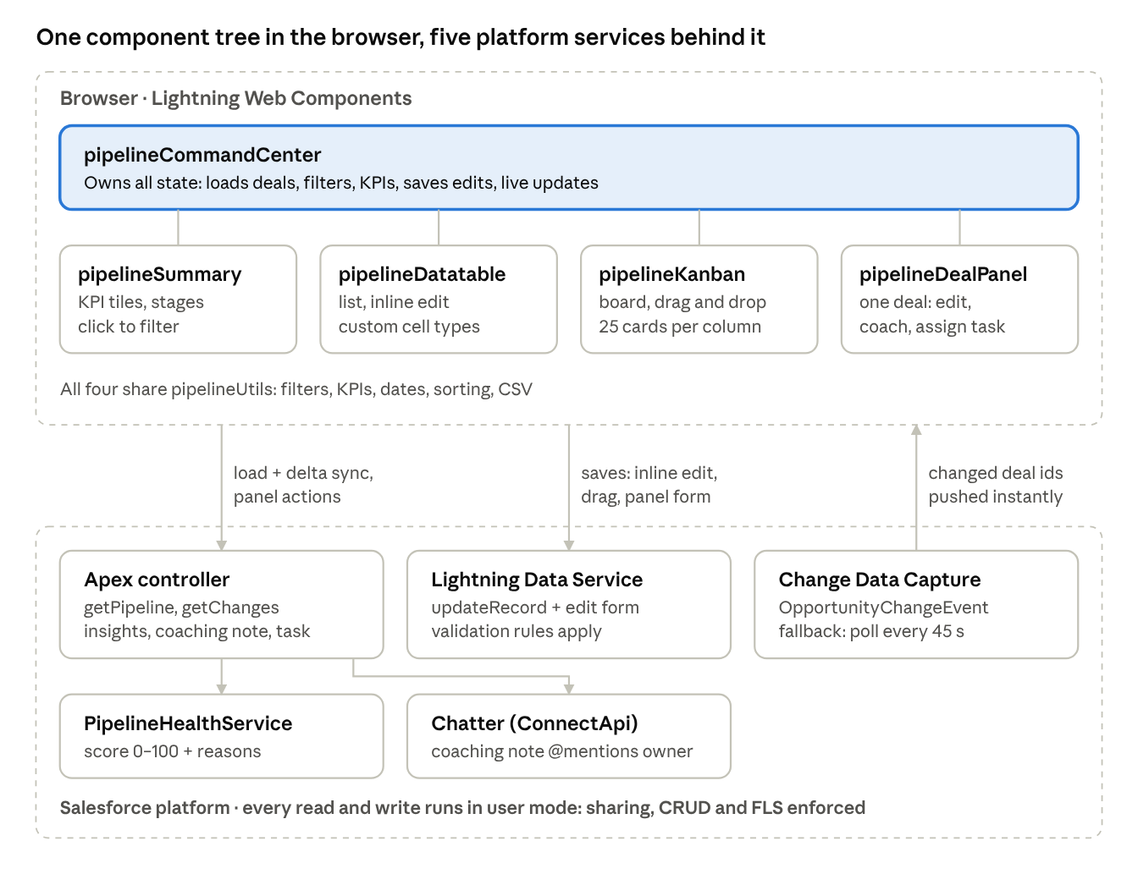
architecture · 5 components in the browser, 5 platform services
The browser components talk to Salesforce through three doors: Apex for reads and collaboration actions, Lightning Data Service for saves, and Change Data Capture for live change notices.

Components
The UI is one exposed component composed of six internal ones; the server side is one controller plus one scoring service. All source is under force-app/main/default/.
Component | Type | Responsibility
pipelineCommandCenter | LWC (exposed: App, Home, Tab) | Owns all state: loads data, applies filters, computes KPIs, saves edits, subscribes to live updates, remembers view and scope per browser
pipelineSummary | LWC | KPI tiles and the Pipeline by stage strip; fires tile and stage filter events
pipelineDatatable | LWC (extends lightning-datatable) | Adds three column types: deal name link, health badge, inline-editable picklist for Stage
pipelineKanban | LWC | Board with one column per stage, drag-and-drop, next-stage arrow, 25 cards per column page
pipelineDealPanel | LWC | Side panel: health reasons, key facts, lightning-record-edit-form, coaching note, follow-up task, recent posts and tasks
pipelineHealthBadge / pipelineDealCell | LWC | Reusable score pill and deal-name cell
pipelineUtils | JS module | Pure functions: filters, KPIs, stage summary, dates, sorting, CSV, error messages (unit-tested)
PipelineCommandCenterController | Apex, with sharing | Load the working set, return changed deals, deal insights, post coaching note, create follow-up task
PipelineHealthService | Apex, with sharing | Scores one Opportunity and returns score, level and reasons
App builder properties on pipelineCommandCenter: title, high-value threshold, stale days, default view (list or kanban), default scope (TEAM, MINE, ALL).

Data flow and live updates
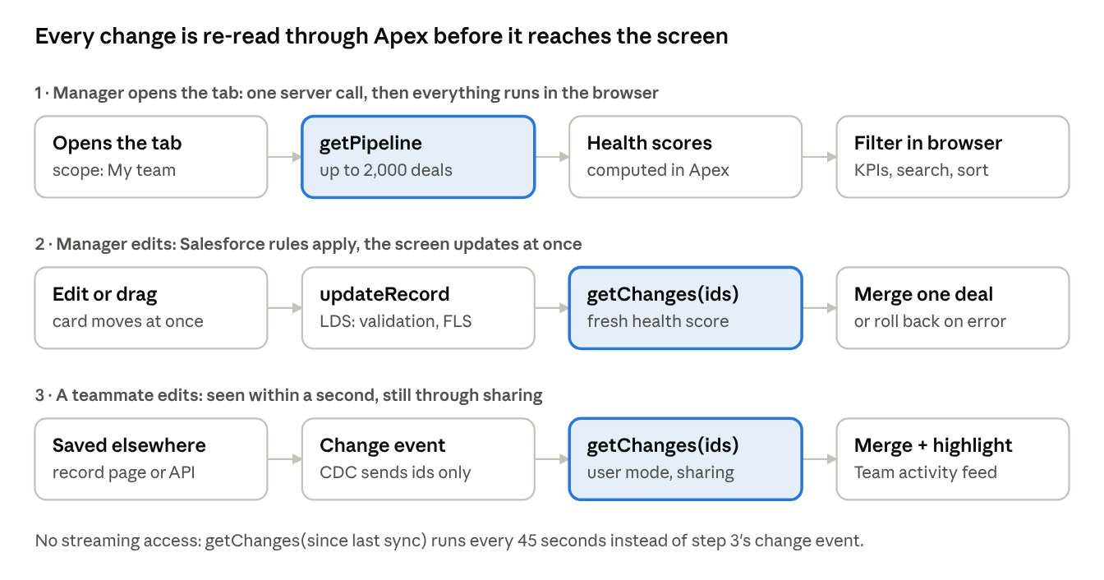
data flow · load, save, live update
A change event never carries deal data, so a teammate's edit only reaches the screen after the same sharing-aware Apex read used for saves. Changes merge one deal at a time; the feed skips changes the screen already has, and a highlight stays on the deal for 3 minutes.

Apex API
Five @AuraEnabled methods on PipelineCommandCenterController; errors come back as AuraHandledException with a readable message (DML errors use the first validation message).
Method | Inputs | Returns | Used by
getPipeline | scope (TEAM, MINE, ALL), staleDays | Deals with health scores, active stages, truncated flag, hasTeam, server time | First load, scope change, refresh
getChanges | scope, sinceIso, recordIds, staleDays | Changed deals, each with inScope true/false, plus server time | Live updates, polling, refresh after a save
getDealInsights | opportunityId | Last 5 Chatter posts and up to 8 tasks (open first, overdue flagged) | Side panel
postCoachingNote | opportunityId, message (max 5,000 chars) | Nothing; posts to the deal feed via ConnectApi, @mentioning the owner unless it is you | Coach rep tab
createFollowUpTask | opportunityId, subject, dueDate, priority, comments | New Task Id, owned by the deal owner | Follow-up task tab
Working set = all open Opportunities plus those closed this fiscal quarter (for the Won tile and win rate), capped at 2,000 rows. Team = the current user plus users up to three levels below on the User Manager field. Stages come from OpportunityStage (active, ordered), which also gives the default probability used for optimistic Kanban moves.
Inline edits and Kanban moves do not go through Apex: they use Lightning Data Service updateRecord, then call getChanges for the saved ids to refresh scores.

Security and performance
Users only ever see and change what Salesforce already allows them to, and the screen stays instant with hundreds of deals because filtering happens in the browser.
Security
- All Apex classes are with sharing; every query uses WITH USER_MODE or Database.queryWithBinds(..., AccessLevel.USER_MODE), and the task insert uses AccessLevel.USER_MODE, so sharing, object and field permissions are enforced.
- Saves from the list, board and side panel go through Lightning Data Service, so validation rules and field-level security behave exactly as on the record page.
- A live-update event only says which records changed; the deal data itself is always re-read through Apex with the user's sharing.
- Access is granted by the Pipeline_Command_Center permission set (Apex class, tab, app).
Performance
Technique | Effect
One Apex call loads the working set (up to 2,000 deals) | Search, filters, sorting and KPIs run in memory with no server round trip
Search waits 250 ms after typing stops | No recalculation on every keystroke
List shows 50 rows and loads 50 more on scroll; Kanban shows 25 cards per column | DOM stays small; KPIs still cover every deal
Live updates merge only the changed deals | No full reload when a teammate edits one deal
Kanban moves are optimistic | The card moves at once; it rolls back with the error message if Salesforce rejects it
Banner when the 2,000 cap is hit | Suggests switching to My team or My deals

Deployment and setup
Everything ships as source in one SFDX project (API 68.0) and installs with one deploy plus four data scripts.
Metadata | Name | Purpose
Apex classes | PipelineCommandCenterController, PipelineHealthService + 3 test classes | Server logic and tests
Lightning components | pipelineCommandCenter + 6 internal components + pipelineUtils | UI
Custom tab | Pipeline_Command_Center | Opens the component full page
Lightning app | Sales_Command_Center | Tabs: command center, Opportunities, Accounts, Contacts, Reports, Dashboards
Permission set | Pipeline_Command_Center | Apex, tab and app access
Platform event channel member | ChangeEvents_OpportunityChangeEvent | Turns on Change Data Capture for Opportunity
Install in a new org:
sf project deploy start -d force-app -o <org>
sf apex run -f scripts/apex/1_createSalesReps.apex -o <org>
sf apex run -f scripts/apex/2_createPipelineData.apex -o <org>
sf apex run -f scripts/apex/3_pushCloseDates.apex -o <org> # run twice
sf apex run -f scripts/apex/3_pushCloseDates.apex -o <org>
The component can also be dropped on any App or Home page in Lightning App Builder. No custom fields or objects are needed. scripts/apex/9_deleteDemoData.apex removes the demo records.

Test data and testing
The demo org holds 320 realistic opportunities tuned to show every risk signal, and all 38 automated tests pass.
Demo data (seeded, so every run looks the same)
Record | Count | Mix
Sales reps | 2 | Maya Patel and Diego Alvarez, reporting to the manager (uses the org's last 2 Salesforce licenses)
Accounts | 30 | Fictional companies across 20+ industries
Open opportunities | 280 | Funnel from 50 Prospecting to 25 Negotiation/Review; 12% past close date, 23% closing this month; 22% without a next step; amounts 5k–500k
Closed this quarter | 40 | 25 won, 15 lost
Tasks | 385 | Recent completed, old-only (stale), none (no activity), overdue open, upcoming
Chatter posts | 18 | Deal notes for the side panel
Slipping deals | 24 | Close date pushed twice, so PushCount = 2
About 7% of deals belong to a user outside the team, so My team and All I can see show different results.
Automated tests
Suite | Tests | Result | Covers
Apex: PipelineHealthServiceTest | 5 | Pass, 100% coverage | Every rule, stacking, closed deals, bad input
Apex: PipelineCommandCenterControllerTest | 12 | Pass, 92% coverage | Scopes, delta sync, in-scope flag, insights, task creation, validation
Apex: PipelineCoachingNoteTest | 1 | Pass | Chatter post via ConnectApi (needs SeeAllData)
Jest: pipelineUtils | 15 | Pass | Dates, filters, KPIs, stage summary, sort, CSV, errors
Jest: pipelineCommandCenter | 5 | Pass | Load, KPI tile filter, Kanban switch, side panel, error state
Layout and scrolling were also checked in the real org with headless Chrome (see the next section).

Lessons from the build
Three layout bugs only appeared inside Lightning Experience, not in Jest; all are fixed, and the fixes are worth reusing on other LWC projects.
Symptom | Cause | Fix
Stage rows drawn on top of each other, covering the KPI tiles on hover | Native <button> rows laid out as a CSS grid were pulled out of place on the Lightning page | Rebuilt as compact stage cards using the same markup as the KPI tiles, with pcc- prefixed class names
In Kanban, the whole Salesforce page could scroll into empty space (page measured 4,180 px tall) | Hidden accessibility text inside each card's → button is absolutely positioned; with no positioned ancestor inside the scrolling column it escaped the column's clipping | position: relative on board, columns and cards so they contain their children
Wheel scrolling over a card did nothing | overscroll-behavior: contain on the columns blocked scrolling from passing to the board and page | Columns scroll vertically only; the board keeps horizontal containment only
Practices adopted:
- Prefix every custom CSS class (pcc-...): Lightning's page CSS can reach into components rendered with synthetic shadow DOM.
- Verify layout in the real org, not only in Jest: a headless Chrome session (one-time login link from sf org open --url-only) plus the Chrome DevTools protocol measures element sizes and scroll positions inside components.
- Lightning caches components in the browser; after a deploy, hard-refresh or test in an incognito window.

Demo script (5 minutes)
- Open the Pipeline Command Center tab on My team. Read the tiles: open pipeline, what closes this month, what is at risk.
- Click At risk. The list narrows to the deals that need attention; the Health column says why.
- Click a deal name. The side panel explains the score; change the close date and save, then use Coach rep → Post and notify.
- Click Past close date, inline-edit several close dates in the list, and save them in one go.
- Switch to Kanban. Drag a deal to the next stage or use the → arrow; drag one to Closed Won and confirm.
- In a second browser tab, edit any opportunity on its record page. Within a second it appears in Team activity and the deal is highlighted.
- Click Export to download the filtered list as CSV.

Known limits and next steps
- Month and quarter filters in the browser use calendar periods; "Won this quarter" uses the org's fiscal quarter.
- One load holds up to 2,000 deals; larger teams should use My team or My deals, or a server-side paging mode in a later version.
- Multi-currency orgs: amounts show in the user's currency without conversion.
- Users who cannot subscribe to Change Data Capture fall back from instant updates to checking every 45 seconds; confirm the streaming permissions reps need before rollout.
- Ideas: risk weights in Custom Metadata, forecast category roll-up, saved views, an AI-drafted coaching note.

