Requirements Specification Document
Group no.: 12

Team Members:

Akshanya S (AM.SC.U4CSE25201)
Krishna Jayakumar (AM.SC.U4CSE25229)
Sanjana S (AM.SC.U4CSE25246)
Yaksh Chauhan (AM.SC.U4CSE25259)

1. Project Summary

Project Overview
The PG Management website is designed to simplify shared living for students and professionals. It helps users manage common challenges such as splitting expenses, tracking dues, and assigning household chores. The platform features an interface with expense cards, chore boards, and easy input forms, enabling users to stay organized, maintain transparency, and collaborate efficiently in a shared living environment.

Project Scope
The scope of this project includes designing a responsive and user-friendly web interface for managing shared living activities in flats or PGs . It incorporates key features such as adding and splitting expenses, tracking balances between users, assigning and managing chores, and maintaining a simple record of payments. The project also includes interactive elements like input forms, basic validations, and dynamic updates using JavaScript, while ensuring smooth navigation and accessibility across devices.
- Secure login for all users
- Creating/joining a flat group
- Adding and splitting expenses (Rent, Food, Wifi , etc.)
- Tracking “who owes whom”
- Assigning and managing chores
- Viewing payment history
The system ensures transparency in all financial transactions among users, promotes a fair and balanced distribution of shared responsibilities, and provides convenient access through both mobile and web platforms for seamless and efficient daily management. It can be accessed in different devices and will be responsive.

2.0 General Description

2.1 Product Functions Overview

Types of users/actors
- Tenants/students living in PG (flatmate)
- Administrators
Tenant’s features
- Join a flat/group via invite
- Tracking, viewing and updating expenses (both individual and shared expenses)
- View personal balance
- Assigning, viewing and updating chores
- Get reminders for dues
Administrator’s features
- Create a new flat/group
- Add/remove members
- Manage overall expenses (WiFi, rent,etc)
- Assign chores

2.2 User interface Design

- Sign-in Page
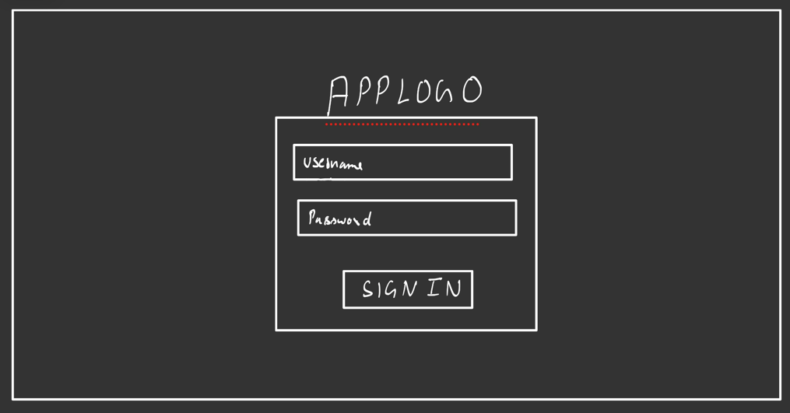

- Home Page
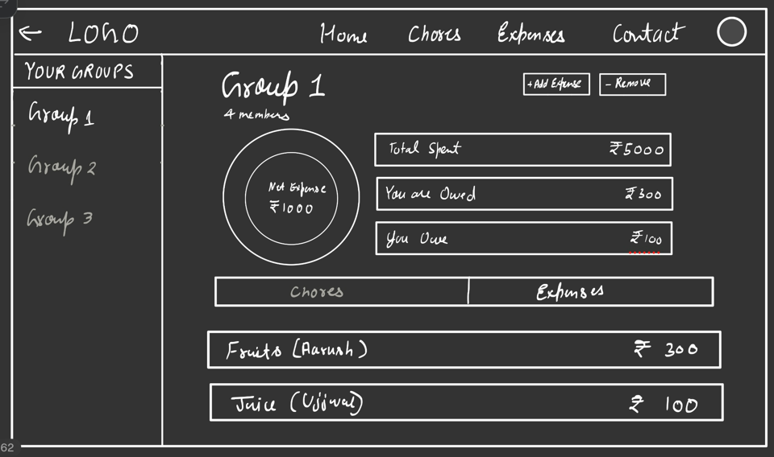
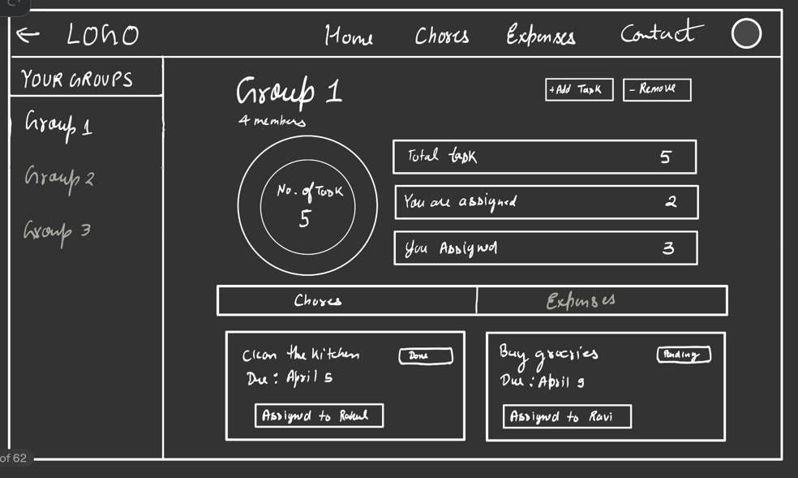

- Expense Page
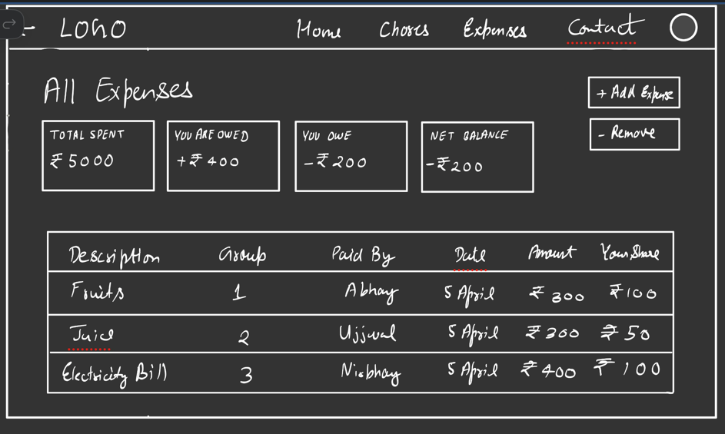

- Chores Page
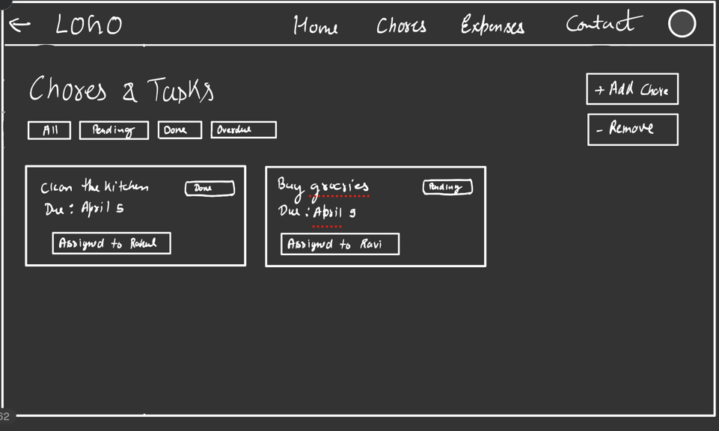

- Contact Page
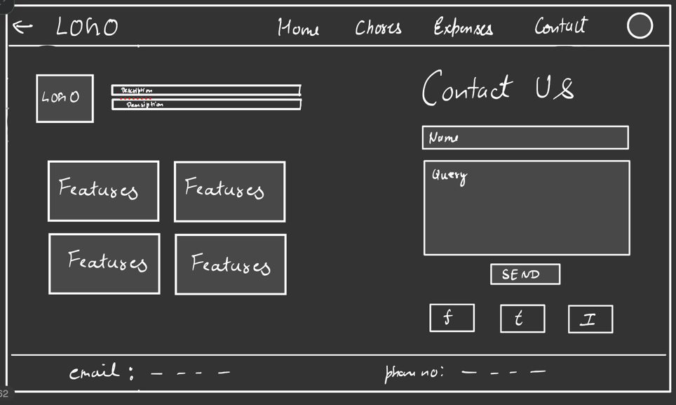

2.3 Link to the developer’s website
This is your personnel website and should have your resume designed well
Akshanya S (AM.SC.U4CSE25201): https://akshanya07.github.io/Portfolio/
Krishna Jayakumar (AM.SC.U4CSE25229): https://krishnajayakumar2006.github.io/Portfolio/

Sanjana S (AM.SC.U4CSE25246): https://sanjanasaji8121.github.io/Portfolio_25246/

Yaksh Chauhan(AM.SC.U4CSE25259): https://yakshchauhan.github.io/Portfolio/

